**MeghnadSaha Institute Of Technology**

Department of Computer Science And Engineering

**Project :HDFC Bank finance Data Analysis**

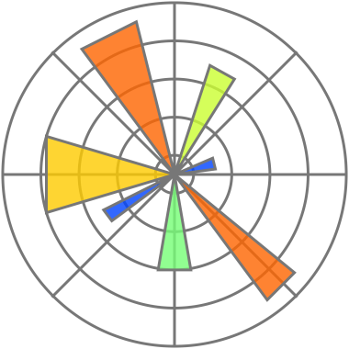ABSTRACT

The project aims to leverage machine learning techniques to conduct a comprehensive topic analysis of HDFC Bank stocks, thereby enabling investors and financial analysts to gain valuable insights into the market trends and factors influencing the bank's stock performance. By utilizing natural language processing (NLP) and sentiment analysis, the project seeks to extract and analyse relevant information from textual data sources such as financial news articles, analyst reports, and social media content related to HDFC Bank.  
  
**INTRODUCTION**

In today's rapidly evolving financial markets, investors and financial analysts are constantly seeking innovative approaches to gain a competitive edge and make informed decisions.  
The analysis of stock market data has traditionally relied on fundamental and technical analysis. However, with the explosion of digital information and the advent of machine learning techniques, the financial industry has witnessed a paradigm shift towards data-driven methodologies.  
The project adopts a multi-faceted approach. Firstly, we employ a web scraping module to collect up-to-date and relevant financial news articles pertaining to HDFC Bank. This ensures that the analysis is based on real-time information, reflecting the most current market dynamics.

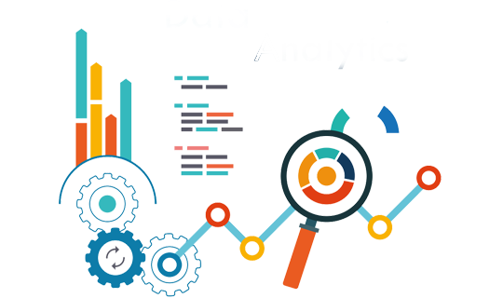

To enhance the predictive power of our model, we incorporate relevant financial indicators and historical stock price data as additional features. By combining textual analysis with quantitative data, we can uncover hidden patterns and trends that may influence HDFC Bank's stock behaviour.  
  
Overall, this project seeks to bridge the gap between traditional financial analysis and cutting-edge machine learning techniques. By providing a data-driven and comprehensive analysis of HDFC Bank stocks, we aim to empower investors and financial professionals with valuable insights that can guide their investment decisions.  
  
However, it's essential to emphasize that this analysis should complement expert financial advice and not be considered a standalone investment strategy.

# **Analysis of the Data**

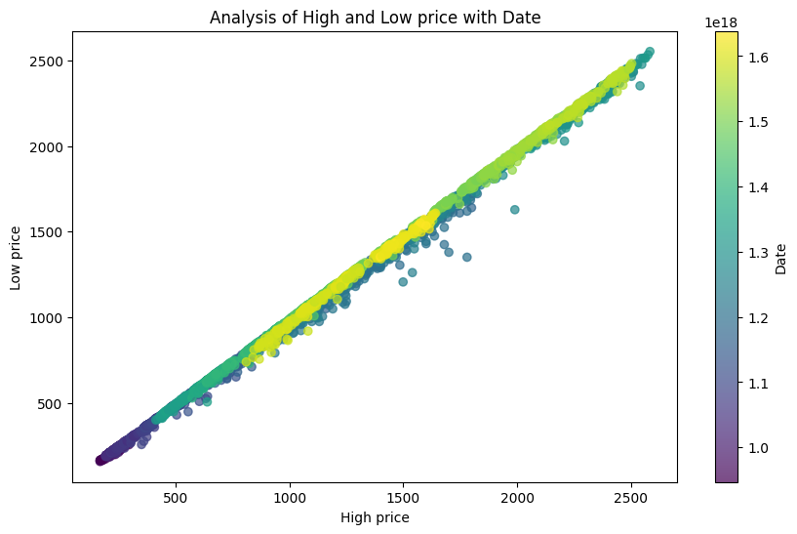

Analysis of High and Low Price with Date:

The graph provides a visual depiction that can help to clarify the link between the "High" and "Low" prices, spot potential trends or patterns, and draw attention to any outliers or temporal impacts. These findings may be useful for financial analysis, trading tactics, risk management, and dataset-related decision-making.

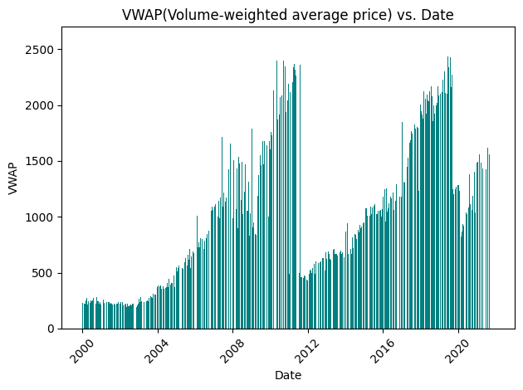**Analysis of VWAP with Date:**

Banks can examine the execution quality of their trading activities using the VWAP graph. Banks can determine if their trades were conducted at advantageous or unfavourable prices in relation to the average market price by comparing the actual transaction prices with the VWAP. Banks often benchmark their trading performance against the VWAP to evaluate how well they performed compared to the average market price.

**Analysis of Volume over Time:**

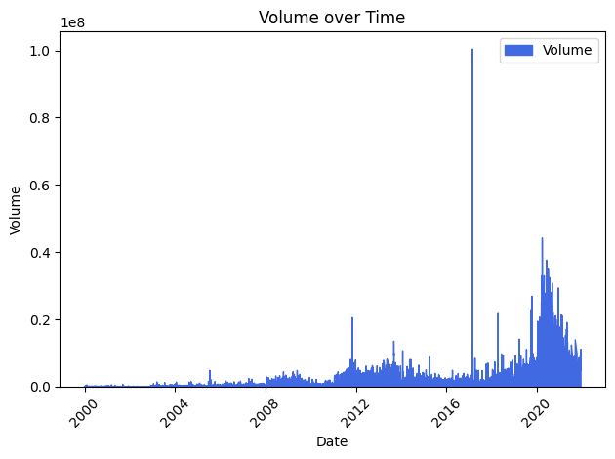   
The graph can show the market presence of the bank. A higher trading volume can indicate that the bank is actively trading, executing trades for customers, or engaged in proprietary trading. It offers information about the market share and competitive standing of the bank within the financial ecosystem. The graph also helps the bank monitor its compliance with trading volume regulations and ensure adherence to applicable rules.

**Daily High and low Prices over Date :**

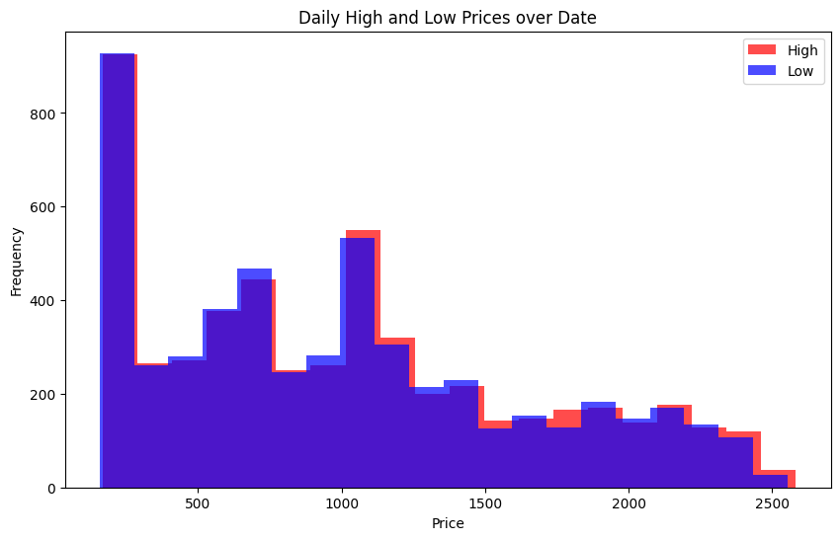

Analyzing this HDFC share data, the graph of daily high and low prices reveals trends, volatility, support/resistance levels, and potential breakouts/breakdowns. It helps investors identify risk, seasonal patterns, and event impacts. Traders use it for technical analysis and divergence signals. However, past performance doesn't guarantee future results, and additional factors like the economy and company developments must be considered for sound investment decisions.

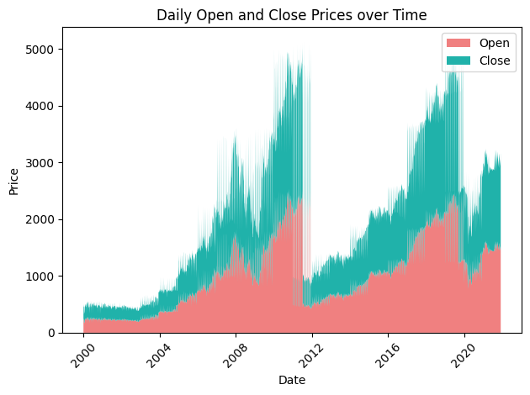**Daliy Open and Close Prices over Time**:

The daily share data graph of HDFC, showing the relationship between daily open and close prices over time, is significant as it provides valuable insights into the stock's price trends and volatility. Analyzing this graph helps identify patterns, such as potential long-term trends, short-term fluctuations, and possible support and resistance levels. This information aids investors in making informed decisions regarding buying, selling, or holding HDFC shares based on historical price movements.

**Turnover over Time :**

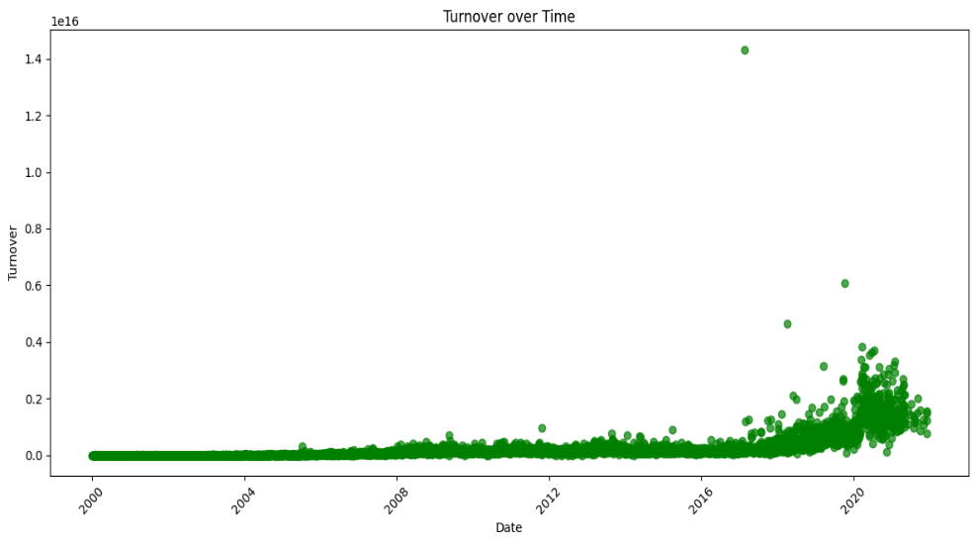The turnover time graph is significant as it illustrates the time taken for a company's assets to be converted into sales and then back into cash. It helps measure operational efficiency and liquidity. A decreasing turnover time indicates improved efficiency, while an increasing one may suggest inventory or cash flow issues. Understanding turnover time assists businesses in optimizing operations and managing working capital effectively.

# **Acknowledgement**

We extend our heartfelt gratitude to the MeghnadSaha Institute of Technology and the Department of Computer Science and Engineering for providing us with the opportunity to undertake this project. We sincerely thank our project guide SubhraPratimNath for their invaluable guidance, support, and expertise throughout the project's duration.

I would like to express my sincere gratitude and appreciation to all those who have contributed to the successful completion of this data analysis report for HDFC Bank. Without their support and collaboration, this project would not have been possible.

Finally, I want to acknowledge the contributions of my fellow team members for their collaboration, ideas, and tireless efforts throughout the entire project.

# **References**

1. HDFC Bank Annual Reports: Various annual reports of HDFC Bank provided valuable financial and operational data used in the analysis. ([www.hdfcbank.com](http://www.hdfcbank.com))
2. Reserve Bank of India (RBI) Reports: The official publications from RBI were used to gather macroeconomic indicators, industry trends, and regulatory information relevant to the banking sector in India. ([www.rbi.org.in](http://www.rbi.org.in))
3. Nagalekshmi V S, Vineetha S Das (2018). Impact of Mergers in Banking Sector: A Case Study.International Journal of Research and Scientific Innovation (IJRSI),| Volume V, Issue VII, 100-102.