Content

Link to the website................................................................................................2

A description of the idea and concept to the solution that we developed………….2

Users, their aim and target group……………………………..…………………...….3

Kanban.Trello. Video.............................................................................................4

Prototype ...............................................................................................................5

Usability...............................................................................................................12

Content..................................................................................................................14

Design coice...........................................................................................................15

Services..................................................................................................................16

Git dokumentation...................................................................................................17

Refleksjonsnotater

A description of the idea and concept to the solution that we developed

Here is the link to the website itself: **http://tek.westerdals.no/~sarmad16/gruppe11webProsjekt/index.php**

**Idea.**

In accordance to our task, we have to create a webpage for students and teacher that will help them to become familiar with the district around the campus. We chose campus Vulcan, since it is the most known, bright and central of other campuses. Website has to be as easy to use and navigate as possible.

**Concept.**

To find the best solution we made a short survey and considered what could be the most important information for a student or a teacher to know about a campus and possibilities around it. Consequently, we came to a decision that there are five main points person pays attention to, when moving into a new area. They are: accommodation, what and where to eat, how to get there, where to go if something goes wrong and you get sick and what to do in your free time. Therefore the concept was to make a unified header with six pages, with information that was mentioned by our survey participants as essential.

Because of very recognizable colors and design of campus Vulcan we decided to use the same color code. Westerdals is an artistic college and we think it’s important to make our site stylish and inspiring.

Users, their aim and targetgroup.

Our main target group are students and teachers who consider studying or working in Westerdals, campus Vulcan or have just began. We decided not to make any inloggings to make our users auditory broader. Website users can get a brief overview of the area and about most important things that they may be concerned about.

We truly believe that main interest of a person, who visits such an informational webpage is to get information on needed topic fast and fully. So our site has a very easy and understandable navigation between categories/ important aspects of life of every student.

Based on the result of our survey we found out that when a youngster moves to a new place, the first thing he has to consider is affordable place to stay. So we have a “Bolig” page which gives information about leading dormitories.

Public transport is also one of the first few things that a person is concerned about in a new location. On the transport page there is information about basic transportation rules and nearest transport stops.

Of course, food, it’s a huge part of everyday life, so it was obvious that we should have it in the description of school environment.

Health is important concern of every human being on the planet. Our students also should know where to look for help if something happens and where to train to try to decrease chances of health problems.

What is a student life without partying and social life? The “Event” page is a guidance to upcoming arrangements around the school.

The last one is a map on a “Kart” page. User gets opportunity to see a visualized version of all the possibilities on the map.

Our aim is to make the website as complete as possible, so that a user wouldn’t need to search through other pages to get extra information.

A description of how we used Kanban in our project. Pros and cons of it.

Link to the video that we have made:

<https://www.youtube.com/watch?v=pzRUP4UEquE&feature=youtu.be>

We chose Trello as our project management tool for kanban. It was easy to use and helped us keep the track of our project process. With Trello we could plan the tasks and divide them between the members of the group. Each member could keep others updated of the tasks they were working on. With Trello we could follow the process of each task from start till the end. Trello can be very good for all types of projects, especially for bigger and long-term ones where there are more members working on the same project or same tasks. It will make it easier to have control over whole process and assist others. Trello also visualizes the project process which makes it easier to know how everything goes on and decreases the misunderstandings.

Of course nowadays that facebook has become a big part of everyones life and people use most of their time on it, it made it easier to communicate on facebook rather than only using Trello when it comes to smaller projects and few members.

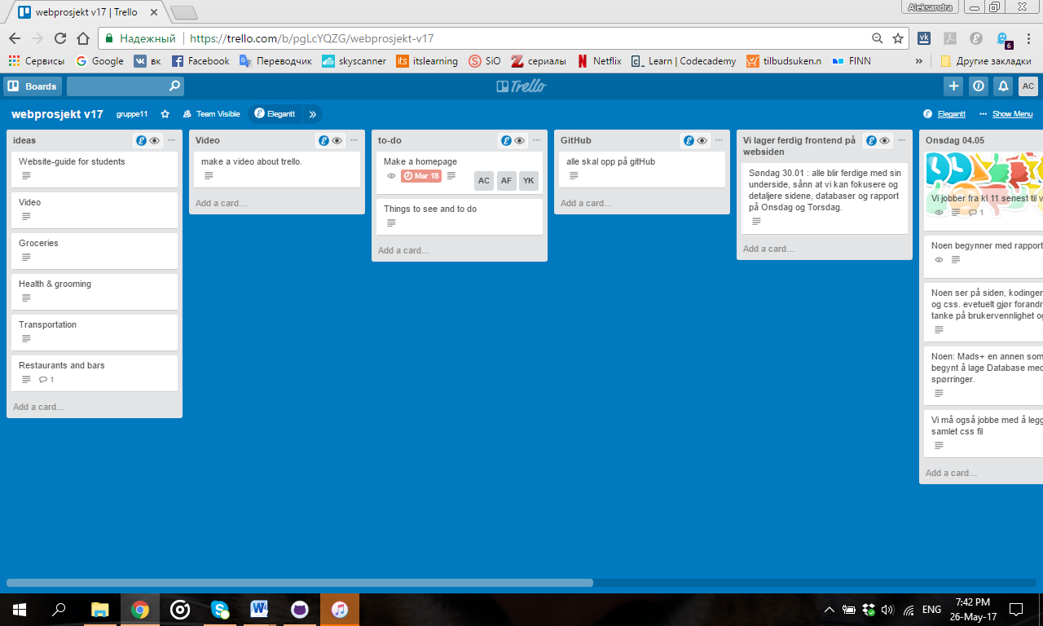

A description of the prototype that was developed in the start of the project.

**Front page**

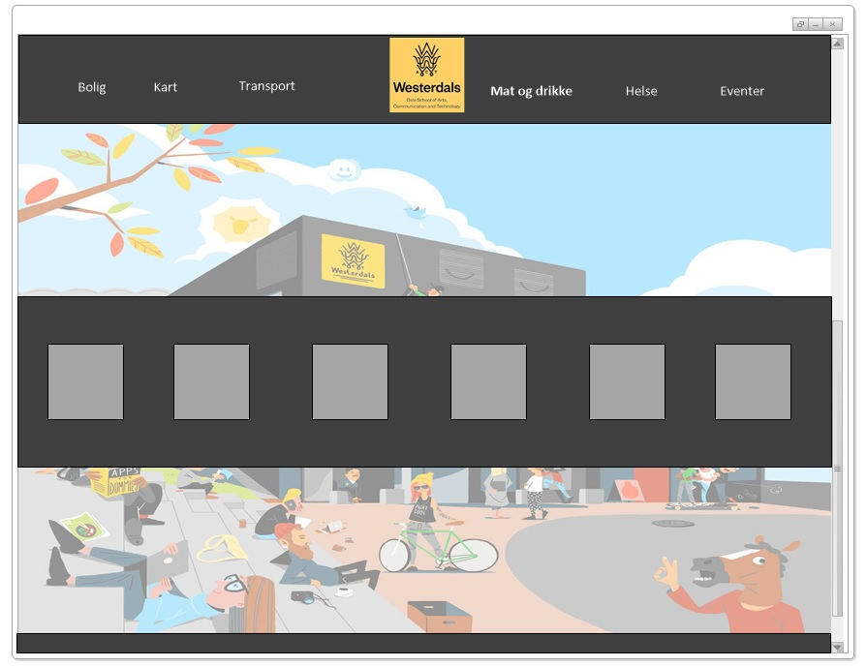

When a user visits our start page he\she will be introduced to all subjects which can be relevant to a student’s life. We have chosen to have two navigation options on our front page. It is going to be a header which will maintain on all of the pages and the icons one which is only available on this page.

The header contains the logo of the school in the center and six text-buttons, three on each side of the logo which link us to the other pages.

There dark block in the middle of the page has six icons which each one of them represents the same page as equivalent text-button from the header.

**Bolig**

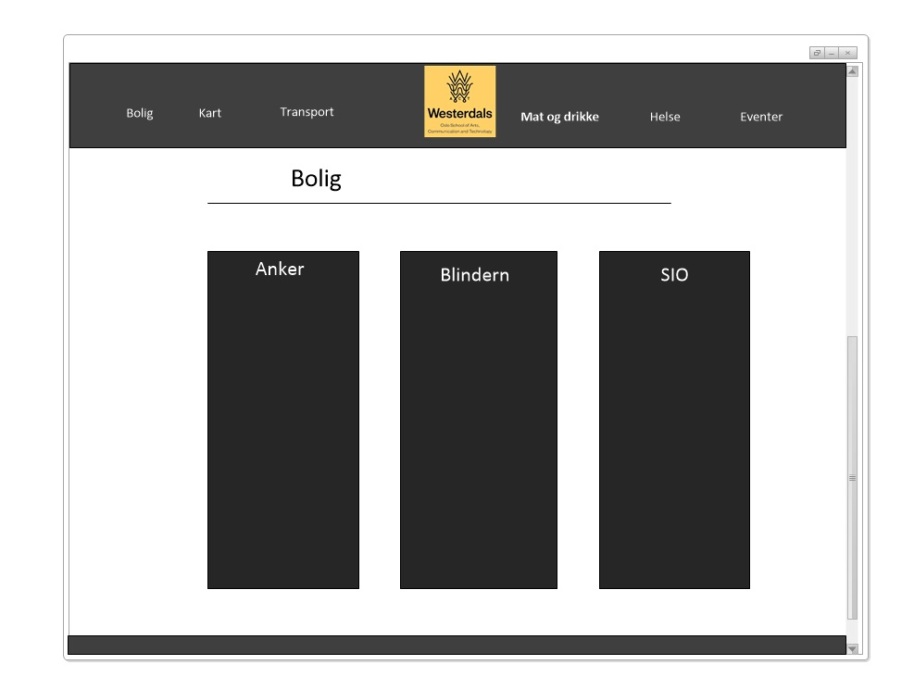

“Bolig” has information about main dormitories in the city. We chose “Anker studentbolig” is one of the nearest accommodation options for Westerdals students, it is located between two main campuses- Vulkan and Fjerdingen.

“Blindern studenthjem” is located at the territory of Oslo University. It is a perfect place for those who want to feel the romance of that special time- being a student. Lots of social events and great student infrastructure are main attractions of Blindern dormitory.

SiO – student organization in Oslo and Akershus, provides enormous choice of different dormitories and campuses located all around the city. There are many options between single room or apartment, with or without furniture in the city center or in quiet neighborhood by the lake or forest.

**Kart**

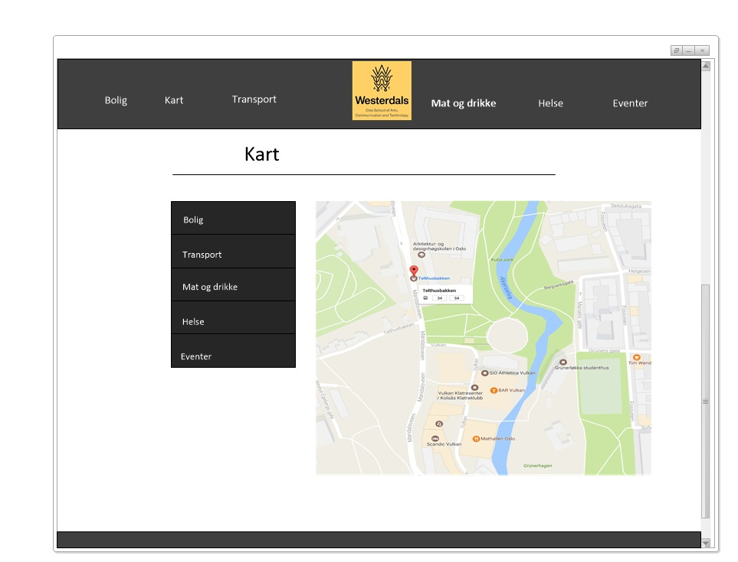

On the “Kart” page there is a big map and a navigation bar on the side. Clicking on each category on the navigation bar results in marks appearing on the map which demonstrates location of chosen elements. Map is a very convenient tool to get general perspective and understand area and distances between objects. That can also be very helpful in, for example, planning days or evenings.

**Transportation**

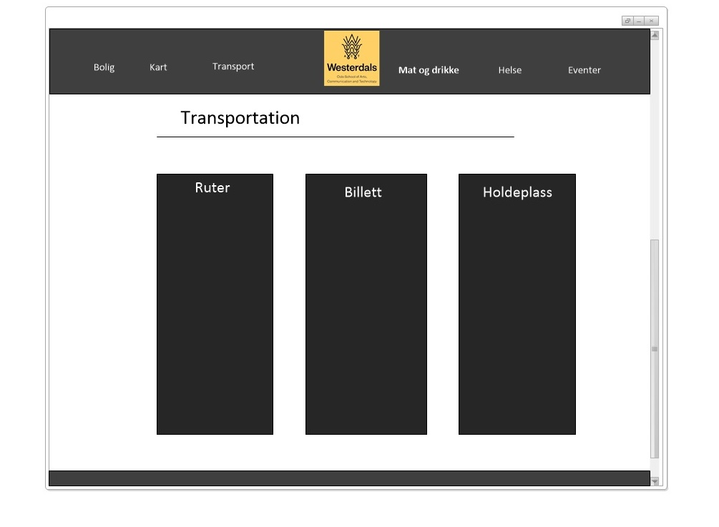

On this page we have three blocks with different information about transportation system in Oslo.

In the “Ruter” box we described the ways of purchasing tickets or monthly cards in Oslo. “Billett” box gives overview of various ticket options and their fares offered in Oslo, discounts that students are entitled to and consequences of refusing to pay for the trips.

“Holdeplass” box presents the nearest bus and metro stops to the school.

**Helse**

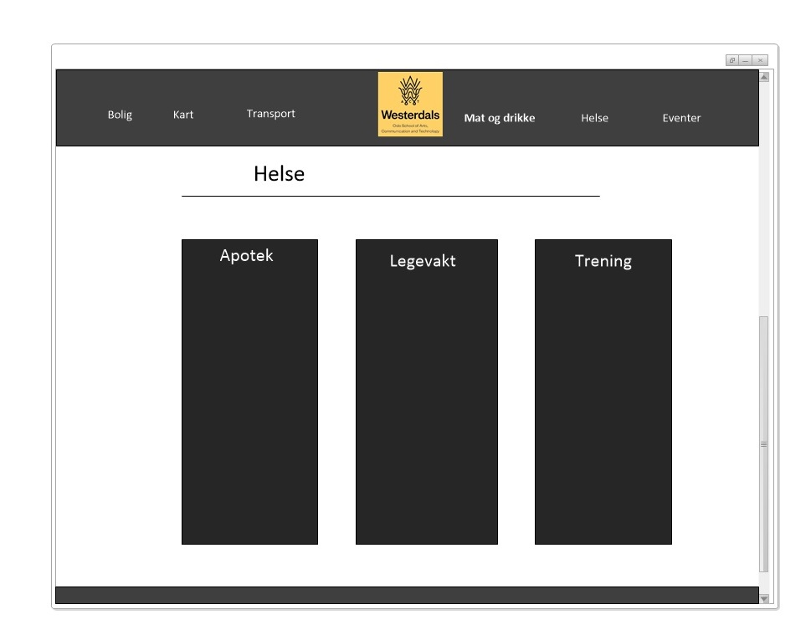

When it comes to health, it is important to know the closest emergency room to school in a case of accident or acute sicknesses. We don’t see it necessary to include family doctors or specialists, since normally people choose and plan such visits in advance.

Pharmacies are also essential to be mentioned. Most people find it convenient to buy the necessities from the places they are passing by daily.

By placing training into the “Health” category we wanted to emphasize that exercising is an everyday contribution that one can make in order to achieve a healthy life.

**Mat og drikke**

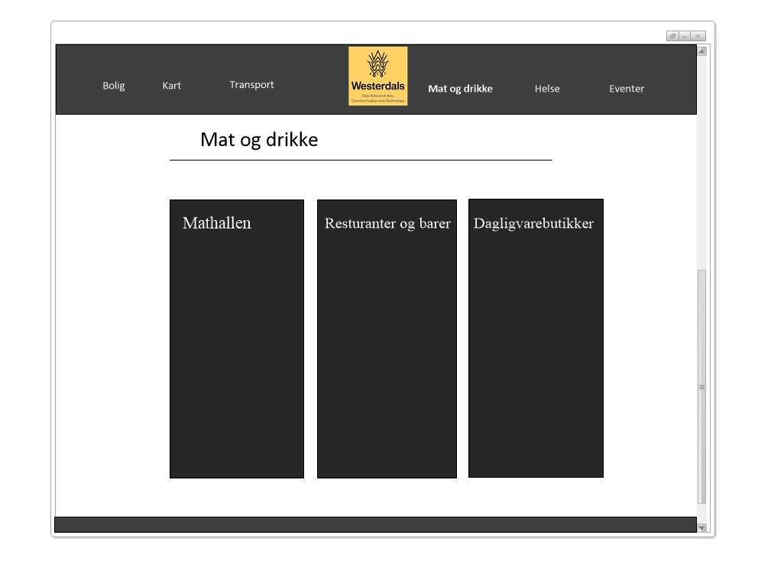

Nutrition and access to grocery stores are few of most important things for a person wherever he or she is. For effective study process it is extremely essintial to supply brain with energy. For students it is even more important to be able to get quick energy boost. On our food page we provide two variants, where user can find more desired way of eating. We have one block with groceries, if one prefer simple snacks from the store or need to go predinner shopping. Another block notices restaurants and bars in the area, for those who like to be served a delicious prepared meal.

We think that it is an obvious decision to mention “Mathallen” as a big part of dining alternatives of the area and the city in general. In addition to great variety of restaurants, it also offers a good choice of wining places to have an amazing expirience of Oslo’s nightlife.

**Events**

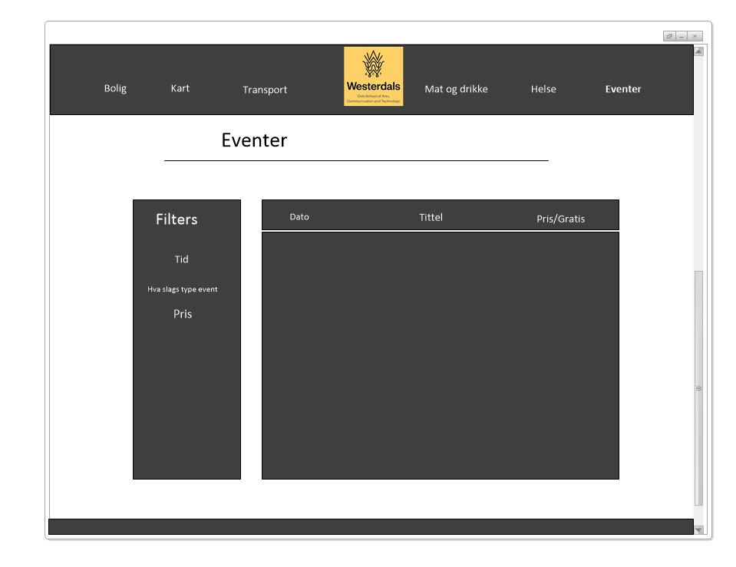

Being a student is not only about books and projects all the time. It is about being socially active to start making friends and professional connections. After spending many hours at school during daytime, it is always nice to have a place to go afterwards with friends to relax. We truly believe that knowing about upcoming arrangements and opportunity to attend them is super cool for young people, therefore we included it to our site.

Usability

Usability is a quality attribute that assesses how easy user interfaces are to use. The word "usability" also refers to methods for improving ease-of-use during the design process. Usability is an important aspect of a website that keeps people on the page and make them loyal users of the service.

There are some conditions that should be fulfilled to achieve good usability of the website.

Availability and Accessibility

* We decided to upload our site to schools server in order to avoid possible crash.
* Avoid broken links – we tried to avoid to big amount of external sources, and used only few links, like for example to the dormitories that students can apply to. All links are checked for not being broken.

## Clarity

A clear and usable design can be achieved through simplicity of the site, familiarity to the way the information is presented, consistency , guidance and good information architecture. So we used all those principles when considered usability of our site.

* Simplicity

Very easy and clear navigation throughout the site is provided by simple header with category buttons on it. Every page has two intro sentences on top of the page and tree blocks with information according the topic.

* Familiarity

We intended to make our website as more typical for such informational sources as possible. When person visit informational website they don’t expect any difficult or overwhelming activities, so we tried our best not to be frustrating.

* Consistency

All pages are made in the same style, same colors, fonts, and design.

* Guidance

To make it easier to scan the content of the page for visitors and get faster familiar with the information every block on the page has an icon on top, indicating what every block is about.

* Good information architecture

Homepage clearly states what we offer and what users can do on the site . Since people visit informational website to get information but not for entertainment, we kept category names simple, to avoid confusion. Every category includes only information concerning the topic.

Thing that is a bit different from other sites of such kind is location information about training centers. The website is made for Norwegian market, where being healthy is getting more and more trendy. So as a part of healthy life propaganda we included training to the “Health page”, to emphasize that training is a huge part of your wellbeing.

Learnability

Our goal was to design intuitive interface — that our users could avoid a long process of figuring out where needed information is. Key to intuitive design is to make use of what people already know, or create something new that is easy to learn. Our idea was to promote training as a part of individual’s health, so we merged them and made training as a part of health.

## Credibility

Credibility is a crucial aspect of any website. People have to know that website is active and information present is up to date, so they can trust the content. We provide it with fresh and constantly updated information about upcoming events.

All links are checked on regular basis.

Since our website should be a kind of addition to schools site, we decided that footer of every page will include Westerdals telephone and e-mail address as contact details, to assure people that site is trustworthy.

## Relevancy

We understand that content must be relevant for the users, that they don’t need to read though lots of information to find what they look for. Relevancy of our content was based on a research – survey, we interview few students, as for what were they looking for when they first found out where they will study and came to Oslo for the first time.

Content

The content of our website is about Vulcan campus of Westerdals School of art, communication and technology and its local environment.

As we have written above, the decision about the content of our webpage was based on the results of survey. The survey’s aim was to research about what kind of information young people want to know when they move to a new place. We tried to gather useful information without making the website too overwhelming, in order to avoid complexity.

Start page’s function is an introduction of what we have on the website and navigation menu between six under pages.

“Bolig” page provides information about the main dormitories in the city. In every section it is a brief description of the accommodation, location and contact info. At the bottom there is a link to the dormitory’s website, if a person needs closer and more detailed information.

“Kart” page gathers maps from all pages for an easier visual presentation of the area for a user. Depending on which button (area of interest) being chosen it appears a new map with marks on selected topic.

“Transport”. Information about transportation system in Oslo, ways of payment, types of tickets for people who are not familiar with the city. It also presents information about nearest bus stop to school and metro station.

“Helse”. Main aim of the page is to help website visitor to get familiar with health services, something you may need when something is wrong with you. If you know what it is and what can help you can find address of nearest pharmacy where to buy remedy, or if something more difficult, there is information about emergency room you can go to. We discussed content of third part, it could be dentist or private doctor. But as a part of promotion of healthy way of life, we wanted to emphasize that training is a huge part of wellbeing, so we included training centers to that page as well.

Our “Mat og drikke” page makes it easier to a person to choose between three alternatives when it comes to nutrition. If it is going to be something high-class, like

Mathallen, which is an iconic place and has big importance in gastronomic life of the whole city, or they can see options of restaurant and bars services, for those who need just a fast snack or shopping before they go home, a groceries section.

“Events” page has an aim to make students and employee of the school familiar with the arrangements that take place in the area or somehow connected to afterschool life. It is a table with a date of the event, its name, location and price. On the left side there is a panel, that allows to filter events according to date, type or price (free of charge or not).

Design choice

Choice of color

Main colors of the site are dark grey and yellow. We think it symbolises colors of the campus and is a great accomplishment to schools logo. Such color combination is very stylish, that is very relevant for school that works with art and design, it’s also comfortable for user’s color perception.

Logo

We recreated the logo symbol from Campus Vulkan on our header, to make it recognizable by using same colors and shape as the original logo. To make page look symmetrical, we located it in the middle of the header. It is also a tiny logo on the footer. Logos from both header and footer directs to the Homepage.

Header and footer

We intentionally made six under pages to make the header look balanced and easy to navigate. Main idea is that it looks clean and easy to read, so the user don’t need to spend time trying to figure out where to click.

Instead of creating extra page “About us”, since it is not relevant to write about developers, we chose to have a fixed footer where a user can always have access to contact information of the school.

Background pictures

Every page has own background picture depending on a theme, to help the user quickly catch the topic of a page. Despite individuality of every category we wanted to make the pages connected to each other. Therefore all of them have common color warmth and idea of simplicity of elements.

Front page

To support the idea of simplicity, the front page has only introductory block with all topics that we wanted to cover on the website. That box is a route map for our users, it has symbolic picture representing theme of the page it is leading to.

Under pages

All pages, except map and events, are done in the same style. Information in each category is divided into subcategories and presented in three dark boxes. Every box has super simple vector picture under the header of the box, for visual navigation of our users. Icons used in the boxes duplicate and accomplish pictures from the front page.

Services

Map

Map is an under page that collects all places described on other pages and places them on a map, depending on which category was chosen.

On the map page, JavaScript is used. The function of this page is that when clicking on different buttons, the information as in this case is coordinates appear as markers in the image. The map on the page is Google Map, and an api used by Google is retrieved.

Code building:

The coordinates are placed in an array. After that, a function is created and the map is created, inside this function, eventListener is added to the buttons, which means that when the buttons are pressed, it extracts the information into specific functions, these functions contain iteration through the array of coordinates as then in addition, make markers.

What could we do to improve the map page:

We could have added more information about what the cursors pointed to, so when you pressed the cursors, the information about the place appears.

We could also have put pictures on the markers.

Events

Events page provides information about upcoming events that can be interesting for young people.

On this page PHP and MySQL have been used to connect to database that retrieves id, time and name of events and places it into an array.

Using PHP it is created a box for each result it gets from the query, it retrieves with the first uploading of the page, adds an id on each div depending on where in the array it is. Using JavaScript, we add a click function on each of the divs. When person clicks on the add a selected id is sent to the URL and refreshes page.

Then we have an if statement that checks if a selected id is added to URL. If this is true, then it will retrieve a new query using the information that is inserted into the URL to run this through the database and extract more info about this event. Where it's going to happen, what's going to happen, address, possibly link to host's webpage and an iframe code line that adds an iframe about where the event will take place.

And instead of filling the page with small boxes, it will fill the page with one event instead of all the small boxes.

Improvement of events can be done by adding filter functionality, where you can sort or filter depending on what you are looking for, sort by date or name, or filter results based on what event it is. A searchable functionality could also be added.

Git usage description with a *Punch card*- og *Contributors*-graph.

