Game: Temporary name: Project Thunder Dragon

2D Turn-based RPG

Chinese art style

Programmers: Jiangnan Fu, Dyland Xue, Yingzhu Zhang, Xiaonan Hu, Caroline Yi.

Artist: Yuming Cao

Musician: Shupeng Cao

Battle will include two teams against each other.

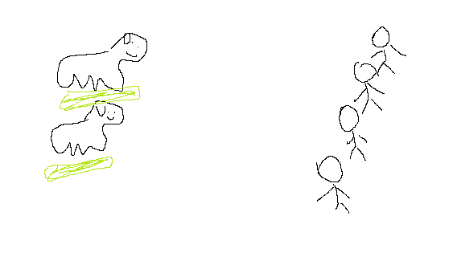

Players can choose from: Attack, Skills, Items, or Run.

Each character, including Monsters, has 3 main stats:

Str: Strength increases Physical damage.

Int: Intelligence increases Magical damage.

Spe: Speed increases how early the character will move, as well as how many actions the character can perform. Will specify later.

There are also secondary stats.

HP: drop to zero, and the player dies.

MP: consumes when using skills. Recovers 5% each turn.

Def: Physical Defense

Spd: Magical Defense

Dodging and Critical strikes do not exist in this game.

Speed: This will be one of the more important and different part of the game. Each character will be able to perform up to 5 times depending on how much more speed he has than his opponent.

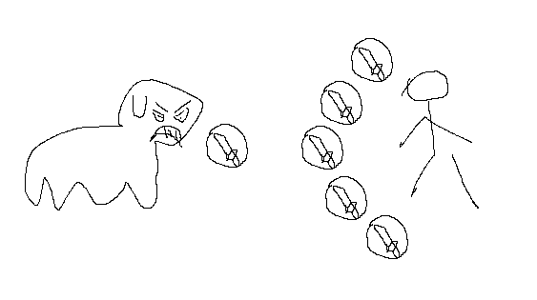

Say we have a character A with 100 speed, and monster M with 10 speed. 100/10 = 10 > 5, therefore character A will perform 5 times, while monster M will only perform 1 time. Each time A performs, we subtract 1/2 from the speed. So 100 -> 50 -> 25 -> 12 -> 6. And at the 5th action, A’s speed (6) is finally smaller than 10, which means it’s time for M to move. Say both characters use “attack” command on all actions, it will be :

C: attack -> C: attack -> C: attack -> C: attack -> C: attack -> M: attack

But when M’s speed is 20, C will still perform 5 times, but the order will be :

C: attack -> C: attack -> C: attack -> M: attack -> C: attack -> C: attack

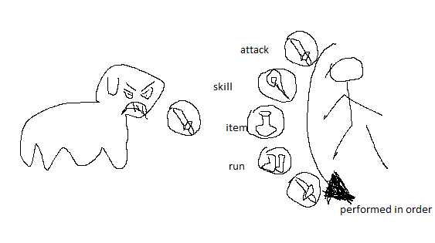

This will provide more strategy and some unique experience.

Customization:

Each character can equip 3 cards, which are dropped from monsters:

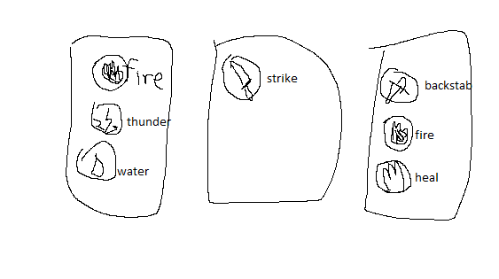

Each card can contain up to 3 skills. Cards are randomized.

When a character equips two cards that contain a same skill, the skill level goes up. Lvl 2 fire will deal 1.5\* damage, lvl 3 fire will deal 2\* damage, lvl 4 fire 2.5\*, and so on.

Each character can equip items too.

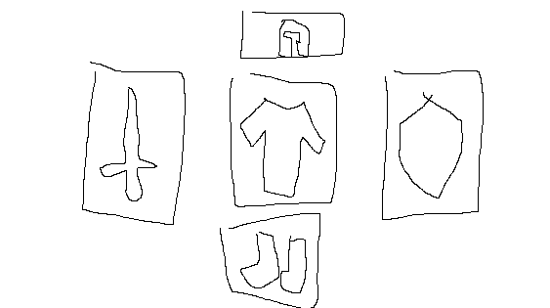

The items will increase stats. So players can mix and match and create their own characters.