**Experiment No:06**

**Aim: To connect Flutter UI with firebase Database.**

**Theory:**

**Firebase:**

Firebase is a platform developed by Google that provides a suite of tools for developing and growing apps. It includes services for real-time databases, authentication, cloud storage, hosting, analytics, and more. Firebase simplifies the development process by offering easy integration, scalability, and cost-effectiveness. It is particularly useful for building mobile and web applications that require real-time updates, user authentication, and data storage.

**Key Concepts:**

1. **Realtime Database:** A NoSQL cloud database that supports data syncing in real time.
2. **Authentication:** Provides ready-to-use authentication services like email/password, social logins, and more.
3. **Cloud Firestore:** A flexible, scalable database for mobile, web, and server development.
4. **Cloud Functions:** Allows you to run backend code in response to events triggered by Firebase features and HTTPS requests.
5. **Cloud Storage:** For storing user-generated content like photos and videos.
6. **Firebase Hosting:** Fast and secure web hosting for your web app's static and dynamic content.
7. **Analytics:** Provides insights into user behavior and app usage.
8. **Performance Monitoring:** Allows you to gain insights into your app's performance and stability.
9. **Remote Config:** Change the behavior and appearance of your app without publishing an app update.
10. **Crashlytics:** A tool to track, prioritize, and fix stability issues that erode app quality.

**Steps To Connect Your Flutter App with Firebase:**

**Step 1:** **Create a Firebase Project**

Go to the Firebase Console.

Click on "Add project" and follow the prompts to create a new project.

Once the project is created, you'll be redirected to the project dashboard.

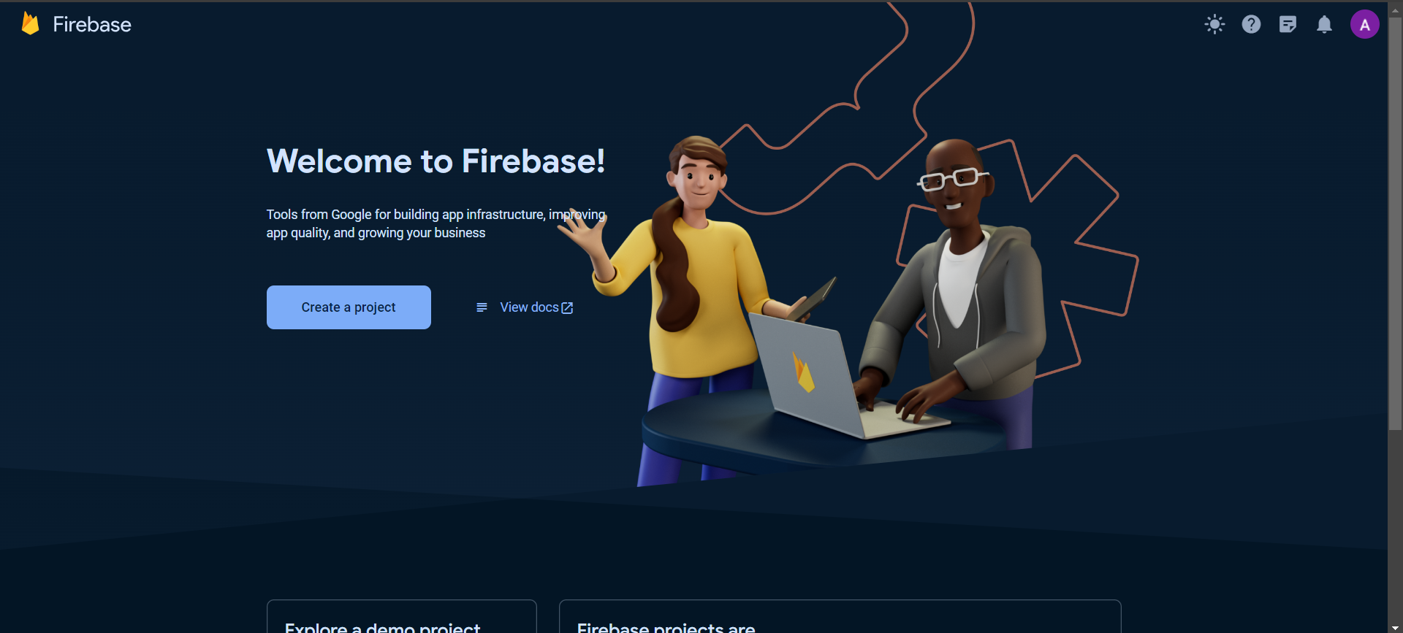

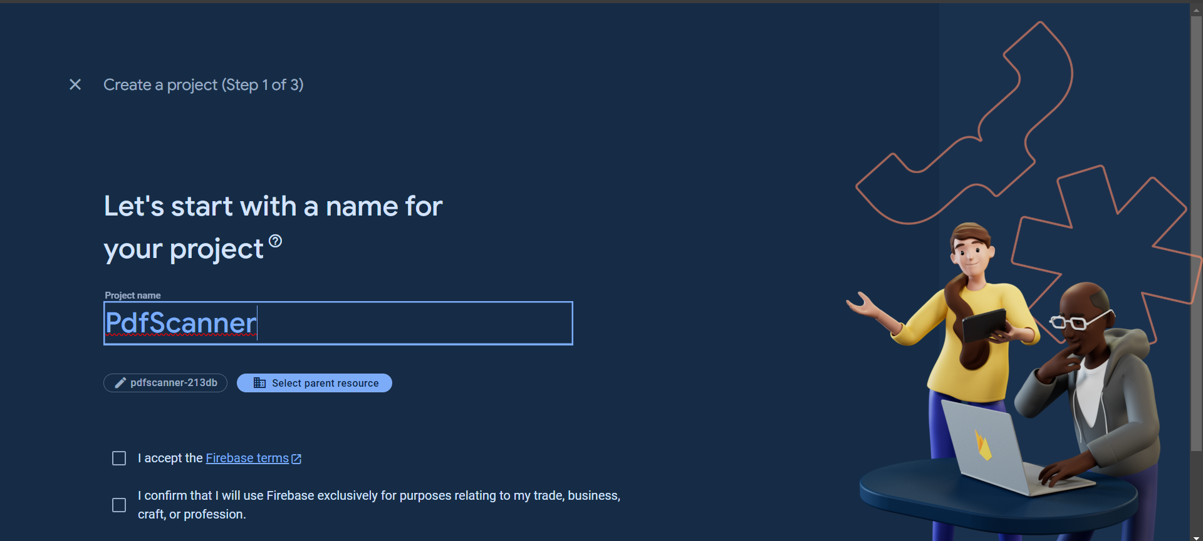

**Step 2: Add your Flutter app to the Firebase project**

Click on the "Add app" button (iOS, Android, web) in the Firebase console.

Follow the instructions to register your app with Firebase. You'll need to provide your app's

package name (for Android), bundle ID (for iOS), or other necessary information.

Download the google-services.json (for Android) or GoogleService-Info.plist (for iOS)

configuration files and place them in your Flutter app's android/app or ios/Runner directories

Respectively.

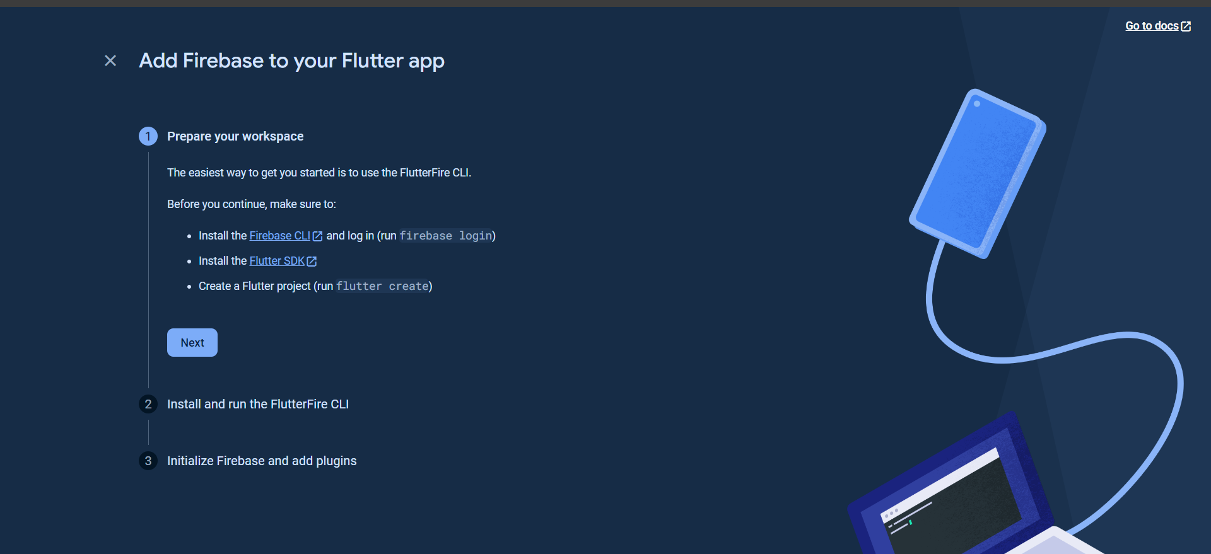

Step3 : Initialize Firebase using the Firebase CLI:

Install the Firebase CLI and log in (run firebase login)

Run commands **dart pub global activate flutterfire_cli** and **flutterfire configure --project=pdfscanner-213db**

This automatically registers your per-platform apps with Firebase and adds a lib/firebase_options.dart configuration file to your Flutter project.

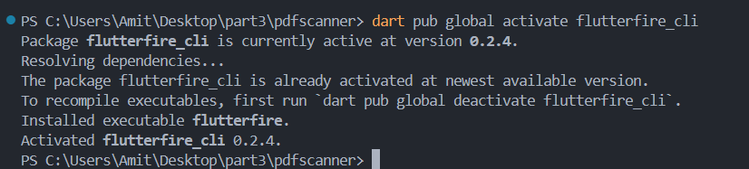

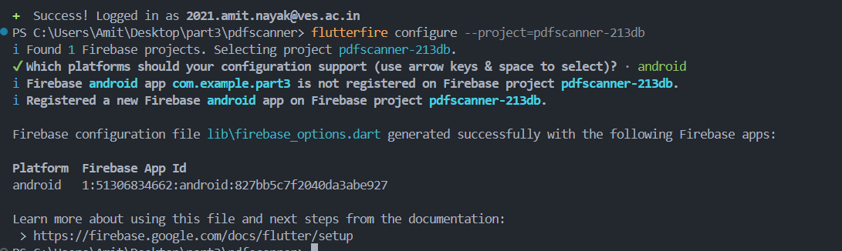

**Step 4:** From your Flutter project directory, run the following command to install the core plugin:

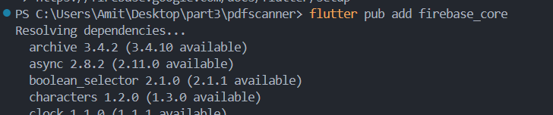

**Step 5:** In your lib/main.dart file, import the Firebase core plugin and the configuration file you generated earlier:

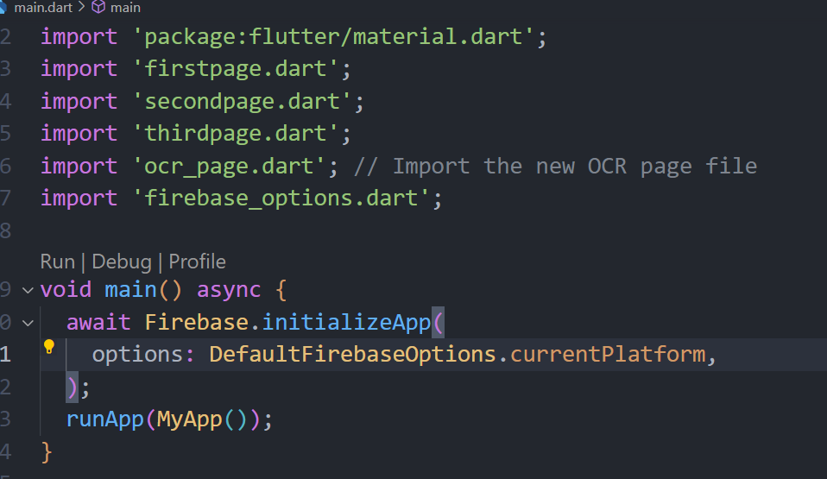

**Step 6:** Set up Authentication or other Firebase services

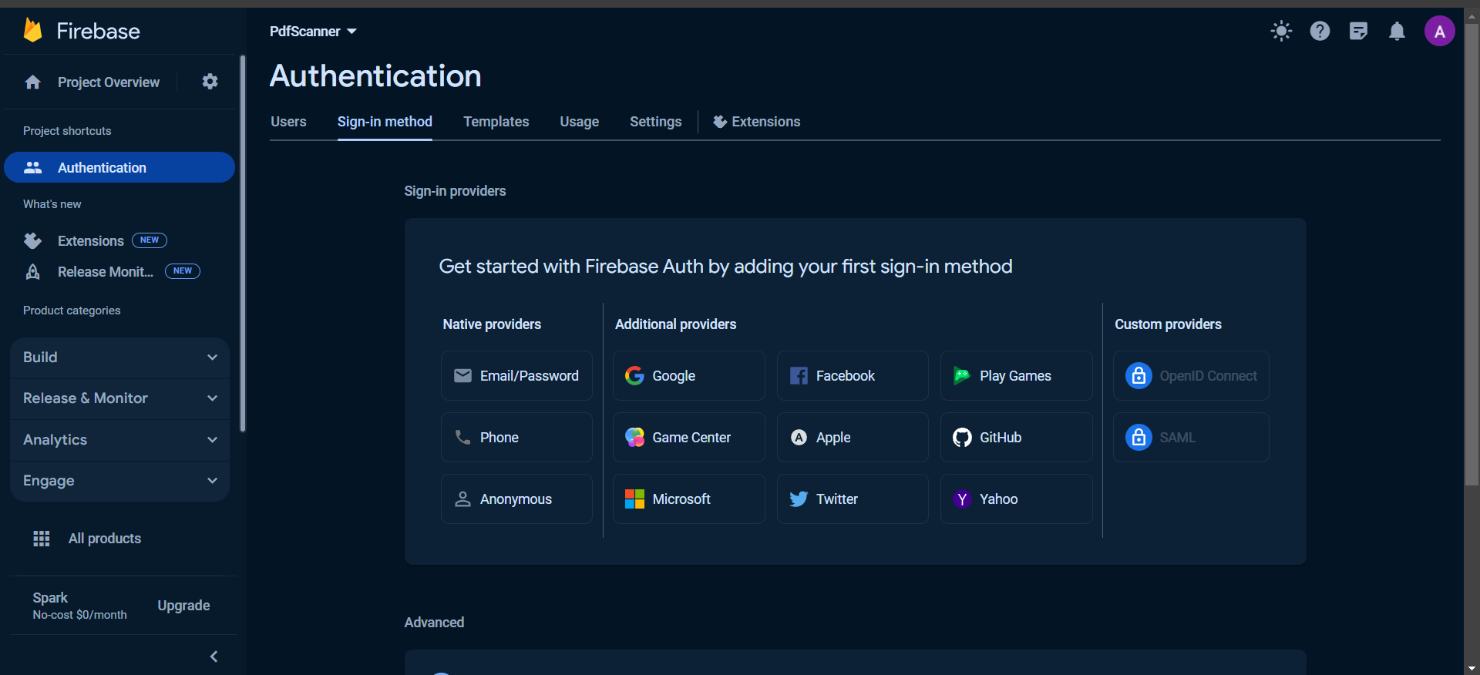

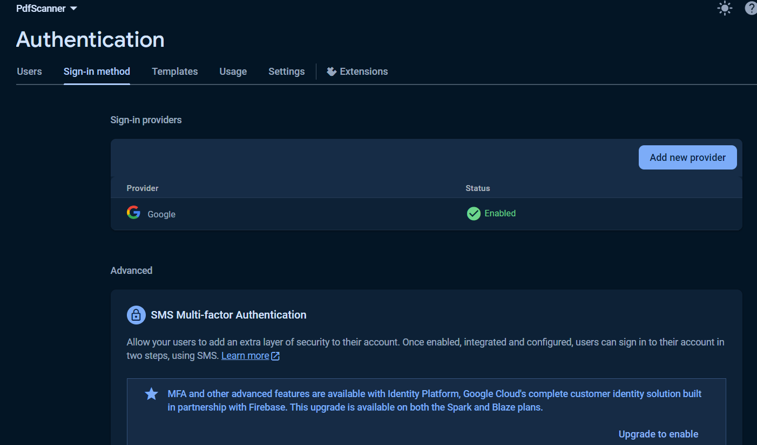

**Step 7:** Add the SHA-1 key to the firebase authentication project settings

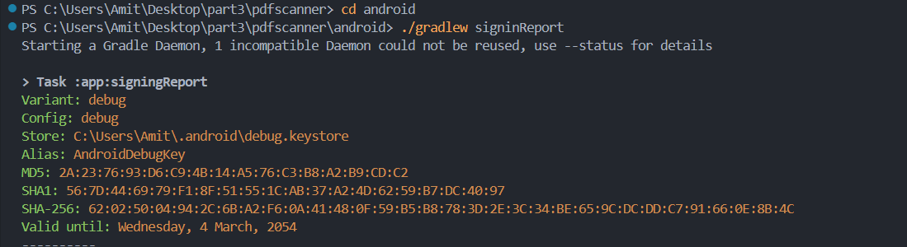

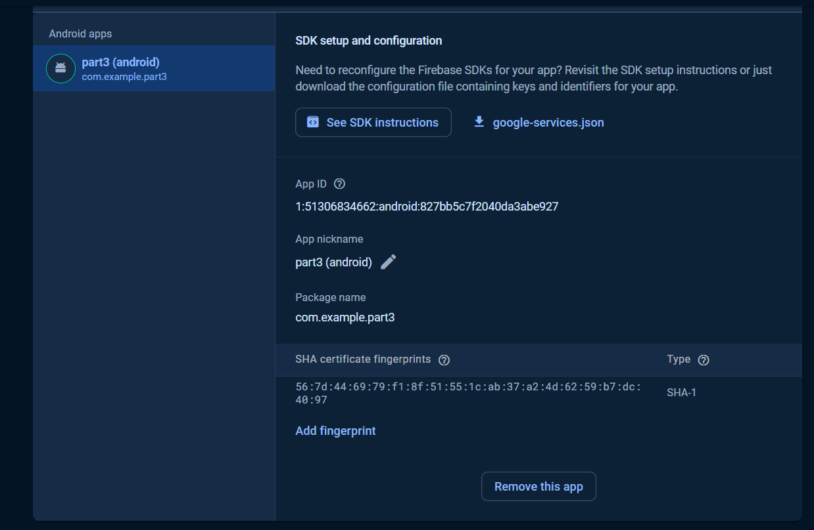

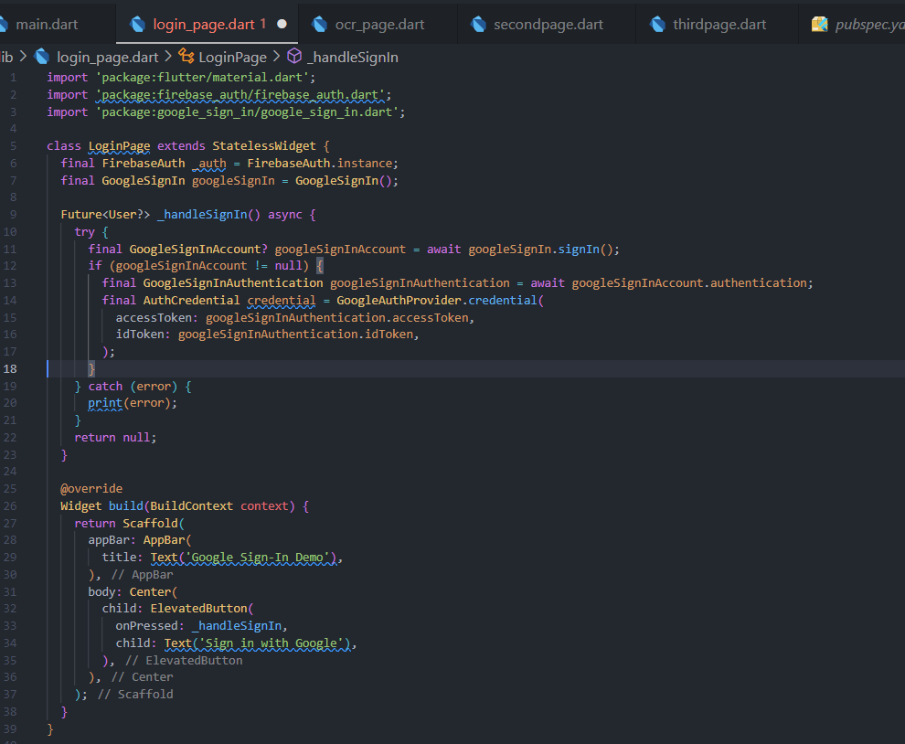

**Conclusion:**

We understood the concepts of navigation , routing and gestures in Flutter. We implemented navigation and routing for the above shown pages. We implemented gestures in a basic Flutter application.