Toolbox Talks

|  |  |  |
| --- | --- | --- |
| Weekly Tailgate Topic | | 11-16 |
| Discuss with crews on | [INSERT DATE] |

LOAD AND UNLOAD MACHINE SAFELY

Loading and unloading machines always involves potential hazards. EXTREME CAUTION SHOULD BE TAKEN.

Know the correct loading and unloading procedures for your machine. All machines are not loaded and unloaded the same way. The procedures recommended by the manufacturer should always be followed.

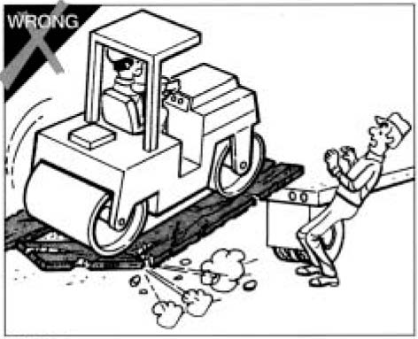Several precautions are applicable to all machines:

* NEVER load or unload machine by yourself.
* Keep all non-essential personnel clear of loading and unloading area.
* Ensure flatdeck is positioned on a flat grade, or facing downhill, with a maximum 2% grade and cross fall
* ALWAYS use ramps of adequate size and strength.
* Be sure ramps are sufficiently wide, and long enough to provide a safe loading slope.
* NEVER use ramps that are cracked, damaged, or of questionable strength.
* Be sure that the ramps are securely positioned and fastened, and that the two sides are at the same level as one another.
* The ramp surface must provide adequate traction. Be sure the surface is clean and free of grease, oil, ice, and loose material.
* The hauling vehicle should be blocked to prevent movement during loading or unloading of the machine.
* For proper tie-down instructions, see the manufacturer’s manual.

**Remember that YOU are the key to safety.** Good safety practices not only protect you but protect the people around you. You should read the manufacturer’s manual(s) for your specific machine. Make them a part of your job duties. Practice all other usual and customary safe working precautions, and above all –**REMEMBER,** **SAFETY IS UP TO YOU,** **YOU CAN PREVENT SERIOUS INJURY**

**CREW MEMBER SAFETY TOPIC**