Beware of Uneven Terrain

Uneven terrain is often a hazard that is overlooked, because many feel that there are many other dangerous hazards present on the work-site. However, each and every year, there are several injuries to ankles and knees due to uneven terrain. What are some of the culprits that many of us may take for granted:

* **Curbs**
* **Milled edges**
* **Tools on the ground**
* **Raised manholes**
* **Dismounting Equipment** – Quickly jumping off a pick-up truck, or even spinning when you only have one ladder rung remaining on a roller can be enough to twist or roll your ankle.
* **Excavations** – Beware of climbing in and out of excavations, in particular, where the excavation is only 1-3’ deep. Company recently had a worker injured while two workers attempted to carry a concrete form out of a 2’ excavation, and the slope gave way while the worker was trying.
* **String-line** – Tripping hazard
* **Concrete structures**

Due to the nature of our work, it would be implausible to mark out each and every item that we could trip or roll our ankle over on. However, **we** **can significantly reduce our chances of injury by:**

* **Being aware of the hazards** – Foremen, Workers: at the start of each job, take a minute to identify possible tripping, slipping or ankle roll-over hazards.
* **Wearing ankle supporting work-boots properly** – Workers must wear work-boots that offer ankle support / protection. Now, take a moment to examine your own foot-wear… Are your laces snugly done up high enough to ensure that if you were to slip off a curb unexpectedly, that your ankle would have enough support to avoid injury.

Ankle, or knee injuries can have a significant impact on your life, so don’t risk an injury that could limit you in years to come. Take the time **NOW** to do up your laces and always remember to keep this as a part of your daily routine.

**mounting and dismounting equipment safely**

You are expected to mount and dismount equipment using the 3-point contact system. This means you must have three extremities holding onto the equipment at all times, as seen in the picture below.

The fundamental steps that must be followed while mounting any machine that is in operation is:

 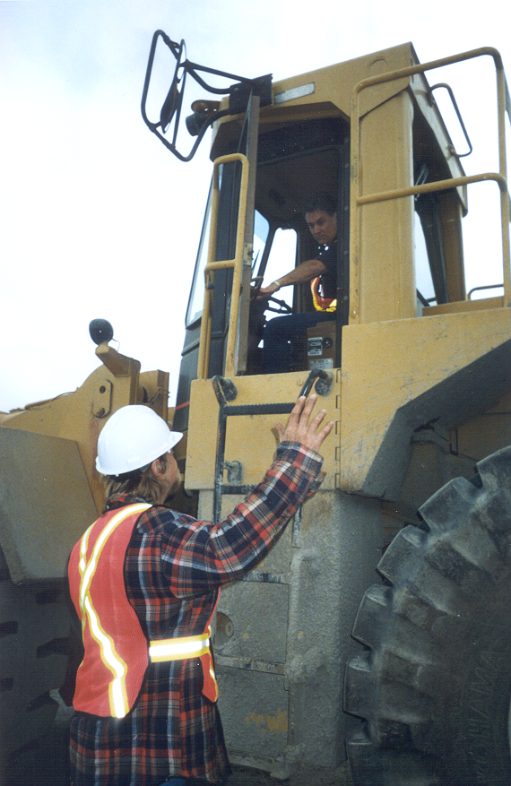 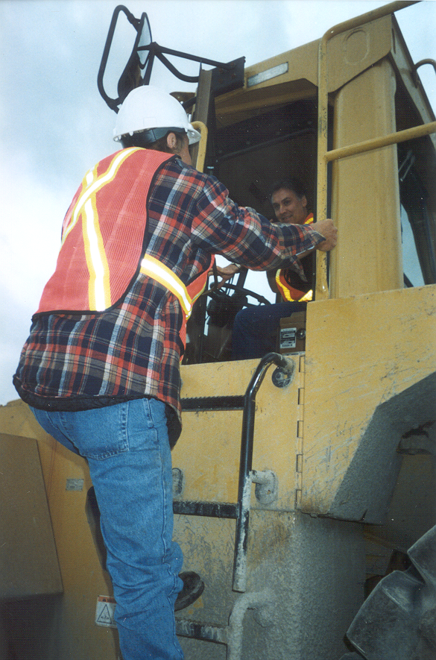 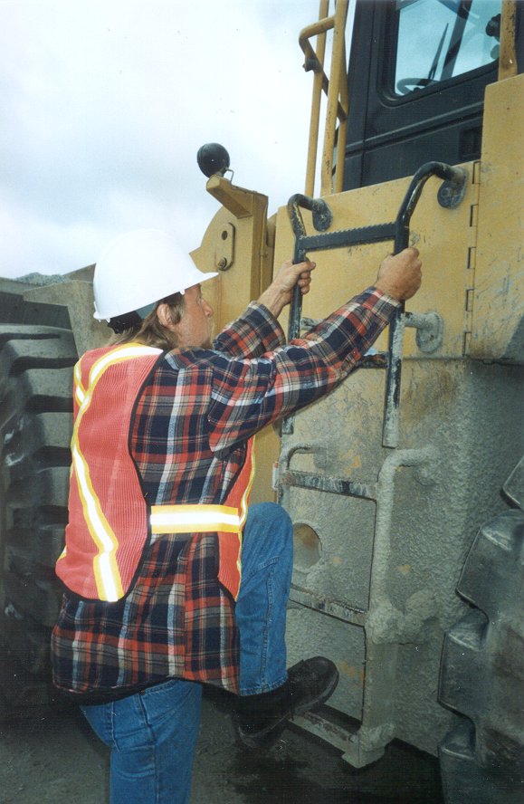

1. Ensure the equipment is completely stopped,
2. Make eye contact with the operator,
3. Ensure that the operator is not going to start moving while you are on the machine,
4. Use the 3-point contact system to mount and dismount equipment.
   1. Face the equipment while mounting and dismounting.
   2. Do not twist while dismounting equipment.
   3. Beware of slippery surfaces.
   4. Do not carry ANYTHING while mounting or dismounting equipment

**CREWMEMBER SAFETY TOPIC**