Decoupling Content from Code: Strapi-Powered CMS Architecture

Introduction
Modern websites require frequent content updates such as blog posts, product pages, landing pages, and marketing information. Traditionally, updating website content requires code changes, database schema updates, and deployments.
To solve this challenge, we implemented Strapi, a headless CMS that allows content to be managed directly without modifying frontend code or database structures frequently. This improves content agility, deployment efficiency, and scalability.

What is Strapi?
Strapi is an open‑source headless CMS that allows developers and content teams to manage website content through APIs. Instead of hardcoding content in the frontend, Strapi delivers dynamic content using REST or GraphQL APIs.
Basic Flow:
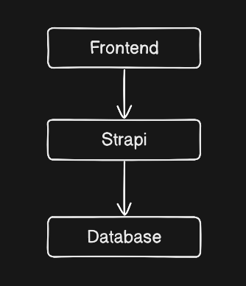

Problem With Traditional Content Updates
Traditional workflow:
Content Change → Developer Updates Code → Database Migration → Testing → Deployment
Problems:
• Slow updates
• Dependency on developers
• Deployment risks
• Not scalable for marketing teams

Our Solution: Strapi-Powered Content Architecture
New workflow:
Content Team → Strapi Admin Panel → Content Stored in DB → Website Fetches via API → Instant Update
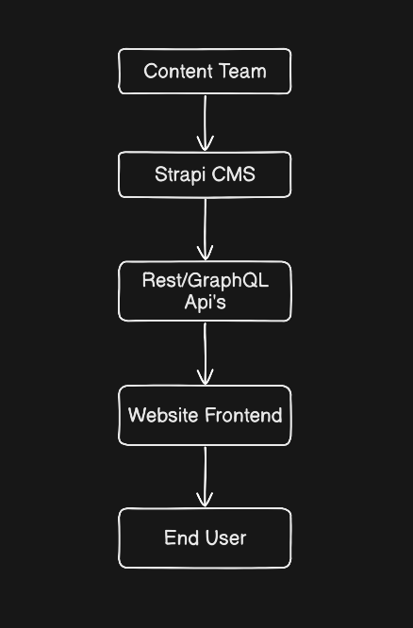

Results:
• No frontend code change
• No deployment required
• No database schema modification
• Faster publishing

Key Features We Use in Strapi
1. Dynamic Content Types
Blogs, Landing Pages, FAQs, Product Sections, Marketing Banners.
2. API‑Driven Content Delivery
Examples:
GET /api/blogs
GET /api/pages
GET /api/products
3. Role‑Based Access Control
Admin – Full access
Editor – Create/Edit content
Viewer – Read only
4. Media Management
Centralized media library for images, videos, and documents.

Business Benefits
• Faster content publishing
• Reduced deployment cycles
• Better scalability
• Improved team collaboration
• Real‑time website updates

Conclusion
By integrating Strapi as a headless CMS, we created a flexible and scalable content architecture. This allows teams to publish content quickly, reduce development overhead, and empower non‑technical users while maintaining a modern API‑driven website.

