Dubs Buddy Codex Pet  Setup Guide for GitHub and UW Sharing  Version: 3.1.0  Format: Codex native custom pet  Platforms: macOS and Windows  Repo: github.com/FlalaGoGoGo/dubs-buddy-codex-pet | 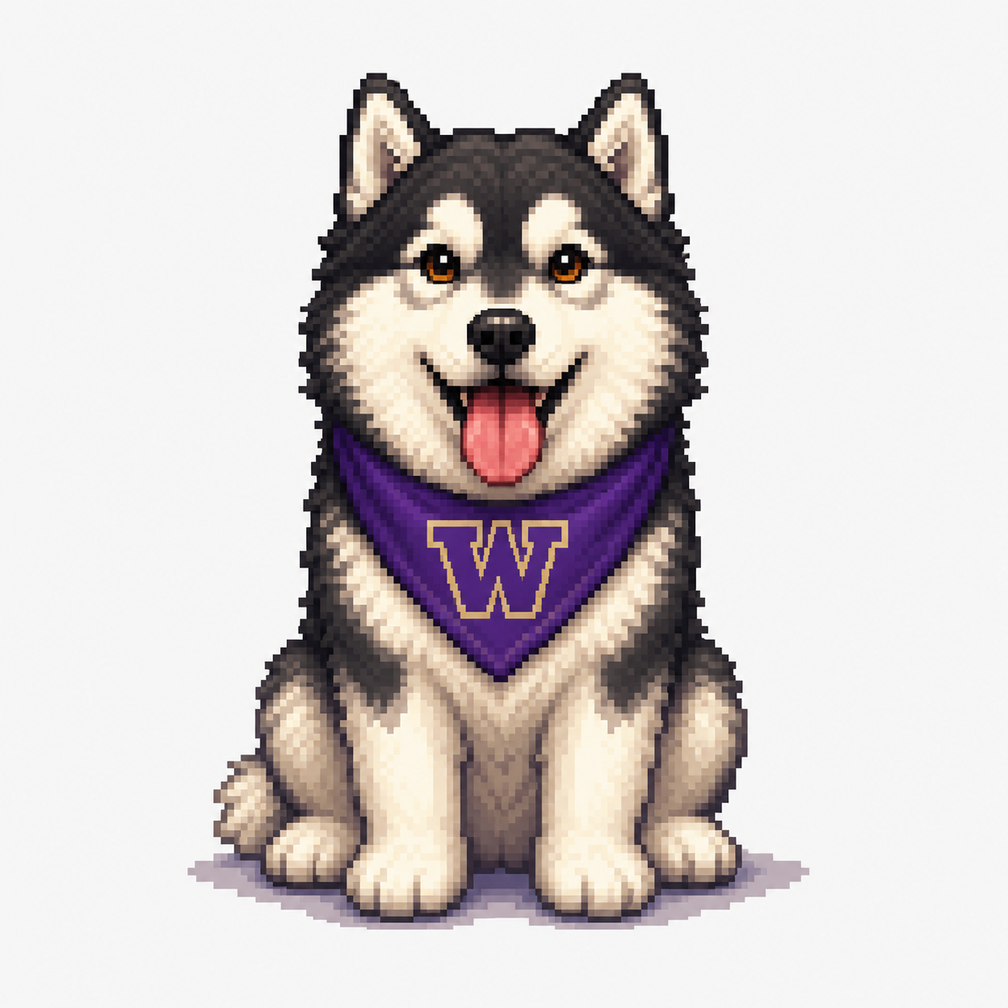

1. What This Is
Dubs Buddy is an unofficial UW-inspired custom pet for Codex Desktop. It is not a separate desktop app; users install it through Codex's native Custom pets feature.
Codex currently expects a fixed 8 x 9 spritesheet: each frame is 192 x 208 px, and the final spritesheet is 1536 x 1872 px.

2. Install From The Release Zip
- Download dubs-buddy-codex-pet-v3.1.0.zip from the latest GitHub release.
- Unzip it. The extracted folder should be named dubs-buddy.
- Copy the dubs-buddy folder into your Codex custom pets directory.
Platform | Custom pets folder
macOS | ~/.codex/pets/dubs-buddy
Windows | %USERPROFILE%\.codex\pets\dubs-buddy

macOS
mkdir -p ~/.codex/pets
cp -R dubs-buddy ~/.codex/pets/dubs-buddy

Windows PowerShell
$petDir = "$env:USERPROFILE\.codex\pets"
New-Item -ItemType Directory -Force $petDir | Out-Null
Copy-Item -Recurse -Force ".\dubs-buddy" "$petDir\dubs-buddy"

3. Build From Source
Use this path if you want to inspect the build, regenerate previews, or contribute changes.
git clone https://github.com/FlalaGoGoGo/dubs-buddy-codex-pet.git
cd dubs-buddy-codex-pet
npm install
npm run build
npm run verify
npm run install:pet
Command | Purpose
npm run build | Generate dist/dubs-buddy, contact sheet, previews, galleries, and demo WebP.
npm run verify | Validate manifest, spritesheet size, transparency, frame drift, and preview files.
npm run status:pet | Compare the repo build with the installed Codex pet folder.
npm run install:pet | Install the built pet into ~/.codex/pets/dubs-buddy.
npm run package:zip | Create the versioned release zip.

4. Enable In Codex
- Open Codex Desktop.
- Open Appearance.
- Go to Pets, then Custom pets.
- Click Refresh.
- Select Dubs Buddy.
- Click Wake Pet.
If Dubs Buddy does not appear, restart Codex and confirm the folder path exactly matches the install path.

5. Validate The Install
Check | Expected result
Folder | dubs-buddy is inside the Codex pets directory.
Manifest | pet.json has id dubs-buddy and spritesheetPath spritesheet.png.
Version | VERSION.txt reports 3.1.0.
Spritesheet | spritesheet.png is 1536 x 1872 with transparency.
Codex UI | Dubs Buddy appears after Refresh and can be selected.

npm run verify
npm run status:pet

6. Animation States
Row | Codex state | Dubs Buddy animation
0 | idle | Sitting, breathing, blinking
1 | running-right | Right-facing side run
2 | running-left | Left-facing side run
3 | waving | Friendly paw wave
4 | jumping | Real jump / hover attention
5 | failed | Sad and crying
6 | waiting | Watching an hourglass
7 | running | Typing on a laptop
8 | review | Happy gift-box success

7. Maintainer Notes
- Keep Dubs.png as the visual style reference.
- Place new 4 x 2, eight-frame reference sheets in v3_1_references.
- Keep side-facing running rows no-logo to avoid reversed or doubled W marks.
- Run npm run prepare:release before publishing a GitHub release.
- Inspect dist/preview-contact-sheet.png, dist/gallery.html, dist/transition-gallery.html, and the demo WebP before publishing.

8. Troubleshooting
Symptom | Likely fix
Dubs Buddy does not appear | Check the install path and click Refresh in Custom pets.
Custom pet fails to load | Run npm run verify and confirm spritesheet.png is exactly 1536 x 1872.
White box behind pet | Rebuild; the generated spritesheet should have transparent corners.
Wrong version appears | Run npm run status:pet, then reinstall with npm run install:pet.
Windows path confusion | Use %USERPROFILE%\.codex\pets\dubs-buddy.

9. Sharing Notes
This is a non-commercial, unofficial fan project. It is not affiliated with, sponsored by, or endorsed by the University of Washington or OpenAI.
- UW Trademarks & Licensing: https://www.washington.edu/trademarks/
- UW Brand Trademarks & Licensing: https://www.washington.edu/brand/marketing-resources/trademarks-licensing/

LinkedIn Draft
I built Dubs Buddy, an unofficial UW-inspired custom pet for Codex Desktop. Download the release zip, copy the dubs-buddy folder into Codex's custom pets directory, then enable it from Appearance -> Pets -> Custom pets. Go Dawgs, and may your tests pass.

