**PERSONAL DIGITAL ASSISTANT**

**A Minor Project Submitted to**



**Rajiv Gandhi Proudyogiki Vishwavidhyalaya, Bhopal**

**Towards Partial Fulfillment for the Award of**

**Bachelor of Technology**

**(Computer Science and Engineering)**

**Submitted By:**

**PRAVEEN GUPTA (0827CS171153)**

**SAGAR MANDIYA (0827CS171181)**

**SAMAY PASHINE (0827CS171186)**

**CS3 III YEAR**

**Supervised By: Guided By:**

**Mr. Avinash Singh Bundela Mr. Rahul Moriwal**

**Assistant Professor Assistant Professor**



**Department of Computer Science and Engineering**

**Acropolis Institute of Technology and Research, Indore**

**July - Dec 2019**

**TABLE OF CONTENTS**

|  |  |  |  |
| --- | --- | --- | --- |
| **S. NO.** | **TOPIC** | **PAGE NO.** | **REMARK** |
| 1. | ABSTRACT |  |  |
| 2. | INTRODUCTION |  |  |
| 3. | LITERATURE SURVEY |  |  |
|  | 3.1 RELATED WORK |  |  |
| 4. | SYSTEM REQUIREMENT SPECIFICATIONS |  |  |
|  | 4.1 HARDWARE REQUIREMENTS |  |  |
|  | 4.2 SOFTWARE REQUIREMENTS |  |  |
| 5. | SYSTEM ANALYSIS & DESIGN |  |  |
|  | 5.1 SYSTEM ANALYSIS |  |  |
|  | 5.1.1 REQUIREMENT ANALYSIS |  |  |
|  | 5.1.2 FEASIBILITY ANALYSIS |  |  |
|  | 5.2 SYSTEM DESIGN |  |  |
|  | 5.2.1 USE CASE, ACTIVITY, SEQUENCE  ER, DATA FLOW DIAGRAM |  |  |
| 6. | PROJECT IMPLEMENTATION &  OUTPUT SCREEN |  |  |
| 7. | TESTING |  |  |
|  | 7.1 TESTING STRATEGY ADOPTED |  |  |
|  | 7.2 SYSTEM & UNIT TESTING |  |  |
|  | 7.4 TEST CASES |  |  |
| 8. | CONCLUSION |  |  |
| 9. | FUTURE ENHANCEMENTS |  |  |

**ABSTRACT**

The Most famous digital assistant application of iPhone is “SIRI”, Microsoft “Cortana” which helps the end user to communicate end user device with voice and it also responds to the voice commands of the user. Same kind of application is also developed by the Google that is “Google Voice Search” which is used for in Android Phones, Desktop etc. But this Application mostly works with Internet Connections. But our Proposed System has capability to work with and without Internet Connectivity. It is named as Personal Assistant with Voice Recognition Intelligence, which takes the user input inform of voice or text and process it and returns the output in various forms like action to be performed or the search result is dictated to the end user. In addition, this proposed system can change the way of interactions between end user and the electronic devices. The system is being designed in such a way that all the services provided by the devices are accessible by the end user on the user's voice commands. In this project we’ve focused on creating an digital assistant with the basic features provided by any other digital assistant only without the need of internet connection. This project describes the approach to develop a personal assistant that reduces the utilization of input devices like keyboard and mouse on our PC (Personal Computer). Giving commands via speech makes it user friendly. This project describes the representation model, along with the implementation of this system. Details about the addition of new commands and additional feature of remote access that makes it different from others are also mentioned.

**INTRODUCTION**

A virtual assistant, also called AI assistant or digital assistant, is an application program that understands natural language voice commands and completes tasks for the user.  
Such tasks, historically performed by a personal assistant or secretary, include taking dictation, reading text or email messages aloud, looking up phone numbers, scheduling, placing phone calls and reminding the end user about appointments. Popular virtual assistants currently include Amazon Alexa, Apple's Siri,Google Assistant and Microsoft's Cortana: the digital assistant built into Windows Phone 8.1 and Windows 10.The basic idea behind this project is to create a simple stand-alone application  
that helps less tech savvy people in the world to use the computer without feeling ignorant or computer illiterate. Computers have became a very important devices and as well as less expensive over time. The application works same like Siri/ Google Assistant etc. But the application deals with the computer itself mainly. The U.I of the application is self-explanatory and minimal. Virtual assistants are typically cloud-based programs that require internet-connected devices and/or applications to work. Three such applications are Siri on Apple devices, Cortana on Microsoft Devices and Google Assistant on Android devices. There are also devices dedicated to providing virtual assistance. The most popular ones are available from Amazon, Google and Microsoft. To use the Amazon Echo virtual assistant, called Alexa, users call out the wake word, "Alexa." A light on the device signals to the user it is ready to receive a command, which typically involves simple language requests, such as "what is the weather today," or "play pop music." Those requests are processed and stored in Amazon's cloud. The technologies that power virtual assistants require massive amounts of data, which feeds artificial intelligence (AI) platforms, including machine learning, natural language processing and speech recognition platforms. As the end user interacts with a virtual assistant, the AI programming uses sophisticated algorithms to learn from data input and become better at predicting the end user's needs. Currently it takes text as input as most of the people are not very good at speaking. The virtual personal assistant is nothing but an implementation of assistance virtually on the user’s PC (Personal Computer). The software can be used via voice, keyboard input and also using internet as the remote access. Virtual assistants typically perform simple jobs for end users, such as adding tasks to a calendar; providing information that would normally be searched in a web browser; or controlling and checking the status of smart home devices, including lights, cameras and thermostats. Users also task virtual assistants to make and receive phone calls, create text messages, get directions, hear news and weather reports, find hotels or restaurants, check flight reservations, hear music, or play games. There are some predefined commands in the system and user can also add new commands. System can notify the user about new emails, news reports, weather, etc. User can set alarms, reminders, etc. System tasks like shutdown, lock system, sleep etc. are also executed on command. File writing can also be done using this system. The system has a Graphical User Interface which is able to take inputs and give outputs. There are various separate modules for each task like time, alarm, search etc. The Graphical User Interface (GUI) calls these modules for the given commands and so on. Same tasks can be achieved using this software. The system also has the feature of interacting with the user, which facilitates user and show its artificial intelligence. Also, it has functionalities like defining words, searching documents, files and folders to help user in most possible ways. There are several modules for each task like alarm, search, time etc. These predefined modules are called by the interface when specified in commands. The system can perform almost all the tasks that require the use of keyboard and/or mouse which is the main goal of the system that will facilitate the disabled people. Now the features that make this application better are remote access and addition of new commands to the system at user’s choice. Using assistant from anywhere is the newest feature as compared to other assistants (like Cortana, Siri). As we can use the assistant by remote access, it removes the limitation of location. We can give commands from any location and get the things done easily. Also user will be able to add new commands which will make the assistant better and user friendly.

Nowadays the Mobile Technology is being very famous for the User Experience, because it is very easy to access the applications and services from anywhere of your Geo- location. Android, Apple, Windows, Blackberry, etc. are various famous and commonly used Mobile Operating Systems. All the Operating Systems provides plenty of applications and services for users. For an instance, the Contacts Applications is used to store the contact details of the user's contact and also helps user to connect a call or send an SMS to other person using the contents stored in this application. We can get similar types of application all around the world via Apple Store, Play Store, etc. All this features gives birth to various kinds of sensors or functionalities to be implemented in the mobile devices. The Most famous application of iPhone is “SIRI” which helps the end user to communicate end user to mobile with voice and it also responds to the voice commands of the user. Same kind of application is also developed by the Google that is “Google Voice Search” which is used for in Android Phones. But this Application mostly works with Internet Connections. But our Proposed System has capability to work with and without Internet Connectivity. It’s named as Personal Assistant with Voice Recognition Intelligence, which takes the user input in form of voice or text and process it and returns the output in various forms like action to be performed or the search result is dictated to the end user.

**Constraints:**  
The application was built on and for an Debian - Linux thus restricting it to the Linux alone. Modules is compatible with all the OS.  
The system also assumes that the user has minimal English knowledge as of now.

**LITERATURE SURVEY**

A computer primarily based approach for performing a command via a voice consumer

interface on a subset of objects. The subset is selected from a ﬁxed of items, each having an object type at least one taggable ﬁeld is associated with the object type and has a corresponding value. The set of objects is saved in the laptop memory. An utterance is acquired from the person and consists of a command, an object type choice, a taggable ﬁeld selection, and a price for the taggable discipline. Responsive to the utterance, at least one item is retrieved from the set of gadgets, the item of the sort selected through the user and having a price within the taggable area selection that matches the taggable ﬁeld fee obtained from the user the command is done on the item. The object includes textual content that’s converted to voice output [1]. They envisioned that someday computers will recognize natural language and count on what we need, whilst and where we need it, and proactively whole responsibilities on our behalf. However, speech recognition and machine getting to know have persevered to be reﬁned, and based records served through packages and content providers have emerged. We agree with that as computer systems turn out to be smaller and greater ubiquitous [e.g., wearable’s and Internet of Things (IoT) [2]. The recognizer is designed to change a verbal articulation from a individual into an alternate method of data (e.g., text). A hand held individual colleague including a voice-recognizer and a characteristic dialect processor is disclosed. This snippet of data can be a plan for the day, data in the individual’s logbook or data from the individual’s address book, Such as a telephone number [3]. The Most well known utilization of iPhone is “SIRI”which causes the end client to impart end client versatile with voice and it additionally reacts to the voice charges of the client. It is named as Personal Assistant with Voice Recognition Intelligence, which takes the client contribution to type of voice or content and process it and returns the yield in different structures like activity to be performed or the item is directed to the end client. Furthermore, this proposed framework can change the method for communications between end client and the cell phones [4]. Open Data is currently gathering consideration for imaginative administration creation, predominantly in the zone of government, bio science, and shrewd venture. Be that as it may, to advance its application more for purchaser administrations, a web crawler for Open Data to realize what sort of information is there would be of assistance. This paper presents a voice colleague which utilizes Open Data as its learning source. It is highlighted by change of precision as per the client criticisms, and obtaining of unregistered information by the client support. We additionally demonstrate an application to help for a ﬁeld-work and afﬁrm its viability [5]. The paper gives a diagram of the VPA applications, and the normal highlights and future patterns. The paper proposes also a bound together choice model in light of a quantitative appraisal of the signiﬁcance of the solicitations and the accessibility of the client. Virtual Personal Assistant (VPA) is the up and coming age of bearer administrations for portable clients. VPA is accepted to be the smart advancement of administrations to take care of the regularly expanding demand by the portable experts for portability and network. The VPA controls the phone calls, deals with the individual exercises through logbook.

In addition to prior work focusing on the design of Sirius, an open end-to-end IPA web-service application that accepts queries in the form of images and voice, and responds with natural language. We then use this work to develop the additional feature of remote access [6]. Focus on natural language understanding and dialog management aspects, as author believe that these parts of the technology pipeline require the biggest amount of augmentation [7]. Prior work also describes a multilingual ASR engine embedded on PDA which can support different languages such as English, Mandarin, and Taiwanese. It is based on a one-stage searching strategy and a unified three-layer

framework [8].P. Milhorat,“Building the next generation of personal digital Assistants,"Published in 2014.Voice-based digital Assistants such as Apple's Siri and Google's Now are currently booming. Yet, despite their promise of being context-aware and adapted to a user's preferences and very distinct needs, truly personal assistants are still missing. In this paper we highlight some of the challenges in building personalized speech-operated assistive technology and propose a number of research and development directions we have undertaken in order to solve them. In particular we focus on natural language understanding and dialog management aspects as we believe that these parts of the technology pipeline require the biggest amount of augmentation

**SYSTEM REQUIREMENT SPECIFICATIONS**

First of all the system starts with respective wake words for the voice assistant. Following the wake word, the system proceeds by receiving voice commands from the users with the help of a microphone, further analyzing the command and processing the given, the device will create appropriate response for the given command. Response is given to user with the help of speakers as shown in diagram given below.Users can also use the device for storing and streaming the data. User can store excess data(Data taking up extra space on the local device) in the wireless storage system of the device with the help of an app on host’s device.This application interacts with system. Uploading downloading and streaming of data

from the system to the host device is now convenient. The application can also host various users simultaneously.The various constraints acting on the system are the purpose of this project is to build a program that will be able to service to humans like a personal assistant. This is an interesting concept and many people around the globe are working it. Today, time and security are the two main things to which people are more sensitive, no one has the time to spoil; nobody would like their security breach and this project is mainly for those kinds of people. Since AC power will be supplied to power up the system (it will be converted into DC) through a wire, functioning area will be short or limited. This system should be able to operate in a one room area which is the main constraint. Another issue with this system would be the operating time. As we know there is no battery backup for power supply, system will power up with AC, so as soon as AC goes off, system will stop working. Clearly, system will function until the power goes off. Customized algorithm will be used for Text-To-Speech, Speech-To- Text, messaging, notification handling and for crash detection.

. Memory Constraints

Application should need small memory for storing the data. Since it is a desktop application, it will process the data just using small amount of memory. For example, driver drowsiness detection algorithm will be implemented in a way where it satisfies with at most 10 pictures to process.

. Function Requirements

The system will perform the following functional requirements

User can enable and disable voice commands

User can send an email

User can acquire device status

User can learn how the application works

User can get general information about the application

**SYSTEM ANALYSIS & SYSTEM DESIGN**

**. SYSTEM ANALYSIS :**

The used of system analyst is to organized grouping of interdependent function units linked together to achieve an objective. The system is an orderly grouping of interdependent components linked together according to a plan to achieve a specific goal.

**.Requirement Analysis:**

1. OS should be android 4.1 / win /IOS 6 or higher

2. The kernel version should be 3.0.16 or higher

3. Support of other basic application like maps, calender ,web connection etc.

Hardware analysis:

1. Our system should be i3 processor

2. Ram should be min 2 gb

3. Internal connectivity

i. Interpreting user input – usability of the agent is one of the high priority requirements for a smart agent application. It needs to be more helpful to the user and ask for fewer inputs. In addition, it needs to support input in regular English language.

1. Supporting voice recognition: Ideally, a smart agent needs to support voice

interface in order to make the agent useful while the user is unable to type the

request on the device. But, this requirement was purposely out of scope in order to

focus more on the other aspects of building such an application while assuming that

agent can later integrate with a voice recognition technology which can convert

spoken text into textual commands for the agent to process.

2. User input should be processed to identify the task to be performed. Define

templates for the supported tasks. These templates should help the user to

type required information for the task so that agent can identify the task and related parameters.

ii. Understanding the task at hand – Traditional task list applications treat the tasks as strings and do not associate any semantics to the task. The smart agent should exhibit an understanding of the task entered thru the system. This is a critical requirement as it enables the agent to use this understanding of the task to plan for the task.

Iii. Contextual awareness – Identifying the context of the user for any given task enables the agent to better serve the user’s intended goal and possibly asks fewer questions to plan for the task. There are multiple contexts associated with an agent

1. Location Context: This context provides current location as the input and lets agent reduce the search path for a given task. This location context refers to low level geo coordinates offered by GPS sensors in mobile devices as well as mapping these co- ordinates to higher level entities such as home, office, airport, mall etc. Location context information coupled with understanding of the task helps the agent to identify type of tasks that can be or cannot be accomplished at this location. 67

2. TimeContext: Time context for an agent includes an understanding of common time terminologies such as morning, afternoon, evening, today, yesterday, tomorrow etc., and using current time or time of the task to filter tasks relevant in this context.

3. Activity Context: An activity context refers to the understanding of an ongoing activity or a planned activity and identifying attributes of the task that need to be managed. For example, if you are executing a task of driving to the airport to catch a flight, then an understanding of catching the flight on time is important. At the same time, generating alerts to the user if the flight is delayed is very useful and utilizes activity contexts.

4.Social Context: This refers to understanding of social interactions between the user and other people in his network. With this contextual information, agent will be able to service requests based on a specific relation mentioned in the task and will be able to use information on people accompanying the user in an activity to suggest sub-tasks for a task or an activity. iv. Understanding external environment context: Agent needs to plan for tasks that interact with the external world. So, any changes in external world such as weather conditions, traffic conditions, delays in other people schedules should be coordinated and provided as input to the agent for planning the execution of tasks. v. Task decomposition: Agent should capture task models that include specifying a given task by decomposed steps that contain sib-tasks, which in itself can be planned by the agent. In this task model, agent should be able to specify ordering of the subtasks, any dependencies between the sub-tasks, pre-conditions as well as post conditions of completing the sub-tasks. It needs to provide preset task decompositions for supported tasks and let the user customize some aspects of these sub-tasks. Part of this task decomposition is driven by the extent of

understanding of the task within the agent’s knowledgebase, so extensibility of the knowledge base will drive adaptability of the agent to new tasks. Agent should

provide a framework to capture sub-tasks for a given task by getting input from the user. vi. Planning tasks: Agent should be ask questions to the user in order to disambiguate any input related to the tasks and to identify specific task in its repository and also to identify the subtasks. Once its done with this process, it should analyze sub-tasks involved in the process, sequence of these tasks, any dependencies, pre-conditions and post conditions and create a plan for executing these tasks either manual thru the user or some

other person or automatically thru the agent. 68 vii. Automating task execution: Agent should be able to identify the tasks or subtasks that can be accomplished by the agent itself by automatically invoking modules within the agent capable of completing the task or subtask. These automated tasks could be for gathering information from variety of data sources the agent is capable of connecting to, or to invoke APIs to book an order for an item at online e-commerce store. viii. Delegating tasks: Each task will be either a manual task or an automated one. Agent should be able to identify the type of the task and execute automated tasks with the information entered by the user and using contextual information of the user within in the agent. Agent should be able to identify number of actors for

manual tasks and should try to identify if the user or the agent can be the default executioner of the task. If it’s a manual task, agent should identify if the user generally

completes it or delegates to others and use this information to assign a default delegate. ix. Record User Interactions: Agent should record user task entries, location, time, and

user selections from list of choices, in a database. This information can be used to train the agent to identify paths that user is more likely going to take based on the past

historical data.

**. Feasible Analysis:**

Virtual Assistants (VA) is a segment of Artificial Intelligence (AI) that is rapidly developing. However, its utilization to address patients’ frequently asked questions

(FAQs) preoperatively remains unexplored. We hypothesize that a VA could address preoperative FAQs related to plastic surgery procedures. We developed a VA and assessed its accuracy and participants’ opinion regarding the answers and the technology.

The system is based on concepts of State Machine, Goals, Rules, Conversation and Interpreter. State Machine: This is the core of the system. This part of the system determines the flow of the conversation and the actions to perform. It is made up of set of states and state transitions. For each state, there are set of achievable goals and set of knowledge items. These items aid conversation, drive product purchase, supply product research

information and personalize. The current state determines the set of goals that this state can achieve. Each goal has set of knowledge items to aid conversation with the customer.

The state can have its own set of knowledge items like research items, promotion items or even product items. Every goal and knowledge item has priority to facilitate choosing the highest priority goal and the highest priority knowledge item for a given state. One state can transition to different states, depending on the transition rules and the

fulfillment of goals. Whenever the state has knowledge items associated with it,

these knowledge items should be brought to the notice of the customer. The idea of states with knowledge items needs a little explanation. Suppose VPA is implemented for

www.somesite.com in a form of a chat popup and the site has a homepage that shows the current items on sale. As given in the above example, let’s assume that the system

has reached “Want TV” state. We see that this state has product articles and promotion articles associated with it. When the system encounters such states which have associated knowledge items, it will bring these knowledge items to the notice of the customer, for example change the home page to reflect the knowledge items associated with the current state. As the conversation flows, the system willkeep switching states and the information displayed on the home page will keep changing depending on the knowledge items associated with the state. It is not mandatory for all states to have knowledge items associated with it.

**. System Design:**

Semantic web is envisioned as a single logical web of meaning that is interconnected between various sites and has self-defined meta-data so that any one willing to use this data can interpret it and extend it. It makes the data machine-readable and using semantic web’s inference technologies, tools can be built to process this data and build applications that can interpret the data

General Architectural and Design Principles :-

Modularity A system with modular architecture can be decomposed into well-defined subsystems. A modular subsystem with well-defined interfaces explicitly specifies expected inputs and outputs of the system and wraps all the complexity associated with implementation internally and hides it from the subsystems interfacing to it. This also reduces coupling between the subsystems. A modular architecture leads to higher reuse of existing components, adaptability to change, shorter time to market, scalability of product design and reliable testing cycles. 5.3.2 Extensibility System should designed such that new features can be added to the system as well as existing features can be modified without a major overhaul to the architecture and ideally by few simple changes. Modular architecture and loose coupling between sub-systems plays a major role in ensuring an extensible system. 36 “ESD.34 System Architecture Course at MIT – Principles of Architecture Assignment.” 69 5.3.3 Complexity A good architecture takes into consideration performance and quality attributes of the system and also considers all the -ilities such as extensibility, modularity, scalability, availability etc., expected of the system. Complexity of the system is thus driven by the essential functionality that need to be implemented to satisfy essential user needs and by these performance and quality attributes that need to be supported by the system. A good architecture will be able to deliver on all these promises by choosing concepts with low essential complexity and by using abstraction, decomposition, hierarchy and recursion to keep the actual complexity to the essential complexity. 5.3.4 Falling back to the user in case of ambiguity or unknowns System should be architected such that in case system is subjected unsupported cases then it should respond gracefully, and in case of personal assistant, should fall back on user for clarifications or choose from available choices. This introduces human component back into the system, reducing complexity that would be otherwise required for the system. 5.3.5 Adopting Open Standards and Data Reuse A system design that promotes adoption of mature open standards enables quick development and deployment as it leads to sharing of the technology, tools as well as other resources developed by the community. Adoption of semantic web technologies, tools, and ontologies relevant to the smart agent makes the implementation of the agent easier thru reuse. 5.3.6 Integrating with external data sources and Services An architecture that offloads functionality to external. components such as web services or external data sources simplifies the design of the system itself at the same time leveraging the expertise of the external systems. It also introduces dependencies on these external systems and fallback mechanisms should be added in order to use alternative paths when one of the dependent paths is not available. 5.3.7 Early Detection Instead of building the whole system at once, iterative development approach insists on breaking up the release artifacts into manageable elements such that each phase results in delivery useable and higher priority features to the stakeholders. Design, development and testing cycles are executed for each phase and any issues with implementation are found during these cycles. User feedback is also ascertained to ensure that features are being implemented as per the user needs and intended goals of the system. This feedback provides any correction in the implementation or re-prioritization of the goals of the system.

**Use Case Diagram**

# This is a use case diagram for online examination system. The use case diagram shows two actors - examiner and student, and how they interact with the examination system to achieve what they want, which includes preparing question back, preparing examination, taking an exam and reviewing exam result.

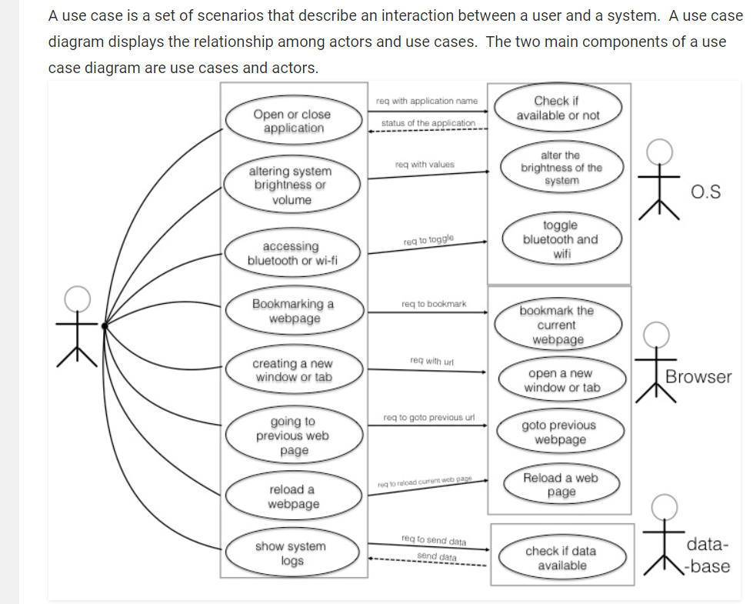

**Activity Diagram**

Activity diagram is basically a flowchart to represent the flow from one activity to another activity. The activity can be described as an operation of the system.The control flow is drawn from one operation to another. This flow can be sequential, branched, or concurrent. Activity diagrams deal with all type of flow control by using different elements such as fork, join, etc.

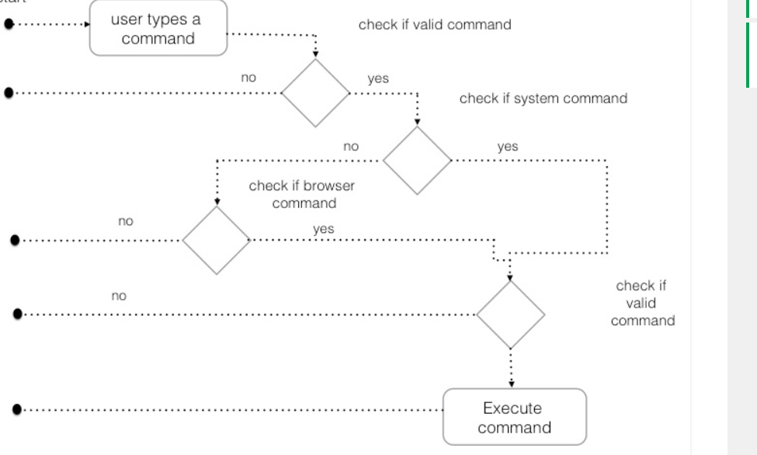

**Sequence Diagram**

A sequence diagram is an interaction diagram that shows how objects operate with one another and in what order. It is a construct of a message sequence chart.  
A sequence diagram shows object interactions arranged in time sequence. It depicts the objects and classes involved in the scenario and the sequence of messages exchanged between the objects needed to carry out the functionality of the scenario.

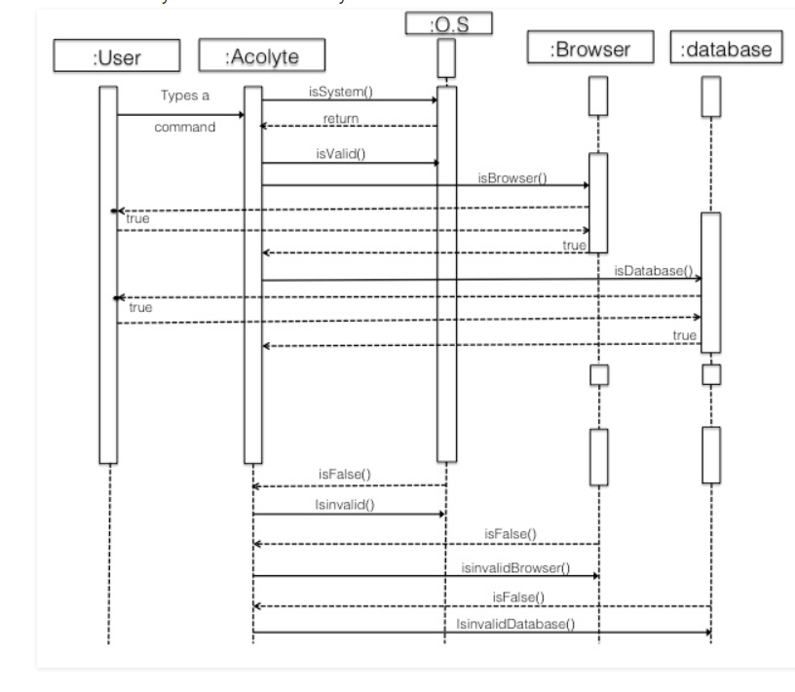

**ER DIAGRAM**

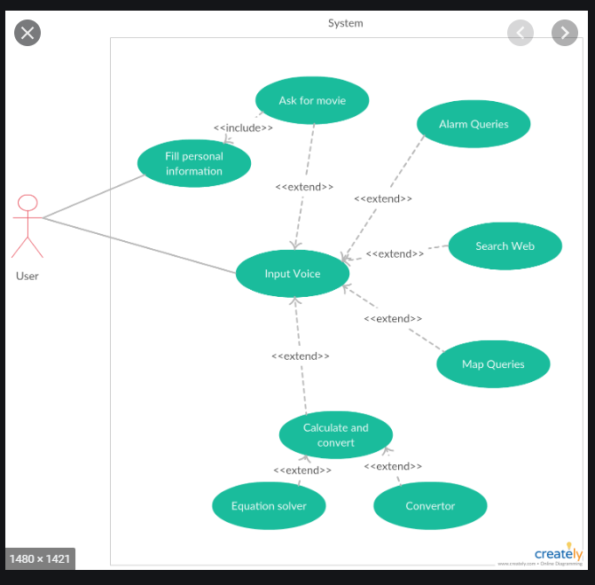

**DATA FLOW DIAGRAM**

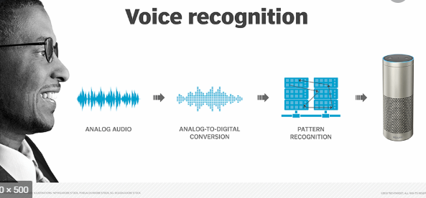

**PROJECT IMPLEMENTATION & OUTPUT SCREEN**

SCREENSHOTS :

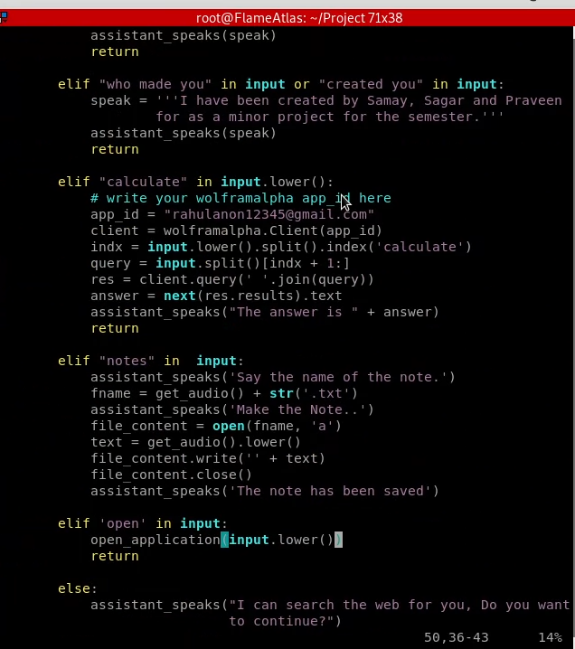

OUTPUT:

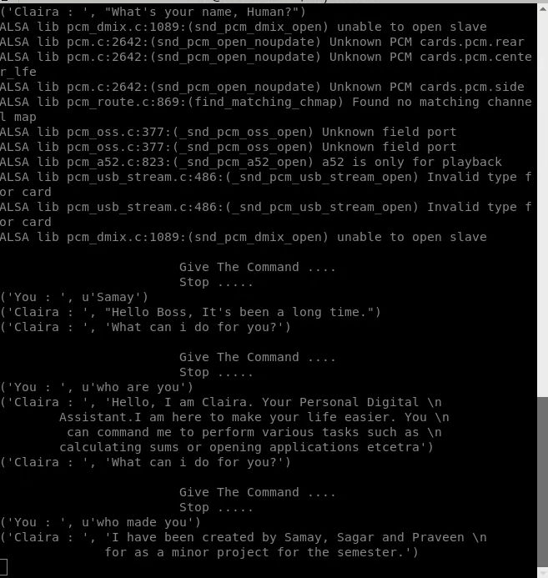

IMPORTANT CODES:

import speech_recognition as sr   
import playsound   
from gtts import gTTS   
import os   
import webbrowser  
import wolframalpha

def process_text(input):  
 try:  
 if 'search' in input or 'play' in input:  
 search_web(input)  
 return  
  
 elif "who are you" in input or "define yourself" in input or "What\'s your name" in input:  
 speak = '''Hello, I am Claira. Your Personal Digital   
 Assistant.I am here to make your life easier. You   
 can command me to perform various tasks such as   
 calculating sums or opening applications etcetra'''  
 assistant_speaks(speak)  
 return

else:  
 assistant_speaks("I can search the web for you, Do you want to continue?")  
 ans = get_audio()

**LIMITATION**

**LIMITATIONS :**

There are no limits. People fail to recognize that natural human intelligence is not magical or mystical. It is just the end result of atoms interacting in physical ways that are all well understood.

It is not yet well understood how those physical interactions create the emergent properties of consciousness and mind/body interactions. But it is well understood that they do so.

The scale is pretty clear too. There are approximately 90 billion nerve cells in the human brain, only 16 billion of which are in the cerebrum where most of planning lies.

Artificial Intelligence as of today might not be limitations a few years later. However, as of today, we use Deep Learning to achieve AI, yet are not entirely sure how these deep neural networks work. Neurons in the brain can connect to any neuron in physical proximity to themselves, but machines have specific layers, where the output from one layer is fed as an input to the next layer, and we still do not know the working that goes on in each layer.

**CONCLUSION**

Virtual Personal Assistants are very effective way to organize your schedule. Now there are many Smart Personal Digital Assistant applications available in the market for various device platforms.Claira is fully working Virtual Personal Assistance, which can perform task in offline condition as we given her local modules to her. In online condition Lizzy gets more resources to work with. Also, any peripheral which is connected with the raspberry pi is can be control with the Virtual Personal Assistance, just by giving the command. The local modules can be added or removed by user as he sees fit. Also, there is simple option for conversation with Lizzy, where it learns further.

The paths of this study regarding IPAs is intended to reveal an overview on how and to what extent these devices might be used in human-computer interaction and learning. In this connection, the working systems of the IPAs namely Apple’s Siri, Google Now and Microsoft Cortana are revised within the context of AI. Although there have been several works related to IPAs in education (also known and conceived as Intelligent Pedagogical Agents by Garrido et al. (2010, p.4) the potential use of IPAs for second language learning within Natural Language Processing (NLP) should be focused particularly. In this regard, it may be suggested that both devices (PDAs) and applications (IPAs) might be used as feasible tools for language learning; so more qualitative and quantitative studies may be conducted accordingly.

These new Software applications are performing really well than the old school PDA devices as they provided all resources of your smart phones.

**PDAs are also reliable than Human Personal Assistant because, PDAs are more portable and you can use them anytime. They also have a lot of information than any assistant as they are connected with internet.**

**FUTURE ENHANCEMENTS**

But then there arises the problem of insecurity as these online based PDAs depend on sharing your private info regularly with their server through internet and so not only is there a possibility of security breach and leaking away all the personal data but also the fact that the end user cannot know for sure that the his/her personal data is safe, thus there is urgent need of a software that eradicates this severe issues and so encompassing the need of a offline PDA which performs just as well but without connecting to the internet 24/7.

Future Scope of Artificial Intelligence. Personal assistant Artificial Intelligence(AI) is the simulation of human intelligence by machines. In other words, it is the method by which machines demonstrate certain aspects of human intelligence like learning, reasoning and self- correction.

**REFERENCES**

1. Gong, L.: San Francisco, CA (US) United States US 2003.01671.67A1 (12) Patent Application

Publication c (10) Pub. No.: US 2003/0167167 A1 Gong (43) Pub. Date: 4 September 2003

for Intelligent Virtual Assistant

2. Sarikaya, R.: The technology behind personal digital assistants. IEEE Signal Process. Mag.

34,67–81(2017). https://doi.org/10.1109/msp.2016.2617341

3. Tsiao, J.C.-S., Tong, P.P., Chao, D.Y.: Natural-Language Voice-Activated Personal Assistant,

United States Patent (10), Patent No.: US 7,216,080 B2 (45), 8 May 2007

4. Sirbi, K., Patankar, A.J.: Personal assistant with voice recognition intelligence. Int. J. Eng. Res.

Technol. 10(1), 416–419 (2017). ISSN 0974-3154

5. Kawamura, T., Ohsuga, A.: Flower voice: virtual assistant for open data

6. Johann Hauswald, Michael A. Laurenzano, Yunqi Zhang, Cheng Li ,Austin Rovinski, Arjun

Khurana, Ronald G. Dreslinski, Trevor Mudge, Vinicius Petrucci1, Lingjia Tang, Jason Mars,

"Sirius: An Open End-to-End Voice and Vision Personal Assistant and Its Implications for Future

Warehouse Scale Computers",ASPLOS’15, March14–18,2015,Istanbul,Turkey.

7. P. Milhorat, S. Schl ̈ogl, G. Chollet, J. Boudy, A Esposito and G. Pelosi," Building The Next

Generation Of Personal Digital Assistants",1st International Conference on Advanced

Technologies for Signal and Image Processing - ATSIP'2014 March 17-19, 2014, Sousse,

Tunisia

8. Hong-wen Sie 1, Dau-Cheng Lyu 1, Zhong-Ing Liou 1, Ren-Yuan Lyu 1,2,Yuang-Chin Chiang3

1Dept. Of Electrical Engineering, Chang Gung University, Taoyuan," A Multilingual Automatic

Speech Recognition (ASR) Engine Embedded on Personal Digital Assistant (PDA)" Cellular Neural

Networks and Their Applications, 2005 9th International Workshop

9. Implemented code link:

https://github.com/Flame-Atlas/Personal_Digital_Assistant_Claira

**Signature of the Candidates Signature of the Guide Signature of the Coordinator**