**PERSONAL DIGITAL ASSISTANT**

**A Minor Project Synopsis Submitted to**



**Rajiv Gandhi Proudyogiki Vishwavidhyalaya, Bhopal**

**Towards Partial Fulfillment for the Award of**

**Bachelor of Engineering**

**(Computer Science and Engineering)**

**Submitted By:**

**SAMAY PASHINE (0827CS171186)**

**SAGAR MANDIYA (0827CS171181)**

**PRAVEEN GUPTA (0827CS171153)**

**CS3 III YEAR**

**Guided By: Project Coordinator:**

**Rahul Moriwal Nidhi Choubey**

**Assistant Professor Assistant Professor**



**Department of Computer Science and Engineering**

**Acropolis Institute of Technology and Research, Indore**

**July - Dec 2019**

**TABLE OF CONTENTS**

|  |  |  |  |
| --- | --- | --- | --- |
| **S. NO.** | **TOPIC** | **PAGE NO.** | **REMARK** |
| 1. | TITLE | 1 |  |
| 2. | INTRODUCTION | 1 |  |
|  | 2.1 PROJECT BENEFITS | 1 |  |
|  | 2.2 PROJECT SCOPE | 1 |  |
| 3. | DISADVANTAGE | 2 |  |
| 4. | OBJECTIVES | 2 |  |
| 5. | INTENTED USER | 2 |  |
| 6. | EXISTING SYSTEM | 2 |  |
|  | 6.1 PROCESS FLOW | 2 |  |
|  | 6.2 LIMITATIONS | 2 |  |
| 7. | PROCESS FLOW | 3 |  |
|  | 7.1 HARDWARE REQUIREMENTS | 3 |  |
|  | 7.2 SOFTWARE REQUIREMENTS | 3 |  |
| 8. | EXPECTED OUTCOMES | 3 |  |
| 9. | CONCLUSION | 4 |  |
|  | 9.1 LIMITATIONS | 4 |  |
|  | 9.2 FUTURE ENHANCEMENTS | 4 |  |
| 10. | REFRENCES | 4 |  |

**SYNOPSIS**

1. **TITLE:**

Personal Assistant based on technology(Artificial intelligence , Machine Learning)

1. **INTRODUCTION:**

The basic idea behind this project is to create a simple stand-alone application  
that helps less tech savvy people in the world to use the computer without feeling ignorant or computer illiterate.  
Computers have became a very important devices and as well as less expensive over time.  
The application works same like Siri/ Google Assistant etc. But the application deals with the computer itself mainly.  
The U.I of the application is self-explanatory and minimal.  
Currently it takes text as input as most of the people are not very good at speaking.

**Constraints:**  
The application was built on and for an apple MacBook thus restricting it to the macOS alone. Acolyte is compatible with all the versions of the Apple macOS.  
The system also assumes that the user has minimal english knowledge as of now.

**Conceptual framework:**

There is always scope for improvement. So the application was built using M.V.C architecture, incremental process design. These design structures follow the modular approach which makes it easy to add in new features to the system.

The system also implements the singleton pattern and the single responsibility principle which ensure the individual functioning of the modules.

**Functions:**  
The system provides all the below stated functions.

* Displaying system information such as network usage, ram etc.
* Opening and closing an application
* Altering system brightness, volume
* Accessing bluetooth, WIFI
* Bookmarking a webpage
* Creating a new window or a tab in browser
* Going to the previous webpage on the web browser
* Reloading a webpage on the web browser
* Keylogging with keystrokes segregated according to the application and time stamps.
* Browser history tracking.

**UML Diagrams:**

**Use Case Diagram:**

A use case is a set of scenarios that describe an interaction between a user and a system.  A use case diagram displays the relationship among actors and use cases.  The two main components of a use case diagram are use cases and actors.

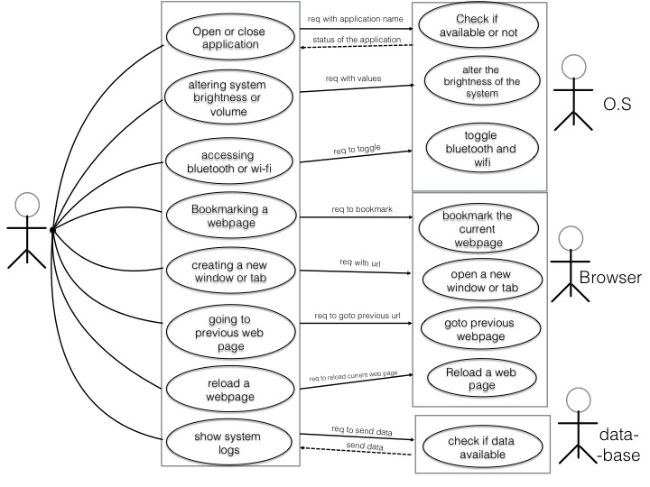

**Activity Diagram:**  
Activity diagram is basically a flowchart to represent the flow from one activity to another activity. The activity can be described as an operation of the system.The control flow is drawn from one operation to another. This flow can be sequential, branched, or concurrent. Activity diagrams deal with all type of flow control by using different elements such as fork, join, etc

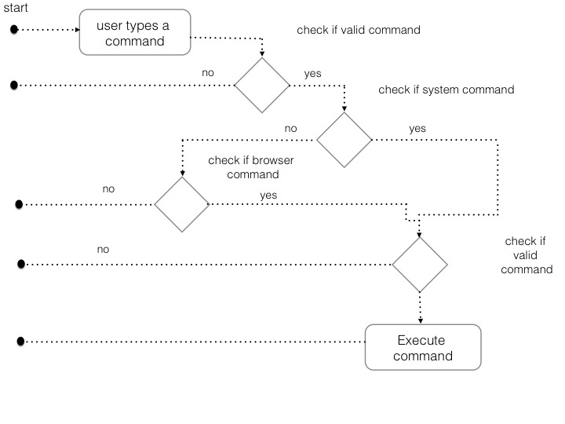

**Sequence diagram**:  
A sequence diagram is an interaction diagram that shows how objects operate with one another and in what order. It is a construct of a message sequence chart.  
A sequence diagram shows object interactions arranged in time sequence. It depicts the objects and classes involved in the scenario and the sequence of messages exchanged between the objects needed to carry out the functionality of the scenario.

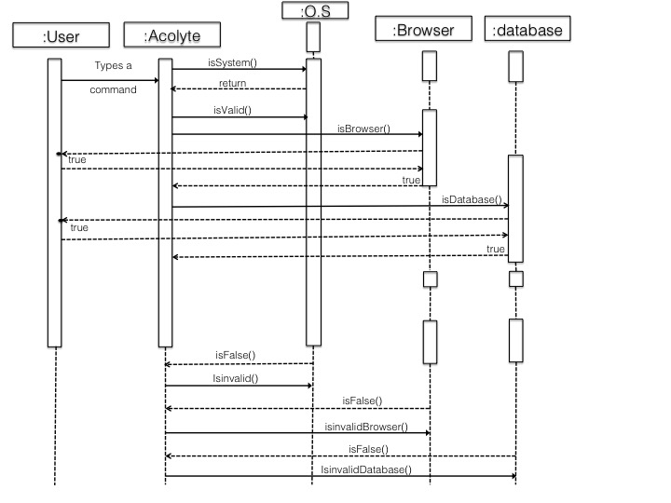

**Algorithms:**  
Most of the algorithms used are custom designed, analysed and tested extensively for the project. We created most of them from scratch to make it as fast as possible.  
The one which we have used as it is Naive Bayes theorem.

**Naive Bayes theorem:**  
The Naive Bayes theorem was used to segregate the commands into 2 groups namely the capabilities and system commands.  
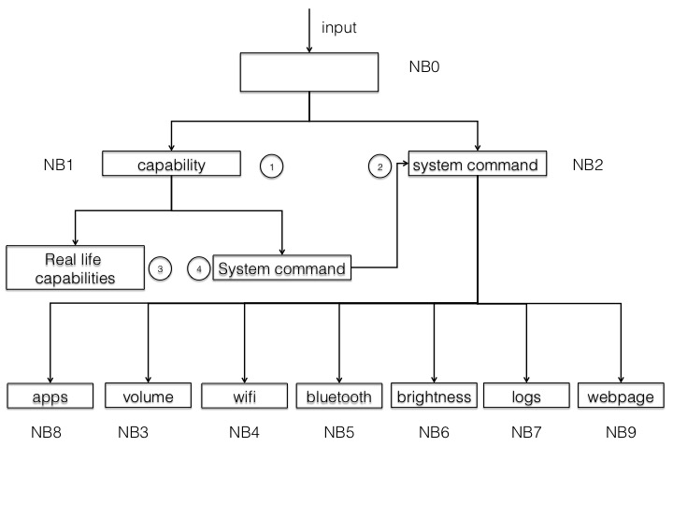

**Tools Used:**  
The project was mainly built using the Swift programming language from scratch according to the required functionalities to attain lightning speed and smooth execution. Some functionalities of the system had to be written in the obj-c and the scripting language AppleScript. The application uses the standard SQLite3 as the database.

* 1. **PROJECT BENEFITS**

i. An assistant can help with smaller tasks such as filing, setting up reminders and scheduling appointments. These errands are important and a personal assistant can easily perform them, saving some time that could be better spent focusing on different projects.

ii. A personal assistant can take care of more sophisticated responsibilities as well like handling resource files of the system and securing the process in it.

iii. A personal assistant can also mark the coordinates events and set reminder of such as birthday parties, wedding events or cooperate events.

iv. A personal assistant can book flights and hotel rooms, according to your voice commands or we can say voice recognition.

**2.2 PROJECT SCOPE**

The scopes of this project are:

i. Our project based on Artificial Intelligence (AI) and (machine learning) is the simulation of human intelligence by machines. In other words, it is the method by which machines demonstrate certain aspects of human intelligence like learning, reasoning and self- correction.

ii. The scope of Virtual Assistant functionality is broad, typically offering end users a range of capabilities. To increase developer productivity and to enable a vibrant ecosystem of reusable conversational experiences, we are providing developers initial examples of reusable conversational skills.

iii. These Skills can be added into a conversational application to lighten up a specific conversation experience, such as finding a point of interest, interacting with calendar, tasks and many other scenarios. Skills are fully customizable and consist of language models for multiple languages, dialogs and code.

**Breakthrough in Science:**

The scope of AI in science is the largest. Recently ‘Eve’ was in the news for discovering that an ingredient found commonly in toothpaste, is capable of curing Malaria. Here the subject in appreciation ‘Eve’ is not a human scientist, rather a Robot created by a team of scientists at the Universities of Manchester, Aberystwyth, and Cambridge.

1. **DISADVANTAGE:**

i. High Cost: Creation of artificial intelligence requires huge costs as they are very complex machines. ...

ii. No Replicating Humans: Intelligence is believed to be a gift of nature. ...

iii. No Improvement with Experience: Unlike humans, artificial intelligence cannot be improved with experience. ...

**4. OBJECTIVES:**

i. Reduce the work effort of the people

ii. Lowering the risk.

iii. Can do certain tasks under your voice commands

iv. Increases the security of your device

**5. INTENDED USER**

The intended users covers all categories and age group of humans who need the assistance with their day to day tasks and errands.

**6. PROPOSED SYSTEM**

* 1. **PROCESS FLOW:**

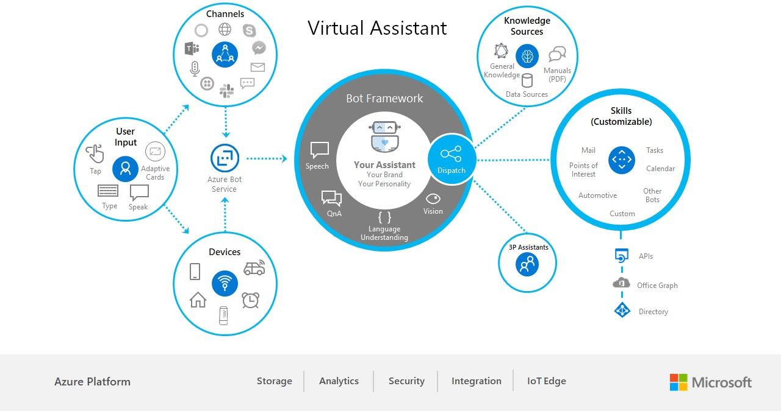

**6.3 HARDWARE REQUIREMENT:**

Raspberry Pi 3 (Model B) Raspberry Pi 3 is card size computer, which is shown in Fig 1, with a 64-bit quad core processor of ARM v7 having computing speed of 1.2 GHz, and 1GB RAM. It has 40 pins for GPIO and 4 USB ports which we need for connection of our USB mic and other peripherals. It also has 3.5mm audio jack which we are using to connect our speaker for output. MIC :Mic, as shown in Fig: 2, is a input device which we have used here to give input to our Virtual Personal Assistance. Mic are a type of transducer- a device which converts energy from one form to another. Its convert acoustic energy i.e. sound waves into electrical energy into electrical energy i.e. audio signals. SPEAKER :Speaker is an output device that we have used for giving us the desired answer from the Virtual Personal Assistance. The speaker is also a kind of transducer which cover the electrical signal i.e. the audio signal, and converts it’s to acoustic energy i.e. sound waves.

**7. SOFTWARE REQUIREMENT**

Lizzy is the name of our AI, or to put in more simple word it is a dead simple API (application programming interface). In Lizzy, we have implemented the STT i.e. the witai and the TTS is the google now for the output voice. In between the STT and TTS, Lizzy performs her task i.e. Lizzy extract the keyword from the text that she receives from STT and check with the local modules that are given to her than give the output if the keywords matches with any of the modules.

**8. CONCLUSION**

Lizzy is fully working Virtual Personal Assistance, which can perform task in offline condition as we given her local modules to her. In online condition Lizzy gets more resources to work with. Also, any peripheral which is connected with the raspberry pi is can be control with the Virtual Personal Assistance, just by giving the command. The local modules can be added or removed by user as he sees fit. Also, there is simple option for conversation with Lizzy, where it learns further.

The paths of this study regarding IPAs is intended to reveal an overview on how and to what extent these devices might be used in human-computer interaction and learning. In this connection, the working systems of the IPAs namely Apple’s Siri, Google Now and Microsoft Cortana are revised within the context of AI. Although there have been several works related to IPAs in education (also known and conceived as Intelligent Pedagogical Agents by Garrido et al. (2010, p.4) the potential use of IPAs for second language learning within Natural Language Processing (NLP) should be focused particularly. In this regard, it may be suggested that both devices (PDAs) and applications (IPAs) might be used as feasible tools for language learning; so more qualitative and quantitative studies may be conducted accordingly.

**9. LIMITATIONS :**

There are no limits. People fail to recognize that natural human intelligence is not magical or mystical. It is just the end result of atoms interacting in physical ways that are all well understood.

It is not yet well understood how those physical interactions create the emergent properties of consciousness and mind/body interactions. But it is well understood that they do so.

The scale is pretty clear too. There are approximately 90 billion nerve cells in the human brain, only 16 billion of which are in the cerebrum where most of planning lies.

**Artificial Intelligence as of today might not be limitations a few years later. However, as of today, we use Deep Learning to achieve AI, yet are not entirely sure how these deep neural networks work. Neurons in the brain can connect to any neuron in physical proximity to themselves, but machines have specific layers, where the output from one layer is fed as an input to the next layer, and we still do not know the working that goes on in each layer.**

* 1. **FUTURE ENHANCEMENTS**

**Future Scope of Artificial Intelligence**. **Personal assistant** **Artificial Intelligence**(**AI**) is the simulation of human intelligence by machines. In other words, it is the method by which machines demonstrate certain aspects of human intelligence like learning, reasoning and self- correction.

**10. REFERENCES**

i. Chen, Y. N. V. (2015). Learning Organized Knowledge for Unsupervised Spoken Language Understanding. Unpublished doctoral dissertation, Carnegie Mellon University, Pennsylvania,

USA. Retrieved from <http://www.cs.cmu.edu/~yvchen/doc/dissertation.pdf>

ii. Chris, L.(2014).Why cortana assistant can help Microsoft in the smart phone market. The Street Retrieved from <http://www.thestreet.com/story/12534433/1/y-cortana-assistant-can-help-microsoft-in-the-smart-phone-market.html> .

iii. Crevier, D.(1993). AI: The tumultuous Search for Artificial Intelligence. New York,NY: Basic Books, ISBN 0-465-02997-3.

iv. Dobrev, C.,&Xhafab, F. (2013). Intelligent services for Big Data Science. Future Generation Computer Systems, 37(2013), 267-281.

v. Fleming R. (2014). Could Cortana in education help students and teachers? Microsoft Education Blog. Retrieved from http://blogs.msdn.com/b/education/archive/2014/09/08/could-cortana-in-education-help-students-and-teachers.aspx

**Signature of the Candidates Signature of the Guide Signature of the Coordinator**