PERSONAL DIGITAL ASSISTANT
A Minor Project SRS Submitted to


Rajiv Gandhi Proudyogiki Vishwavidhyalaya, Bhopal
Towards Partial Fulfillment for the Award of

Bachelor of Engineering
(Computer Science and Engineering)

Submitted By:
SAMAY PASHINE (0827CS171186)
SAGAR MANDIYA (0827CS171181)
PRAVEEN GUPTA (0827CS171153)
CS3 III YEAR

Guided By: Project Coordinator:
Rahul Moriwal Nidhi Choubey
Assistant Professor Assistant Professor

Department of Computer Science and Engineering
Acropolis Institute of Technology and Research, Indore
July - Dec 2019

INDEX

S. NO. | TOPIC | PAGE NO. | REMARK
1. | INTRODUCTION | 4
1.1 | PURPOSE | 4
1.2 | SCOPE | 4
1.3 | REFERENCES | 4
1.4 | TECHNOLOGIES TO BE USED | 5
 | 1.4.1 ESP8266 Wi-Fi Chip | 5
 | 1.4.2 ARDUINO | 5
 | 1.4.3 RASPBERRY PI | 6
 | 1.4.4 MICROSOFT SPEECH API | 6
1.5 | OVERVIEW | 7
2. | GENERAL DESCRIPTION | 7
2.1 | PRODUCT PERSPECTIVE | 7
2.2 | PRODUCT FUNCTIONS | 7
2.3 | USER CHARACTERISTICS | 8
2.4 | GENERAL CONSTRAINTS | 8
2.5 | ARCHITECTURAL DESIGN | 9
2.6 | USE CASE DESIGN | 10
3 | SPECIFIC REQUIREMENTS | 11
3.1 | EXTERNAL INTERFACE REQUIREMENTS | 11
 | 3.1.1 USER INTERFACE | 11
 | 3.1.2 HARDWARE INTERFACE | 12
 | 3.1.3 SOFTWARE INTERFACE | 13
3.2 | FUNCTIONAL REQUIREMENTS | 13
3.3 | USABLITY REQUIREMENTS | 14
4 | CONCLUSION | 14
5 | REFERENCES | 15

INTRODUCTION

The purpose of this project is to build a program that will be able to service to humans like a personal assistant. This is an interesting concept and many people around the globe are working it. Today, time and security are the two main things to which people are more sensitive, no one has the time to spoil; nobody would like their security breach and this project is mainly for those kinds of people.

1.1 PURPOSE
The purpose of this personal assistant is to reduce the physical effort and increase the efficiency of the any work project.

1.2 SCOPE
The scope of this project is to reduce the dependency of typing anything on keyword its all done through your voice commands.The concept is to make only the main program has the privileges to access them. This might enhance the functional capacity of any program and reduce the overhead to humans. The another scope of this project, I would like to mention is that, there would be the great chance of saving electrical power which eventually would affect our nation power supply system by making the artificial intelligence for home electrical appliences or security system .

• IIS: Internet Information Service
• API: Application Programming Interface
• CMD: Command(s)
• UI: User Interface
• SAPI: Speech Application Programming Interface
• VCC/GND: power (5 to 9 v)/Ground
• COM: Communication
• GUI : Graphical User Interface
• OPEN SOURCE : Software for which the code is freely available for use and research
• IIS: Internet Information Service
• IoT: Internet of thin
• IIS: Internet Information Service
• API: Application Programming Interface
• CMD: Command(s)
• UI: User Interface
• SAPI: Speech Application Programming Interface
• VCC/GND: power (5 to 9 v)/Ground
• COM: Communication
• GUI : Graphical User Interface
• OPEN SOURCE : Software for which the code is freely available for use and research

1.3 REFERENCES
https://en.wikipedia.org/wiki/Internet_Information_Services
https://en.wikipedia.org/wiki/Raspberry_Pi
https://en.wikipedia.org/wiki/ESP8266
https://en.wikipedia.org/wiki/Arduino
https://en.wikipedia.org/wiki/Microsoft_Speech_API
http://whatis.techtarget.com/definition/sensor
http://www.azosensors.com/article.aspx?ArticleID=339
http://wiki.seeed.cc/Grove-Sound_Sensor/
http://www.futureelectronics.com/en/drivers/motor-driver.aspx

1.4 TECHNOLOGIES TO BE USED

1.4.1 ESP8266 Wi-Fi Chip
The ESP8266 is a low-cost Wi-Fi chip with full TCP/IP stack and MCU (Micro
Controller Unit) capability produced by Shanghai-based Chinese manufacturer, Espressif
Systems.
The chip first came to the attention of western makers in August 2014 with the ESP-01
module, made by a third-party manufacturer, AI-Thinker. This small module allows
microcontrollers to connect to a Wi-Fi network and make simple TCP/IP connections
using Hayes-style commands. However, at the time there was almost no English-
language documentation on the chip and the commands it accepted. The very low price
and the fact that there were very few external components on the module which suggests
that it could eventually be very inexpensive in volume, attracted many hackers to explore
the module, chip, and the software on it, as well as to translate the Chinese
documentation.
The ESP8285 is an ESP8266 with 1 MB of built-in flash, allowing for single-chip
devices capable of connecting to Wi-Fi. The successor to these modules is ESP32.

1.5.3 ARDUINO
Arduino is an open source hardware and software project, created with a simple aim in
mind, to be as simple as possible. Arduino is not some hardware you should be afraid of.
Arduino comes in a variety of flavors and sizes. It is used by artists, hackers, hobbyists,
and professionals to easily design, prototype and experiment with electronics. Use it as
brains for your robot, to build a new digital music instrument, or to make your house
plant tweet you when it's dry. An Arduino contains a microchip, which is a very small
computer that you can program. You can attach sensors to it so that it can measure
conditions (like how much light there is in the room). It can control how other objects
react to those conditions (room gets dark. LED turns on).
The project is based on microcontroller board designs, produced by several vendors,
using various microcontrollers. Microcontrollers use inputs and outputs like any
computer. Inputs capture information from the user or the environment while outputs do
something with the information that has been captured. A switch and a sensor could be a
digital and an analog input respectively into the Arduino. Any object we want to turn on
and off and control could be an output. It could be a motor or even a computer. These
systems provide sets of digital and analog input/output (I/O) pins that can interface to
various expansion boards (termed shields) and other circuits.

1.5.4 RASPBERRY PI
The Raspberry Pi is a series of credit card-sized single-board computers developed in
the United Kingdom by the Raspberry Pi Foundation to promote the teaching of
basic computer science in schools and developing countries.
Several generations of Raspberry Pi’s have been released. The first generation (Raspberry
Pi 1 Model B) was released in February 2012. It was followed by a simpler and
inexpensive model Model A. In 2014 the foundation released a board with an improved
design in Raspberry Pi 1 Model B+. The model laid the current "mainline" form-factor.
Improved A+ and B+ models were released a year later. A cut down "compute" model
was released in April 2014, and a Raspberry Pi Zero with smaller size and
limited input/output (I/O) and general-purpose input/output (GPIO) abilities was released
in November 2015 for US$5.

1.5.5 MICROSOFT SPEECH API
The Speech Application Programming Interface or SAPI is an API developed
by Microsoft to allow the use of speech recognition and speech synthesis within Windows
applications. To date, a number of versions of the API have been released, which have
shipped either as part of a Speech SDK, or as part of the Windows OS itself. Applications
that use SAPI include Microsoft Office, Microsoft Agent and Microsoft Speech Server.
In general all versions of the API have been designed such that a software developer can
write an application to perform speech recognition and synthesis by using a standard set of
interfaces, accessible from a variety of programming languages. In addition, it is possible
for a 3rd-party company to produce their own Speech Recognition and Text-To-
Speech engines or adapt existing engines to work with SAPI. In principle, as long as these
engines conform to the defined interfaces they can be used instead of the Microsoft-
supplied engines.
In general the Speech API is a freely redistributable component which can be shipped with
any Windows application that wishes to use speech technology. Many versions (although
not all) of the speech recognition and synthesis engines are also freely redistributable.
There have been two main 'families' of the Microsoft Speech API. SAPI versions 1 through
4 are all similar to each other, with extra features in each newer version. SAPI 5 however
was a completely new interface, released in 2000. Since then several sub-versions of this
API have been released.

1.5 OVERVIEW

From now, the purpose of the project, its scope and the technologies that will be used in
building of this project has been described. The rest of the SRS examines the specifications
of the project in detail. Section 2 of the SRS presents the overall description and
requirements, such as user characteristics, project constraints, architecture design, design etc.
Section 3 outlines the detailed, specific functional, performance, system and other related
requirements of the project

GENERAL DESCRIPTION

2.1 PRODUCT PERSPECTIVE

As we know researches on AI system vastly increase since the last decade. Everyday new AI
model/prototype has been introduced by the people around the globe. By following the same
flow this project comes into play. This project is only one of its kinds since various features
of different categories will be installed. We have seen that these types of system are
dedicated to a specific task, but this system also functions other tasks too.
Below are some tasks on which this system shall function:
• Chat-bot
• Providing answers to user about his/her queries from search engine over the internet
• Personal assistant
Above are the main features on which this system will function. Additional features could
also be installed during the build.

2.2 PRODUCT FUNCTION
Functioning of the system is described below in a step by step flow:
• This system will take speech commands as input.
• Input will then send serially to the application running on raspberry pi.
• Application will then process the command and generate a code.
• Since raspberry pi has 40 GPIO connected to specific electrical component, the
generated code will be used for making the pin high or low.
• Also the application will update the changes made by the user through ESP8266.
• This update can be received by the user anywhere in the world.

Specifically, the application running on raspberry pi should account as the main/master
application. This application will be responsible for any kind of functioning/event happen
during the execution. Other slave programs control rest of the component like sensors,
motor-drivers etc. The detailed description will be found in section 3.

2.3 USER CHARACTERSTICS

Since this project function by getting commands from the user, so it’s necessary that user
should be able to pronounce English commands to make system function. Except this, no
special skills are required. Efforts shall be made in the direction of recognizing commands
and synthesizing feedback in Hindi language, so that Indians (especially people from rural
areas) can interact with the system easily.
Help book will be provided in case if user faces any trouble or any kind of system
malfunctioning. The same can be found in the root folder of the app in pdf format.

2.4 CONSTRAINTS

Since AC power will be supplied to power up the system (it will be converted into DC)
through a wire, functioning area will be short or limited. This system should be able to
operate in a one room area which is the main constraint.
Another issue with this system would be the operating time. As we know there is no battery
backup for power supply, system will power up with AC, so as soon as AC goes off, system
will stop working. Clearly, system will function until the power goes off.

2.5 ARCHITECTURE DESIGN

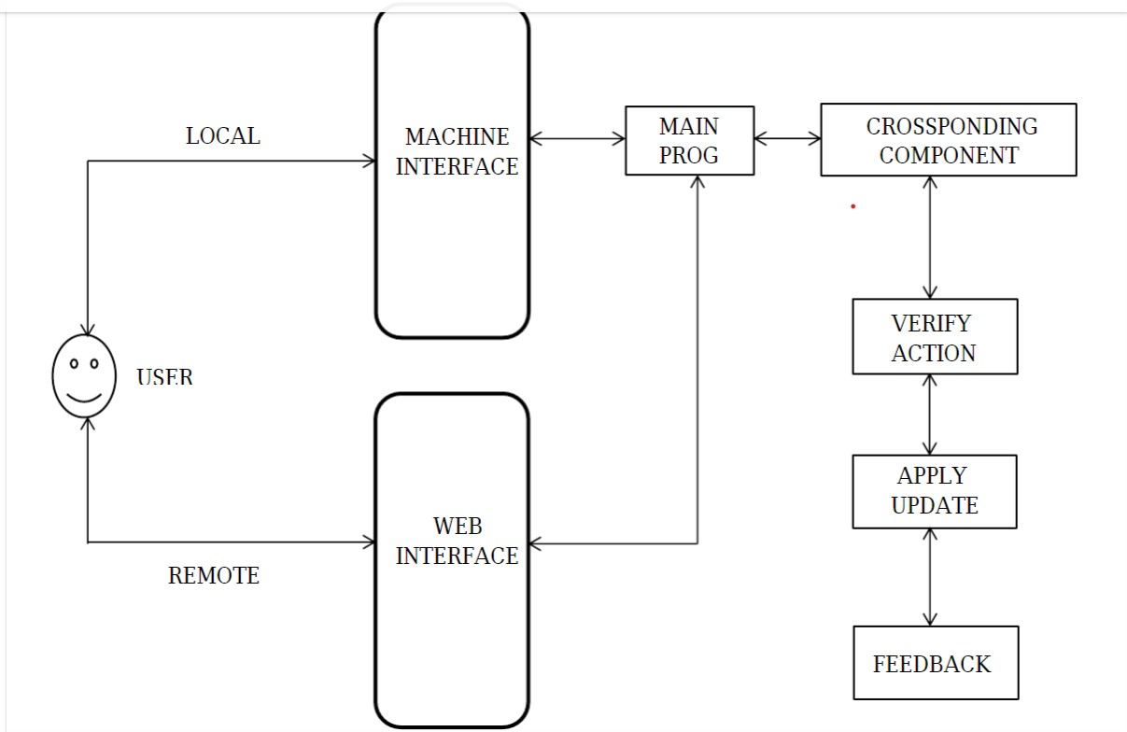

2.6 USE CASE MODEL DESCRIPTION

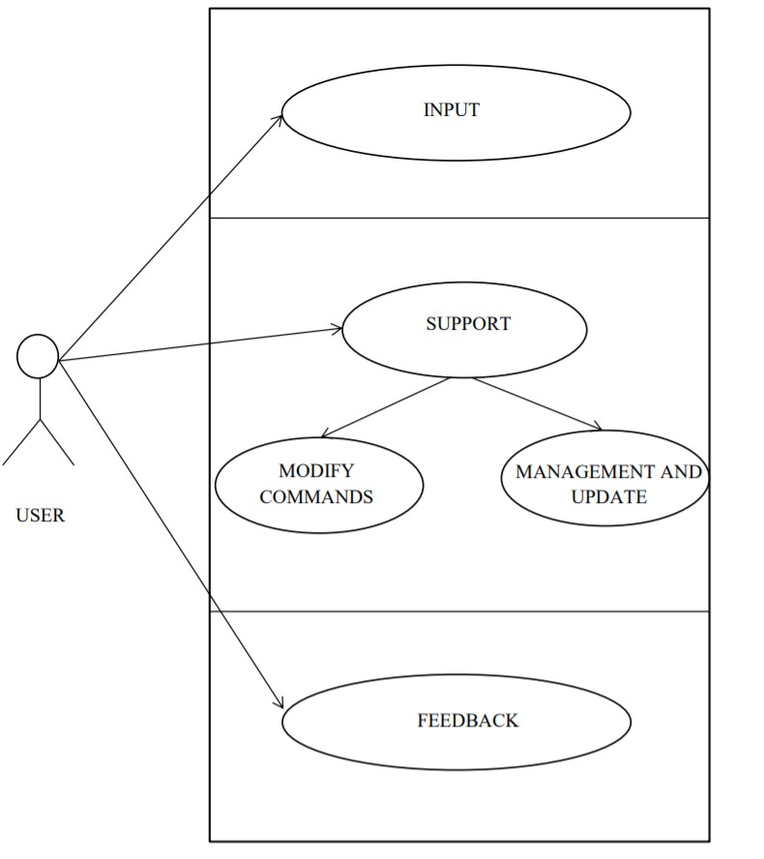

EXTERNAL INTERFACE REQUIREMENTS

3.1 USER INTERFACE
No special kind of user interface shell provide in this project. User can interact only through
his/her voice. A microphone will be set on the top front part of the body, which I called
‘head’. This portion is chosen because its lot easier to detect user’s voice clearly and much
accurately at the top front instead of any other portion. Two speakers on the left and right
side of the ‘head’ will also be provided to provide the response/feedback. This will help user
to get to know that his/her command has successfully been executed or not.
So these two components will interact with the user vice versa. No other interface tool like
graphical, LCD, LED screens/display are provided. Below a detailed description of these
two UI components are provided:

3.1.1 MICROPHONE
Every system requires input to work on. This system needs the same but slightly of
different format. Actually, this system is purely voice operational and function on a
simple concept; provide speech input and get voice response. But as we know that speech
commands are analog in nature and we must first convert them into digital form to do
some computation, so we need some sort of equipment/component/device which can do
this conversion (the conversion of analog signals to digital signals).
As we know that a microphone, colloquially nicknamed mic or mike is a transducer that
converts sound into an electrical signal. These electrical signals then feed to the program
as input. Now, within the program itself, there are some predefined signals and as soon as
the input signal matches the stored signal crossponding action will be taken.
So, microphone is the main foundation of the system and it is one of the two user interface
unit.

3.1.2 SPEAKERS
Two 8 ohm speakers are used to provide the output to the user. These speakers will be
placed on the both side of the head (right and left side). These speakers will operate at 0.5
W power and 40mm miniature.

3.2 HARDWARE INTERFACE
Hardware Interface may include the following main components like as follows :

3.2.8 SENSORS
As we know that a sensor is a device that detects and responds to some type of input
from the physical environment. The specific input could be light, heat, motion, moisture,
pressure, or any one of a great number of other environmental phenomena. Well, in this
project, some sensors will be used which are as follows:

3.2.8.1 SOUND SENSOR
Grove - Sound Sensor can detect the sound strength of the environment. The main
component of the module is a simple microphone, which is based on the LM358
amplifier and an electret microphone. This module’s output is analog and can be easily
sampled.
The main use of this sensor is to detect the source of the sound so that it can move itself
and could check what’s going on.

3.3 SOFTWARE INTERFACE
Since this project uses various components, so in order to control these component some sort
of controlling part must exist which will be responsible for the communication and functioning
of these components. In our scenario, different program code will handle their crossponding
electrical component (I’ll call them slave programs) and they will report to the main program
(master program). Hence everything should be smooth and controlled.
Below are some tools which will be used to write the code:

3.3.2 WINDOWS 10 IOT CORE
Windows 10 IoT Core is a version of Windows 10 that is optimized for smaller devices
with or without a display, and that runs on the Raspberry Pi 2 and 3, Arrow Dragon
Board 410c & Minnow Board MAX. Windows 10 IoT Core utilizes the rich, extensible
Universal Windows Platform (UWP) API for building great solutions. This will be
installed on raspberry pi to run our window application. The main program will run
within this system and control other slave programs.

3.3.3 IIS

IIS is a web server which is used to run web applications locally as well as globally. The
web application will be developed using MS ASP.net. The main use of this service is to
run the web application which can get the request from the ESP8266 address and also
send the request to the same. This will let us control the system anywhere in the world.
The flow control is described below:
• User must visit the specified web site.
• UI is fairly easy to use. Various components are provided in order to control the
system.
• When user generates a request, a connection will be established between the web
application and the web address provided by the ESP8266 module.
• The request will then send to the specified web address.
• Necessary actions will be taken corresponding to the request and those actions will then transfer to the hardware module.
• That hardware module (ESP8266) then sends binary digit (either 0 or 1) to the
controller.
• Microcontroller then takes action crossponding to the received digit.
• Similar happens when feedback is required to the end node of the system.
Thus in this way, user would be able to access and control his/her assistant anywhere,
anytime!

3.2 FUNCTIONAL REQUIREMENTS
Given below is a list of functional requirements that the application should meet:
1. Multiple Users: Each project created by one user can be joined by multiple other users, where none or more joining participants can be attributed owner privilege. The creator of the project will receive owner privilege by default. The application should also facilitate reviews from supervisors or other members.
2. Template: The application will provide several templates for the user, or allow the user to upload his or her own template.
3. Schedule: There has to be a module in which the users can schedule their writing progress according to their chosen template.
4. Propose Suggestions/Tips: The system should be able to suggest tips and information to the user on how to write specific sections.
5. Send/Receive Feedback: The application should facilitate giving feedback on a report written by a student from a reviewer.
6. Upload/Download Document: The application should allow for the ability to upload or download a document to and from a project.
7. Built-in Chat mechanism: It should be possible to display the feedback from a reviewer and create an environment to discuss about specific submission.
8. Versioning: Keep track of the versions of publications that a user has uploaded.
9. Logging: Save the user’s records in a separate log file for usage analytics.

3.3 USABILITY REQUIREMENTS
Finally there are also some usability requirements that should be met in order to guarantee a user-friendly application:
1. The application must be fully functional on modern web browsers.
2. Efficient in use: System must facilitate efficiency of use for the user by providing usage
Information.
3. Intuitiveness: The User Interface must be intuitive and easy to use.

CONCLUSION
It started off with an intensive research phase, where all possible angles, frameworks and implementation strategies were compared with each other in order to be able to set out the most viable planning. Keeping in mind all the required features, the Model-View-Controller architecture was adopted in combination with the Java/Scala Play Framework. The framework was used to design models which would cater to the application’s requirements. These models predominantly included a User model, a Project model, a Calendar model, a Discussion model and a Task model. In this version the suggestion feature did not require any back-end functionality so a model for this feature was omitted. Roughly stated, each feature of this application was assigned a dedicated view, controller and model to provide low coupling and high cohesion. Also for future reference and developers this was proven as the best way to go.
These projects are closely related to a Calendar, where students have the option to plan out their writing process. They can choose a template which comes with a predefined planning, or do their own thing and plan their own planning. For the purpose of giving and receiving feedback, each project is assigned a discussion page where contributors can easily discuss issues with each other in real-time. Reviewers also have access to the discussion page and can also give their feedback on topics started by either students or themselves. A Task feature was added to the application as a user-specific ‘to-do’ list. These tasks do not show up on the Calendar, however the users do get notified by email about approaching deadlines.

REFERENCES
https://en.wikipedia.org/wiki/Internet_Information_Services
https://en.wikipedia.org/wiki/Raspberry_Pi
https://en.wikipedia.org/wiki/ESP8266
https://en.wikipedia.org/wiki/Arduino
https://en.wikipedia.org/wiki/Microsoft_Speech_API
http://whatis.techtarget.com/definition/sensor
http://www.azosensors.com/article.aspx?ArticleID=339
http://wiki.seeed.cc/Grove-Sound_Sensor/
http://www.futureelectronics.com/en/drivers/motor-driver.aspx

