**STUDENT NAME AND ID:**

GAN SAI FOCK (SCKL1900220)

**SUBJECT:** Windows Programming

**SUBJECT CODE:** 3CS0224

**LECTURER:** Ms. Lim Sin Chee

Contents

User Interface 3

Splash Screen 3

Main Form 4

About Box 5

Checkout form 5

Functionality 6

Adding first item into basket 6

Adding second item into basket 8

Adding third item into basket 10

Placing an order without discount. 11

Placing an order with self pick-up discount. 12

Menu Strips 12

Error handling 13

Adding to basket without selecting flavour. 13

Placing order with an empty basket. 14

Issues faced 15

Object-Oriented Programming 15

Design 15

Refactor 15

References 15

# User Interface

## Splash Screen

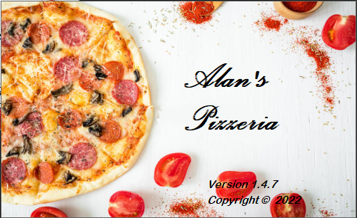

## Main Form

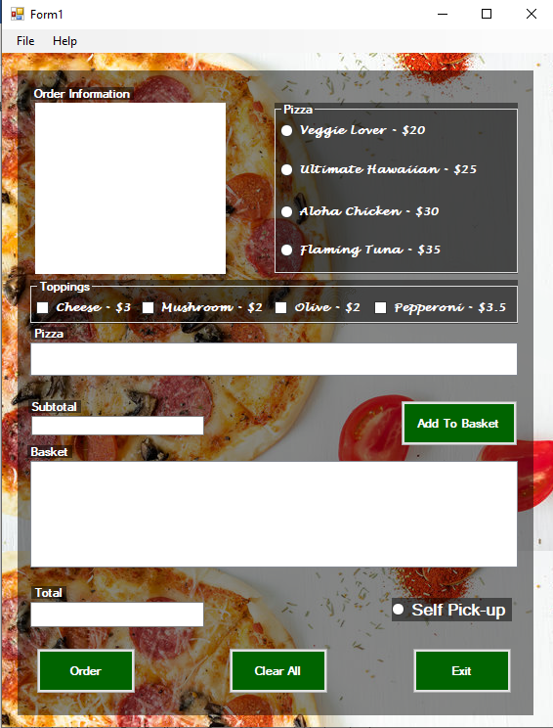

## About Box

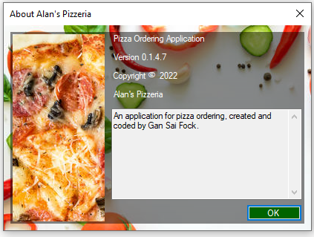

## Checkout form

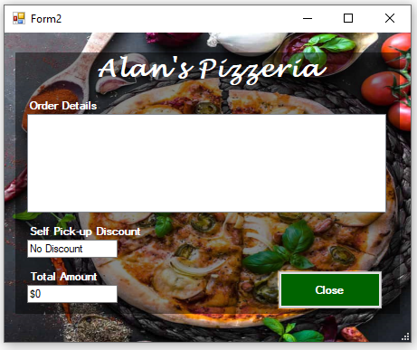

# Functionality

## Adding first item into basket

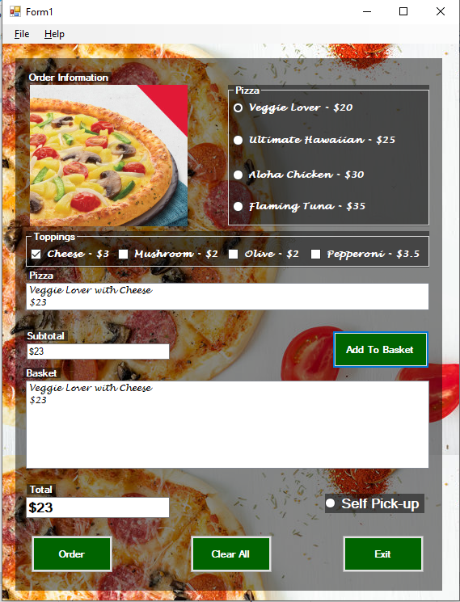

Above figure is the screenshot of adding an item to the basket, this is done by selecting the flavour and topping, then clicking the “Add To Basket” button. Then the pizza selected will be displayed on the Pizza listbox and the basket. Price is also displayed on the “Subtotal” and “Total” textboxes.

## Adding second item into basket

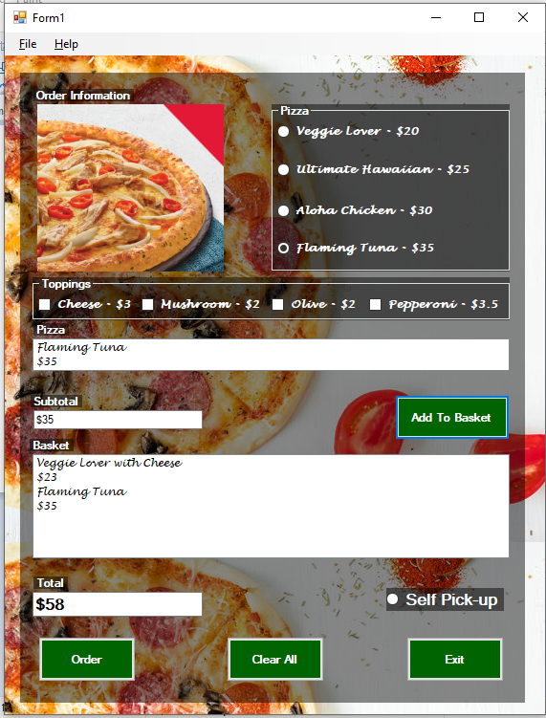

The above figure is the screenshot of adding a second pizza to the existing order. As seen in the Basket, the new pizza is added to the listbox while the first pizza is remaining in the listbox. The “Total” textbox displays the sum of the price for the two pizzas. While “Subtotal” textbox displays the current pizza’s price.

## Adding third item into basket

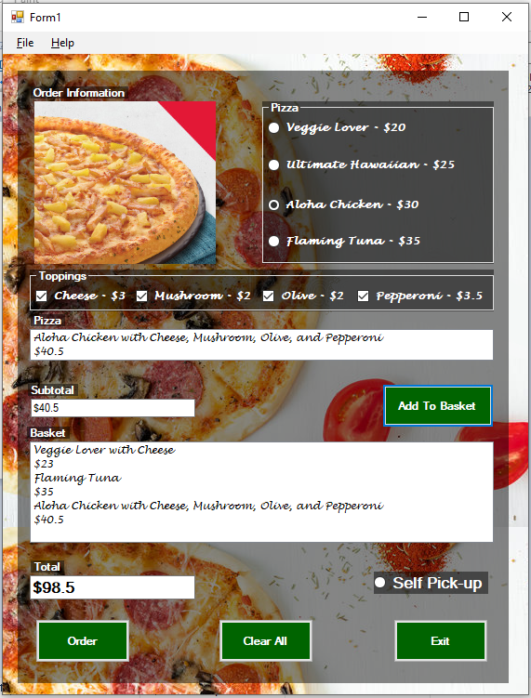

From the above figure, there is a third pizza being added to the basket. The pizza has all the toppings selected and displayed in the listboxes. To place the order, the user can click on the “Order” button, if the user wishes to pick up the order, they may select the “Self Pick-up" button. If the user wishes to clear out the current order, they may click on the “Clear All” button. The “Exit” button will close the application when clicked.

## Placing an order without discount.

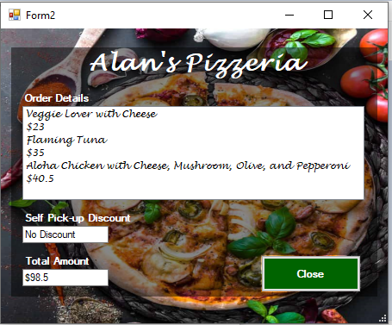

After clicking the “Order Button”, another form will appear, showing the order details. Other than that, the total price is also displayed.

## Placing an order with self pick-up discount.

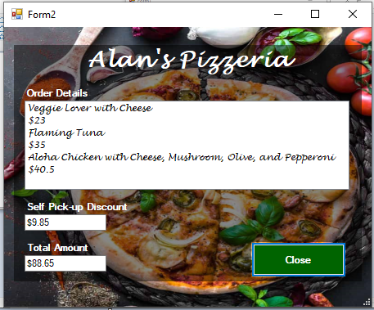

If the user places an order with the “Self Pick-up” selected, then they may enjoy 10% discount. The discount is shown in the “Self Pick-up Discount” textbox.

## Menu Strips

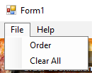 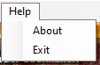

As shown on the two screenshots above, the user can also achieve the same result as the button through menu strip. Clicking “About” will display the About form to the user.

# Error handling

## Adding to basket without selecting flavour.

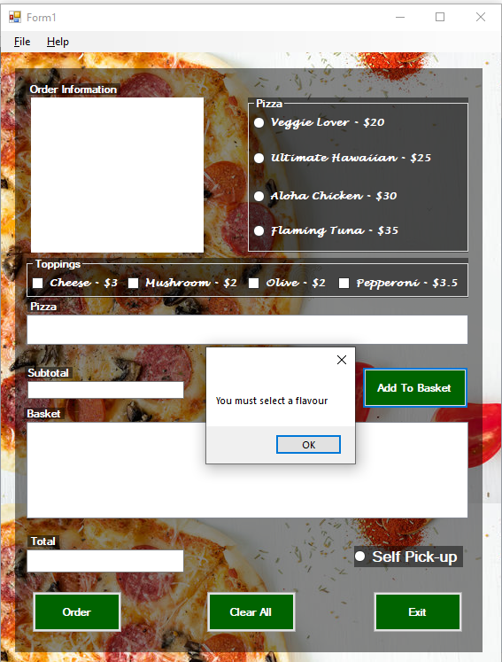

If the user attempts to click “Add To Basket” without selecting any flavour, a message will be displayed, telling the user, “You must select a flavour”.

## Placing order with an empty basket.

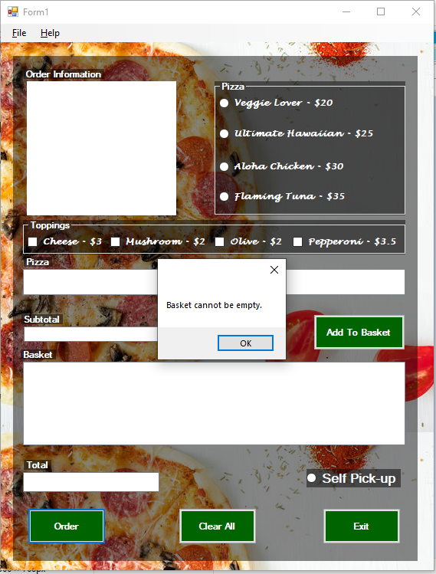

If the user attempts to place an order with an empty basket, a message saying, “Basket cannot be empty.” Will be shown. Preventing the user from completing the action.

# Issues faced

## Object-Oriented Programming

I faced some issues with applying object-oriented programming to the project in the beginning because the chapter wasn’t covered in lecturer at the time when I started the project. I did not have a proper grasp of how objects and attributes are declared in VB.NET, so I had to resolve this issue by searching it on the Internet. I ended up using properties in VB.NET to get and set values for my objects.

## Design

I encountered difficulty with creating a design for the system as I am inexperienced with UI/UX. I ended up solving this problem by watching some tutorial videos for VB.NET design. The result is that I wrote some code to change the font, background and colour of

## Refactor

Over the course of few days, I have made many edits and changes to the code until it became cluttered and hard to keep track. This led to difficulty in making changes as I must go through multiple lines of code to change a feature. I ended up spending a day to clean up the code by refactoring some parts by writing functions and subroutine. Other than that, I also improved and reorganized the code to make it easier to read by adding comments.

# References

1bestCsharp Blog (n.d.) *How To Design a Login Form In Visual Studio Basic.NET.* Viewed: 15th March. 2022. Available from: <https://1bestcsharp.blogspot.com/2019/04/vb.net-design-login-form.html>

Dot net perls (n.d.) *VB.NET Property Examples (Get, Set).* Viewed: 14th March. 2022 Available from: <https://www.dotnetperls.com/property-vbnet>

Tutorialspoint (n.d.) VB.Net – *Classes & Objects.* Viewed: 14th March. 2022. Available from: <https://www.tutorialspoint.com/vb.net/vb.net_classes_objects.htm>