**PRACTICAL-2**

**AIM:** Use CrypTool to encrypt and decrypt passwords.

**STEPS: (For Caesar Cipher)**

1. Install CrypTool from https://www.cryptool.org/en/ct1-downloads.

2. Plain Text

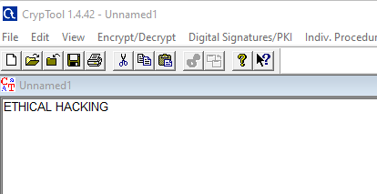

3. To Encrypt Click on Encrypt/Decrypt > Symmetric (Classic) > Caesar/ ROT-13

4. Enter Key Entry as Number Value and enter the key. And then click on Encrypt.

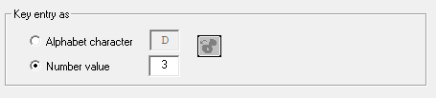

After clicking on Encrypt,

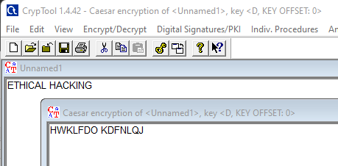

5. To Decrypt Again click on Encrypt/Decrypt > Symmetric (Classic) > Caesar/ ROT-13. Enter Key Entry as Number Value and enter the key. And then click on decrypt.

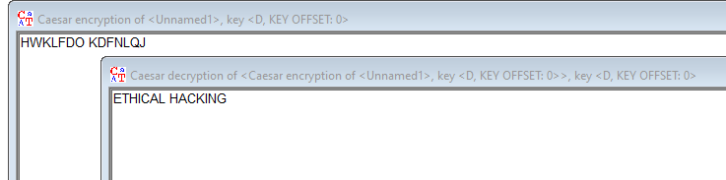

**Playfair Cipher:**

To Encrypt Click on Encrypt/Decrypt > Symmetric (Classic) > Playfair.

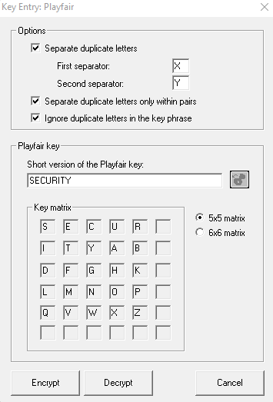

**Cipher Text:**

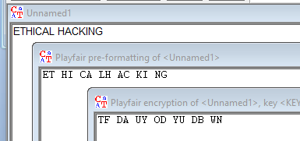

**Plain Text:**

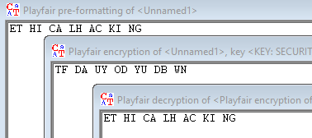

**RailFence:**

To Encrypt Click on Encrypt/Decrypt > Symmetric (Classic) > Scytale/ Rail Fence.

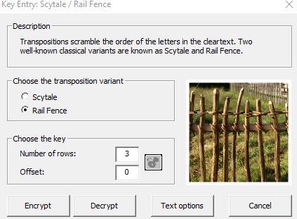

**Cipher Text:**

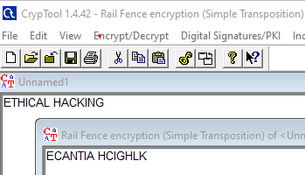

**Plain Text:**

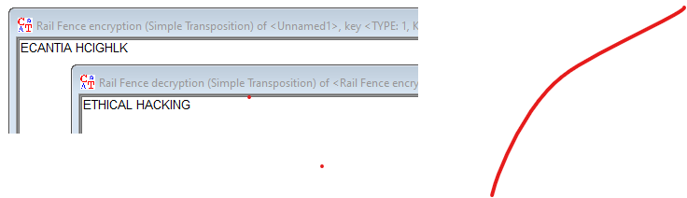

**RC4 Algorithm:**

To Encrypt Click on Encrypt/Decrypt > Symmetric (modern) > RC4

Click the number of bits and Encrypt.

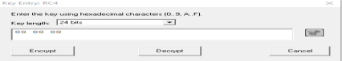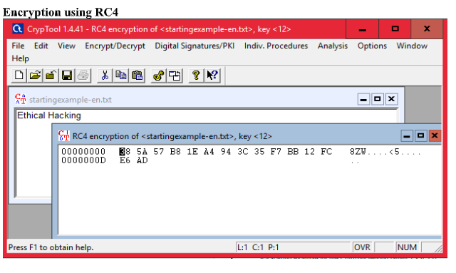 Click the number of bits. And then Decrypt.

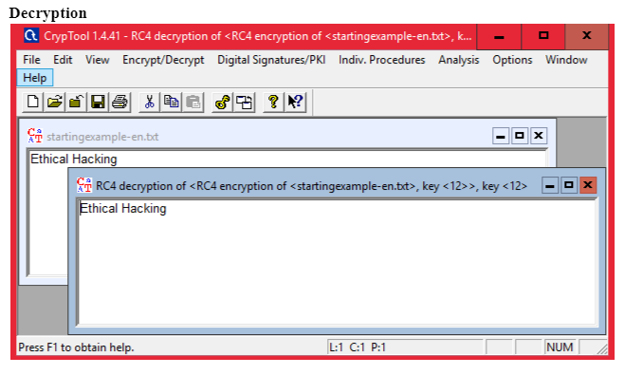

**CONCLUSION:** Thus, we conclude to use Crypt Tool to encrypt and decrypt passwords