Computer Network Security
TE
-
IT
Prof.
S
tella
J
Department of Information Technology
Xavier Institute of Engineering
Lecture
-
26
& 27
27
/0
9
/2022
Session: 11:00
-
12:00
PM

Outline
✓
Intrusion
Detection
System
✓
Types
of
IDS
✓
IDS
Vulnerabilities

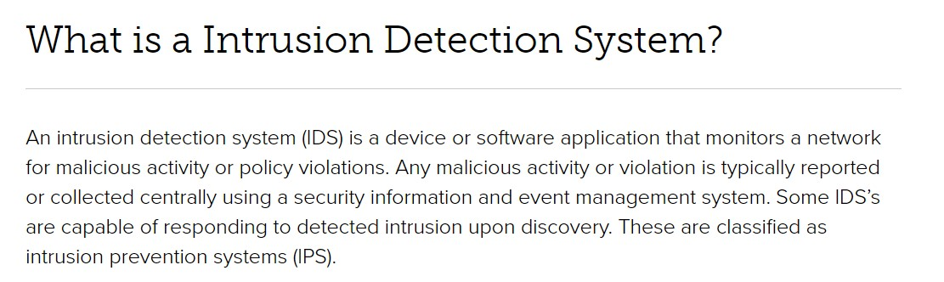
Intrusion Detection System

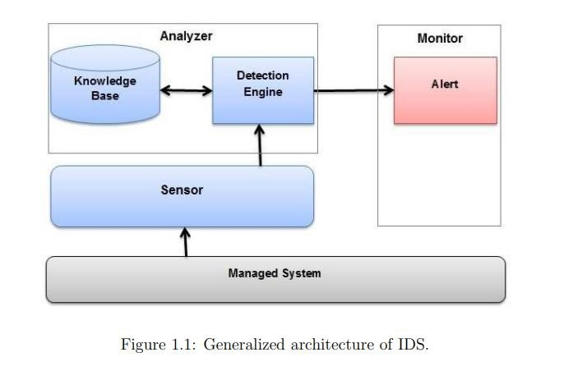
Architecture of
Intrusion Detection System

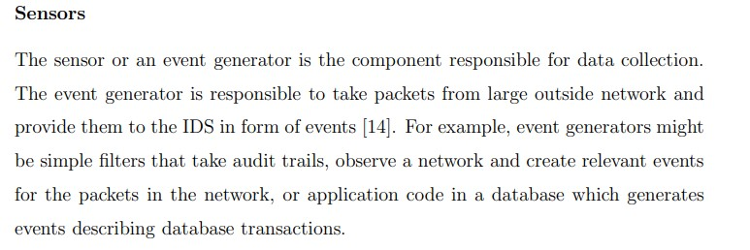
Subset of IDS

Analyzers
The raw data collected by the sensors is submitted to the analyzers to classify either as an attack or dismissed as safe.
Analyzer contains two components, detection engine and knowledge base. Detection engine filters information and throw-outs irrelevant data found by event generator.
The analyzer has a knowledge base that comprises the information such as profiles of normal system behavior, attack signatures, essential attributes (i.e. thresholds).
Initial analysis determines severity of the attack, then further analysis determines scope, intention, or frequency of the attack.
A significant amount of historical data storage may require for accurate analysis. Good analyzer can correlate two attacks or determine the inappropriate correlation
It is an interface to send a notification to the administrator about the threat detected by IDS. Adjustment of the monitor must be done according to the
Monitor
network traffic.

Intrusion detection elements can be categorized according to its primary
Classification of IDS
components
(
i) Intruder Type
(
ii) Detection methodology
(
iii) Deployment based
(
iv) Detection Behavior
(
v) Processing of collected data
Intrusion detection systems can be categorized based on five, parameters:

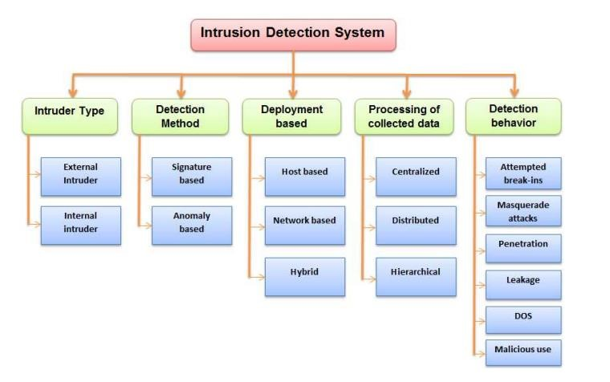
IDS

(i) Intruder type
IDS classified based on the users (intruders) are of two types, internal and external.
External intruders don’t have any authority to use the machine they attack. On the other hand internal intruders have limited authority to the machine, but try to perform additional activities (i.e. Administrative activities) for which they are not authorized.
Internal intruders are of three type masqueraders, misfeasor and clandestine .
- Masquerader is a person who enters into a system’s access control to exploit the account of a legitimate user.
- Misfeasor is a genuine user who accesses resources, programs, or data for which such access is not authorized, or misuses the privileges of the authorized access.
- Clandestine user is a person who takes hold of system’s supervisory control and uses it to avoid the auditing and access controls or to destroy audit collection.

(ii) Detection Based Method
An IDS that detects intrusion according to security policies, are based on one of the detection methodologies. Based on detection methodology IDS are either Signaturebased or anomaly-based. More than one detection methods are used, in maximum intrusion detection techniques for more accurate and broad detection.
Signature based: Signature based intrusion detection systems use known attacks signature to detect intrusion. Signature based detection is also known as misuse detection. In this approach, at first abnormal activities (signature) are defined, and any other undefined is treated as normal activity. A signature is a pattern related to some known attack. This detection methodology matches the signatures of observed events to known attack signatures to identify attack.
This method of intrusion detection is the simplest one. Examples of
An attempt of Telnet login with root username, which violates the security policy of any organization.
Signature Based Detection
signatures are as follows:
•
•
characteristics.
•
host’s auditing
An e-mail with freepics.exe file attached, which contains malware
An OS log file entry having status code 645, which indicates disabled

Signature Based Detection
Signature based IDS can be classified into further categories based on the
techniques used such as string matching, simple rule based, state modeling based, expert system based.
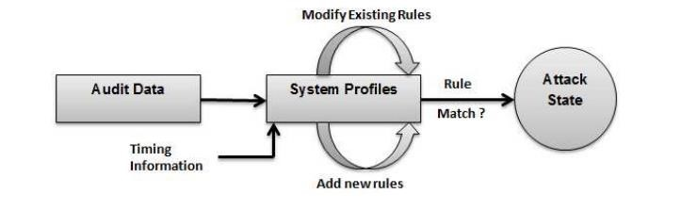
Signature based detection is quick and effective for identifying known attacks yet profoundly inadequate in detection unknown attacks, different variants of known attacks, and attacks masked by some evasion techniques.
if an attacker changed the malware in above mentioned example to use a filename of ”my freepics.exe” rather than ”freepics.exe” than a signature searching for ”freepics.exe” will treat it as different and hence will not match. It fails to detect truly new attacks, also known as novel attacks.

Anomaly Based Detection
Anomaly based detection is the methodology of collating the definitions of a new activity against the normal activity to find the deviations. This is based on statistical behavior modeling. Normal operations of the members are profiled and a certain amount of deviation from the normal behaviour is hailed as an anomaly. An IDS using anomaly based detection represents the typical behaviour of things, for example, hosts, users, applications, or network connections by utilizing the profiles. The profiles are created by observing the normal activities over a certain period of time
for example, the
number of failed login attempts for a host, the number of e-mails sent by a user, and usage of processor for a host in a given duration.
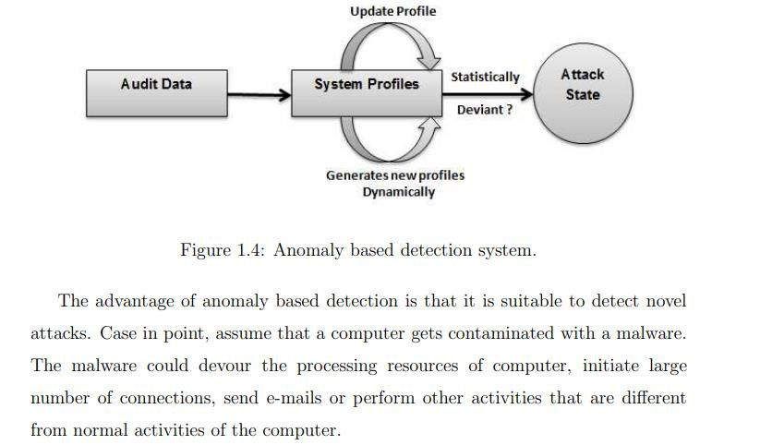
Anomaly Based Detection

Anomaly Based Detection
Some common examples of attack that can be detected by anomaly
based IDS
but not by signature based
IDS are
•
Probe attack
•
DoS (Denial of Service) attack
•
R2L (Remote to Local) attack
•
U2R (User to Root) attack

Anomaly Based Detection
Probe attack: The probe attacks are intended to acquire the information about the target network. Examples of probe attack are port-scan, ping-sweep.
DoS (Denial of Service) attack: It is a sort of attack on a system that is planned to flood the system or network and force the target system to stop the service(s) by flooding it with futile data. Examples of DoS attack are ping-of-death, teardrop, smurf, SYN flood. R2L (Remote to Local) attack: Unauthorized access from a remote machine. The R2L attacks are most troublesome to identify as they contain the network level characteristics (duration of connection and service requested) and the host level characteristics (number of failed login attempts). Example of R2L attack is guessing passwords U2R (User to Root) attack: Unauthorized access to local superuser privileges by a local unprivileged user. The U2r attacks contains the semantic points of interest that are extremely testing to find at a beginning stage. Such attacks target an application and are often content based. Examples of U2R attacks are various buffer overflow attacks.
Anomaly Based Detection

Anomaly Based Detection
Anomaly based IDSs are further divided into three categories
Statistical based: In statistical based anomaly intrusion detection systems, the network traffic is captured and after that a profile of its stochastic behaviour is produced. As the network operates in normal conditions (without any attack), a reference profile is created. After that, the network is monitored and profiles are generated and an anomaly score is generated by collating it to the reference
profile. If the score passes a certain threshold, the IDS will flag an occurrence of the anomaly
Anomaly based IDSs are further divided into three categories
Knowledge based: Knowledge based anomaly IDSs rely on the availability of the prior knowledge (data) of the network parameters in normal operating condition as well as the one under certain attacks. Knowledge base used in IDS may be expert systems, description languages(UML), finite state machines, data clustering.
Anomaly Based Detection
Anomaly based IDSs are further divided into three categories
Knowledge based: Knowledge based anomaly IDSs rely on the availability of the prior knowledge (data) of the network parameters in normal operating condition as well as the one under certain attacks. Knowledge base used in IDS may be expert systems, description languages(UML), finite state machines, data clustering.
Anomaly Based Detection
Machine learning based: In machine learning based anomaly IDSs, an explicit or implicit model of the analyzed patterns is generated. These models are updated periodically, in order to improve the intrusion detection performance on the premise of the past results. Machine learning techniques such as Bayesian networks, Markov model, fuzzy logic, genetic algorithm, neural networks, or principle conponent analysis can be used.
Anomaly Based Detection
IDS can be deployed on a individual host or in a segment of the
(
iii) Deployment based
network
There are 3 different types
1
. Host Based IDS
2
. Network Based IDS
3
. Hybrid IDS

(iii) Deployment based
1. Host Based IDS
Host-based IDS observes the characteristics of an individual host and the events happening on that host for malicious actions. The HIDS is generally deployed to the critical hosts to provide protection by monitoring the system entities and their attributes. Such systems typically make use of the information specific to operating systems of the target machines. HIDS monitors incoming and outgoing wired and wireless network traffic, system logs, running processes, file access and modification, system and application configuration changes.
HIDS reports intrusion by writing logs, sending e-mails, etc.
Host-Based IDS can be divided into four types
- File system monitors: Systems checking the integrity of les and
- Log file analysers: Systems analyzing log les for patterns showing
(
iii) Deployment based
directories.
malicious activity.
and to a host
- Connection analysers: Systems that monitor connection attempts from

- Kernel based IDSs: Systems that detect kernel level suspicious activity

(iii) Deployment based
HIDS has an advantage that it provides detailed information about the attack and is also known as System Integrity Verifier. HIDS is also have some limitations such as HIDS itself can be attacked (If an attacked host is down, then HIDS is also down), local installation on each host, and much host resources are needed.
Despite the fact that HIDS is much superior to NIDS in detecting malicious activities for an individual host yet they have restricted perspective of network topology and henceforth can’t detect attacks that is focused for another host in a network where HIDS installed

(iii) Deployment based
Strength of HIDS:
- Can verify success or failure of an attack
- Log verification
- Monitors specific system activities
- File access activity
- Logon/logoff activity
- Account changes
- Policy changes

• Detects attacks that network-based IDS may miss
- Keyboard attacks
- Brute-Force Logins

(iii) Deployment based
2. Network Based IDS:
- A network based IDS generally contains network device with a Network Interface Card (NIC) that operates in promiscuous mode.
- The IDS is placed on the boundary or along a network segment to monitor most of the traffic on that network segment. NIDS can be passively deployed, without many changes to networks or systems. NIDS are very effective for monitoring both outbound and inbound traffic. Load balancing in NIDS allows it to efficiently utilize the processing power of the nodes in a distributed system for scalability
- A single NIDS is able to protect the entire network and turning off a target system will not affect the NIDS. But NIDS cannot monitor the network if the system bandwidth is overloaded

(iii) Deployment based
Strength of NIDS:
- Lower cost of ownership
- Fewer detection points required
- Greater view

- More manageable, less intrusive
- Detects attacks that host-based systems miss
- IP based Denial of Service
- Packet or Payload Content

• More difficult for an attacker to remove evidence
- Uses live network traffic
- Captured network traffic
Operating system independence
(
iii) Deployment based
Strength of NIDS:
•
Real
-
time detection and response
•
Faster notification and responses
•
Can stop before damage is done
—
(
TCP Reset
)
•
Detects unsuccessful attacks and malicious intent
•
•
Does not require information from the target OS
•
Does not have to wait until events are logged

Hybrid IDS improves HIDS technology by making it capable to monitor the network traffic flowing through the host, either into or out from individual host. Hybrid agents unite the functionality of HIDS with network based sensor technology that is just to analyze the network traffic focused to the particular host where the hybrid agent is installed. The processor utilization in a hybrid agent is much more than a hostbased agent.
(
iii) Deployment based
3
. Hybrid IDS
:
•
Data are collected from one or more sources in intrusion detection systems. Collected data is stored and processed to detect intrusion. Based on storage and processing IDS can be classified as follows:
(
iii) Processing of collected data
1
.
Centralized IDS
2
.
Distributed IDS
3
.
Hierarchical IDS

A centralized IDS is a system where the data analysis is performed in a fixed number of places, that does not depend on the number hosts are being monitored. Location is considered of only analysis
(
iii) Processing of collected data
1
.
Centralized IDS:
components.

A distributed IDS is the system where the data analysis is done at numerous locations, may be equivalent to the number of hosts that are being monitored. Locations and number are considered of just the analysis components, not the collection components
(
iii) Processing of collected data
2
.
Distributed IDS:

This is proposed for multi-layer (clustering) network infrastructures. Cluster heads (CHs) are responsible for monitoring their member nodes, as well as participating in the global intrusion detection
(
iii) Processing of collected data
3
. Hierarchical IDS:
decisions

(iv) Detection behavior
Based on detection behavior IDS can be classified as follows
- Attempted break-ins: Detected by common behaviour profiles or by security constraint violations.
- Masquerade attacks: Also detected by common behaviour profiles or by security constraint violations
3.Penetration of the security control system: Detected by searching for particular activity patterns.
- Leakage: Detected by common utilization of system resources.
- Malicious use: Detected by common behaviour profiles, utilization of
special privileges, by security constraint violations
IDS can produce some Error report when monitoring
Vulnerabilities in IDS
False positives:
•
intrusion
False negatives:
•

Something abnormal (as defined by the IDS) is reported, but it is not an

-Too many false positives, So you will turn off your IDS
An intrusion is going on, but your IDS does not report it
- One false negative So the system is compromised
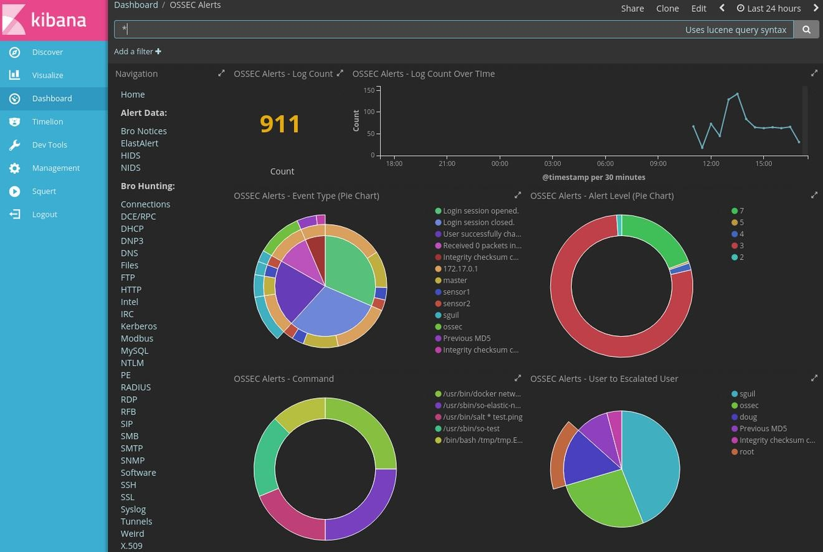
OSSEC Features
THANK YOU

