Computer Network Security
TE
-
IT
Prof.
S
tella
J
Department of Information Technology
Xavier Institute of Engineering
Lecture
-
29
10
/
10
/2022
Session: 12:00
-
1:00
PM

Outline
✓
Network
Acess
Control
✓
Principle
element
of
NAC
✓
NAC
Enforcement
Methods
✓
Types
of
NAC
✓
Use
of
NAC
✓
Implementation
of
NAC

The threat of viruses, worms, information theft, roaming users, and the lack of control of the IT infrastructure lead companies to implement security solutions to control the access to their internal IT networks
Introduction
•
•
•
A new breed of software and hardware solutions from a variety of vendors has emerged recently
All are tasked with one goal – controlling the access to a network using different methods and solutions

NAC
Network Access Control (NAC) is a set of technologies and defined processes, which its aim is to control
access to the network
NAC is a valid technology that should play a key role in internal network security
A common criterion for NAC does not exist and therefore the definition of what does a NAC solution should (and/or must) contain varies from one vendor to another
Cisco Network Admission Control (NAC)
Microsoft Network Access Protection (NAP)
The Trusted Computing Group (TCG), Trusted
Network Connect (TNC)

Many different vendors offer NAC solutions
NAC
Various initiatives:
•
•
•
•
Other

NAC Capabilities
The most essential capabilities any NAC solution must have are the ability to detect a new element connecting to the network, and the ability to verify whether or not it complies with a defined security policy
If the element does not comply with the defined security policy, the NAC solution must restrict the element’s access to the network
The following is a list of functions that may, or may not, be included with a
Element detection – The ability to detect new elements as they are
NAC Functions
•
vendor’s NAC offering:
•
introduced to the network
•
Authentication – The ability to authenticate each user accessing the network no matter where they are authenticating from and/or which device they are using

NAC Functions
End point security assessment – The ability to assess whether a newly introduced network element complies with the security policy. These checks may include the ability to gather knowledge regarding an element’s operating system, the list of installed patches, the presence of an A/V software and its virus signatures date, etc. In most cases it involves the installation of a client software on the end system

Remediation – The process of quarantine an element not complying with the defined security policy until the issues causing it to be non-compliant are fixed. When quarantined, the element is able to access a defined set of remediation servers allowing the user fixing the non-compliant issues

NAC Functions
Enforcement – If the element does not comply with the defined security policy, the NAC solution must restrict the element’s access to the network
Authorization – The ability to verify access by users to network resources complies with an authorization scheme defined in an existing authorization system (such as Active Directory, RADIUS servers, etc.) allowing enforcing identity-based policies
Post-Admission Protection – Is the process of continuously monitoring users, elements and their sessions for suspicious activity (i.e. worms, viruses, malware, etc.). If detected the action taken by a NAC system may vary from isolating the offending system to dropping the session. Post admission protection functions are similar to Intrusion Prevention Systems (IPS)
The ability to control each user and/or element accessing the network no matter where they are accessing the network from and/or which device they
NAC Capability Implications
are using
Local Network
VPN
Client
-
based
SSL
-
VPN
IPSEC
Heavily
rely on Client
-
based software
Heavily rely on Host
-
based security

Must have intimate knowledge regarding the enterprise network
NAC Attack Vectors:
- A solution’s architecture
- The placement of the different pieces of a solution
- Technology used
- Element detection
- Quarantine abilities
- Enforcement methods
- A solution’s components
- Client-side software
- Server-side software (and hardware)

NAC TYPES
Types of Network Access Control:
Pre-admission: It happens before access to the network is granted on initialization of request by user or device to access the network. It evaluates the access attempt and only allows the access if the user or device is compliant with organization security policies and authorized to access the network.
Post-admission: It happens within the network when the user or device attempts to access the different parts of the network. It restricts the lateral movement of the device within the network by asking for reauthentication for each request to access a different part of the network.
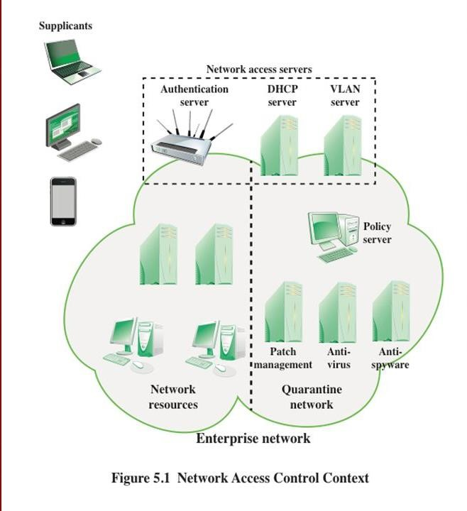
NAC Principles

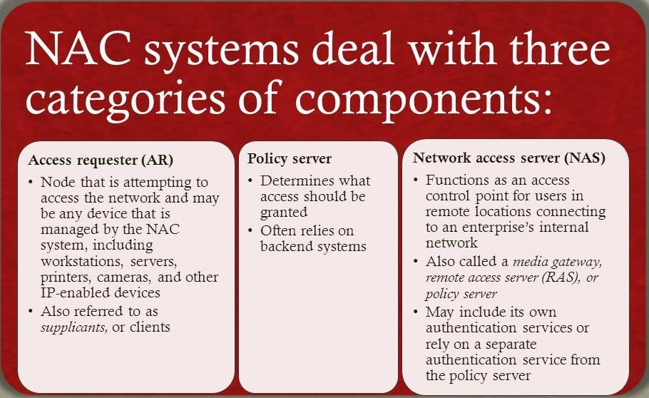
NAC Principles

THANK YOU

