**Experiment No. 3**

**Aim:** Experiment with Angular JS to demonstrate Routing

**LO3:** Construct Single Page Applications using AngularJS Framework.

**Theory:**

**Code:**

<!DOCTYPE html>

<html lang="en">

<head>

<meta charset="UTF-8">

<meta name="viewport" content="width=device-width, initial-scale=1.0">

<title>AngularJS Routing Example</title>

<script src="https://ajax.googleapis.com/ajax/libs/angularjs/1.8.2/angular.min.js"></script>

<script src="https://ajax.googleapis.com/ajax/libs/angularjs/1.8.2/angular-route.js"></script>

<style>

body {

font-family: Arial, sans-serif;

text-align: center;

background-color: #f4f4f4;

margin: 0;

padding: 0;

}

h1 {

background-color: #007BFF;

color: white;

padding: 15px;

margin: 0;

}

nav {

margin: 20px;

}

nav a {

text-decoration: none;

color: #007BFF;

font-size: 18px;

margin: 0 15px;

font-weight: bold;

}

nav a:hover {

text-decoration: underline;

}

.container {

background: white;

padding: 20px;

margin: 20px auto;

width: 50%;

border-radius: 10px;

box-shadow: 0px 0px 10px rgba(0, 0, 0, 0.1);

}

</style>

</head>

<body ng-app="myApp">

<h1>AngularJS Routing Example</h1>

<nav>

<a href="#!/">Home</a>

<a href="#!/about">About</a>

<a href="#!/contact">Contact</a>

</nav>

<div class="container">

<div ng-view></div>

</div>

<script>

var app = angular.module('myApp', ['ngRoute']);

app.config(function($routeProvider) {

$routeProvider

.when("/", {

template: "<h2>Welcome to the Home Page</h2><p>This is the home page content.</p>"

})

.when("/about", {

template: "<h2>About Us</h2><p>Here is some information about us.</p>"

})

.when("/contact", {

template: "<h2>Contact Us</h2><p>Email: example@example.com</p>"

})

.otherwise({

template: "<h2>404 Not Found</h2><p>The page you are looking for does not exist.</p>"

});

});

</script>

</body>

</html>

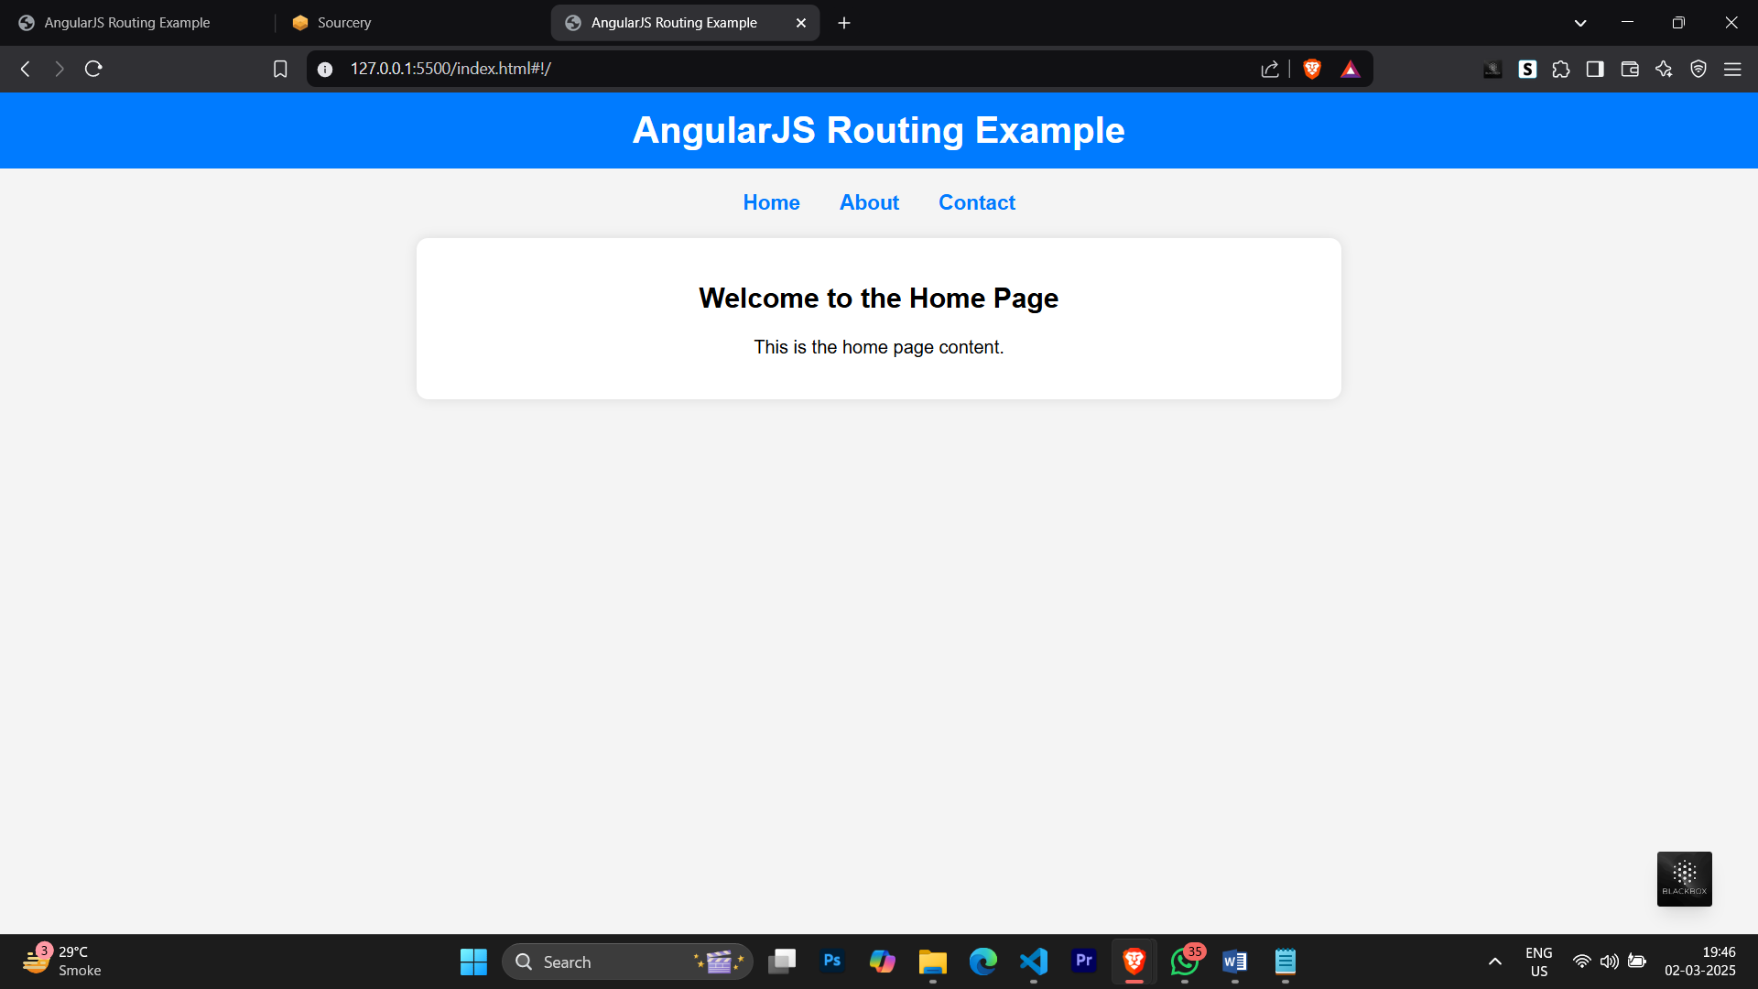**Output:**

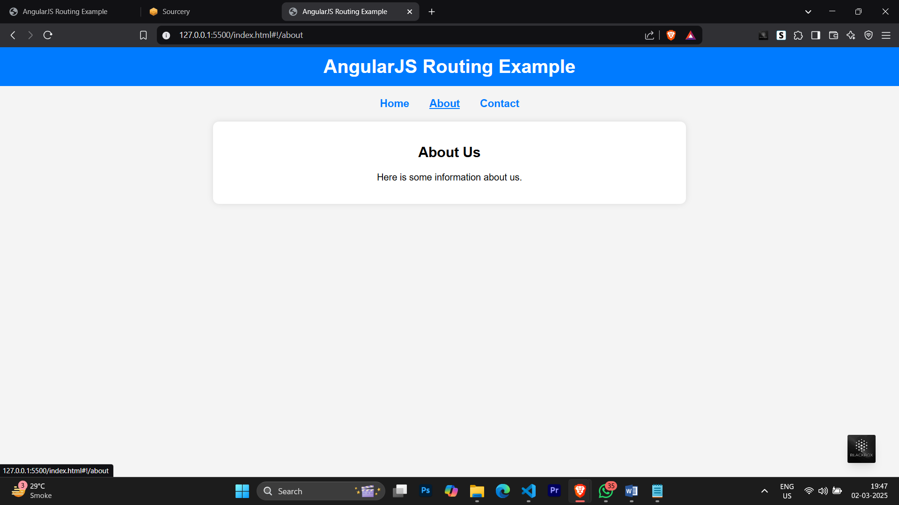

\

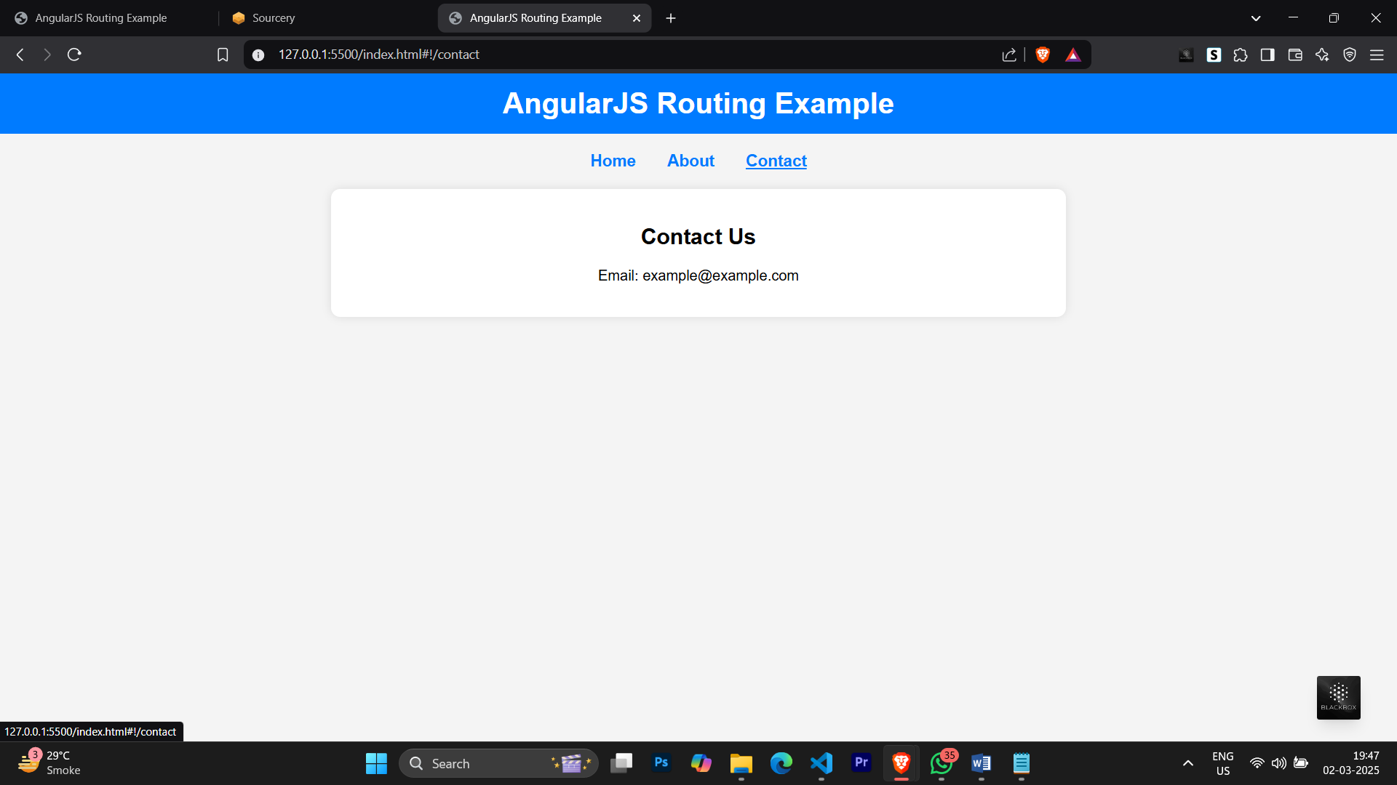

**Conclusion**: In this experiment, we explored AngularJS routing and how it helps create dynamic, single-page applications (SPAs). By implementing routing, we demonstrated how users can navigate between different views without reloading the page, improving performance and user experience. This experiment showcased the use of ngRoute for defining routes, linking different components, and displaying content dynamically.

**LO’s achieved:** LO3

**PO’s achieved:** PO1-PO5, PO8-P012