**PROJECT**

**By Rahul Kumar|Shiv Shankar|Satwik Bhakta**

**IIIT BHAGALPUR**

**Under the guidance of Mr.Kumar Ujjwal and REC club**

**-From : 14th June to 14th July 2023**

TRAFFIC CONTROL SYSTEM

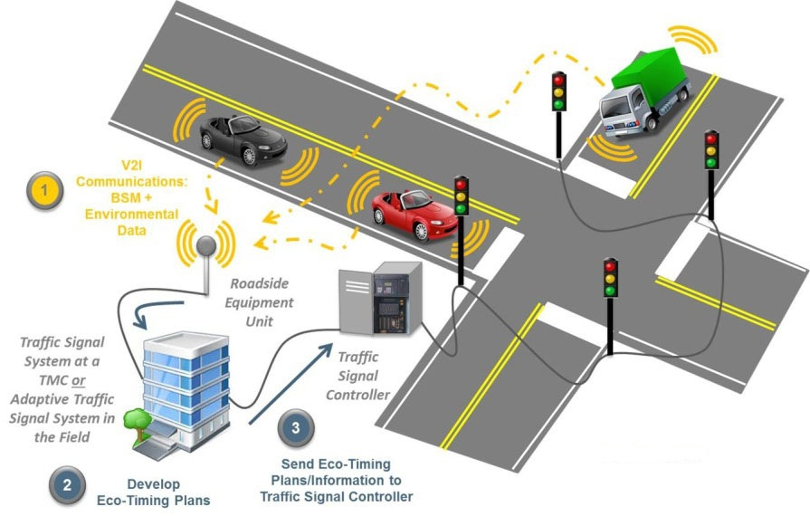

* What is a traffic control system?

**Road traffic control** involves directing vehicular and pedestrian traffic around a construction zone, accident or other road disruption, thus ensuring the safety of emergency response teams, [construction workers](https://en.wikipedia.org/wiki/Construction_worker) and the general public.

Traffic control also includes the use of [CCTV](https://en.wikipedia.org/wiki/Closed-circuit_television), ultrasonic sensors  and other means of monitoring traffic by local or state roadways authorities to manage traffic flows and providing advice concerning [traffic congestion](https://en.wikipedia.org/wiki/Traffic_congestion). **COMPONENTS USED:**

* **Ultrasonic sensors:**

**Ultrasonic transducers** and **ultrasonic sensors** are devices that generate or sense ultrasound energy. They can be divided into three broad categories: transmitters, receivers and transceivers. Transmitters convert [electrical signals](https://en.wikipedia.org/wiki/Signal_(electrical_engineering)) into [ultrasound](https://en.wikipedia.org/wiki/Ultrasound), receivers convert ultrasound into electrical signals, and transceivers can both transmit and receive ultrasound.[[1]](https://en.wikipedia.org/wiki/Ultrasonic_transducer#cite_note-:0-1)

* **Arduino mega:**

**Road traffic control** involves directing vehicular and pedestrian traffic around a construction zone, accident or other road disruption, thus ensuring the safety of emergency response teams, [construction workers](https://en.wikipedia.org/wiki/Construction_worker) and the general public.

Traffic control also includes the use of [CCTV](https://en.wikipedia.org/wiki/Closed-circuit_television) and other means of monitoring traffic by local or state roadways authorities to manage traffic flows and providing advice concerning [traffic congestion](https://en.wikipedia.org/wiki/Traffic_congestion).

Arduino mega used for handling more number of pins

* **RGB Leds:**

A **light-emitting diode** (**LED**) is a [semiconductor](https://en.wikipedia.org/wiki/Semiconductor) [device](https://en.wikipedia.org/wiki/Electronics) that [emits light](https://en.wikipedia.org/wiki/Light#Light_sources) when [current](https://en.wikipedia.org/wiki/Electric_current) flows through it. [Electrons](https://en.wikipedia.org/wiki/Electron) in the semiconductor recombine with [electron holes](https://en.wikipedia.org/wiki/Electron_hole), releasing energy in the form of [photons](https://en.wikipedia.org/wiki/Photon). The color of the light (corresponding to the energy of the photons) is determined by the energy required for electrons to cross the [band gap](https://en.wikipedia.org/wiki/Band_gap) of the semiconductor.

* **Breadboard**
  + - **WORKING OF TRAFFIC CONTROL SYSTEM**

The traffic control system is designed for four lane road system. It uses for ultrasonic sensors which finds the distance of pedestrian from the traffic light and changes the traffic accordingly with help of input from the sensor given by the code provided ,ensuring that there is no clash between vehicles. It ensures priority between pedestrian and traffic accordingly in different situation.

* **Traffic Signal Controller**

**PROBLEM SATEMENT:** A system that detects pedestrians and manipulates the traffic signal accordingly for smooth and safe traffic flow.

– **Tools & technologies used**: Ultrasonic sensors, Servo motor, Arduino Mega, Arduino IDE, RGB Leds

* The project involved analysis of different combinations possible during movement of vehicle in a four way roads. We checked each of the combinations and ensured a smooth traffic ensuring the movement of pedestrians, keeping in mind that which one should be prioritize first ensuring mishaps avoidance (We learned that a lot of combinations are possible in such a simple looking real-life scenario and hence it was challenging to ensure both safety to pedestrian and fellow people driving
  + - * 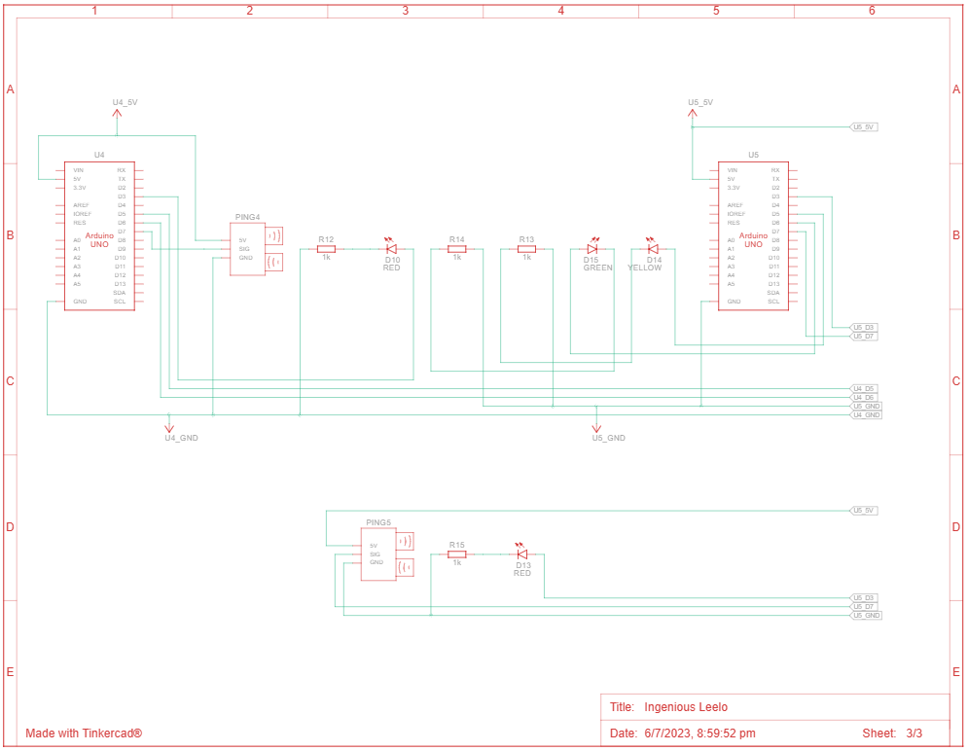**CIRCUIT DIAGRAM**

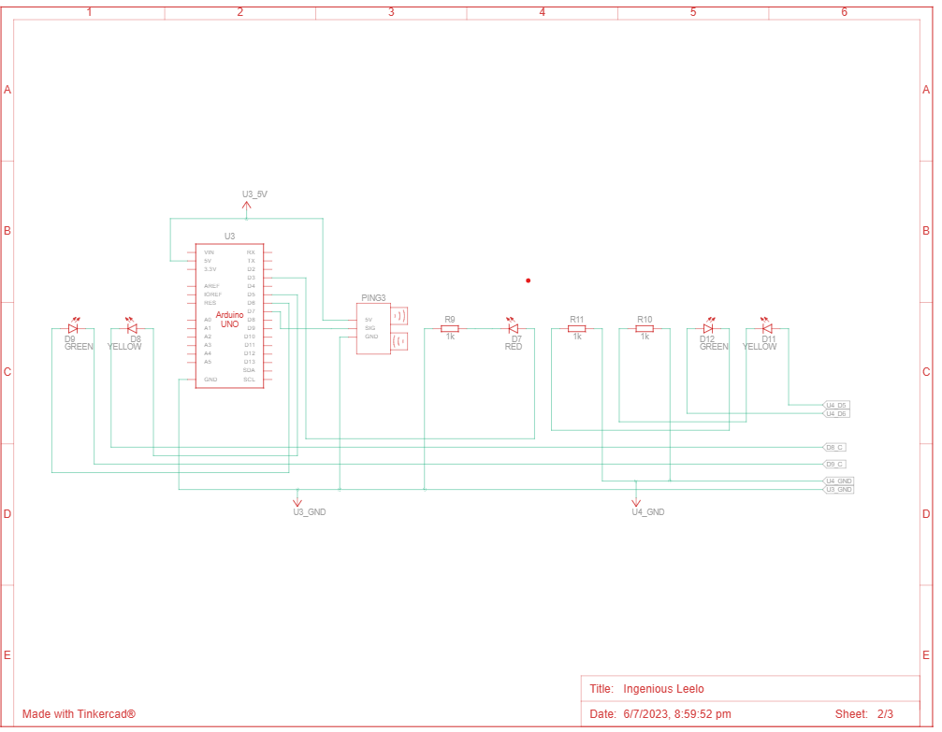

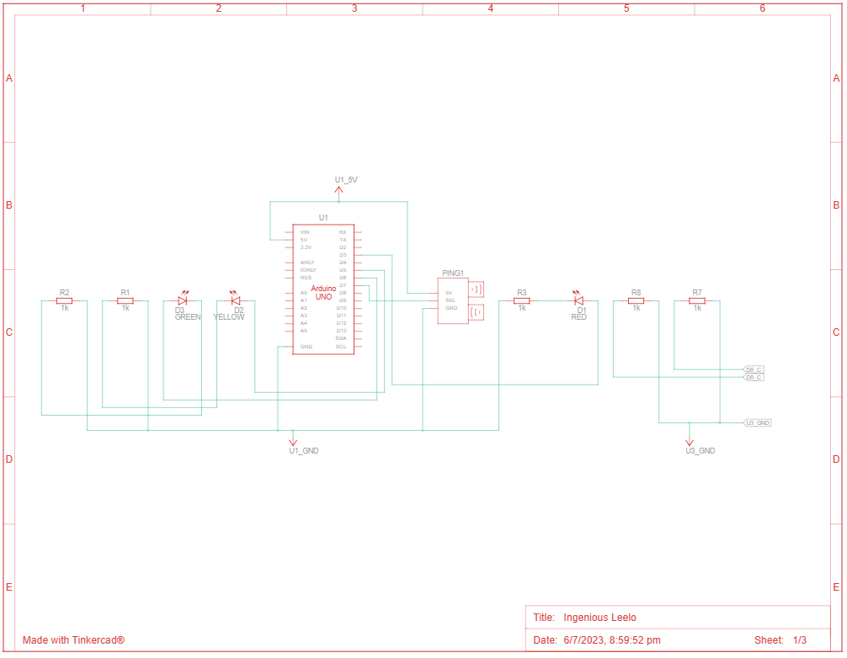

* **FUTURE ENCHANCEMENT**

This project can we further improved if we use some advanced sensors like (LIDAR sensor for real time basis and accuracy) or use of google maps API for traffic density detection, use of ICs for frequency setting for the fluctuations of light signals and thereby, looking for any possible failures i.e. involving a error check or feedback path for safety or by building a delay logic as used in my project . We can further use AI and ML or reinforcement learning models for smooth traffic or designing a system for specialized road (for example, such routes which are mainly use for commercial purpose or involves heading towards such roadways can be set to work accordingly from the control center).

* ***LINKS***
* <https://www.tinkercad.com/things/5hBu3TV0ZPS-ingenious-leelo/editel?sharecode=1sfsLds5MyPKpd0PBrmxLXJpCS1dG1OeNqn_4jiY2xo>

Our team would like to thank our REC club and mentors for giving us an insightful project.