
{{report_type_label}}
{{market_name}} Market
{{report_subtitle}}
Market Outlook
{{outlook_period}} Market Outlook
Methanol
CH3OH
{{market_name_title}}
Technologies
Supplier Landscape
{{company_name}}
Table of content
Chapter 1. Executive Summary 14
1.1. Introduction of {{market_name_upper}} Market 15
1.1.1. Global {{market_name_upper}} Market, {{base_year}} & {{forecast_end_year}} 15
1.2. Global {{market_name_upper}} Market, {{history_start_year}} – {{forecast_end_year}} (USD MILLION) 16
Chapter 2. Market Introduction – {{market_name_upper}} Market 17
2.1. Market Definition 17
2.2. Scope of the Study 18
2.3. Research Methodology 19
2.4. Key Assumptions 23
Chapter 3. Market Dynamics- {{market_name_upper}} Market 24
3.1. Market Drivers 25
3.2. Market Restraints 26
3.3. Market Opportunities 27
3.4. Market Challenges 28
3.5. Technological Advancements & Innovations 29
Chapter 4. Industry Outlook- {{market_name_upper}} Market 30
4.1. Value Chain Analysis 30
4.2. Regulatory Landscape 32
4.3. ESG (Environmental, Social, Governance) Impact 33
4.4. PESTLE Analysis 34
4.5. Porter’s Five Forces Analysis 35
4.6. Emerging Business Models & Ecosystem Partnerships 36
4.7. Market Attractiveness 37
4.8. Equipment (Supplier Landscape Focus) 38
4.9. Cost Breakdown of E-methanol and bio-methanol 39
4.10. Production Technologies analysis 40
4.11. Competitive Landscape & White Space 40
4.11.1. White space for independent players 40
Chapter 5. {{market_name_upper}} Market – Type Analysis 41
5.1. Global {{market_name_upper}} Market –Type OVERVIEW 41
5.2. Global {{market_name_upper}} Market Share, by Type, 2024 & 2035 (%) 42
5.3. Bio-methanol 44
5.3.1. Global {{market_name_upper}} Market by Bio-methanol, 2020 – 2035 (usd million) 44
5.4. E-methanol (Bio-methanol) 45
5.5. Bio-methanol + Green Hydrogen (Hybrid) 45
Chapter 6. {{market_name_upper}} Market – Technology Analysis 46
6.1. Global {{market_name_upper}} Market – Overview 46
6.2. Global {{market_name_upper}} Market Share, by Technology, 2024 & 2035 (%) 47
6.3. Biomass Gasification 49
6.3.1. Global {{market_name_upper}} Market for Biomass Gasification, 2020 – 2035 (USD MILLION) 49
6.4. Fermentation 50
6.5. Electrochemical Reduction (e-methanol) 50
Chapter 7. {{market_name_upper}} Market –Application Analysis 51
7.1. Global {{market_name_upper}} Market –Application Overview 51
7.2. Global {{market_name_upper}} Market Share, by Application, 2024 & 2035 (%) 52
7.3. Marine Fuel 54
7.3.1. Global {{market_name_upper}} Market by Marine Fuel, 2020 - 2035 (USD MILLION) 54
7.4. Power Generation 55
7.5. Automotive Fuel 55
Chapter 8. {{market_name_upper}} Market – Regional Analysis 56
8.1. Global {{market_name_upper}} Market Regional Overview 56
8.2. Global {{market_name_upper}} Market Share, by Region, 2024 & 2035 (%) 57
8.3. North America 59
8.3.1. North America {{market_name_upper}} Market, 2020 - 2035 (USD MILLION) 59
8.3.2. North America {{market_name_upper}} Market, by Country, 2020 – 2035 (USD MILLION) 60
8.3.3. North America {{market_name_upper}} Market, by Type, 2020 – 2035 (USD MILLION) 60
8.3.4. North America {{market_name_upper}} Market, by Technology, 2020 – 2035 (USD MILLION) 61
8.3.5. North America {{market_name_upper}} Market, by Application, 2020 – 2035 (USD MILLION) 62
8.3.6. U.S. 63
8.3.6.1.1. U.S. {{market_name_upper}} Market, by Type, 2020 – 2035 (USD MILLION) 64
8.3.6.2. U.S. {{market_name_upper}} Market, by TECHNOLOGY, 2020 – 2035 (USD MILLION) 64
8.3.6.3. U.S. {{market_name_upper}} Market, by Application, 2020 – 2035 (USD MILLION) 65
8.3.7. Canada 66
8.3.7.1.1. CANADA {{market_name_upper}} Market, by Type, 2020 – 2035 (USD MILLION) 67
8.3.7.1.2. CANADA {{market_name_upper}} Market, by TECHNOLOGY, 2020 – 2035 (USD MILLION) 67
8.3.7.1.3. CANADA {{market_name_upper}} Market, by Application, 2020 – 2035 (USD MILLION) 68
8.3.8. Mexico 69
8.3.8.1.1. MEXICO {{market_name_upper}} Market, by Type, 2020 – 2035 (USD MILLION) 70
8.3.8.1.2. MEXICO {{market_name_upper}} Market, by TECHNOLOGY, 2020 – 2035 (USD MILLION) 70
8.3.8.1.3. MEXICO {{market_name_upper}} Market, by Application, 2020 – 2035 (USD MILLION) 71
8.4. Europe 72
8.5. Asia-Pacific 72
8.6. Latin America 72
8.7. Middle East & Africa 72
Chapter 9. {{market_name_upper}} Market – Competitive Landscape 73
9.1. Market Share Analysis (2024) 73
9.2. Strategic Developments 74
9.2.1. Acquisitions and Mergers 74
9.2.2. Product Launches 75
9.2.3. Research & Development Activities 75
Chapter 10. Company Profiles 76
10.1. BASF 76
10.1.1. Company Overview 76
10.1.2. Product Portfolio 77
10.1.3. BASF Sales/Revenue, Net Income, and Gross Margin 78
10.1.4. BASF Revenue (2023-2025) 79
10.1.5. BASF Segmental Revenue (%) (2024) 80
10.1.6. BASF Regional Revenue (%) (2025) 81
10.2. OCI N.V. 82
10.3. Methanex Corporation 82
10.4. Carbon Recycling International 82
10.5. Enerkem 82
10.6. Södra 82
10.7. Siemens Energy 82
10.8. Proman 82
10.9. Liquid Wind 82
10.10. Vertimass 82
Chapter 11. Future Outlook & Forecast- {{market_name_upper}} Market 83
11.1. Introduction and Taxonomy 83
11.2. Demand Forecast 85
11.3. Investment Opportunity 86
11.4. Market Disruptions & Scenario Analysis 87
Chapter 12. Strategic Recommendations – {{market_name_upper}} Market 88
12.1. Introduction and Taxonomy 88
12.2. For Manufacturers 89
12.3. For Investors 90
12.4. For Policy Makers 91
Chapter 13. Appendix 92
13.1. Data Sources 92
13.2. Glossary of Terms 93
13.3. Research Assumptions 94

List of tables
TABLE 1 Global {{market_name_upper}} Market, {{base_year}} & {{forecast_end_year}} 15
TABLE 2 Global {{market_name_upper}} Market, by Type, 2020 - 2035 (USD MILLION) 43
TABLE 3 Global {{market_name_upper}} Market by Bio-methanol, by Region, 2020 - 2035 45
TABLE 4 Global {{market_name_upper}} Market, by Technology, 2020 - 2035 (USD MILLION) 48
TABLE 5 Global {{market_name_upper}} Market for Biomass Gasification, by Region, 2020 - 2035 (USD MILLION) 50
TABLE 6 Global {{market_name_upper}} Market, by Application, 2020 – 2035 (USD MILLION) 53
TABLE 7 Global {{market_name_upper}} Market by Marine Fuel, by Region, 2020 – 2035 (USD MILLION) 55
TABLE 8 Global {{market_name_upper}} Market, by Region, 2020 – 2035 (USD MILLION) 58
TABLE 9 North America {{market_name_upper}} Market, by Country, 2020 – 2035 (USD MILLION) 60
TABLE 10 North America {{market_name_upper}} Market, by Type, 2020 – 2035 (USD MILLION) 60
TABLE 11 North America {{market_name_upper}} Market, by Technology, 2020 – 2035 (USD MILLION) 61
TABLE 12 North America {{market_name_upper}} Market, by Application, 2020 – 2035 (USD MILLION) 62
TABLE 13 U.S. {{market_name_upper}} Market, by Type, 2020 – 2035 (USD MILLION) 64
TABLE 14 U.S. {{market_name_upper}} Market, by TECHNOLOGY, 2020 – 2035 (USD MILLION) 64
TABLE 15 U.S. {{market_name_upper}} Market, by Application, 2020 – 2035 (USD MILLION) 65
TABLE 16 CANADA {{market_name_upper}} Market, by Type, 2020 – 2035 (USD MILLION) 67
TABLE 17 CANADA {{market_name_upper}} Market, by TECHNOLOGY, 2020 – 2035 (USD MILLION) 67
TABLE 18 CANADA {{market_name_upper}} Market, by Application, 2020 – 2035 (USD MILLION) 68
TABLE 19 MEXICO {{market_name_upper}} Market, by Type, 2020 – 2035 (USD MILLION) 70
TABLE 20 MEXICO {{market_name_upper}} Market, by TECHNOLOGY, 2020 – 2035 (USD MILLION) 70
TABLE 21 MEXICO {{market_name_upper}} Market, by Application, 2020 – 2035 (USD MILLION) 71
TABLE 22 Acquisitions and Mergers 74
TABLE 23 Company snapshot 77

List of Figures
Figure 01 Global {{market_name_upper}} Market, {{history_start_year}} – {{forecast_end_year}} (USD MILLION) 16
Figure 02 Market Dynamics 24
Figure 03 Technological Advancements & Innovations 29
Figure 04 Value Chain Analysis 30
Figure 05 Global {{market_name_upper}} Market Share, by Type, 2024 & 2035 (%) 42
Figure 06 Global {{market_name_upper}} Market by Bio-methanol, 2020 - 2035 44
Figure 07 Global {{market_name_upper}} Market Share, by Technology, 2024 & 2035 47
Figure 08 Global {{market_name_upper}} Market for Biomass Gasification, 2020 - 2035 (USD MILLION) 49
Figure 09 Global {{market_name_upper}} Market Share, by Application, 2024 & 2035 (%) 52
Figure 10 Global {{market_name_upper}} Market by Marine Fuel, 2020 – 2035 (USD MILLION) 54
Figure 11 Global {{market_name_upper}} Market Share, by Region, 2024 & 2035 (%) 57
Figure 12 North America {{market_name_upper}} Market, 2020 - 2035 (USD MILLION) 59
Figure 13 U.S. {{market_name_upper}} Market, {{history_start_year}} – {{forecast_end_year}} (USD MILLION) 63
Figure 14 Canada {{market_name_upper}} Market, {{history_start_year}} – {{forecast_end_year}} (USD MILLION) 66
Figure 15 Mexico {{market_name_upper}} Market, {{history_start_year}} – {{forecast_end_year}} (USD MILLION) 69
Figure 16 Market Share Analysis (2024) 73
Figure 17 BASF REVENUE (2023-2025) 79
Figure 18 BASF SEGMENTAL Revenue (%) (2024) 80
Figure 19 BASF Regional Revenue (%) (2025) 81

- Executive Summary
{{market_product_name}} {{executive_summary_intro}}
{{applications_heading}}
- {{app_1_name}}: {{app_1_description}}
- {{app_2_name}}: {{app_2_description}}
- {{app_3_name}}: Serves as a liquid carrier for hydrogen, making it easier to transport and store renewable energy over long distances.
- Transportation: Utilized in high-performance automotive engines and as a precursor for sustainable aviation fuel (SAF).

  - Introduction of {{market_name_upper}} Market
    - Global {{market_name_upper}} Market, {{base_year}} & {{forecast_end_year}}
- Global {{market_name_upper}} Market, {{base_year}} & {{forecast_end_year}}
Parameter | 2024 | 2035
{{overview_table_param_1}} | XX | XX
CAGR % ({{forecast_start_year}}-{{forecast_end_year}}) | XX%
{{overview_table_param_3}} | XX Segment: XX | XX Segment: XX
{{overview_table_param_4}} | XX Segment: XX | XX Segment: XX
Largest Market Segment, by Application (USD Million) | XX Segment: XX | XX Segment: XX
Key Growth Market Segment, by Region CAGR % (2025-2035) | XX Segment – XX%
Source: Primary Interviews, Surveys, Secondary Sources, Web-Based & Paid External Databases, 2025

  - Global {{market_name_upper}} Market, 2020 – 2035 (USD MILLION)
- Global {{market_name_upper}} Market, 2020 – 2035 (USD MILLION)
Source: Primary Interviews, Surveys, Secondary Sources, Web-Based & Paid External Databases, 2025

- Market Introduction – {{market_name_upper}} Market
  - Market Definition
{{market_definition}}

  - Scope of the Study
{{scope_intro_text}}
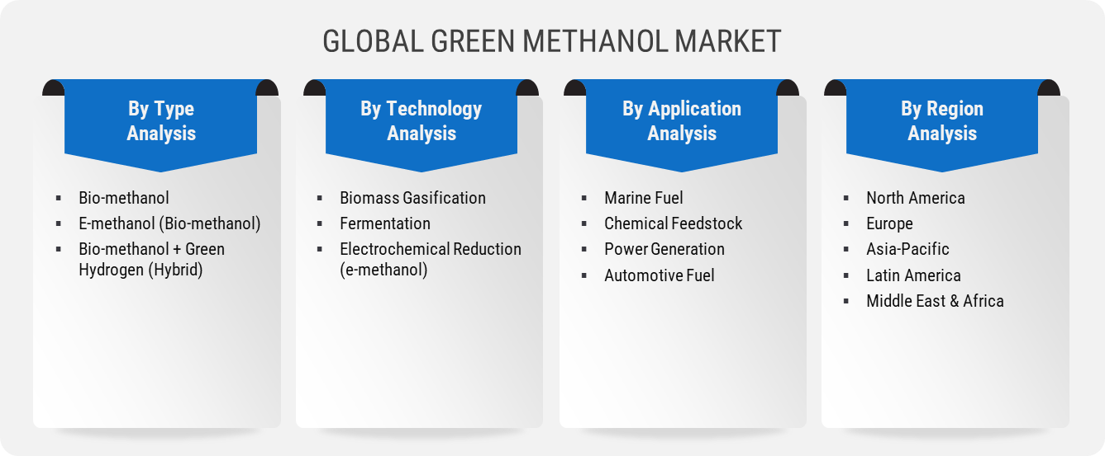
Source: {{data_source_year}}

  - Research Methodology
Source: {{data_source_year}}
We adopts a thorough and iterative research methodology designed to minimize deviations and deliver the most precise estimates and forecasts. The company applies both bottom-up and top-down approaches to segment the market and quantify key metrics accurately. A consistent feature across all our research reports is data triangulation, which examines the market from three distinct perspectives to enhance reliability. Core Industry of our research methodology include:

Preliminary Data Mining
The research process starts with the broad collection of raw market data sourced from validated and credible channels. This data undergoes continuous filtration to ensure only verified and relevant information is retained. In addition to leveraging proprietary databases and internal report archives, data is sourced from trusted, subscription-based Types.
To develop a holistic view of the market, the entire value chain is analyzed—gathering insights from TECHNOLOGYs suppliers, intermediaries, distributors, and Industry. Technical developments and industry challenges are captured through targeted surveys, expert conferences, and respected trade journals. Intellectual property research, including white space and freedom-to-operate analysis, adds depth to the Trial Phase evaluation. Key market drivers, restraints, pricing trends, and competitive dynamics are also compiled and validated against published data to ensure consistency and accuracy.

Statistical Model
Forecasts and market estimates are developed using tailored simulation models crafted for each specific study. Key inputs—including market drivers, pricing trends, product, and the evolving technological landscape—are analyzed concurrently using statistical methods such as regression analysis, time series forecasting, and correlation modeling.
Short-term forecasts rely heavily on econometric models, while long-term projections incorporate factors such as technological developments, regulatory shifts, macroeconomic trends, and strategic business insights. A bottom-up estimation approach is applied, starting at the regional level and aggregating to form global estimates, ensuring both accuracy and a comprehensive understanding of market dynamics:
Key parameters considered for forecasting include:
- Key market drivers and restraints are identified, along with an assessment of their projected impact over time.
- Trends in TECHNOLOGY availability and pricing are closely monitored to understand their influence on the market.
- The regulatory landscape is evaluated, including current frameworks and expected policy shifts.
- Existing capacity is analyzed, with forecasts extending to planned expansions through 2033.
A weighted average analysis is applied to assign appropriate significance to each factor, ensuring a balanced and comprehensive projection of market growth.
Primary Validation
Primary validation marks the final phase of our market estimation and forecasting process. At this stage, in-depth interviews are conducted—both in person and via phone—with key stakeholders to verify the accuracy of collected data and the assumptions driving our analysis.
Interviewees are carefully selected from leading organizations across the industry value chain, including product suppliers, Application developers, domain experts, and others. This diverse representation ensures a balanced and objective view of the market.
To ensure comprehensive global coverage, interviews are conducted across multiple regions, with language differences managed through local staff or professional interpreters. These conversations not only validate our findings but also provide valuable insights into current trends, evolving business conditions, and future developments, significantly enriching the quality of our analysis.
All projections are rigorously validated through direct engagement with Key Industry Participants (KIPs), typically comprising:
- Major industry players
- Product suppliers
- Distributors and logistics providers
- Product and Application buyers
The Key Objectives of Primary Research are as Follows:
- Verify the accuracy, credibility, and relevance of the gathered data
- Gain a clear understanding of current market dynamics and collect expert insights on anticipated future trends

  - Key Assumptions

- Market Dynamics- {{market_name_upper}} Market
- Market Dynamics
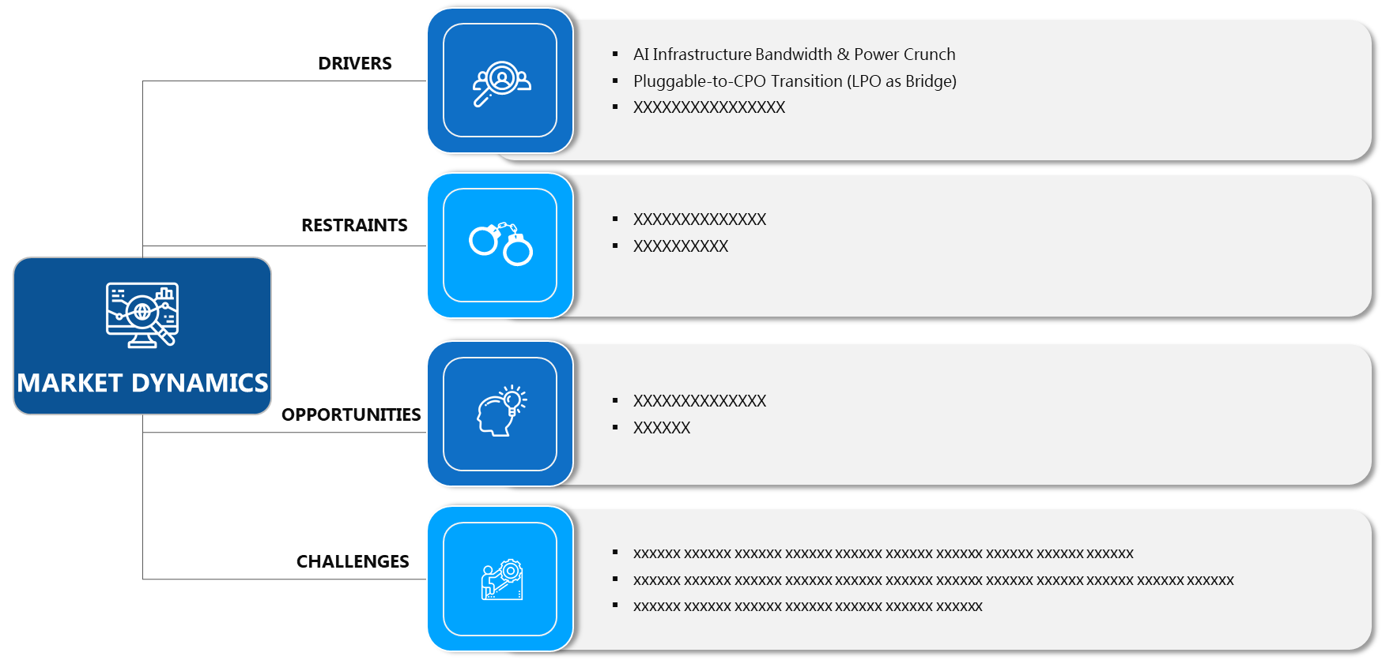
Source: {{data_source_year}}
  - Market Drivers
{{driver_1_title}}
{{driver_1_body_paragraph_1}}
For instance, major shipping lines have committed billions to fleet renewal programs. This "vessel-led" demand creates a predictable offtake market for fuel producers, encouraging them to invest in large-scale production facilities. Furthermore, regional regulations such as the EU Emissions Trading System (ETS) and FuelEU Maritime have introduced financial penalties for high-carbon fuels in European waters. This makes the "green premium" of methanol more palatable for operators, as the cost of carbon credits begins to outweigh the extra cost of the fuel. The infrastructure transition is also relatively straightforward; existing bunker barges and storage tanks can be retrofitted for methanol with far less capital than is required for liquefied natural gas (LNG). This combination of regulatory pressure, corporate sustainability goals, and technical feasibility makes maritime decarbonization the primary catalyst for market expansion.

{{driver_2_title}}
{{driver_2_body_paragraph_1}}
{{driver_2_body_paragraph_2}}

  - Market Restraints
{{restraint_1_title}}
{{restraint_1_body_paragraph_1}}
{{restraint_1_body_paragraph_2}}
  - Market Opportunities



  - Market Challenges

  - Technological Advancements & Innovations
- Technological Advancements & Innovations
Source: {{data_source_year}}
- Industry Outlook- {{market_name_upper}} Market
  - Value Chain Analysis
- Value Chain Analysis
Source: {{data_source_year}}
Value Chain Analysis is a strategic framework used to examine the internal activities of a business or industry to understand how value is created and where competitive advantage can be gained. The objective is to analyze each step involved in the marketing, and delivery of a device or service, from initial sourcing to after-sales support, in order to identify opportunities for cost reduction, process improvement, or value enhancement.
The value chain is typically divided into two categories: primary activities and support activities. Primary activities are directly involved in the creation and delivery of a product or service. These include inbound logistics, which encompasses the receiving and storage; operations, which refers to the transformation of inputs into final product; outbound logistics, which involves the distribution of finished goods; marketing and sales, which focus on customer engagement and revenue generation; and service, which includes post-sale support such as maintenance and customer care.
Support activities, on the other hand, provide the necessary infrastructure and inputs that allow the primary activities to function efficiently. These include firm here infrastructure such as finance, planning, and legal; human resource management, which ensures the recruitment and development of skilled personnel; product development, which drives innovation and process improvement; and procurement, which involves acquiring the resources and inputs required for device.
Conducting a value chain analysis enables organizations to identify specific activities where value is added or lost. This insight supports strategic decisions such as outsourcing non-core functions, investing in product to streamline operations, or reengineering processes to better meet customer needs. Furthermore, by benchmarking against competitors, firms can assess where they hold cost or differentiation advantages within the value chain.
Ultimately, value chain analysis is a powerful tool for uncovering internal strengths and weaknesses, aligning operations with strategic goals, and enhancing overall organizational performance. It plays a crucial role in shaping competitive strategy by focusing on activities that contribute most to customer value and business success.

  - Regulatory Landscape

Source: {{data_source_year}}

  - ESG (Environmental, Social, Governance) Impact
Source: {{data_source_year}}

  - PESTLE Analysis
Source: 2025

  - Porter’s Five Forces Analysis
Source: {{data_source_year}}
  - Emerging Business Models & Ecosystem Partnerships

  - Market Attractiveness
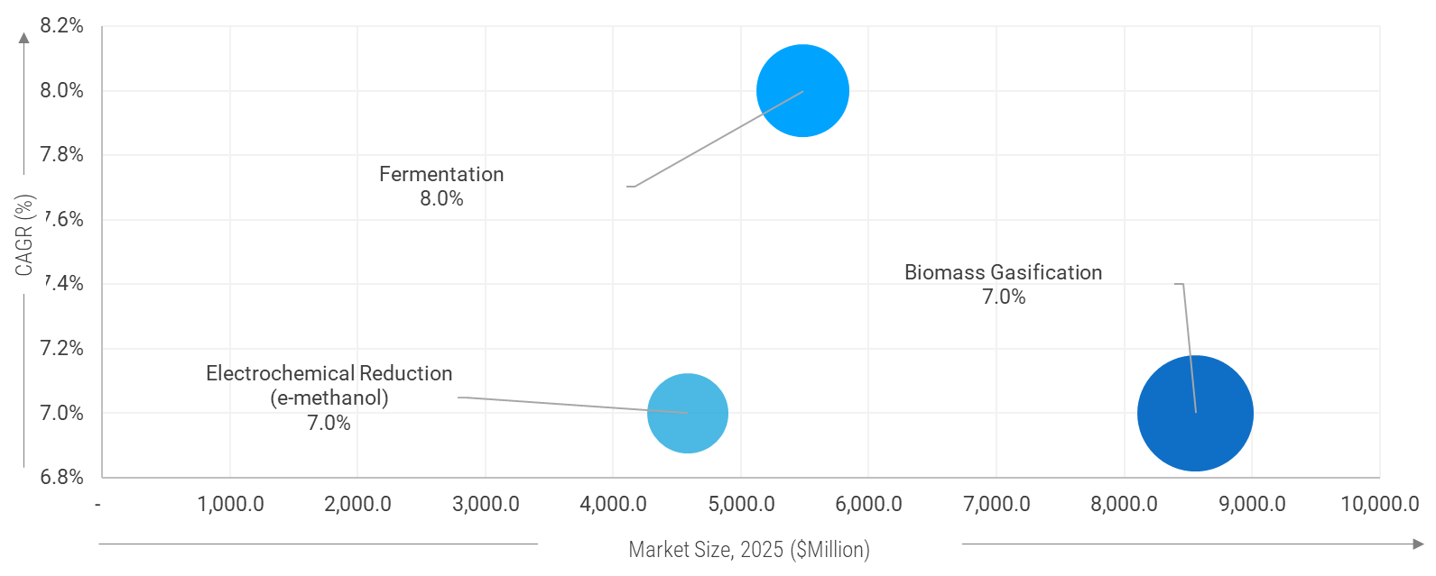
Source: {{data_source_year}}
Note: The Above figures are for illustrative purposes and similar attractiveness will be covered for rest of segmentation.

  - Equipment (Supplier Landscape Focus)

  - Cost Breakdown of E-methanol and bio-methanol

  - Production Technologies analysis
  - Competitive Landscape & White Space
    - White space for independent players

- {{market_name_upper}} Market – Type Analysis
  - Global {{market_name_upper}} Market –Type OVERVIEW

  - Global {{market_name_upper}} Market Share, by Type, 2024 & 2035 (%)
- Global {{market_name_upper}} Market Share, by Type, 2024 & 2035 (%)
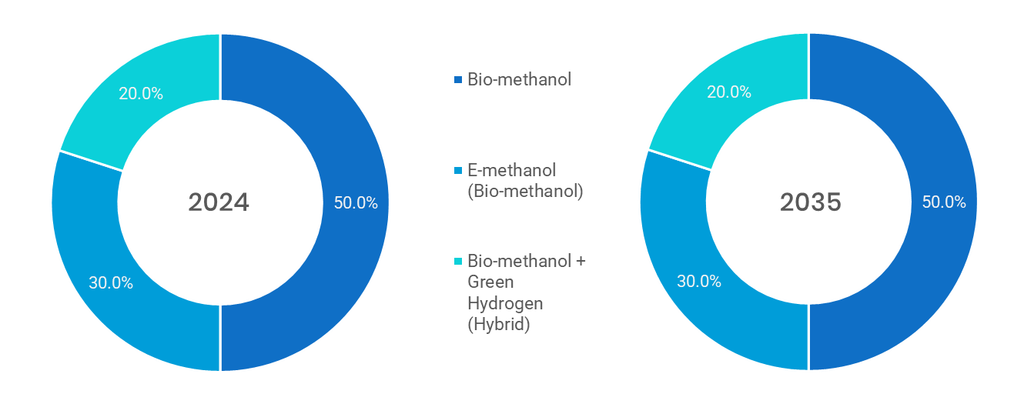
Source: Primary Interviews, Surveys, Secondary Sources, Web-Based & Paid External Databases, 2025
Note: Charts & Figures only for Illustration purposes
- Global {{market_name_upper}} Market, by Type, 2020 - 2035 (USD MILLION)
By Type | 2020 | 2021 | 2022 | 2023 | 2024 | 2025 | 2026 | 2027 | 2028 | 2029 | 2030 | 2031 | 2032 | 2033 | 2034 | 20235 | CAGR%  (2025-2035)
Bio-methanol | XX | XX | XX | XX | XX | XX | XX | XX | XX | XX | XX | XX | XX | XX | XX | XX | XX
E-methanol (Bio-methanol) | XX | XX | XX | XX | XX | XX | XX | XX | XX | XX | XX | XX | XX | XX | XX | XX | XX
Bio-methanol + Green Hydrogen (Hybrid) | XX | XX | XX | XX | XX | XX | XX | XX | XX | XX | XX | XX | XX | XX | XX | XX | XX
Total | XX | XX | XX | XX | XX | XX | XX | XX | XX | XX | XX | XX | XX | XX | XX | XX | XX
Source: Primary Interviews, Surveys, Secondary Sources, Web-Based & Paid External Databases, 2025

  - Bio-methanol
    - Global {{market_name_upper}} Market by Bio-methanol, 2020 – 2035 (usd million)
- Global {{market_name_upper}} Market by Bio-methanol, 2020 - 2035
Source: Primary Interviews, Surveys, Secondary Sources, Web-Based & Paid External Databases, 2025

- Global {{market_name_upper}} Market by Bio-methanol, by Region, 2020 - 2035
By Region | 2020 | 2021 | 2022 | 2023 | 2024 | 2025 | 2026 | 2027 | 2028 | 2029 | 2030 | 2031 | 2032 | 2033 | 2034 | 2035 | CAGR%  (2025-2035)
North America | XX | XX | XX | XX | XX | XX | XX | XX | XX | XX | XX | XX | XX | XX | XX | XX | XX
Europe | XX | XX | XX | XX | XX | XX | XX | XX | XX | XX | XX | XX | XX | XX | XX | XX | XX
Asia-Pacific | XX | XX | XX | XX | XX | XX | XX | XX | XX | XX | XX | XX | XX | XX | XX | XX | XX
Latin America | XX | XX | XX | XX | XX | XX | XX | XX | XX | XX | XX | XX | XX | XX | XX | XX | XX
Middle East & Africa | XX | XX | XX | XX | XX | XX | XX | XX | XX | XX | XX | XX | XX | XX | XX | XX | XX
Total | XX | XX | XX | XX | XX | XX | XX | XX | XX | XX | XX | XX | XX | XX | XX | XX | XX
Source: Primary Interviews, Surveys, Secondary Sources, Web-Based & Paid External Databases, 2025

*The above similar information will be cover for below segment as well.
  - E-methanol (Bio-methanol)
  - Bio-methanol + Green Hydrogen (Hybrid)
- {{market_name_upper}} Market – Technology Analysis
  - Global {{market_name_upper}} Market – Overview

  - Global {{market_name_upper}} Market Share, by Technology, 2024 & 2035 (%)
- Global {{market_name_upper}} Market Share, by Technology, 2024 & 2035
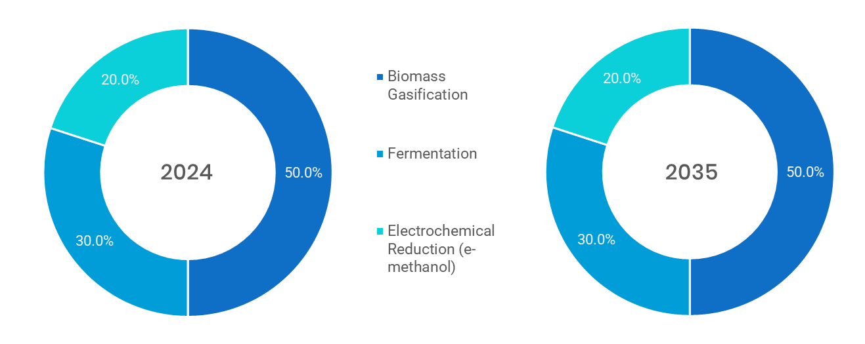
Source: Primary Interviews, Surveys, Secondary Sources, Web-Based & Paid External Databases, 2025
Note: Charts & Figures are only for Illustration purposes

- Global {{market_name_upper}} Market, by Technology, 2020 - 2035 (USD MILLION)
By TECHNOLOGY | 2020 | 2021 | 2022 | 2023 | 2024 | 2025 | 2026 | 2027 | 2028 | 2029 | 2030 | 2031 | 2032 | 2033 | 2034 | 2035 | CAGR%  (2025-2035)
Biomass Gasification | XX | XX | XX | XX | XX | XX | XX | XX | XX | XX | XX | XX | XX | XX | XX | XX | XX
Fermentation | XX | XX | XX | XX | XX | XX | XX | XX | XX | XX | XX | XX | XX | XX | XX | XX | XX
Electrochemical Reduction (e-methanol) | XX | XX | XX | XX | XX | XX | XX | XX | XX | XX | XX | XX | XX | XX | XX | XX | XX
Total | XX | XX | XX | XX | XX | XX | XX | XX | XX | XX | XX | XX | XX | XX | XX | XX | XX
Source: Primary Interviews, Surveys, Secondary Sources, Web-Based & Paid External Databases, 2025

  - Biomass Gasification
    - Global {{market_name_upper}} Market for Biomass Gasification, 2020 – 2035 (USD MILLION)
- Global {{market_name_upper}} Market for Biomass Gasification, 2020 - 2035 (USD MILLION)
Source: Primary Interviews, Surveys, Secondary Sources, Web-Based & Paid External Databases, 2025

- Global {{market_name_upper}} Market for Biomass Gasification, by Region, 2020 - 2035 (USD MILLION)
By Region | 2020 | 2021 | 2022 | 2023 | 2024 | 2025 | 2026 | 2027 | 2028 | 2029 | 2030 | 2031 | 2032 | 2033 | 2034 | 2035 | CAGR%  (2025-2035)
North America | XX | XX | XX | XX | XX | XX | XX | XX | XX | XX | XX | XX | XX | XX | XX | XX | XX
Europe | XX | XX | XX | XX | XX | XX | XX | XX | XX | XX | XX | XX | XX | XX | XX | XX | XX
Asia-Pacific | XX | XX | XX | XX | XX | XX | XX | XX | XX | XX | XX | XX | XX | XX | XX | XX | XX
Latin America | XX | XX | XX | XX | XX | XX | XX | XX | XX | XX | XX | XX | XX | XX | XX | XX | XX
Middle East & Africa | XX | XX | XX | XX | XX | XX | XX | XX | XX | XX | XX | XX | XX | XX | XX | XX | XX
Total | XX | XX | XX | XX | XX | XX | XX | XX | XX | XX | XX | XX | XX | XX | XX | XX | XX
Source: Primary Interviews, Surveys, Secondary Sources, Web-Based & Paid External Databases, 2025

*The above similar information will be cover for below segment.
  - Fermentation
  - Electrochemical Reduction (e-methanol)
- {{market_name_upper}} Market –Application Analysis
  - Global {{market_name_upper}} Market –Application Overview

  - Global {{market_name_upper}} Market Share, by Application, 2024 & 2035 (%)
- Global {{market_name_upper}} Market Share, by Application, 2024 & 2035 (%)
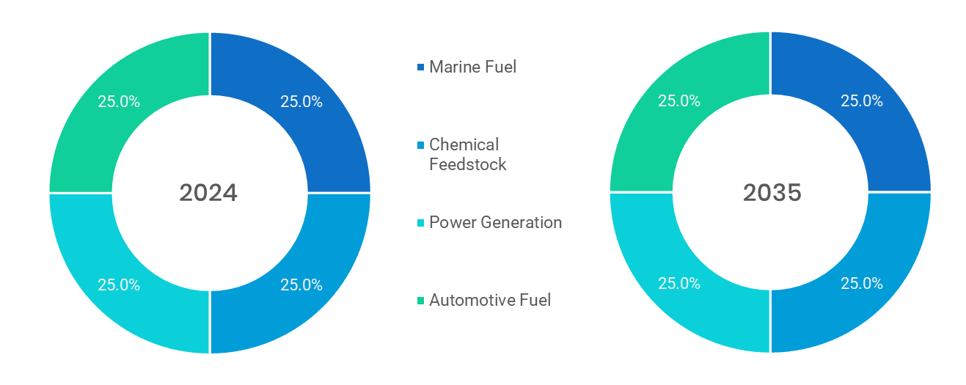
Source: Primary Interviews, Surveys, Secondary Sources, Web-Based & Paid External Databases, 2025
Note: Charts & Figures only for Illustration purposes
- Global {{market_name_upper}} Market, by Application, 2020 – 2035 (USD MILLION)
By Application | 2020 | 2021 | 2022 | 2023 | 2024 | 2025 | 2026 | 2027 | 2028 | 2029 | 2030 | 2031 | 2032 | 2033 | 2034 | 2035 | CAGR%  (2025-2035)
Marine Fuel | XX | XX | XX | XX | XX | XX | XX | XX | XX | XX | XX | XX | XX | XX | XX | XX | XX
Chemical Feedstock | XX | XX | XX | XX | XX | XX | XX | XX | XX | XX | XX | XX | XX | XX | XX | XX | XX
Power Generation | XX | XX | XX | XX | XX | XX | XX | XX | XX | XX | XX | XX | XX | XX | XX | XX | XX
Automotive Fuel | XX | XX | XX | XX | XX | XX | XX | XX | XX | XX | XX | XX | XX | XX | XX | XX | XX
Total | XX | XX | XX | XX | XX | XX | XX | XX | XX | XX | XX | XX | XX | XX | XX | XX | XX
Source: Primary Interviews, Surveys, Secondary Sources, Web-Based & Paid External Databases, 2025

  - Marine Fuel
    - Global {{market_name_upper}} Market by Marine Fuel, 2020 - 2035 (USD MILLION)
- Global {{market_name_upper}} Market by Marine Fuel, 2020 – 2035 (USD MILLION)
Source: Primary Interviews, Surveys, Secondary Sources, Web-Based & Paid External Databases, 2025

- Global {{market_name_upper}} Market by Marine Fuel, by Region, 2020 – 2035 (USD MILLION)
By Region | 2020 | 2021 | 2022 | 2023 | 2024 | 2025 | 2026 | 2027 | 2028 | 2029 | 2030 | 2031 | 2032 | 2033 | 2034 | 2035 | CAGR%  (2025-2035)
North America | XX | XX | XX | XX | XX | XX | XX | XX | XX | XX | XX | XX | XX | XX | XX | XX | XX
Europe | XX | XX | XX | XX | XX | XX | XX | XX | XX | XX | XX | XX | XX | XX | XX | XX | XX
Asia-Pacific | XX | XX | XX | XX | XX | XX | XX | XX | XX | XX | XX | XX | XX | XX | XX | XX | XX
Latin America | XX | XX | XX | XX | XX | XX | XX | XX | XX | XX | XX | XX | XX | XX | XX | XX | XX
Middle East & Africa | XX | XX | XX | XX | XX | XX | XX | XX | XX | XX | XX | XX | XX | XX | XX | XX | XX
Total | XX | XX | XX | XX | XX | XX | XX | XX | XX | XX | XX | XX | XX | XX | XX | XX | XX
Source: Primary Interviews, Surveys, Secondary Sources, Web-Based & Paid External Databases, 2025
*The above similar information will be cover for below segment as well.
  - Power Generation
  - Automotive Fuel
- {{market_name_upper}} Market – Regional Analysis
  - Global {{market_name_upper}} Market Regional Overview

  - Global {{market_name_upper}} Market Share, by Region, 2024 & 2035 (%)
- Global {{market_name_upper}} Market Share, by Region, 2024 & 2035 (%)
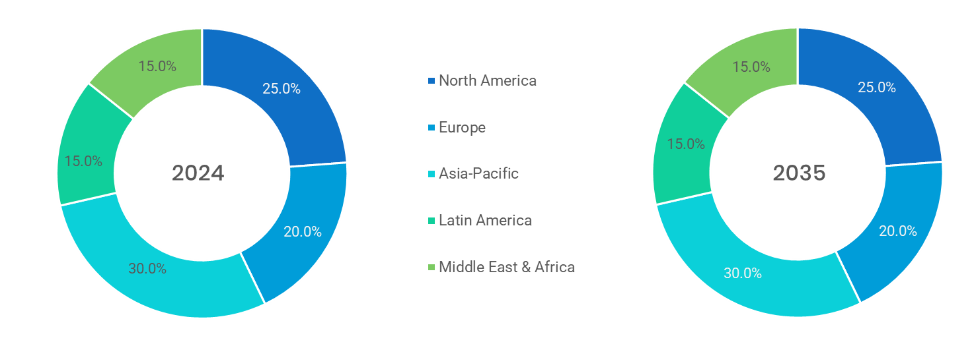
Source: Primary Interviews, Surveys, Secondary Sources, Web-Based & Paid External Databases, 2025
Note: Charts & Figures are only for Illustration purposes
- Global {{market_name_upper}} Market, by Region, 2020 – 2035 (USD MILLION)
By Region | 2020 | 2021 | 2022 | 2023 | 2024 | 2025 | 2026 | 2027 | 2028 | 2029 | 2030 | 2031 | 2032 | 2033 | 2034 | 2035 | CAGR%  (2025-2035)
North America | XX | XX | XX | XX | XX | XX | XX | XX | XX | XX | XX | XX | XX | XX | XX | XX | XX
Europe | XX | XX | XX | XX | XX | XX | XX | XX | XX | XX | XX | XX | XX | XX | XX | XX | XX
Asia-Pacific | XX | XX | XX | XX | XX | XX | XX | XX | XX | XX | XX | XX | XX | XX | XX | XX | XX
Latin America | XX | XX | XX | XX | XX | XX | XX | XX | XX | XX | XX | XX | XX | XX | XX | XX | XX
Middle East & Africa | XX | XX | XX | XX | XX | XX | XX | XX | XX | XX | XX | XX | XX | XX | XX | XX | XX
Total | XX | XX | XX | XX | XX | XX | XX | XX | XX | XX | XX | XX | XX | XX | XX | XX | XX
Source: Primary Interviews, Surveys, Secondary Sources, Web-Based & Paid External Databases, 2025

  - North America
    - North America {{market_name_upper}} Market, 2020 - 2035 (USD MILLION)
- North America {{market_name_upper}} Market, 2020 - 2035 (USD MILLION)
Source: Primary Interviews, Surveys, Secondary Sources, Web-Based & Paid External Databases, 2025

    - North America {{market_name_upper}} Market, by Country, 2020 – 2035 (USD MILLION)
- North America {{market_name_upper}} Market, by Country, 2020 – 2035 (USD MILLION)
By Country | 2020 | 2021 | 2022 | 2023 | 2024 | 2025 | 2026 | 2027 | 2028 | 2029 | 2030 | 2031 | 2032 | 2033 | 2034 | 2035 | CAGR%  (2025-2035)
U.S. | XX | XX | XX | XX | XX | XX | XX | XX | XX | XX | XX | XX | XX | XX | XX | XX | XX
Canada | XX | XX | XX | XX | XX | XX | XX | XX | XX | XX | XX | XX | XX | XX | XX | XX | XX
Mexico | XX | XX | XX | XX | XX | XX | XX | XX | XX | XX | XX | XX | XX | XX | XX | XX | XX
Total | XX | XX | XX | XX | XX | XX | XX | XX | XX | XX | XX | XX | XX | XX | XX | XX | XX
Source: Primary Interviews, Surveys, Secondary Sources, Web-Based & Paid External Databases, 2025

    - North America {{market_name_upper}} Market, by Type, 2020 – 2035 (USD MILLION)
- North America {{market_name_upper}} Market, by Type, 2020 – 2035 (USD MILLION)
By Type | 2020 | 2021 | 2022 | 2023 | 2024 | 2025 | 2026 | 2027 | 2028 | 2029 | 2030 | 2031 | 2032 | 2033 | 2034 | 20235 | CAGR%  (2025-2035)
Bio-methanol | XX | XX | XX | XX | XX | XX | XX | XX | XX | XX | XX | XX | XX | XX | XX | XX | XX
E-methanol (Bio-methanol) | XX | XX | XX | XX | XX | XX | XX | XX | XX | XX | XX | XX | XX | XX | XX | XX | XX
Bio-methanol + Green Hydrogen (Hybrid) | XX | XX | XX | XX | XX | XX | XX | XX | XX | XX | XX | XX | XX | XX | XX | XX | XX
Total | XX | XX | XX | XX | XX | XX | XX | XX | XX | XX | XX | XX | XX | XX | XX | XX | XX
Source: Primary Interviews, Surveys, Secondary Sources, Web-Based & Paid External Databases, 2025

    - North America {{market_name_upper}} Market, by Technology, 2020 – 2035 (USD MILLION)
- North America {{market_name_upper}} Market, by Technology, 2020 – 2035 (USD MILLION)
By TECHNOLOGY | 2020 | 2021 | 2022 | 2023 | 2024 | 2025 | 2026 | 2027 | 2028 | 2029 | 2030 | 2031 | 2032 | 2033 | 2034 | 2035 | CAGR%  (2025-2035)
Biomass Gasification | XX | XX | XX | XX | XX | XX | XX | XX | XX | XX | XX | XX | XX | XX | XX | XX | XX
Fermentation | XX | XX | XX | XX | XX | XX | XX | XX | XX | XX | XX | XX | XX | XX | XX | XX | XX
Electrochemical Reduction (e-methanol) | XX | XX | XX | XX | XX | XX | XX | XX | XX | XX | XX | XX | XX | XX | XX | XX | XX
Total | XX | XX | XX | XX | XX | XX | XX | XX | XX | XX | XX | XX | XX | XX | XX | XX | XX
Source: Primary Interviews, Surveys, Secondary Sources, Web-Based & Paid External Databases, 2025

    - North America {{market_name_upper}} Market, by Application, 2020 – 2035 (USD MILLION)
- North America {{market_name_upper}} Market, by Application, 2020 – 2035 (USD MILLION)
By Application | 2020 | 2021 | 2022 | 2023 | 2024 | 2025 | 2026 | 2027 | 2028 | 2029 | 2030 | 2031 | 2032 | 2033 | 2034 | 2035 | CAGR%  (2025-2035)
Marine Fuel | XX | XX | XX | XX | XX | XX | XX | XX | XX | XX | XX | XX | XX | XX | XX | XX | XX
Chemical Feedstock | XX | XX | XX | XX | XX | XX | XX | XX | XX | XX | XX | XX | XX | XX | XX | XX | XX
Power Generation | XX | XX | XX | XX | XX | XX | XX | XX | XX | XX | XX | XX | XX | XX | XX | XX | XX
Automotive Fuel | XX | XX | XX | XX | XX | XX | XX | XX | XX | XX | XX | XX | XX | XX | XX | XX | XX
Total | XX | XX | XX | XX | XX | XX | XX | XX | XX | XX | XX | XX | XX | XX | XX | XX | XX
Source: Primary Interviews, Surveys, Secondary Sources, Web-Based & Paid External Databases, 2025
    - U.S.
- U.S. {{market_name_upper}} Market, 2020 – 2035 (USD MILLION)
Source: Primary Interviews, Surveys, Secondary Sources, Web-Based & Paid External Databases, 2025

        - U.S. {{market_name_upper}} Market, by Type, 2020 – 2035 (USD MILLION)
- U.S. {{market_name_upper}} Market, by Type, 2020 – 2035 (USD MILLION)
By Type | 2020 | 2021 | 2022 | 2023 | 2024 | 2025 | 2026 | 2027 | 2028 | 2029 | 2030 | 2031 | 2032 | 2033 | 2034 | 20235 | CAGR%  (2025-2035)
Bio-methanol | XX | XX | XX | XX | XX | XX | XX | XX | XX | XX | XX | XX | XX | XX | XX | XX | XX
E-methanol (Bio-methanol) | XX | XX | XX | XX | XX | XX | XX | XX | XX | XX | XX | XX | XX | XX | XX | XX | XX
Bio-methanol + Green Hydrogen (Hybrid) | XX | XX | XX | XX | XX | XX | XX | XX | XX | XX | XX | XX | XX | XX | XX | XX | XX
Total | XX | XX | XX | XX | XX | XX | XX | XX | XX | XX | XX | XX | XX | XX | XX | XX | XX
Source: Primary Interviews, Surveys, Secondary Sources, Web-Based & Paid External Databases, 2025

      - U.S. {{market_name_upper}} Market, by TECHNOLOGY, 2020 – 2035 (USD MILLION)
- U.S. {{market_name_upper}} Market, by TECHNOLOGY, 2020 – 2035 (USD MILLION)
By TECHNOLOGY | 2020 | 2021 | 2022 | 2023 | 2024 | 2025 | 2026 | 2027 | 2028 | 2029 | 2030 | 2031 | 2032 | 2033 | 2034 | 2035 | CAGR%  (2025-2035)
Biomass Gasification | XX | XX | XX | XX | XX | XX | XX | XX | XX | XX | XX | XX | XX | XX | XX | XX | XX
Fermentation | XX | XX | XX | XX | XX | XX | XX | XX | XX | XX | XX | XX | XX | XX | XX | XX | XX
Electrochemical Reduction (e-methanol) | XX | XX | XX | XX | XX | XX | XX | XX | XX | XX | XX | XX | XX | XX | XX | XX | XX
Total | XX | XX | XX | XX | XX | XX | XX | XX | XX | XX | XX | XX | XX | XX | XX | XX | XX
Source: Primary Interviews, Surveys, Secondary Sources, Web-Based & Paid External Databases, 2025

      - U.S. {{market_name_upper}} Market, by Application, 2020 – 2035 (USD MILLION)
- U.S. {{market_name_upper}} Market, by Application, 2020 – 2035 (USD MILLION)
By Application | 2020 | 2021 | 2022 | 2023 | 2024 | 2025 | 2026 | 2027 | 2028 | 2029 | 2030 | 2031 | 2032 | 2033 | 2034 | 2035 | CAGR%  (2025-2035)
Marine Fuel | XX | XX | XX | XX | XX | XX | XX | XX | XX | XX | XX | XX | XX | XX | XX | XX | XX
Chemical Feedstock | XX | XX | XX | XX | XX | XX | XX | XX | XX | XX | XX | XX | XX | XX | XX | XX | XX
Power Generation | XX | XX | XX | XX | XX | XX | XX | XX | XX | XX | XX | XX | XX | XX | XX | XX | XX
Automotive Fuel | XX | XX | XX | XX | XX | XX | XX | XX | XX | XX | XX | XX | XX | XX | XX | XX | XX
Total | XX | XX | XX | XX | XX | XX | XX | XX | XX | XX | XX | XX | XX | XX | XX | XX | XX
Source: Primary Interviews, Surveys, Secondary Sources, Web-Based & Paid External Databases, 2025

    - Canada
- Canada {{market_name_upper}} Market, 2020 – 2035 (USD MILLION)
Source: Primary Interviews, Surveys, Secondary Sources, Web-Based & Paid External Databases, 2025

        - CANADA {{market_name_upper}} Market, by Type, 2020 – 2035 (USD MILLION)
- CANADA {{market_name_upper}} Market, by Type, 2020 – 2035 (USD MILLION)
By Type | 2020 | 2021 | 2022 | 2023 | 2024 | 2025 | 2026 | 2027 | 2028 | 2029 | 2030 | 2031 | 2032 | 2033 | 2034 | 20235 | CAGR%  (2025-2035)
Bio-methanol | XX | XX | XX | XX | XX | XX | XX | XX | XX | XX | XX | XX | XX | XX | XX | XX | XX
E-methanol (Bio-methanol) | XX | XX | XX | XX | XX | XX | XX | XX | XX | XX | XX | XX | XX | XX | XX | XX | XX
Bio-methanol + Green Hydrogen (Hybrid) | XX | XX | XX | XX | XX | XX | XX | XX | XX | XX | XX | XX | XX | XX | XX | XX | XX
Total | XX | XX | XX | XX | XX | XX | XX | XX | XX | XX | XX | XX | XX | XX | XX | XX | XX
Source: Primary Interviews, Surveys, Secondary Sources, Web-Based & Paid External Databases, 2025
        - CANADA {{market_name_upper}} Market, by TECHNOLOGY, 2020 – 2035 (USD MILLION)
- CANADA {{market_name_upper}} Market, by TECHNOLOGY, 2020 – 2035 (USD MILLION)
By TECHNOLOGY | 2020 | 2021 | 2022 | 2023 | 2024 | 2025 | 2026 | 2027 | 2028 | 2029 | 2030 | 2031 | 2032 | 2033 | 2034 | 2035 | CAGR%  (2025-2035)
Biomass Gasification | XX | XX | XX | XX | XX | XX | XX | XX | XX | XX | XX | XX | XX | XX | XX | XX | XX
Fermentation | XX | XX | XX | XX | XX | XX | XX | XX | XX | XX | XX | XX | XX | XX | XX | XX | XX
Electrochemical Reduction (e-methanol) | XX | XX | XX | XX | XX | XX | XX | XX | XX | XX | XX | XX | XX | XX | XX | XX | XX
Total | XX | XX | XX | XX | XX | XX | XX | XX | XX | XX | XX | XX | XX | XX | XX | XX | XX
Source: Primary Interviews, Surveys, Secondary Sources, Web-Based & Paid External Databases, 2025

        - CANADA {{market_name_upper}} Market, by Application, 2020 – 2035 (USD MILLION)
- CANADA {{market_name_upper}} Market, by Application, 2020 – 2035 (USD MILLION)
By Application | 2020 | 2021 | 2022 | 2023 | 2024 | 2025 | 2026 | 2027 | 2028 | 2029 | 2030 | 2031 | 2032 | 2033 | 2034 | 2035 | CAGR%  (2025-2035)
Marine Fuel | XX | XX | XX | XX | XX | XX | XX | XX | XX | XX | XX | XX | XX | XX | XX | XX | XX
Chemical Feedstock | XX | XX | XX | XX | XX | XX | XX | XX | XX | XX | XX | XX | XX | XX | XX | XX | XX
Power Generation | XX | XX | XX | XX | XX | XX | XX | XX | XX | XX | XX | XX | XX | XX | XX | XX | XX
Automotive Fuel | XX | XX | XX | XX | XX | XX | XX | XX | XX | XX | XX | XX | XX | XX | XX | XX | XX
Total | XX | XX | XX | XX | XX | XX | XX | XX | XX | XX | XX | XX | XX | XX | XX | XX | XX
Source: Primary Interviews, Surveys, Secondary Sources, Web-Based & Paid External Databases, 2025

    - Mexico
- Mexico {{market_name_upper}} Market, 2020 – 2035 (USD MILLION)
Source: Primary Interviews, Surveys, Secondary Sources, Web-Based & Paid External Databases, 2025

        - MEXICO {{market_name_upper}} Market, by Type, 2020 – 2035 (USD MILLION)
- MEXICO {{market_name_upper}} Market, by Type, 2020 – 2035 (USD MILLION)
By Type | 2020 | 2021 | 2022 | 2023 | 2024 | 2025 | 2026 | 2027 | 2028 | 2029 | 2030 | 2031 | 2032 | 2033 | 2034 | 20235 | CAGR%  (2025-2035)
Bio-methanol | XX | XX | XX | XX | XX | XX | XX | XX | XX | XX | XX | XX | XX | XX | XX | XX | XX
E-methanol (Bio-methanol) | XX | XX | XX | XX | XX | XX | XX | XX | XX | XX | XX | XX | XX | XX | XX | XX | XX
Bio-methanol + Green Hydrogen (Hybrid) | XX | XX | XX | XX | XX | XX | XX | XX | XX | XX | XX | XX | XX | XX | XX | XX | XX
Total | XX | XX | XX | XX | XX | XX | XX | XX | XX | XX | XX | XX | XX | XX | XX | XX | XX
Source: Primary Interviews, Surveys, Secondary Sources, Web-Based & Paid External Databases, 2025
        - MEXICO {{market_name_upper}} Market, by TECHNOLOGY, 2020 – 2035 (USD MILLION)
- MEXICO {{market_name_upper}} Market, by TECHNOLOGY, 2020 – 2035 (USD MILLION)
By TECHNOLOGY | 2020 | 2021 | 2022 | 2023 | 2024 | 2025 | 2026 | 2027 | 2028 | 2029 | 2030 | 2031 | 2032 | 2033 | 2034 | 2035 | CAGR%  (2025-2035)
Biomass Gasification | XX | XX | XX | XX | XX | XX | XX | XX | XX | XX | XX | XX | XX | XX | XX | XX | XX
Fermentation | XX | XX | XX | XX | XX | XX | XX | XX | XX | XX | XX | XX | XX | XX | XX | XX | XX
Electrochemical Reduction (e-methanol) | XX | XX | XX | XX | XX | XX | XX | XX | XX | XX | XX | XX | XX | XX | XX | XX | XX
Total | XX | XX | XX | XX | XX | XX | XX | XX | XX | XX | XX | XX | XX | XX | XX | XX | XX
Source: Primary Interviews, Surveys, Secondary Sources, Web-Based & Paid External Databases, 202

        - MEXICO {{market_name_upper}} Market, by Application, 2020 – 2035 (USD MILLION)
- MEXICO {{market_name_upper}} Market, by Application, 2020 – 2035 (USD MILLION)
By Application | 2020 | 2021 | 2022 | 2023 | 2024 | 2025 | 2026 | 2027 | 2028 | 2029 | 2030 | 2031 | 2032 | 2033 | 2034 | 2035 | CAGR%  (2025-2035)
Marine Fuel | XX | XX | XX | XX | XX | XX | XX | XX | XX | XX | XX | XX | XX | XX | XX | XX | XX
Chemical Feedstock | XX | XX | XX | XX | XX | XX | XX | XX | XX | XX | XX | XX | XX | XX | XX | XX | XX
Power Generation | XX | XX | XX | XX | XX | XX | XX | XX | XX | XX | XX | XX | XX | XX | XX | XX | XX
Automotive Fuel | XX | XX | XX | XX | XX | XX | XX | XX | XX | XX | XX | XX | XX | XX | XX | XX | XX
Total | XX | XX | XX | XX | XX | XX | XX | XX | XX | XX | XX | XX | XX | XX | XX | XX | XX
Source: Primary Interviews, Surveys, Secondary Sources, Web-Based & Paid External Databases, 2025

*The above similar information will be cover for below region and countries involved in each region.
  - Europe
  - Asia-Pacific
  - Latin America
  - Middle East & Africa

- {{market_name_upper}} Market – Competitive Landscape
  - Market Share Analysis (2024)
- Market Share Analysis (2024)
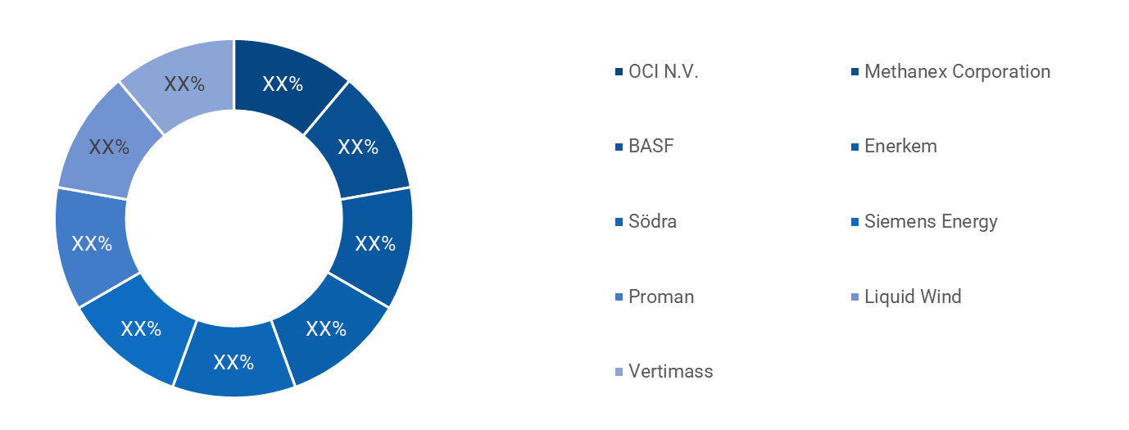
Source: Primary Interviews, Surveys, Secondary Sources, Web-Based & Paid External Databases, 2025
Note: Chart only for illustration purpose

  - Strategic Developments
    - Acquisitions and Mergers
- Acquisitions and Mergers
Date | Company | Development
March 2024 | XX | XX
Feb 2025 | XX | XX
March 2024 | XX | XX
July 2022 | XX | XX
January 2021 | XX | XX
May 2021 | XX | XX
Source: Primary Interviews, Surveys, Secondary Sources, Web-Based & Paid External Databases, 2025

    - Product Launches
Date | Company | Development
April 2025 | XX | XX
March 2024 | XX | XX
January 2022 | XX | XX
July 2022 | XX | XX
January 2021 | XX | XX
May 2021 | XX | XX
Source: Primary Interviews, Surveys, Secondary Sources, Web-Based & Paid External Databases, 2025
    - Research & Development Activities
Date | Company | Development
April 2025 | XX | XX
March 2024 | XX | XX
January 2022 | XX | XX
July 2022 | XX | XX
January 2021 | XX | XX
May 2021 | XX | XX
- Company Profiles
  - BASF
    - Company Overview
BASF SE is the largest chemical producer in the world, renowned for its "Verbund" (integration) model, which creates highly efficient value chains by linking production plants and energy flows. As a leader in the global chemical industry, BASF has committed to reaching Net Zero $CO_2$ emissions by 2050. The company is a pioneer in the "Green Methanol" space through its biomass balance approach and its development of carbon-neutral production technologies. BASF is currently focusing on electrifying its chemical processes and using renewable feedstocks to "defossilize" its massive product portfolio.

- Company snapshot
Sr. No. | ITEM | DESCRIPTION
1 | Company Name | BASF
2 | Website | www. BASF.com
3 | Established | 1865
4 | Headquarters | Germany
5 | Key Products | Chemicals, Materials, Industrial Solutions, Surface Technologies, and Agricultural Solutions
6 | Key Regions of Sales | 1) North America  2) Europe  3) Asia-Pacific  4) Latin America
    - Product Portfolio
Product | FEATURES / DESCRIPTION | APPLICATION
XX | XX | XX
XX | XX | XX
XX | XX | XX
XX | XX | XX

    - BASF Sales/Revenue, Net Income, and Gross Margin
PARAMETER | 2022 | 2023 | 2024 | 2025
Revenue (Euro Billion) | 87.33 | 68.90 | 65.31 | XX
Net Income | XX | XX | XX | XX
Gross Margin | XX | XX | XX | XX
Source: Annual Reports, Primary Interviews, Surveys, Secondary Research, , 2025

    - BASF Revenue (2023-2025)
- BASF REVENUE (2023-2025)
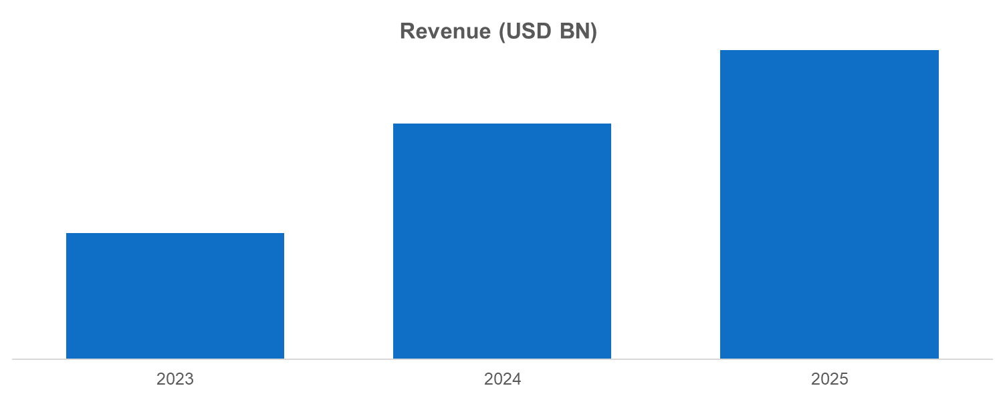
Source: Annual Reports, Primary Interviews, Surveys, Secondary Research, , 2025

    - BASF Segmental Revenue (%) (2024)
- BASF SEGMENTAL Revenue (%) (2024)
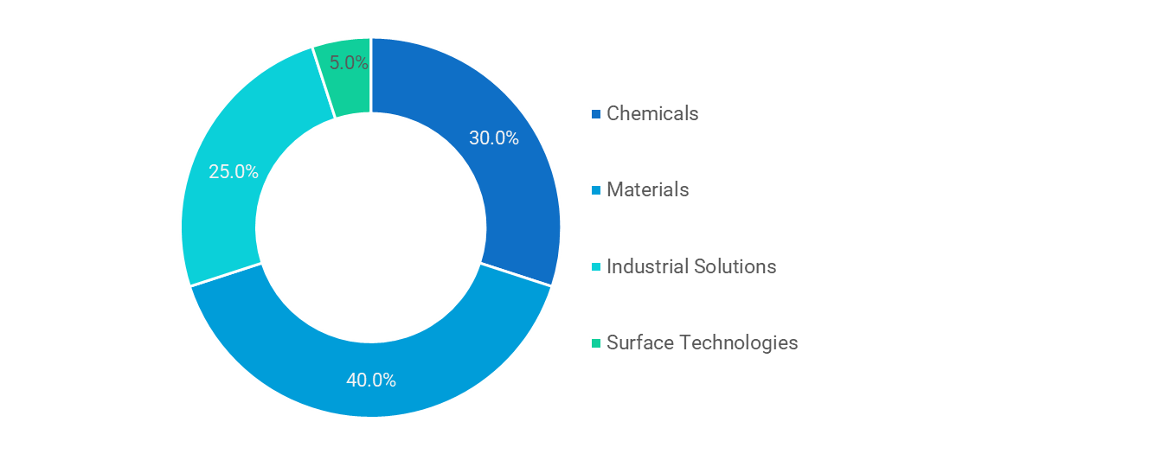
Source: Annual Reports, Primary Interviews, Surveys, Secondary Research, , 2025

    - BASF Regional Revenue (%) (2025)
- BASF Regional Revenue (%) (2025)
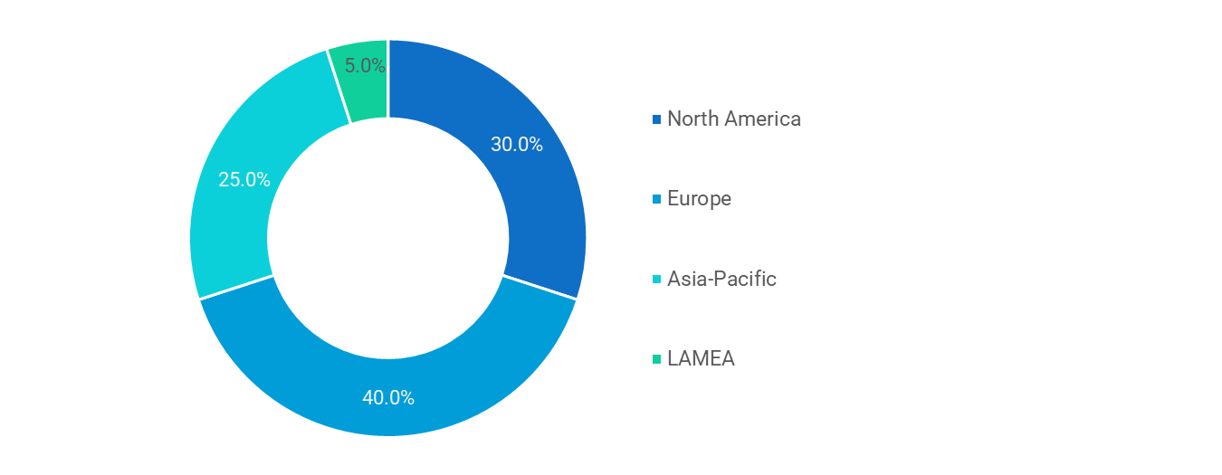
Source: Annual Reports, Primary Interviews, Surveys, Secondary Research, , 2025
Similar infoamtion will be provided for berlow companies
  - OCI N.V.
  - Methanex Corporation
  - Carbon Recycling International
  - Enerkem
  - Södra
  - Siemens Energy
  - Proman
  - Liquid Wind
  - Vertimass
- Future Outlook & Forecast- {{market_name_upper}} Market
  - Introduction and Taxonomy

  - Demand Forecast

  - Investment Opportunity

  - Market Disruptions & Scenario Analysis
- Strategic Recommendations – {{market_name_upper}} Market
  - Introduction and Taxonomy

  - For Manufacturers

  - For Investors

  - For Policy Makers

- Appendix
  - Data Sources

  - Glossary of Terms

  - Research Assumptions

About us
Welcome to NextGen Intelligence Stats and Consulting -your trusted partner in market research and consulting.
Founded with a mission to bring clarity to complex markets, we are dedicated to helping businesses make smarter, data-driven decisions. Since our inception, we’ve consistently expanded our offerings, stayed rooted in a client-first approach, and remained focused on eliminating unreliable or outdated data from strategic planning.
We are more than just a research firm-we are a one-stop hub for meaningful industry intelligence. Whether you're a startup exploring new markets or an enterprise navigating growth, our team works closely with you to uncover real opportunities, decode market movements, and guide you toward sustainable success.
We understand that every client is unique. Syndicated reports can’t always capture the nuances of your business goals — which is why we offer flexible, custom research solutions tailored to your specific objectives and budget. From targeted market analysis to in-depth consulting, we’re here to provide insights that are both practical and powerful.
At NextGen Intelligence Stats and Consulting, we stand for quality, integrity, and partnership. Our commitment is simple: to deliver best-in-class research and consulting services that empower your business to stay ahead of the curve.

Let us help you turn data into direction-and insights into impact.

Copyright © 2025 {{company_name}} All rights reserved

Disclaimer
The information and insights provided by NextGen Intelligence Stats and Consulting are intended solely for general informational purposes. While we strive to ensure accuracy and reliability in our research and consulting services, we make no representations or warranties, express or implied, regarding the completeness, accuracy, or suitability of the content for any specific purpose. All opinions and analyses are based on available data at the time of publication and are subject to change without notice.
NextGen Intelligence Stats and Consulting shall not be held liable for any direct or indirect loss or damage arising from the use of our reports, publications, or services. Clients are advised to exercise their own judgment and seek independent professional advice before making any business or investment decisions based on our research.
Use of our services or content implies acceptance of this disclaimer and our terms of service.

