
MARKET INTELLIGENCE REPORT
{{market_name}} Market
Market Outlook
2025 – 2030 Market Outlook
{{market_name}}
Technologies
Supplier Landscape
{{company_name}}
Table of content
Chapter 1. Executive Summary 16
1.1. Introduction of {{market_name_upper}} Market 17
1.1.1. {{report_geography}} {{market_name_upper}} Market, 2024 & 2035 17
1.2. {{report_geography}} {{market_name_upper}} Market, 2020 – 2035 (USD MILLION) 18
Chapter 2. Market Introduction – {{market_name_upper}} Market 19
2.1. Market Definition 19
2.2. Scope of the Study 20
2.3. Research Methodology 21
2.4. Key Assumptions 25
Chapter 3. Market Dynamics- {{market_name_upper}} Market 26
3.1. Market Drivers 27
3.2. Market Restraints 28
3.3. Market Opportunities 29
3.4. Market Challenges 30
3.5. Technological Advancements & Innovations 31
Chapter 4. Industry Outlook- {{market_name_upper}} Market 32
4.1. Value Chain Analysis 32
4.2. Regulatory Landscape 34
4.3. ESG (Environmental, Social, Governance) Impact 35
4.4. PESTLE Analysis 36
4.5. Porter’s Five Forces Analysis 37
4.6. Emerging Business Models & Ecosystem Partnerships 38
4.7. Market Attractiveness 39
4.8. {{ch4_custom_section_1_title}} 40
4.9. {{ch4_custom_section_2_title}} 41
4.10. {{ch4_custom_section_3_title}} 42
4.11. {{ch4_custom_section_4_title}} 42
4.11.1. {{ch4_custom_subsection_4_1_title}} 42
Chapter 5. {{market_name_upper}} Market – Type Analysis 43
5.1. {{report_geography}} {{market_name_upper}} Market –Type OVERVIEW 43
5.2. {{report_geography}} {{market_name_upper}} Market Share, by Type, 2024 & 2035 (%) 44
5.3. {{type_segment_1}} 46
5.3.1. {{report_geography}} {{market_name_upper}} Market by {{type_segment_1}}, 2020 – 2035 (usd million) 46
5.4. {{type_segment_2}} 47
5.5. {{type_segment_3}} 47
Chapter 6. {{market_name_upper}} Market – Technology Analysis 48
6.1. {{report_geography}} {{market_name_upper}} Market – Overview 48
6.2. {{report_geography}} {{market_name_upper}} Market Share, by Technology, 2024 & 2035 (%) 49
6.3. {{tech_segment_1}} 51
6.3.1. {{report_geography}} {{market_name_upper}} Market for {{tech_segment_1}}, 2020 – 2035 (USD MILLION) 51
6.4. {{tech_segment_2}} 52
6.5. {{tech_segment_3}} 52
Chapter 7. {{market_name_upper}} Market –Application Analysis 53
7.1. {{report_geography}} {{market_name_upper}} Market –Application Overview 53
7.2. {{report_geography}} {{market_name_upper}} Market Share, by Application, 2024 & 2035 (%) 54
7.3. {{app_segment_1}} 56
7.3.1. {{report_geography}} {{market_name_upper}} Market by {{app_segment_1}}, 2020 - 2035 (USD MILLION) 56
7.4. {{app_segment_2}} 57
7.5. {{app_segment_3}} 57
Chapter 8. {{market_name_upper}} Market –{{seg4_name}} Analysis 58
8.1. {{report_geography}} {{market_name_upper}} Market –{{seg4_name}} Overview 58
8.2. {{report_geography}} {{market_name_upper}} Market Share, by {{seg4_name}}, 2024 & 2035 (%) 59
8.3. {{seg4_sub1}} 61
8.3.1. {{report_geography}} {{market_name_upper}} Market by {{seg4_sub1}}, 2020 - 2035 (USD MILLION) 61
8.4. {{seg4_sub2}} 62
8.5. {{seg4_sub3}} 62
8.6. Sub-{{seg4_name}} 62
Chapter 9. {{market_name_upper}} Market –{{seg5_name}} Analysis 63
9.1. {{report_geography}} {{market_name_upper}} Market –{{seg5_name}} Overview 63
9.2. {{report_geography}} {{market_name_upper}} Market Share, by {{seg5_name}}, 2024 & 2035 (%) 64
9.3. {{seg5_sub1}} 66
9.3.1. {{report_geography}} {{market_name_upper}} Market by {{seg5_sub1}}, 2020 - 2035 (USD MILLION) 66
9.4. {{seg5_sub2}} 67
9.5. {{seg5_sub3}} 67
9.6. Sub-{{seg4_name}} 67
Chapter 10. {{market_name_upper}} Market –{{seg6_name}} Analysis 68
10.1. {{report_geography}} {{market_name_upper}} Market –{{seg6_name}} Overview 68
10.2. {{report_geography}} {{market_name_upper}} Market Share, by {{seg6_name}}, 2024 & 2035 (%) 69
10.3. {{seg6_sub1}} 71
10.3.1. {{report_geography}} {{market_name_upper}} Market by {{seg6_sub1}}, 2020 - 2035 (USD MILLION) 71
10.4. {{seg6_sub2}} 72
10.5. {{seg6_sub3}} 72
10.6. Sub-{{seg4_name}} 72
Chapter 11. {{market_name_upper}} Market – Regional Analysis 73
11.1. {{report_geography}} {{market_name_upper}} Market Regional Overview 73
11.2. {{report_geography}} {{market_name_upper}} Market Share, by Region, 2024 & 2035 (%) 74
11.3. North America 76
11.3.1. North America {{market_name_upper}} Market, 2020 - 2035 (USD MILLION) 76
11.3.2. North America {{market_name_upper}} Market, by Country, 2020 – 2035 (USD MILLION) 77
11.3.3. North America {{market_name_upper}} Market, by Type, 2020 – 2035 (USD MILLION) 77
11.3.4. North America {{market_name_upper}} Market, by Technology, 2020 – 2035 (USD MILLION) 78
11.3.5. North America {{market_name_upper}} Market, by Application, 2020 – 2035 (USD MILLION) 79
11.3.6. North America {{market_name_upper}} Market, by {{seg4_name}}, 2020 – 2035 (USD MILLION) 79
11.3.7. North America {{market_name_upper}} Market, by {{seg5_name}}, 2020 – 2035 (USD MILLION) 80
11.3.8. North America {{market_name_upper}} Market, by {{seg6_name}}, 2020 – 2035 (USD MILLION) 80
11.3.9. U.S. 81
11.3.9.1. U.S. {{market_name_upper}} Market, by Type, 2020 – 2035 (USD MILLION) 82
11.3.9.2. U.S. {{market_name_upper}} Market, by TECHNOLOGY, 2020 – 2035 (USD MILLION) 82
11.3.9.3. U.S. {{market_name_upper}} Market, by Application, 2020 – 2035 (USD MILLION) 83
11.3.9.4. U.S. {{market_name_upper}} Market, by {{seg4_name}}, 2020 – 2035 (USD MILLION) 83
11.3.9.5. U.S. {{market_name_upper}} Market, by {{seg5_name}}, 2020 – 2035 (USD MILLION) 84
11.3.9.6. U.S. {{market_name_upper}} Market, by {{seg6_name}}, 2020 – 2035 (USD MILLION) 84
11.3.10. Canada 85
11.3.10.1. CANADA {{market_name_upper}} Market, by Type, 2020 – 2035 (USD MILLION) 86
11.3.10.2. CANADA {{market_name_upper}} Market, by TECHNOLOGY, 2020 – 2035 (USD MILLION) 86
11.3.10.3. CANADA {{market_name_upper}} Market, by Application, 2020 – 2035 (USD MILLION) 87
11.3.10.4. CANADA {{market_name_upper}} Market, by {{seg4_name}}, 2020 – 2035 (USD MILLION) 87
11.3.10.5. CANADA {{market_name_upper}} Market, by {{seg5_name}}, 2020 – 2035 (USD MILLION) 88
11.3.10.6. CANADA {{market_name_upper}} Market, by {{seg6_name}}, 2020 – 2035 (USD MILLION) 88
11.3.11. Mexico 89
11.3.11.1. MEXICO {{market_name_upper}} Market, by Type, 2020 – 2035 (USD MILLION) 90
11.3.11.2. MEXICO {{market_name_upper}} Market, by TECHNOLOGY, 2020 – 2035 (USD MILLION) 90
11.3.11.3. MEXICO {{market_name_upper}} Market, by Application, 2020 – 2035 (USD MILLION) 91
11.3.11.4. MEXICO {{market_name_upper}} Market, by {{seg4_name}}, 2020 – 2035 (USD MILLION) 91
11.3.11.5. MEXICO {{market_name_upper}} Market, by {{seg5_name}}, 2020 – 2035 (USD MILLION) 92
11.3.11.6. MEXICO {{market_name_upper}} Market, by {{seg6_name}}, 2020 – 2035 (USD MILLION) 92
11.4. Europe 93
11.5. Asia-Pacific 93
11.6. Latin America 93
11.7. Middle East & Africa 93
Chapter 12. {{market_name_upper}} Market – Competitive Landscape 94
12.1. Market Share Analysis (2024) 94
12.2. Strategic Developments 95
12.2.1. Acquisitions and Mergers 95
12.2.2. Product Launches 96
12.2.3. Research & Development Activities 96
Chapter 13. Company Profiles 97
13.1. {{co1_name_upper}} 97
13.1.1. Company Overview 97
13.1.2. Product Portfolio 98
13.1.3. {{co1_name_upper}} Sales/Revenue, Net Income, and Gross Margin 99
13.1.4. {{co1_name_upper}} Revenue (2023-2025) 100
13.1.5. {{co1_name_upper}} Segmental Revenue (%) (2024) 101
13.1.6. {{co1_name_upper}} Regional Revenue (%) (2025) 102
13.2. {{co2_name}} 103
13.3. {{co3_name}} 103
13.4. {{co4_name}} 103
13.5. {{co5_name}} 103
13.6. Södra 103
13.7. {{co7_name}} 103
13.8. {{co8_name}} 103
13.9. {{co9_name}} 103
13.10. {{co10_name}} 103
Chapter 14. Future Outlook & Forecast- {{market_name_upper}} Market 104
14.1. Introduction and Taxonomy 104
14.2. Demand Forecast 106
14.3. Investment Opportunity 107
14.4. Market Disruptions & Scenario Analysis 108
Chapter 15. Strategic Recommendations – {{market_name_upper}} Market 109
15.1. Introduction and Taxonomy 109
15.2. For Manufacturers 110
15.3. For Investors 111
15.4. For Policy Makers 112
Chapter 16. Appendix 113
16.1. Data Sources 113
16.2. Glossary of Terms 114
16.3. Research Assumptions 115

List of tables
TABLE 1 {{report_geography}} {{market_name_upper}} Market, 2024 & 2035 18
TABLE 2 {{report_geography}} {{market_name_upper}} Market, by Type, 2020 - 2035 (USD MILLION) 46
TABLE 3 {{report_geography}} {{market_name_upper}} Market by {{type_segment_1}}, by Region, 2020 - 2035 48
TABLE 4 {{report_geography}} {{market_name_upper}} Market, by Technology, 2020 - 2035 (USD MILLION) 51
TABLE 5 {{report_geography}} {{market_name_upper}} Market for {{tech_segment_1}}, by Region, 2020 - 2035 (USD MILLION) 53
TABLE 6 {{report_geography}} {{market_name_upper}} Market, by Application, 2020 – 2035 (USD MILLION) 56
TABLE 7 {{report_geography}} {{market_name_upper}} Market by {{app_segment_1}}, by Region, 2020 – 2035 (USD MILLION) 58
TABLE 8 {{report_geography}} {{market_name_upper}} Market, by {{seg4_name}}, 2020 – 2035 (USD MILLION) 61
TABLE 9 {{report_geography}} {{market_name_upper}} Market by {{seg6_sub1}}, by Region, 2020 – 2035 (USD MILLION) 63
TABLE 10 {{report_geography}} {{market_name_upper}} Market, by {{seg5_name}}, 2020 – 2035 (USD MILLION) 66
TABLE 11 {{report_geography}} {{market_name_upper}} Market by {{seg6_sub1}}, by Region, 2020 – 2035 (USD MILLION) 68
TABLE 12 {{report_geography}} {{market_name_upper}} Market, by {{seg6_name}}, 2020 – 2035 (USD MILLION) 71
TABLE 13 {{report_geography}} {{market_name_upper}} Market by {{seg6_sub1}}, by Region, 2020 – 2035 (USD MILLION) 73
TABLE 14 {{report_geography}} {{market_name_upper}} Market, by Region, 2020 – 2035 (USD MILLION) 76
TABLE 15 North America {{market_name_upper}} Market, by Country, 2020 – 2035 (USD MILLION) 78
TABLE 16 North America {{market_name_upper}} Market, by Type, 2020 – 2035 (USD MILLION) 78
TABLE 17 North America {{market_name_upper}} Market, by Technology, 2020 – 2035 (USD MILLION) 79
TABLE 18 North America {{market_name_upper}} Market, by Application, 2020 – 2035 (USD MILLION) 80
TABLE 19 North America {{market_name_upper}} Market, by {{seg4_name}}, 2020 – 2035 (USD MILLION) 80
TABLE 20 North America {{market_name_upper}} Market, by {{seg5_name}}, 2020 – 2035 (USD MILLION) 81
TABLE 21 North America {{market_name_upper}} Market, by {{seg6_name}}, 2020 – 2035 (USD MILLION) 81
TABLE 22 U.S. {{market_name_upper}} Market, by Type, 2020 – 2035 (USD MILLION) 83
TABLE 23 U.S. {{market_name_upper}} Market, by TECHNOLOGY, 2020 – 2035 (USD MILLION) 83
TABLE 24 U.S. {{market_name_upper}} Market, by Application, 2020 – 2035 (USD MILLION) 84
TABLE 25 U.S. {{market_name_upper}} Market, by {{seg4_name}}, 2020 – 2035 (USD MILLION) 84
TABLE 26 U.S. {{market_name_upper}} Market, by {{seg5_name}}, 2020 – 2035 (USD MILLION) 85
TABLE 27 U.S. {{market_name_upper}} Market, by {{seg6_name}}, 2020 – 2035 (USD MILLION) 85
TABLE 28 CANADA {{market_name_upper}} Market, by Type, 2020 – 2035 (USD MILLION) 87
TABLE 29 CANADA {{market_name_upper}} Market, by TECHNOLOGY, 2020 – 2035 (USD MILLION) 87
TABLE 30 CANADA {{market_name_upper}} Market, by Application, 2020 – 2035 (USD MILLION) 88
TABLE 31 CANADA {{market_name_upper}} Market, by {{seg4_name}}, 2020 – 2035 (USD MILLION) 88
TABLE 32 CANADA {{market_name_upper}} Market, by {{seg5_name}}, 2020 – 2035 (USD MILLION) 89
TABLE 33 CANADA {{market_name_upper}} Market, by {{seg6_name}}, 2020 – 2035 (USD MILLION) 89
TABLE 34 MEXICO {{market_name_upper}} Market, by Type, 2020 – 2035 (USD MILLION) 91
TABLE 35 MEXICO {{market_name_upper}} Market, by TECHNOLOGY, 2020 – 2035 (USD MILLION) 91
TABLE 36 MEXICO {{market_name_upper}} Market, by Application, 2020 – 2035 (USD MILLION) 92
TABLE 37 MEXICO {{market_name_upper}} Market, by {{seg4_name}}, 2020 – 2035 (USD MILLION) 92
TABLE 38 MEXICO {{market_name_upper}} Market, by {{seg5_name}}, 2020 – 2035 (USD MILLION) 93
TABLE 39 MEXICO {{market_name_upper}} Market, by {{seg6_name}}, 2020 – 2035 (USD MILLION) 93
TABLE 40 Acquisitions and Mergers 96
TABLE 41 Company snapshot 99

List of Figures
Figure 01 {{report_geography}} {{market_name_upper}} Market, 2020 – 2035 (USD MILLION) 19
Figure 02 Market Dynamics 27
Figure 03 Technological Advancements & Innovations 32
Figure 04 Value Chain Analysis 33
Figure 05 {{report_geography}} {{market_name_upper}} Market Share, by Type, 2024 & 2035 (%) 45
Figure 06 {{report_geography}} {{market_name_upper}} Market by {{type_segment_1}}, 2020 - 2035 47
Figure 07 {{report_geography}} {{market_name_upper}} Market Share, by Technology, 2024 & 2035 50
Figure 08 {{report_geography}} {{market_name_upper}} Market for {{tech_segment_1}}, 2020 - 2035 (USD MILLION) 52
Figure 09 {{report_geography}} {{market_name_upper}} Market Share, by Application, 2024 & 2035 (%) 55
Figure 10 {{report_geography}} {{market_name_upper}} Market by {{app_segment_1}}, 2020 – 2035 (USD MILLION) 57
Figure 11 {{report_geography}} {{market_name_upper}} Market Share, by {{seg4_name}}, 2024 & 2035 (%) 60
Figure 12 {{report_geography}} {{market_name_upper}} Market by {{seg6_sub1}}, 2020 – 2035 (USD MILLION) 62
Figure 13 {{report_geography}} {{market_name_upper}} Market Share, by {{seg5_name}}, 2024 & 2035 (%) 65
Figure 14 {{report_geography}} {{market_name_upper}} Market by {{seg6_sub1}}, 2020 – 2035 (USD MILLION) 67
Figure 15 {{report_geography}} {{market_name_upper}} Market Share, by {{seg6_name}}, 2024 & 2035 (%) 70
Figure 16 {{report_geography}} {{market_name_upper}} Market by {{seg6_sub1}}, 2020 – 2035 (USD MILLION) 72
Figure 17 {{report_geography}} {{market_name_upper}} Market Share, by Region, 2024 & 2035 (%) 75
Figure 18 North America {{market_name_upper}} Market, 2020 - 2035 (USD MILLION) 77
Figure 19 U.S. {{market_name_upper}} Market, 2020 – 2035 (USD MILLION) 82
Figure 20 Canada {{market_name_upper}} Market, 2020 – 2035 (USD MILLION) 86
Figure 21 Mexico {{market_name_upper}} Market, 2020 – 2035 (USD MILLION) 90
Figure 22 Market Share Analysis (2024) 95
Figure 23 {{co1_name_upper}} REVENUE (2023-2025) 101
Figure 24 {{co1_name_upper}} SEGMENTAL Revenue (%) (2024) 102
Figure 25 {{co1_name_upper}} Regional Revenue (%) (2025) 103

- Executive Summary
{{market_name}} is a low-carbon, renewable version of methyl alcohol ($CH_3OH$) produced through processes that emit little to no greenhouse gases. It exists in two primary forms: {{type_segment_1}}, produced by gasifying sustainable biomass (livestock waste, forestry residues), and E-methanol, synthesized from green hydrogen (produced via water electrolysis using renewable power) and captured carbon dioxide ($CO_2$). Unlike traditional "grey" methanol derived from natural gas or coal, green methanol is chemically identical but environmentally superior.
Uses and Applications:
- Maritime Fuel: Acts as a direct "drop-in" fuel for dual-fuel ship engines, significantly reducing sulfur and nitrogen oxides.
- {{app_segment_4}}: Used to produce "green" plastics, resins, and adhesives, enabling a sustainable supply chain for consumer goods.
- Energy Storage: Serves as a liquid carrier for hydrogen, making it easier to transport and store renewable energy over long distances.
- Transportation: Utilized in high-performance automotive engines and as a precursor for sustainable aviation fuel (SAF).

  - Introduction of {{market_name_upper}} Market
    - {{report_geography}} {{market_name_upper}} Market, 2024 & 2035
- {{report_geography}} {{market_name_upper}} Market, 2024 & 2035
Parameter | {{base_year}} | {{forecast_end_year}}
{{report_geography}} {{market_name}} Market Value (USD Million) | XX | XX
CAGR % (2025-2035) | XX%
Largest Market Segment, by Type (USD Million) | XX Segment: XX | XX Segment: XX
Largest Market Segment, by Technology (USD Million) | XX Segment: XX | XX Segment: XX
Largest Market Segment, by Application (USD Million) | XX Segment: XX | XX Segment: XX
Key Growth Market Segment, by Region CAGR % (2025-2035) | XX Segment – XX%
Source: Primary Interviews, Surveys, Secondary Sources, Web-Based & Paid External Databases, 2025

  - {{report_geography}} {{market_name_upper}} Market, 2020 – 2035 (USD MILLION)
- {{report_geography}} {{market_name_upper}} Market, 2020 – 2035 (USD MILLION)
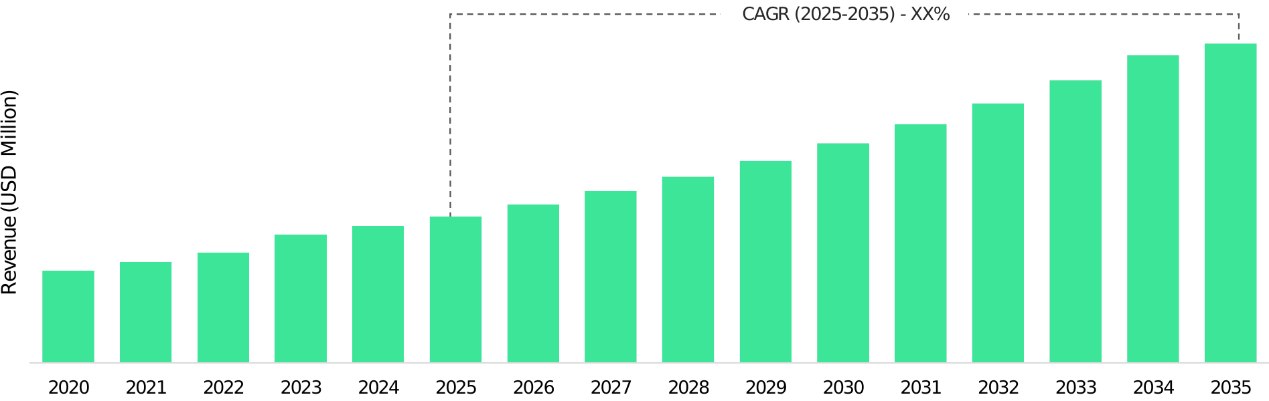
Source: Primary Interviews, Surveys, Secondary Sources, Web-Based & Paid External Databases, 2025

- Market Introduction – {{market_name_upper}} Market
  - Market Definition
Key trends in 2026 include the rapid scaling of e-methanol production, which utilizes captured $CO_2$ and green hydrogen, and a significant increase in bio-methanol projects leveraging agricultural and municipal waste. This transition offers a massive opportunity for chemical manufacturers to switch to renewable feedstocks, thereby reducing the Scope 3 emissions of consumer products. However, the market faces significant hurdles, including the massive price premium of green methanol over its fossil-based counterparts and the lack of widespread bunkering infrastructure. Opportunities lie in "Power-to-X" projects and the integration of carbon capture technologies at industrial sites. As governments provide more subsidies (like the U.S. Inflation Reduction Act), the market is shifting from pilot-scale demonstrations to industrial-grade production hubs.

  - Scope of the Study
This report segments the global {{market_name}} Market as follows:

GLOBAL {{MARKET_NAME_UPPER}} MARKET
- {{type_segment_1}}
- {{type_segment_2}}
- {{type_segment_3}}

By Type
Analysis
By Application Analysis
By Technology Analysis
By Region
Analysis
- {{app_segment_1}}
- {{app_segment_2}}
- {{app_segment_3}}
- {{app_segment_4}}

- {{tech_segment_1}}
- {{tech_segment_2}}
- {{tech_segment_3}}

- North America
- Europe
- Asia-Pacific
- Latin America
- Middle East & Africa
Source: 2025

  - Research Methodology
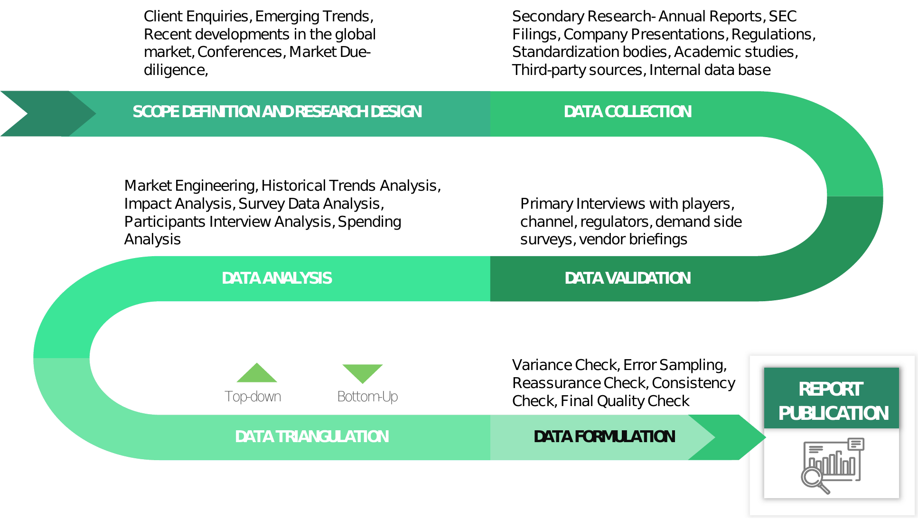
Source: 2025
We adopts a thorough and iterative research methodology designed to minimize deviations and deliver the most precise estimates and forecasts. The company applies both bottom-up and top-down approaches to segment the market and quantify key metrics accurately. A consistent feature across all our research reports is data triangulation, which examines the market from three distinct perspectives to enhance reliability. Core Industry of our research methodology include:



Preliminary Data Mining
The research process starts with the broad collection of raw market data sourced from validated and credible channels. This data undergoes continuous filtration to ensure only verified and relevant information is retained. In addition to leveraging proprietary databases and internal report archives, data is sourced from trusted, subscription-based Types.
To develop a holistic view of the market, the entire value chain is analyzed—gathering insights from TECHNOLOGYs suppliers, intermediaries, distributors, and Industry. Technical developments and industry challenges are captured through targeted surveys, expert conferences, and respected trade journals. Intellectual property research, including white space and freedom-to-operate analysis, adds depth to the Trial Phase evaluation. Key market drivers, restraints, pricing trends, and competitive dynamics are also compiled and validated against published data to ensure consistency and accuracy.

Statistical Model
Forecasts and market estimates are developed using tailored simulation models crafted for each specific study. Key inputs—including market drivers, pricing trends, product, and the evolving technological landscape—are analyzed concurrently using statistical methods such as regression analysis, time series forecasting, and correlation modeling.
Short-term forecasts rely heavily on econometric models, while long-term projections incorporate factors such as technological developments, regulatory shifts, macroeconomic trends, and strategic business insights. A bottom-up estimation approach is applied, starting at the regional level and aggregating to form global estimates, ensuring both accuracy and a comprehensive understanding of market dynamics:
Key parameters considered for forecasting include:
- Key market drivers and restraints are identified, along with an assessment of their projected impact over time.
- Trends in TECHNOLOGY availability and pricing are closely monitored to understand their influence on the market.
- The regulatory landscape is evaluated, including current frameworks and expected policy shifts.
- Existing capacity is analyzed, with forecasts extending to planned expansions through 2033.
A weighted average analysis is applied to assign appropriate significance to each factor, ensuring a balanced and comprehensive projection of market growth.
Primary Validation
Primary validation marks the final phase of our market estimation and forecasting process. At this stage, in-depth interviews are conducted—both in person and via phone—with key stakeholders to verify the accuracy of collected data and the assumptions driving our analysis.
Interviewees are carefully selected from leading organizations across the industry value chain, including product suppliers, Application developers, domain experts, and others. This diverse representation ensures a balanced and objective view of the market.
To ensure comprehensive global coverage, interviews are conducted across multiple regions, with language differences managed through local staff or professional interpreters. These conversations not only validate our findings but also provide valuable insights into current trends, evolving business conditions, and future developments, significantly enriching the quality of our analysis.
All projections are rigorously validated through direct engagement with Key Industry Participants (KIPs), typically comprising:
- Major industry players
- Product suppliers
- Distributors and logistics providers
- Product and Application buyers
The Key Objectives of Primary Research are as Follows:
- Verify the accuracy, credibility, and relevance of the gathered data
- Gain a clear understanding of current market dynamics and collect expert insights on anticipated future trends

  - Key Assumptions
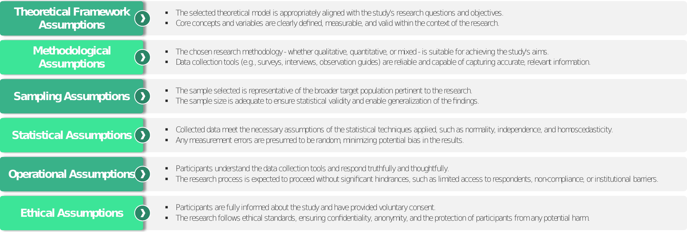

- Market Dynamics- {{market_name_upper}} Market
- Market Dynamics
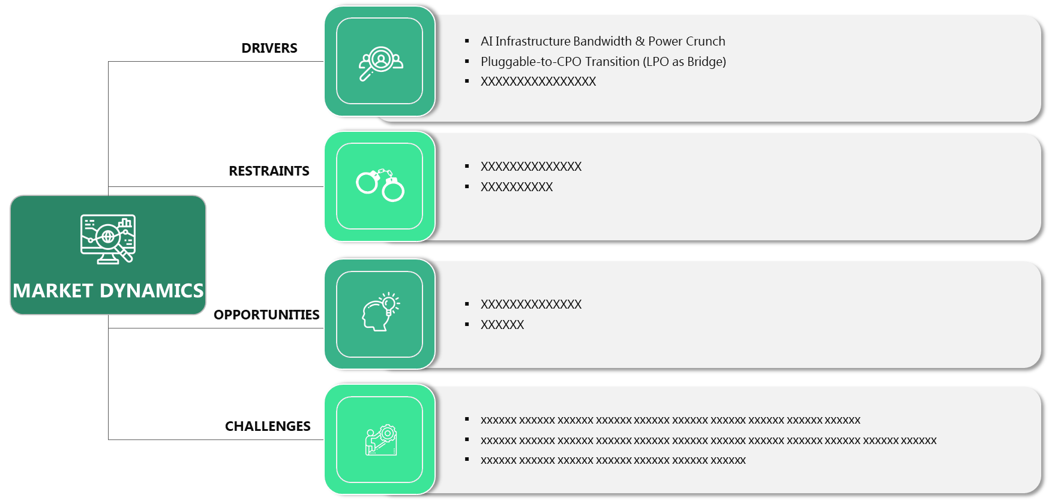
Source: 2025
  - Market Drivers
Decarbonization Mandates in the Maritime Industry
The maritime sector is the single most powerful engine driving the green methanol market in 2026. Historically, shipping has been one of the most difficult sectors to electrify due to the extreme energy density required for long-haul voyages. Green methanol has emerged as the frontrunner because it is liquid at ambient temperatures, making it significantly easier to handle and store than hydrogen or ammonia. The International Maritime Organization (IMO) has set a target to reach net-zero emissions by or around 2050, with "checkpoints" in 2030 and 2040. To meet these targets, shipowners are ordering hundreds of new methanol-ready vessels.
For instance, major shipping lines have committed billions to fleet renewal programs. This "vessel-led" demand creates a predictable offtake market for fuel producers, encouraging them to invest in large-scale production facilities. Furthermore, regional regulations such as the EU Emissions Trading System (ETS) and FuelEU Maritime have introduced financial penalties for high-carbon fuels in European waters. This makes the "green premium" of methanol more palatable for operators, as the cost of carbon credits begins to outweigh the extra cost of the fuel. The infrastructure transition is also relatively straightforward; existing bunker barges and storage tanks can be retrofitted for methanol with far less capital than is required for liquefied natural gas (LNG). This combination of regulatory pressure, corporate sustainability goals, and technical feasibility makes maritime decarbonization the primary catalyst for market expansion.

Scaling of Green Hydrogen and "Power-to-X" Infrastructure
The second major driver is the global expansion of Green Hydrogen production. Since e-methanol requires green hydrogen as a primary input, the decreasing cost of electrolyzers and the increasing abundance of renewable energy (wind and solar) are directly lowering the barriers to methanol production. In 2026, many nations are adopting "Power-to-X" strategies, where excess renewable electricity is converted into liquid fuels to prevent energy wastage during periods of oversupply. Green methanol serves as an ideal "liquid battery," allowing countries with high renewable potential, such as Chile, Australia, and Egypt, to export their sunshine and wind to energy-hungry regions in Europe and Asia.
The technological maturity of Carbon Capture and Utilization (CCU) is also playing a critical role. Industrial plants—such as cement kilns and steel mills—are increasingly capturing their $CO_2$ emissions to avoid carbon taxes. Instead of simply sequestering this carbon underground, they are partnering with methanol producers to use the $CO_2$ as a feedstock. This creates a circular economy where waste carbon becomes a valuable commodity. Government incentives, such as the Clean Hydrogen Production Tax Credit in the U.S., have further de-risked these projects, leading to a "gold rush" of investment. As electrolysis efficiency improves and the supply of green hydrogen stabilizes, the scalability of e-methanol will continue to accelerate, making it a competitive alternative to traditional fossil fuels.

  - Market Restraints
High Production Costs and the "Green Premium"
The most significant barrier to the adoption of green methanol is its prohibitively high cost compared to conventional "grey" methanol. In 2026, green methanol is estimated to cost anywhere from two to four times more than fossil-based methanol. The price of e-methanol is heavily dictated by the cost of renewable electricity and the current high capital expenditure (CapEx) of electrolyzers. While renewable energy prices have fallen, the intermittent nature of wind and solar requires expensive storage solutions or backup power to keep methanol synthesis plants running 24/7, which further inflates the final price per ton.
{{type_segment_1}}, while slightly cheaper than e-methanol, faces its own cost challenges related to feedstock logistics. Collecting, transporting, and processing biomass (such as agricultural waste) is a labor-intensive process with thin margins. Furthermore, the global supply of "truly sustainable" biomass is limited, leading to competition with other biofuels (like SAF) and driving up prices. For many cost-sensitive industries, particularly in developing economies, this "green premium" is a deal-breaker. Without massive carbon taxes on fossil fuels or significant government subsidies to bridge the price gap, many potential offtakers are hesitant to sign the 10- or 15-year contracts that producers need to secure project financing. This "chicken-and-egg" problem—where high costs prevent scaling, and a lack of scale keeps costs high—remains a persistent drag on the market.

  - Market Opportunities



  - Market Challenges

  - Technological Advancements & Innovations
- Technological Advancements & Innovations
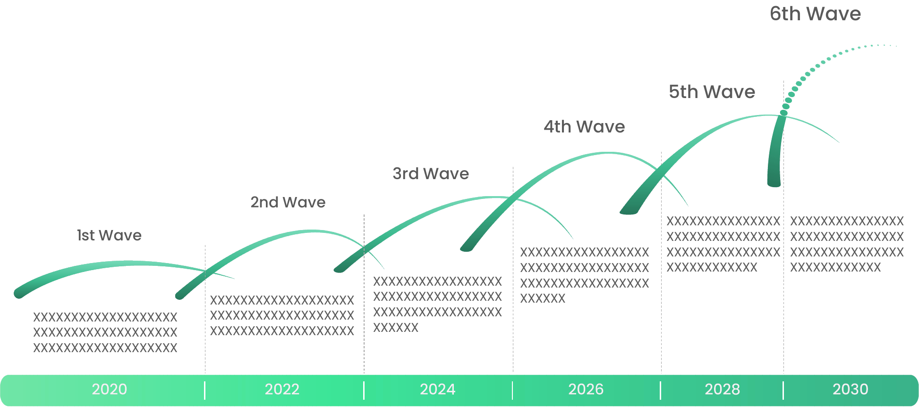
Source: 2025
- Industry Outlook- {{market_name_upper}} Market
  - Value Chain Analysis
- Value Chain Analysis
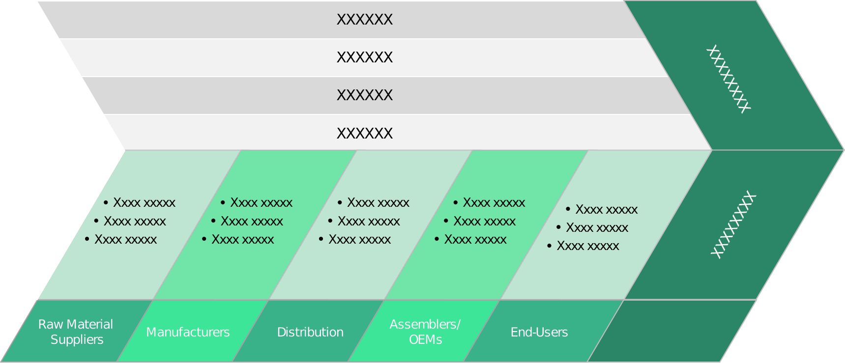
Source: 2025
Value Chain Analysis is a strategic framework used to examine the internal activities of a business or industry to understand how value is created and where competitive advantage can be gained. The objective is to analyze each step involved in the marketing, and delivery of a device or service, from initial sourcing to after-sales support, in order to identify opportunities for cost reduction, process improvement, or value enhancement.
The value chain is typically divided into two categories: primary activities and support activities. Primary activities are directly involved in the creation and delivery of a product or service. These include inbound logistics, which encompasses the receiving and storage; operations, which refers to the transformation of inputs into final product; outbound logistics, which involves the distribution of finished goods; marketing and sales, which focus on customer engagement and revenue generation; and service, which includes post-sale support such as maintenance and customer care.
Support activities, on the other hand, provide the necessary infrastructure and inputs that allow the primary activities to function efficiently. These include firm here infrastructure such as finance, planning, and legal; human resource management, which ensures the recruitment and development of skilled personnel; product development, which drives innovation and process improvement; and procurement, which involves acquiring the resources and inputs required for device.
Conducting a value chain analysis enables organizations to identify specific activities where value is added or lost. This insight supports strategic decisions such as outsourcing non-core functions, investing in product to streamline operations, or reengineering processes to better meet customer needs. Furthermore, by benchmarking against competitors, firms can assess where they hold cost or differentiation advantages within the value chain.
Ultimately, value chain analysis is a powerful tool for uncovering internal strengths and weaknesses, aligning operations with strategic goals, and enhancing overall organizational performance. It plays a crucial role in shaping competitive strategy by focusing on activities that contribute most to customer value and business success.

  - Regulatory Landscape

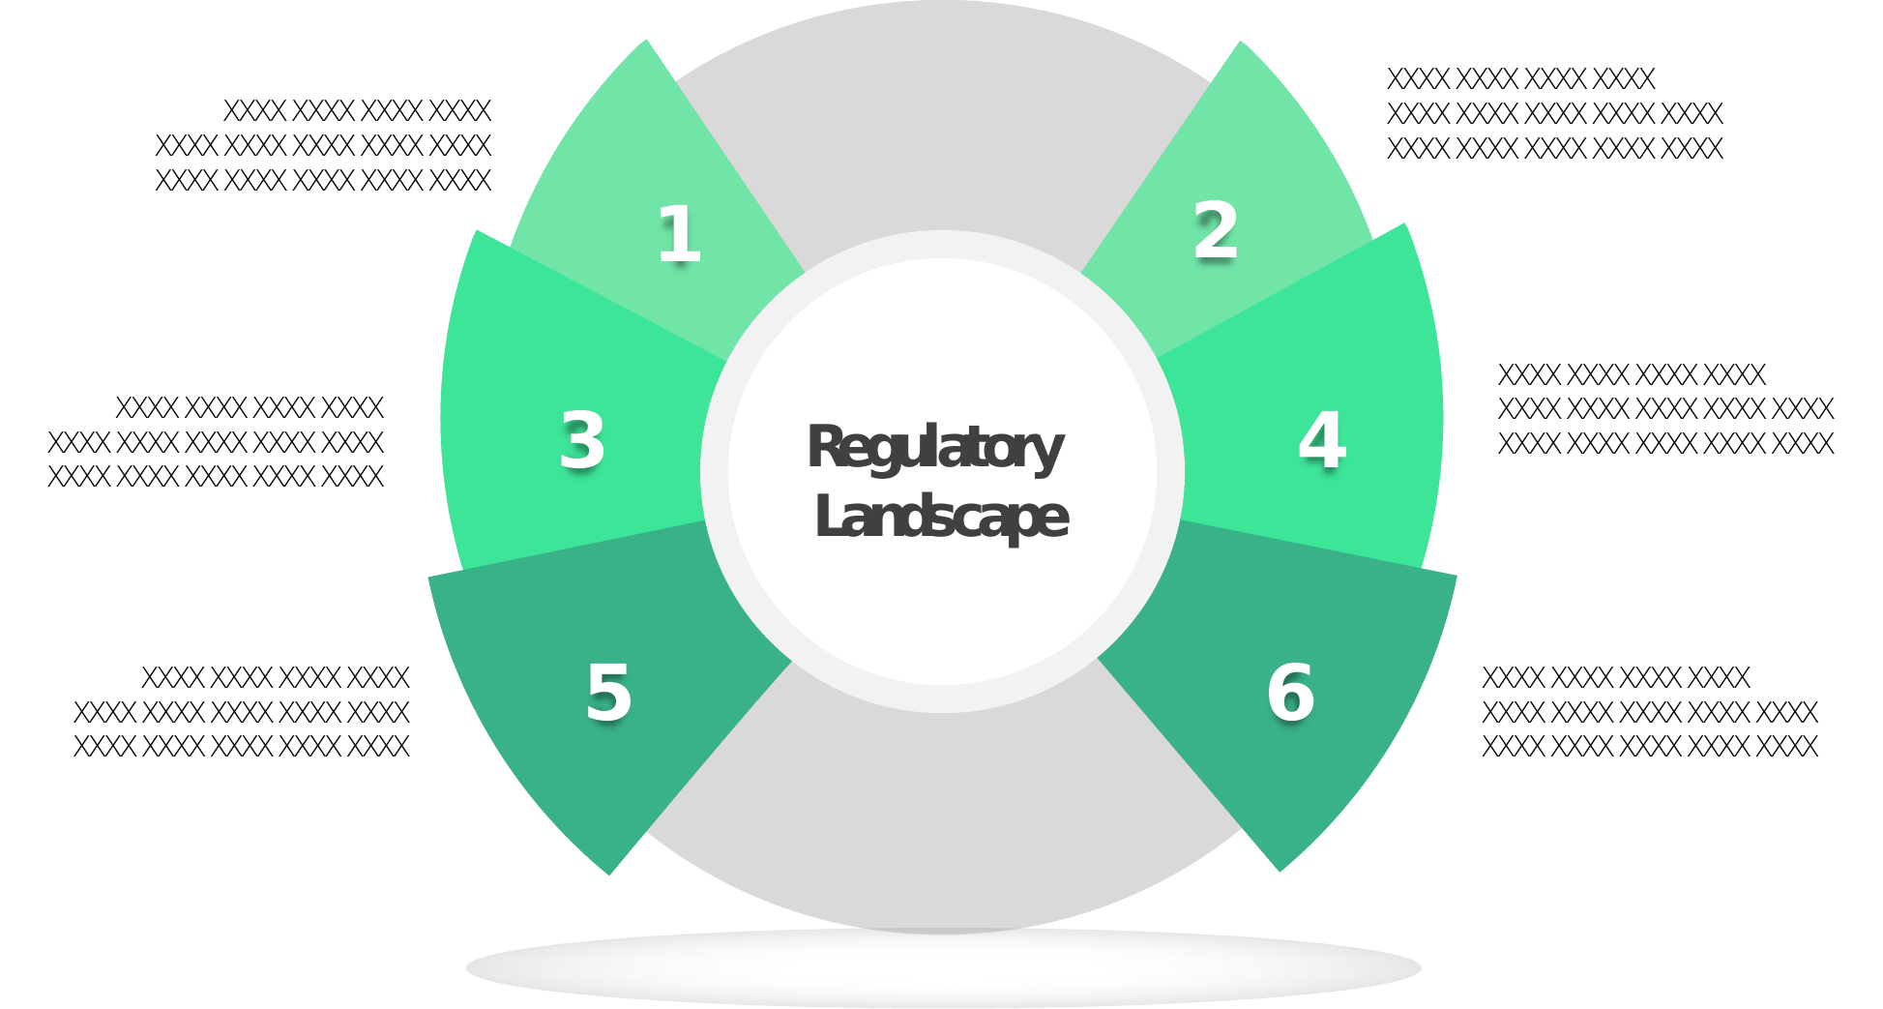
Source: 2025

  - ESG (Environmental, Social, Governance) Impact
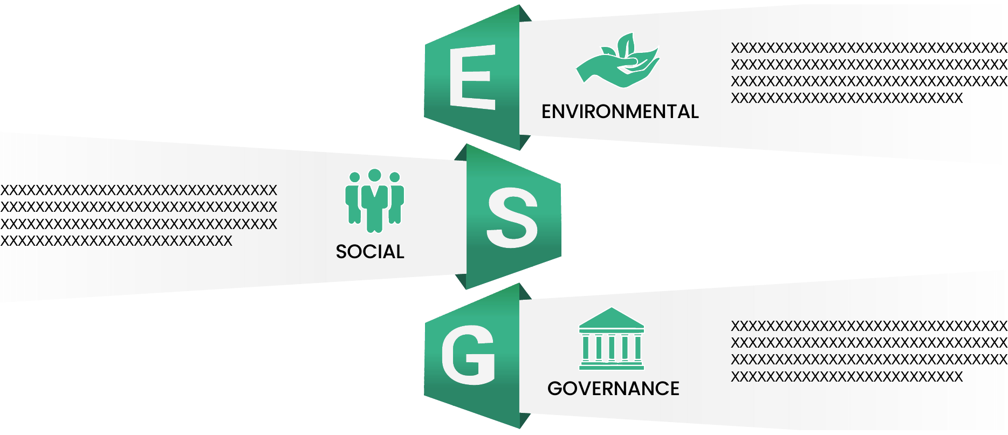
Source: 2025

  - PESTLE Analysis
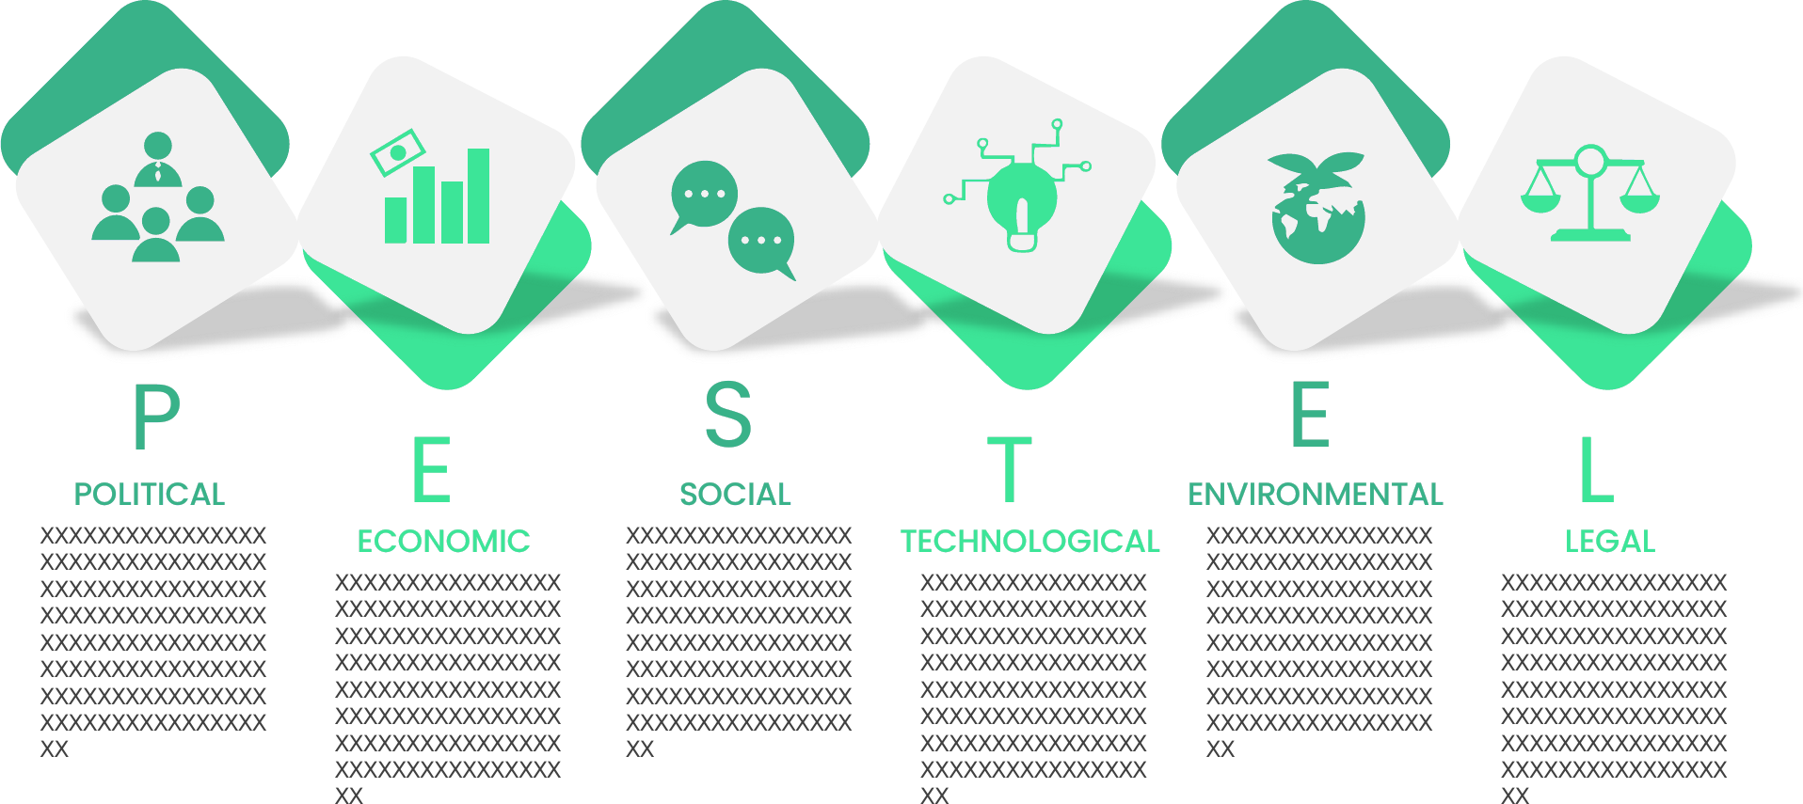
Source: 2025

  - Porter’s Five Forces Analysis
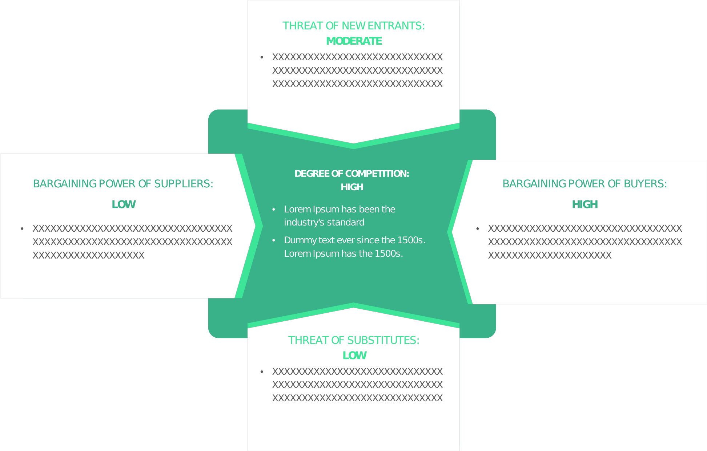
Source: 2025
  - Emerging Business Models & Ecosystem Partnerships

  - Market Attractiveness
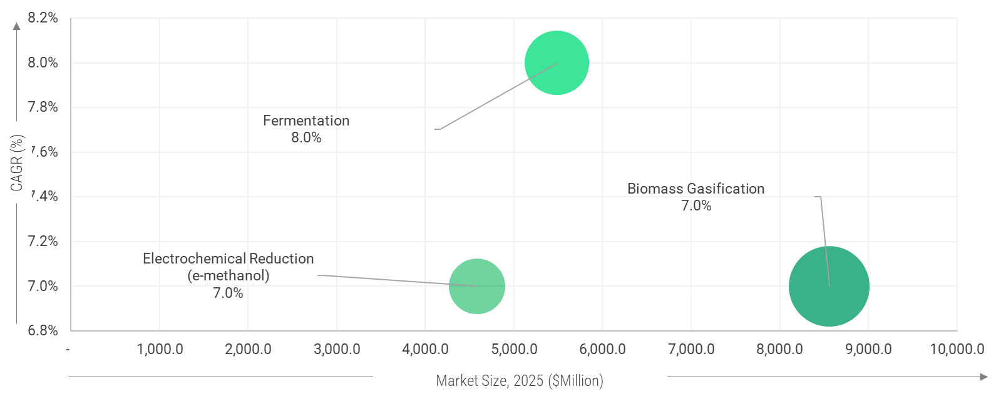
CAGR (%)
Market Size, 2025 ($Million)
Source: 2025
Note: The Above figures are for illustrative purposes and similar attractiveness will be covered for rest of segmentation.

  - {{ch4_custom_section_1_title}}

  - {{ch4_custom_section_2_title}}

  - {{ch4_custom_section_3_title}}
  - {{ch4_custom_section_4_title}}
    - {{ch4_custom_subsection_4_1_title}}

- {{market_name_upper}} Market – Type Analysis
  - {{report_geography}} {{market_name_upper}} Market –Type OVERVIEW

  - {{report_geography}} {{market_name_upper}} Market Share, by Type, 2024 & 2035 (%)
- {{report_geography}} {{market_name_upper}} Market Share, by Type, 2024 & 2035 (%)
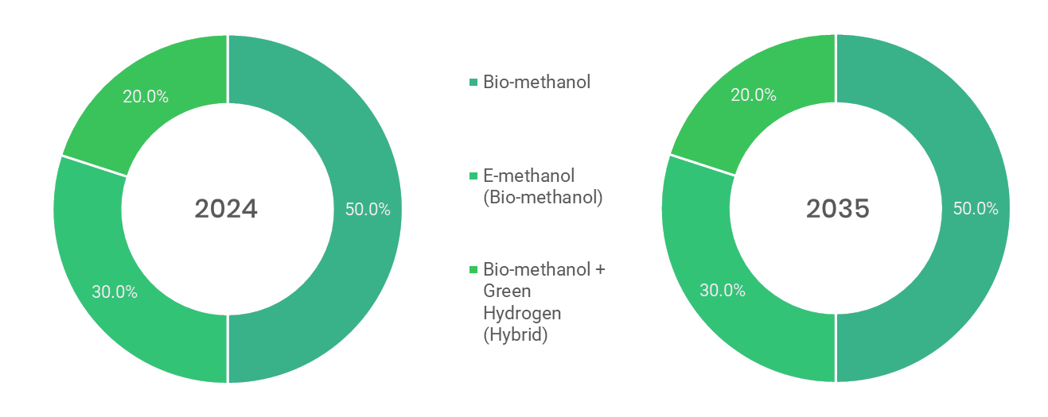
Source: Primary Interviews, Surveys, Secondary Sources, Web-Based & Paid External Databases, 2025
Note: Charts & Figures only for Illustration purposes
- {{report_geography}} {{market_name_upper}} Market, by Type, 2020 - 2035 (USD MILLION)
By Type | {{history_start_year}} | 2021 | 2022 | 2023 | {{base_year}} | {{forecast_start_year}} | 2026 | 2027 | 2028 | 2029 | 2030 | 2031 | 2032 | 2033 | 2034 | 20235 | CAGR%  (2025-2035)
{{type_segment_1}} | XX | XX | XX | XX | XX | XX | XX | XX | XX | XX | XX | XX | XX | XX | XX | XX | XX
{{type_segment_2}} | XX | XX | XX | XX | XX | XX | XX | XX | XX | XX | XX | XX | XX | XX | XX | XX | XX
{{type_segment_3}} | XX | XX | XX | XX | XX | XX | XX | XX | XX | XX | XX | XX | XX | XX | XX | XX | XX
Total | XX | XX | XX | XX | XX | XX | XX | XX | XX | XX | XX | XX | XX | XX | XX | XX | XX
Source: Primary Interviews, Surveys, Secondary Sources, Web-Based & Paid External Databases, 2025

  - {{type_segment_1}}
    - {{report_geography}} {{market_name_upper}} Market by {{type_segment_1}}, 2020 – 2035 (usd million)
- {{report_geography}} {{market_name_upper}} Market by {{type_segment_1}}, 2020 - 2035
Source: Primary Interviews, Surveys, Secondary Sources, Web-Based & Paid External Databases, 2025

- {{report_geography}} {{market_name_upper}} Market by {{type_segment_1}}, by Region, 2020 - 2035
By Region | {{history_start_year}} | 2021 | 2022 | 2023 | {{base_year}} | {{forecast_start_year}} | 2026 | 2027 | 2028 | 2029 | 2030 | 2031 | 2032 | 2033 | 2034 | {{forecast_end_year}} | CAGR%  (2025-2035)
North America | XX | XX | XX | XX | XX | XX | XX | XX | XX | XX | XX | XX | XX | XX | XX | XX | XX
Europe | XX | XX | XX | XX | XX | XX | XX | XX | XX | XX | XX | XX | XX | XX | XX | XX | XX
Asia-Pacific | XX | XX | XX | XX | XX | XX | XX | XX | XX | XX | XX | XX | XX | XX | XX | XX | XX
Latin America | XX | XX | XX | XX | XX | XX | XX | XX | XX | XX | XX | XX | XX | XX | XX | XX | XX
Middle East & Africa | XX | XX | XX | XX | XX | XX | XX | XX | XX | XX | XX | XX | XX | XX | XX | XX | XX
Total | XX | XX | XX | XX | XX | XX | XX | XX | XX | XX | XX | XX | XX | XX | XX | XX | XX
Source: Primary Interviews, Surveys, Secondary Sources, Web-Based & Paid External Databases, 2025

*The above similar information will be cover for below segment as well.
  - {{type_segment_2}}
  - {{type_segment_3}}
- {{market_name_upper}} Market – Technology Analysis
  - {{report_geography}} {{market_name_upper}} Market – Overview

  - {{report_geography}} {{market_name_upper}} Market Share, by Technology, 2024 & 2035 (%)
- {{report_geography}} {{market_name_upper}} Market Share, by Technology, 2024 & 2035
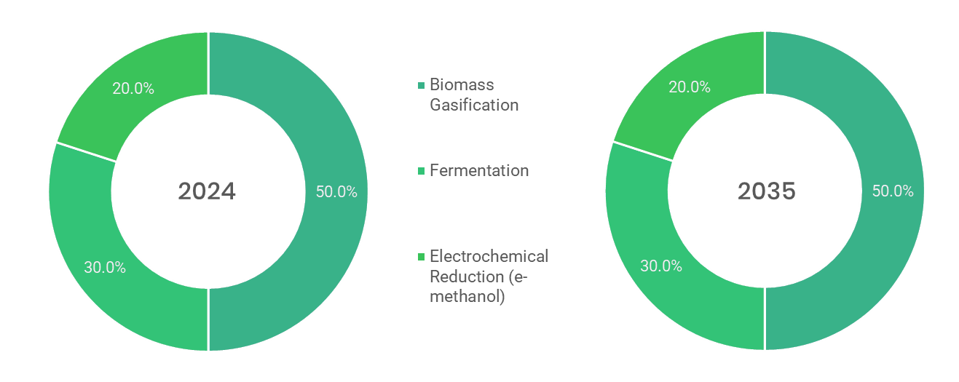
Source: Primary Interviews, Surveys, Secondary Sources, Web-Based & Paid External Databases, 2025
Note: Charts & Figures are only for Illustration purposes

- {{report_geography}} {{market_name_upper}} Market, by Technology, 2020 - 2035 (USD MILLION)
By TECHNOLOGY | {{history_start_year}} | 2021 | 2022 | 2023 | {{base_year}} | {{forecast_start_year}} | 2026 | 2027 | 2028 | 2029 | 2030 | 2031 | 2032 | 2033 | 2034 | {{forecast_end_year}} | CAGR%  (2025-2035)
{{tech_segment_1}} | XX | XX | XX | XX | XX | XX | XX | XX | XX | XX | XX | XX | XX | XX | XX | XX | XX
{{tech_segment_2}} | XX | XX | XX | XX | XX | XX | XX | XX | XX | XX | XX | XX | XX | XX | XX | XX | XX
{{tech_segment_3}} | XX | XX | XX | XX | XX | XX | XX | XX | XX | XX | XX | XX | XX | XX | XX | XX | XX
Total | XX | XX | XX | XX | XX | XX | XX | XX | XX | XX | XX | XX | XX | XX | XX | XX | XX
Source: Primary Interviews, Surveys, Secondary Sources, Web-Based & Paid External Databases, 2025

  - {{tech_segment_1}}
    - {{report_geography}} {{market_name_upper}} Market for {{tech_segment_1}}, 2020 – 2035 (USD MILLION)
- {{report_geography}} {{market_name_upper}} Market for {{tech_segment_1}}, 2020 - 2035 (USD MILLION)
Source: Primary Interviews, Surveys, Secondary Sources, Web-Based & Paid External Databases, 2025

- {{report_geography}} {{market_name_upper}} Market for {{tech_segment_1}}, by Region, 2020 - 2035 (USD MILLION)
By Region | {{history_start_year}} | 2021 | 2022 | 2023 | {{base_year}} | {{forecast_start_year}} | 2026 | 2027 | 2028 | 2029 | 2030 | 2031 | 2032 | 2033 | 2034 | {{forecast_end_year}} | CAGR%  (2025-2035)
North America | XX | XX | XX | XX | XX | XX | XX | XX | XX | XX | XX | XX | XX | XX | XX | XX | XX
Europe | XX | XX | XX | XX | XX | XX | XX | XX | XX | XX | XX | XX | XX | XX | XX | XX | XX
Asia-Pacific | XX | XX | XX | XX | XX | XX | XX | XX | XX | XX | XX | XX | XX | XX | XX | XX | XX
Latin America | XX | XX | XX | XX | XX | XX | XX | XX | XX | XX | XX | XX | XX | XX | XX | XX | XX
Middle East & Africa | XX | XX | XX | XX | XX | XX | XX | XX | XX | XX | XX | XX | XX | XX | XX | XX | XX
Total | XX | XX | XX | XX | XX | XX | XX | XX | XX | XX | XX | XX | XX | XX | XX | XX | XX
Source: Primary Interviews, Surveys, Secondary Sources, Web-Based & Paid External Databases, 2025

*The above similar information will be cover for below segment.
  - {{tech_segment_2}}
  - {{tech_segment_3}}
- {{market_name_upper}} Market –Application Analysis
  - {{report_geography}} {{market_name_upper}} Market –Application Overview

  - {{report_geography}} {{market_name_upper}} Market Share, by Application, 2024 & 2035 (%)
- {{report_geography}} {{market_name_upper}} Market Share, by Application, 2024 & 2035 (%)
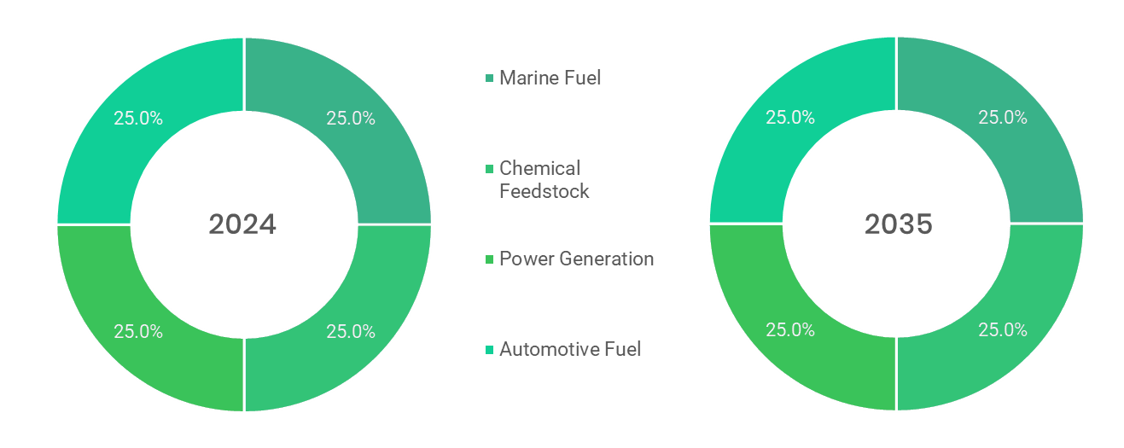
Source: Primary Interviews, Surveys, Secondary Sources, Web-Based & Paid External Databases, 2025
Note: Charts & Figures only for Illustration purposes
- {{report_geography}} {{market_name_upper}} Market, by Application, 2020 – 2035 (USD MILLION)
By Application | {{history_start_year}} | 2021 | 2022 | 2023 | {{base_year}} | {{forecast_start_year}} | 2026 | 2027 | 2028 | 2029 | 2030 | 2031 | 2032 | 2033 | 2034 | {{forecast_end_year}} | CAGR%  (2025-2035)
{{app_segment_1}} | XX | XX | XX | XX | XX | XX | XX | XX | XX | XX | XX | XX | XX | XX | XX | XX | XX
{{app_segment_4}} | XX | XX | XX | XX | XX | XX | XX | XX | XX | XX | XX | XX | XX | XX | XX | XX | XX
{{app_segment_2}} | XX | XX | XX | XX | XX | XX | XX | XX | XX | XX | XX | XX | XX | XX | XX | XX | XX
{{app_segment_3}} | XX | XX | XX | XX | XX | XX | XX | XX | XX | XX | XX | XX | XX | XX | XX | XX | XX
Total | XX | XX | XX | XX | XX | XX | XX | XX | XX | XX | XX | XX | XX | XX | XX | XX | XX
Source: Primary Interviews, Surveys, Secondary Sources, Web-Based & Paid External Databases, 2025

  - {{app_segment_1}}
    - {{report_geography}} {{market_name_upper}} Market by {{app_segment_1}}, 2020 - 2035 (USD MILLION)
- {{report_geography}} {{market_name_upper}} Market by {{app_segment_1}}, 2020 – 2035 (USD MILLION)
Source: Primary Interviews, Surveys, Secondary Sources, Web-Based & Paid External Databases, 2025

- {{report_geography}} {{market_name_upper}} Market by {{app_segment_1}}, by Region, 2020 – 2035 (USD MILLION)
By Region | {{history_start_year}} | 2021 | 2022 | 2023 | {{base_year}} | {{forecast_start_year}} | 2026 | 2027 | 2028 | 2029 | 2030 | 2031 | 2032 | 2033 | 2034 | {{forecast_end_year}} | CAGR%  (2025-2035)
North America | XX | XX | XX | XX | XX | XX | XX | XX | XX | XX | XX | XX | XX | XX | XX | XX | XX
Europe | XX | XX | XX | XX | XX | XX | XX | XX | XX | XX | XX | XX | XX | XX | XX | XX | XX
Asia-Pacific | XX | XX | XX | XX | XX | XX | XX | XX | XX | XX | XX | XX | XX | XX | XX | XX | XX
Latin America | XX | XX | XX | XX | XX | XX | XX | XX | XX | XX | XX | XX | XX | XX | XX | XX | XX
Middle East & Africa | XX | XX | XX | XX | XX | XX | XX | XX | XX | XX | XX | XX | XX | XX | XX | XX | XX
Total | XX | XX | XX | XX | XX | XX | XX | XX | XX | XX | XX | XX | XX | XX | XX | XX | XX
Source: Primary Interviews, Surveys, Secondary Sources, Web-Based & Paid External Databases, 2025
*The above similar information will be cover for below segment as well.
  - {{app_segment_2}}
  - {{app_segment_3}}

XXX
- {{market_name_upper}} Market –{{seg4_name}} Analysis
  - {{report_geography}} {{market_name_upper}} Market –{{seg4_name}} Overview

  - {{report_geography}} {{market_name_upper}} Market Share, by {{seg4_name}}, 2024 & 2035 (%)
- {{report_geography}} {{market_name_upper}} Market Share, by {{seg4_name}}, 2024 & 2035 (%)
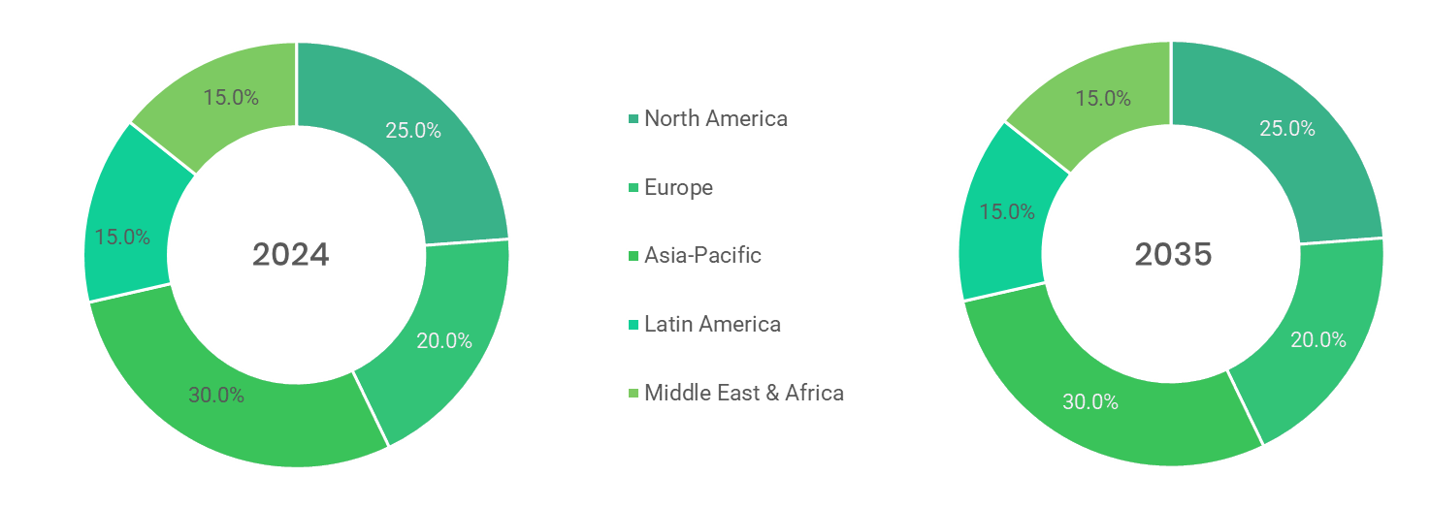
Source: Primary Interviews, Surveys, Secondary Sources, Web-Based & Paid External Databases, 2025
Note: Charts & Figures only for Illustration purposes
- {{report_geography}} {{market_name_upper}} Market, by {{seg4_name}}, 2020 – 2035 (USD MILLION)
By {{seg4_name}} | {{history_start_year}} | 2021 | 2022 | 2023 | {{base_year}} | {{forecast_start_year}} | 2026 | 2027 | 2028 | 2029 | 2030 | 2031 | 2032 | 2033 | 2034 | {{forecast_end_year}} | CAGR%  (2025-2035)
{{seg4_sub1}} | XX | XX | XX | XX | XX | XX | XX | XX | XX | XX | XX | XX | XX | XX | XX | XX | XX
{{seg4_sub2}} | XX | XX | XX | XX | XX | XX | XX | XX | XX | XX | XX | XX | XX | XX | XX | XX | XX
{{seg4_sub3}} | XX | XX | XX | XX | XX | XX | XX | XX | XX | XX | XX | XX | XX | XX | XX | XX | XX
Sub-{{seg4_name}} | XX | XX | XX | XX | XX | XX | XX | XX | XX | XX | XX | XX | XX | XX | XX | XX | XX
Total | XX | XX | XX | XX | XX | XX | XX | XX | XX | XX | XX | XX | XX | XX | XX | XX | XX
Source: Primary Interviews, Surveys, Secondary Sources, Web-Based & Paid External Databases, 2025

  - {{seg4_sub1}}
    - {{report_geography}} {{market_name_upper}} Market by {{seg4_sub1}}, 2020 - 2035 (USD MILLION)
- {{report_geography}} {{market_name_upper}} Market by {{seg4_sub1}}, 2020 – 2035 (USD MILLION)
Source: Primary Interviews, Surveys, Secondary Sources, Web-Based & Paid External Databases, 2025

- {{report_geography}} {{market_name_upper}} Market by {{seg4_sub1}}, by Region, 2020 – 2035 (USD MILLION)
By Region | {{history_start_year}} | 2021 | 2022 | 2023 | {{base_year}} | {{forecast_start_year}} | 2026 | 2027 | 2028 | 2029 | 2030 | 2031 | 2032 | 2033 | 2034 | {{forecast_end_year}} | CAGR%  (2025-2035)
North America | XX | XX | XX | XX | XX | XX | XX | XX | XX | XX | XX | XX | XX | XX | XX | XX | XX
Europe | XX | XX | XX | XX | XX | XX | XX | XX | XX | XX | XX | XX | XX | XX | XX | XX | XX
Asia-Pacific | XX | XX | XX | XX | XX | XX | XX | XX | XX | XX | XX | XX | XX | XX | XX | XX | XX
Latin America | XX | XX | XX | XX | XX | XX | XX | XX | XX | XX | XX | XX | XX | XX | XX | XX | XX
Middle East & Africa | XX | XX | XX | XX | XX | XX | XX | XX | XX | XX | XX | XX | XX | XX | XX | XX | XX
Total | XX | XX | XX | XX | XX | XX | XX | XX | XX | XX | XX | XX | XX | XX | XX | XX | XX
Source: Primary Interviews, Surveys, Secondary Sources, Web-Based & Paid External Databases, 2025
*The above similar information will be cover for below segment as well.
  - {{seg4_sub2}}
  - {{seg4_sub3}}
  - Sub-{{seg4_name}}
X
X

- {{market_name_upper}} Market –{{seg5_name}} Analysis
  - {{report_geography}} {{market_name_upper}} Market –{{seg5_name}} Overview

  - {{report_geography}} {{market_name_upper}} Market Share, by {{seg5_name}}, 2024 & 2035 (%)
- {{report_geography}} {{market_name_upper}} Market Share, by {{seg5_name}}, 2024 & 2035 (%)
Source: Primary Interviews, Surveys, Secondary Sources, Web-Based & Paid External Databases, 2025
Note: Charts & Figures only for Illustration purposes
- {{report_geography}} {{market_name_upper}} Market, by {{seg5_name}}, 2020 – 2035 (USD MILLION)
By {{seg5_name}} | {{history_start_year}} | 2021 | 2022 | 2023 | {{base_year}} | {{forecast_start_year}} | 2026 | 2027 | 2028 | 2029 | 2030 | 2031 | 2032 | 2033 | 2034 | {{forecast_end_year}} | CAGR%  (2025-2035)
{{seg5_sub1}} | XX | XX | XX | XX | XX | XX | XX | XX | XX | XX | XX | XX | XX | XX | XX | XX | XX
{{seg5_sub2}} | XX | XX | XX | XX | XX | XX | XX | XX | XX | XX | XX | XX | XX | XX | XX | XX | XX
{{seg5_sub3}} | XX | XX | XX | XX | XX | XX | XX | XX | XX | XX | XX | XX | XX | XX | XX | XX | XX
Sub-{{seg4_name}} | XX | XX | XX | XX | XX | XX | XX | XX | XX | XX | XX | XX | XX | XX | XX | XX | XX
Total | XX | XX | XX | XX | XX | XX | XX | XX | XX | XX | XX | XX | XX | XX | XX | XX | XX
Source: Primary Interviews, Surveys, Secondary Sources, Web-Based & Paid External Databases, 2025

  - {{seg5_sub1}}
    - {{report_geography}} {{market_name_upper}} Market by {{seg5_sub1}}, 2020 - 2035 (USD MILLION)
- {{report_geography}} {{market_name_upper}} Market by {{seg5_sub1}}, 2020 – 2035 (USD MILLION)
Source: Primary Interviews, Surveys, Secondary Sources, Web-Based & Paid External Databases, 2025

- {{report_geography}} {{market_name_upper}} Market by {{seg5_sub1}}, by Region, 2020 – 2035 (USD MILLION)
By Region | {{history_start_year}} | 2021 | 2022 | 2023 | {{base_year}} | {{forecast_start_year}} | 2026 | 2027 | 2028 | 2029 | 2030 | 2031 | 2032 | 2033 | 2034 | {{forecast_end_year}} | CAGR%  (2025-2035)
North America | XX | XX | XX | XX | XX | XX | XX | XX | XX | XX | XX | XX | XX | XX | XX | XX | XX
Europe | XX | XX | XX | XX | XX | XX | XX | XX | XX | XX | XX | XX | XX | XX | XX | XX | XX
Asia-Pacific | XX | XX | XX | XX | XX | XX | XX | XX | XX | XX | XX | XX | XX | XX | XX | XX | XX
Latin America | XX | XX | XX | XX | XX | XX | XX | XX | XX | XX | XX | XX | XX | XX | XX | XX | XX
Middle East & Africa | XX | XX | XX | XX | XX | XX | XX | XX | XX | XX | XX | XX | XX | XX | XX | XX | XX
Total | XX | XX | XX | XX | XX | XX | XX | XX | XX | XX | XX | XX | XX | XX | XX | XX | XX
Source: Primary Interviews, Surveys, Secondary Sources, Web-Based & Paid External Databases, 2025
*The above similar information will be cover for below segment as well.
  - {{seg5_sub2}}
  - {{seg5_sub3}}
  - Sub-{{seg4_name}}

x

- {{market_name_upper}} Market –{{seg6_name}} Analysis
  - {{report_geography}} {{market_name_upper}} Market –{{seg6_name}} Overview

  - {{report_geography}} {{market_name_upper}} Market Share, by {{seg6_name}}, 2024 & 2035 (%)
- {{report_geography}} {{market_name_upper}} Market Share, by {{seg6_name}}, 2024 & 2035 (%)
Source: Primary Interviews, Surveys, Secondary Sources, Web-Based & Paid External Databases, 2025
Note: Charts & Figures only for Illustration purposes
- {{report_geography}} {{market_name_upper}} Market, by {{seg6_name}}, 2020 – 2035 (USD MILLION)
By {{seg5_name}} | {{history_start_year}} | 2021 | 2022 | 2023 | {{base_year}} | {{forecast_start_year}} | 2026 | 2027 | 2028 | 2029 | 2030 | 2031 | 2032 | 2033 | 2034 | {{forecast_end_year}} | CAGR%  (2025-2035)
{{seg6_sub1}} | XX | XX | XX | XX | XX | XX | XX | XX | XX | XX | XX | XX | XX | XX | XX | XX | XX
{{seg6_sub2}} | XX | XX | XX | XX | XX | XX | XX | XX | XX | XX | XX | XX | XX | XX | XX | XX | XX
{{seg6_sub3}} | XX | XX | XX | XX | XX | XX | XX | XX | XX | XX | XX | XX | XX | XX | XX | XX | XX
Sub-{{seg4_name}} | XX | XX | XX | XX | XX | XX | XX | XX | XX | XX | XX | XX | XX | XX | XX | XX | XX
Total | XX | XX | XX | XX | XX | XX | XX | XX | XX | XX | XX | XX | XX | XX | XX | XX | XX
Source: Primary Interviews, Surveys, Secondary Sources, Web-Based & Paid External Databases, 2025

  - {{seg6_sub1}}
    - {{report_geography}} {{market_name_upper}} Market by {{seg6_sub1}}, 2020 - 2035 (USD MILLION)
- {{report_geography}} {{market_name_upper}} Market by {{seg6_sub1}}, 2020 – 2035 (USD MILLION)
Source: Primary Interviews, Surveys, Secondary Sources, Web-Based & Paid External Databases, 2025

- {{report_geography}} {{market_name_upper}} Market by {{seg6_sub1}}, by Region, 2020 – 2035 (USD MILLION)
By Region | {{history_start_year}} | 2021 | 2022 | 2023 | {{base_year}} | {{forecast_start_year}} | 2026 | 2027 | 2028 | 2029 | 2030 | 2031 | 2032 | 2033 | 2034 | {{forecast_end_year}} | CAGR%  (2025-2035)
North America | XX | XX | XX | XX | XX | XX | XX | XX | XX | XX | XX | XX | XX | XX | XX | XX | XX
Europe | XX | XX | XX | XX | XX | XX | XX | XX | XX | XX | XX | XX | XX | XX | XX | XX | XX
Asia-Pacific | XX | XX | XX | XX | XX | XX | XX | XX | XX | XX | XX | XX | XX | XX | XX | XX | XX
Latin America | XX | XX | XX | XX | XX | XX | XX | XX | XX | XX | XX | XX | XX | XX | XX | XX | XX
Middle East & Africa | XX | XX | XX | XX | XX | XX | XX | XX | XX | XX | XX | XX | XX | XX | XX | XX | XX
Total | XX | XX | XX | XX | XX | XX | XX | XX | XX | XX | XX | XX | XX | XX | XX | XX | XX
Source: Primary Interviews, Surveys, Secondary Sources, Web-Based & Paid External Databases, 2025
*The above similar information will be cover for below segment as well.
  - {{seg6_sub2}}
  - {{seg6_sub3}}
  - Sub-{{seg4_name}}

- {{market_name_upper}} Market – Regional Analysis
  - {{report_geography}} {{market_name_upper}} Market Regional Overview
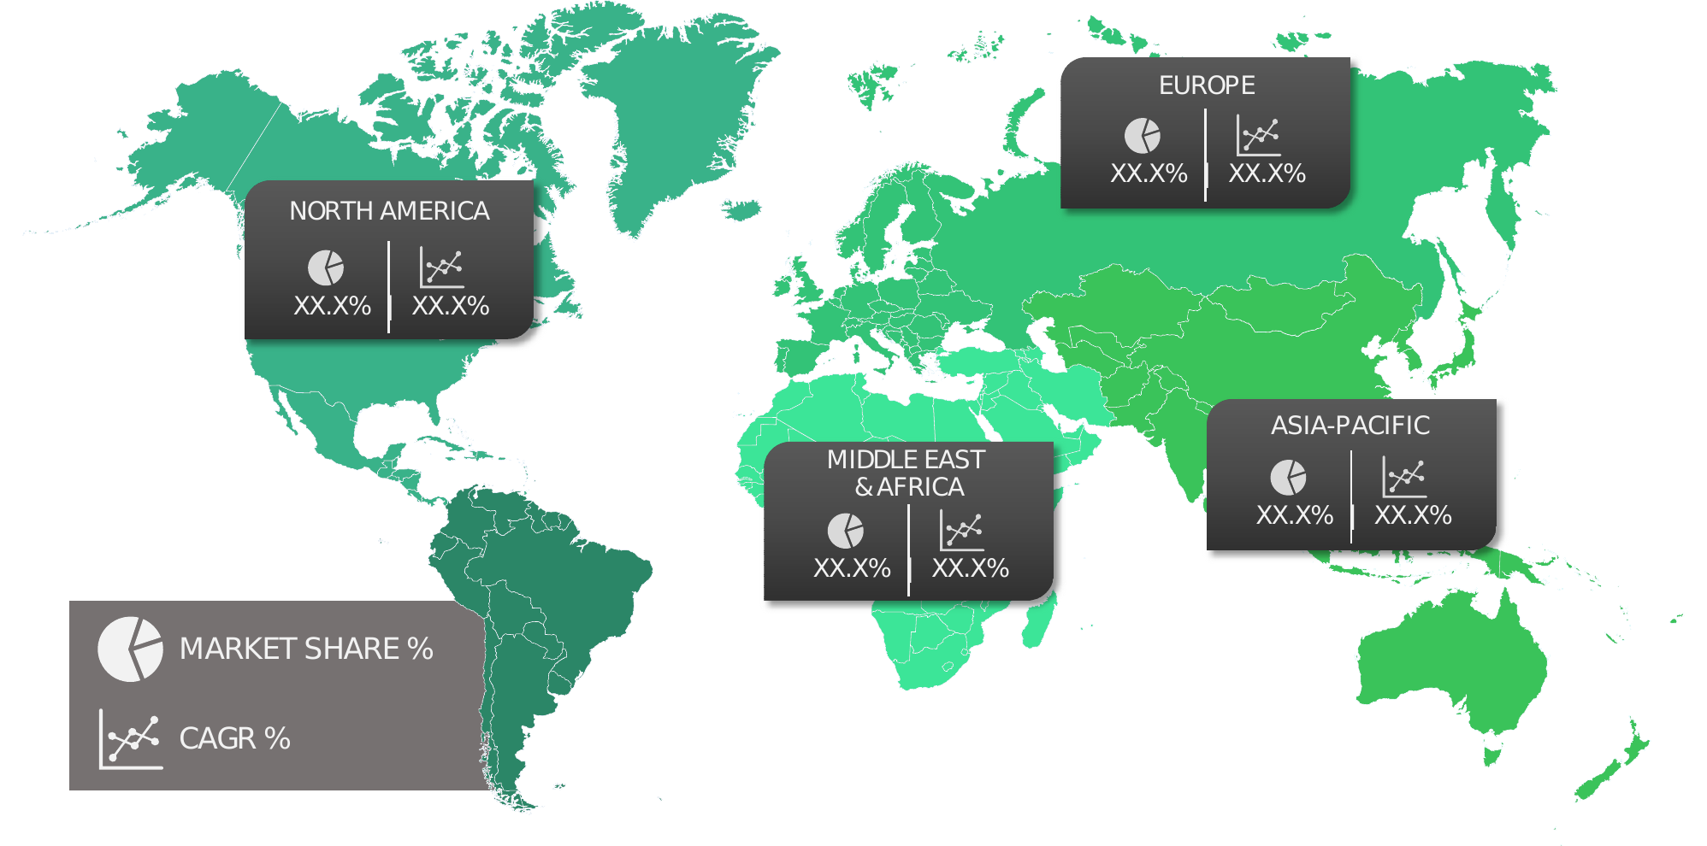

  - {{report_geography}} {{market_name_upper}} Market Share, by Region, 2024 & 2035 (%)
- {{report_geography}} {{market_name_upper}} Market Share, by Region, 2024 & 2035 (%)
Source: Primary Interviews, Surveys, Secondary Sources, Web-Based & Paid External Databases, 2025
Note: Charts & Figures are only for Illustration purposes
- {{report_geography}} {{market_name_upper}} Market, by Region, 2020 – 2035 (USD MILLION)
By Region | {{history_start_year}} | 2021 | 2022 | 2023 | {{base_year}} | {{forecast_start_year}} | 2026 | 2027 | 2028 | 2029 | 2030 | 2031 | 2032 | 2033 | 2034 | {{forecast_end_year}} | CAGR%  (2025-2035)
North America | XX | XX | XX | XX | XX | XX | XX | XX | XX | XX | XX | XX | XX | XX | XX | XX | XX
Europe | XX | XX | XX | XX | XX | XX | XX | XX | XX | XX | XX | XX | XX | XX | XX | XX | XX
Asia-Pacific | XX | XX | XX | XX | XX | XX | XX | XX | XX | XX | XX | XX | XX | XX | XX | XX | XX
Latin America | XX | XX | XX | XX | XX | XX | XX | XX | XX | XX | XX | XX | XX | XX | XX | XX | XX
Middle East & Africa | XX | XX | XX | XX | XX | XX | XX | XX | XX | XX | XX | XX | XX | XX | XX | XX | XX
Total | XX | XX | XX | XX | XX | XX | XX | XX | XX | XX | XX | XX | XX | XX | XX | XX | XX
Source: Primary Interviews, Surveys, Secondary Sources, Web-Based & Paid External Databases, 2025

  - North America
    - North America {{market_name_upper}} Market, 2020 - 2035 (USD MILLION)
- North America {{market_name_upper}} Market, 2020 - 2035 (USD MILLION)
Source: Primary Interviews, Surveys, Secondary Sources, Web-Based & Paid External Databases, 2025

    - North America {{market_name_upper}} Market, by Country, 2020 – 2035 (USD MILLION)
- North America {{market_name_upper}} Market, by Country, 2020 – 2035 (USD MILLION)
By Country | {{history_start_year}} | 2021 | 2022 | 2023 | {{base_year}} | {{forecast_start_year}} | 2026 | 2027 | 2028 | 2029 | 2030 | 2031 | 2032 | 2033 | 2034 | {{forecast_end_year}} | CAGR%  (2025-2035)
U.S. | XX | XX | XX | XX | XX | XX | XX | XX | XX | XX | XX | XX | XX | XX | XX | XX | XX
Canada | XX | XX | XX | XX | XX | XX | XX | XX | XX | XX | XX | XX | XX | XX | XX | XX | XX
Mexico | XX | XX | XX | XX | XX | XX | XX | XX | XX | XX | XX | XX | XX | XX | XX | XX | XX
Total | XX | XX | XX | XX | XX | XX | XX | XX | XX | XX | XX | XX | XX | XX | XX | XX | XX
Source: Primary Interviews, Surveys, Secondary Sources, Web-Based & Paid External Databases, 2025

    - North America {{market_name_upper}} Market, by Type, 2020 – 2035 (USD MILLION)
- North America {{market_name_upper}} Market, by Type, 2020 – 2035 (USD MILLION)
By Type | {{history_start_year}} | 2021 | 2022 | 2023 | {{base_year}} | {{forecast_start_year}} | 2026 | 2027 | 2028 | 2029 | 2030 | 2031 | 2032 | 2033 | 2034 | 20235 | CAGR%  (2025-2035)
{{type_segment_1}} | XX | XX | XX | XX | XX | XX | XX | XX | XX | XX | XX | XX | XX | XX | XX | XX | XX
{{type_segment_2}} | XX | XX | XX | XX | XX | XX | XX | XX | XX | XX | XX | XX | XX | XX | XX | XX | XX
{{type_segment_3}} | XX | XX | XX | XX | XX | XX | XX | XX | XX | XX | XX | XX | XX | XX | XX | XX | XX
Total | XX | XX | XX | XX | XX | XX | XX | XX | XX | XX | XX | XX | XX | XX | XX | XX | XX
Source: Primary Interviews, Surveys, Secondary Sources, Web-Based & Paid External Databases, 2025

    - North America {{market_name_upper}} Market, by Technology, 2020 – 2035 (USD MILLION)
- North America {{market_name_upper}} Market, by Technology, 2020 – 2035 (USD MILLION)
By TECHNOLOGY | {{history_start_year}} | 2021 | 2022 | 2023 | {{base_year}} | {{forecast_start_year}} | 2026 | 2027 | 2028 | 2029 | 2030 | 2031 | 2032 | 2033 | 2034 | {{forecast_end_year}} | CAGR%  (2025-2035)
{{tech_segment_1}} | XX | XX | XX | XX | XX | XX | XX | XX | XX | XX | XX | XX | XX | XX | XX | XX | XX
{{tech_segment_2}} | XX | XX | XX | XX | XX | XX | XX | XX | XX | XX | XX | XX | XX | XX | XX | XX | XX
{{tech_segment_3}} | XX | XX | XX | XX | XX | XX | XX | XX | XX | XX | XX | XX | XX | XX | XX | XX | XX
Total | XX | XX | XX | XX | XX | XX | XX | XX | XX | XX | XX | XX | XX | XX | XX | XX | XX
Source: Primary Interviews, Surveys, Secondary Sources, Web-Based & Paid External Databases, 2025

    - North America {{market_name_upper}} Market, by Application, 2020 – 2035 (USD MILLION)
- North America {{market_name_upper}} Market, by Application, 2020 – 2035 (USD MILLION)
By Application | {{history_start_year}} | 2021 | 2022 | 2023 | {{base_year}} | {{forecast_start_year}} | 2026 | 2027 | 2028 | 2029 | 2030 | 2031 | 2032 | 2033 | 2034 | {{forecast_end_year}} | CAGR%  (2025-2035)
{{app_segment_1}} | XX | XX | XX | XX | XX | XX | XX | XX | XX | XX | XX | XX | XX | XX | XX | XX | XX
{{app_segment_4}} | XX | XX | XX | XX | XX | XX | XX | XX | XX | XX | XX | XX | XX | XX | XX | XX | XX
{{app_segment_2}} | XX | XX | XX | XX | XX | XX | XX | XX | XX | XX | XX | XX | XX | XX | XX | XX | XX
{{app_segment_3}} | XX | XX | XX | XX | XX | XX | XX | XX | XX | XX | XX | XX | XX | XX | XX | XX | XX
Total | XX | XX | XX | XX | XX | XX | XX | XX | XX | XX | XX | XX | XX | XX | XX | XX | XX
Source: Primary Interviews, Surveys, Secondary Sources, Web-Based & Paid External Databases, 2025
    - North America {{market_name_upper}} Market, by {{seg4_name}}, 2020 – 2035 (USD MILLION)
- North America {{market_name_upper}} Market, by {{seg4_name}}, 2020 – 2035 (USD MILLION)
By Application | {{history_start_year}} | 2021 | 2022 | 2023 | {{base_year}} | {{forecast_start_year}} | 2026 | 2027 | 2028 | 2029 | 2030 | 2031 | 2032 | 2033 | 2034 | {{forecast_end_year}} | CAGR%  (2025-2035)
{{app_segment_1}} | XX | XX | XX | XX | XX | XX | XX | XX | XX | XX | XX | XX | XX | XX | XX | XX | XX
{{app_segment_4}} | XX | XX | XX | XX | XX | XX | XX | XX | XX | XX | XX | XX | XX | XX | XX | XX | XX
{{app_segment_2}} | XX | XX | XX | XX | XX | XX | XX | XX | XX | XX | XX | XX | XX | XX | XX | XX | XX
{{app_segment_3}} | XX | XX | XX | XX | XX | XX | XX | XX | XX | XX | XX | XX | XX | XX | XX | XX | XX
Total | XX | XX | XX | XX | XX | XX | XX | XX | XX | XX | XX | XX | XX | XX | XX | XX | XX
Source: Primary Interviews, Surveys, Secondary Sources, Web-Based & Paid External Databases, 2025
    - North America {{market_name_upper}} Market, by {{seg5_name}}, 2020 – 2035 (USD MILLION)
- North America {{market_name_upper}} Market, by {{seg5_name}}, 2020 – 2035 (USD MILLION)
By Application | {{history_start_year}} | 2021 | 2022 | 2023 | {{base_year}} | {{forecast_start_year}} | 2026 | 2027 | 2028 | 2029 | 2030 | 2031 | 2032 | 2033 | 2034 | {{forecast_end_year}} | CAGR%  (2025-2035)
{{app_segment_1}} | XX | XX | XX | XX | XX | XX | XX | XX | XX | XX | XX | XX | XX | XX | XX | XX | XX
{{app_segment_4}} | XX | XX | XX | XX | XX | XX | XX | XX | XX | XX | XX | XX | XX | XX | XX | XX | XX
{{app_segment_2}} | XX | XX | XX | XX | XX | XX | XX | XX | XX | XX | XX | XX | XX | XX | XX | XX | XX
{{app_segment_3}} | XX | XX | XX | XX | XX | XX | XX | XX | XX | XX | XX | XX | XX | XX | XX | XX | XX
Total | XX | XX | XX | XX | XX | XX | XX | XX | XX | XX | XX | XX | XX | XX | XX | XX | XX
Source: Primary Interviews, Surveys, Secondary Sources, Web-Based & Paid External Databases, 2025
    - North America {{market_name_upper}} Market, by {{seg6_name}}, 2020 – 2035 (USD MILLION)
- North America {{market_name_upper}} Market, by {{seg6_name}}, 2020 – 2035 (USD MILLION)
By Application | {{history_start_year}} | 2021 | 2022 | 2023 | {{base_year}} | {{forecast_start_year}} | 2026 | 2027 | 2028 | 2029 | 2030 | 2031 | 2032 | 2033 | 2034 | {{forecast_end_year}} | CAGR%  (2025-2035)
{{app_segment_1}} | XX | XX | XX | XX | XX | XX | XX | XX | XX | XX | XX | XX | XX | XX | XX | XX | XX
{{app_segment_4}} | XX | XX | XX | XX | XX | XX | XX | XX | XX | XX | XX | XX | XX | XX | XX | XX | XX
{{app_segment_2}} | XX | XX | XX | XX | XX | XX | XX | XX | XX | XX | XX | XX | XX | XX | XX | XX | XX
{{app_segment_3}} | XX | XX | XX | XX | XX | XX | XX | XX | XX | XX | XX | XX | XX | XX | XX | XX | XX
Total | XX | XX | XX | XX | XX | XX | XX | XX | XX | XX | XX | XX | XX | XX | XX | XX | XX
Source: Primary Interviews, Surveys, Secondary Sources, Web-Based & Paid External Databases, 2025
    - U.S.
- U.S. {{market_name_upper}} Market, 2020 – 2035 (USD MILLION)
Source: Primary Interviews, Surveys, Secondary Sources, Web-Based & Paid External Databases, 2025

      - U.S. {{market_name_upper}} Market, by Type, 2020 – 2035 (USD MILLION)
- U.S. {{market_name_upper}} Market, by Type, 2020 – 2035 (USD MILLION)
By Type | {{history_start_year}} | 2021 | 2022 | 2023 | {{base_year}} | {{forecast_start_year}} | 2026 | 2027 | 2028 | 2029 | 2030 | 2031 | 2032 | 2033 | 2034 | 20235 | CAGR%  (2025-2035)
{{type_segment_1}} | XX | XX | XX | XX | XX | XX | XX | XX | XX | XX | XX | XX | XX | XX | XX | XX | XX
{{type_segment_2}} | XX | XX | XX | XX | XX | XX | XX | XX | XX | XX | XX | XX | XX | XX | XX | XX | XX
{{type_segment_3}} | XX | XX | XX | XX | XX | XX | XX | XX | XX | XX | XX | XX | XX | XX | XX | XX | XX
Total | XX | XX | XX | XX | XX | XX | XX | XX | XX | XX | XX | XX | XX | XX | XX | XX | XX
Source: Primary Interviews, Surveys, Secondary Sources, Web-Based & Paid External Databases, 2025

      - U.S. {{market_name_upper}} Market, by TECHNOLOGY, 2020 – 2035 (USD MILLION)
- U.S. {{market_name_upper}} Market, by TECHNOLOGY, 2020 – 2035 (USD MILLION)
By TECHNOLOGY | {{history_start_year}} | 2021 | 2022 | 2023 | {{base_year}} | {{forecast_start_year}} | 2026 | 2027 | 2028 | 2029 | 2030 | 2031 | 2032 | 2033 | 2034 | {{forecast_end_year}} | CAGR%  (2025-2035)
{{tech_segment_1}} | XX | XX | XX | XX | XX | XX | XX | XX | XX | XX | XX | XX | XX | XX | XX | XX | XX
{{tech_segment_2}} | XX | XX | XX | XX | XX | XX | XX | XX | XX | XX | XX | XX | XX | XX | XX | XX | XX
{{tech_segment_3}} | XX | XX | XX | XX | XX | XX | XX | XX | XX | XX | XX | XX | XX | XX | XX | XX | XX
Total | XX | XX | XX | XX | XX | XX | XX | XX | XX | XX | XX | XX | XX | XX | XX | XX | XX
Source: Primary Interviews, Surveys, Secondary Sources, Web-Based & Paid External Databases, 2025

      - U.S. {{market_name_upper}} Market, by Application, 2020 – 2035 (USD MILLION)
- U.S. {{market_name_upper}} Market, by Application, 2020 – 2035 (USD MILLION)
By Application | {{history_start_year}} | 2021 | 2022 | 2023 | {{base_year}} | {{forecast_start_year}} | 2026 | 2027 | 2028 | 2029 | 2030 | 2031 | 2032 | 2033 | 2034 | {{forecast_end_year}} | CAGR%  (2025-2035)
{{app_segment_1}} | XX | XX | XX | XX | XX | XX | XX | XX | XX | XX | XX | XX | XX | XX | XX | XX | XX
{{app_segment_4}} | XX | XX | XX | XX | XX | XX | XX | XX | XX | XX | XX | XX | XX | XX | XX | XX | XX
{{app_segment_2}} | XX | XX | XX | XX | XX | XX | XX | XX | XX | XX | XX | XX | XX | XX | XX | XX | XX
{{app_segment_3}} | XX | XX | XX | XX | XX | XX | XX | XX | XX | XX | XX | XX | XX | XX | XX | XX | XX
Total | XX | XX | XX | XX | XX | XX | XX | XX | XX | XX | XX | XX | XX | XX | XX | XX | XX
Source: Primary Interviews, Surveys, Secondary Sources, Web-Based & Paid External Databases, 2025
      - U.S. {{market_name_upper}} Market, by {{seg4_name}}, 2020 – 2035 (USD MILLION)
- U.S. {{market_name_upper}} Market, by {{seg4_name}}, 2020 – 2035 (USD MILLION)
By Application | {{history_start_year}} | 2021 | 2022 | 2023 | {{base_year}} | {{forecast_start_year}} | 2026 | 2027 | 2028 | 2029 | 2030 | 2031 | 2032 | 2033 | 2034 | {{forecast_end_year}} | CAGR%  (2025-2035)
{{app_segment_1}} | XX | XX | XX | XX | XX | XX | XX | XX | XX | XX | XX | XX | XX | XX | XX | XX | XX
{{app_segment_4}} | XX | XX | XX | XX | XX | XX | XX | XX | XX | XX | XX | XX | XX | XX | XX | XX | XX
{{app_segment_2}} | XX | XX | XX | XX | XX | XX | XX | XX | XX | XX | XX | XX | XX | XX | XX | XX | XX
{{app_segment_3}} | XX | XX | XX | XX | XX | XX | XX | XX | XX | XX | XX | XX | XX | XX | XX | XX | XX
Total | XX | XX | XX | XX | XX | XX | XX | XX | XX | XX | XX | XX | XX | XX | XX | XX | XX
Source: Primary Interviews, Surveys, Secondary Sources, Web-Based & Paid External Databases, 2025
      - U.S. {{market_name_upper}} Market, by {{seg5_name}}, 2020 – 2035 (USD MILLION)
- U.S. {{market_name_upper}} Market, by {{seg5_name}}, 2020 – 2035 (USD MILLION)
By Application | {{history_start_year}} | 2021 | 2022 | 2023 | {{base_year}} | {{forecast_start_year}} | 2026 | 2027 | 2028 | 2029 | 2030 | 2031 | 2032 | 2033 | 2034 | {{forecast_end_year}} | CAGR%  (2025-2035)
{{app_segment_1}} | XX | XX | XX | XX | XX | XX | XX | XX | XX | XX | XX | XX | XX | XX | XX | XX | XX
{{app_segment_4}} | XX | XX | XX | XX | XX | XX | XX | XX | XX | XX | XX | XX | XX | XX | XX | XX | XX
{{app_segment_2}} | XX | XX | XX | XX | XX | XX | XX | XX | XX | XX | XX | XX | XX | XX | XX | XX | XX
{{app_segment_3}} | XX | XX | XX | XX | XX | XX | XX | XX | XX | XX | XX | XX | XX | XX | XX | XX | XX
Total | XX | XX | XX | XX | XX | XX | XX | XX | XX | XX | XX | XX | XX | XX | XX | XX | XX
Source: Primary Interviews, Surveys, Secondary Sources, Web-Based & Paid External Databases, 2025
      - U.S. {{market_name_upper}} Market, by {{seg6_name}}, 2020 – 2035 (USD MILLION)
- U.S. {{market_name_upper}} Market, by {{seg6_name}}, 2020 – 2035 (USD MILLION)
By Application | {{history_start_year}} | 2021 | 2022 | 2023 | {{base_year}} | {{forecast_start_year}} | 2026 | 2027 | 2028 | 2029 | 2030 | 2031 | 2032 | 2033 | 2034 | {{forecast_end_year}} | CAGR%  (2025-2035)
{{app_segment_1}} | XX | XX | XX | XX | XX | XX | XX | XX | XX | XX | XX | XX | XX | XX | XX | XX | XX
{{app_segment_4}} | XX | XX | XX | XX | XX | XX | XX | XX | XX | XX | XX | XX | XX | XX | XX | XX | XX
{{app_segment_2}} | XX | XX | XX | XX | XX | XX | XX | XX | XX | XX | XX | XX | XX | XX | XX | XX | XX
{{app_segment_3}} | XX | XX | XX | XX | XX | XX | XX | XX | XX | XX | XX | XX | XX | XX | XX | XX | XX
Total | XX | XX | XX | XX | XX | XX | XX | XX | XX | XX | XX | XX | XX | XX | XX | XX | XX
Source: Primary Interviews, Surveys, Secondary Sources, Web-Based & Paid External Databases, 2025
    - Canada
- Canada {{market_name_upper}} Market, 2020 – 2035 (USD MILLION)
Source: Primary Interviews, Surveys, Secondary Sources, Web-Based & Paid External Databases, 2025

      - CANADA {{market_name_upper}} Market, by Type, 2020 – 2035 (USD MILLION)
- CANADA {{market_name_upper}} Market, by Type, 2020 – 2035 (USD MILLION)
By Type | {{history_start_year}} | 2021 | 2022 | 2023 | {{base_year}} | {{forecast_start_year}} | 2026 | 2027 | 2028 | 2029 | 2030 | 2031 | 2032 | 2033 | 2034 | 20235 | CAGR%  (2025-2035)
{{type_segment_1}} | XX | XX | XX | XX | XX | XX | XX | XX | XX | XX | XX | XX | XX | XX | XX | XX | XX
{{type_segment_2}} | XX | XX | XX | XX | XX | XX | XX | XX | XX | XX | XX | XX | XX | XX | XX | XX | XX
{{type_segment_3}} | XX | XX | XX | XX | XX | XX | XX | XX | XX | XX | XX | XX | XX | XX | XX | XX | XX
Total | XX | XX | XX | XX | XX | XX | XX | XX | XX | XX | XX | XX | XX | XX | XX | XX | XX
Source: Primary Interviews, Surveys, Secondary Sources, Web-Based & Paid External Databases, 2025
      - CANADA {{market_name_upper}} Market, by TECHNOLOGY, 2020 – 2035 (USD MILLION)
- CANADA {{market_name_upper}} Market, by TECHNOLOGY, 2020 – 2035 (USD MILLION)
By TECHNOLOGY | {{history_start_year}} | 2021 | 2022 | 2023 | {{base_year}} | {{forecast_start_year}} | 2026 | 2027 | 2028 | 2029 | 2030 | 2031 | 2032 | 2033 | 2034 | {{forecast_end_year}} | CAGR%  (2025-2035)
{{tech_segment_1}} | XX | XX | XX | XX | XX | XX | XX | XX | XX | XX | XX | XX | XX | XX | XX | XX | XX
{{tech_segment_2}} | XX | XX | XX | XX | XX | XX | XX | XX | XX | XX | XX | XX | XX | XX | XX | XX | XX
{{tech_segment_3}} | XX | XX | XX | XX | XX | XX | XX | XX | XX | XX | XX | XX | XX | XX | XX | XX | XX
Total | XX | XX | XX | XX | XX | XX | XX | XX | XX | XX | XX | XX | XX | XX | XX | XX | XX
Source: Primary Interviews, Surveys, Secondary Sources, Web-Based & Paid External Databases, 2025

      - CANADA {{market_name_upper}} Market, by Application, 2020 – 2035 (USD MILLION)
- CANADA {{market_name_upper}} Market, by Application, 2020 – 2035 (USD MILLION)
By Application | {{history_start_year}} | 2021 | 2022 | 2023 | {{base_year}} | {{forecast_start_year}} | 2026 | 2027 | 2028 | 2029 | 2030 | 2031 | 2032 | 2033 | 2034 | {{forecast_end_year}} | CAGR%  (2025-2035)
{{app_segment_1}} | XX | XX | XX | XX | XX | XX | XX | XX | XX | XX | XX | XX | XX | XX | XX | XX | XX
{{app_segment_4}} | XX | XX | XX | XX | XX | XX | XX | XX | XX | XX | XX | XX | XX | XX | XX | XX | XX
{{app_segment_2}} | XX | XX | XX | XX | XX | XX | XX | XX | XX | XX | XX | XX | XX | XX | XX | XX | XX
{{app_segment_3}} | XX | XX | XX | XX | XX | XX | XX | XX | XX | XX | XX | XX | XX | XX | XX | XX | XX
Total | XX | XX | XX | XX | XX | XX | XX | XX | XX | XX | XX | XX | XX | XX | XX | XX | XX
Source: Primary Interviews, Surveys, Secondary Sources, Web-Based & Paid External Databases, 2025
      - CANADA {{market_name_upper}} Market, by {{seg4_name}}, 2020 – 2035 (USD MILLION)
- CANADA {{market_name_upper}} Market, by {{seg4_name}}, 2020 – 2035 (USD MILLION)
By Application | {{history_start_year}} | 2021 | 2022 | 2023 | {{base_year}} | {{forecast_start_year}} | 2026 | 2027 | 2028 | 2029 | 2030 | 2031 | 2032 | 2033 | 2034 | {{forecast_end_year}} | CAGR%  (2025-2035)
{{app_segment_1}} | XX | XX | XX | XX | XX | XX | XX | XX | XX | XX | XX | XX | XX | XX | XX | XX | XX
{{app_segment_4}} | XX | XX | XX | XX | XX | XX | XX | XX | XX | XX | XX | XX | XX | XX | XX | XX | XX
{{app_segment_2}} | XX | XX | XX | XX | XX | XX | XX | XX | XX | XX | XX | XX | XX | XX | XX | XX | XX
{{app_segment_3}} | XX | XX | XX | XX | XX | XX | XX | XX | XX | XX | XX | XX | XX | XX | XX | XX | XX
Total | XX | XX | XX | XX | XX | XX | XX | XX | XX | XX | XX | XX | XX | XX | XX | XX | XX
Source: Primary Interviews, Surveys, Secondary Sources, Web-Based & Paid External Databases, 2025
      - CANADA {{market_name_upper}} Market, by {{seg5_name}}, 2020 – 2035 (USD MILLION)
- CANADA {{market_name_upper}} Market, by {{seg5_name}}, 2020 – 2035 (USD MILLION)
By Application | {{history_start_year}} | 2021 | 2022 | 2023 | {{base_year}} | {{forecast_start_year}} | 2026 | 2027 | 2028 | 2029 | 2030 | 2031 | 2032 | 2033 | 2034 | {{forecast_end_year}} | CAGR%  (2025-2035)
{{app_segment_1}} | XX | XX | XX | XX | XX | XX | XX | XX | XX | XX | XX | XX | XX | XX | XX | XX | XX
{{app_segment_4}} | XX | XX | XX | XX | XX | XX | XX | XX | XX | XX | XX | XX | XX | XX | XX | XX | XX
{{app_segment_2}} | XX | XX | XX | XX | XX | XX | XX | XX | XX | XX | XX | XX | XX | XX | XX | XX | XX
{{app_segment_3}} | XX | XX | XX | XX | XX | XX | XX | XX | XX | XX | XX | XX | XX | XX | XX | XX | XX
Total | XX | XX | XX | XX | XX | XX | XX | XX | XX | XX | XX | XX | XX | XX | XX | XX | XX
Source: Primary Interviews, Surveys, Secondary Sources, Web-Based & Paid External Databases, 2025
      - CANADA {{market_name_upper}} Market, by {{seg6_name}}, 2020 – 2035 (USD MILLION)
- CANADA {{market_name_upper}} Market, by {{seg6_name}}, 2020 – 2035 (USD MILLION)
By Application | {{history_start_year}} | 2021 | 2022 | 2023 | {{base_year}} | {{forecast_start_year}} | 2026 | 2027 | 2028 | 2029 | 2030 | 2031 | 2032 | 2033 | 2034 | {{forecast_end_year}} | CAGR%  (2025-2035)
{{app_segment_1}} | XX | XX | XX | XX | XX | XX | XX | XX | XX | XX | XX | XX | XX | XX | XX | XX | XX
{{app_segment_4}} | XX | XX | XX | XX | XX | XX | XX | XX | XX | XX | XX | XX | XX | XX | XX | XX | XX
{{app_segment_2}} | XX | XX | XX | XX | XX | XX | XX | XX | XX | XX | XX | XX | XX | XX | XX | XX | XX
{{app_segment_3}} | XX | XX | XX | XX | XX | XX | XX | XX | XX | XX | XX | XX | XX | XX | XX | XX | XX
Total | XX | XX | XX | XX | XX | XX | XX | XX | XX | XX | XX | XX | XX | XX | XX | XX | XX
Source: Primary Interviews, Surveys, Secondary Sources, Web-Based & Paid External Databases, 2025
    - Mexico
- Mexico {{market_name_upper}} Market, 2020 – 2035 (USD MILLION)
Source: Primary Interviews, Surveys, Secondary Sources, Web-Based & Paid External Databases, 2025

      - MEXICO {{market_name_upper}} Market, by Type, 2020 – 2035 (USD MILLION)
- MEXICO {{market_name_upper}} Market, by Type, 2020 – 2035 (USD MILLION)
By Type | {{history_start_year}} | 2021 | 2022 | 2023 | {{base_year}} | {{forecast_start_year}} | 2026 | 2027 | 2028 | 2029 | 2030 | 2031 | 2032 | 2033 | 2034 | 20235 | CAGR%  (2025-2035)
{{type_segment_1}} | XX | XX | XX | XX | XX | XX | XX | XX | XX | XX | XX | XX | XX | XX | XX | XX | XX
{{type_segment_2}} | XX | XX | XX | XX | XX | XX | XX | XX | XX | XX | XX | XX | XX | XX | XX | XX | XX
{{type_segment_3}} | XX | XX | XX | XX | XX | XX | XX | XX | XX | XX | XX | XX | XX | XX | XX | XX | XX
Total | XX | XX | XX | XX | XX | XX | XX | XX | XX | XX | XX | XX | XX | XX | XX | XX | XX
Source: Primary Interviews, Surveys, Secondary Sources, Web-Based & Paid External Databases, 2025
      - MEXICO {{market_name_upper}} Market, by TECHNOLOGY, 2020 – 2035 (USD MILLION)
- MEXICO {{market_name_upper}} Market, by TECHNOLOGY, 2020 – 2035 (USD MILLION)
By TECHNOLOGY | {{history_start_year}} | 2021 | 2022 | 2023 | {{base_year}} | {{forecast_start_year}} | 2026 | 2027 | 2028 | 2029 | 2030 | 2031 | 2032 | 2033 | 2034 | {{forecast_end_year}} | CAGR%  (2025-2035)
{{tech_segment_1}} | XX | XX | XX | XX | XX | XX | XX | XX | XX | XX | XX | XX | XX | XX | XX | XX | XX
{{tech_segment_2}} | XX | XX | XX | XX | XX | XX | XX | XX | XX | XX | XX | XX | XX | XX | XX | XX | XX
{{tech_segment_3}} | XX | XX | XX | XX | XX | XX | XX | XX | XX | XX | XX | XX | XX | XX | XX | XX | XX
Total | XX | XX | XX | XX | XX | XX | XX | XX | XX | XX | XX | XX | XX | XX | XX | XX | XX
Source: Primary Interviews, Surveys, Secondary Sources, Web-Based & Paid External Databases, 202

      - MEXICO {{market_name_upper}} Market, by Application, 2020 – 2035 (USD MILLION)
- MEXICO {{market_name_upper}} Market, by Application, 2020 – 2035 (USD MILLION)
By Application | {{history_start_year}} | 2021 | 2022 | 2023 | {{base_year}} | {{forecast_start_year}} | 2026 | 2027 | 2028 | 2029 | 2030 | 2031 | 2032 | 2033 | 2034 | {{forecast_end_year}} | CAGR%  (2025-2035)
{{app_segment_1}} | XX | XX | XX | XX | XX | XX | XX | XX | XX | XX | XX | XX | XX | XX | XX | XX | XX
{{app_segment_4}} | XX | XX | XX | XX | XX | XX | XX | XX | XX | XX | XX | XX | XX | XX | XX | XX | XX
{{app_segment_2}} | XX | XX | XX | XX | XX | XX | XX | XX | XX | XX | XX | XX | XX | XX | XX | XX | XX
{{app_segment_3}} | XX | XX | XX | XX | XX | XX | XX | XX | XX | XX | XX | XX | XX | XX | XX | XX | XX
Total | XX | XX | XX | XX | XX | XX | XX | XX | XX | XX | XX | XX | XX | XX | XX | XX | XX
Source: Primary Interviews, Surveys, Secondary Sources, Web-Based & Paid External Databases, 2025
      - MEXICO {{market_name_upper}} Market, by {{seg4_name}}, 2020 – 2035 (USD MILLION)
- MEXICO {{market_name_upper}} Market, by {{seg4_name}}, 2020 – 2035 (USD MILLION)
By Application | {{history_start_year}} | 2021 | 2022 | 2023 | {{base_year}} | {{forecast_start_year}} | 2026 | 2027 | 2028 | 2029 | 2030 | 2031 | 2032 | 2033 | 2034 | {{forecast_end_year}} | CAGR%  (2025-2035)
{{app_segment_1}} | XX | XX | XX | XX | XX | XX | XX | XX | XX | XX | XX | XX | XX | XX | XX | XX | XX
{{app_segment_4}} | XX | XX | XX | XX | XX | XX | XX | XX | XX | XX | XX | XX | XX | XX | XX | XX | XX
{{app_segment_2}} | XX | XX | XX | XX | XX | XX | XX | XX | XX | XX | XX | XX | XX | XX | XX | XX | XX
{{app_segment_3}} | XX | XX | XX | XX | XX | XX | XX | XX | XX | XX | XX | XX | XX | XX | XX | XX | XX
Total | XX | XX | XX | XX | XX | XX | XX | XX | XX | XX | XX | XX | XX | XX | XX | XX | XX
Source: Primary Interviews, Surveys, Secondary Sources, Web-Based & Paid External Databases, 2025
      - MEXICO {{market_name_upper}} Market, by {{seg5_name}}, 2020 – 2035 (USD MILLION)
- MEXICO {{market_name_upper}} Market, by {{seg5_name}}, 2020 – 2035 (USD MILLION)
By Application | {{history_start_year}} | 2021 | 2022 | 2023 | {{base_year}} | {{forecast_start_year}} | 2026 | 2027 | 2028 | 2029 | 2030 | 2031 | 2032 | 2033 | 2034 | {{forecast_end_year}} | CAGR%  (2025-2035)
{{app_segment_1}} | XX | XX | XX | XX | XX | XX | XX | XX | XX | XX | XX | XX | XX | XX | XX | XX | XX
{{app_segment_4}} | XX | XX | XX | XX | XX | XX | XX | XX | XX | XX | XX | XX | XX | XX | XX | XX | XX
{{app_segment_2}} | XX | XX | XX | XX | XX | XX | XX | XX | XX | XX | XX | XX | XX | XX | XX | XX | XX
{{app_segment_3}} | XX | XX | XX | XX | XX | XX | XX | XX | XX | XX | XX | XX | XX | XX | XX | XX | XX
Total | XX | XX | XX | XX | XX | XX | XX | XX | XX | XX | XX | XX | XX | XX | XX | XX | XX
Source: Primary Interviews, Surveys, Secondary Sources, Web-Based & Paid External Databases, 2025
      - MEXICO {{market_name_upper}} Market, by {{seg6_name}}, 2020 – 2035 (USD MILLION)
- MEXICO {{market_name_upper}} Market, by {{seg6_name}}, 2020 – 2035 (USD MILLION)
By Application | {{history_start_year}} | 2021 | 2022 | 2023 | {{base_year}} | {{forecast_start_year}} | 2026 | 2027 | 2028 | 2029 | 2030 | 2031 | 2032 | 2033 | 2034 | {{forecast_end_year}} | CAGR%  (2025-2035)
{{app_segment_1}} | XX | XX | XX | XX | XX | XX | XX | XX | XX | XX | XX | XX | XX | XX | XX | XX | XX
{{app_segment_4}} | XX | XX | XX | XX | XX | XX | XX | XX | XX | XX | XX | XX | XX | XX | XX | XX | XX
{{app_segment_2}} | XX | XX | XX | XX | XX | XX | XX | XX | XX | XX | XX | XX | XX | XX | XX | XX | XX
{{app_segment_3}} | XX | XX | XX | XX | XX | XX | XX | XX | XX | XX | XX | XX | XX | XX | XX | XX | XX
Total | XX | XX | XX | XX | XX | XX | XX | XX | XX | XX | XX | XX | XX | XX | XX | XX | XX
Source: Primary Interviews, Surveys, Secondary Sources, Web-Based & Paid External Databases, 2025
*The above similar information will be cover for below region and countries involved in each region.
  - Europe
  - Asia-Pacific
  - Latin America
  - Middle East & Africa

- {{market_name_upper}} Market – Competitive Landscape
  - Market Share Analysis (2024)
- Market Share Analysis (2024)

Source: Primary Interviews, Surveys, Secondary Sources, Web-Based & Paid External Databases, 2025
Note: Chart only for illustration purpose

  - Strategic Developments
    - Acquisitions and Mergers
- Acquisitions and Mergers
Date | Company | Development
March 2024 | XX | XX
Feb 2025 | XX | XX
March 2024 | XX | XX
July 2022 | XX | XX
January 2021 | XX | XX
May 2021 | XX | XX
Source: Primary Interviews, Surveys, Secondary Sources, Web-Based & Paid External Databases, 2025

    - Product Launches
Date | Company | Development
April 2025 | XX | XX
March 2024 | XX | XX
January 2022 | XX | XX
July 2022 | XX | XX
January 2021 | XX | XX
May 2021 | XX | XX
Source: Primary Interviews, Surveys, Secondary Sources, Web-Based & Paid External Databases, 2025
    - Research & Development Activities
Date | Company | Development
April 2025 | XX | XX
March 2024 | XX | XX
January 2022 | XX | XX
July 2022 | XX | XX
January 2021 | XX | XX
May 2021 | XX | XX
- Company Profiles
  - {{co1_name_upper}}
    - Company Overview
{{co1_name_upper}} SE is the largest chemical producer in the world, renowned for its "Verbund" (integration) model, which creates highly efficient value chains by linking production plants and energy flows. As a leader in the global chemical industry, {{co1_name_upper}} has committed to reaching Net Zero $CO_2$ emissions by 2050. The company is a pioneer in the "{{market_name}}" space through its biomass balance approach and its development of carbon-neutral production technologies. {{co1_name_upper}} is currently focusing on electrifying its chemical processes and using renewable feedstocks to "defossilize" its massive product portfolio.

- Company snapshot
Sr. No. | ITEM | DESCRIPTION
1 | Company Name | {{co1_name_upper}}
2 | Website | www. {{co1_name_upper}}.com
3 | Established | 1865
4 | Headquarters | Germany
5 | Key Products | Chemicals, Materials, Industrial Solutions, Surface Technologies, and Agricultural Solutions
6 | Key Regions of Sales | 1) North America  2) Europe  3) Asia-Pacific  4) Latin America
    - Product Portfolio
Product | FEATURES / DESCRIPTION | APPLICATION
XX | XX | XX
XX | XX | XX
XX | XX | XX
XX | XX | XX

    - {{co1_name_upper}} Sales/Revenue, Net Income, and Gross Margin
PARAMETER | 2022 | 2023 | {{base_year}} | {{forecast_start_year}}
Revenue (Euro Billion) | 87.33 | 68.90 | 65.31 | XX
Net Income | XX | XX | XX | XX
Gross Margin | XX | XX | XX | XX
Source: Annual Reports, Primary Interviews, Surveys, Secondary Research, , 2025

    - {{co1_name_upper}} Revenue (2023-2025)
- {{co1_name_upper}} REVENUE (2023-2025)
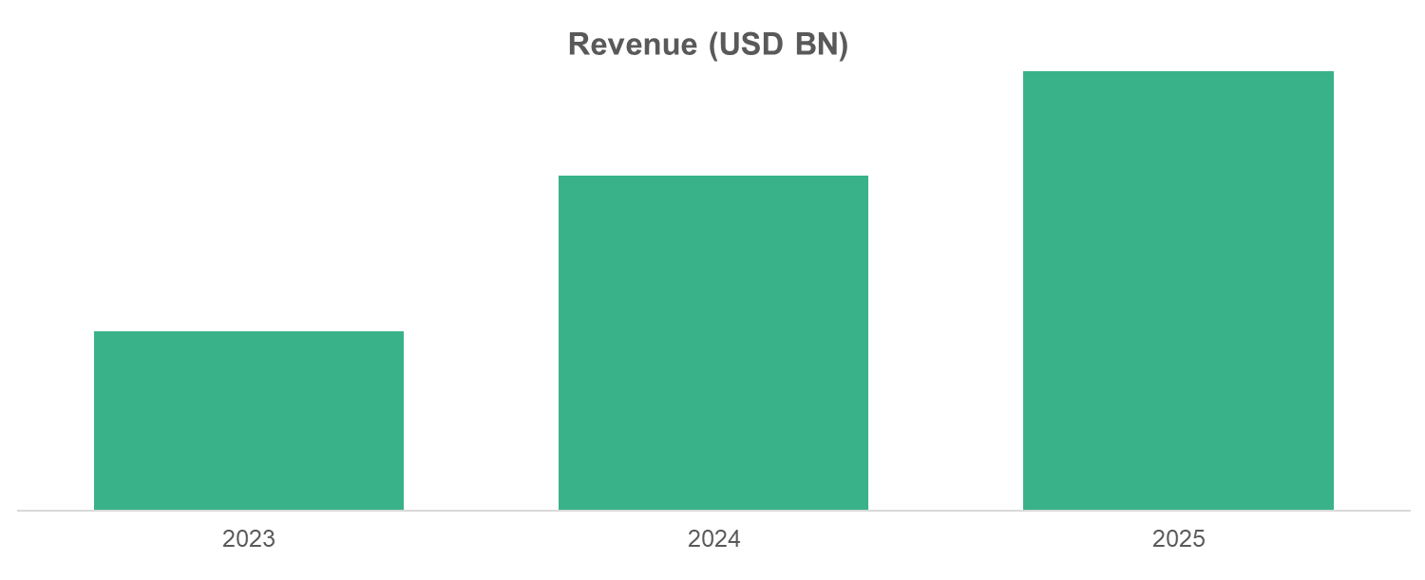
Source: Annual Reports, Primary Interviews, Surveys, Secondary Research, , 2025

    - {{co1_name_upper}} Segmental Revenue (%) (2024)
- {{co1_name_upper}} SEGMENTAL Revenue (%) (2024)

Source: Annual Reports, Primary Interviews, Surveys, Secondary Research, , 2025

    - {{co1_name_upper}} Regional Revenue (%) (2025)
- {{co1_name_upper}} Regional Revenue (%) (2025)
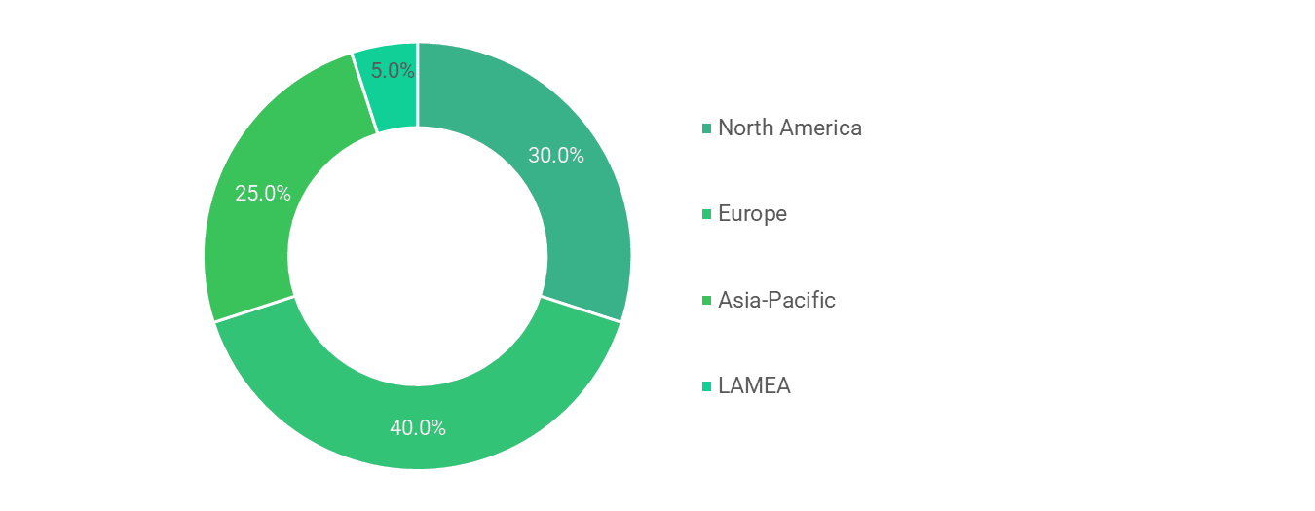
Source: Annual Reports, Primary Interviews, Surveys, Secondary Research, , 2025
Similar infoamtion will be provided for berlow companies
  - {{co2_name}}
  - {{co3_name}}
  - {{co4_name}}
  - {{co5_name}}
  - {{co6_name}}
  - {{co7_name}}
  - {{co8_name}}
  - {{co9_name}}
  - {{co10_name}}
- Future Outlook & Forecast- {{market_name_upper}} Market
  - Introduction and Taxonomy

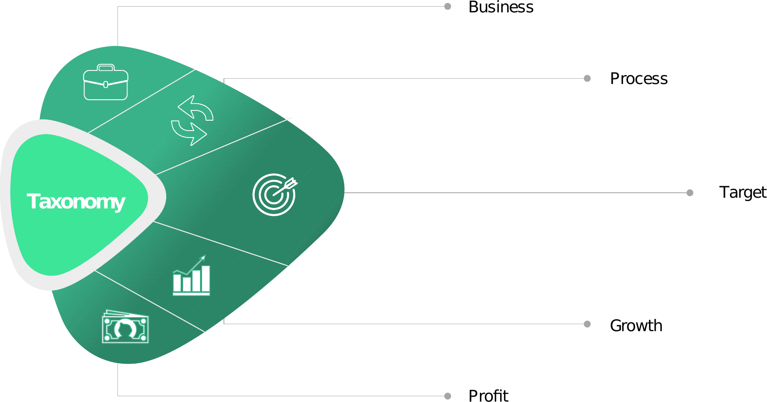

  - Demand Forecast

  - Investment Opportunity

  - Market Disruptions & Scenario Analysis
- Strategic Recommendations – {{market_name_upper}} Market
  - Introduction and Taxonomy

  - For Manufacturers

  - For Investors

  - For Policy Makers

- Appendix
  - Data Sources

  - Glossary of Terms

  - Research Assumptions

About us
Welcome to {{company_name}} -your trusted partner in market research and consulting.
Founded with a mission to bring clarity to complex markets, we are dedicated to helping businesses make smarter, data-driven decisions. Since our inception, we’ve consistently expanded our offerings, stayed rooted in a client-first approach, and remained focused on eliminating unreliable or outdated data from strategic planning.
We are more than just a research firm-we are a one-stop hub for meaningful industry intelligence. Whether you're a startup exploring new markets or an enterprise navigating growth, our team works closely with you to uncover real opportunities, decode market movements, and guide you toward sustainable success.
We understand that every client is unique. Syndicated reports can’t always capture the nuances of your business goals — which is why we offer flexible, custom research solutions tailored to your specific objectives and budget. From targeted market analysis to in-depth consulting, we’re here to provide insights that are both practical and powerful.
At {{company_name}}, we stand for quality, integrity, and partnership. Our commitment is simple: to deliver best-in-class research and consulting services that empower your business to stay ahead of the curve.

Let us help you turn data into direction-and insights into impact.

Copyright © 2025 {{company_name}} All rights reserved

Disclaimer
The information and insights provided by {{company_name}} are intended solely for general informational purposes. While we strive to ensure accuracy and reliability in our research and consulting services, we make no representations or warranties, express or implied, regarding the completeness, accuracy, or suitability of the content for any specific purpose. All opinions and analyses are based on available data at the time of publication and are subject to change without notice.
{{company_name}} shall not be held liable for any direct or indirect loss or damage arising from the use of our reports, publications, or services. Clients are advised to exercise their own judgment and seek independent professional advice before making any business or investment decisions based on our research.
Use of our services or content implies acceptance of this disclaimer and our terms of service.

