**SIMULATION OF THE ELECTRICAL AND THERMAL PROPERTIES OF A GRAPHENE FIELD EFFECT TRANSISTOR**

Presented by

RAHUL ANIL NAIR 19BEC1431

A project report submitted to

**Dr. Kaustabh Ghosh & Dr. Gargi Raina**

**SCHOOL OF ELECTRONICS ENGINEERING**

in partial fulfilment of the requirements for the course of

**ECE1006 – Introduction to Nano-science and Nanotechnology**

in

**B.Tech. ELECTRONICS AND COMMUNICATION ENGINEERING**



**VIT UNIVERSITY, CHENNAI**

**Vandalur-Kelambakkam Road**

**Chennai – 600127**

**JUNE 2021**

**BONAFIDE CERTIFICATE**

Certified that this project report entitled “**SIMULATION OF THE ELECTRICAL AND THERMAL PROPERTIES OF A GRAPHENE FIELD EFFECT TRANSISTOR**

**”**is a bonafide work of **RAHUL ANIL NAIR (19BEC1431)** who carried out the Project work under my supervision and guidance.

**Dr. Kaustabh Ghosh &** **Dr. Gargi Raina**

Professor

School of Electronics Engineering (SENSE),

VIT University, Chennai

Chennai-600127.

**ACKNOWLEDGEMENT**

We wish to express our sincere thanks and deep sense of gratitude to our project guide, **Dr. Kaustabh Ghosh & Dr. Gargi Raina ,** Professors, School of Electronics Engineering, for their consistent encouragement and valuable guidance offered to us in a pleasant manner throughout the course of the project work.

We are extremely grateful to **Dr.A.Sivasubramanian,** Dean of the School of Electronics Engineering, VIT Chennai, for extending the facilities of the School towards our project and for her unstinting support.

We express our thanks to our Programme Chair **Dr.Vetrivelan.P** for his support throughout the course of this project.

We also take this opportunity to thank all the faculty of the School for their support and their wisdom imparted to us throughout the course.

We thank our parents, family, and friends for bearing with us throughout the course of our project and for the opportunity they provided us in undergoing this course in such a prestigious institution.

**INDEX**

1. ABSTRACT
2. INTRODUCTION
3. SOFTWARE REQUIRED
4. PROJECT DESCRIPTION
5. PRINCIPLE
6. PROJECT BRIEFING
7. PARAMETERS
8. CONCLUSIONS
9. BIBLIOGRAPHY

**ABSTRACT**

In this project work, the electrical and thermal properties of Graphene field effect transistor (GFET) has been simulated by varying the width of graphene channel. Here, the electrical characteristics, like electron density, hole density, I-V Characteristics and charge carrier velocity profile in the channel region has been studied for three different values of graphene channel width : 1 nm, 2 nm and 5 nm. To analyse the thermal properties of the GFET device, the temperature profile of the graphene channel has been simulated for 100,300 and 500K. After analysing the simulation of this characteristics, it is concluded that, both electrical and thermal properties of GFET can be improved by fabricating the channel with larger width in the GFET device.

**INTRODUCTION**

OBJECTIVES AND GOALS

* To study the electrical characteristics, like electron density, hole density, I-V Characteristics and charge carrier velocity profile in the channel region
* To analyze the thermal properties of the GFET device, the temperature profile of the graphene channel

**SOFTWARE REQUIRED:**

* nanoHUB’s GFET tool

**PROJECT DESCRIPTION**

Graphene is a two-dimensional, single carbon atom layer material which is usually found as tightly-packed atoms in 2D honeycomb or hexagonal lattice. Graphene material has some exquisite notable properties like high electrical properties, high thermal conductivity, good optical properties and excellent chemical propertieswhich make GFETs suitable for a wide range of applications in the electronics, communications, chemical, biological, energy, and other industries.

The basic **GFET** is a three-terminal device that is similar to the conventional FET in some ways. It is composed of a source, drain, and a top or back gate. Unlike a silicon-based transistor, the GFET has a thin graphene channel, usually tens of microns thickness, between the source and drain metal electrodes. The gate controls how electrons respond and hence the channel's behavior.

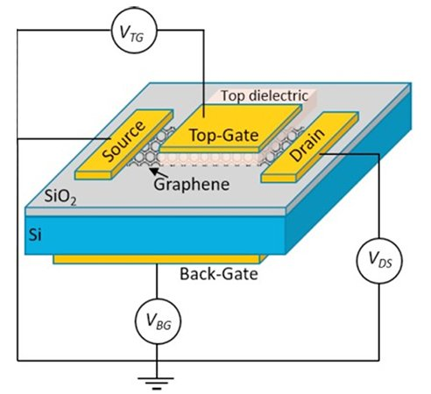

**BENEFITS OF GRAPHENE-FETs OVER CONVENTIONAL FETs**

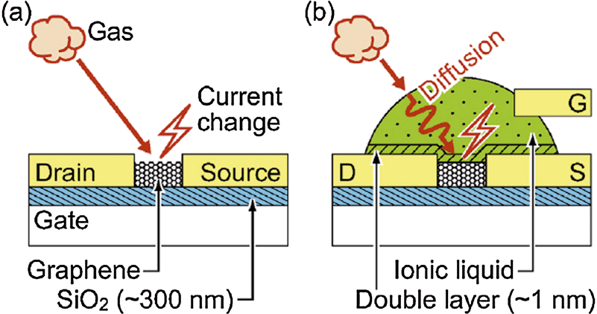

Graphene’s superior electrical and thermal conductivity results in low resistance losses and better heat dissipation than silicon. Consequently, graphene transistors have the potential to provide enhanced performance and efficiency. Its one-atom-thick structure make it highly sensitive and suitable for a wide range of bio- and chemical-sensing applications.

*Therefore, Graphene Field Effect Transistors (GFETs) can be a great replacement for the conventional FETs which have been used for a long time now and are nearing their size and performance limits and to utilise it to its capacity its very important to know about the electrical and thermal properties of GFET.*

**CHALLENGES IN GFETs**

* The absence of a band gap in GFET makes it hard to turn off the transistor since it cannot behave as an insulator
* The fabrication process for the graphene transistor differs from that of silicon devices and requires a delicate, complex, and costly method.
* Insufficient current saturation which prevents the transistor from reaching the maximum voltage gain and oscillation frequency in RF applications.

**PRINCIPLE**

The GFET Tool in Nanohub is used to simulate the electrical and thermal characteristics of a graphene field-effect transistor (GFET). The code uses the drift-diffusion approach to calculate the current vs. voltage behavior of the GFET, self-consistently with the temperature of the device. It can also output the carrier density, temperature profile, drift velocity, and electric field along the GFET channel. Many parameters (dimensions, mobility, contact resistance) can be set by the user, we used length, Initial temperature, Gate voltage, Dirac voltage, Maximum drain current, Drain current steps, Top gate thickness, Mobility, width values 1,2,5 micro meter and initial temperatures 100,300,500 kelvin for simulation and analysis in this research.

**PROJECT BRIEFING**

**Project goals:**

Studying the electrical characteristics, like electron density, hole density, I-V characteristics and charge carrier velocity profile in the channel region and analyzed the thermal properties of the GFET device, the temperature profile of the graphene channel.

**Timeline:**

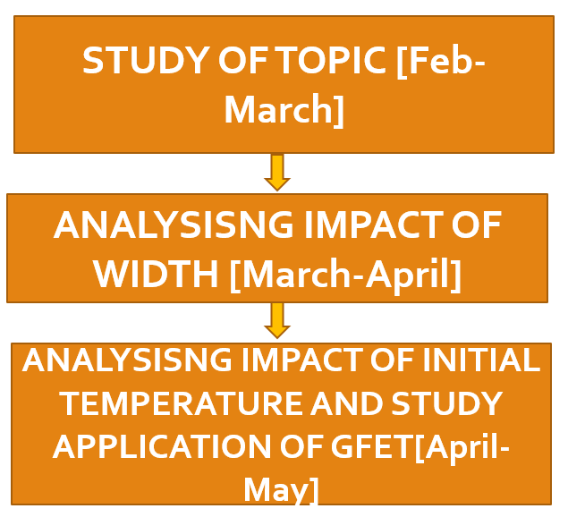

**Success metrics:**

* **ANALYSING IMPACT OF WIDTH (for channel width of 1 nm, 2nm and 5 nm)**

**Electron Density vs Position**

Graphene channels of small width has large number of electron density at the channel end, but for graphene channel of large width, the electron density is less.

**Hole Density vs Position**

For, graphene channel of lower width, the hole density Is lower than that of the channel of larger width.

**Temperature vs Position**

In the channels of smaller width, the electron density increases to a very high value, which increases temperature to large value, but in the channels of larger width, lower density of electrons increases temperature to small value than that of the channels of smaller width.

**Velocity vs Position**

The velocity remains constant throughout the channel with GFET of smaller width having greater velocity.

**Field vs Position**

From the starting point of the channel, the field is linear up to the center of the channel and remains constant throughout the center of the channel. The field linearly decreases at the end of the channel.

The field at the center of the channel for larger values of width.

**Id vs Vd characteristics**

For, graphene channel of larger width, the conduction of electrons may be more in ballistic regime, so more linear characteristics of current-voltage can be achieved.

* **ANALYSING IMPACT OF WIDTH WITH VARYING TEMPERATURE (for initial temperatures of 100k,300k,500k)**

**Electron Density vs Position**

Electron density increases linearly from the centre of the GFET and electron density is higher for higher initial temperature values.

**Hole Density vs Position**

The Hole density is lower for lower initial temperature values.

**Temperature vs Position(insignificant)**

**Velocity vs Position**

It Isn’t affected by the varying temperature

**Field vs Position**

It Isn’t affected by temperature.

**Id vs Vd characteristics**

It is not affected by temperature.

*Thereby final outputs implicate that the channel with larger width improved both electrical and thermal properties of GFET.*

**BASIC PARAMETERS**

**BASIC SETTINGS:**

1. Width: 5 e-07m to 5 e-05m or 0.5 to 50 micro meter
2. Length: 5 e-07m to 5 e-05m or 0.5 to 50 micro meter
3. Initial temperature: 100K to 600K
4. Gate voltage: -50V to 50V
5. Dirac Voltage: -30 to 30V
6. Maximum Drain current: 0.5e-03 to 10e-03A
7. Drain Current Step:5e-06 to 100e-06A
8. Top gate oxide thickness:1e-09 to 500e-09m
9. Mobility:100 to 10,000 cm^2/V-s

**OUR SETTINGS FOR** **ANALYSING IMPACT OF WIDTH**

**Constant settings:**

1) Length:5 micro meter

2) Initial temperature: 300K

3) Gate voltage: 40V

4) Dirac voltage: 0V

5)Maximum drain current:1mA

6)Drain current steps:50 micro A

7)Top gate thickness:1e-08m

8)Mobility:4000

**For width values 1,2,5 micro meter**

**CONCLUSION**

**1)** **Electron Density vs Position**

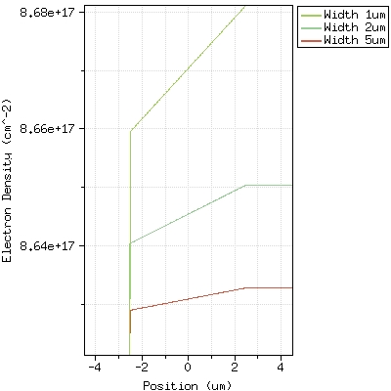

In the electron density characteristics of the GFET channel, it has been studied that, density of electrons increases linearly as proceeded through the channel from the center position. But at certain position of the channel, the density of electrons become fixed. As, at the near end of the channel, the injected electrons become jammed and as a result, the total density of the electron from that certain position of the channel, become fixed. It has also been observed from this simulation curve that, for graphene channels of small width has large number of electron density at the channel end, but for graphene channel of large width, the electron density is less.

**2)** **HoleDensity vs Position**

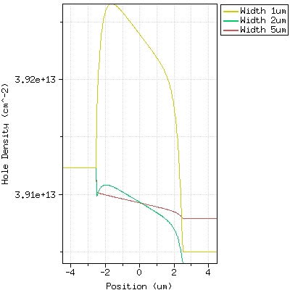

As electron density increases along the channel, each electron occupies a hole at the channel, so as electron density increases, at the same rate, hole density decreases, as observed from the simulation curve. At the near end of the channel, all electrons are jammed, so no more holes are occupied at this position; as a result, density of hole becomes fixed at this position. For, graphene channel of lower width, the hole density Is lower than that of the channel of larger width. For lower width channels, electron density is high at the channel end, so lots of free electrons are unoccupied at this position, so hole density becomes lower in lower width channel than that of the channel of larger width.

**3)** **Id vs Vd**

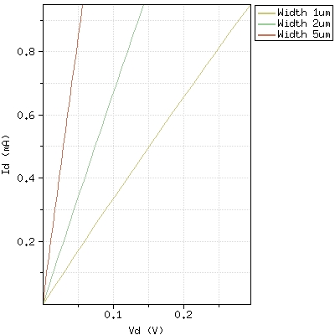

I-V characteristics of GFET have been simulated for channel width of 1 nm, 2nm and 5 nm. The characteristics is more linear than that of the I-V characteristics of Field Effect Transistors (FET). Because, in GFET, the channel is very high conductive i.e consists of Graphene Layer, so no pinch off occur here. The injected electrons in the grapheme channel propagate with high mobility and so ballistic conduction of the charge carriers occur here. So, current increases ideally i.e linearly with applied voltage. For large applied voltage, the charge carriers face avalanche breakdown, which damages the devices. For, graphene channel of larger width, the conduction of electrons may be more in ballistic regime, so more linear characteristics of current-voltage can be achieved.

**4) Temperature vs Position**

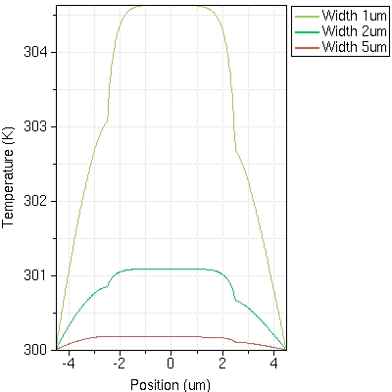

The temperature varies linearly along the channel within this position. At this position, electrons are injected from the source to the grapheme channel and the electrons flow through the channel. So, density of electrons gradually increases at the Graphene channel. In normal metal cannels, the flow of charge carriers doesn’t change the temperature of the channel. But, Graphene is a highly conductive nano-device where the flow of charge carriers of high mobility cause increase of the temperature. So, the temperature varies linearly at this position. As proceeded from the center to the near end of the channel, the concentration of electrons become nearly constant, so the temperature of grapheme channel decreases gradually to the room temperature and at the end of the channels, temperature falls linearly to the ideal temperature.

The temperature profile has been studied for graphene channel width of 1 nm, 2 nm and 3 nm, shown in Figure 5. It has been observed that, the temperature increases to large value or channel of smaller width. In the channels of smaller width, the electron density increases to a very high value, which increases temperature to large value, but in the channels of larger width, lower density of electrons increases temperature to small value than that of the channels of smaller width.

**5)** **Velocity vs Position**

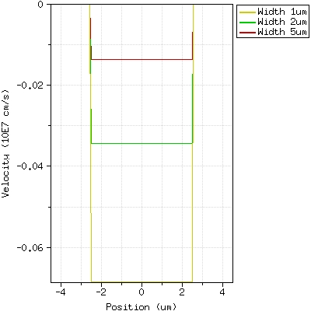

**6)** **Field vs Position**

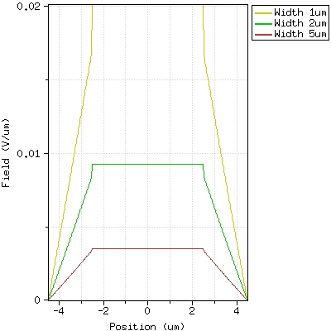

Finally, it is concluded in this research that, both electrical and thermal properties of GFET can be improved by fabricating the channel with larger width in the GFET device.

**OUR SETTINGS FOR** **ANALYSING IMPACT OF WIDTH WITH VARYING TEMPERATURE**

**Constant settings:**

1) Length:5 micro meter

2) width: 5 micro meter

3) Gate voltage: 40V

4) Dirac voltage: 0V

5)Maximum drain current:1mA

6)Drain current setps:50 micro A

7)Top gate thickness:1e-08m

8)Mobility:4000

**For** **initial temperatures 100,300,500**

**1)** **Electron Density vs Position**

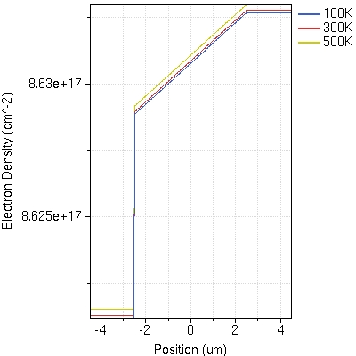

It has been observed that the electron density increases linearly from the centre of the GFET and electron density is higher for higher initial temperature values

**2)****Hole Density vs Position**

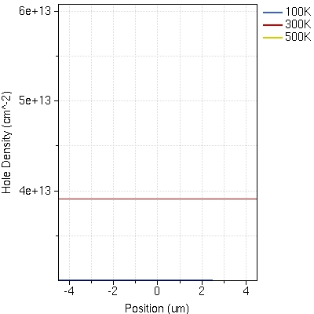

The Hole density is lower for lower initial temperature values

**3) Id vs Vd**

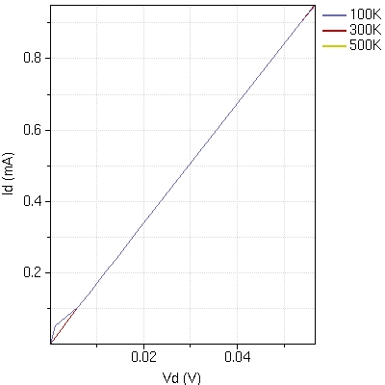

It is not affected by temperature.

**4)** **Temperature vs Position(insignificant)**

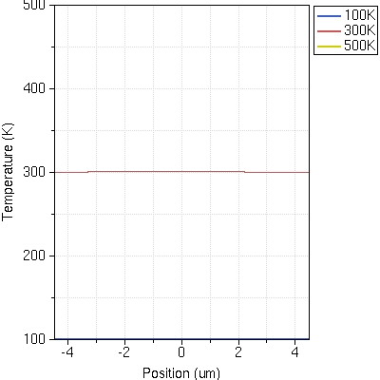

**5)** **Velocity vs Position**

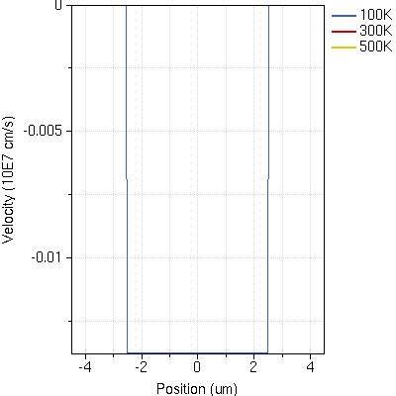

It Isn’t affected by the varying temperature

**6)** **Field vs Position**

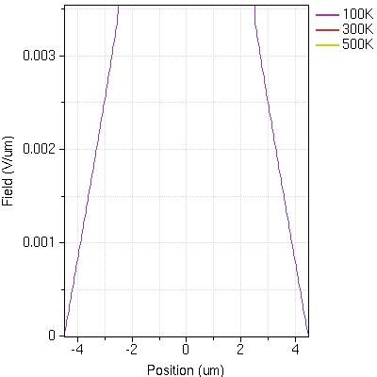

It Isn’t affected by temperature.

**REFERENCES**

1. www.google.com
2. [www.comsol.com](http://www.comsol.com)
3. [www.academia.com](http://www.academia.com)
4. www.ijert.org