Oscars Wireframes

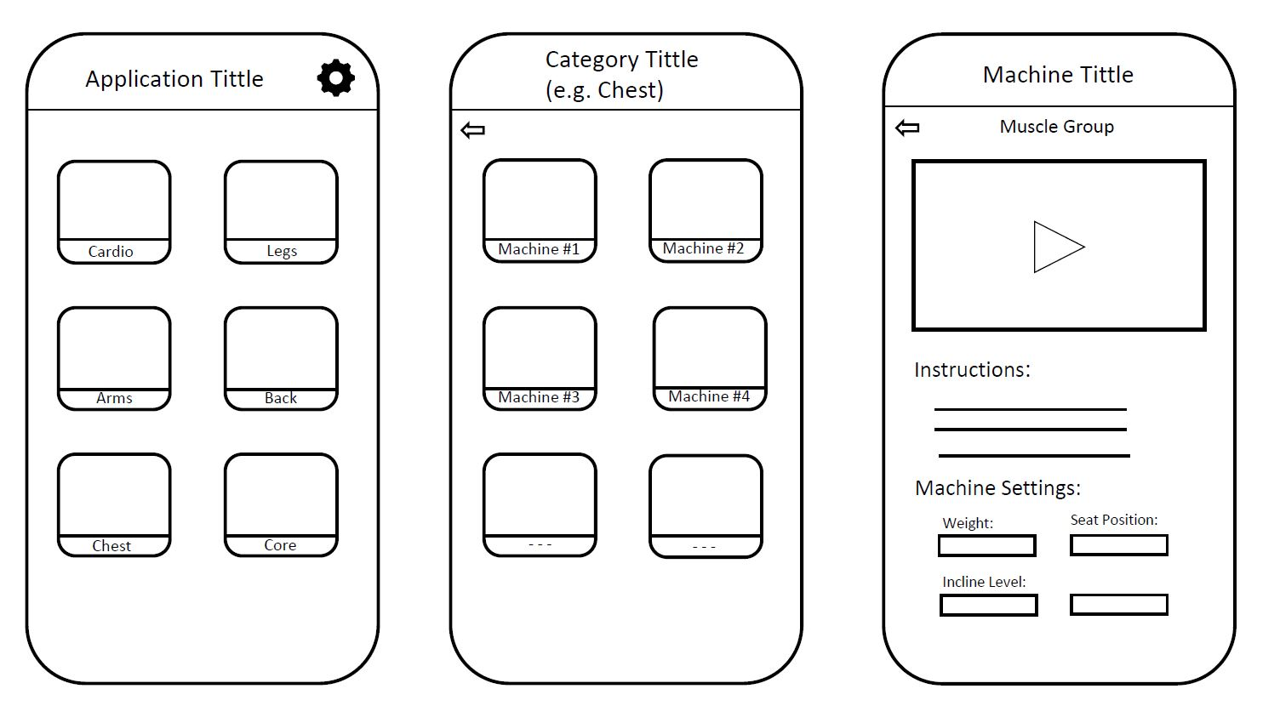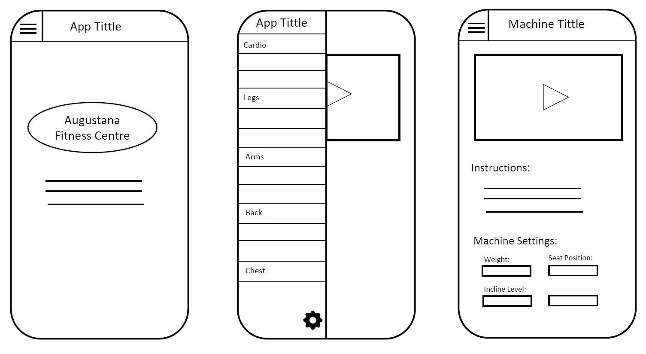

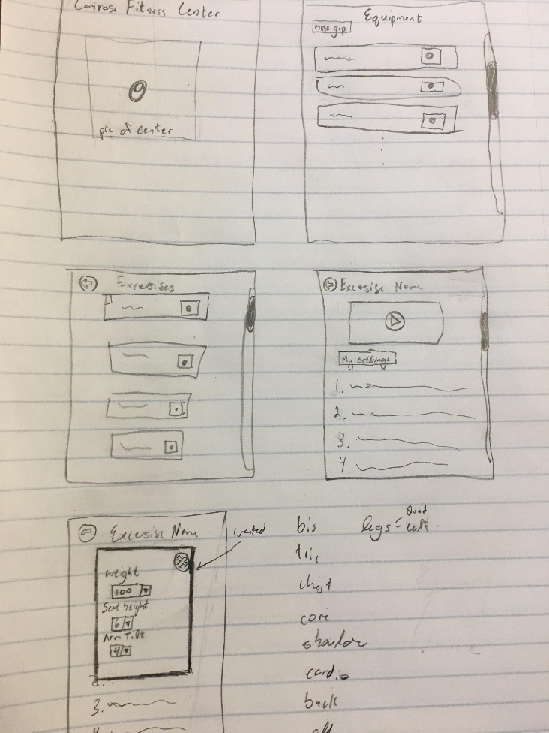Barret’s Wireframe

Nathan’s Wireframe

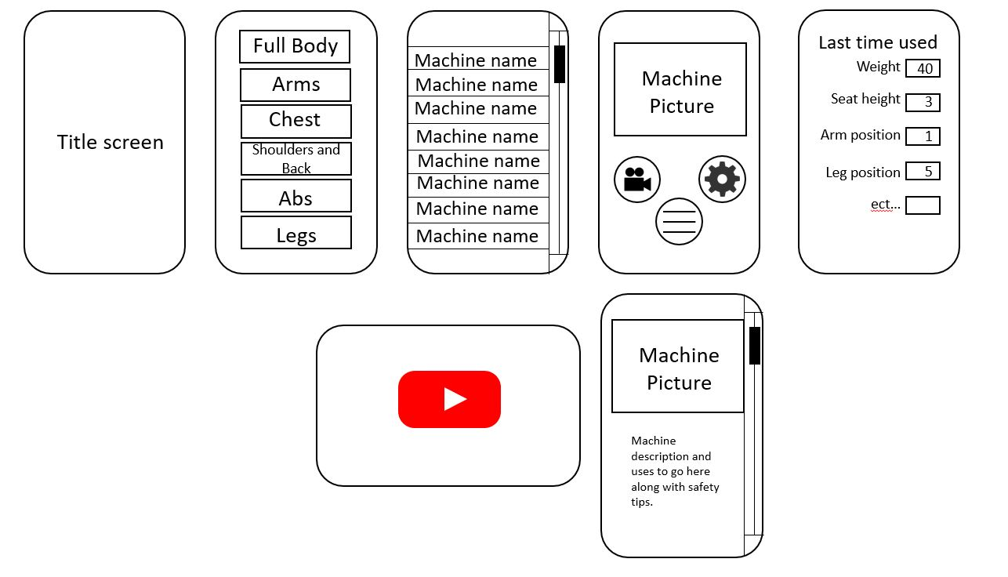

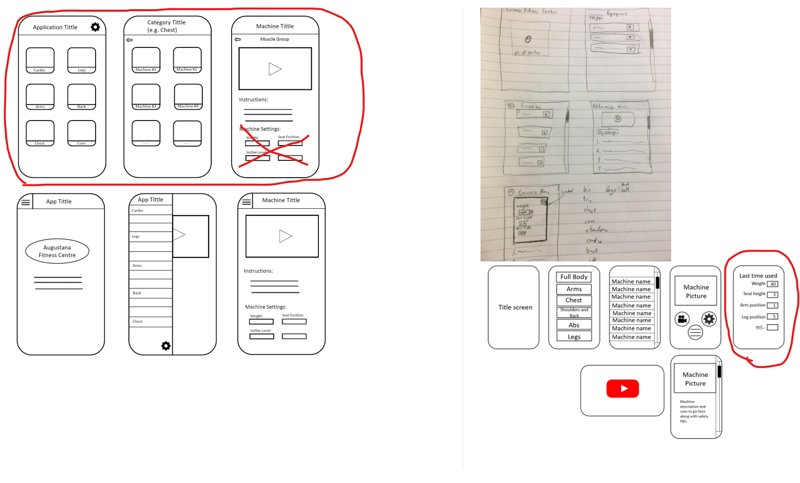Of these wire frames presented our client chose these following circled features

Oscars general menu style and button layout.

Nathans separate option menu with one wrinkle. Our client wished for a popup menu.

She also liked Barrets loading screen idea.

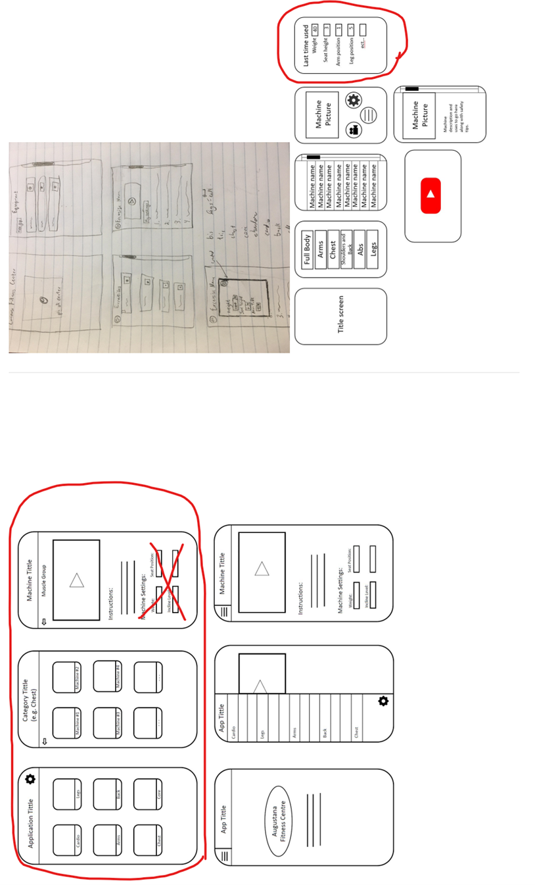On top of theses wireframes our client wished for a facility information page, which included a google map view of the building, and a graph of the user’s progress.