**Derek Frank**

**AMS 114**

**Homework #6**

**6.1.8:**

For the given system, plot the phase portrait:

Given system:



Phase portrait:

Phase portrait:

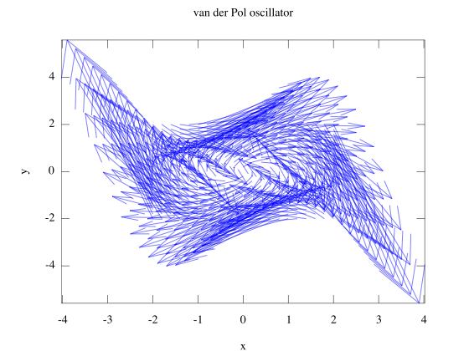

**7.1.1:**

Sketch the phase portrait for the following system:

Given system:



Phase portrait:

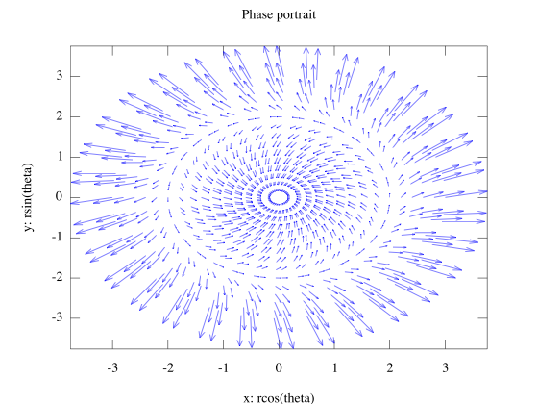

**7.2.10:**

Show that the given system has no closed orbits, by constructing a Liapunov funtion V = ax2 + by2 with suitable a,b.:

Given system:

 

Liapunov function:





Solution:







**7.4.1:**

Show that the given equation has exactly one periodic solution, and classify its stability:

Given system:



Liénard’s equation:





Satisfies Liénard’s Theorem  system has a unique, stable limit cycle.

Fixed points:



Jacobian matrix:



Jacobian at fixed point:



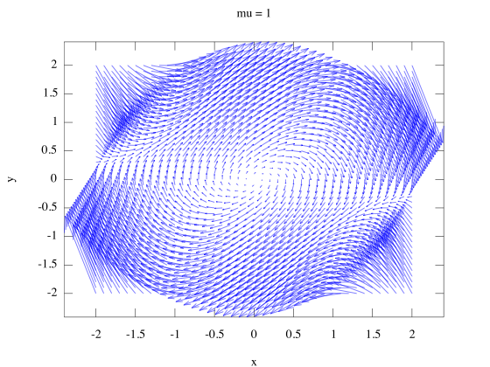 Phase portraits:

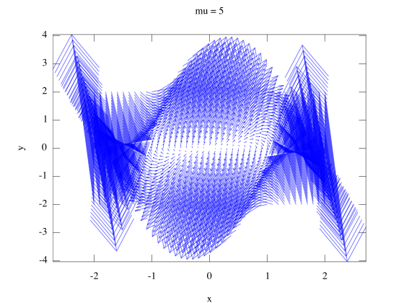

**7.4.2:**

Consider the sytem:



a) Prove that the system has a unique stable limit cycle if 

Liénard’s equation:





Satisfies Liénard’s Theorem  system has a unique, stable limit cycle

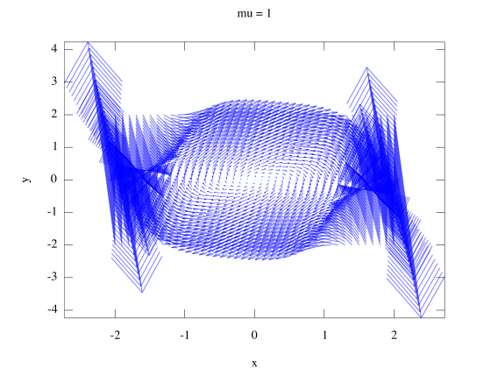b) Phase portraits:

**Octave Code:**

# prob1.m

function prob1

clear

figure(1);

hold off

[x,y] = meshgrid(-2:.2:2);

x_dot=y;

y_dot=-x+y.*(1-x.^2);

h=quiver(x,y,x_dot,y_dot);

set(h, "autoscalefactor", 5);

axis("tight");

title("van der Pol oscillator");

xlabel("x");

ylabel("y");

fixAxes;

endfunction

# prob2.m

function prob2

clear

figure(1);

hold off

[r,theta]=meshgrid(-3:.2:3);

r_dot=(r.^3)-4.*r;

theta_dot=1;

x=r.*cos(theta);

y=r.*sin(theta);

x_dot=r_dot.*cos(theta)-theta_dot.*r.*sin(theta);

y_dot=r_dot.*sin(theta)+theta_dot.*r.*cos(theta);

h=quiver(x,y,x_dot,y_dot);

set(h,"autoscalefactor",2);

axis("tight");

title("Phase portrait");

xlabel("x: rcos(theta)");

ylabel("y: rsin(theta)");

fixAxes;

endfunction;

# prob4.m

function prob4

clear

figure(1);

hold off

[x,y]=meshgrid(-2:.1:2);

mu=5;

x_dot=y;

y_dot=((1-(exp(2.*x)))./(1+(exp(2.*x))))-mu.*((x.^2)-1).*y;

h=quiver(x,y,x_dot,y_dot);

set(h,"autoscalefactor",2);

axis("tight");

title("mu = 5");

xlabel("x");

ylabel("y");

fixAxes;

endfunction

# prob5.m

function prob5

clear

figure(1);

hold off

[x,y]=meshgrid(-2:.1:2);

mu=1;

x_dot=y;

y_dot=-x-mu.*((x.^4)-1).*y;

h=quiver(x,y,x_dot,y_dot);

set(h,"autoscalefactor",2);

axis("tight");

title("mu = 1");

xlabel("x");

ylabel("y");

fixAxes;

endfunction