**Derek Frank**

**AMS 114**

**Homework #7**

**8.2.2:**

Show that the given system has pure imaginary eigenvalues when :

Given system:

  

Fixed points:



Jacobian:



Eigenvalues at fixed points:







- All have pure imaginary values.

**8.2.3:**

By plotting the phase portraits on the computer, show that the given system undergoes a Hopf bifurcation at . Is it subcritical, supercritical, or degenerate?

Given system:



Phase portrait:

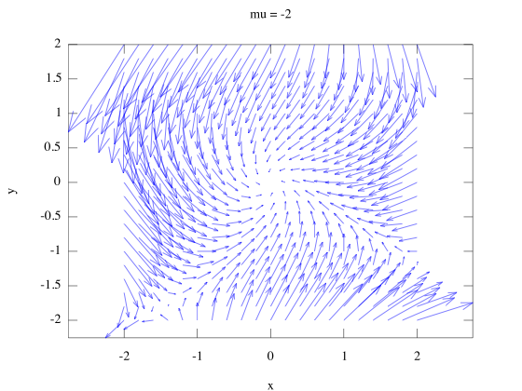

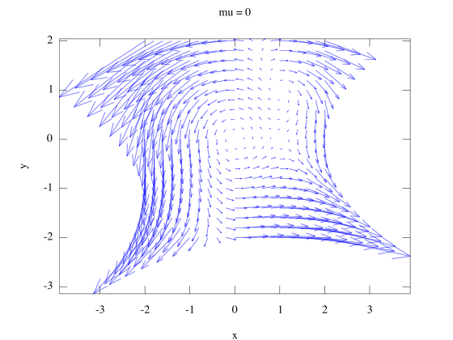

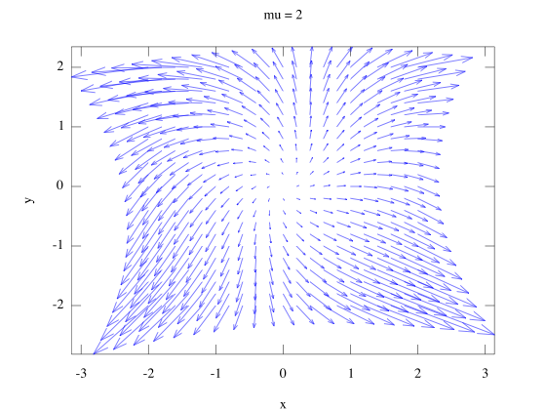

Classification:

- Degenerate Hopf bifurcation

**8.2.5:**

For the given system, a Hopf bifurcation occurs at the origin when . Plot the phase portrait and determine whether the bifuracation is subcritical or supercritical:

Given system:



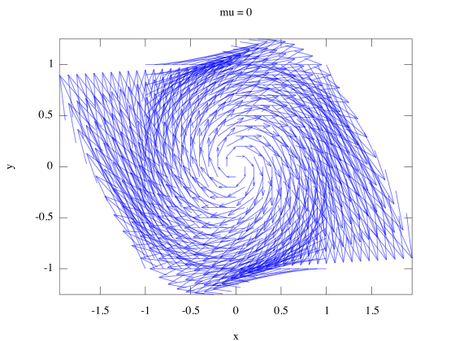Phase portrait:

Classification:

- Subcritical

**Octave Code:**

# prob2a.m

function prob2a

clear

figure(1);

hold off

[x,y] = meshgrid(-2:.2:2);

mu=-2;

x_dot=-y+(mu.*x)+(x.*(y.^2));

y_dot=x+(mu.*y)-(x.^2);

h=quiver(x,y,x_dot,y_dot);

set(h, "autoscalefactor", 4);

axis("tight");

title("mu = -2");

xlabel("x");

ylabel("y");

fixAxes;

endfunction

# prob3.m

function prob3

clear

figure(1);

hold off

[x,y] = meshgrid(-1:.1:1);

mu=0;

x_dot=y+(mu.*x);

y_dot=-x+(mu.*y)-((x.^2).*y);

h=quiver(x,y,x_dot,y_dot);

set(h, "autoscalefactor", 5);

axis("tight");

title("mu = 0");

xlabel("x");

ylabel("y");

fixAxes;

endfunction