**Derek Frank**

**AMS 114**

**Final Exam**

**Problem 1:**

Three aircraft fly straight and parallel to each other. Each aircraft knows the velocity of the other two and adjusts its velocity to theirs.

Given system:

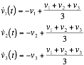, 

Fixed points:



a) Use the given Liapunov function to show that for the time , the three aircraft fly at the same speed, the so-called consensus speed .

Given Liapunov function:



Show fixed point is globally asymptotically stable for all initial conditions,  as :

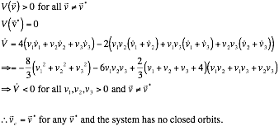

b) Assuming that at  what is the consensus speed?

Consensus speed:



**Problem 2:**

Given system:



a) Use the Dulac’s criterion to show that the given system does not have closed orbits in the first quadrant . (Hint: use  for the real-valued function of the criterion.)

Dulac’s criterion:

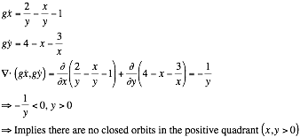

b) Find all fixed points and classify them.

Fixed points:



Jacobian:



Jacobian evaluated at fixed points with corresponding eigenvalues and eigenvectors:

    

    

    

    

Classify fixed points:

  Saddle node

  Stable node

  Stable spiral

  Stable spiral

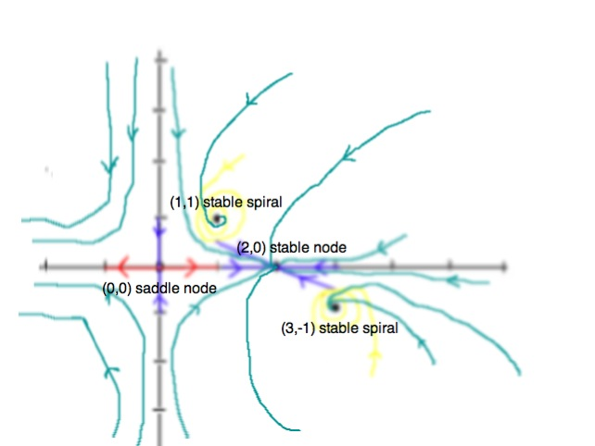c) Sketch the phase portrait.

Phase portrait:

**Problem 3:**

For certain species of organisms, the effective growth rate  is highest at intermediate . This is the so-called Allee effect.

Given system:



a) Show that the given system provides an example of the Allee effect, i.e., find the value of  at which the effective growth rate is maximal.

Maximal effective growth rate:

  maximal when the derivative is 0.

 

   

b) Find the algebraic constraints for  that should be satisfied so that the organisms are not extinct.

Fixed points:



Stablility of fixed point:



  differs with 

  stable

  differs with 

Constraints for  that satisfy no extinction:

Desire an unstable node for 

  must be greater than 0

, 

c) Find the carrying capacity as a function of the parameters .

Carrying capacity:

, 

**Problem 4:**

Use the index theory to show that the given system has no closed orbits. Plot the phase portrait.

Given system:



Fixed points:



Find :





Phase portrait:

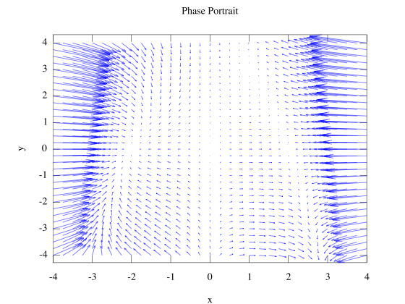

**Problem 5:**

Consider the given system.

Given system:



a) Show that the given system is equivalent to alternate given system.

Alternate given system:



Given system as Lienard System:

 

Fixed points of both systems:



Alternate systems equivalence:

The alternate system is equivalent to the Lienard system for .

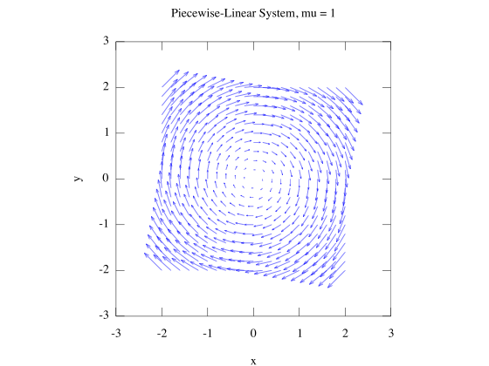

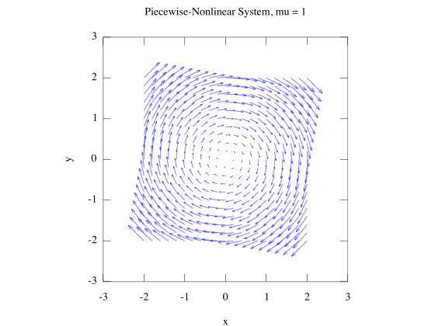

Introduce different phase plane variables for the given system that shows equivalence of both given and alternate system:

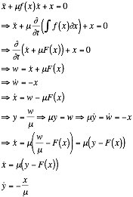

b) Graph the nullclines.

Nullclines:

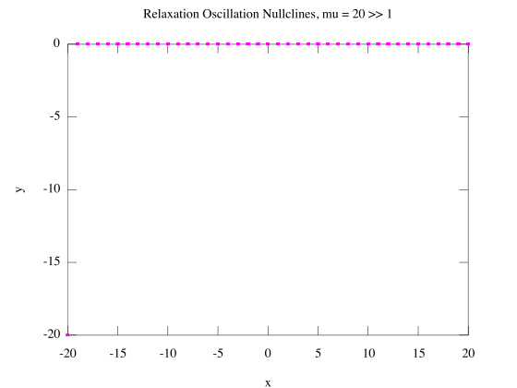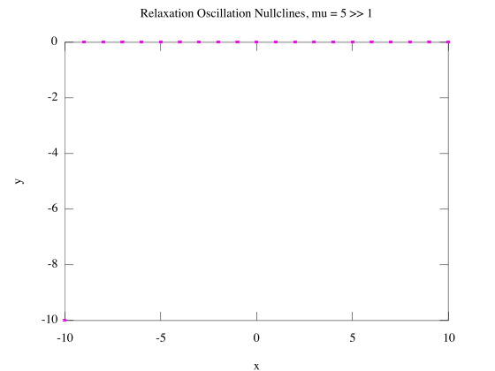

c) Since the system exhibits relaxation oscillation for , plot the limit cycle in the  plane.

Limit cycles:

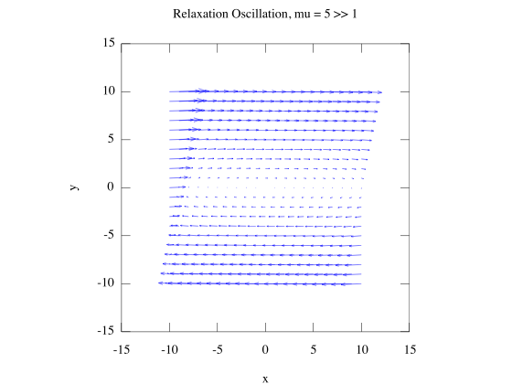

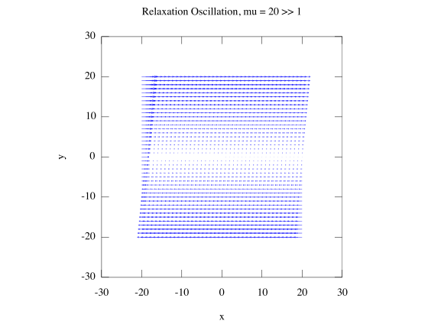

d) Estimate the period of the limit cycle for  (show the derivation).