Derek Frank

dmfrank@ucsc.edu

AMS 147

Due: 1/20/10

Homework #1

PartB:

(1):

i) The given quadratic equation, x^2+b*x+c=0, has two roots,

r1(b)=(-b+sqrt(b^2-4*c))/2 and r2(b)=(-b-sqrt(b^2-4*c))/2.

Since c is set to equal 1, c=1, the two roots are functions

of b. Using Matlab, I have to plot these functions for when

b is between [2,3].

ii) Using Matlab code to plot 100 points for each function, I

attain a 2-dimensional graph with two lines.

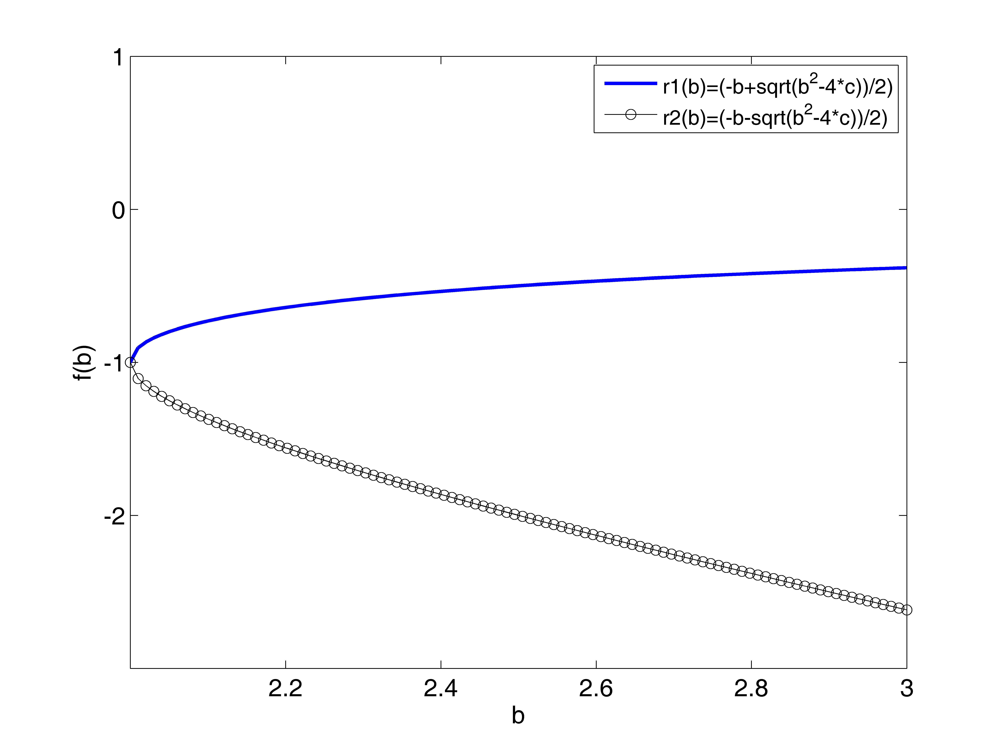

iii) The resulting graph is that of a sideways parabola opening

to the right. The vertex is at (2,-1). The roots, r1 and r2,

are reflections of the other over the line y=-1.

(2):

i) Given f(x,y)=sin(x^2+y^2)*exp(-sprt(x^2+y^2)), I am going

to use Matlab to plot the function when x is between [-3,3]

and y is between [-3,3].

ii) Using Matlab code to plot the function with 30 points, I

attain a 3-dimensional graph of a surface.

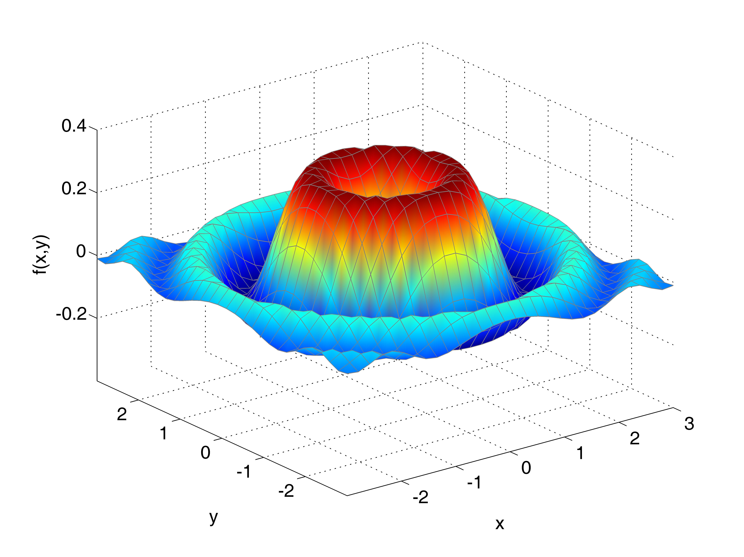

iii) The resulting graph appears like the look of water after

dropping something heavy into it. A large ring, like a wave,

is surrounded by smaller wave rings with a cave-in in the

center. The surface is limited in height to under .4 and

contained above -.4.

(3):

i) Given a file "data1.txt" and a fitting function (a function

that resembles the given data points when plotted),

f(x)=exp(-c*x)*cos(2*x), I need to find an approximation for

the value of c and use Matlab to plot the given data and

fitting function.

ii) To find an approximation for c I take a look at the values

for x and y in the file "data1.txt" and plug them into the

given fitting function and solve for c. I do this for when

x=2,3,4,5,6 and attain five different values of c. I take

the average of these values to attain the best approximation

and find that c approximately equals .2295528077. I use this

value of c in Matlab to plot the function and after loading

and plotting the data in "data1.txt" I attain a 2-dimensional

graph.

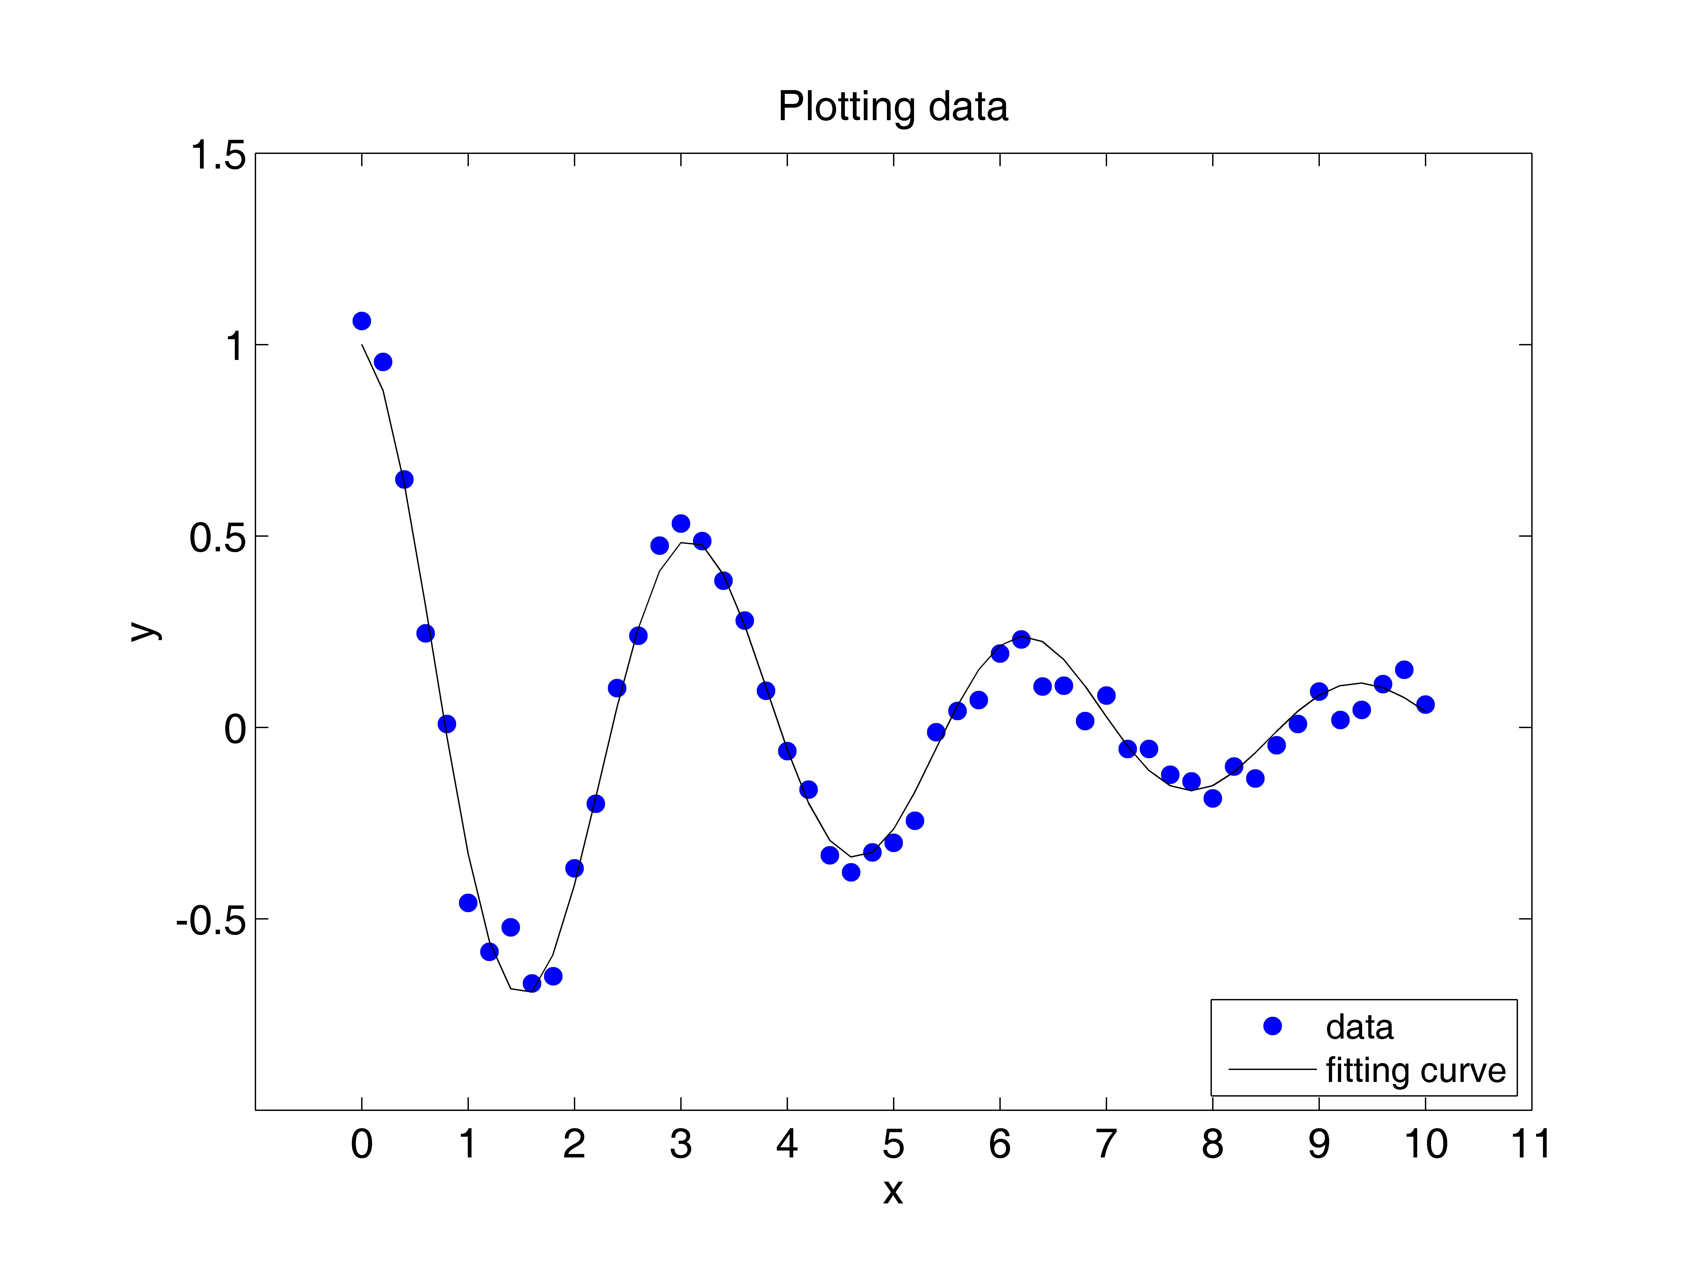

iii) The fitting curve is not perfect so that is contains the

exact same data points as plotted from "data1.txt," but it

follows the same shape. The curve is similar to a cosine

function because it is wave-like, yet the wave gets smaller

as x gets bigger. y appears to be approaching 0 as x gets

large.

APPENDIX (1): “plot_rb.m”

%

% Plot r1 = f1(b) = (-b+sqrt(b^2-4*c))/2) and

% r2 = f2(b) = (-b-sqrt(b^2-4*c))/2) for b in [2,3]

%

clear;

clf;

%

n=100;

db=1/(n-1);

b=[2:db:3];

c=1;

r1=(-b+sqrt((b.^2)-4*c))/2;

r2=(-b-sqrt((b.^2)-4*c))/2;

%

plot(b,r1,'b-','linewidth',2.0)

hold on

plot(b,r2,'k-o')

axis([2.0,3.0,-3.0,1.0])

set(gca,'xtick',[2.2:.2:3])

set(gca,'ytick',[-2:1:1])

set(gca,'fontsize',14)

xlabel('b')

ylabel('f(b)')

h1=legend('r1(b)=(-b+sqrt(b^2-4*c))/2)','r2(b)=(-b-sqrt(b^2-4*c))/2)');

set(h1,'fontsize',12)

%

APPENDIX (2): “plot_fxy.m”

%

% Plot f(x,y) = sin(x^2+y^2)*exp(-sqrt(x^2+y^2))

% for x in [-3,3] and y in [-3,3].

%

clear;

clf;

%

m=30;

n=30;

dx=6/(n-1);

dy=6/(m-1);

x1=[-3:dx:3];

y1=[-3:dy:3];

%

[x,y]=meshgrid(x1,y1);

%

f=sin(x.^2+y.^2).*exp(-sqrt(x.^2+y.^2)) ;

%

h=surf(x,y,f);

set(h,'facecolor','interp')

set(h,'edgecolor',[0.5,0.5,0.5])

%

axis([-3.0,3.0,-3.0,3.0,-.4,.4])

set(gca,'xtick',[-2:1:3])

set(gca,'ytick',[-2:1:2])

set(gca,'ztick',[-.2:.2:.4])

set(gca,'fontsize',14)

xlabel('x')

ylabel('y')

zlabel('f(x,y)')

%

APPENDIX (3): “plot_fx_data.m”

% Derek Frank, dmfrank@ucsc.edu

% HW1: PartB (3)

% Due: 1/20/10

%

% This code reads in data from data1.txt and plots

% f(x) = exp(-c*x)*cos(2*x) along with the data from data1.txt

%

clear

figure(3)

clf reset

axes('position',[0.15,0.13,0.75,0.75])

%

load -ascii data1.txt

x=data1(:,1);

y=data1(:,2);

%

% fit the data to f(x)

x2=[0:.2:10];

C=.2295528077;

y2=exp(-C.*x2).*cos(2.*x2);

%

plot(x,y,'bo','markerfacecolor','b')

hold on

plot(x2,y2,'k-')

set(gca,'fontsize',14)

axis([-1.0,11.0,-1.0,1.5])

set(gca,'xtick',[0:1:11])

set(gca,'ytick',[-.5:.5:1.5])

xlabel('x')

ylabel('y')

title('Plotting data')

h1=legend('data','fitting curve',4);

set(h1,'fontsize',12)

%

APPENDIX (4): “data1.txt”

% x y

%

0.0000000e+00 1.0616627e+00

2.0000000e-01 9.5438313e-01

4.0000000e-01 6.4726669e-01

6.0000000e-01 2.4543142e-01

8.0000000e-01 8.6474234e-03

1.0000000e+00 -4.5847332e-01

1.2000000e+00 -5.8629116e-01

1.4000000e+00 -5.2270060e-01

1.6000000e+00 -6.6897708e-01

1.8000000e+00 -6.5025323e-01

2.0000000e+00 -3.6829629e-01

2.2000000e+00 -1.9946104e-01

2.4000000e+00 1.0214847e-01

2.6000000e+00 2.3939828e-01

2.8000000e+00 4.7441685e-01

3.0000000e+00 5.3204202e-01

3.2000000e+00 4.8645531e-01

3.4000000e+00 3.8277756e-01

3.6000000e+00 2.7859469e-01

3.8000000e+00 9.5304196e-02

4.0000000e+00 -6.1937557e-02

4.2000000e+00 -1.6264995e-01

4.4000000e+00 -3.3465224e-01

4.6000000e+00 -3.7848057e-01

4.8000000e+00 -3.2684557e-01

5.0000000e+00 -3.0202142e-01

5.2000000e+00 -2.4418751e-01

5.4000000e+00 -1.2606921e-02

5.6000000e+00 4.2709432e-02

5.8000000e+00 7.1364914e-02

6.0000000e+00 1.9256373e-01

6.2000000e+00 2.2975779e-01

6.4000000e+00 1.0651973e-01

6.6000000e+00 1.0873230e-01

6.8000000e+00 1.6313790e-02

7.0000000e+00 8.2753168e-02

7.2000000e+00 -5.6705147e-02

7.4000000e+00 -5.6552321e-02

7.6000000e+00 -1.2417349e-01

7.8000000e+00 -1.4140695e-01

8.0000000e+00 -1.8606224e-01

8.2000000e+00 -1.0253530e-01

8.4000000e+00 -1.3337982e-01

8.6000000e+00 -4.7083796e-02

8.8000000e+00 8.5379099e-03

9.0000000e+00 9.3244738e-02

9.2000000e+00 1.8795176e-02

9.4000000e+00 4.5569780e-02

9.6000000e+00 1.1312777e-01

9.8000000e+00 1.5024618e-01

1.0000000e+01 5.9238496e-02

%