一、目的和要求
基本要求：利用多模传感器扩展板设计一款智能手环模型，能 够实时显示当前的温度以及步数，准确率5%内为合格。
扩展要求：能够将当前信息通过蓝牙传送到手机或者电脑上显 示。

二、实验器材
STM32F401RE、X-NUCLEO-IKS01A1、X-NUCLEO-IDB04A1
连接方式如下图：
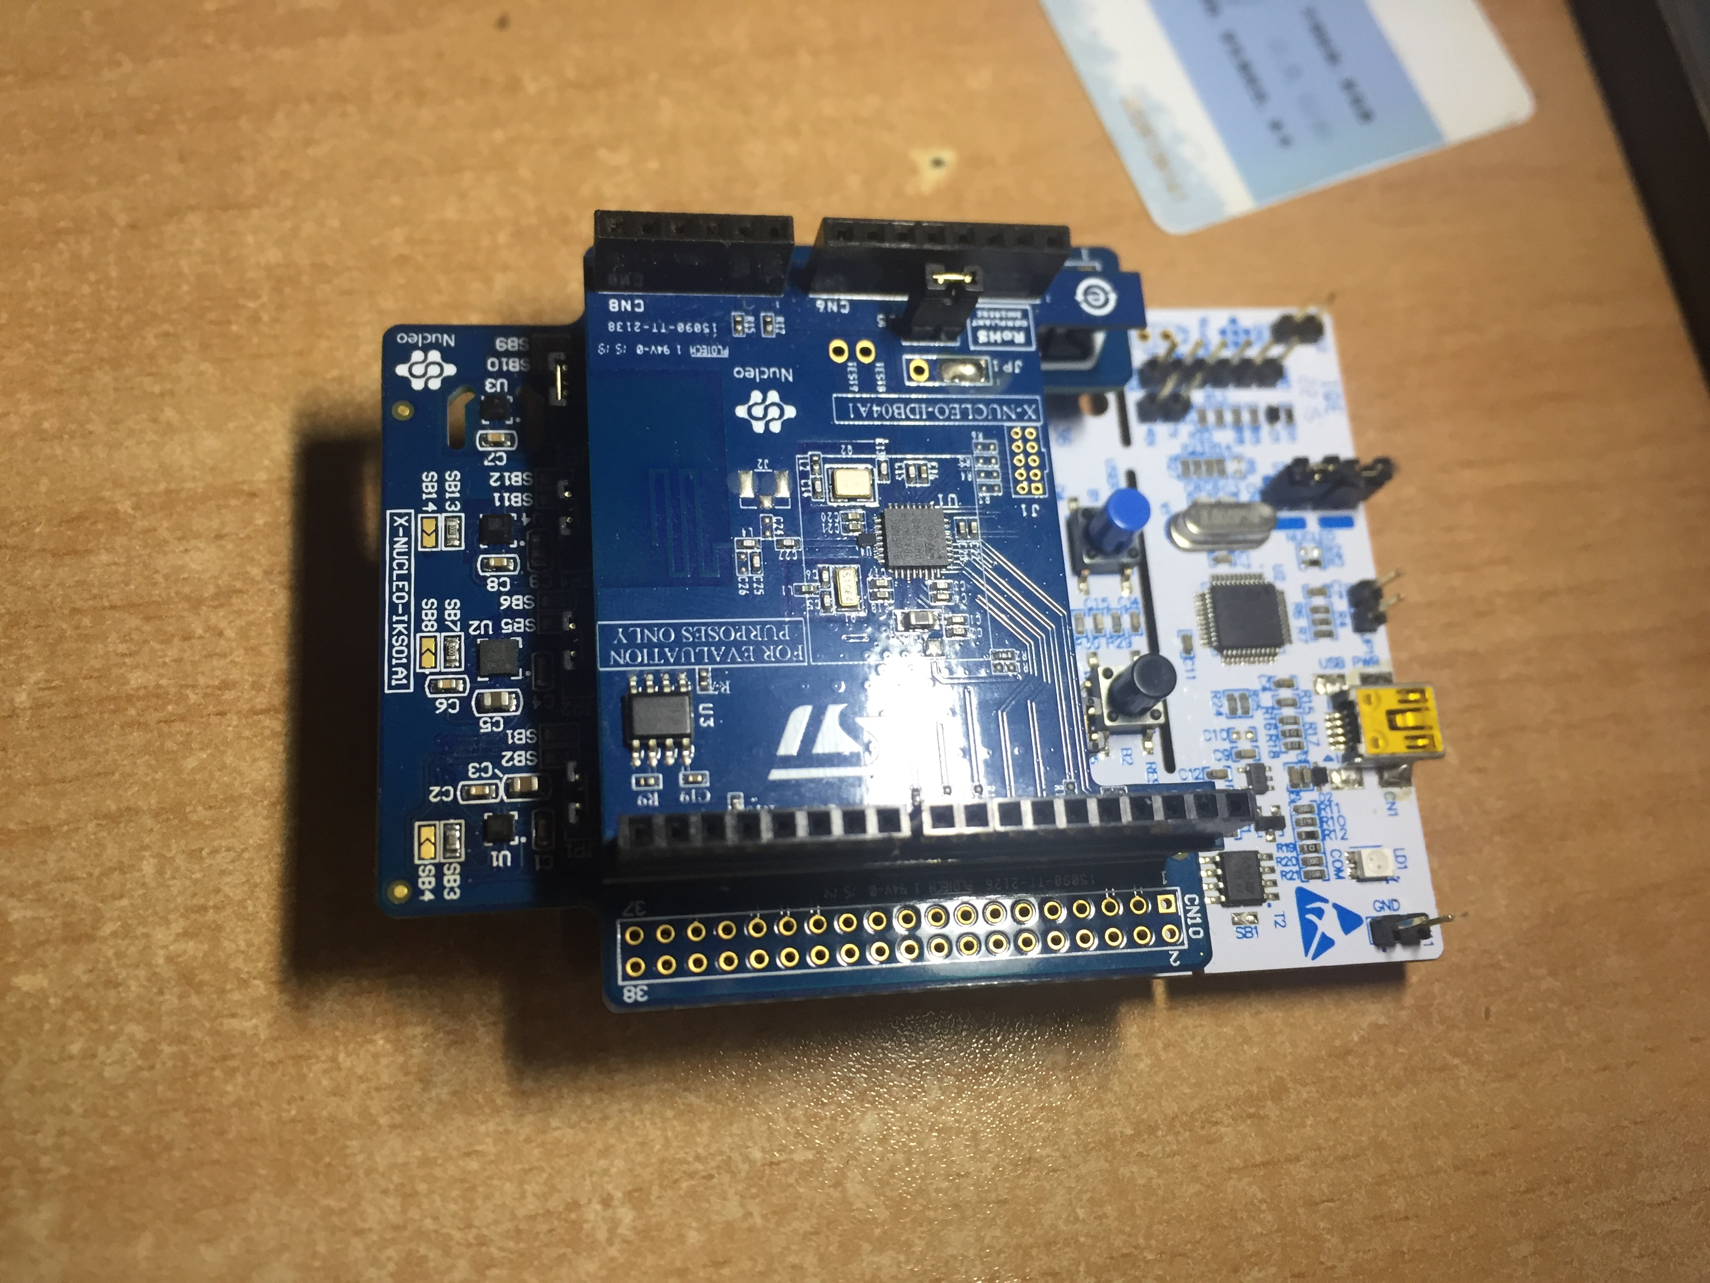
图1 实验器材

三、实验原理和过程
- 步行模型和算法模型
  - 步行模型
在可用于分析跑步或步行的特征当中，我们将个体（及其相关轴）的运动包括三个分量，分别是前向、竖向和侧向，如图2所示。
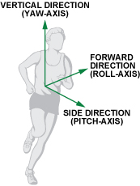
图2 运动模型各轴定义
在步行过程中，竖向轴上的加速度幅度最大，且周期性最明显，如图3所示。

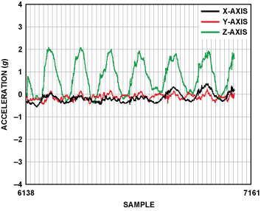
图3 步行过程中的三轴加速度
1.2算法模型
在设计 计步算法时，要知道的是加速度传感器与人体的相对位置是任意的，因此算法应当使加速度传感器的三轴处于相对人体的任意方向上都能够监测到步数。
为了能够更好地验证算法模型，以50Hz的频率采集了一组步行数据如图4，data1、data2、data3分别对应加速度计的x、y、z轴数据。
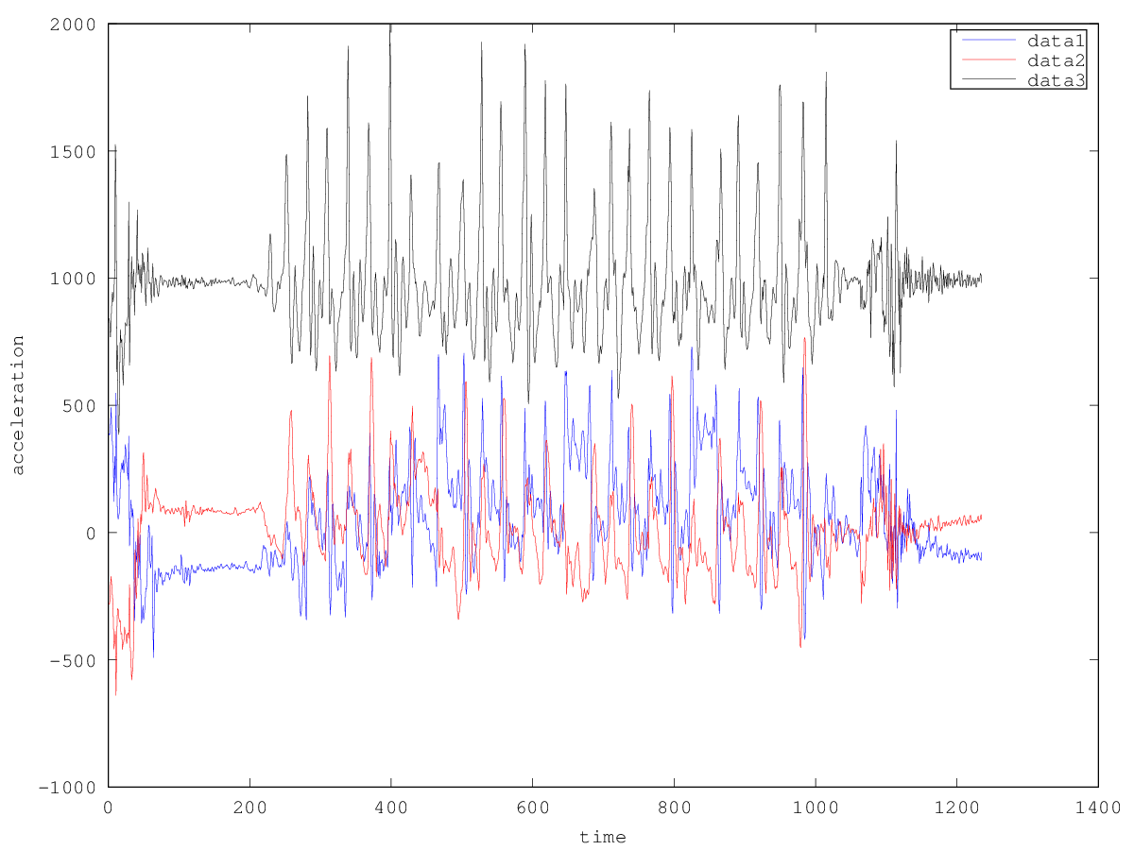
图4 采集到的步行数据
1.2.1 平滑滤波
可以看到由于噪声等缘故，图像非常不平滑，在算法的第一步，每次采样后可以通过一个数字滤波器（如图5）对图像进行平滑。
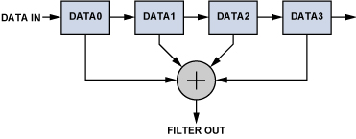
图5 数字滤波器
1.2.2 动态阈值计算
第二步是取得三轴数据的最大值最小值，并且动态地更新阈值。例如，每取50次样本（即1秒）计算一次阈值为(max+min)/2，并且重置max和min值。
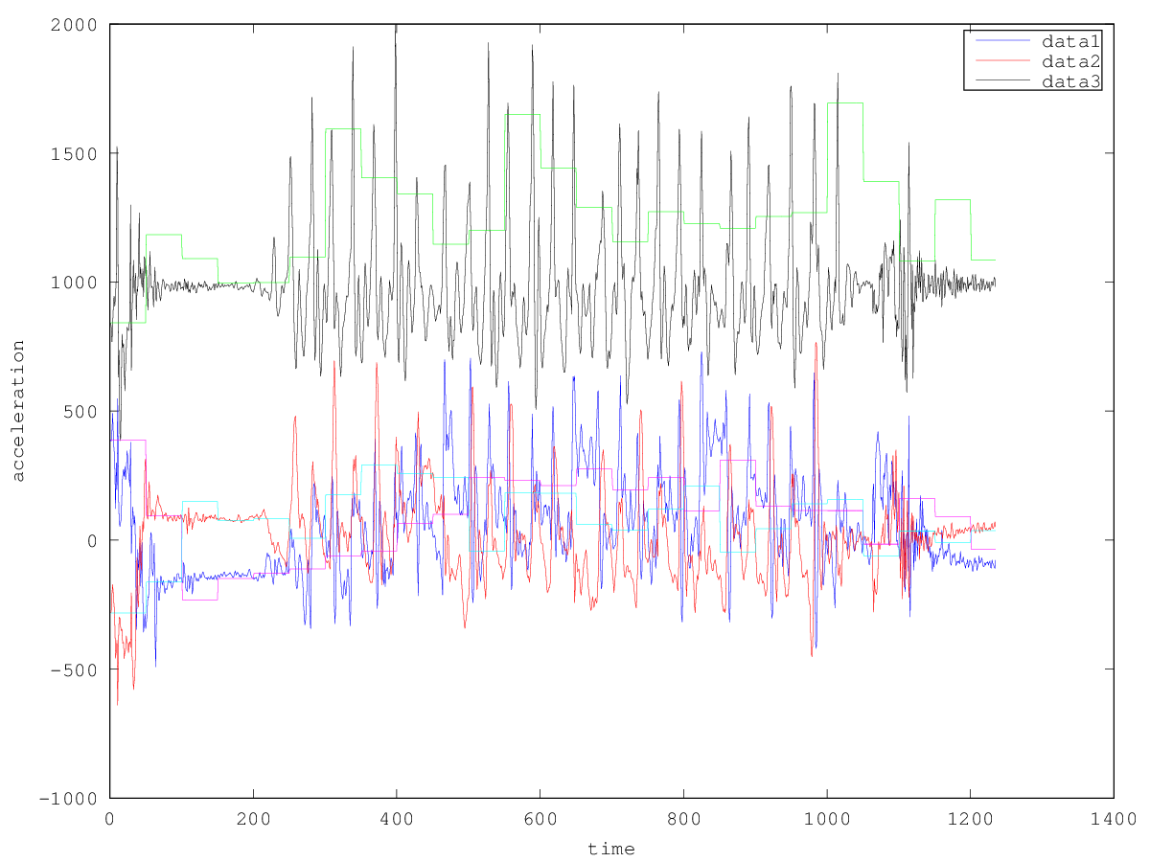
图6 动态阈值计算结果
1.2.3 消除高频噪声
第三步是消除高频噪声。设置两个变量为sample_new和sample_old。当新采样数据sample_result到来时，sample_new无条件移入sample_old寄存器。然而，sample_result是否移入sample_new寄存器取决于下述条件：如果加速度变化大于预定义精度，则最新的采样结果sample_result移入sample_new寄存器，否则sample_new寄存器保持不变。因此，移位寄存器组可以消除高频噪声，从而保证结果更加精确。结果如图7。
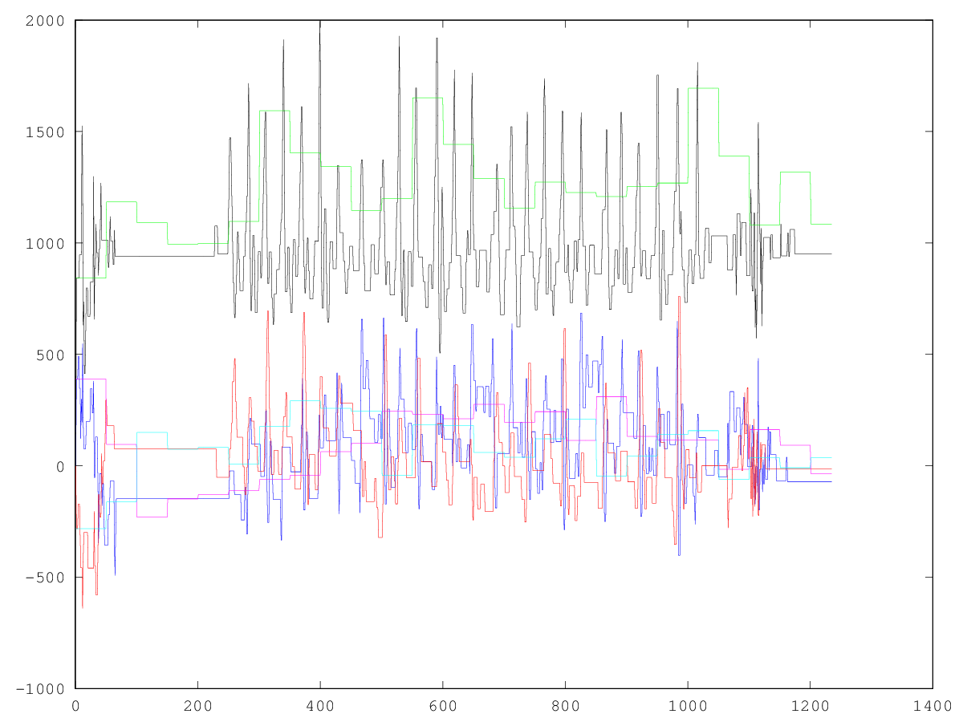
图7 三轴的sample_new和阈值图像
1.2.4 判断有效步伐
最后一步是判断步伐是否迈出。首先要选定三轴中哪一轴更加接近竖向轴。由于在竖直方向上有重力加速度分量，因此这三轴中峰值最大（峰值不仅指最大值，也可能是数据均为负数，峰值为最小值的绝对值）中的一轴最接近竖向轴。如本次采集数据的z轴最接近竖直轴的。则只考虑z轴，判断步伐迈出的条件是z_sample_old大于阈值并且z_sample_new小于阈值。
由于人步行是具有某范围的间隔，可以通过“时间窗口”来滤除无效的有规律震动。一般跑步速度较快每秒应当在5步以内，而较慢地步行速度应当是2秒一步，因此两次有效步伐间隔应当在[0.2s,2s]之间。时间不在这个时间窗口之内应当滤除。
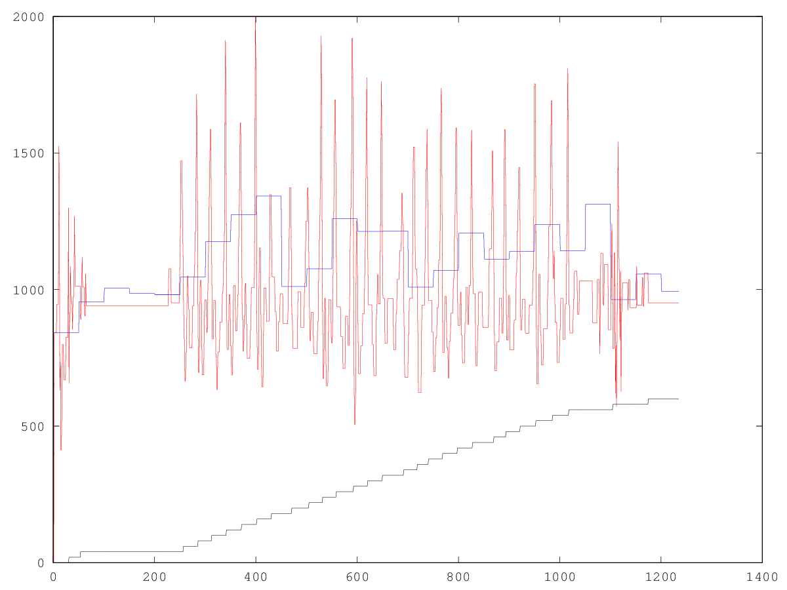
图8 判断步伐是否迈出（计步数目为黑色线，为了显示更明显单次增加较大）
有图8可见，在[200,1000]范围左右正常步行时计步器工作比较正常，二在刚开始和结尾时的一些由于身体的震动引起地、频率也接近步行时间窗口的震动会引起计步器误计，在实际完成时可以通过设定计步器模式来消除这些噪声。
例如，我们认为设定一个阈值，认为不超过这个阈值的连续地、满足时间窗口的步伐不是有效步伐，并不计入步伐，而满足时间窗口的步数超过这个阈值后，才判定是人在正常步行，并将这个阈值也加入到步伐计算中。
- 实际工程
由于实际算法在上一节已经阐述，本节不再讨论。在此主要讨论一些keil uvision和各种板卡的一些函数库和使用方法。
  - 建立工程
按照《零死角玩转STM32——初级篇》的教程，搭建好了工程，并下载了相应板卡的驱动。工程路径如下：
-projects
-Drivers
-BSP
-Components
-STM32F4xx_Nucleo
-X_NUCLEO_IKS01A1
-X_NUCLEO_IDB04A1
-CMSIS
-STM32F4xx_HAL_Driver
-Middlewares
-Pedometer
-Inc
-Src
-mdk-projects
并在target configuration中C/C++中的Include Paths设置为Drivers和Middleware中的路径，如图9。
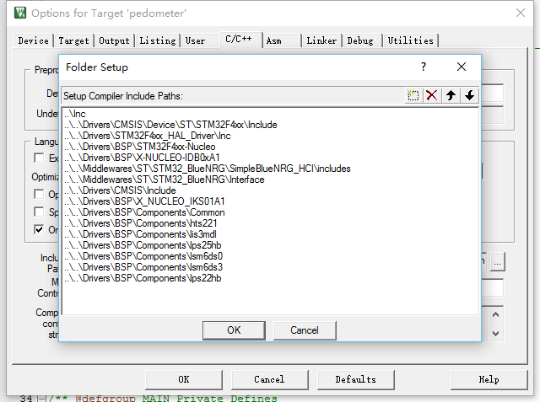
图9 Include Paths
之后将需要的文件加入工程即可。
  - X-NUCLEO-IKS01A1
X-NUCLEO-IKS01A1是一款运动MEMS和环境传感器扩展板，通过I2C总线与STM32微处理器通信。
使用方法：
- 初始化传感器
/* Try to use LSM6DS3 DIL24 if present, otherwise use LSM6DS0 on board */
BSP_ACCELERO_Init( ACCELERO_SENSORS_AUTO, &ACCELERO_handle );
/* Force to use HTS221 */
BSP_TEMPERATURE_Init( HTS221_T_0, &TEMPERATURE_handle );
- 打开传感器
BSP_ACCELERO_Sensor_Enable( ACCELERO_handle );
BSP_TEMPERATURE_Sensor_Enable( TEMPERATURE_handle );
- 读取参数
BSP_ACCELERO_Get_Axes(ACCELERO_handle, &ACC_Value);
BSP_TEMPERATURE_Get_Temp( TEMPERATURE_handle, &temperature );
  - X-NUCLEO-IDB04A1
X-NUCLEO-IDB04A1是低功耗蓝牙扩展板，STM32微处理器可以通过SPI总线与其通信。在本次实验中我们将其设置为server，用手机进行连接。
- 初始化
BNRG_SPI_Init();
- 重置
BlueNRG_RST(void);
- 传输数据可以使用Drivers中的下列函数做读取操作：
int32_t BlueNRG_SPI_Read_All(uint8_t *buffer,
uint8_t buff_size);
int32_t BlueNRG_SPI_Write(uint8_t* data1,
uint8_t* data2,
uint8_t Nb_bytes1,
uint8_t Nb_bytes2);
这里我们使用官方提供的example中的sample_service.c封装的函数，参数更少，使用更方便。
void receiveData(uint8_t* data_buffer, uint8_t Nb_bytes);
void sendData(uint8_t* data_buffer, uint8_t Nb_bytes); 2.4 手机端蓝牙接收工具
手机端可以通过蓝牙接收开发板传递的数据，由于手机端自己开发的蓝牙接收工具可以自定义界面，但在底层并没有太大区别，但是使用iOS或Android中提供的蓝牙部分的sdk对手机进行操作，为了做实验的速度，我使用了常用的蓝牙调试工具lightblue。
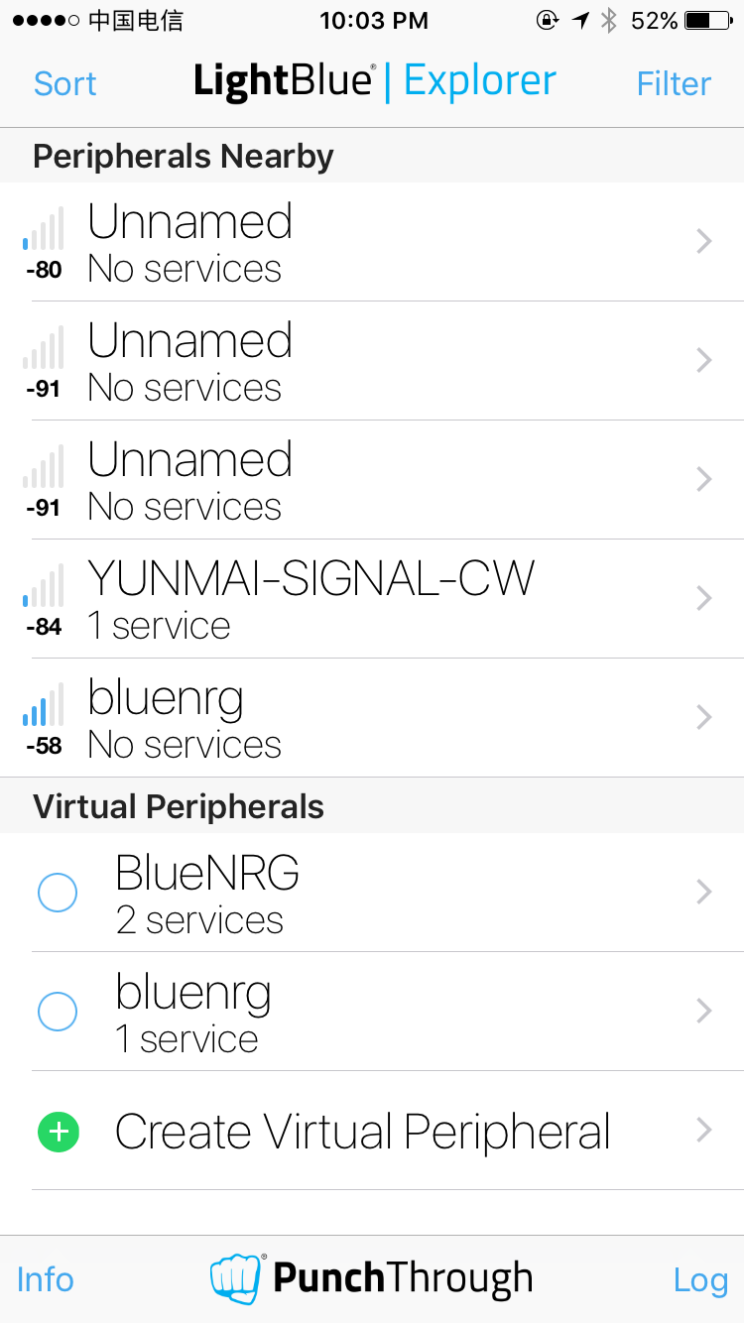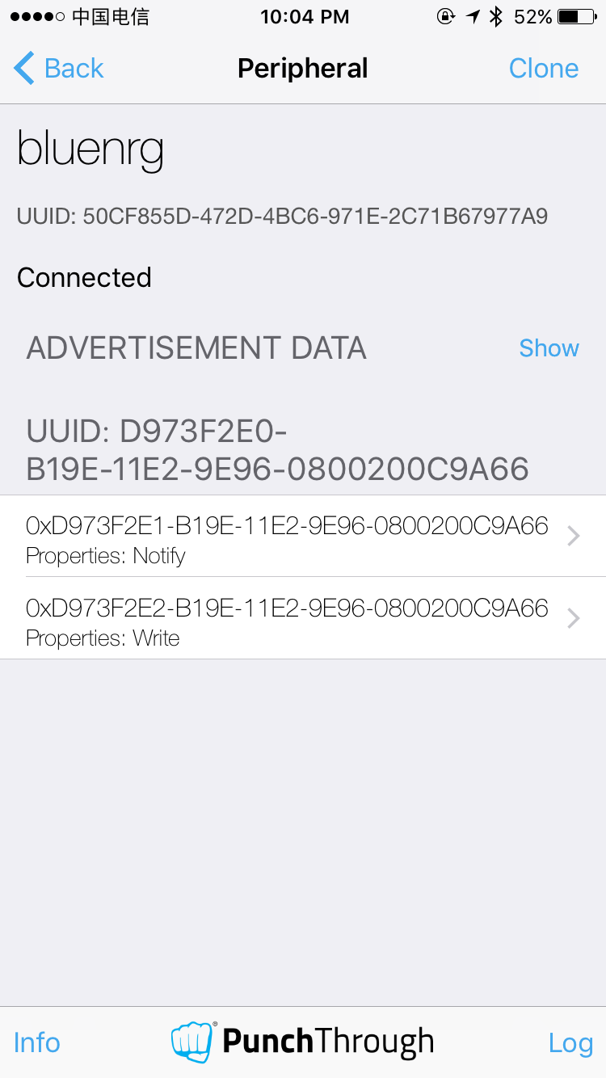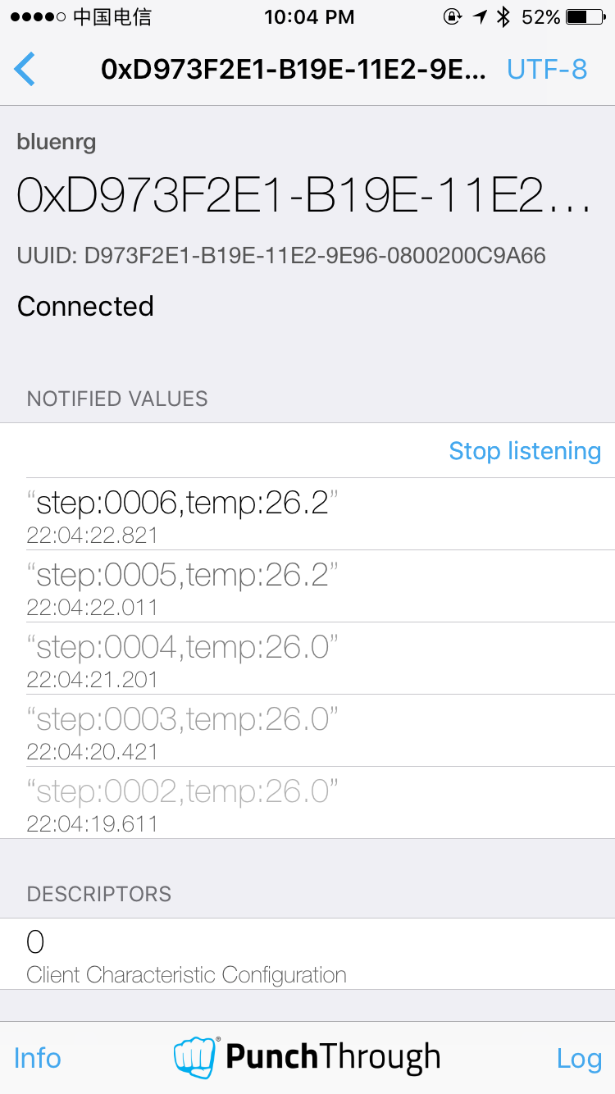
(a) (b) (c)
图10 (a)匹配界面 (b)连接成功后的界面 (c)将格式设置为UTF-8后可以查看数据

四、实验结果
见视频结果，实验满足精度要求。

五、参考文献
- Neil, Zhao. 利用 3 轴数字加速度计实现功能全面的计步器设计[EB/OL]. http://www.analog.com/zh/analog-dialogue/articles/pedometer-design-3-axis-digital-acceler.html.

附件一：处理步伐数据的Octave代码
pedometer.m
clear ; close all; clc;

data = csvread('walkingdata.csv');
t = data(:,1);
x = data(:,2);
y = data(:,3);
z = data(:,4);
length = size(t,1);

precision = 100;

x_max = x(1);
x_min = x(1);
x_th = zeros(length,1);
x_peakValue = 0;
y_max = y(1);
y_min = y(1);
y_th = zeros(length,1);
y_peakValue = 0;
z_max = z(1);
z_min = z(1);
z_th = zeros(length,1);
z_peakValue = 0;

x_old = zeros(length,1);
x_new = zeros(length,1);
y_old = zeros(length,1);
y_new = zeros(length,1);
z_old = zeros(length,1);
z_new = zeros(length,1);

count = zeros(length,1);
lastTime = zeros(length,1);

for i = 1:length,
if mod(i,50) == 1,
x_th(i:i+49) = (x_max + x_min) / 2;
y_th(i:i+49) = (y_max + y_min) / 2;
z_th(i:i+49) = (z_max + z_min) / 2;
x_max = x(i);
x_min = x(i);
x_peakValue = x(i);
y_max = y(i);
y_min = y(i);
y_peakValue = y(i);
z_max = z(i);
z_min = z(i);
z_peakValue = z(i);
end;
if x(i) > x_max,
x_max = x(i);
x_peakValue = max(abs(x_max),abs(x_min));
elseif x(i) < x_min,
x_min = x(i);
x_peakValue = max(abs(x_max),abs(x_min));
end;
if y(i) > y_max,
y_max = y(i);
y_peakValue = max(abs(y_max),abs(y_min));
elseif y(i) < y_min,
y_min = y(i);
y_peakValue = max(abs(y_max),abs(y_min));
end;
if z(i) > z_max,
z_max = z(i);
z_peakValue = max(abs(z_max),abs(z_min));
elseif z(i) < z_min,
z_min = z(i);
z_peakValue = max(abs(z_max),abs(z_min));
end;

x_old(i+1) = x_new(i);
y_old(i+1) = y_new(i);
z_old(i+1) = z_new(i);

if abs(x(i) - x_new(i)) > precision,
x_new(i+1) = x(i);
else
x_new(i+1) = x_new(i);
end;
if abs(y(i) - y_new(i)) > precision,
y_new(i+1) = y(i);
else
y_new(i+1) = y_new(i);
end;
if abs(z(i) - z_new(i)) > precision,
z_new(i+1) = z(i);
else
z_new(i+1) = z_new(i);
end;

count(i+1) = count(i);
lastTime(i+1) = lastTime(i);
if x_peakValue > y_peakValue && x_peakValue > z_peakValue,
if x_old(i+1) > x_th(i) && x_new(i+1) < x_th(i),
[lastTime(i+1), count(i+1)] = newStep(lastTime(i),i,count(i));
end;
elseif y_peakValue > x_peakValue && y_peakValue > z_peakValue,
if y_old(i+1) > y_th(i) && y_new(i+1) < y_th(i),
[lastTime(i+1), count(i+1)] = newStep(lastTime(i),i,count(i));
end;
else
if z_old(i+1) > z_th(i) && z_new(i+1) < z_th(i),
[lastTime(i+1), count(i+1)] = newStep(lastTime(i),i,count(i));
end;
end;

end;

newStep.m
function [lastTime, steps] = newStep(formerTime,nowTime,formerSteps)
min_time = 15;
max_time = 100;

lastTime = nowTime;

if nowTime - formerTime > min_time && nowTime - formerTime < max_time,
steps = formerSteps + 20;
else
steps = formerSteps;
end;

end

附件二：实际工程代码
main.c
/* Includes ------------------------------------------------------------------*/
#include "main.h"
#include "cube_hal.h"

#include "osal.h"
#include "sample_service.h"
#include "role_type.h"
#include "debug.h"
#include "stm32_bluenrg_ble.h"
#include "bluenrg_utils.h"

#include <math.h>
#include <stdio.h>

/* Private defines -----------------------------------------------------------*/
#define BDADDR_SIZE 6
#define FILTER_SAMPLE 5
#define PRECISION 100
#define SAMPLE_PERIOD 20
#define MAX_VALUE 4096
#define MIN_TIMEWIN 350
#define MAX_TIMEWIN 2000
#define STEPTHRESHOLD 4

//typedef enum
//{
// PedometerMode_STEADY = 0,
// PedometerMode_WALK = 1
//}PedometerMode_TypeDef;

/**
* @}
*/

/* Private macros ------------------------------------------------------------*/

/* Private variables ---------------------------------------------------------*/
uint8_t bnrg_expansion_board = IDB04A1; /* at startup, suppose the X-NUCLEO-IDB04A1 is used */

float TEMPERATURE_Value; /*!< Temperature Value */
SensorAxes_t ACC_Value; /*!< Acceleration Value */
void *ACCELERO_handle = NULL;
void *TEMPERATURE_handle = NULL;
void *GYRO_handle = NULL;
void *PRESSURE_handle = NULL;
int32_t x[FILTER_SAMPLE], y[FILTER_SAMPLE], z[FILTER_SAMPLE];
int32_t x_max = - MAX_VALUE;
int32_t x_min = MAX_VALUE;
int32_t y_max = - MAX_VALUE;
int32_t y_min = MAX_VALUE;
int32_t z_max = - MAX_VALUE;
int32_t z_min = MAX_VALUE;
int32_t x_th, y_th, z_th;
int32_t x_absmax,y_absmax,z_absmax;
int32_t x_new, x_old, y_new, y_old, z_new, z_old;
int32_t x_result, y_result, z_result;
int32_t d1, d2;
float temperature;
int counter;
int32_t steps;
int tempSteps = 0;
int formerSteps = -1;
//PedometerMode_TypeDef mode;
int active;
uint32_t old_time, new_time;

BLE_RoleTypeDef BLE_Role = SERVER;

#ifdef THROUGHPUT_TEST
uint8_t throughput_test = 1; /* enable the test for the estimation of the throughput */
#else
uint8_t throughput_test = 0; /* disable the test for the estimation of the throughput */
#endif

UART_HandleTypeDef UartHandle;

extern volatile uint8_t set_connectable;
extern volatile int connected;
extern volatile uint8_t notification_enabled;

extern volatile uint8_t start_read_tx_char_handle;
extern volatile uint8_t start_read_rx_char_handle;
extern volatile uint8_t end_read_tx_char_handle;
extern volatile uint8_t end_read_rx_char_handle;

/**
* @}
*/

/** @defgroup MAIN_Private_Function_Prototypes
* @{
*/
/* Private function prototypes -----------------------------------------------*/
void User_Process(void);
static void start(void);
static void newStep(void);
static void initializeAllSensors(void);
static void enableAllSensors(void);
uint8_t intToChar(int32_t);
static void floatToInt( float in, int32_t *out_int, int32_t *out_dec, int32_t dec_prec );
static int32_t int32abs(int32_t);
/**
* @}
*/

/**
* @brief UART MSP Initialization
* This function configures the hardware resources used in this example:
* - Peripheral's clock enable
* - Peripheral's GPIO Configuration
* - NVIC configuration for UART interrupt request enable
* @param huart: UART handle pointer
* @retval None
*/
void HAL_UART_MspInit(UART_HandleTypeDef *huart)
{
GPIO_InitTypeDef GPIO_InitStruct;

/*##-1- Enable peripherals and GPIO Clocks #################################*/
/* Enable GPIO TX/RX clock */
USARTx_TX_GPIO_CLK_ENABLE();
USARTx_RX_GPIO_CLK_ENABLE();
/* Enable USART1 clock */
USARTx_CLK_ENABLE();

/*##-2- Configure peripheral GPIO ##########################################*/
/* UART TX GPIO pin configuration */
GPIO_InitStruct.Pin = USARTx_TX_PIN;
GPIO_InitStruct.Mode = GPIO_MODE_AF_PP;
GPIO_InitStruct.Pull = GPIO_PULLUP;
GPIO_InitStruct.Speed = GPIO_SPEED_FAST;
GPIO_InitStruct.Alternate = USARTx_TX_AF;

HAL_GPIO_Init(USARTx_TX_GPIO_PORT, &GPIO_InitStruct);

/* UART RX GPIO pin configuration */
GPIO_InitStruct.Pin = USARTx_RX_PIN;
GPIO_InitStruct.Alternate = USARTx_RX_AF;

HAL_GPIO_Init(USARTx_RX_GPIO_PORT, &GPIO_InitStruct);
}

/**
* @brief Init the VCOM.
* @param None
* @return None
*/
void vcom_init(void)
{
/*## Configure the UART peripheral ######################################*/
/* Put the USART peripheral in the Asynchronous mode (UART Mode) */
/* UART1 configured as follow:
- Word Length = 8 Bits
- Stop Bit = One Stop bit
- Parity = ODD parity
- BaudRate = 9600 baud
- Hardware flow control disabled (RTS and CTS signals) */
UartHandle.Instance = USARTx;

UartHandle.Init.BaudRate = 9600;
UartHandle.Init.WordLength = UART_WORDLENGTH_8B;
UartHandle.Init.StopBits = UART_STOPBITS_1;
UartHandle.Init.Parity = UART_PARITY_NONE;
UartHandle.Init.HwFlowCtl = UART_HWCONTROL_NONE;
UartHandle.Init.Mode = UART_MODE_TX_RX;

if(HAL_UART_Init(&UartHandle) != HAL_OK)
{
/* Initialization Error */
Error_Handler();
}
}

void change_absmax(void)
{
x_absmax = int32abs(x_max) > int32abs(x_min) ? int32abs(x_max) : int32abs(x_min);
y_absmax = int32abs(y_max) > int32abs(y_min) ? int32abs(y_max) : int32abs(y_min);
z_absmax = int32abs(z_max) > int32abs(z_min) ? int32abs(z_max) : int32abs(z_min);
}

int main(void)
{
uint8_t CLIENT_BDADDR[] = {0xbb, 0x00, 0x00, 0xE1, 0x80, 0x02};
uint8_t SERVER_BDADDR[] = {0xaa, 0x00, 0x00, 0xE1, 0x80, 0x02};
uint8_t bdaddr[BDADDR_SIZE];
uint16_t service_handle, dev_name_char_handle, appearance_char_handle;

uint8_t hwVersion;
uint16_t fwVersion;

int ret;

/* STM32Cube HAL library initialization:
* - Configure the Flash prefetch, Flash preread and Buffer caches
* - Systick timer is configured by default as source of time base, but user
* can eventually implement his proper time base source (a general purpose
* timer for example or other time source), keeping in mind that Time base
* duration should be kept 1ms since PPP_TIMEOUT_VALUEs are defined and
* handled in milliseconds basis.
* - Low Level Initialization
*/
HAL_Init();

/* Configure LED2 */
BSP_LED_Init(LED2);

/* Configure the User Button in GPIO Mode */
BSP_PB_Init(BUTTON_KEY, BUTTON_MODE_GPIO);

/* Configure the system clock */
SystemClock_Config();

/* Initialize the VCOM interface */
vcom_init();

/* Initialize the BlueNRG SPI driver */
BNRG_SPI_Init();

/* Initialize the BlueNRG HCI */
HCI_Init();

/* Reset BlueNRG hardware */
BlueNRG_RST();

/* get the BlueNRG HW and FW versions */
getBlueNRGVersion(&hwVersion, &fwVersion);

/*
* Reset BlueNRG again otherwise we won't
* be able to change its MAC address.
* aci_hal_write_config_data() must be the first
* command after reset otherwise it will fail.
*/
BlueNRG_RST();

PRINTF("HWver %d, FWver %d\n", hwVersion, fwVersion);

if (hwVersion > 0x30) { /* X-NUCLEO-IDB05A1 expansion board is used */
bnrg_expansion_board = IDB05A1;
}

ret = aci_hal_write_config_data(CONFIG_DATA_PUBADDR_OFFSET,
CONFIG_DATA_PUBADDR_LEN,
bdaddr);
if(ret){
PRINTF("Setting BD_ADDR failed 0x%02x.\n", ret);
}

ret = aci_gatt_init();
if(ret){
PRINTF("GATT_Init failed.\n");
}

if (bnrg_expansion_board == IDB05A1) {
ret = aci_gap_init_IDB05A1(GAP_PERIPHERAL_ROLE_IDB05A1, 0, 0x07, &service_handle, &dev_name_char_handle, &appearance_char_handle);
}
else {
ret = aci_gap_init_IDB04A1(GAP_PERIPHERAL_ROLE_IDB04A1, &service_handle, &dev_name_char_handle, &appearance_char_handle);
}

if(ret != BLE_STATUS_SUCCESS){
PRINTF("GAP_Init failed.\n");
}

ret = aci_gap_set_auth_requirement(MITM_PROTECTION_REQUIRED,
OOB_AUTH_DATA_ABSENT,
NULL,
7,
16,
USE_FIXED_PIN_FOR_PAIRING,
123456,
BONDING);
if (ret == BLE_STATUS_SUCCESS) {
PRINTF("BLE Stack Initialized.\n");
}

ret = Add_Sample_Service();

if(ret == BLE_STATUS_SUCCESS)
PRINTF("Service added successfully.\n");
else
PRINTF("Error while adding service.\n");

/* Set output power level */
ret = aci_hal_set_tx_power_level(1,4);

initializeAllSensors();
enableAllSensors();

active = 1;
//mode = PedometerMode_STEADY;

while(1)
{
HCI_Process();
User_Process();
}
}

/**
* @brief Process user input (i.e. pressing the USER button on Nucleo board)
* and send a LED toggle command to the remote board.
* @param None
* @retval None
*/
void User_Process(void)
{
if(set_connectable){
/* Establish connection with remote device */
Make_Connection();
set_connectable = FALSE;
}

start();
if(steps != formerSteps)
{
unsigned char dataOut[20] = {'s','t','e','p',':',intToChar(steps/1000%10), intToChar(steps/100%10),intToChar(steps/10%10),intToChar(steps%10),',','t','e','m','p',':',intToChar(d1/10%10),intToChar(d1%10),'.',intToChar(d2)};
//sprintf(dataOut, "steps: %d", (int)steps);
sendData(dataOut, sizeof(dataOut));
formerSteps = steps;
}

/* Check if the user has pushed the button */
if(BSP_PB_GetState(BUTTON_KEY) == RESET)
{
while (BSP_PB_GetState(BUTTON_KEY) == RESET);

if(connected && notification_enabled){
/* Send a toggle command to the remote device */
uint8_t data[20] = {'0','1','2','3','4','5','6','7','8','9','A','B','C','D','E','F','G','H','I','J'};
sendData(data, sizeof(data));

steps = 0;
formerSteps = -1;
//mode = PedometerMode_STEADY;

//BSP_LED_Toggle(LED2); // toggle the LED2 locally.
// If uncommented be sure BSP_LED_Init(LED2) is
// called in main().
// E.g. it can be enabled for debugging.
}
}

HAL_Delay(20);
}

/**
* @brief Get the current tick value in millisecond
* @param None
* @retval The tick value
*/
uint32_t user_currentTimeGetTick(void)
{
return HAL_GetTick();
}

/**
* @brief Get the delta tick value in millisecond from Tick1 to the current tick
* @param Tick1 the reference tick used to compute the delta
* @retval The delta tick value
*/
uint32_t user_currentTimeGetElapsedMS(uint32_t Tick1)
{
volatile uint32_t Delta, Tick2;

Tick2 = HAL_GetTick();

/* Capture computation */
Delta = Tick2 - Tick1;
return Delta;
}

static void start()
{
if(active)
{
/*SUM FILTERING */
BSP_ACCELERO_Get_Axes(ACCELERO_handle, &ACC_Value);
x[0] = ACC_Value.AXIS_X;
y[0] = ACC_Value.AXIS_Y;
z[0] = ACC_Value.AXIS_Z;
BSP_ACCELERO_Get_Axes(ACCELERO_handle, &ACC_Value);
x[1] = ACC_Value.AXIS_X;
y[1] = ACC_Value.AXIS_Y;
z[1] = ACC_Value.AXIS_Z;
BSP_ACCELERO_Get_Axes(ACCELERO_handle, &ACC_Value);
x[2] = ACC_Value.AXIS_X;
y[2] = ACC_Value.AXIS_Y;
z[2] = ACC_Value.AXIS_Z;
BSP_ACCELERO_Get_Axes(ACCELERO_handle, &ACC_Value);
x[3] = ACC_Value.AXIS_X;
y[3] = ACC_Value.AXIS_Y;
z[3] = ACC_Value.AXIS_Z;
x_result = (x[0] + x[1] + x[2] + x[3])/4;
y_result = (y[0] + y[1] + y[2] + y[3])/4;
z_result = (z[0] + z[1] + z[2] + z[3])/4;
/*END SUM FILTERING*/

/*FIND MAX AND MIN VALUE*/
if (x_result > x_max) {x_max = x_result;change_absmax();}
if (x_result < x_min) {x_min = x_result;change_absmax();}

if (y_result > y_max) {y_max = y_result;change_absmax();}
if (y_result < y_min) {y_min = y_result;change_absmax();}

if (z_result > z_max) {z_max = z_result;change_absmax();}
if (z_result < z_min) {z_min = z_result;change_absmax();}
/*END FIND MAX AND MIN VALUE*/

++counter;

if(counter > 50)
{
counter = 0;
//º∆À„„–÷µ
x_th = (x_max + x_min) >>1;
y_th = (y_max + y_min) >>1;
z_th = (z_max + z_min) >>1;

/*INIT VALUE*/
/*
x_max = -MAX_VALUE;
x_min = MAX_VALUE;
y_max = -MAX_VALUE;
y_min = MAX_VALUE;
z_max = -MAX_VALUE;
z_min = MAX_VALUE;
*/
x_max = x_result;
x_min = x_result;
y_max = y_result;
y_min = y_result;
z_max = z_result;
z_min = z_result;

BSP_TEMPERATURE_Get_Temp( TEMPERATURE_handle, &temperature );
floatToInt( temperature, &d1, &d2, 2 );
while(d2>10) d2 /= 10;
}

x_old = x_new;
y_old = y_new;
z_old = z_new;

if (x_new - x_result > PRECISION || x_result - x_new > PRECISION) x_new = x_result;
if (y_new - y_result > PRECISION || y_result - y_new > PRECISION) y_new = y_result;
if (z_new - z_result > PRECISION || z_result - z_new > PRECISION) z_new = z_result;

/*FIND LARGEST ACCEL AXIS*/
if(x_absmax > y_absmax && x_absmax > z_absmax)
{
if(x_old > x_th && x_new < x_th)
{
newStep();
}
} else if (y_absmax > x_absmax && y_absmax > z_absmax)
{
if(y_old > y_th && y_new < y_th)
{
newStep();

}
} else
{
if(z_old > z_th && z_new < z_th)
{
newStep();
}
}
}
}

static void newStep()
{
old_time = new_time;
new_time = HAL_GetTick();
uint32_t time = new_time - old_time;

//if(time > MAX_TIMEWIN)
//{
//if(mode == PedometerMode_WALK)
//{
// mode = PedometerMode_STEADY;
//}
//tempSteps = 1;
//}
//else
if(time >= MIN_TIMEWIN && time <= MAX_TIMEWIN)
{
//if(mode == PedometerMode_WALK)
//{
++steps;
//}
//else {
// if(tempSteps < STEPTHRESHOLD)
// {
// tempSteps++;
// return;
// }
// else {
// tempSteps = 0;
// steps = steps + STEPTHRESHOLD + 1;
// mode = PedometerMode_WALK;
// }
// }
}
}

/**
* @brief Initialize all sensors
* @param None
* @retval None
*/
static void initializeAllSensors(void)
{
/* Try to use LSM6DS3 DIL24 if present, otherwise use LSM6DS0 on board */
BSP_ACCELERO_Init( ACCELERO_SENSORS_AUTO, &ACCELERO_handle );
/* Force to use HTS221 */
BSP_TEMPERATURE_Init( HTS221_T_0, &TEMPERATURE_handle );
}

/**
* @brief Enable all sensors
* @param None
* @retval None
*/
static void enableAllSensors(void)
{
BSP_ACCELERO_Sensor_Enable( ACCELERO_handle );
BSP_TEMPERATURE_Sensor_Enable( TEMPERATURE_handle );
}

uint8_t intToChar(int32_t num)
{
switch(num){
case 0: return '0';
case 1: return '1';
case 2: return '2';
case 3: return '3';
case 4: return '4';
case 5: return '5';
case 6: return '6';
case 7: return '7';
case 8: return '8';
case 9: return '9';
}
return '0';
}

static int32_t int32abs(int32_t num)
{
return num >= 0 ? num : -num;
}

#ifdef USE_FULL_ASSERT
/*******************************************************************************
* Function Name : assert_failed
* Description : Reports the name of the source file and the source line number
* where the assert_param error has occurred.
* Input : - file: pointer to the source file name
* - line: assert_param error line source number
* Output : None
* Return : None
*******************************************************************************/
void assert_failed(uint8_t* file, uint32_t line)
{
/* User can add his own implementation to report the file name and line number,
ex: printf("Wrong parameters value: file %s on line %d\r\n", file, line) */

/* Infinite loop */
while (1)
{}
}
#endif

/**
* @brief This function is executed in case of error occurrence.
* @param None
* @retval None
*/
void Error_Handler(void)
{
//printf("Error_Handler\n");
/* Blink LED2 */
while(1)
{
BSP_LED_Toggle(LED2);
HAL_Delay(100);
}
}

/**
* @brief Splits a float into two integer values.
* @param in the float value as input
* @param out_int the pointer to the integer part as output
* @param out_dec the pointer to the decimal part as output
* @param dec_prec the decimal precision to be used
* @retval None
*/
static void floatToInt( float in, int32_t *out_int, int32_t *out_dec, int32_t dec_prec )
{

*out_int = (int32_t)in;
if(in >= 0.0f)
{
in = in - (float)(*out_int);
}
else
{
in = (float)(*out_int) - in;
}
*out_dec = (int32_t)trunc(in * pow(10, dec_prec));
}

