model <- cito::dnn(X = X_train, Y = Y_train,
hidden = c(50L,50L),
epochs =100,
lr = 0.002, #learning rate
# loss = "gaussian",
activation = "relu",
lr_scheduler = cito::config_lr_scheduler("reduce_on_plateau",
patience = 5,
factor = 0.5), #divide by 2 lr if the loss is constant over 5 epochs
validation = 0.2, #take 20% of the data to test the model
early_stopping = 10,
lambda = 0.001,
alpha = 0.2,
batchsize = round(nrow(X_train) * 0.1)
# ,
# bootstrap = 10

)

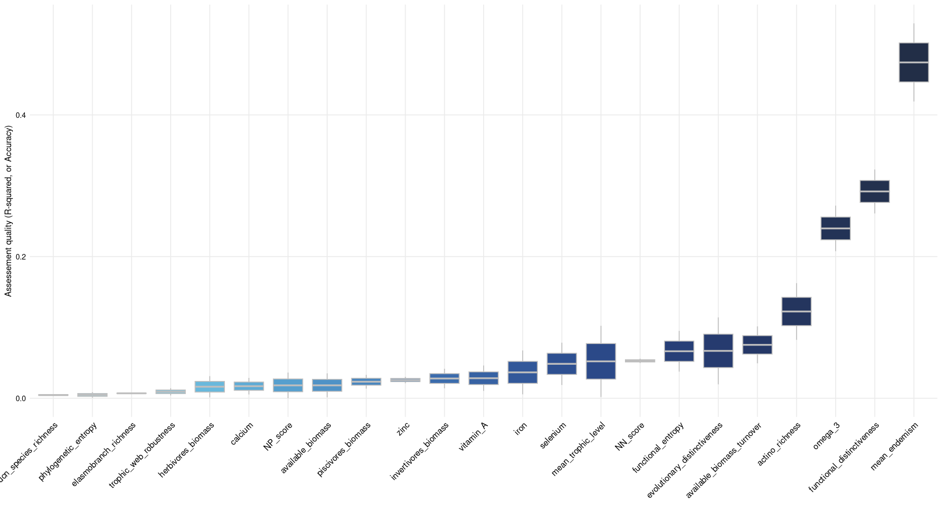

model <- cito::dnn(X = X_train, Y = Y_train,
hidden = c(50L,50L),
epochs =100,
lr = 0.01, #learning rate
# loss = "gaussian",
activation = "selu",
lr_scheduler = cito::config_lr_scheduler("reduce_on_plateau",
patience = 5,
factor = 0.5), #divide by 2 lr if the loss is constant over 5 epochs
validation = 0.2, #take 20% of the data to test the model
early_stopping = 10,
lambda = 0.001,
alpha = 0.2
# ,
# batchsize = round(nrow(X_train) * 0.1)
# ,
# bootstrap = 10

)
