高级数据库实验报告

学号：SA18225510 姓名:郑嘉

ER图：

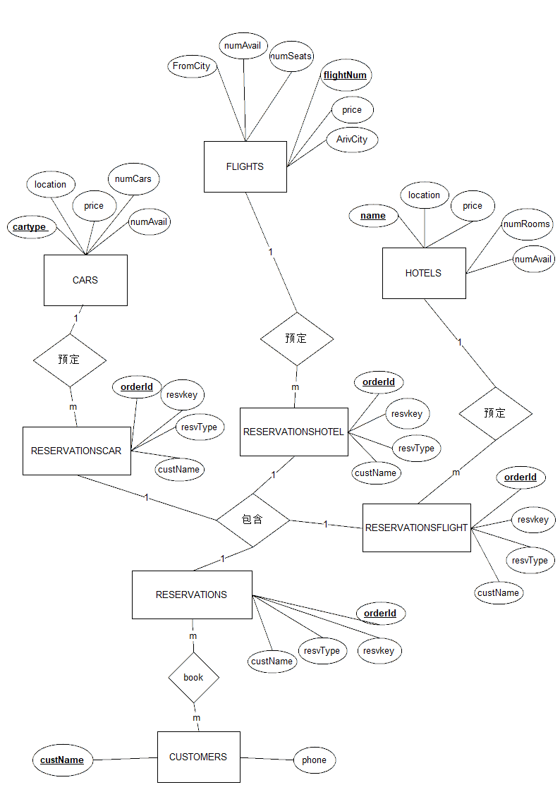

ER图解释：

总共存在八个关系。

CUSTOMERS表：custName为客户姓名（主键），phone为客户的电话号码。

RESERVATIONS表：orderId为订单表，resvType为订单类型，resvkey为类型中的属性具体名称，custName为订单所属用户名。

RESERVATIONSFLIGHT表：orderId为订单表，resvType为订单类型，resvkey为类型中的属性具体名称（外键-FLIGHTS），custName为订单所属用户名（外键-CUSTOMERS）。

RESERVATIONSHOTEL表：orderId为订单表，resvType为订单类型，resvkey为类型中的属性具体名称（外键-HOTELS），custName为订单所属用户名（外键-CUSTOMERS）。

RESERVATIONSCAR表：orderId为订单表，resvType为订单类型，resvkey为类型中的属性具体名称（外键-CARS），custName为订单所属用户名（外键-CUSTOMERS）。

RESERVATIONS关系为强实体，RESERVATIONSFLIGHT、RESERVATIONSCAR、RESERVATIONSHOTEL三者为弱实体。这两类存在包含关系。

CARS表：cartype为出租车类型（主键），location为出租车所在位置，price为价格，numCars为总共车的数量，numAvail为当前可用数量。

HOTELS表：name为旅店名（主键），location为旅店所在位置，price为价格，numRooms为总共房间的数量，numAvail为当前可用数量。

FLIGHTS表：flightNum为航班号（主键），price为价格，FromCity为出发城市，ArivCity为到达城市，numSeats为座位的数量，numAvail为当前可用数量。

ER图到关系模式的转换：将上述的8个表作为8个关系一一对应。属性也一一对应。

完成的功能及说明：

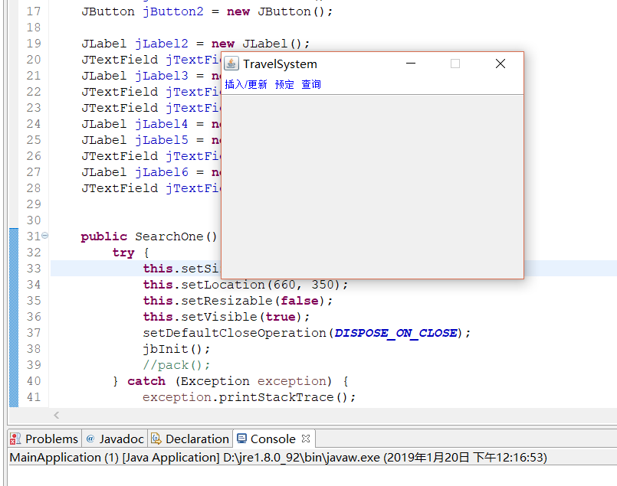

这是程序运行后的主界面。上面有插入、更新、预定、查询的功能。

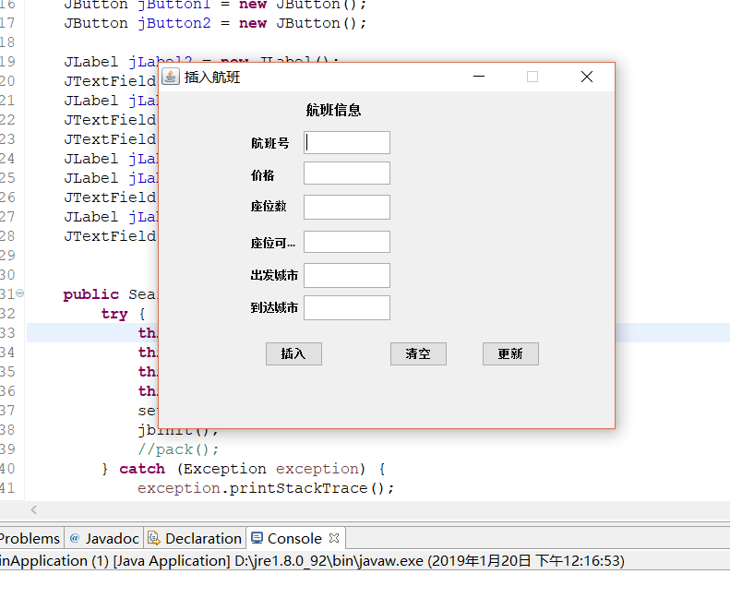

这是插入航班信息的界面，有三个按钮，分别为插入，更新和清空（清空输入）

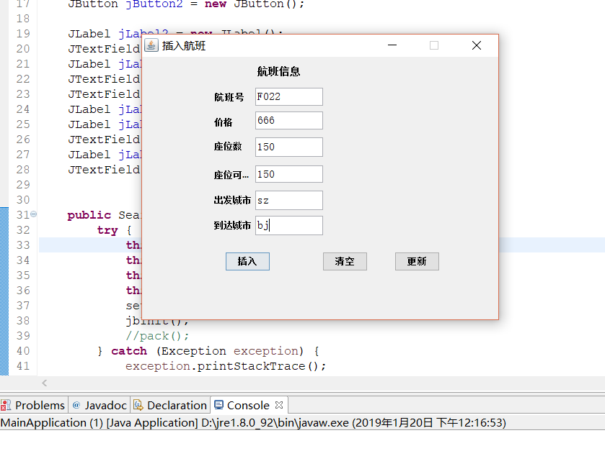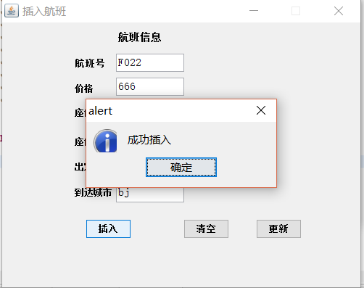

成功插入新的信息。

成功将座位输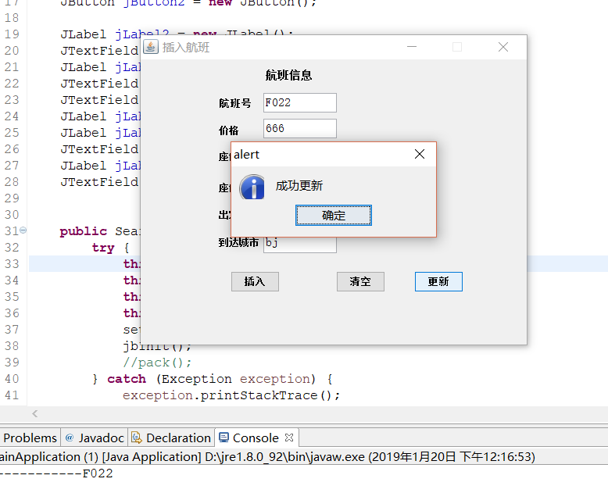

成功将座位数更新为60.

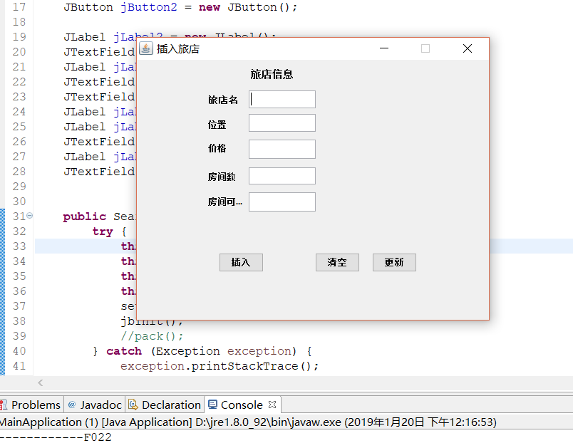

这是插入、更新旅店的界面。

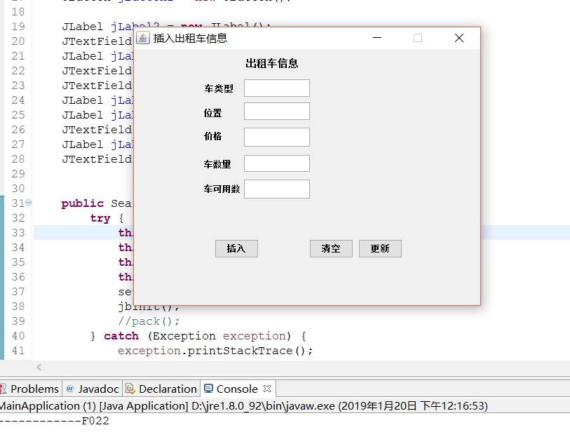

这是插入、更新出租车信息的界面。

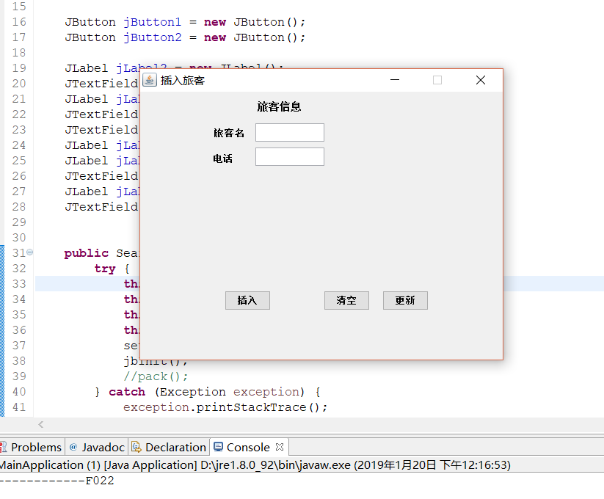

这是插入、更新旅客信息的界面。

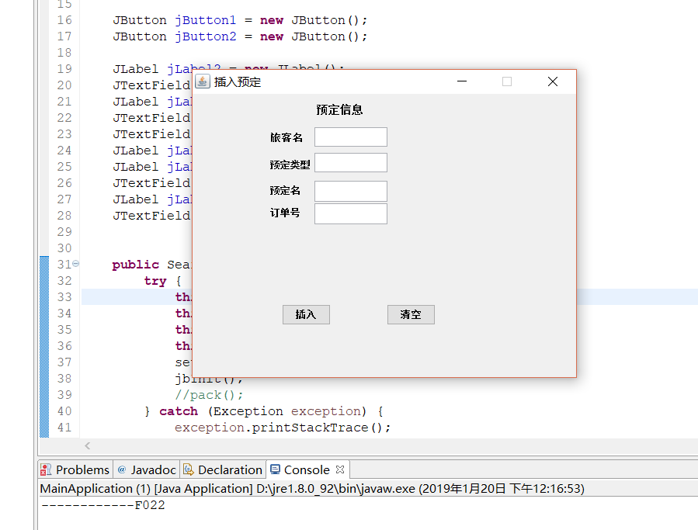

这是插入预定信息的界面。

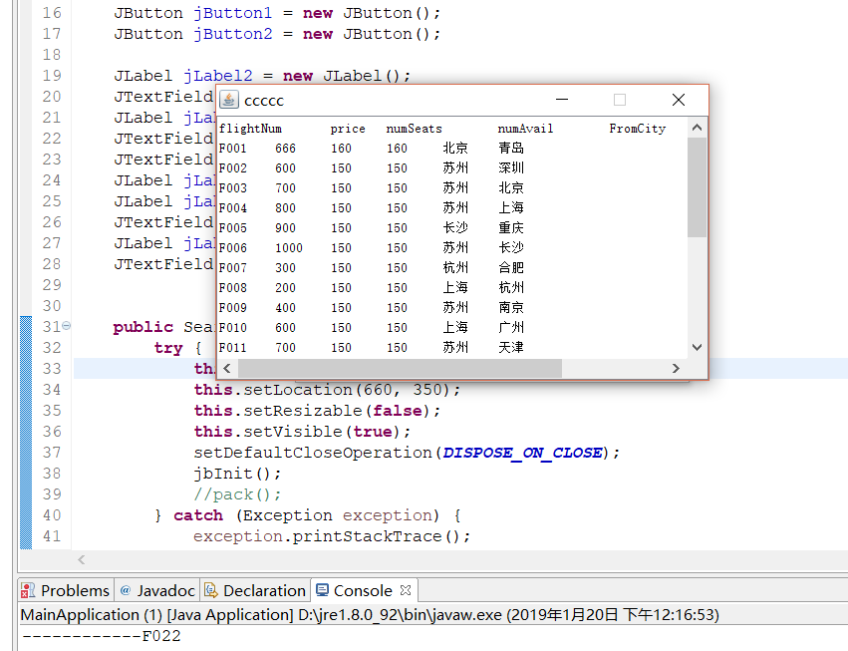这是查询航班信息的界面。

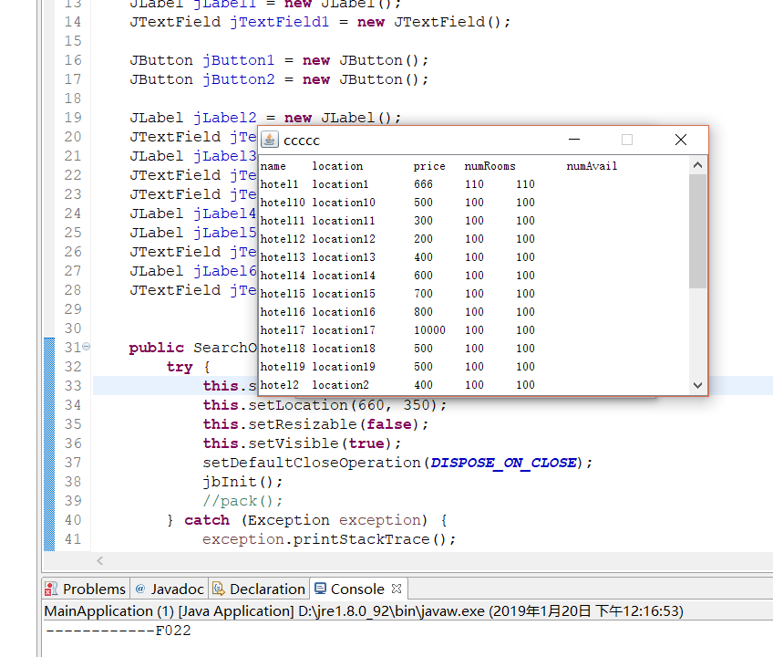

这是查询旅店信息的界面。

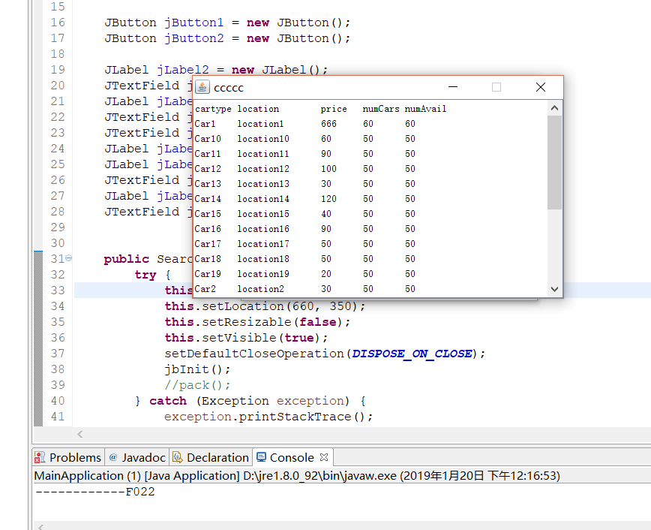

这是查询出租车信息的界面。

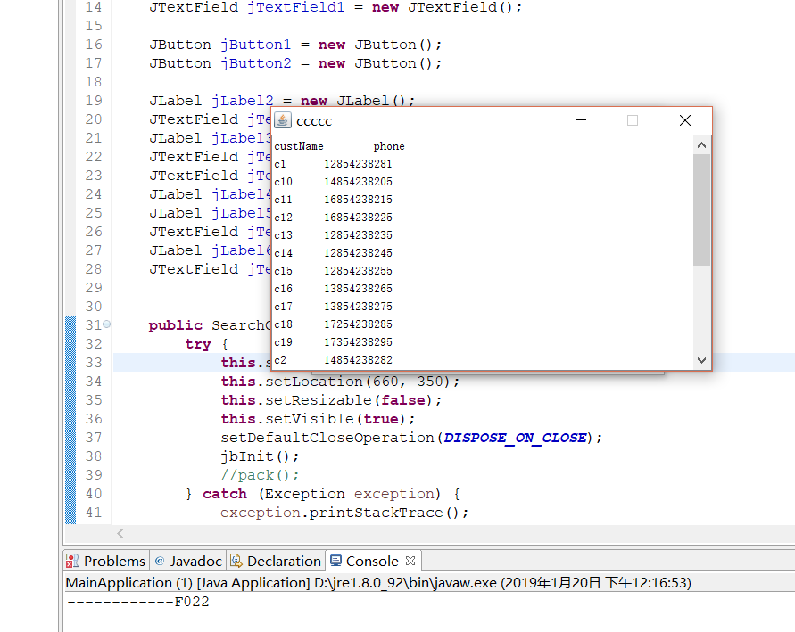

这是查询顾客的信息。

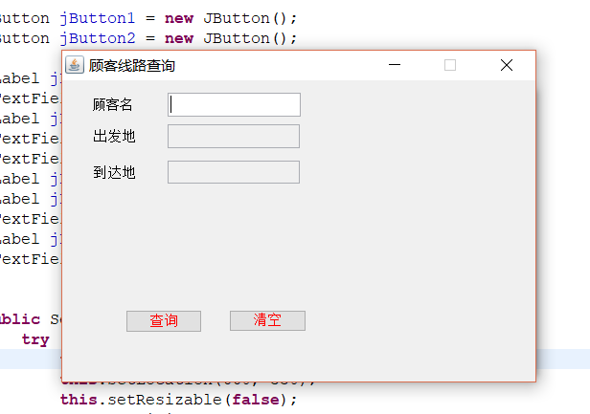

这是查询的顾客线路的查询。

首先输入顾客姓名，去预定表查询顾客的姓名，获取航班号，再从航班表获取出发城市和到达城市。并一起显示出来

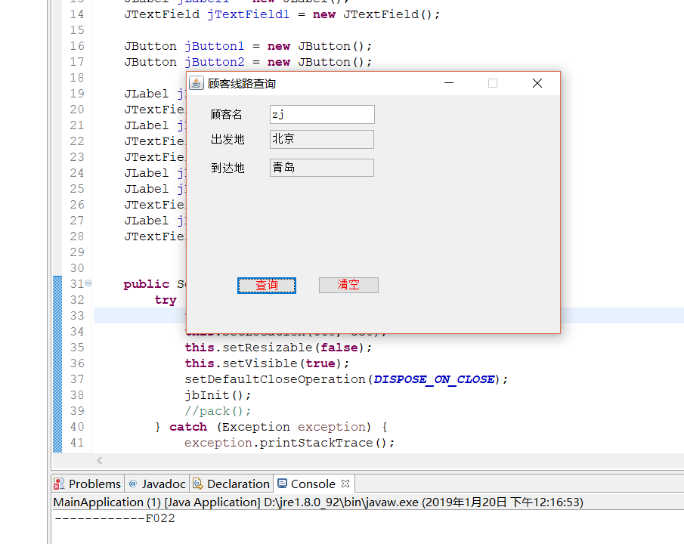

系统实现的环境：

实现语言java，使用的ui框架为java swing，Ide为eclipse。

数据库用SQL server。Sql语言编写。

关系元组数据文件。

--创建TravelDB数据库：

Create Database TravelDB;

--使用TravelDB：

Use TravelDB

--创建表：

--航班表

Create table FLIGHTS

(

flightNum varchar(255) primary key,

price int not null,

numSeats int not null,

numAvail int not null,

FromCity varchar(255) not null,

ArivCity varchar(255) not null

)

--旅店表

Create table HOTELS

(

name varchar(255) primary key,

location varchar(255) not null,

price int not null,

numRooms int not null,

numAvail int not null

)

--出租车表：

Create table CARS

(

cartype varchar(255) primary key,

location varchar(255),

price int not null,

numRooms int not null,

numAvail int not null

)

--旅客表

Create table CUSTOMERS

(

custName varchar(255) primary key,

phone varchar(50)

)

--预定表

Create table RESERVATIONS

(

custName varchar(255) not null,

resvType varchar(255) not null,

resvKey varchar(255) not null,

)

Create table RESERVATIONSFLIGHT

(

orderId int primary key,

custName varchar(255) not null foreign key references CUSTOMERS(custName),

resvType varchar(255) not null,

resvKey varchar(255) not null foreign key references FLIGHTS(flightNum),

)

Create table RESERVATIONSHOTEL

(

orderId int primary key,

custName varchar(255) not null foreign key references CUSTOMERS(custName),

resvType varchar(255) not null,

resvKey varchar(255) not null foreign key references HOTELS(name),

)

Create table RESERVATIONSCAR

(

orderId int primary key,

custName varchar(255) not null foreign key references CUSTOMERS(custName),

resvType varchar(255) not null,

resvKey varchar(255) not null foreign key references CARS(cartype),

)

--插入数据：

--给FLIGHTS关系插入数据：

Insert into FLIGHTS values('F001',500,150,150,'北京','青岛')

Insert into FLIGHTS values('F002',600,150,150,'苏州','深圳')

Insert into FLIGHTS values('F003',700,150,150,'苏州','北京')

Insert into FLIGHTS values('F004',800,150,150,'苏州','上海')

Insert into FLIGHTS values('F005',900,150,150,'长沙','重庆')

Insert into FLIGHTS values('F006',1000,150,150,'苏州','长沙')

Insert into FLIGHTS values('F007',300,150,150,'杭州','合肥')

Insert into FLIGHTS values('F008',200,150,150,'上海','杭州')

Insert into FLIGHTS values('F009',400,150,150,'苏州','南京')

Insert into FLIGHTS values('F010',600,150,150,'上海','广州')

Insert into FLIGHTS values('F011',700,150,150,'苏州','天津')

Insert into FLIGHTS values('F012',800,150,150,'广州','昆明')

Insert into FLIGHTS values('F013',900,150,150,'苏州','延安')

Insert into FLIGHTS values('F014',500,150,150,'深圳','宝鸡')

Insert into FLIGHTS values('F015',100,150,150,'苏州','三亚')

Insert into FLIGHTS values('F016',500,150,150,'太原','惠州')

Insert into FLIGHTS values('F017',500,150,150,'苏州','玉林')

Insert into FLIGHTS values('F018',500,150,150,'苏州','济南')

Insert into FLIGHTS values('F019',500,150,150,'青岛','太原')

Insert into FLIGHTS values('F020',500,150,150,'苏州','沈阳')

--给HOTELS关系插入数据：

Insert into HOTELS values('hotel1','location1',500,100,100)

Insert into HOTELS values('hotel2','location2',400,100,100)

Insert into HOTELS values('hotel3','location3',300,100,100)

Insert into HOTELS values('hotel4','location4',200,100,100)

Insert into HOTELS values('hotel5','location5',600,100,100)

Insert into HOTELS values('hotel6','location6',700,100,100)

Insert into HOTELS values('hotel7','location7',800,100,100)

Insert into HOTELS values('hotel8','location8',900,100,100)

Insert into HOTELS values('hotel9','location9',1000,100,100)

Insert into HOTELS values('hotel10','location10',500,100,100)

Insert into HOTELS values('hotel11','location11',300,100,100)

Insert into HOTELS values('hotel12','location12',200,100,100)

Insert into HOTELS values('hotel13','location13',400,100,100)

Insert into HOTELS values('hotel14','location14',600,100,100)

Insert into HOTELS values('hotel15','location15',700,100,100)

Insert into HOTELS values('hotel16','location16',800,100,100)

Insert into HOTELS values('hotel17','location17',10000,100,100)

Insert into HOTELS values('hotel18','location18',500,100,100)

Insert into HOTELS values('hotel19','location19',500,100,100)

Insert into HOTELS values('hotel20','location20',500,100,100)

--给CARS关系插入数据：

Insert into CARS values('Car1','location1',50,50,50)

Insert into CARS values('Car2','location2',30,50,50)

Insert into CARS values('Car3','location3',40,50,50)

Insert into CARS values('Car4','location4',20,50,50)

Insert into CARS values('Car5','location5',10,50,50)

Insert into CARS values('Car6','location6',60,50,50)

Insert into CARS values('Car7','location7',50,50,50)

Insert into CARS values('Car8','location8',70,50,50)

Insert into CARS values('Car9','location9',80,50,50)

Insert into CARS values('Car10','location10',60,50,50)

Insert into CARS values('Car11','location11',90,50,50)

Insert into CARS values('Car12','location12',100,50,50)

Insert into CARS values('Car13','location13',30,50,50)

Insert into CARS values('Car14','location14',120,50,50)

Insert into CARS values('Car15','location15',40,50,50)

Insert into CARS values('Car16','location16',90,50,50)

Insert into CARS values('Car17','location17',50,50,50)

Insert into CARS values('Car18','location18',50,50,50)

Insert into CARS values('Car19','location19',20,50,50)

Insert into CARS values('Car20','location20',80,50,50)

--给CUSTOMERS关系插入数据：

Insert into CUSTOMERS values('zj','17854238285')

Insert into CUSTOMERS values('c1','12854238281')

Insert into CUSTOMERS values('c2','14854238282')

Insert into CUSTOMERS values('c3','16854238283')

Insert into CUSTOMERS values('c4','1854238284')

Insert into CUSTOMERS values('c5','18854238285')

Insert into CUSTOMERS values('c6','19854238286')

Insert into CUSTOMERS values('c7','12854238287')

Insert into CUSTOMERS values('c8','14854238288')

Insert into CUSTOMERS values('c9','14854238289')

Insert into CUSTOMERS values('c10','14854238205')

Insert into CUSTOMERS values('c11','16854238215')

Insert into CUSTOMERS values('c12','16854238225')

Insert into CUSTOMERS values('c13','12854238235')

Insert into CUSTOMERS values('c14','12854238245')

Insert into CUSTOMERS values('c15','12854238255')

Insert into CUSTOMERS values('c16','13854238265')

Insert into CUSTOMERS values('c17','13854238275')

Insert into CUSTOMERS values('c18','17254238285')

Insert into CUSTOMERS values('c19','17354238295')

