Software Design Document

for

Spot the Signs: An Interactive Awareness Activity?

Author: Jordan Bassett

Course: CS416 Capstone Project

Instructor: Steve Smily

Columbia Basin College

June 2026

Live application: https://flareprime.github.io/sts/index.html

Source code repository: https://github.com/flareprime/sts

Verions
Version | Date | Author | Reason
1.0 | 3/3/26 | Steve Smiley | Initial Document Created
0418 | 4/1/26 | Jordan Baseet | Project Desc, Current system
0426 | 4/4/26 | Jordan Bassett | Architecture, hardware & software needs, component diagram
0504 | 5/5/26 | Jordan Bassett | User Interface
0507 | 5/7/26 | Jordan Bassett | Data Dictionary
0509 | 5/9/26 | Jordan Bassett | Added new variables from Data Dictionary to UI variables table  Added TraffickStop to references.  Prettier diagram in Systems Software/ Architecture
0512 | 5/12/26 | Jordan Bassett | Added node notation to data dictionary
0517 | 5/17/26 | Jordan Bassett | Hardware section and its references
0524 | 5/24/26 | Jordan Bassett | Removed calculated data from data section  Did Software Architecture & Structure section
0525 | 5/25/26 | Jordan Bassett | SDD Pre Review
0631 | 6/31/26 | Jordan Bassett | Use cases
0613 | 6/13/26 | Jordan Bassett | Added Safe or Sus module (UC-019); updated UC-009 for tappable resource links; added testing-approach paragraph (Test plan intro); documented shared shuffle/cap pattern and content.json editability (Software Architecture)
0614 | 6/14/26 | Jordan Bassett | Added Stop Sign Situations module (UC-020); added “scenario” activity to content.json with six situations sourced from the TraffickSTOP Toolkit (pp. 47–48); generalized AnswerOption rendering to support two to six multiple-choice options; updated index.html to mark Stop Sign Situations available.
0616 | 6/16/26 | Jordan Bassett | Merged 0613 and 0614 SDD update notes into main document (UC-019, UC-020, JSONContentLoader shuffle/cap pattern, content.json editability note, generalized AnswerOption rendering note, updated UC-009 and References); updated UC-004 status from Planned to Implemented to reflect completed Myth vs Fact module.  Broad, general edits and fixes.
0617 | 6/17/26 | Jordan Bassett | More general fixes and organization  Project completed and live

Table of contents
Verions 2
Table of contents 3
Project Description 4
Overview Of Current System And Processes To Be Updated 4
Systems/Software Architecture 4
Hardware Needs 5
Software Needs 8
Data Dictionary and Implementation Considerations 13
Software Architecture and Structure 13
Test plan and Use Cases 22
Deployment Plan 43
References 45

Project Description
Human trafficking awareness efforts often rely on passive materials such as posters, flyers, or informational handouts. While these methods provide important information, they often fail to engage participants in a meaningful way. At events such as campus awareness booths, many individuals either walk past or only briefly interact, limiting the overall impact of the message.
The primary users of this system are community members, students, and event attendees, particularly those participating in Phi Theta Kappa (PTK) outreach activities. These users benefit from a more engaging and interactive approach that encourages active participation rather than passive observation. By turning awareness content into short, guided interactive experiences, this project provides a more effective and memorable way to educate users.
The purpose of this project is to develop a web-based interactive awareness activity that educates users about human trafficking in an engaging and accessible format. The system will be designed for use at community events, such as Phi Theta Kappa (PTK) awareness booths, where participants can quickly access the activity using a QR code on their mobile device.
The application will guide users through short, interactive exercises that focus on identifying warning signs, challenging common misconceptions, and increasing awareness of risk factors. Each activity is designed to be completed within a few minutes, making it suitable as a tool for public presentations.
The project is scheduled for completion by June 17, 2026.
The current working version of the application is deployed and publicly accessible at https://flareprime.github.io/StS/index.html, with the complete source code maintained at https://github.com/Flareprime/StS.

OVERVIEW OF CURRENT SYSTEM AND PROCESSES TO BE UPDATED
Current human trafficking awareness efforts at community events typically rely on passive methods such as posters, flyers, or brief conversations with volunteers. While these approaches provide important information, they often fail to engage participants in a meaningful way. Many people will walk past awareness booths or only interact briefly. This limits the effectiveness of the outreach.
These methods also depend heavily on the availability and communication style of volunteers, which can lead to inconsistent delivery of information. Participants may leave without fully understanding key warning signs or risk factors associated with human trafficking.
The proposed system addresses these limitations by introducing an interactive, web-based awareness activity that encourages active participation. By allowing users to engage directly with short scenarios and questions, the system creates a more consistent, engaging, and memorable learning experience.

Systems/Software Architecture
The system is designed as a simple web-based application intended for use at community awareness events. Users access the system by scanning a QR code with a mobile device, which opens the application in a web browser. The application presents short, interactive activities focused on human trafficking awareness. While the system is designed primarily for mobile use, it can also be accessed on laptops or tablets available at the event.
The architecture follows a lightweight client-based model. The user interacts with the system through a mobile web interface built with HTML, CSS, and JavaScript. This frontend application is responsible for displaying content, handling user input, and providing immediate feedback during the activity.
Educational content such as scenarios, questions, answers, and explanations is stored separately from the application logic in a structured data format. For the prototype, this is implemented using a JSON-based data store. The frontend retrieves this content dynamically and presents it during user interaction.
Because content retrieval relies on the browser’s fetch() API, the application must be served over HTTP or HTTPS from a web server. Opening the HTML files directly from the local file system using the file:// protocol will cause content requests to fail due to standard browser security restrictions, and no questions, answers, or resources will load.
The system does not require user accounts or persistent user data. All interactions occur within the user’s browser session, keeping the system simple and focused on awareness rather than data collection.
At a high level, the system consists of the following components:
- User Device (smartphone, computer, tablet)
- Web Browser (interface)
- Frontend Application (HTML, CSS, JavaScript)
- Content Data Store (JSON-based educational content)
Component relationships are straightforward: The user interacts with the web application through a browser, and the application retrieves content from the data store to drive the interactive experience. This architecture keeps the system light, accessible, and easy to deploy in a real world event setting.
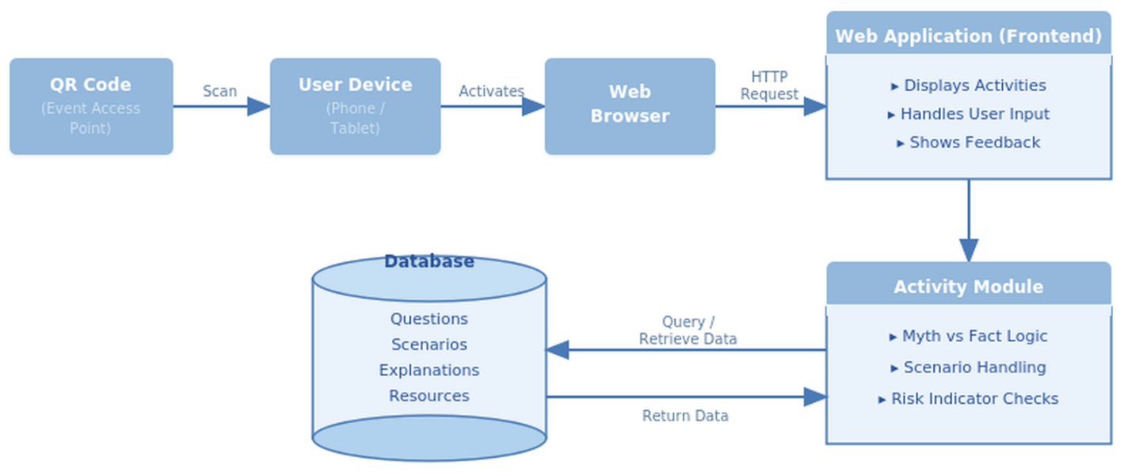

Hardware Needs
The system requires minimal hardware because it is designed as a lightweight web-based application. The primary hardware component is the user’s device, which may include a smartphone, tablet, laptop, or desktop computer. These devices must be capable of running a modern web browser and connecting to the internet.
The system is intended to function as a facilitated interactive awareness activity at live community events. Participants may access the activity by scanning a QR code with a mobile device or by opening a direct web link. In some cases, event organizers may provide a laptop, tablet, or shared display for users who do not have access to a personal device.
No specialized hardware is required. The system is designed to use commonly available devices and standard web technologies so that it can be used in a variety of event environments with minimal setup.

Minimum Required Environment
The minimum required environment for the starting development version is a modern web browser running on a device with internet access. Supported devices include smartphones, tablets, laptops, and desktop computers. The system is designed primarily for mobile portrait use, but it should remain usable on larger tablet, laptop, desktop, and projected displays.
The expected operating systems include Windows 11, current Android versions, current iOS/iPadOS versions, macOS, and ChromeOS. Windows 10 may work if the browser is current, but Windows 11 is preferred for development and testing because Windows 10 is no longer the long-term target platform. Microsoft currently lists Windows 11 version 25H2 as the current release. (Microsoft)
The application should run in current versions of major browsers, including Google Chrome, Mozilla Firefox, Microsoft Edge, and Safari. Because the project uses standard HTML5, CSS3, and JavaScript, no software installation is required on the user device.
The client device should have enough memory and processing power to run a modern browser. Since the application does not use video processing, large downloads, 3D graphics, or local data storage, memory and processor requirements are expected to be low. A typical modern smartphone, tablet, Chromebook, or Windows laptop should be sufficient.

Browser and JavaScript Requirements
The application will use standard browser-based technologies:
- HTML5 for page structure
- CSS3 for layout and responsive design
- JavaScript using modern ECMAScript features, generally ES6 / ECMAScript 2015 or later
- JSON files for structured educational content
JavaScript does not require a separate installed interpreter for this project because it runs inside the user’s web browser. MDN describes JavaScript as the scripting language commonly used for web pages, and modern browsers provide the runtime needed to execute it. (MDN Web Docs)
The application should avoid experimental or browser-specific features unless they are tested first. The goal is broad compatibility rather than using advanced features that may behave differently between browsers.

Network Requirements
The application requires internet access through Wi-Fi or cellular data so that users can open the site through a QR code or direct URL. QR code scanning is recommended for convenience, but it is not required if the user can access the web link directly.
Because the project is lightweight and does not collect user accounts or personal data, network requirements are low. The main network activity is loading the web page, images, style files, JavaScript files, and JSON content. If the application is hosted as a static website, server-side processing is not required.

Hosting / Server Environment
For the prototype, the application can be hosted as a static website. A static hosting environment is appropriate because the application consists of HTML, CSS, JavaScript, images, and JSON content files. GitHub Pages is one possible hosting option because it can publish a live website directly from a GitHub repository without separate hosting. (GitHub Pages). The application is currently deployed using GitHub Pages and is live at https://flareprime.github.io/StS/index.html. The source repository is maintained at https://github.com/Flareprime/StS. As noted above, GitHub Pages serves files over HTTPS, satisfying the requirement that the application not be opened directly from local files.

The hosting environment should provide:
- HTTPS access
- A stable public URL
- Web root or repository location for application files
- Storage for HTML, CSS, JavaScript, image, and JSON files
- Enough bandwidth for event users to load the activity
- Basic file backup or version control
No production database server is required for the current version because educational content is stored in structured JSON files. If a later version adds administrator editing, reporting, analytics, or saved results, then database storage and additional server resources would need to be reconsidered.

Display and Interaction Requirements
The interface is designed for short, mobile-friendly interactions at live awareness events. The expected display environment is a common smartphone screen in portrait orientation. Buttons, navigation controls, text areas, and avatar feedback should be large enough for touch interaction.
The layout should use responsive design so that the same web page can adjust to phones, tablets, laptops, and projected displays without requiring a separate mobile version and desktop version. Responsive design is the standard approach for making web pages work across multiple screen sizes and resolutions. (MDN Web Docs)

Development and Testing Environment
The project will be developed and tested primarily on a Windows 11 laptop using modern web development tools. Testing will focus on browser compatibility, screen layout, navigation, touch-friendly controls, JavaScript behavior, and successful loading of structured educational content.
Development and testing tools may include:
- Visual Studio Code or another code editor
- Firefox Developer Tools
- Firefox Responsive Design Mode
- Google Chrome, Microsoft Edge, and Firefox browser testing
- GitHub for version control and possible static hosting
- Android phone testing when available
Firefox Developer Tools and Responsive Design Mode will be used to test how the interface behaves at different screen sizes. MDN notes that browser developer tools allow developers to inspect and debug HTML, CSS, JavaScript, network traffic, and performance, and that Firefox Responsive Design Mode is useful for testing responsive layout breakpoints. (MDN Web Docs)

Ideal Expanded Environment
If the application becomes widely used, the ideal environment would include reliable static web hosting with HTTPs, a stable public URL, printed QR code signage, and optional event-provided tablets or laptops for users who do not have a personal device available.
A reasonable maximum use case would be multiple campus or community awareness events using the activity at the same time, with several hundred to a few thousand users during an awareness campaign. Since the application is lightweight and does not require user accounts or personal data storage, the hardware and server requirements would remain low compared to a full database-driven web application.
In the expanded environment, the application could be hosted through a scalable static hosting service such as GitHub Pages, Azure Static Web Apps, Netlify, or a college-managed web server. If future versions add analytics, reporting, administrator tools, content management, or saved user results, then additional storage, database support, logging, privacy review, and administrative access controls would need to be considered.

Software Needs
The system is designed to run as a browser-based application. Users access the activities through a modern web browser on a smartphone, tablet, or laptop. The browser must support standard web technologies, including HTML, CSS, and JavaScript.
The frontend software will handle screen layout, user interaction, response checking, and feedback. Because the application is intended to be lightweight and accessible, no installation is required beyond access to a current browser version.
The system uses a structured content data source to store educational material such as scenarios, questions, answers, explanations, and resource links. For the prototype, this content is managed in JSON format and loaded dynamically by the frontend application.
This approach keeps the software simple, portable, and easy to maintain while supporting the project goal of a quick, interactive awareness activity in a live facilitated event setting.

User Interfaces – Input and Output

Inputs
The user interacts with the system through a mobile web interface by:
- Selecting an activity (e.g., Myth vs Fact, Scenario)
- Choosing answers using buttons (such as “Myth” or “Fact”)
- Navigating between screens using simple controls (Next, Back, Restart)
A simple guide avatar is used throughout the interface to present instructions, ask questions, and provide feedback, creating a more engaging and guided user experience. The avatar displays different expressions (neutral, positive, corrective) based on user interaction.
The system is designed to require minimal effort and no typing, making it suitable for quick interaction at community events.

Outputs
The system displays:
- Question or scenario text
- Answer choices
- Immediate feedback (correct/incorrect with explanation)
- Optional educational or resource information
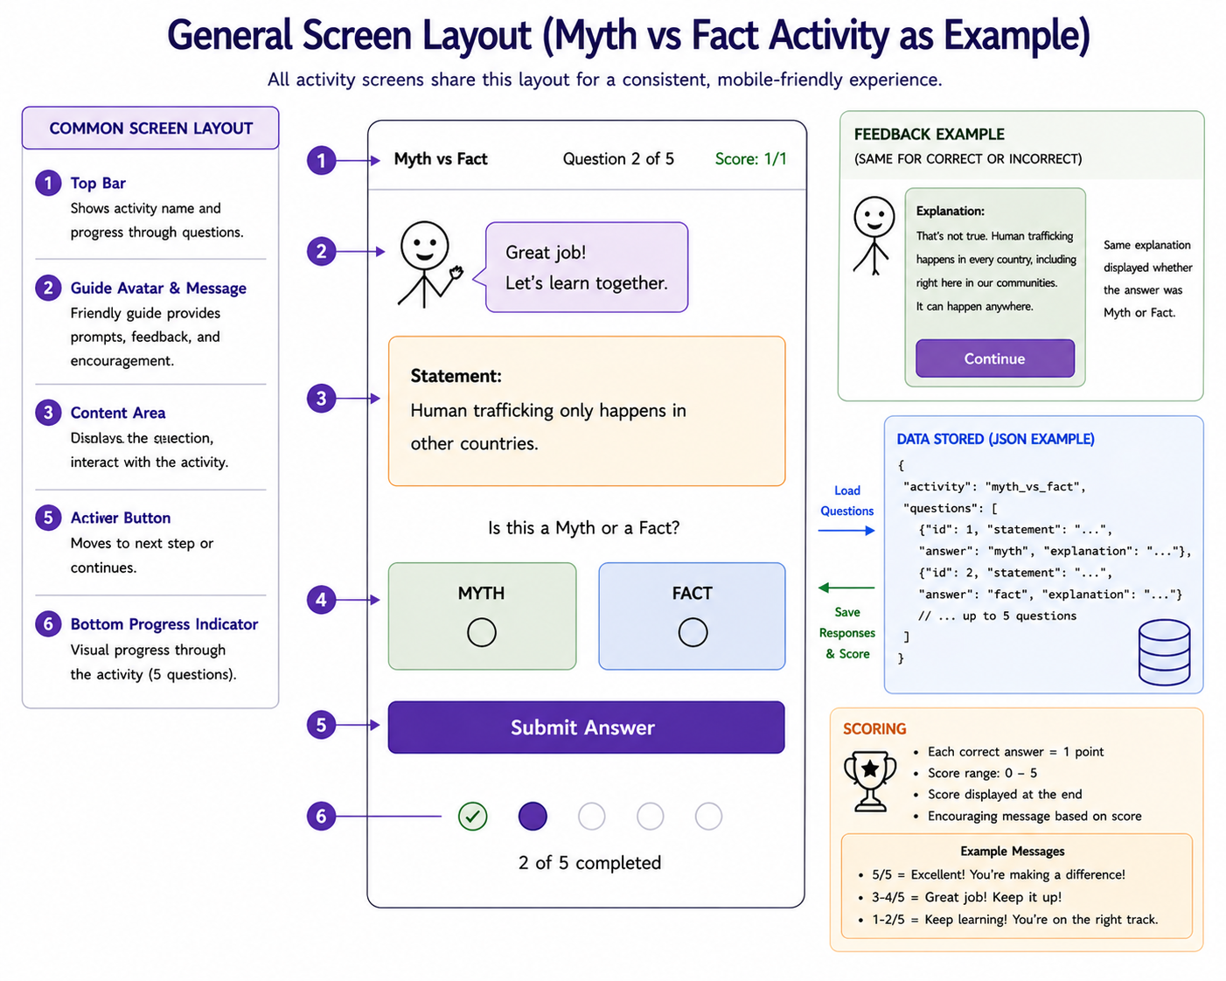
Figure 1 shows the general screen layout used across all activities. The interface includes a guide avatar, content area, answer options, and navigation controls

User Expectations
Users expect:
- A fast and simple experience (1–3 minutes per activity)
- Clear instructions and easy navigation
- Immediate feedback after making a selection
- The ability to restart or try another activity

Business Rules
- No user login or account creation is required
- No personal data is collected
- All users have equal access to all content
- Activities follow a fixed structure: Question → Answer → Feedback

Legal Considerations
- The system does not collect, store, or process personal user data
- Content is educational and based on verified sources
- Sensitive topics are presented using appropriate and respectful language
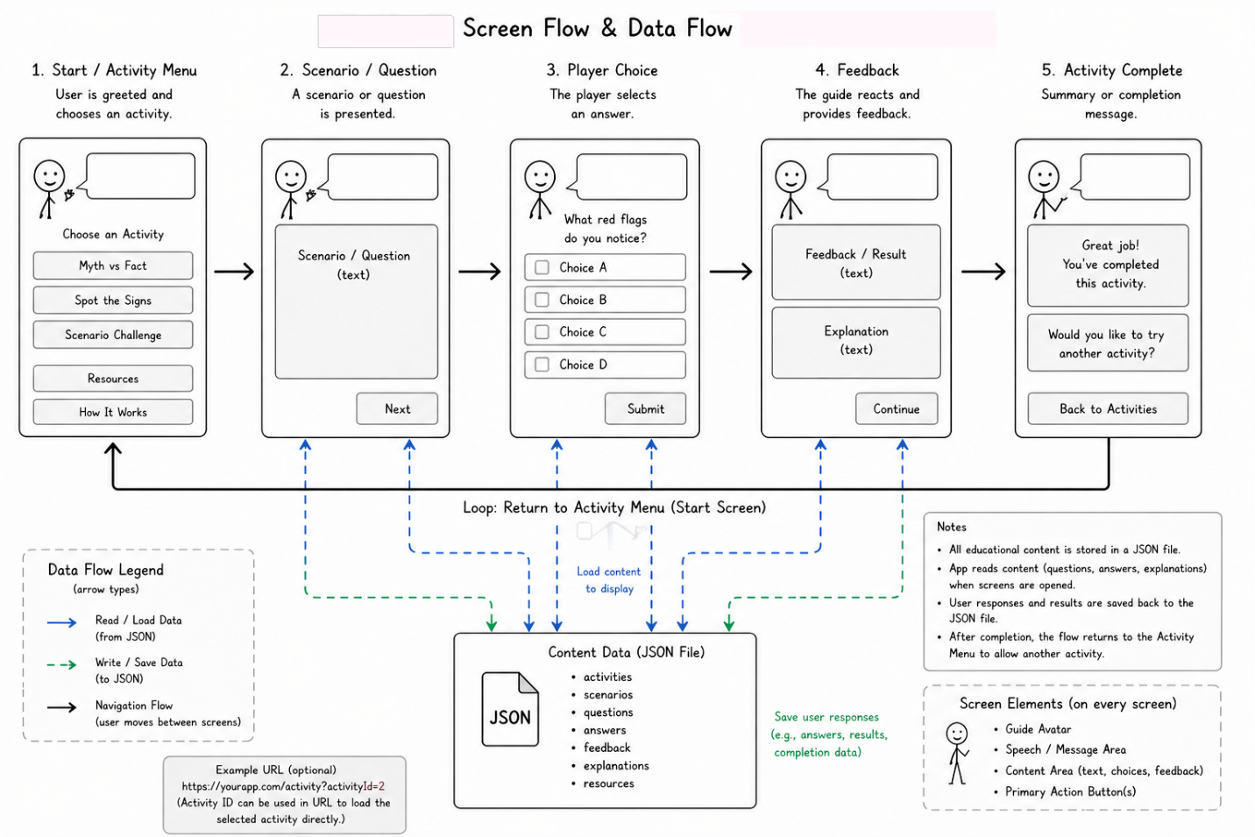
Figure 2 illustrates the flow of screens and the movement of data within the system. Content is loaded from a JSON data source and user responses are processed as the user progresses through the activity.
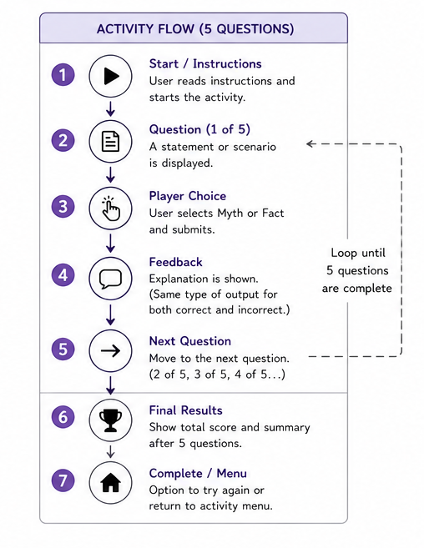
Figure 3 provides a detailed walkthrough of a typical activity flow, showing the sequence of user interactions from start to completion.

Data Elements
The system uses simple structured data to display content. Data elements are organized by logical unit. Runtime variables are held in the browser session only and are never stored.
Display Name | Storage Name | Type | Source

ACTIVITIES
Activity ID | activity_id | Integer | System Generated
Activity Type | activity_type | VARCHAR(50) | Content Admin
Activity Title | activity_title | VARCHAR(100) | TraffickSTOP Toolkit
Description | activity_description | TEXT | TraffickSTOP Toolkit

QUESTIONS
Question ID | question_id | Integer | System Generated
Question | question_text | TEXT | TraffickSTOP Toolkit
Order | question_order | Integer | Content Admin

ANSWER OPTIONS
Answer ID | answer_id | Integer | System Generated
Answer Option | answer_option | VARCHAR(255) | TraffickSTOP Toolkit
Correct? | correct_answer | Boolean | Content Admin
Feedback | feedback_text | TEXT | TraffickSTOP Toolkit / Polaris
SCENARIOS
Scenario ID | scenario_id | Integer | System Generated
Scenario | scenario_text | TEXT | TraffickSTOP Toolkit

RESOURCES
Resource ID | resource_id | Integer | System Generated
Resource Name | resource_name | VARCHAR(150) | Polaris / SARC / NHTH
Website / Link | resource_url | VARCHAR(500) | Polaris / SARC / NHTH
Phone Number | resource_phone | VARCHAR(20) | Polaris / SARC / NHTH

RUNTIME (not stored)
Current Screen | current_screen | Integer (JS) | Frontend JavaScript
Your Answer | user_response | String (JS) | User Input
Correct? | is_correct | Boolean (JS) | Frontend JavaScript

Calculated vs Stored Data

Stored Data:
- Questions
- Answers
- Explanations
- Activity content
- Resource information

Runtime-Calculated Data (not persistently stored):
- Whether the user’s selected answer matches the correct answer
- Current navigation state (active screen)
These values are calculated dynamically by the frontend JavaScript application during user interaction and are not permanently stored within the JSON content structure.

Data Dictionary and Implementation Considerations
The system content is organized using a hierarchical node structure to support lightweight JSON data storage. Educational content such as questions, answers, feedback, navigation states, and avatar behavior are grouped into parent and child nodes to simplify content management and interaction flow
<APPLICATION>
<ACTIVITY>
<QUESTION>
<TEXT>
<ANSWER_OPTION>
<CORRECT_ANSWER>
</QUESTION>
</ACTIVITY>
</APPLICATION>
The complete Data Dictionary for this project is provided as a separate accompanying file: JBassett_Data_Dictionary.xlsx
This document contains three worksheets:
- Full JSON Nodes
- Data List - all data elements documented by variable name, type, source, valid values, and ownership
- Data by Unit - data elements organized by logical table grouping (activities, questions, answer_options, scenarios, resources, and runtime)

Software Architecture and Structure
The application is designed as a modular browser-based educational system using HTML5, CSS3, and JavaScript. The architecture separates user interface components, navigation control, educational content, and activity data into distinct objects in order to support maintainability, scalability, and future expansions.
Educational content is stored in structured JSON files and loaded dynamically. The application architecture emphasizes lightweight deployment, reusable functionality, and responsive design suitable for mobile devices and live community awareness events.
Because all educational content is stored in content.json rather than hard-coded into the application, content authors can add, edit, or remove questions, scenarios, and resources without making any code changes. The question_order field in content.json defines each item’s base position before the shuffle-and-cap behavior described below is applied.
The following UML component definitions and relationship diagrams illustrate the primary executable portions of the application and the relationships between user interface components and data.

IntroPage

Purpose
The IntroPage component displays the introduction screen shown when the user first accesses the activity. It provides instructions, explains the purpose of the activity, and allows the user to begin participation.

Responsibilities
- Display welcome text
- Display instructions
- Allow the user to start the activity
- Introduce the guide avatar
- Transition the user to the activity portion of the application

Methods
- displayIntro() — Displays the introductory content and layout.
- beginActivity() — Starts the selected activity and transitions to the main interaction screen.
- showInstructions() — Displays user instructions and participation guidance.
- displayAvatar() — Displays the guide avatar and associated introductory dialogue.
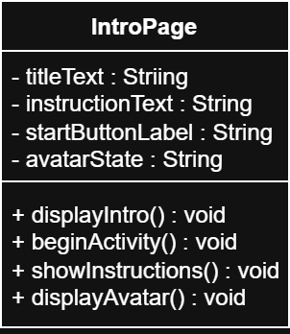

NavigationController

Purpose
The NavigationController component manages movement between application screens and controls the overall flow of the activity. It tracks the user’s current progress and handles transitions between the introduction, activity, feedback, and resource screens.

Responsibilities
- Manage movement between screens
- Track user progress and activity state
- Control screen transitions
- Restart activities when requested
- Maintain overall application flow

Methods
- nextPage() — Advances the user to the next screen or activity step.
- previousPage() — Returns the user to the previous screen when allowed.
- restartActivity() — Resets the activity state and returns the user to the starting point.
- trackProgress() — Maintains the current navigation and activity progress state.
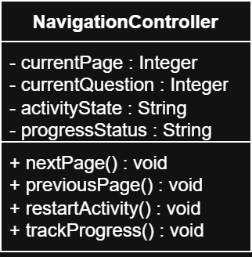

ActivityPage

Purpose
The ActivityPage component manages the primary interactive portion of the application. It presents awareness questions and scenarios to the user, accepts user responses, evaluates answers, and displays educational feedback during the activity.

Responsibilities
- Display activity titles and question content
- Display answer options
- Accept and process user selections
- Evaluate whether responses are correct
- Display educational feedback
- Advance the user through activity questions

Methods
- loadQuestion() — Loads the current question and related activity content.
- displayAnswers() — Displays answer choices for the current question.
- checkAnswer() — Evaluates the user’s selected answer and returns whether it is correct.
- displayFeedback() — Displays feedback and explanation content related to the user’s answer.
- nextQuestion() — Advances the activity to the next available question.
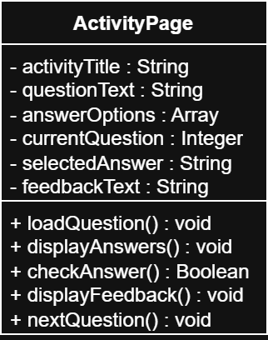

FeedbackPage

Purpose
The FeedbackPage component displays immediate educational feedback after a user submits an answer during an activity. It reinforces learning by explaining whether the selected response was correct and providing additional context or clarification related to the topic.

Responsibilities
- Display feedback messages
- Display whether the selected answer was correct
- Display explanations and educational context
- Allow the user to continue to the next activity step
- Reinforce awareness and learning objectives

Methods
- showFeedback() — Displays the feedback screen after a user response.
- displayCorrectAnswer() — Displays the correct answer for the current question.
- displayExplanation() — Displays educational explanation and supporting context.
- continueActivity() — Returns control to the activity flow and advances the user forward.
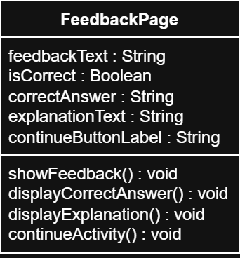

ResourcePage

Purpose
The ResourcePage component displays hotline information, educational resources, and external support links related to human trafficking awareness. It provides users with access to additional information and assistance resources after completing activities.

Responsibilities
- Display hotline and support resources
- Display educational and informational links
- Provide access to organization contact information
- Support continued learning and assistance access
- Allow users to open external resource pages

Methods
- displayResources() — Displays available educational resources and support information.
- openResourceLink() — Opens an external resource or support website.
- displayHotlineInfo() — Displays hotline numbers and emergency contact information.
- returnToMenu() — Returns the user to the main activity flow or menu.
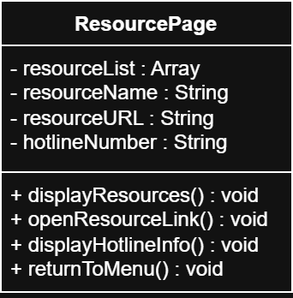

AvatarGuide

Purpose
The AvatarGuide component manages the visual guide character used throughout the application. It displays instructional dialogue, reacts to user interaction, and helps create a guided and engaging experience during activities.

Responsibilities
- Display avatar dialogue and instructional text
- Display avatar reactions and emotional states
- Support guided user interaction
- Reinforce feedback and educational tone
- Maintain avatar presentation across activities

Methods
- displayMessage() — Displays dialogue or instructional text associated with the avatar.
- changeExpression() — Changes the avatar’s visual expression or reaction state.
- showReaction() — Displays positive, corrective, or neutral reactions based on user interaction.
- resetAvatar() — Returns the avatar to its default state.
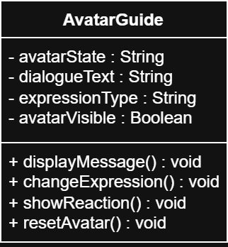

JSONContentLoader

Purpose
The JSONContentLoader component manages retrieval and processing of structured educational content used throughout the application. It loads activity data, questions, answers, explanations, and resource information from JSON-based content files.

Responsibilities
- Load structured educational content
- Retrieve activity questions and answers
- Retrieve educational resource information
- Parse JSON content into usable application data
- Supply content to application components

Methods
- loadJSON() — Loads JSON content files into the application.
- getQuestions() — Retrieves question and answer data for activities.
- getResources() — Retrieves educational resources and support information.
- parseContent() — Processes structured JSON data into application-ready objects.
- shuffleQuestions() — Randomizes the order of loaded questions using a Fisher-Yates shuffle and limits the active set to a maximum of 10 items (MAX_QUESTIONS) per playthrough, regardless of how many questions exist in the content file.
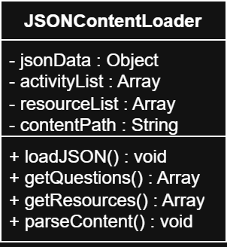
This shuffle-and-cap behavior is implemented once in a shared content loading module (content.js) and is used by every activity module (Myth vs Fact, Safe or Sus, and future activities). Each playthrough therefore presents a different question order, and activities with more than 10 items in content.json will show a random subset of 10 rather than the full set, keeping each session short and varied for repeat visitors.

Activity

Purpose
The Activity component represents a complete educational activity within the application. It stores activity metadata, maintains the collection of associated questions, and manages the beginning and completion of the activity experience.

Responsibilities
- Store activity information and metadata
- Maintain collections of activity questions
- Control activity lifecycle state
- Support organization of educational content
- Provide activity information to application components

Methods
- startActivity() — Initializes and begins the selected activity.
- endActivity() — Ends the current activity and finalizes the activity session.
- getQuestionList() — Retrieves the collection of questions associated with the activity.
- getActivityType() — Retrieves the activity classification or category.
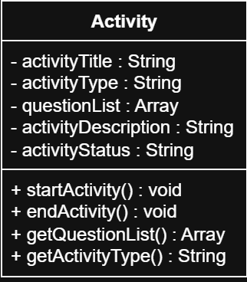

Question

Purpose
The Question component represents an individual educational question or scenario used within an activity. It stores question content, answer options, correct answer information, and associated educational feedback.

Responsibilities
- Store question content
- Store answer options
- Store correct answer information
- Store educational feedback text
- Validate user responses

Methods
- validateAnswer() — Evaluates whether the selected answer matches the correct answer.
- getQuestionText() — Retrieves the current question content.
- getAnswerOptions() — Retrieves available answer choices.
- getFeedback() — Retrieves educational feedback associated with the question.
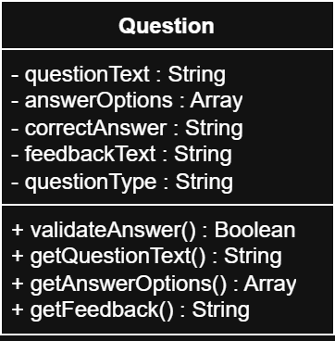

AnswerOption

Purpose
The AnswerOption component represents an individual selectable answer associated with a question. It stores the displayed answer text and whether the option represents the correct response.

Responsibilities
- Store answer option text
- Store correct/incorrect status
- Support user answer selection
- Provide answer data to activity components

Methods
- selectOption() — Registers the selected answer option during user interaction.
- getAnswerText() — Retrieves the displayed answer text.
- checkCorrectness() — Returns whether the answer option is correct.
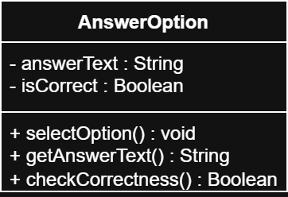
Myth vs Fact and Safe or Sus each present a fixed pair of answer options. Stop Sign Situations introduces questions with two to four answer_options per question, so the AnswerOption rendering logic was generalized: ActivityPage now builds the answer list dynamically from the answer_options array in content.json, rendering each option as a labeled button (A, B, C, D) rather than assuming a fixed two button layout. Selection, correct/incorrect styling, and reveal-the-correct-answer behavior all operate on this dynamic list, so this same path now supports any activity with two to six answer_options without further code changes.
The following UML relationship diagram illustrates the primary user interface and navigation relationships between frontend application components. The NavigationController component manages movement between major application screens, while ActivityPage and FeedbackPage interact with the AvatarGuide component to support guided user interaction and educational feedback.
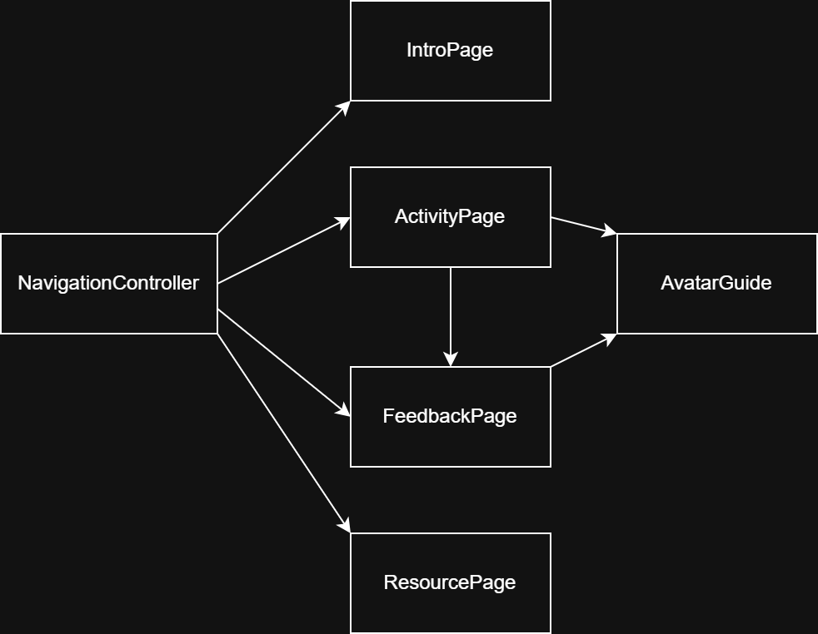
The following UML relationship diagram illustrates the hierarchical relationships between educational activity objects, questions, and selectable answer options. Multiplicity indicators identify one-to-many relationships between the primary data objects used throughout the application.

The following UML relationship diagram illustrates how frontend application components retrieve structured educational content through the JSONContentLoader component. The loader component accesses external JSON content files containing activity questions, answers, educational explanations, and resource information.
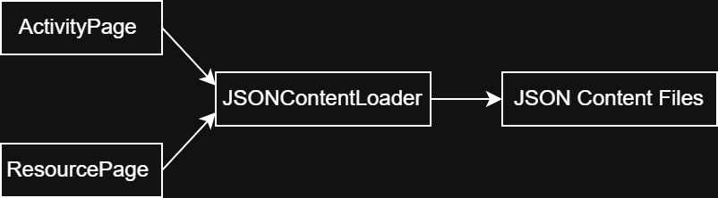

Test plan and Use Cases
The following use cases define the planned testing approach for the Spot the Signs awareness application. These use cases were developed from the user interface design, system architecture, and project requirements documented in this Software Design Document. They describe both normal user interactions and abnormal situations that may occur while using the application.
The use cases will be used during testing to verify that the system functions correctly and meets stakeholder expectations. The test cases cover application navigation, activity completion, feedback delivery, content loading, error handling, and device compatibility. Together, these use cases provide a foundation for validating that all major components of the application operate as intended.
Testing for Spot the Signs follows a three-tier approach. Unit testing verifies that individual components such as JSONContentLoader, ActivityPage, Question, and AnswerOption function correctly on their own. Integration testing then confirms that these tested components work together as intended, verifying that content loads correctly into activities, that user selections are evaluated properly, and that navigation between screens functions as designed. Finally, validation testing uses the use cases below to confirm that the completed application meets the requirements and expectations described in this Software Design Document.
ID: | UC-001
Title: | Launch Application from QR Code
Description: | User scans a QR code at a community awareness event and launches the application in a web browser.
Primary Actor: | Participant
Preconditions: | - QR code is displayed at the event.  - User has a device capable of scanning QR codes.  - Device has internet access.  - Application is deployed and available.
Postconditions: | - Application home screen is shown  - User can begin interacting with the system.
Main Success Scenario: | - User opens camera application.  - User scans QR code.  - Device recognizes QR code URL.  - Browser opens automatically.  - Application loads successfully  - Home screen is shown
Extensions: | 2a. QR code is damaged or unreadable  User is unable to scan the QR code.  Facilitator provides a direct URL or alternate QR code.  User manually accesses the application.  4a. User has no internet connection  Browser cannot access the application.  User receives a network error message.  Facilitator may provide a device with connectivity.  5a. Website is unavailable  Application fails to load.  User sees a browser error page.  User may retry later or use a backup device.  5b. Browser failure  Browser crashes or cannot open the URL.  User restarts the browser or uses another supported browser.  User attempts access again.
Frequency of Use: | Very High
Status: | Implemented
Owner: | Jordan Bassett
Priority: | High

ID: | UC-002
Title: | View Introduction Screen
Description: | User views the introduction screen, including the welcome message, instructions, and guide avatar before beginning an activity.
Primary Actor: | Event Participant
Preconditions: | - Application has successfully launched.  - User has reached the introduction screen.  - Required content has loaded successfully.
Postconditions: | - Introduction content is displayed.  - User understands the purpose of the activity.  - User is able to proceed to the next screen.
Main Success Scenario: | - User accesses the application.  - The introduction screen loads.  - The welcome message is displayed.  - The guide avatar is displayed.  - Instructions for participation are displayed.  - User reads the information.  - User selects the option to continue.
Extensions: | 2a. Introduction content fails to load.  System displays an error message.  User may refresh the page or return to the previous screen.  4a. Avatar image fails to display.  System displays a default avatar image or placeholder graphic.  User may continue using the application.  6a. User closes the application before continuing.  Application session ends  No activity progress is recorded.  7a. User refreshes the page.  Introduction screen reloads.  User may continue from the beginning of the introduction.
Frequency of Use: | Very High
Status: | Implemented
Owner: | Jordan Bassett
Priority: | High

ID: | UC-003
Title: | Navigate to Activity Menu
Description: | User proceeds from the introduction screen to the activity selection menu.
Primary Actor: | Event Participant
Preconditions: | - Introduction screen is displayed.  - Application has loaded successfully.
Postconditions: | - Activity menu is displayed.  - User can select an activity.
Main Success Scenario: | - User reviews introduction information.  - User selects Continue.  - System loads activity menu.  - Available activities are displayed.  - User is ready to make a selection.
Extensions: | 3a. Activity menu fails to load.  System displays an error message.  User may refresh the page or return to the introduction screen.  3b. Continue button does not respond.  User attempts to select Continue.  System does not advance to the activity menu.  User may try again or refresh the page.  4a. Content data is unavailable.  System cannot retrieve activity information.  System displays a content unavailable message.  User may retry later or exit the application.
Frequency of Use: | Very High
Status: | Implemented
Owner: | Jordan Bassett
Priority: | High

ID: | UC-004
Title: | Complete Myth vs Fact Activity
Description: | User participates in a Myth vs Fact activity by reading a statement and selecting whether it is a myth or a fact.
Primary Actor: | Event Participant
Preconditions: | - User has accessed the activity menu  - Myth vs Fact activity is available.  - Activity content has loaded successfully.
Postconditions: | - User response has been evaluated.  - Feedback has been displayed.  - User may continue to the next question or activity.
Main Success Scenario: | - User selects the Myth vs Fact activity from the activity menu.  - System displays a statement.  - User reviews the statement.  - User selects either Myth or Fact.  - System evaluates the response.  - System displays whether the answer was correct or incorrect.  - System displays an educational explanation.  - User proceeds to the next question or completes the activity.
Extensions: | 2a. Activity content fails to load.  System displays an error message.  User may return to the activity menu or retry loading the activity.  4a. User closes the application before answering.  Application session ends.  Current activity progress is lost.  4b. User refreshes the page during the activity.  Activity reloads from the beginning.  User may restart the activity.  5a. User attempts to continue without selecting an answer.  System displays a message requesting answer selection.  User remains on the current question until an answer is selected.
Frequency of Use: | Very High
Status: | Implemented
Owner: | Jordan Bassett
Priority: | High

ID: | UC-005
Title: | Complete Scenario Activity
Description: | User participates in a scenario based activity by reading a short situation and identifying potential warning signs or indicators related to human trafficking awareness.
Primary Actor: | Event Participant
Preconditions: | - User has accessed the activity menu.  - Scenario activity is available.  - Scenario content has loaded successfully.
Postconditions: | - User response has been evaluated.  - Feedback and educational information have been displayed.  - User may continue to another scenario or activity.
Main Success Scenario: | - User selects the activity from the activity menu.  - System displays a scenario.  - User reads the scenario description.  - User reviews the available response options.  - User selects an answer.  - System evaluates the response.  - System displays feedback and explanation.  - User proceeds to the next scenario or completes the activity.
Extensions: | 2a. Scenario content fails to load.  - System displays an error message.  - User may return to the activity menu or retry loading the activity.  5a. User exits the activity before answering.  - Application session ends.  - Current activity progress is lost.  5b. User refreshes the page during the activity.  - Scenario activity reloads from the beginning.  - User may restart the activity.  5c. User attempts to continue without selecting an answer.  - System displays a message requesting answer selection.  - User remains on the current scenario until an answer is selected.  7a. User selects an incorrect response.  - System identifies the response as incorrect.  - Corrective feedback and educational explanation are displayed.  User may continue to the next scenario or activity
Frequency of Use: | High
Status: | Superseded by UC-020 (Stop Sign Situations)
Owner: | Jordan Bassett
Priority: | High

ID: | UC-006
Title: | Receive Correct Feedback
Description: | User receives positive feedback after selecting the correct answer during an activity.
Primary Actor: | Event Participant
Preconditions: | - User is participating in an activity.  - A question or scenario has been presented.  - User has selected the correct answer.
Postconditions: | - Correct response is confirmed.  - Positive feedback is displayed.  - Educational explanation is shown.  - User may continue to the next activity item.
Main Success Scenario: | - User reviews the question or scenario.  - User selects the correct answer.  - System evaluates the response  - System identifies the answer as correct  - Positive feedback is displayed.  - Educational explanation is displayed.  - User proceeds to the next item.
Extensions: | 5a. Feedback content fails to load.  - System displays a generic success message.  - User may continue to the next activity item.  6a. User exits before viewing feedback.  - Application session ends.  - Current activity progress is lost.  6b. User refreshes the page after answering.  - Feedback screen reloads or returns to the current activity.  User may continue through the activity.
Frequency of Use: | High
Status: | Implemented
Owner: | Jordan Bassett
Priority: | Medium

ID: | UC-007
Title: | Receive Incorrect Feedback
Description: | User receives corrective feedback after selecting an incorrect answer during an activity.
Primary Actor: | Event Participant
Preconditions: | - User is participating in an activity.  - A question or scenario has been presented.  - User has selected an incorrect answer.
Postconditions: | - Incorrect response is found.  - Corrective feedback is displayed.  - Educational explanation is shown.  - User gains additional information before continuing.
Main Success Scenario: | - User reviews the question or scenario.  - User selects an incorrect answer.  - System evaluates the response.  - System identifies the answer as incorrect.  - Corrective feedback is displayed.  - Educational explanation is displayed.  - User proceeds to the next item.
Extensions: | 5a. Feedback content fails to load.  System displays a generic feedback message.  User may continue to the next activity item.  6a. User exits before viewing feedback.  Application session ends.  Current activity progress is lost.  6b. User refreshes the page after answering.  Feedback screen reloads or returns to the current activity.  User may continue through the activity.
Frequency of Use: | High
Status: | Implemented
Owner: | Jordan Bassett
Priority: | Medium

ID: | UC-008
Title: | View Educational Explanation
Description: | User reviews the educational explanation provided after answering a question or completing a scenario activity.
Primary Actor: | Event Participant
Preconditions: | - User has submitted an answer.  - System has evaluated the response.  - Explanation content is available.
Postconditions: | - Educational information has been displayed.  - User has received additional context for the topic.  - User may continue to the next activity item.
Main Success Scenario: | - User submits an answer  - System evaluates the response.  - System displays an educational explanation.  - User reads the explanation.  - User selects the option to continue.  - System advances to the next screen or activity item.
Extensions: | 3a. Explanation content fails to load.  - System displays a message that the explanation is unavailable.  - User may continue to the next activity item.  4a. User skips the explanation.  - System advances to the next activity item.  - User continues through the activity.  4b. User exits the application before continuing.  - Application session ends.  - Current activity progress is lost.  4c. User refreshes the page while viewing the explanation.  - Explanation screen reloads.  - User may continue through the activity.
Frequency of Use: | Very High
Status: | Implemented
Owner: | Jordan Bassett
Priority: | High

ID: | UC-009
Title: | View Resource Information
Description: | User accesses resource information containing support services, educational resources, or contact information related to human trafficking awareness.
Primary Actor: | Event Participant
Preconditions: | - Application is running.  - Resource information is available.  - User has navigated to the resource section.
Postconditions: | - Resource information is displayed.  - User can review available support and educational resources.  - Tapped resource links open the appropriate application (phone dialer or browser).  - User may return to the main menu or exit the application.
Main Success Scenario: | - User selects the resource information option.  - System loads the resource screen.  - Resource information is displayed.  - User reviews the available resources.  - User may tap a phone number to open the device’s dialer, or tap a website link to open it in the browser.  - User returns to the main menu or exits the application.
Extensions: | 2a. Resource content fails to load.  System displays an error message.  User may return to the main menu or retry loading resources.  3a. External resource links are unavailable.  System displays the available resource information.  User may manually access the resource at a later time.  4a. User exits before reviewing resources.  Application session ends.  User returns to the device's normal environment.  4b. Resource information is incomplete or unavailable.  System displays any available resource information.  User may return to the main menu or exit the application.
Frequency of Use: | Medium
Status: | Implemented
Owner: | Jordan Bassett
Priority: | High

ID: | UC-010
Title: | Restart Activity
Description: | User restarts the current activity and returns to the beginning of the activity sequence.
Primary Actor: | Event Participant
Preconditions: | • User is currently participating in an activity.  • Activity content has been loaded.  • Restart option is available.
Postconditions: | • Current progress is cleared.  • Activity returns to the starting screen.  • User may begin the activity again.
Main Success Scenario: | 1. User selects the Restart option.  2. System prompts for confirmation if required.  3. User confirms restart.  4. System clears current activity progress.  5. System loads the first screen of the activity.  6. User begins the activity again.
Extensions: | 2a. User cancels the restart request.  System returns to the current activity screen.  Current activity progress is preserved.  4a. Activity content fails to reload.  System displays an error message.  User may retry the restart or return to the main menu.  4b. System encounters an error while resetting progress.  System displays an error message.  Current activity state remains unchanged.  5a. User exits the application instead of restarting.  Application session ends.  Current activity progress is lost.
Frequency of Use: | Medium
Status: | Implemented
Owner: | Jordan Bassett
Priority: | High

ID: | UC-011
Title: | Return to Main Menu
Description: | User returns from an activity or information screen to the application's main menu.
Primary Actor: | Event Participant
Preconditions: | User is viewing an activity, explanation, or resource screen.  Main menu option is available.
Postconditions: | Main menu is displayed.  User can select another activity or application feature.
Main Success Scenario: | - User selects the Main Menu option.  - System saves or clears temporary activity state as appropriate.  - System loads the main menu screen.  - Available activities and options are displayed.  - User may select another activity or exit the application.
Extensions: | 3a. Main menu fails to load.  System displays an error message.  User may retry navigation or refresh the page.  1a. Navigation button does not respond.  User attempts to select the Main Menu option.  System does not respond.  User may try again or refresh the page.  3b. User refreshes the page during navigation.  Application reloads.  User is returned to the main menu or current screen.  3c. Application encounters an unexpected error.  System displays an error message.  User may retry navigation or restart the application.
Frequency of Use: | High
Status: | Implemented
Owner: | Jordan Bassett
Priority: | High

ID: | UC-012
Title: | Load Content from JSON File
Description: | The application retrieves activity content from the JSON data source and displays it to the user.
Primary Actor: | Frontend Application
Preconditions: | - Application has launched successfully.  - JSON content file exists and is accessible.  - Content file contains valid data.
Postconditions: | - Activity content is loaded into memory.  - Questions, answers, and explanations are available for display.  - User may interact with activities.
Main Success Scenario: | - Application starts.  - System requests content from the JSON file.  - JSON file is located and opened.  - Content is parsed successfully.  - Questions, answers, and explanations are loaded.  - Content is displayed to the user when requested.  - User proceeds through activities normally.
Extensions: | 3a. JSON file cannot be located.  System displays an error message.  Content loading is stopped.  User may retry loading content or exit the application.  4a. JSON file contains invalid formatting.  System detects the parsing error.  System displays a content unavailable message.  Application prevents access to invalid content.  5a. Required content fields are missing.  System skips the incomplete content when possible.  System displays available content.  User may continue with limited functionality.  5b. Content loads only partially.  System displays available content.  Unavailable content is omitted.  User may continue using the application.  2a. Network or file access error occurs.  System displays an error message.  Content loading is halted.  User may retry after connectivity is restored.
Frequency of Use: | Very High
Status: | Implemented
Owner: | Jordan Bassett
Priority: | High

ID: | UC-013
Title: | Handle Missing JSON Content
Description: | The application detects that content cannot be loaded and responds gracefully without crashing.
Primary Actor: | Frontend Application
Preconditions: | - Application has launched.  - JSON file is missing, inaccessible, or invalid.
Postconditions: | - Error condition is handled safely.  - User receives an appropriate error message.  - Application remains operational or exits gracefully.
Main Success Scenario: | - Application attempts to load content.  - System detects that the JSON file is unavailable or invalid.  - System logs or identifies the error condition.  - User is presented with an informative error message.  - Application prevents access to unavailable content.  - User may retry or exit the application.
Extensions: | 4a. Error message fails to display.  System logs the error condition.  Application prevents access to unavailable content.  User may exit the application.  3a. Application becomes unresponsive.  System stops responding during content loading.  User refreshes the page or restarts the application.  5a. Partial content remains available.  System loads available content.  Unavailable content is omitted.  User may continue with limited functionality.  6a. User retries loading content after the issue is resolved.  System attempts to load the content again.  Content loads successfully.  User proceeds normally through the application.
Frequency of Use: | Low
Status: | Planned
Owner: | Jordan Bassett
Priority: | Medium

ID: | UC-014
Title: | Prevent Progress Without Answer Selection
Description: | The application prevents users from advancing to the next question or screen until an answer has been selected.
Primary Actor: | Event Participant
Preconditions: | - User is viewing a question or scenario.  - No answer has been selected.  - Continue or Next button is available.
Postconditions: | - User remains on the current screen.  - User is notified that an answer must be selected.  - Application state remains unchanged.
Main Success Scenario: | - User views a question or scenario.  - User does not select an answer.  - User selects the Continue or Next button.  - System checks for a selected answer.  - System determines that no answer has been selected.  - System displays a message requesting an answer selection.  - User remains on the current screen until an answer is selected.
Extensions: | 6a. Warning message fails to display.  System prevents progression to the next question.  User remains on the current screen until an answer is selected.  3a. User refreshes the page.  Current question reloads.  User may continue the activity from the reloaded screen.  3b. User returns to the main menu instead of answering.  System loads the main menu.  Current question is abandoned.  5a. System incorrectly allows progression.  Application advances without a selected answer.  Issue is recorded during testing for correction.
Frequency of Use: | Medium
Status: | Implemented
Owner: | Jordan Bassett
Priority: | High

ID: | UC-015
Title: | Display Application on Mobile Device
Description: | The application displays correctly and remains fully functional when accessed from a mobile device.
Primary Actor: | Event Participant
Preconditions: | - User has a smartphone with a supported web browser.  - Application is accessible through a QR code or direct URL.  - Internet connection is available.
Postconditions: | - Application displays correctly on the mobile screen.  - All interface elements are visible and functional.  - User can complete activities successfully.
Main Success Scenario: | - User scans the QR code with a mobile device.  - Mobile browser opens the application.  - Application loads successfully.  - Interface adjusts to the device screen size.  - User navigates through activities.  - Buttons, text, images, and avatar display correctly.  - User completes an activity without layout or navigation issues.
Extensions: | 4a. Screen elements overlap or display incorrectly.  System continues to function.  User may rotate the device or refresh the page.  5a. Text becomes unreadable on smaller screens.  User may zoom the browser display.  Application remains accessible.  6a. Buttons are difficult to select.  User attempts to select the button again.  Activity continues after successful selection.  3a. Browser compatibility issues  Some interface elements may not display correctly.  User may switch to a supported browser.  2a. Internet connection is interrupted.  Application cannot load additional content.  User receives a network error message.  User may retry after connectivity is restored.
Frequency of Use: | Very High
Status: | Implemented
Owner: | Jordan Bassett
Priority: | High

ID: | UC-016
Title: | Display Application on Tablet/Laptop
Description: | The application displays correctly and remains fully functional when accessed from a tablet or laptop device.
Primary Actor: | Event Participant
Preconditions: | - User has access to a tablet or laptop with a supported web browser.  - Application is accessible through a URL or QR code.  - Internet connection is available.
Postconditions: | - Application displays correctly on the larger screen.  - All interface elements remain functional.  - User can complete activities successfully.
Main Success Scenario: | - User opens the application on a tablet or laptop.  - Browser loads the application successfully.  - Interface adjusts to the larger screen size.  - Text, images, buttons, and avatar display correctly.  - User navigates through activities.  - User completes an activity without layout or navigation issues.
Extensions: | 3a. Screen elements display incorrectly.  Interface layout does not adjust properly to the larger screen.  User may refresh the page or resize the browser window.  2a. Browser compatibility issues occur.  Certain interface elements may not function as expected.  User may switch to a supported browser.  4a. Images or content fail to load.  System displays available content.  Missing elements are omitted or replaced with placeholders.  2b. Internet connection is interrupted during use.  Application cannot load additional content.  User receives a network error message.  User may retry after connectivity is restored.
Frequency of Use: | Medium
Status: | Implemented
Owner: | Jordan Bassett
Priority: | Medium

ID: | UC-017
Title: | Complete Entire Awareness Session
Description: | User successfully completes a full awareness session from application launch through activity completion and resource review.
Primary Actor: | Event Participant
Preconditions: | - Application is available and operational.  - Activity content has loaded successfully.  - User has access to a supported device.
Postconditions: | - User has completed one or more activities.  - Feedback and educational explanations have been displayed.  - Resource information has been reviewed.  - Session objectives have been completed.
Main Success Scenario: | - User launches the application.  - User views the introduction screen.  - User navigates to the activity menu.  - User selects an activity.  - User completes one or more questions or scenarios.  - User receives feedback and educational explanations.  - User views available resource information.  - User returns to the main menu or exits the application.  - Awareness session is completed successfully.
Extensions: | 5a. User exits before completing activities.  Application session ends.  Current activity progress is lost.  4a. Content fails to load during the session.  System displays an error message.  User may retry loading content or return to the main menu.  8a. Navigation issues prevent completion.  System cannot advance to the next screen.  User may refresh the page or restart the application.  2a. Internet connectivity is lost.  Application cannot load additional content.  User receives a network error message.  User may retry after connectivity is restored.
Frequency of Use: | High
Status: | Implemented
Owner: | Jordan Bassett
Priority: | High

ID: | UC-018
Title: | Exit Application
Description: | User exits the application after completing or abandoning an activity session.
Primary Actor: | Event Participant
Preconditions: | - Application is currently running.  - User is viewing any application screen.
Postconditions: | - Application session is ended.  - User is returned to the browser or device environment.  - Temporary session data is cleared.
Main Success Scenario: | - User decides to leave the application.  - User closes the browser or navigates away from the application.  - Application session ends.  - Temporary activity state is cleared.  - User returns to the device's normal environment.
Extensions: | 2a. User exits unexpectedly due to browser or device failure.  Application session ends immediately.  Temporary session data may be lost.  2b. Internet connection is interrupted.  Current session cannot continue.  User may reopen the application when connectivity is restored.  2c. User accidentally closes the application.  Application session ends.  User may relaunch the application and begin a new session.
Frequency of Use: | Very High
Status: | Planned
Owner: | Jordan Bassett
Priority: | Low
ID: | UC-019
Title: | Complete Safe or Sus Activity
Description: | User participates in a Safe or Sus activity by reading a short relationship or boundary-related scenario and selecting whether the situation described is Safe or Sus (suspicious, or a boundary violation).
Primary Actor: | Event Participant
Preconditions: | - User has accessed the activity menu.  - Safe or Sus activity is available.  - Activity content has loaded successfully.
Postconditions: | - User response has been evaluated.  - Feedback has been displayed.  - User may continue to the next scenario or activity.
Main Success Scenario: | - User selects the Safe or Sus activity from the activity menu.  - System displays a scenario.  - User reviews the scenario.  - User selects either Safe or Sus.  - System evaluates the response.  - System displays whether the answer was correct or incorrect.  - System displays an educational explanation of the boundary issue involved.  - User proceeds to the next scenario or completes the activity.
Extensions: | 2a. Activity content fails to load.  System displays an error message.  User may return to the activity menu or retry loading the activity.  4a. User closes the application before answering.  Application session ends.  Current activity progress is lost.  4b. User refreshes the page during the activity.  Activity reloads from the beginning.  User may restart the activity.  5a. User attempts to continue without selecting an answer.  System displays a message requesting answer selection.  User remains on the current scenario until an answer is selected.
Frequency of Use: | Very High
Status: | Implemented
Owner: | Jordan Bassett
Priority: | High

ID: | UC-020
Title: | Complete Stop Sign Situations Activity
Description: | User participates in a Stop Sign Situations activity by reading a short real-world situation involving potential grooming, trafficking, or exploitation, and selecting the answer choice that best identifies the warning sign present, or correctly identifies that no significant warning sign is present.
Primary Actor: | Event Participant
Preconditions: | - User has accessed the activity menu.  - Stop Sign Situations activity is available.  - Activity content has loaded successfully.
Postconditions: | - User response has been evaluated.  - Feedback has been displayed.  - User may continue to the next situation or activity.
Main Success Scenario: | - User selects the Stop Sign Situations activity from the activity menu.  - System displays a situation and a question with multiple answer choices (two to four options).  - User reviews the situation.  - User selects one answer choice.  - System evaluates the response.  - System displays whether the answer was correct or incorrect, and highlights the correct choice if the user was incorrect.  - System displays an educational explanation of the warning sign, or lack thereof.  - User proceeds to the next situation or completes the activity.
Extensions: | 2a. Activity content fails to load.  System displays an error message.  User may return to the activity menu or retry loading the activity.  4a. User closes the application before answering.  Application session ends.  Current activity progress is lost.  4b. User refreshes the page during the activity.  Activity reloads from the beginning.  User may restart the activity.  5a. User attempts to continue without selecting an answer choice.  System displays a message requesting answer selection.  User remains on the current situation until an answer choice is selected.
Frequency of Use: | Very High
Status: | Implemented
Owner: | Jordan Bassett
Priority: | High

Deployment plan
The Spot the Signs application will be deployed as a publicly accessible web application to support human trafficking awareness activities conducted by Phi Theta Kappa (PTK) and other community outreach organizations. The deployment objective is to provide a simple, reliable, and mobile-friendly educational experience that can be accessed through a QR code at awareness events.
Key stakeholders include:
- Phi Theta Kappa (PTK) Chapter
- Event Facilitators
- Community Participants

Deployment strategy
Continuous deployment via GitHub Pages repo publishes automatically, with no separate staging environment, since development and production are effectively the same static environment (matches the local Live Server → push-at-the end of workflow already described earlier in this SDD). This is justified by the project's scope: no database, no server config, no environment drift to manage, which removes an entire category of deployment risk and lets content fixes ship in minutes — useful since the app keeps getting refined all summer ahead of the Fall event.

Predeployment requirements
System and environment prerequisites are already covered under Hardware Needs and Software Needs earlier in this document; nothing additional is required for production since it's the same browser-based environment. Configuration: the site is published via GitHub Pages from the Flareprime/StS repository, publicly reachable at the URL above. Data migration: none — there's nothing to migrate, by design. Security and compliance: no accounts, no personal data, no cookies or stored user data, nothing server-side beyond what GitHub Pages itself logs as host. Since there's no data at rest, the real ongoing security requirement is a process one: any future feature must be checked against the "no data collection" rule before it ships.

Deployment phases
Since the app deploys continuously, phases map to a timeline toward the Fall event rather than a traditional rollout: Phase 1, core build — Myth vs Fact, Safe or Sus, Stop Sign Situations, and Resources all built and live (complete). Phase 2, informal peer testing — link shared with PTK members and friends, several of whom ran through it multiple times; issues they found were triaged and fixed (complete). Phase 3, summer refinement — incorporate any remaining feedback and finish updating index.html so Resources no longer shows "Coming Soon" (in progress). Phase 4, pre-event readiness check — full run-through on multiple real devices about one to two weeks before the event, plus content sign-off from PTK leadership. Phase 5, event-day deployment — QR signage posted at the booth, feature freeze in the days immediately beforehand so nothing changes mid-event. Jordan owns code and content; the PTK chapter owns booth signage and QR printing; the instructor owns the academic checkpoint.

Deployment environment
The current deployment target is GitHub Pages, a static-hosting service tied directly to the project’s GitHub repository. The live application is available at https://flareprime.github.io/StS/index.html, and the source code is maintained at https://github.com/Flareprime/StS. Because the application relies on browser-based fetch() calls to load JSON content, it must be accessed through a web server such as GitHub Pages rather than opened directly from local files.

Environment setup and configuration steps
Repository hosted at github.com/Flareprime/StS with GitHub Pages enabled against the publishing branch already configured in the repo's settings. No environment variables, API keys, or secrets are needed since there's no backend. A QR code is generated pointing at the live URL and test-printed at booth signage size to confirm it scans cleanly from a normal standing distance.

Verification and validation procedures
Informal verification already happened through the PTK/friends beta test described above — effectively informal user acceptance testing. Formal verification maps to the use cases already defined in this SDD's Test Plan section; UC-001 through UC-020 collectively define "ready for the Fall event." One additional structured pass is worth doing closer to the event date: a checklist walkthrough of the core flow on at least two device types (a typical phone plus a tablet or laptop), since UC-015 and UC-016 — mobile vs. tablet/laptop display — haven't been explicitly confirmed yet per our last conversation.

Tools and resources
GitHub and GitHub Pages for hosting and version control; VS Code with Live Server for local development; browser DevTools for responsive testing; a personal smartphone, tablet, and laptop for real-device verification; a QR code generator for booth signage; and PTK chapter members and personal contacts as informal volunteer testers. Resource cost is effectively zero - GitHub Pages hosting is free, and the only real cost is testers' time and printing the signage.

Figure 4 QR Code used for participant access to the deployed application.

Deployment testing
Pre-deployment testing already performed: the informal beta test, with several testers completing multiple passes and surfacing bugs that got fixed before this write-up. Successful deployment criteria: the site loads within a few seconds on a first scan under typical event connectivity, all four modules complete start to finish without errors, resource links and tap-to-call numbers work, and there are no console errors across at least two device/browser combinations. Post-deployment validation: a same-day smoke test at the booth before doors open, where a volunteer scans the actual printed QR code (not just the URL) and completes one full activity, confirming the signage and venue network conditions work in practice, not just in development.

Risk management
No signal or data at the venue — mitigated because the QR/URL just fails gracefully to the browser's own offline message, and the booth keeps the free TraffickSTOP Toolkit materials and other passive handouts on hand regardless, so nothing depends on one device working. An attendee's device is too old or incompatible — mitigated by the broad browser support already documented in Software Needs; fallback is simply a different device or the paper materials. GitHub Pages has an outage on event day (rare but possible) — same paper/PDF fallback covers it. A late code change introduces a bug — mitigated by the feature freeze in the days before the event. A future feature accidentally collects personal data, undermining the core privacy promise — treated as a hard constraint checked before any merge, not a preference. The topic itself causes a distressed reaction from an attendee — the Resources page surfaces crisis hotlines prominently, and a PTK volunteer is staffing the booth in person to step in if someone needs more than the app can offer.

References used
Columbia Basin College. (n.d.). Columbia web color guide. Retrieved June 16, 2026, from https://ccit.college.columbia.edu/knowledgebase/article/columbia-web-color-guide
GitHub. (n.d.). *GitHub Pages documentation*. GitHub Docs. Retrieved May 17, 2026, from https://docs.github.com/en/pages
Microsoft. (n.d.). Download Windows 11. Retrieved May 17, 2026, from https://www.microsoft.com/en-us/software-download/windows11
Mozilla Developer Network. (n.d.). JavaScript. MDN Web Docs. Retrieved May 17, 2026, from https://developer.mozilla.org/en-US/docs/Web/JavaScript
Polaris. (n.d.). Polaris. https://polarisproject.org/
TraffickSTOP. (2024). TraffickSTOP toolkit. https://www.traffickingstop.org/wp-content/uploads/2024/07/TraffickSTOP-Toolkit-2024_07.pdf

