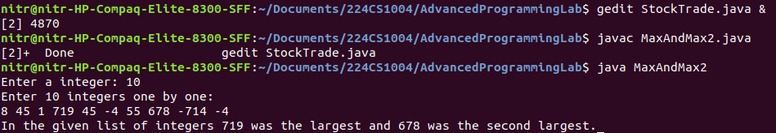
import java.io.*;
import java.util.Scanner;

public class MaxAndMax2 {

/**
* Main driver program
*/
public static void main(String[] args) {
Scanner sc = new Scanner(System.in);

System.out.print("Enter a integer: ");
int N = sc.nextInt(); sc.nextLine(); // reading integer N

int max = Integer.MIN_VALUE, max2 = Integer.MIN_VALUE + 1; // values to store max and second max

while (N-- > 0) {
System.out.printf("Enter integer #%d: ", N+1);
int num = sc.nextInt(); sc.nextLine();

if (num > max) {
max2 = max;
max = num;
} else if (num > max2) {
max2 = num;
}
}

System.out.printf("In the given list of integers %d was the largest and %d was the second largest.\n", max, max2);

sc.close();
}
}

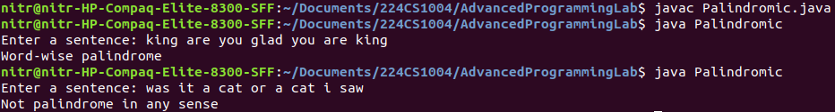
import java.io.*;
import java.util.Scanner;

public class Palindromic {

/**
* Checks if given string is palindrome or not
* @param s: given string (can be either word or sentence)
*/
public static boolean isPalindrome(String s) {
for (int i = 0, j = s.length()-1; i <= j; i++, j--) {
// System.out.printf("Comparing %c and %c\n", s.charAt(i), s.charAt(j));
if (s.charAt(i) != s.charAt(j)) return false;
}

return true;
}

/**
* Checks if given word list is palindrome or not
* @param s: given string (can be either word or sentence)
*/
public static boolean isPalindrome(String[] wordlist) {
for (int i = 0, j = wordlist.length-1; i <= j; i++, j--) {
// System.out.printf("Comparing %s and %s\n", wordlist[i], wordlist[j]);
if (!(wordlist[i].equalsIgnoreCase(wordlist[j]))) return false;
}

return true;
}

/**
* Main driver program
*/
public static void main(String[] args) {
Scanner sc = new Scanner(System.in);

System.out.print("Enter a sentence: ");
String sentence = sc.nextLine();

String[] wordlist = sentence.split(" ");
String joinedSentence = String.join("", wordlist);

boolean wordWise = isPalindrome(wordlist), charWise = isPalindrome(joinedSentence);

if (charWise)
System.out.println("Character-wise palindrome");
if (wordWise)
System.out.println("Word-wise palindrome");
if (!wordWise && !charWise)
System.out.println("Not palindrome in any sense");

sc.close();
}
}

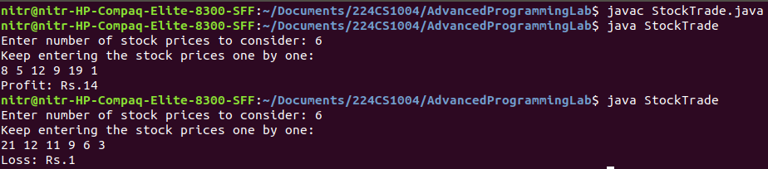
import java.io.*;
import java.util.Scanner;

public class StockTrade {

/**
* Get maximum possible profit
* @param stockPrices: list of stock prices
* @param minPriceTill: stores the minimum price till an index
*/
public static int getProfit(int[] stocks, int[] minPriceTill) {
int sellIndex = stocks.length - 1, buyPrice = minPriceTill[sellIndex-1];
int maxProfit = stocks[sellIndex] - buyPrice; // init

while (sellIndex > 1) {
if (maxProfit < (stocks[sellIndex] - buyPrice)) {
maxProfit = stocks[sellIndex] - buyPrice;
}
sellIndex--;
buyPrice = minPriceTill[sellIndex - 1];
}
return maxProfit;
}

/**
* Main driver program
*/
public static void main(String[] args) {
Scanner sc = new Scanner(System.in);

System.out.print("Enter number of stock prices to consider: ");
int stocks = sc.nextInt(); sc.nextLine(); // reading number of stock prices

System.out.println("Keep entering the stock prices one by one: ");
int[] stockPrices = new int[stocks]; // stock prices
int[] minPriceTill = new int[stocks]; // minimum stock price till an index for all indices

for (int i = 0; i < stocks; i++) {
stockPrices[i] = sc.nextInt();

// maintaining a list of min stock prices till current index
if (i == 0) minPriceTill[i] = stockPrices[i];
else if (minPriceTill[i-1] > stockPrices[i]) {
minPriceTill[i] = stockPrices[i];
} else {
minPriceTill[i] = minPriceTill[i-1];
}
}

int profit = getProfit(stockPrices, minPriceTill);

System.out.println(((profit < 0)?"Loss: Rs.": "Profit: Rs.")+ Math.abs(profit));

sc.close();
}
}

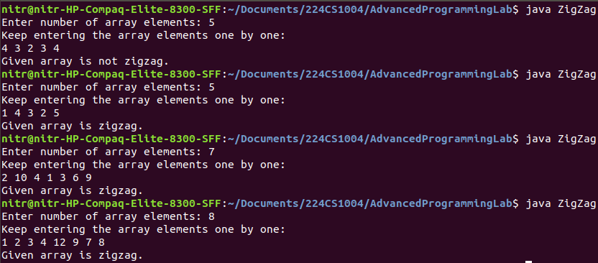
import java.io.*;
import java.util.Scanner;

public class ZigZag {

/**
* Finds index till which it is increasing given a start index
*/
public static int isIncreasingTill(int[] list, int startIndex) {
int endIndex = startIndex + 1;
while(endIndex < list.length && list[endIndex - 1] < list[endIndex]) {
endIndex++;
}
return (endIndex-1 != startIndex)? endIndex-1: -1;
}

/**
* Finds index till which it is decreasing given a start index
*/
public static int isDecreasingTill(int[] list, int startIndex) {
int endIndex = startIndex + 1;
while(list[endIndex - 1] > list[endIndex]) {
endIndex++;
}
return (endIndex-1 != startIndex)? endIndex-1: -1;
}

/**
* Checks if an array is zigzag or not
* @param a: array of integers
*/
public static boolean isZigZag(int[] a) {
int i = isIncreasingTill(a, 0);
// System.out.println(i);
if (i == -1) return false;

int j = isDecreasingTill(a, i);
// System.out.println(j);
if (j == -1) return false;

int k = isIncreasingTill(a, j);
// System.out.println(k);
if (k == -1 || k != a.length-1) return false;

return true;
}

/**
* Main driver program
*/
public static void main(String[] args) {
Scanner sc = new Scanner(System.in);

System.out.print("Enter number of array elements: ");
int n = sc.nextInt(); sc.nextLine(); // number of array elements

System.out.println("Keep entering the array elements one by one: ");
int[] a = new int[n];
for (int i = 0; i < n; i++) {
a[i] = sc.nextInt();
}

System.out.println("Given array is " + ((n > 4 && a[0] <= a[1] && isZigZag(a))?"zigzag.":"not zigzag."));

sc.close();
}
}

