**Weather Alarm App**

Contributor: Erik Wenkel  
Source: <https://github.com/hessionb/WeatherAlarm>  
License: GPLv2 or later  
License URI: <http://www.gnu.org/licenses/gpl-2.0.html>

**Description**

This Andriod Application was designed to display the current weather and temperature at a specified location when an alarm goes off. It was designed so that when you wake up due to an alarm you are automatically given the weather.

The application has three activities corrosponding to the panels that are displayed. Upon startup the MainActivity panel is displayed. From here you can either see the current zip code entered and the time set for the alarm, if they have been set, or click the Set New Alarm button to switch to the TimeSet panel. In the TimeSet panel you use a time picker to pick the alarm time and enter the US zip code you want the weather for. Once you have picked the setting you want you can click the Set button to go back to the MainActivity panel.

Once you return to the MainActivity the AsyncTask set the location and time labels and also calculates the time until the alarm should go off. Once the time is reached the application switches to the OutputWeather panel and the phone vibrates. The AsyncTask GetWeather triggers threads that connect to weather.com and weather.gov using GET and retrieve the html page for the location specified. The html page is then parsed for the relevant information and the the weather text is displayed. You can stop the vibation by clicking on the turn off alarm button. You can also click the set new alarm button to take you back to the TimeSet panel.

**License**

Copyright (C) 2013 Erik Wenkel

This program is free software; you can redistribute it and/or modify it under the terms of the GNU General Public License as published by the Free Software Foundation; either version 2 of the License, or (at your option) any later version.

This program is distributed in the hope that it will be useful, but WITHOUT ANY WARRANTY; without even the implied warranty of MERCHANTABILITY or FITNESS FOR A PARTICULAR PURPOSE. See the GNU General Public License for more details.

**Sequence Diagram**

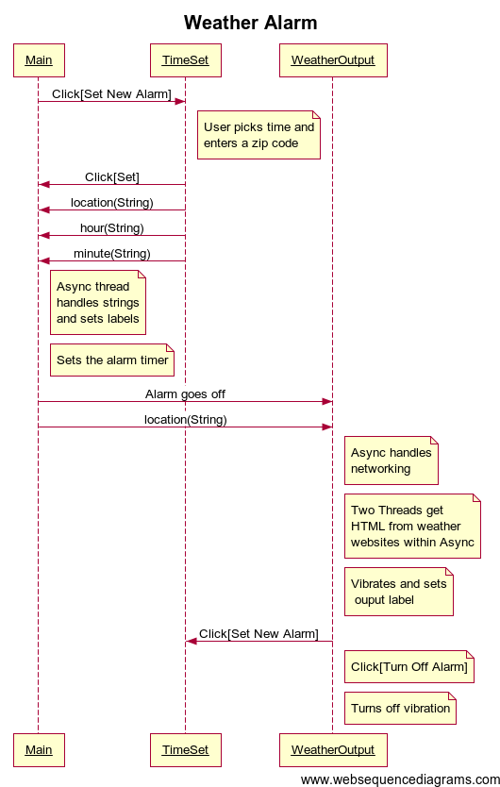

**Class Diagram**

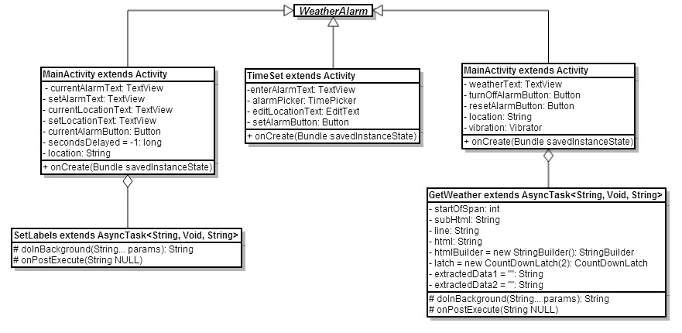

**WireShark**

