COL 774: Machine Learning. Assignment 1

1. A) Learning rate = 0.0015,

theta = ${\left[0.9966201 0.0013402\right]}^{T}$

Convergence Condition: error < 0.001 or # of iterations > 1000

B) 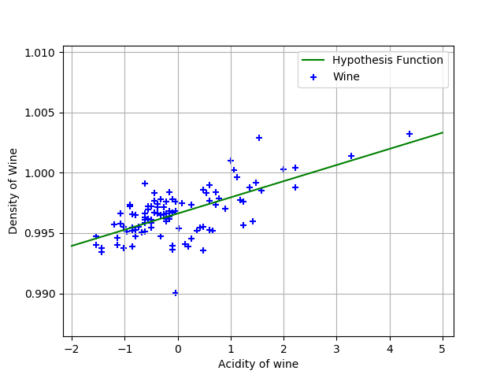

C) 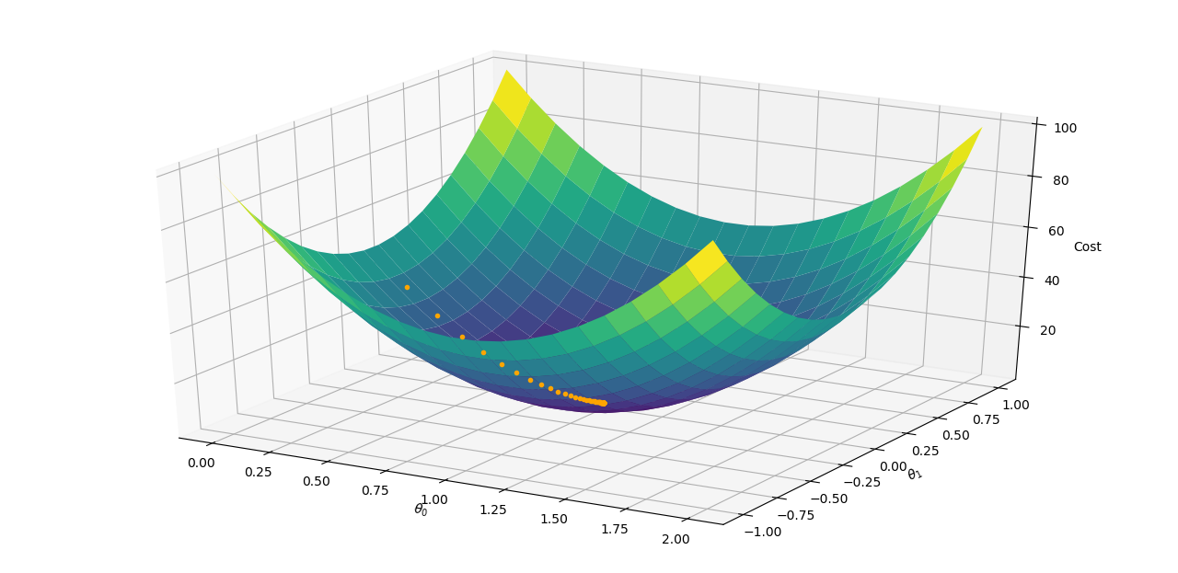

D) η = 0.0015

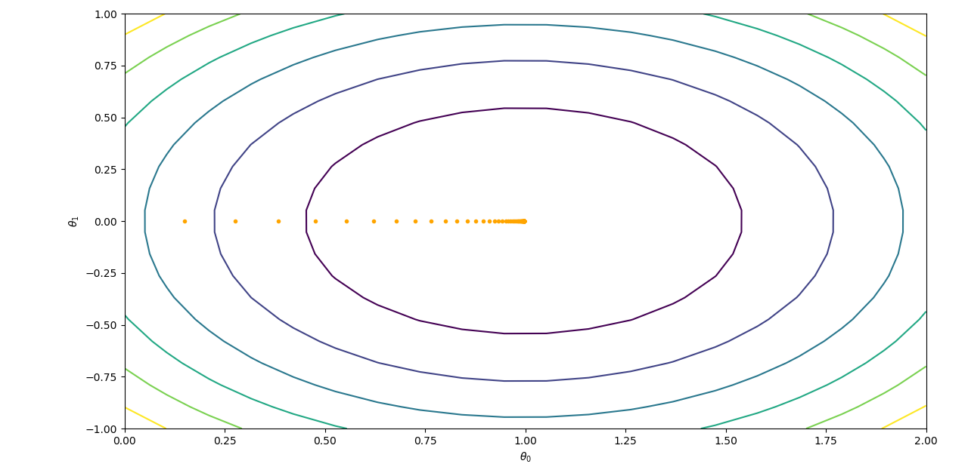

E) η = 0.001

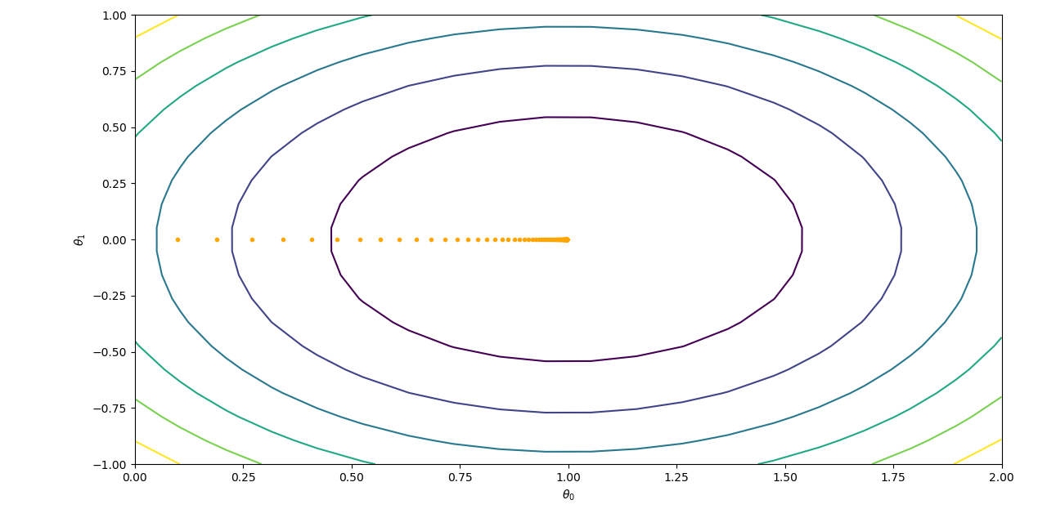

η = 0.025

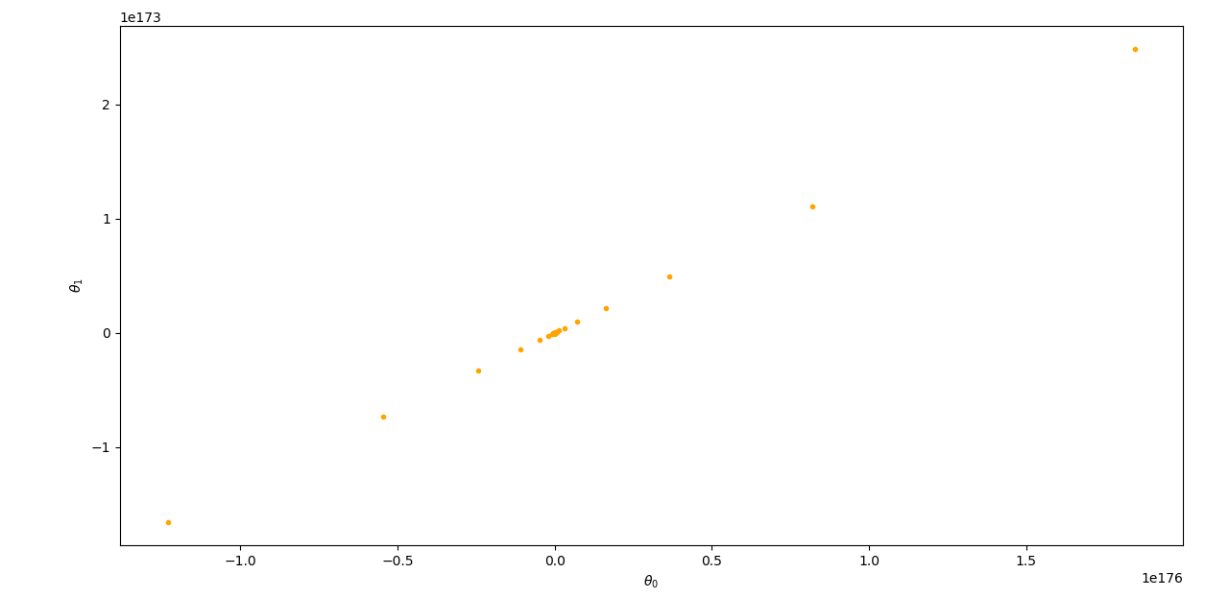

η = 0.1

We observe that as the learning rate increases beyond a point the cost function starts diverging. Like for η = 0.001 its converging but diverging for η = 0.025 , 0.1 . Initially there are small oscillations and the function still converges . As η increases there are more oscillations near the minimum, each time overshooting even more .

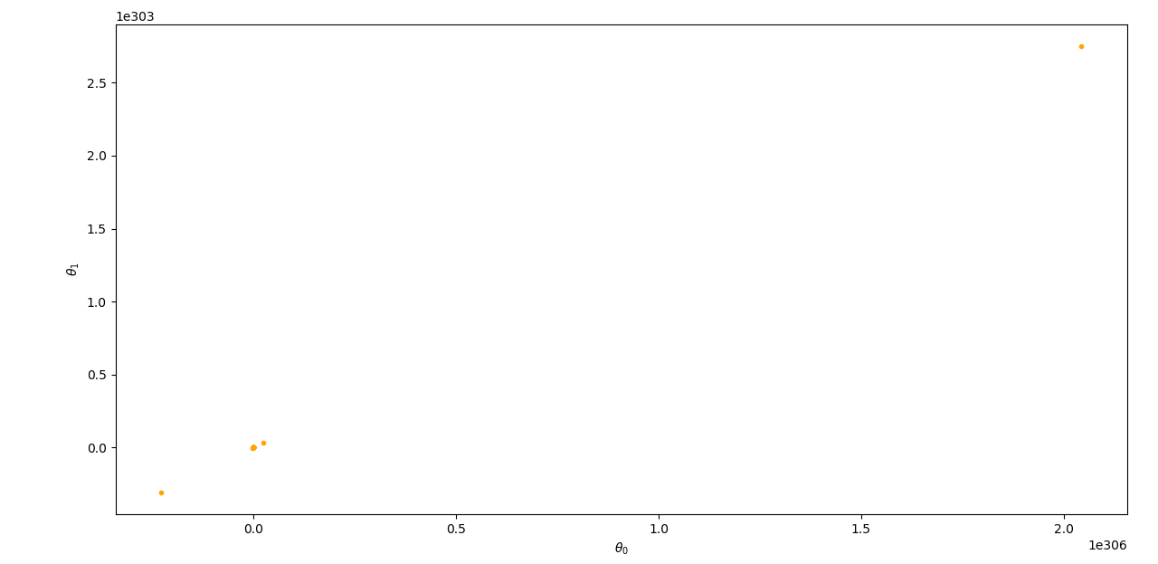

3.)

a) theta = ${\left[ 0.40125316 2.5885477 -2.72558849\right]}^{T}$

b) 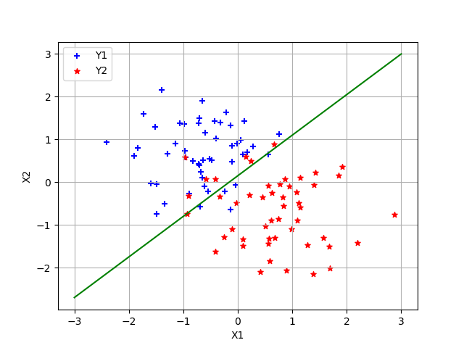

The green line is the decision Boundary

4.)

a) $μ_{0}= {\left[-1.10106488 1.18368785\right]}^{T}$

$μ_{1}= {\left[-0.8315402 0.74891723\right]}^{T}$

$Σ= [\left[ 0.0136741 -0.00127227\right] \left[-0.00127227 0.05342744\right]]$

y[i] = 0 corresponds to Alaska

b) 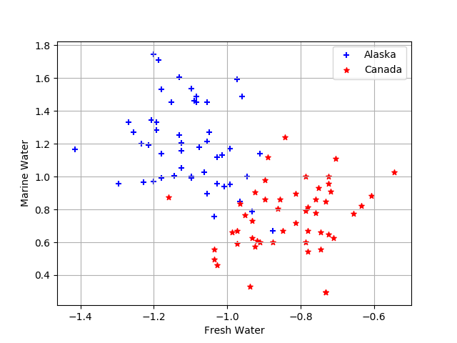

c) 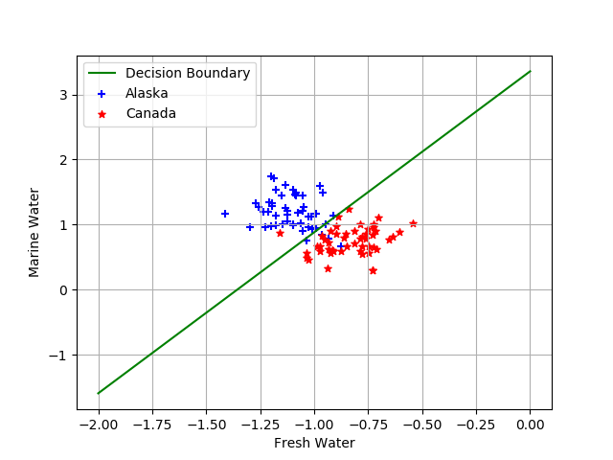

d)

$Σ_{0}= [\left[ 0.0121479 -0.0087677 \right] [-0.0087677 0.06521665]]$

$Σ_{1} = [\left[0.01520029 0.00622316\right] [0.00622316 0.04163824]]$

$μ_{0}= {\left[-1.10106488 1.18368785\right]}^{T}$

$μ_{1}= {\left[-0.8315402 0.74891723\right]}^{T}$

e) 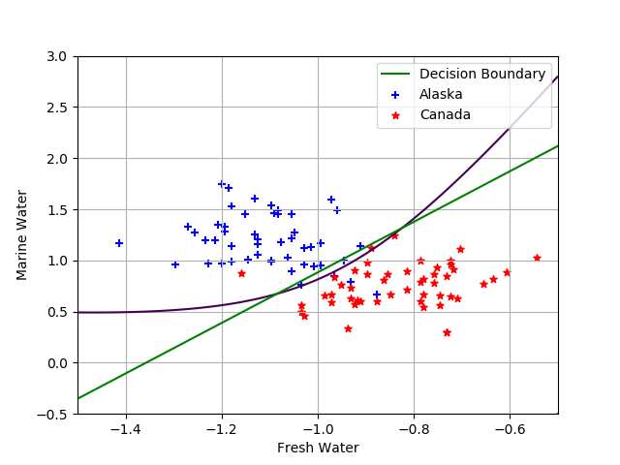

f) Quadratic decision Boundary does a better job than the linear decision boundary (Logistic Regression). The assumption that the underlying data belong to gaussian distribution is valid to a great extent.

2)

b) [3.00371 0.99475 1.9981] 65183 1

[2.999 0.99 1.99] 28455 100

[2.922 1.01 1.99] 13100 10000

[2.983 1.1081 1.99547] 6674 1000000

Theta (# of iteration) r

c)Number of iterations inversely proportional to r

The value of theta very close to the given theta

Speed of convergence is inversely proportional to r

0.9850678759592312 – error for r = 1

0.9958009697879703 – error for r = 100

0.98 – error for original Hypothesis

SGD Converges to the original Hypothesis

d)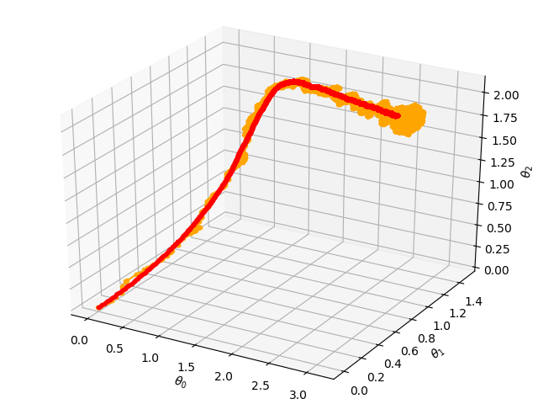

red corresponds to r = 100

orange corresponds to r = 1

It is noticed that SGD gets theta close to minimum but the parameters keep oscillating near the minimum value.

Report By:

**Shivam Jadhav**

**2017CS10378**