Report Assignment 3:

Q1.

Day 1

number of unique clients is:

522

number of unique servers is:

45

Day 2

number of unique clients is:

939

number of unique servers is:

50

Day 3

number of unique clients is :

510

number of unique servers is :

89

Q2.

Day 1

number of TCP flows is :

3256

Day 2

number of TCP flows is :

5422

Day 3

number of TCP flows is :

3280

Q3.

A SYN flood occurs when an attacker sends a request to connect to the target server, but never completes the connection through what is known as a three-way handshake—a method used in a TCP/IP network to create a connection between a local host/client and server. The incomplete handshake leaves the connected port in an occupied status and unavailable for further requests. An attacker will continue to send requests, saturating all open ports, so that legitimate users cannot connect.

Day 1

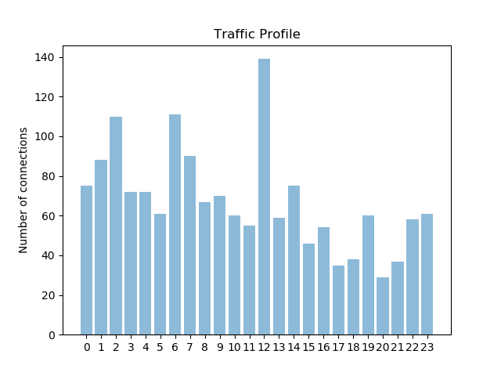

Day 2

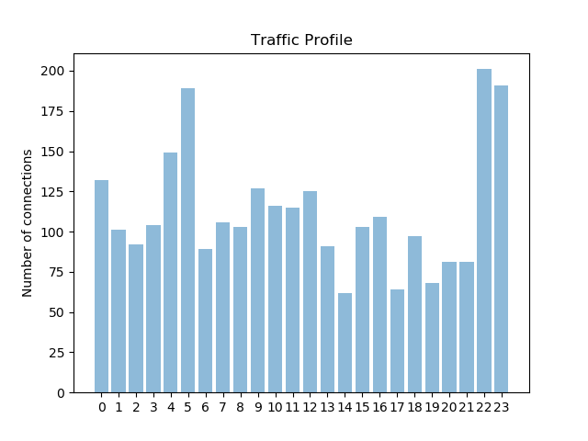

Day 3

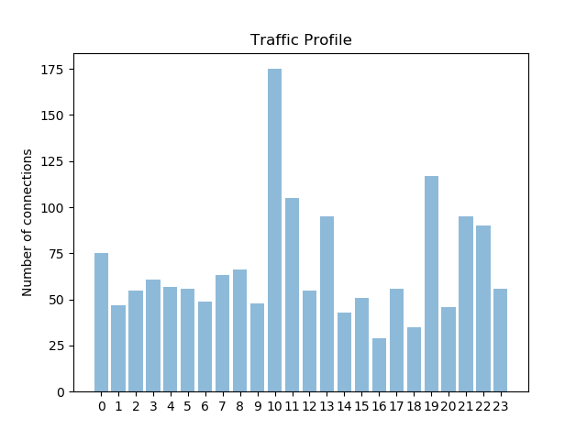

Q4.

because non-persistent connection. Non persistent implies once it loads then TCP connection closed.

Day1

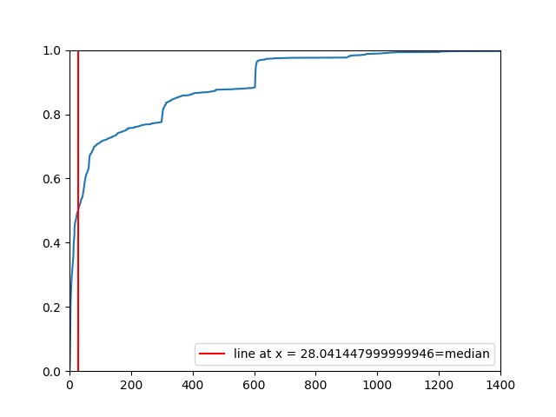

Day 3

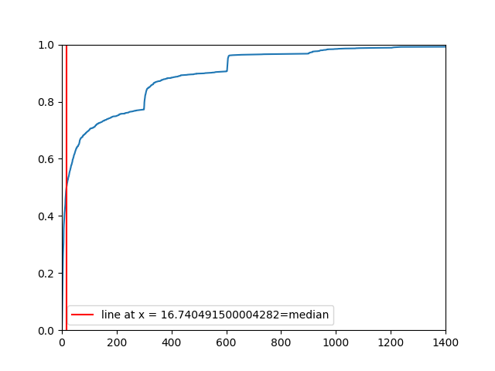\

Day 2

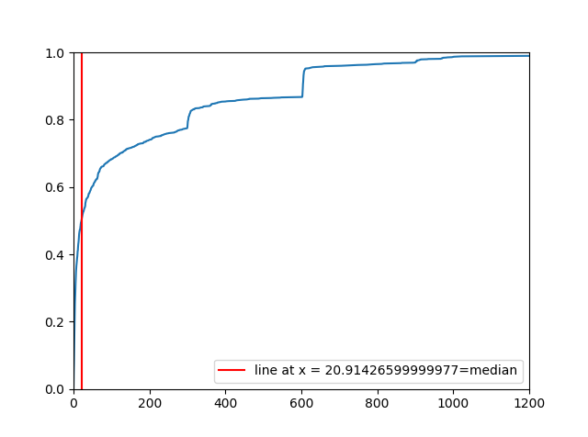

Q5.

Yes, we can mark the outliers from the scatter plot.

Corr almost equal 1 implies they are linearly related

And very close value to zero implies linearly independent

Day 1

corr, _ = pearsonr(packet_server, packet_client)

corr1, _ = pearsonr(packet_client, timings)

corr2, _ = pearsonr(packet_server, timings)

corr corr1 corr2

0.9612620166907865 0.45264286391923036 0.4422743125221402

Day 2

0.9340946981621345 0.17346131227502176 0.1627203615301457

Day 1 graph:

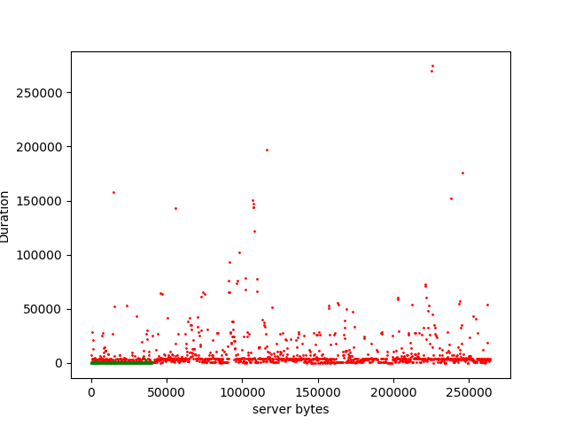

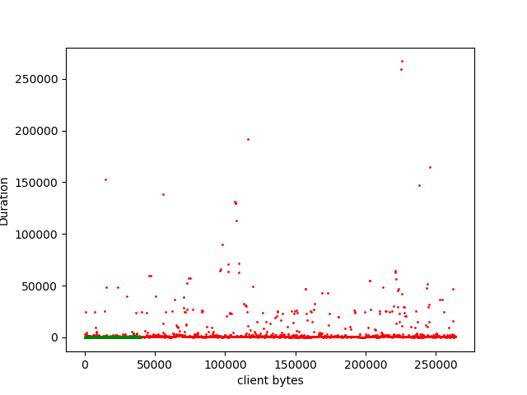

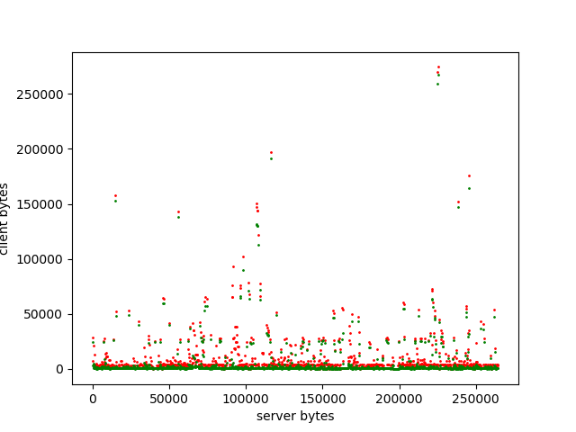

Day 2 graph:

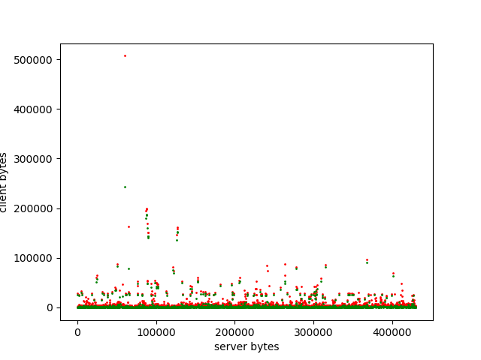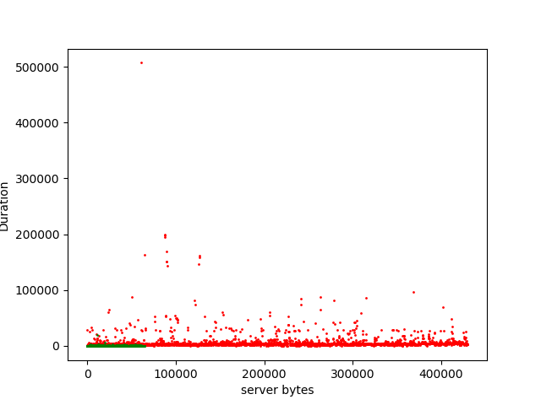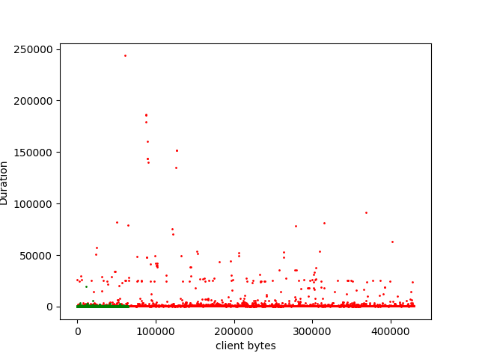

6. Day 1

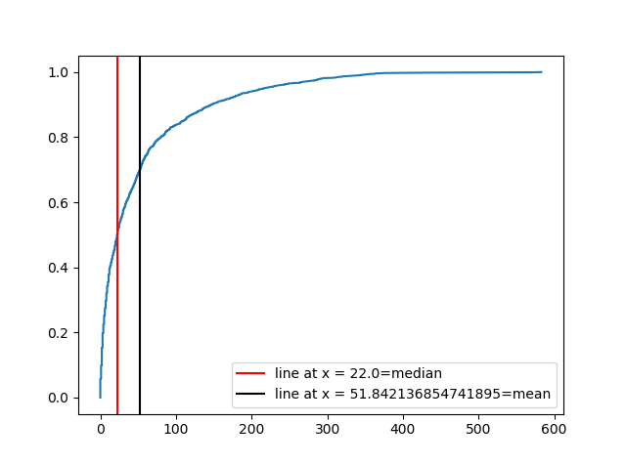

Day 2

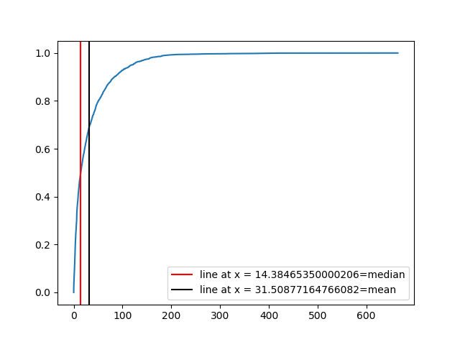

Day 3

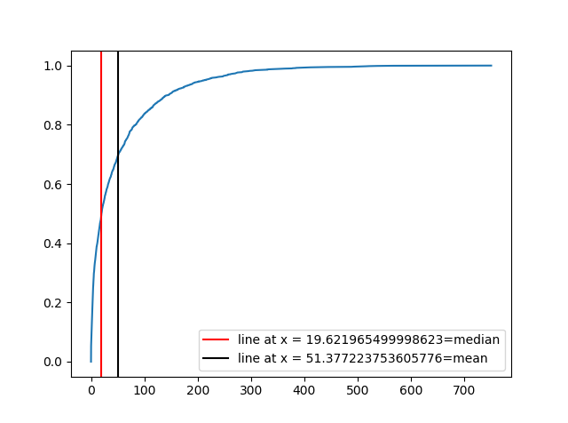

7.FTP Connections are open till the file is transferred. Most files are short in size but may vary in the range .(because some can be big)

Day1

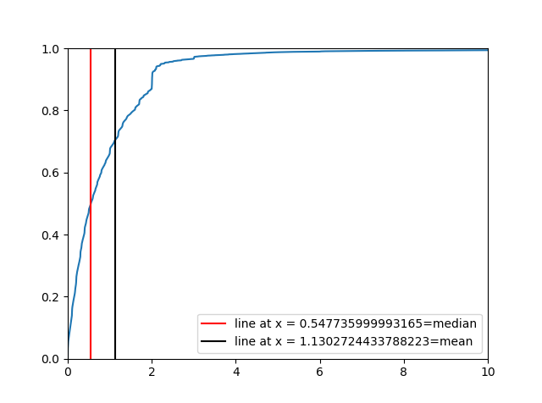

Day 2

Day3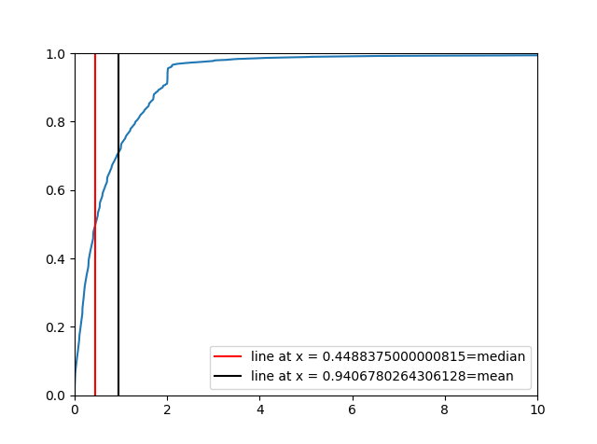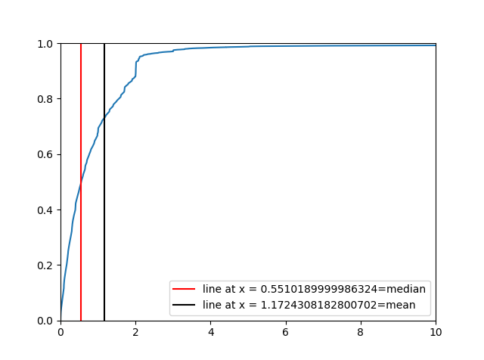

8.Yes CDF appears to be clustered at few points

Instructions are almost constant so very less change. So they tend to appear clustered at few points.

Day 1 input

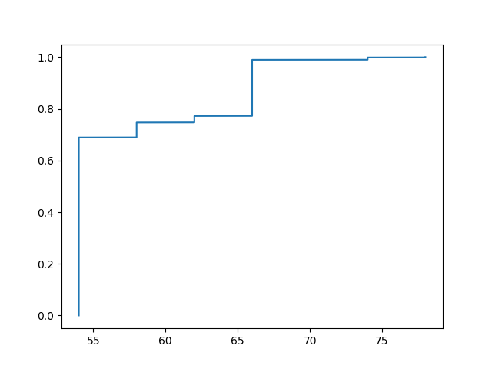

Day 1 output

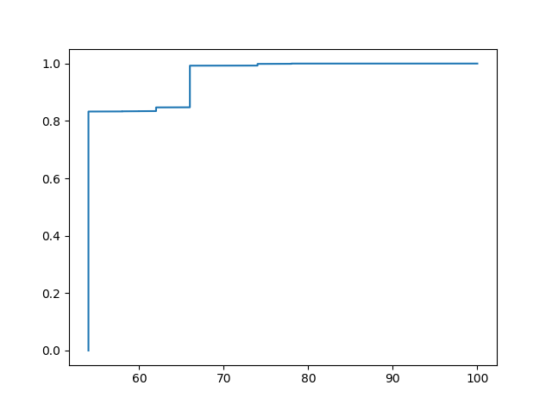

Day 2 input

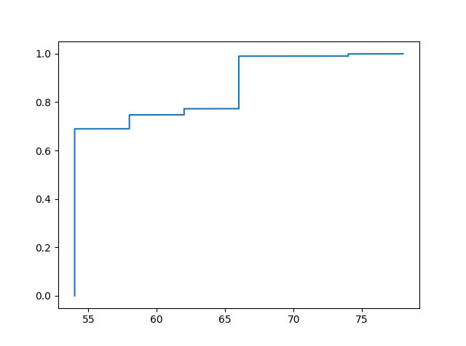

Day 2 output

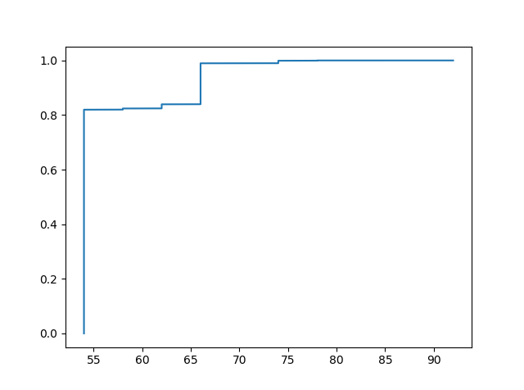

Day 3 input

Day 3 output

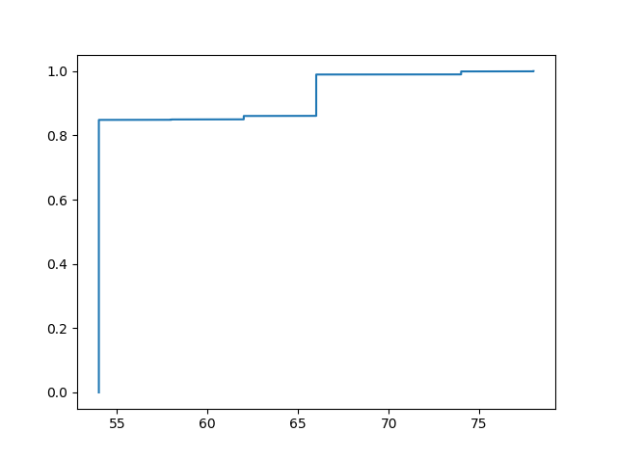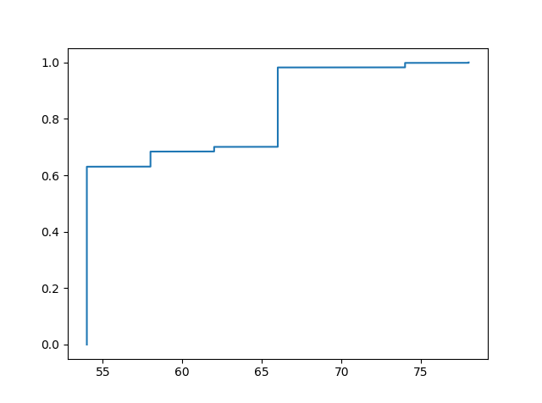

9.

A retransmission can be spotted by checking if the same sequence number is transmitted more than once. It can be checked if on horizontal line in graph has more than one point then these points have same sequence number.

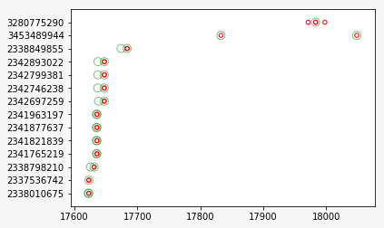

Day 1

Part 1

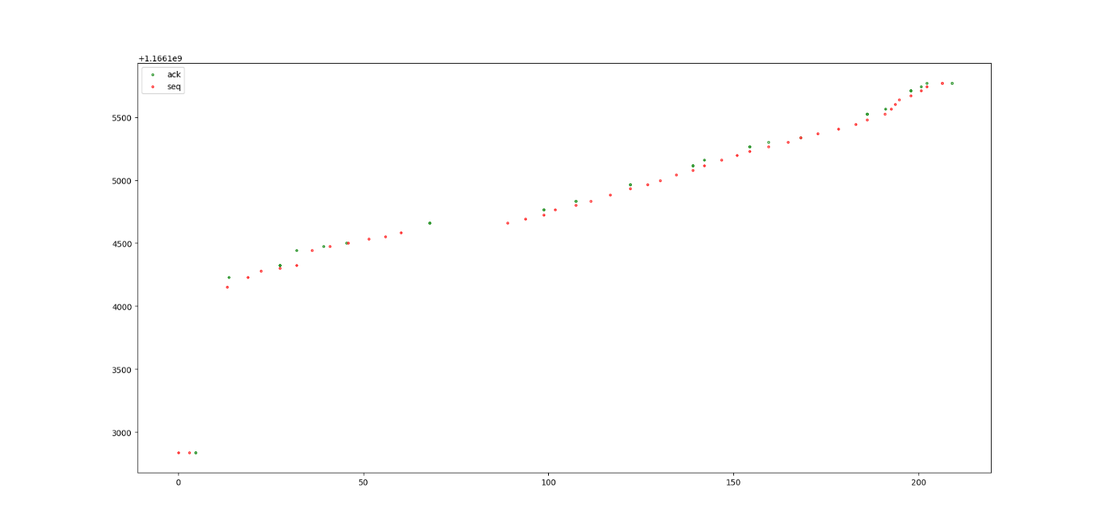

Part2

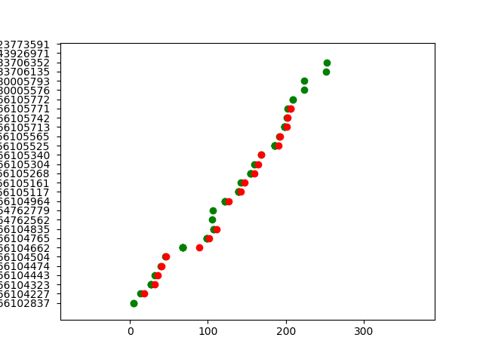

10.

Day 1:

Lambda = 0.0192782

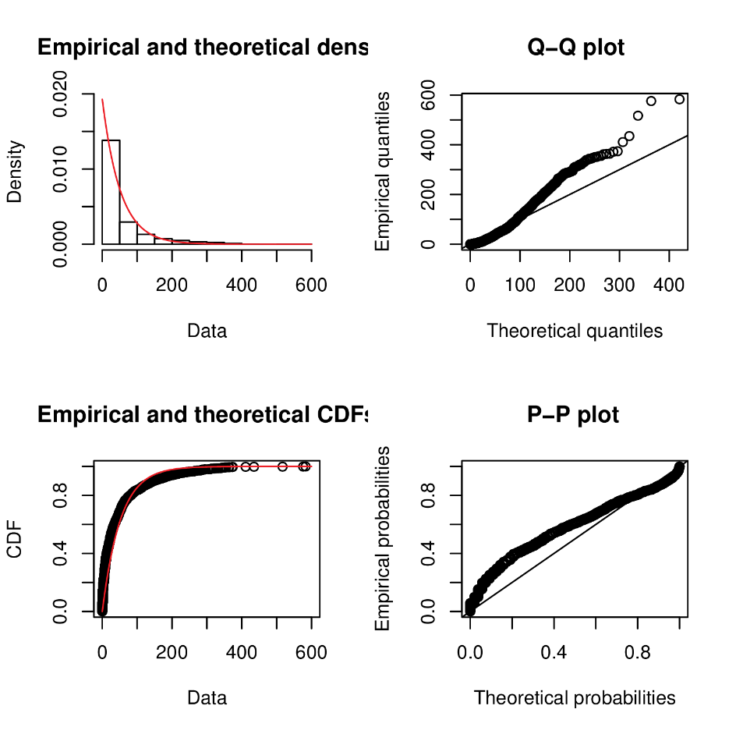

Day 1 with Norm Dist Fitting

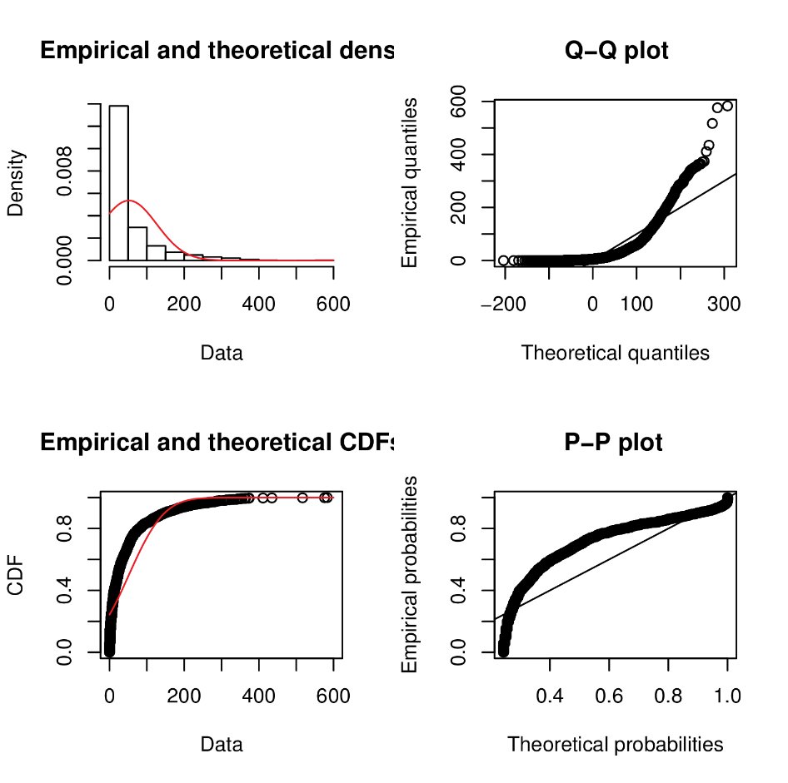

Day1 with lnorm dist fit

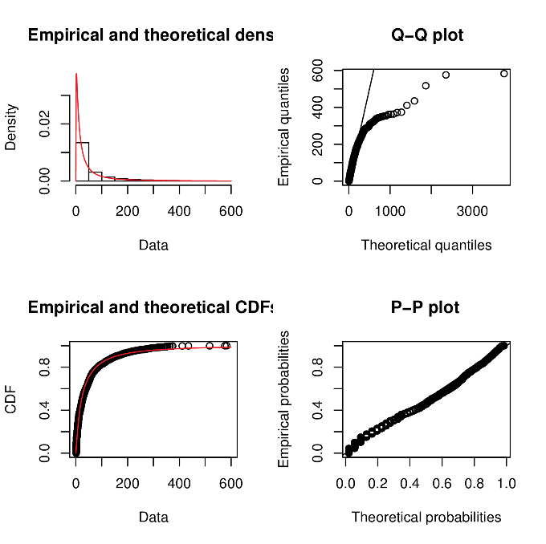

Day1 scatter plot for finding outliers

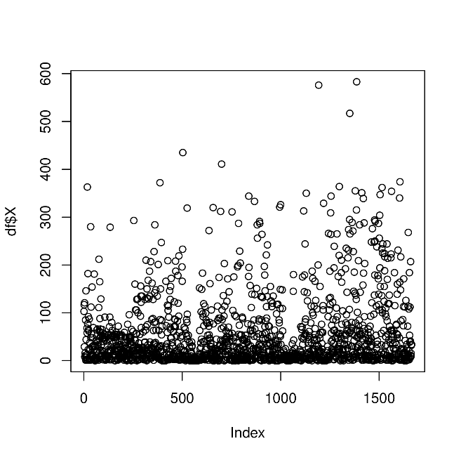

Day1 histogram

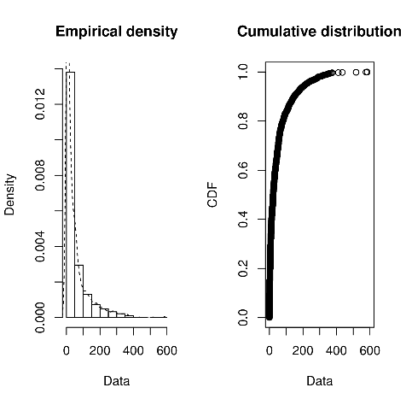

Day 2 exp dist fit

Lambda = 0.0317

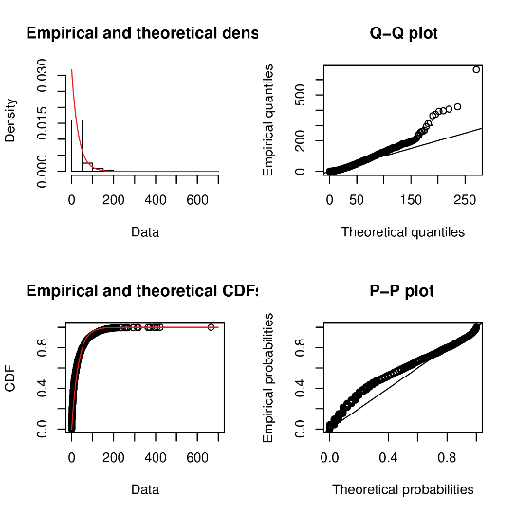

Day 2 with norm fit

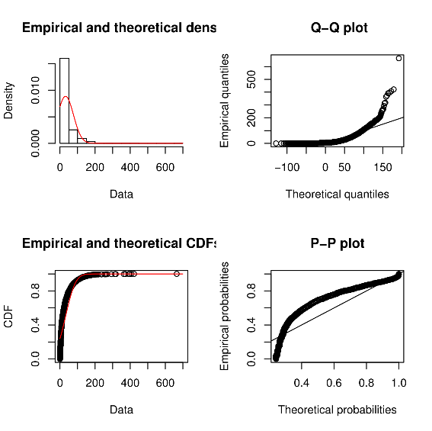

Day 2 lnorm dist fit

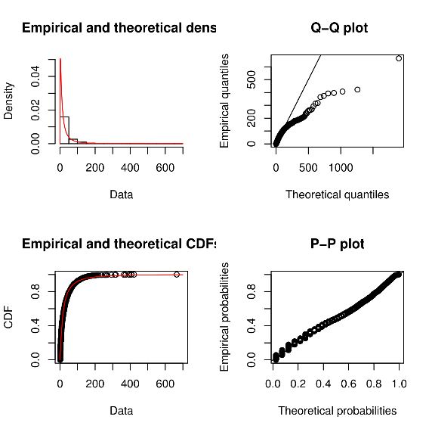

Day 2 scatter plot for outliers

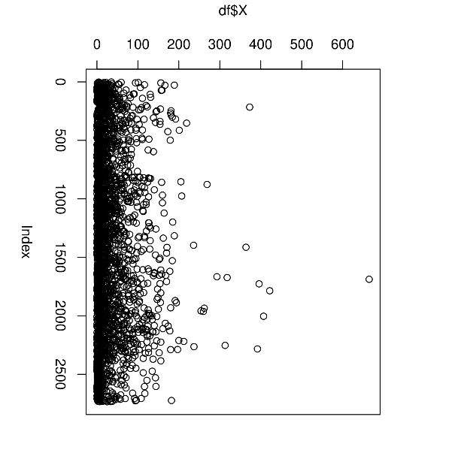

Day 2 skew

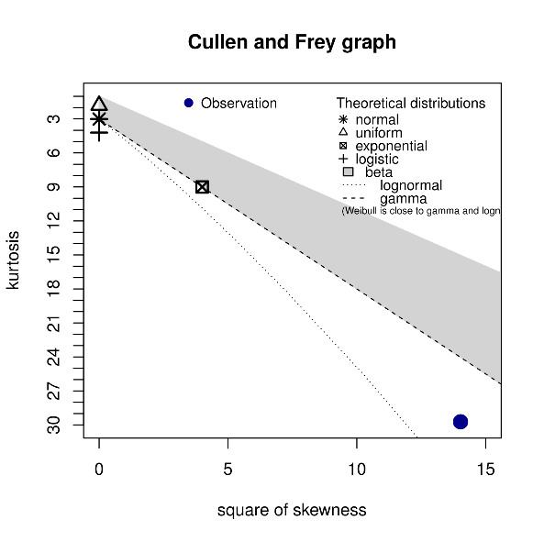

Day 3 exp dist fit

Lambda = 0.01949361

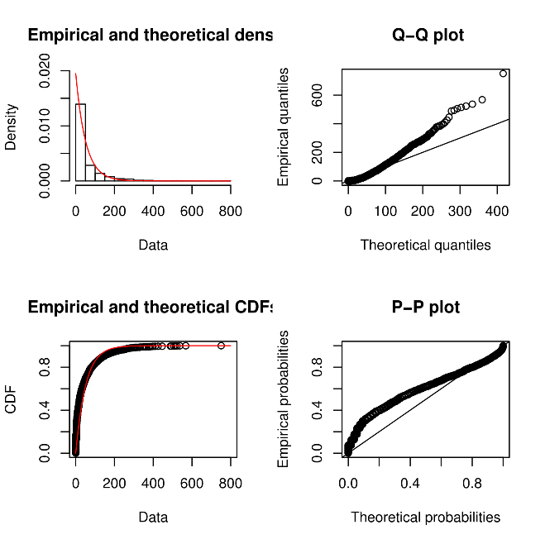

Day 3 norm dist fit

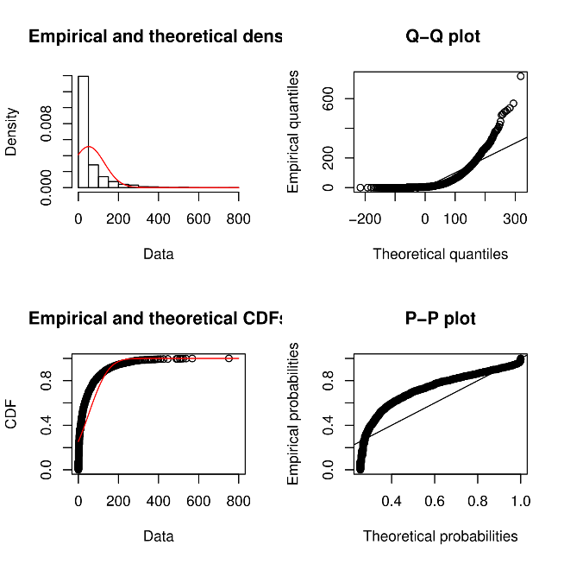

Day 3 lnorm dist fit

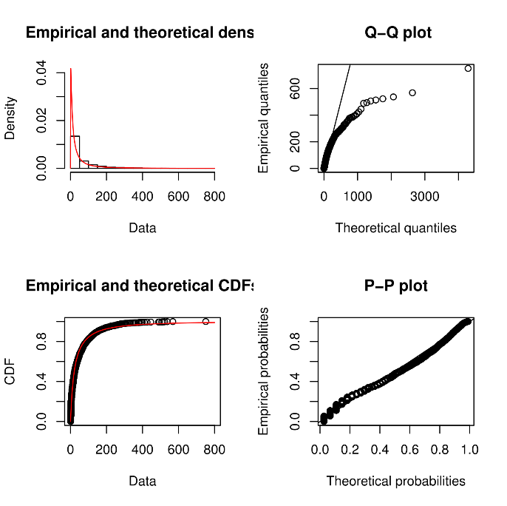

Day 3 scatter

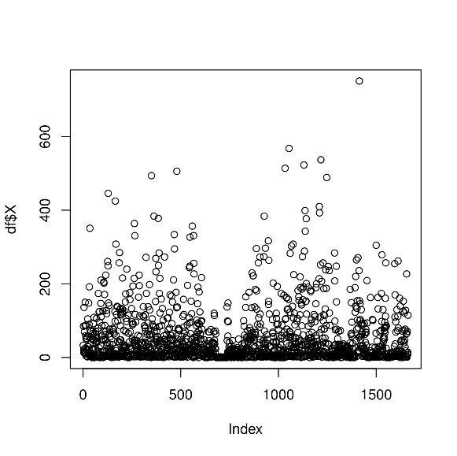

Day 3 skew

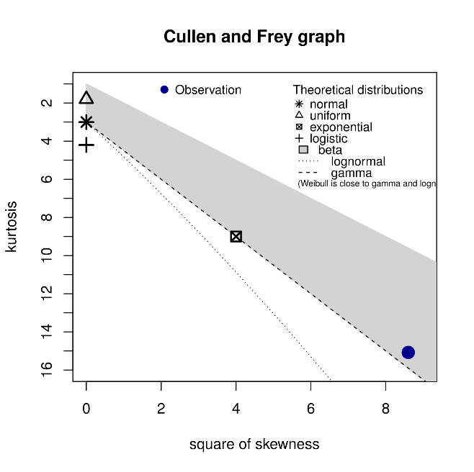

11.

Mu =Speed at which link can transmit data / average ( packet length)

For day 1

Average packet length = 57

Mu 1 = 128 * 1000/57*8

= 280.7

For day 2

Average packet length = 56

Mu 1 = 128 * 1000/56*8

= 285.71

For day 3

Average packet length = 58

Mu 1 = 128 * 1000/58*8

= 275.8

Since values of mu is close and we are varying lambda from 0 to mu

The graph of all three days will be similar

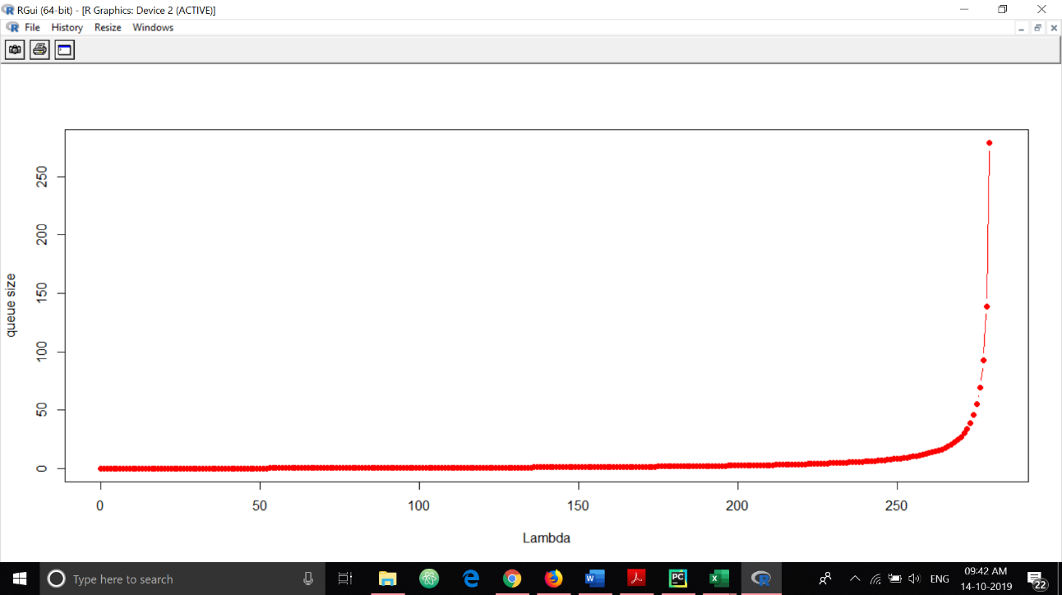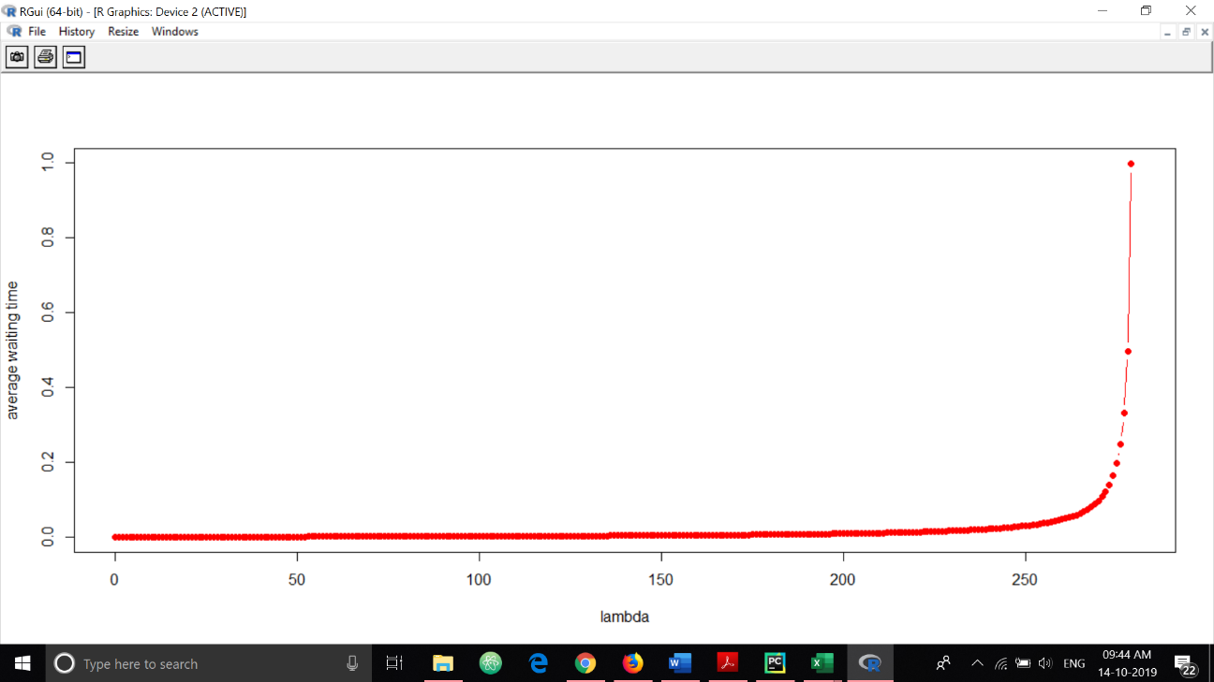

Load increases on the network implies lambda is high and according to the graph the average waiting time and queue size maximizes at that point.

Utilization factor i.e rho is used to check the stability of the system. if rho < 1 then the system is stable. i.e service rate < queue rate

The average queue size N = Lambda/(mu – lambda)

The average waiting time for a packet in the queue W = 1/(mu – lambda) – 1/mu.

Lambda1 = 0.019 = lambda3 , lambda2 = 0.031

N1 = 6.65 * 10^-5

N2 = 0.0001

N3 = 6.9*10^(-5)

W1 = 1.25 * 10^-5 sec

W2 = 1.16 * 10^(-5) sec

W3 = 1.32 * 10^(-5) sec