**Abstract**

Type Ia Supernovae are thermonuclear explosions of white dwarf (WD) stars. Past studies predict the existence of "hybrid" white dwarfs, made of a C/O/Ne core with a O/Ne shell, and that these are viable progenitors for supernovae. More recent work found that the C/O core is mixed with the surrounding O/Ne while the WD cools. Inspired by this scenario, we performed simulations of thermonuclear supernovae in the single degenerate paradigm from these hybrid progenitors. A hybrid white dwarf model constructed with the one-dimensional stellar evolution code MESA[5] was provided (Brooks et al. 2017) for our simulations.  This model had been run through the phase of unstable interior mixing followed by accretion until central ignition of carbon burning. The MESA model was then mapped to a two-dimensional initial condition and an explosion simulated from that with FLASH[4]. For comparison, a similar simulation of an explosion was performed from a traditional C/O progenitor WD. Comparing the yields produced by explosion simulations allows us to determine which model produces more 56Ni, and therefore brighter events, and how explosions from these models differ from explosions from previous models without the mixing during the WD cooling.

**Intro**

When a main sequence star runs out of fuel, it dies off to become a dense remnant of the MS, known as a white dwarf. Type Ia Supernova are bright explosions produced from radioactive Ni-56 determined by the white dwarf (WD). Astronomers use the fact that they give off a known amount of light and the inverse square law to determine distances of far objects. They were also used to find Hubble’s expansion of the universe.

There has been debate over what triggers a WD explosion. One of the primary ideas is the single degenerate process. During this process the white dwarf accretes material from a giant companion. Once the white dwarf reaches the Chandrasekhar limit, the star is consumed by thermonuclear runaway and explodes. Another idea is the double degenerate process: two white dwarfs merge to exceed the Chandrasekhar limit. Hydrogen is not expected to be observed since both stars exhausted their hydrogen long ago.

In our study, we use the single degenerate process to ignite a flame. The flame in the core starts out in the deflagration process, sub sonically burning C/O/Ne in its path. Once it reaches a certain density, the wave moves into the detonation front and sweeps through the rest of the star. This process is the deflagration to detonation process (DDT): when a wave moves from being subsonic to supersonic.

**Dons**

For Dons model, the assumption was that there is no mixing before accretion. Therefore, the hybrid model’s abundances represent the end of the accretion and convective core phase with a distinct small carbon rich core. Another differing assumption in Dons progenitor is they included Urca resulting in an off center ignition and unsmooth mixing.

For my model, there is an additional step: mixing while cooling. The white dwarf mixes as it is cooling resulting in no accretion and no burning. Therefore, the contrast between the carbon rich core and the non-Carbon rich shell, shown in Don’s hybrid model, is destroyed because of the convection. The cooling process is represented by the loss of structure in the core. The central ignition is a result of not including Urca physics during the core convective carbon burning phase.

Even with the differences in the evolution process (cooling, accretion and simmering) the composition structure of the hybrids are not too different, therefore, we assume the outcome to not be very different. The important information to look for: how much each model expands before the DDT, and their initial density.

**The Chandrasekhar-mass Single Degenerate Scenario** DDT Process**:** The fuel starts off cold. The elections in the plasma conduct heat and the fuel begins to heat up. Once the fuel reaches a certain temperature, the reaction starts. The fuel abundance begins to decline because it is consuming fuel. Energy is produced which makes the fuel hot. Eventually, all that’s left is ash. As surface area grows, conducted energy increases and density decreases. At low densities Rayleigh-Taylor instability causes the flame to get more tangled and unstable. Eventually, the star will get a large enough surface area in this volume that the net burning effect is supersonic. Therefore, the transition from deflagration to detonation is made.

A deflagration alone will not produce an event of normal brightness and expansion velocity. Instead, the initial deflagration must transition to a detonation after the star has expanded some in order to produce abundances and a stratified ejecta in keeping with observations. The physics of this “deflagration-to- detonation transition” (DDT) are not completely understood, but there has been considerable study based on mechanisms involving flame fronts in highly turbulent conditions. These models generally reproduce the observations under certain assumptions about the ignition, but research has shown that the results are very sensitive to the details of the ignition. In our simulations, we initialize a detonation once the deflagration front reaches a characteristic DDT fuel density, which controls the degree of expansion the star undergoes during the deflagration stage.

The comparison study of tradition C/O progenitor WDs used the same initial conditions for the realizations within the suite. The traditional models are simulated with the same code and the same set of perturbations on the initial match head (realization). The only difference is the different nuclear burning to include the other Ne and the initial profile of the 1-d model.

**Methodology**

**Created 2-D model from 1-D model and Suits of Explosions**

We mapped our hybrid model to the FLASH grid. In order to convert our 1-D MESA model into FLASH, which is a 2-D code, we needed symmetric nuclear matter. This means that the ratio of neutrons to protons in the nuclei must be the same ratio as in the mesa profile. This is because the amount of extra neutrons around is important when burning the star because that determines how much neutron rich isotopes the burning produces.

Using the FLASH code from University of Chicago, simulations of explosions were preformed. For each simulation we varied the central ignition seed.

**Initial Conditions**

We used MESA, a 1-D stellar evolution code, to create the hybrid model. We made the hybrid model have the same central temperature and density as the classic model.

We found that the most abundant isotopes in the model were C12, O16, Ne20. There were a few other isotopes that were added to form Ne22 later. We saw that ….

Plotting the density verses solar radii, we found that the densest part of the star is in the center slowly decreasing until it hits 0 at the outer edge of the star.

In order to see where we should ignite the flame, we plotted the temperature profile. It was found that the peak temperature is at the center of the star, therefore, it was obvious to ignite the flame in the core. (PUT IN TEMP PROFILE)

Figure 1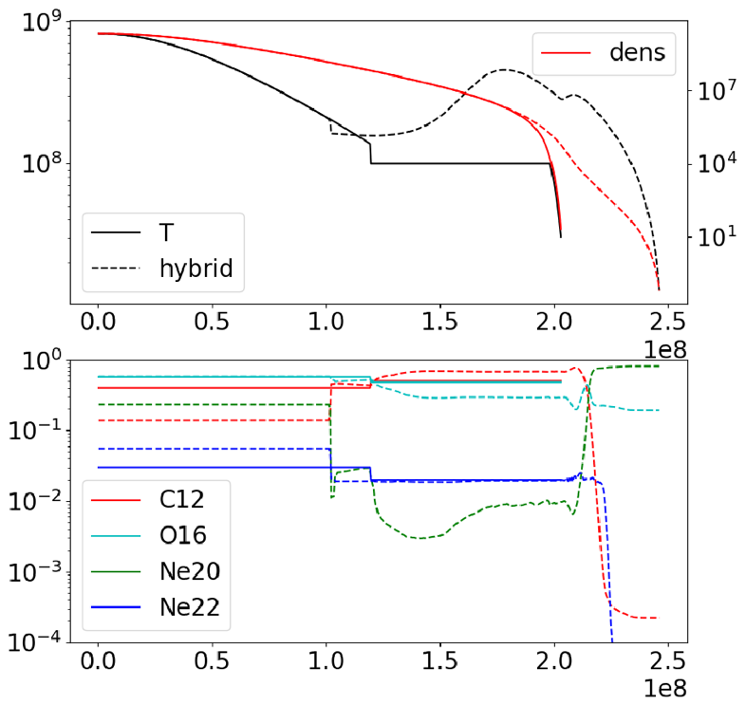

**Results**

Figure 2

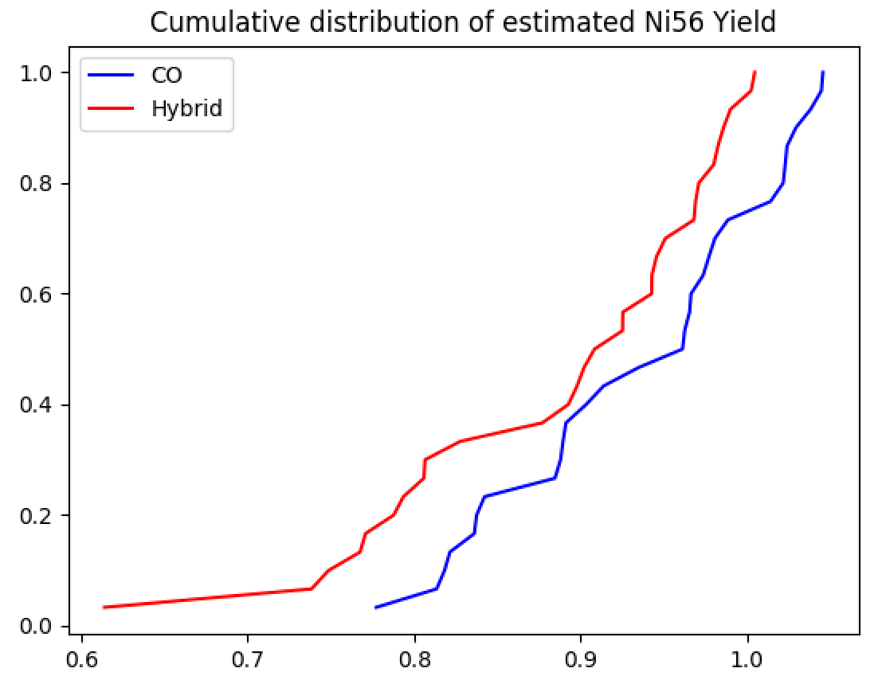

A plot of the estimated Ni56 yield as a function of the final, burned mass for all CO and Hybrid runs. The Hybrid model is shown in red, and the CO model is shown in blue. As it is shown, the CO model has a higher final mass then the Hybrid model.

Estimated Ni56 mass for Hybrid Model

Figure 3

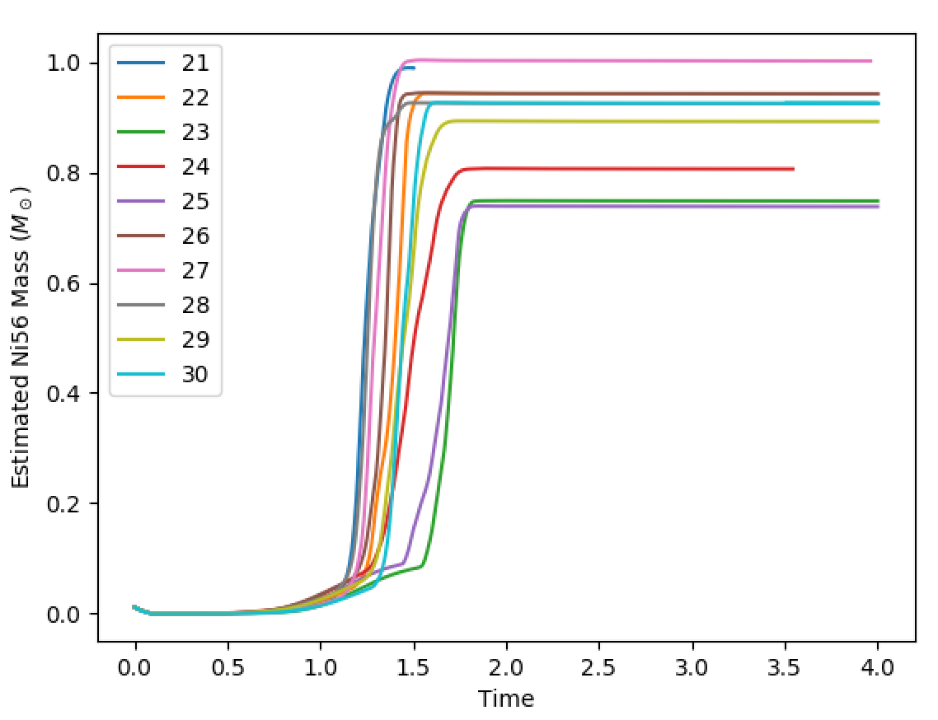

Estimated Ni56 mass for CO Model

Figure 4

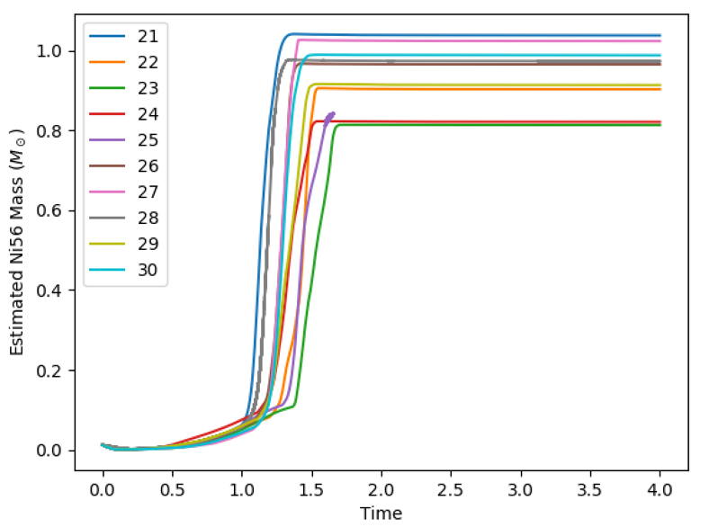

The figures show that the final Estimated Ni56 for the CO model is slightly larger then the Hybrid model. Therefore, the CO produces more Ni56. The Hybrid model has a larger range then the CO model. Also, on average, the CO model reaches the DDT phase sooner then the Hybrid model. The Hybrid model shows a delay in electron capture compared to the CO model. This was determined by the time of the DDT.

This is a plot of the estimated Ni56 yield vs. mass below 2e7 g/cc at the time of the DDT.

The degree of expansion was found using the time at which the first detonation point occurred, and the mass at density less then 2e7 g/cc. The estimated Ni56 Yield is the final estimated mass of the model.

Hybrid- Red

CO- Blue

Figure 5

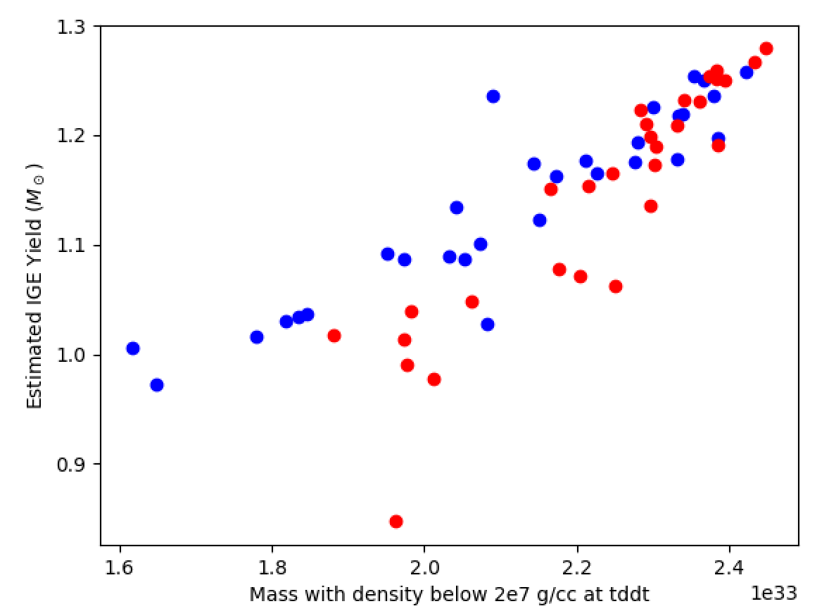

For a given amount of mass at high density, the CO produces more Iron group elements then the Hybrid model.

Figure 6

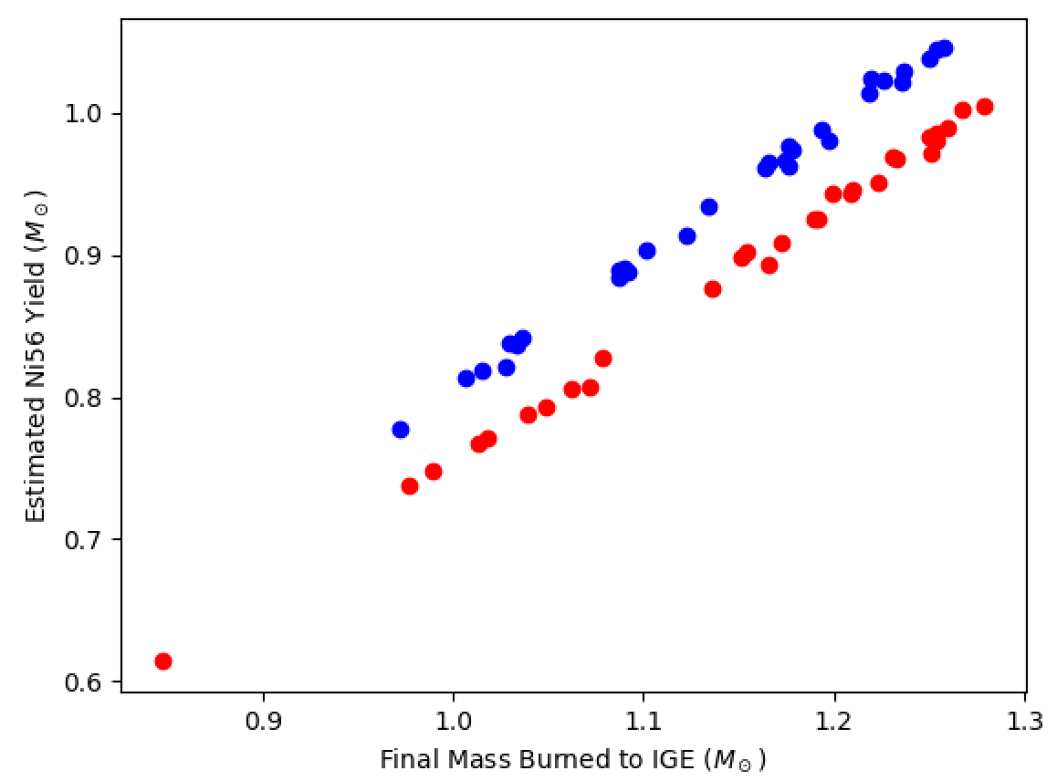

The conversion of Ni56 to Iron group elements are more pronounced in my case. There are two assumptions as to why figure 6 is more pronounced in my paper then in Dons.

First is that higher critical density leads to higher electron capture resulting in less Ni56 produced. Figure 4 shows that CO model has a stronger electron capture then the hybrid model. The second is that the central ignition leads to early burning at higher density. Both of these cases lead to more electron capture resulting in a larger difference in evolution between the models.

Figure 7

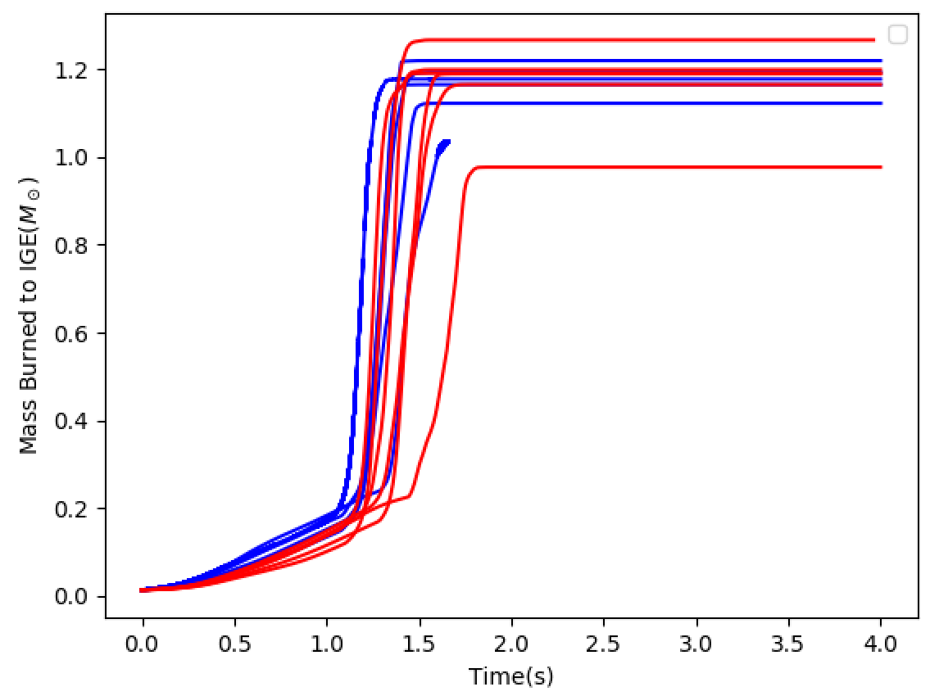

Figure 8

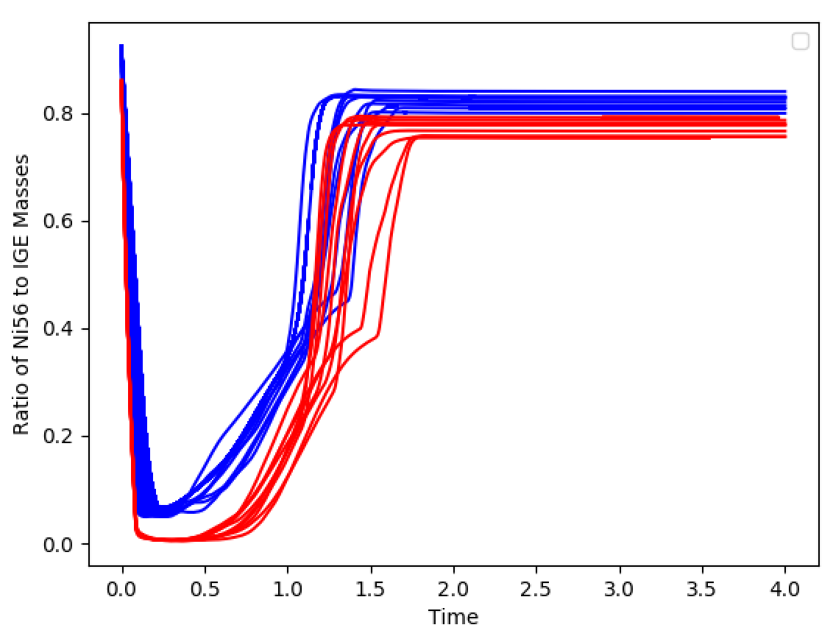

Figure 8 shows the evolution of the materials for both models. It is determined that the CO model had the greatest amount of Ni56, then the other IGE materials, compared to the hybrid model.

**Conclusions**:

As the star burns mass, the surface area grows, resulting in a decrease in density. The results show that the models that burned less mass during the deflagration phase, expand less, produce more Ni-56. This is because the density rich mass the model has at the DDT point is the ‘fuel’ it needs to produce Ni-56. Therefore, the more mass, the more Ni-56. On average, the CO model, shown in figure 4, reaches the DDT faster then the hybrid model. Figures 3 and 4 show that the hybrid model has a wider range of estimated Ni-56 mass suggesting a greater range of burned mass and expansion during the deflagration phase.