E05 Template Reuse-depth Success Condition Validation
After v0.2.40 Builder/provider timeout boundary
Stage: v0.2.41_e05_success_condition_after_timeout_boundary
Date: 2026-07-09
Provider / model: multi / deepseek-v4-pro
Raw evidence: docs/experiment-status/evidence/experiment_v0.2.41_e05_success_condition_2026_07_09.json

1. Background
E05 asks whether Template reuse depth improves Builder-generated BlockFlow quality and cost. v0.2.38 showed that template reuse could be more expensive and unstable; v0.2.39 fixed the marketplace template expansion contract; v0.2.40 added a deterministic provider-timeout boundary and Harness metadata. This run returns to E05 with those fixes in place.

2. Experiment Design
The experiment used the same code-review and repair BlockFlow requirement across three reuse-depth arms. All arms used the configured paid model and the same build budget: max_turns=42, max_repair_cycles=2, per-arm timeout=900s, provider stream timeout=180s.
- none: templates intentionally disabled, then build from scratch.
- shallow: call template suggestions and lightly expand a suggested template when useful.
- deep: compose around reusable template modules where possible.

3. Result Summary
Depth | Build status | Elapsed | Model/tool | Suggest/expand | Score/pass | Timeout
none | needs_attention | 437.1s | 27 / 45 | 1 / 0 | 0.85 / 1.0 | yes
shallow | published | 123.3s | 20 / 30 | 1 / 1 | 0.85 / 1.0 | no
deep | ready | 331.2s | 47 / 57 | 1 / 1 | 0.85 / 1.0 | no

Figure 1. Runtime and call-count comparison across E05 v0.2.41 arms.
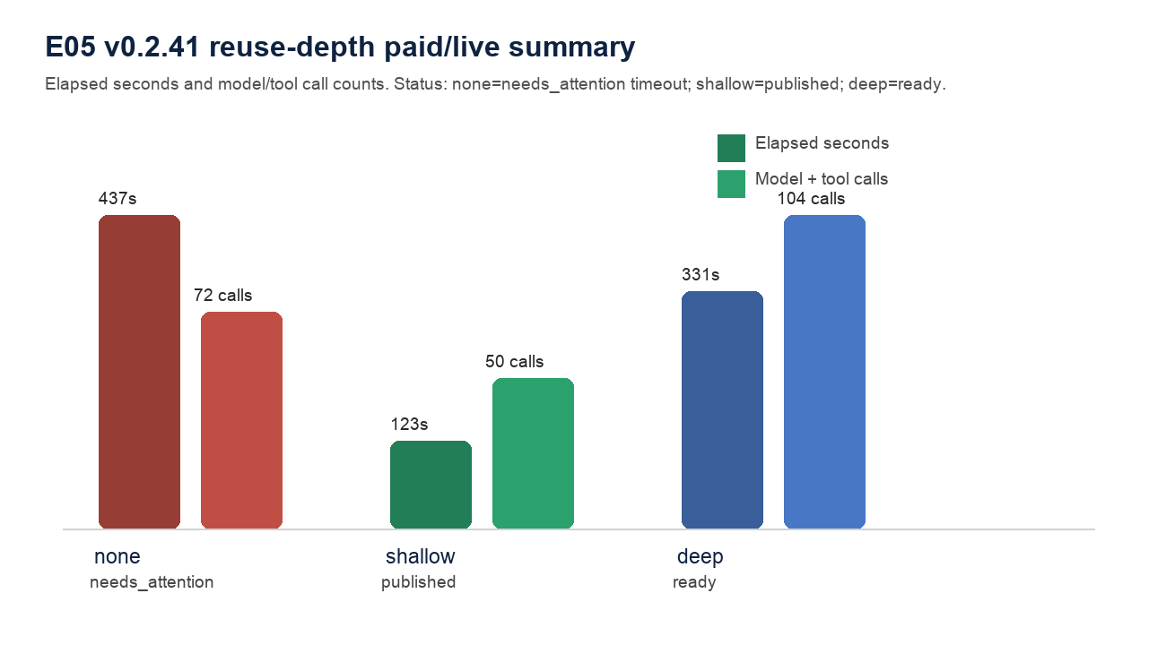

4. Key Findings
- The none arm failed at the Builder level with model stream timeout after 180s. The new v0.2.40 boundary worked: the raw result contains task_failure.type=model_provider, retryable=true, timeout_like=true, and model_timeout_event_count=1.
- The shallow arm reached published, expanded one template, passed the benchmark, and used the lowest observed model/tool calls among successful arms: 20 model calls and 30 tool calls.
- The deep arm reached ready and passed the benchmark, but used far more calls than shallow: 47 model calls and 57 tool calls. In this case deep reuse did not dominate shallow reuse.
- Benchmark pass does not equal Builder success. The none arm benchmark passed structurally, but the build still ended needs_attention and had no generated tests.

5. Conclusion
For this code_reviewer-like case, shallow Template reuse is the best supported current operating point: it reached published, expanded the relevant template, passed the benchmark, and cost less than deep. The result is stronger than v0.2.39 because timeout evidence is now explicit. However, original E05 should remain open: this is still a single requirement family, and the none arm failure was a provider timeout rather than a clean quality comparison.

6. Engineering Implication
The result supports keeping Template suggestions and marketplace expansion active, but defaulting to shallow reuse unless a requirement clearly needs deep modular composition. The next engineering question is not template expandability; it is success-condition policy: when should Builder choose shallow, when should it escalate to deep, and when should a long build trigger a build-level watchdog or retry strategy?

7. Evidence Chain
- Raw JSON evidence: docs/experiment-status/evidence/experiment_v0.2.41_e05_success_condition_2026_07_09.json
- Chart: docs/experiment-status/evidence/experiment_v0.2.41_e05_success_condition_summary.png
- Focused script tests: tests/test_e05_template_reuse_depth_experiment.py passed after adding timeout evidence extraction.
- v0.2.40 prerequisite: runtime timeout event and Builder Harness failure metadata.

