E05 Customer Support Template Reuse-depth Experiment
v0.2.43 paid/live validation after Builder build-level watchdog
Run window | Raw evidence uses run id 2026-07-09; this DOCX was generated at 2026-07-10 00:24 JST.
Provider/model | multi / deepseek-v4-pro
Case | customer_support_router (Customer support routing)
Budget | 3 arms; max_turns=42; max_repair_cycles=2; max_elapsed_seconds=600; provider_timeout=180s; script wait timeout=900s.
Evidence | docs/experiment-status/evidence/experiment_v0.2.43_e05_customer_support_2026_07_09.json

Key result: For the customer-support template family, no-reuse reached published status, while shallow reuse failed on provider stream timeout and deep reuse failed on an invalid draft. This does not close E05 globally; it adds a second task-family data point and exposes a template-customization reliability gap.

1. Background
E05 asks whether Template reuse depth improves Builder Team BlockFlow generation quality and cost. Earlier code-review evidence supported shallow reuse as a promising single-case working point after marketplace template expansion and provider timeout evidence capture. v0.2.42 then added a build-level watchdog. v0.2.43 tests whether the same reuse-depth story generalizes to a non-code-review, Template-friendly customer-support routing case.

2. Experiment Design
The runner executed the same requirement under three reuse-depth instructions: none, shallow, and deep. Each arm used the real Builder API, real paid DeepSeek model configuration, Platform Harness task usage records, template suggestion/expand tools, and a benchmark reference requiring start, question_classifier, if_else, template_transform, and end node types.
none | Call template_suggestions with reuse_depth=none, then build the BlockFlow from scratch.
shallow | Call template_suggestions with reuse_depth=shallow; lightly expand the customer_support_router marketplace template if suggested.
deep | Call template_suggestions with reuse_depth=deep; compose around the reusable template module.
Watchdog | Every Builder build received max_elapsed_seconds=600. Provider stream timeout remained 180s.

3. Results
Figure 1 compares model/tool calls and elapsed time. The table separates Builder terminal status from benchmark case status; this is important because the benchmark suite minimum_pass_rate is currently 0.0, so a suite may pass while its single case fails.
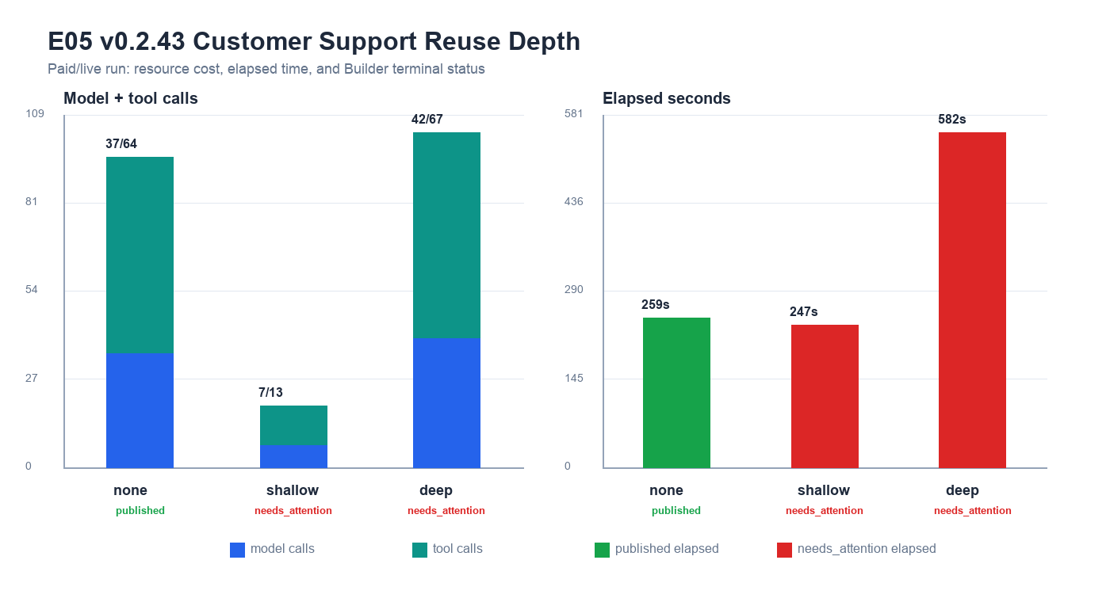
Figure 1. E05 v0.2.43 calls and elapsed time by reuse depth.
Depth | Build | Calls M/T | Elapsed | Template | Benchmark case | Failure meaning
none | published | 37/64 | 259.4s | suggest=1; expand=0 | fail; score=0.78 | Published; benchmark case failed because if_else was missing.
shallow | needs_attention | 7/13 | 247.2s | suggest=1; expand=1 | pass; score=0.85 | Provider stream timeout captured as retryable model_provider failure.
deep | needs_attention | 42/67 | 581.9s | suggest=1; expand=1 | pass; score=0.85 | builder stopped with invalid draft: unreachable nodes: ['customer_support_router_end', 'llm_response', 'tpl_prompt']; test test_ur

4. Conclusion
• Second-family evidence does not support a blanket rule that deeper Template reuse is better. On customer_support_router, none published, shallow timed out, and deep failed during invalid-draft validation.
• Template suggestion and template_expand both worked for shallow/deep. The remaining weakness is not template discoverability; it is post-expansion customization, graph reachability, and test/required-node consistency.
• The v0.2.42 build-level budget reached Platform Harness metadata in all arms. In this run, shallow failed at provider stream timeout and deep failed by runtime validation before the 600s deadline; no clean build_timeout was triggered.
• Benchmark semantics need careful reading: none published but failed the benchmark case because it omitted if_else; shallow/deep achieved benchmark node coverage but did not complete Builder success. Future reporting should show both dimensions by default.

5. Next Engineering Implication
Do not close original E05. The next credible engineering slice is to repair marketplace template expansion customization for customer_support_router: preserve reachable template edges after edits, avoid required_node_types drift, and make benchmark/reporting show build status and case status independently.

6. Evidence Chain
• docs/experiment-status/evidence/experiment_v0.2.43_e05_customer_support_2026_07_09.json
• docs/experiment-status/evidence/experiment_v0.2.43_e05_customer_support_summary.png
• tests/test_e05_template_reuse_depth_experiment.py::6 passed
• scripts/e05_template_reuse_depth_experiment.py

