**CS151 Spring 2020 Project 1**

**Output from JAVA program**

**Project description:**

Install Java and BlueJ on your home computer or do project at CCSU in the computer lab.

1. Open BlueJ

2. Click “Project”, “New Project …”

3. It is your choice to select project folder and project name

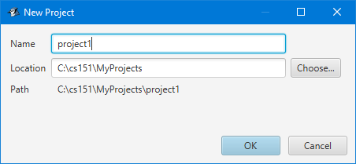

4. Click “New Class” button and create class FiveMovies.

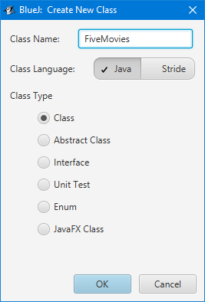

5. Right click on the class icon and select “Open Editor

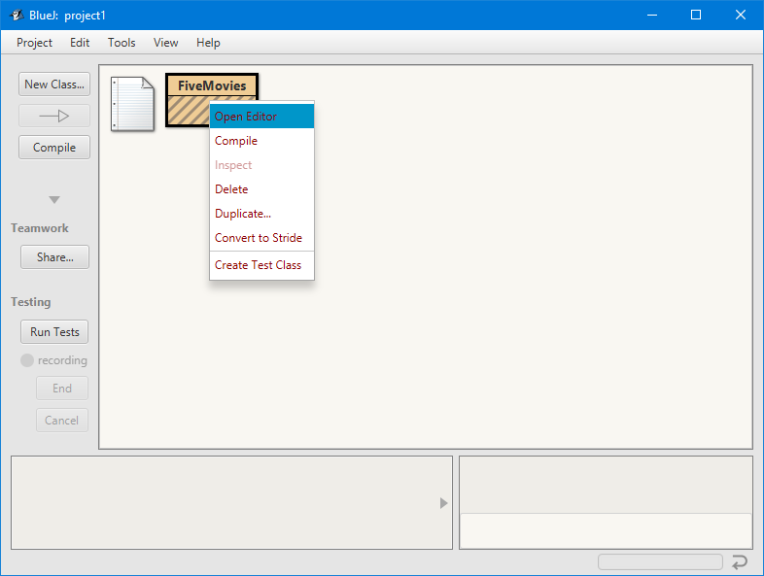

6. Remove unnecessary lines from the code and add main method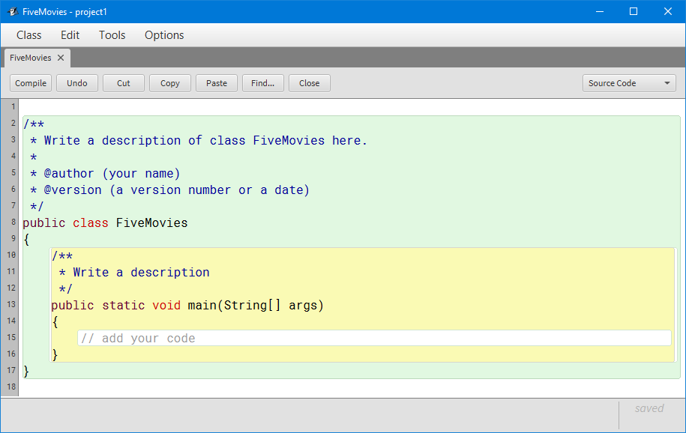

7. Write description of the project, your name and date.

8. Add Java statements to display five movies of your choice.

9. Click “Compile” button.

10. Upon successful compilation, close the editor and right click on class icon again and select main method.

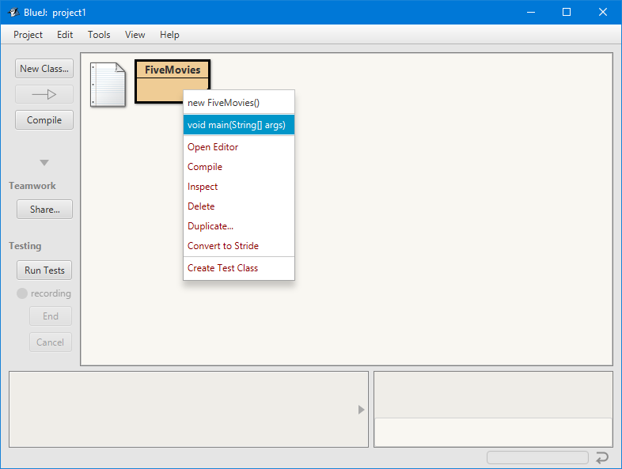

You are now ready to make project document.

1. Open MS Word and select new document

2. Set font to “Courier New” font size 10

3. Set paragraph spacing to 0

4. Hide spelling and grammar errors.

5. Open FiveMovies class in BluJ Editor and copy the code (CTRL A, CTRL C).

6. Go back to MS Word and paste the code into your document (CTRL V)

7. Go back to BlueJ Terminal and click ALT Print Screen

8. Finally, go back to MS Word and do another CTRL V, that will copy BlueJ Terminal picture   
 showing the outcome of your program run.

9. Close the document and save as P1_YourLastName.docx.

10. Submit project via Blackboard Learn in Project 1 assignment any time before the due

date/time.

Pay attention to proper indentation.

Open and matching closed braces must be left aligned.

Method main inside the class Quotes should be indented (2-4 characters).

Code in the main method should be indented (2-4 characters) further.

All statements in the main method should be left aligned.

Pay attention to style. It is up to 50% of the grade.

Before you copy picture of any window, resize that window so that it only shows non-empty lines.

NOTE: Picture of any active window can be put into paste buffer by pressing ALT and PrtScrn together. You can paste it from the buffer into Word document by pressing CTR V.

This is a sample project document:

/**

* Write a description of class MyClass.

*

* @author (your name)

* @version (a version number or a date)

*/

public class MyClass

{

/**

* Write a description

*/

public static void main(String[] args)

{

// add your code

System.out.println("Under construction");

}

}

