CS152 Project # 5

Event Driven Programming

Design JavaFX application with 7 labels and one textfield where user enters input inches. When user enters his choice and presses enter key to complete input, program outputs resulting yards, feet, and inches.

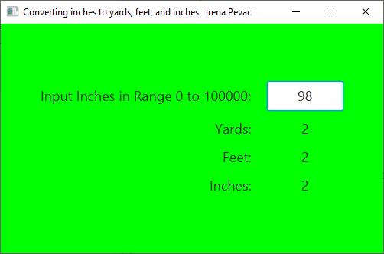

* Use class P5 that extends Application with start method in it, and class P5Pane that extends GridPane. The only inctance variables for P5Pane class are inputInches where user enters input inches, and three labels: outYards, outFeet, and outInches where program displays result of conversion. Use the following names for instance variables:

private Label outYards, outFeet, outInches;

private TextField inputInches;

* All other variables should be local where needed.
* Title bar of the output window must have your first and last name and not mine at the end of the given title.
* Provide also UML with classes P5, P5Pane, Application, and GridPane. The boxes for Application and GridPane can only have top part filled, since they are Java classes. Relationships must be specified.

**SUBMIT** one Word or PDF file with code, UML, and Output run pictures for 3 different input inches. One must be 98.