Output
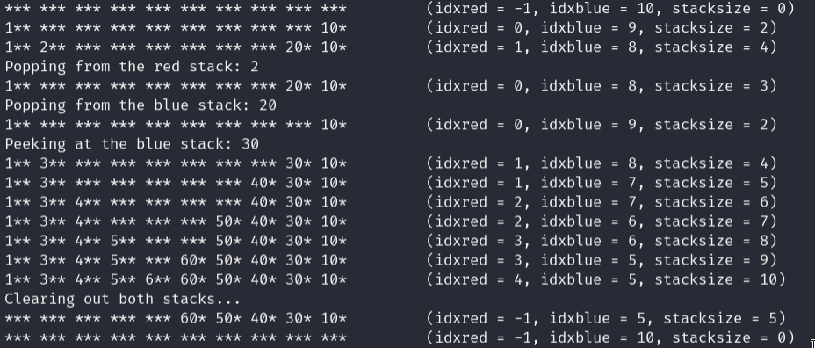

Assignment is on the next page.
Driver.java
public class Driver
{
public static void main(String[] args)
{
DoubleStack<Integer> ds = new DoubleStack<>(10);
ds.redPush(1);
ds.bluePush(10);
ds.print();
ds.redPush(2);
ds.bluePush(20);
ds.print();
System.out.println("Popping from the red stack: " + ds.redPop());
ds.print();
System.out.println("Popping from the blue stack: " + ds.bluePop());
ds.print();
ds.redPush(3);
ds.bluePush(30);
System.out.println("Peeking at the blue stack: " + ds.blueTop());
ds.print();

try {
for (int i = 4; i < 7; i++)
{
ds.bluePush(i*10);
ds.print();
ds.redPush(i);
ds.print();
}
} catch (IllegalStateException e) {
System.out.println("Cannot add any more elements to the stack. It's full!");
}

System.out.println("Clearing out both stacks...");
ds.redClear();
ds.print();
ds.blueClear();
ds.print();
}
}
DoubleStack.java
public class DoubleStack<E>
{
// The character used when printing the stack on a null element
private static final String DEBUG_NULL_ELEMENT = "*";

/** The double stack. */
private E[] stack;
// The indicies of each stack.
private int idxred, idxblue;

@SuppressWarnings("unchecked")
public DoubleStack(int capacity)
{
this.stack = (E[]) new Object[capacity + 1];
this.idxred = -1;
this.idxblue = capacity;
print();
}

/**
* @param element
* @throws IllegalStateException
* If the stack is full
*/
public void redPush(E element) throws IllegalStateException
{
if (isFull())
{
throw new IllegalStateException(
String.format("Cannot push element %s because the stack is full.",
element.toString()));
}

idxred++;
stack[idxred] = element;
}

/**
* @param element
* @throws IllegalStateException
* If the stack is full
*/
public void bluePush(E element) throws IllegalStateException
{
if (isFull())
{
throw new IllegalStateException(
String.format("Cannot push element %s because the stack is full.",
element.toString()));
}

idxblue--;
stack[idxblue] = element;
}

/**
* Removes the top element of the red stack and returns it.
* @return The top element of the red stack (null if none exist)
*/
public E redPop()
{
if (isEmpty() || redSize() == 0)
{
System.err.println("Cannot pop an element from the red stack.");
return null;
}

E element = stack[idxred];
stack[idxred] = null;
idxred--;
return element;
}

/**
* Removes the top element of the blue stack and returns it.
* @return The top element of the blue stack (null if none exist)
*/
public E bluePop()
{
if (isEmpty() || blueSize() == 0)
{
System.err.println("Cannot pop an element from the blue stack.");
return null;
}

E element = stack[idxblue];
stack[idxblue] = null;
idxblue++;
return element;
}

/**
* Returns the top element of the red stack, but does not remove it.
* @return The top element of the red stack (null if none exist)
*/
public E redTop()
{
if (isEmpty())
{
System.err.println("There's no element to peek at on the red stack.");
return null;
}

return stack[idxred];
}

/**
* Returns the top element of the blue stack, but does not remove it.
* @return The top element of the blue stack (null if none exist)
*/
public E blueTop()
{
if (isEmpty())
{
System.err.println("There's no element to peek at on the blue stack.");
return null;
}

return stack[idxblue];
}

public void redClear()
{
while (redSize() > 0)
redPop();
}

public void blueClear()
{
while (blueSize() > 0)
bluePop();
}

public int redSize()
{
return idxred + 1;
}

public int blueSize()
{
return stack.length - idxblue - 1;
}

public boolean isEmpty()
{
return redSize() == 0 && blueSize() == 0;
}

public boolean isFull()
{
return redSize() + blueSize() == stack.length - 1;
}

public void print()
{
String element = "";
int pad = 0;
for (int i = 0; i < stack.length - 1; i++)
{
// If the element is null, print the null character instead
element = stack[i] == null ? DEBUG_NULL_ELEMENT : stack[i].toString();
// String.repeat is used here for even padding (tab doesn't look good otherwise)
pad = 3 - element.length() > 0 ? 3 - element.length() : 0;
System.out.print(element + DEBUG_NULL_ELEMENT.repeat(pad) + " ");
}

System.out.printf("\t(idxred = %d, idxblue = %d, stacksize = %d)\n",
idxred, idxblue, redSize() + blueSize());
}
}

