

**ABSTRACT METHODOLOGY (CONT)**

*FASTER AND SAFE WIRELESS COMMUNICATIONNETWORK USING LIFI*

**SHUBHAM GUPTA, Prof. THOMAS ABRAHAM J V**

**SCSE, Vellore Institute of Technology, Chennai**

This paper is based on LiFi technology and its application. In the first section audio transmission using Lifi is implemented and that explain working audio transmission. It is shown that audio transmission can be achieved with a distance up to 30cm and improvements can be made by adding a focusing lens between the transmitter and the receiver. Second phase deals this text transmission. For this Arduino Uno to transmit data using an LED. In the data transmission prototype, the code has give to Arduino to transmit character or number. On the third phase Lifi is implemented based on application that can solve the real world problems of visually impaired peoples.

A world where every LED light bulb could connect everyone to the internet. The LED light in our homes, offices, cars, and even street lights connect to us with high speed wireless internet. LiFi is high speed, bidirectional fully networked wireless communication allowing transfer of data through the light that we use. LiFi enabled LED light modulate illumination level to send data like morse code that modulation happens so fast the eye can't perceive it. LiFi is where light becomes data. Every year the world consumes 60 percent more wireless data, almost all of this is consumed indoors using wireless internet connection that utilize radio frequencies. The space for radio frequencies is becoming oversaturated resulting in which what is known as the spectrum crunch. Eventually radio frequency technology like WiFi will no longer keep up demand, however, LiFi does not use radio frequency, it uses the light spectrum which can open up 1000 times more spectrum than radio frequency. LiFi will be an integral part of the future of wireless networks such as 5G and further.

**INTRODUCTION**

**CONCLUSION**

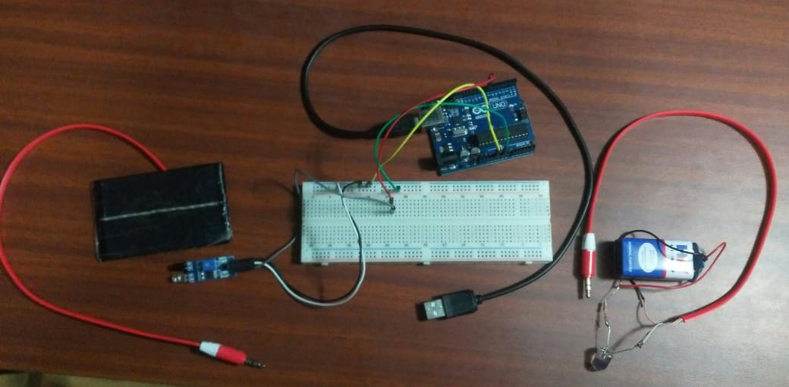

**BLIND INDOOR NAVIGATION SYSTEM MODEL**

**CIRCUIT-DIAGRAM TEXT TRANSMISSION**

**ABSTRACT**

**HOW IS LIFI WORKS**

The objective is to show how LiFi works through a working

model and with that model make a use of real life application

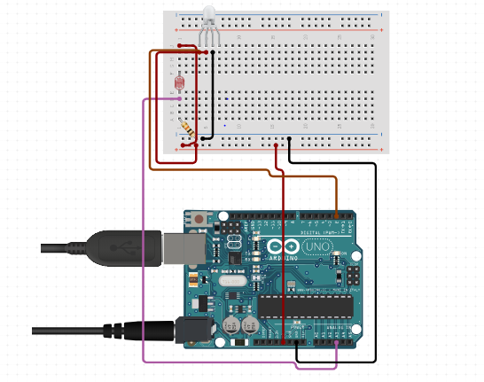

**REFERENCES**

[1] What is LiFi?( Harald Haas), Member, IEEE, Liang Yin, Student Member, IEEE, Yunlu Wang, Student Member, IEEE, and Cheng Chen, Student Member, IEEE.

[2] LiFi: Conceptions, Misconceptions and Opportunities (Harald Haas). LiFi Research and

Development Centre, The University of Edinburgh, Edinburgh EH9 3JL, UK, h.haas@ed.ac.uk.

**CONTACT DETAILS**

shubhamgupta.2018@vitstudent.ac.in

Data is transmitted over Lifi by modulating the intensity of the light essentially dimming the light or turning it on and off at a very high speed. This happen very fast and human eye can't really feel or see this. The light get receive by photo-detector and demodulation (processing) happens to generate the data stream which was sent by the transmitter.

**OBJECTIVE**

LIFI- "LIGHT FIDELITY". It is a progression for remote correspondence between IoT devices utilizing light to transmit information. In-specialized term we can state that ,LIFI is an obvious light correspondence framework that is equipped for transmitting information at high speeds over the noticeable light range, bright and infrared radiation. The idea of lifi is information correspondence on quick gleaming of light which isn't distinguished by human eye yet it is centered around photodetector which changes over the on-off state into parallel computerized information. This happens in the form of a binary transmission of data, where ‘0’ is the LED in its ‘off state’ and ‘1’ is the LED in its ‘on-state’.