In situ multispectral fluorescence, a new method for the assessment of phytoplankton community taxonomic composition from BGC-Argo floats

1) Introduction

Phytoplankton plays a key role in numerous biogeochemical cycles. In a context of global changes it is crucial to study processes that intervein in the carbon cycle. Doing so implies to monitor the phytoplankton communities on the global and vertical scale. The emergence of new observation tools such as Biogeochemical Argo (BGC-Argo) Floats opened the possibility to embark sensors to collect optical and chemical data. The phytoplankton component is mostly looked through its biomass using a fluorometer that is used to estimate chlorophyll-a concentration ([chla]). However, the phytoplankton community plays a key role in the carbon cycle in many ways. Some methods have been previously developed to estimate an index of the size structure of the community, either from optical data or from fluorescence profiles. Even if those measurements provide a good estimation of the size structure of the phytoplankton community we still miss the taxonomic variability hidden inside of each size class. Yet, it is established that the taxonomic composition of the phytoplankton community play a role in the carbon cycle. This study aims to evaluate a new method, based on the combination of already existent optical sensors and of a new multispectral fluorometer, that would enable the estimation of the phytoplankton community taxonomic composition. Multispectral fluorescence rely on the diversity of pigment composition of the different phytoplankton taxon. Its composition influence the absorption spectra of the cell, and so, would define its fluorescence response in different wavelength. We hypothesize that the pigment composition of phytoplankton on the global scale is contrasted enough to induce significant variability of fluorescence response between the three wavelength of excitation of the multispectral fluorometer that would allow to define a classification method from the fluorometer output. We combine two different approach to test this hypothesis. At first, we selected ten different phytoplankton strains that correspond to the typical diversity observed during the seasonal succession of the north western (NW) Mediterranean sea. We measured in laboratory the fluorometer signal on those ten strains on a dilution scale. The results where then compared to in-situ data collected monthly for a year in the NW Mediterranean sea. We finally aimed to introduce a classification method to assess the different phytoplankton populations observed in the NW Mediterranean sea from BGC-Argo floats.

2) Mat & Met

2.1) Laboratory work

2.1.1) Strain culture

Ten strains were selected for the protocol and provided by the Rocoff Culture Collection (RCC). Three Synechococcus strains that are commonly observed in the summer surface waters, *nom des souches*, three Prochlorococcus that are representative of deep picophytoplankton communities, *nom des souches*, three diatoms with different sizes, *nom des souches*, two dinoflagellates and one pelagophyte.
10 souches : PCC9511, RCC156, RCC2374, RCC 2319, RCC2379, RCC76, RCC100, RCC1717, RCC4213, RCC3006.
All strains were grown under the same controlled conditions, *récupérer données de temp entre 26/10/2020 et 06/11/2020*, at 52 μE of continuous wihte light, in K+Si or PCRS11 medium. The growth state of the culture was monitored with a Pulse Amplification Method (PAM) fluorometer, using the Fv/Fm index. The protocol of multispectral fluorescence measurement was performed on each culture in the end of the exponential growth phase. Afterward each culture was putted back in growth condition until a new exponential growth, three times, to get biological triplicate.

2.1.2) Determination of Chla concentration

The first [Chla] estimation of each dilution was performed using a spectrophotometer. This estimation was then validated by High Performance Liquid Chromatography (HPLC) on two different dilution levels for each culture.
Dosage de la chlorophylle a à l’aide du spectrophotomètre (ref) :
- Prélèvement de 10 mL de culture dans un falcon pré-rempli avec 10 μL de pluronic ( ?%, Sigma) ;
- Première centrifugation (ref) à 10000 rpm (à convertir en g), 4°C et pendant 5 min ;
-Retirer 8 mL de surnageant et deuxième centrifugation (même conditions que la première) ;
- Retirer le reste du surnageant ;
- Ajouter 1 mL de METOH (ref) dans le tube et resuspendre le culot ;
- Laisser à -20°C pendant 30 min à 1h ;
- Troisième centrifugation (même conditions que la première) ;
- Prélever le surnageant et le mettre dans une cuve d’absorption (ref) ;
- Mesure d’absorption avec le SAPAS (ref) :
LO départ : 550
LO arrivée : 720
Moyennes (sec) 0.2
Pas (nm) 1
LO cummuation filtre IR 610
- Placer deux cuves de METOH pur et acquérir la ligne de base particulière ;
- Réaliser un spectre « normal » afin de vérifier que la ligne de base a été bien enregistrée ;
- Passer les échantillons et noter les valeurs nécessaires au dosage de la chlorophylle a (cf. fichier de calculs de Flavien basé sur les équations trichromatiques et équations de Fred pour Syn et Proc). Se référer aux équations trichromatiques de Jeffrey et Humphrey (1975) avec des coefficients ajustés pour l’extraction au méthanol (Ritchie, 2006 DOI : 10.1007/s11120-006-9065-9).
- Une fois la Chl a dosée, calculs du volume de culture (PCRS11 ou K+SI) nécessaires pour réaliser les 5 dilutions (Cf. fichier Flavien) ;
- Inoculer un nouveau réplicat avec la culture mère ;
- Puis mettre la culture au noir pendant 15 minutes (dark adaptation).

2.1.3) Multispectral fluorescence measurements

Manip 3X1M en elle-même :
Pour la culture mère et chaque dilution,
- Prélever 2 fois 1.485 μL de culture pour la cytométrie en flux* dans des tubes pré-remplis avec un 15 μL d’un mélange pluronic/glutaraldéhyde (ref) – Après 10 minutes au noir, congeler les échantillons à -80°C jusqu’à analyse ;
- Prélever 2 mL dans un cuve de spectrofluorimétrie (ref) pour mesurer le F0 aux 5 longueurs d’ondes (440, 480, 540, 590, 625 nm), le Fmd et le Fm et calculer le Fv/Fm à l’aide du PAM (ref) ;
- S’assurer que le fluorimètre est droit et au centre du bécher immergé de 5mm dans la culture. S’assurer de l’absence de bulles au niveaux des canaux d’excitations et du canal de mesure, mettre la culture sous légère agitation statique. Mesurer 3 * 1minutes avec 2 minutes de désexcitation entre chaque acquisition.
Pour la culture mère et la deuxième dilution, faire de l’HPLC (ref des filtres). Les volumes filtrés ont été renseignés sur le fichier de données de Flavien.
Pour la culture mère, créer une référence avec le PAM.

* Pour RCC1717, fixation dans du lugol pour comptage sous microscope.

2.2) Time series acquisition

2.3) Statistics

2.3.1) Support Vector Machine classification

2.3.2) Clustering method

2.3.3) Histogram Gradient Boosting classification

3) Results and discussion

3.1) Discrimination of phytoplankton taxa in controlled conditions

Firstly, we investigate the possibility to discriminate the taxa we selected in our laboratory protocol with the MF fluorometer. The ratio between the three different fluorescence signal from the three excitation wavelengths of the 3X1M is shown on the figure 1. The aims of the classification is to discriminate taxa rather than species, so the different strains are group by taxa in this study. The different taxa appears to be discriminated in the scatterplot. Synechococcus have a consistently high value of F532/F470 and a relatively heterogeneous values of F440/F470. Pelagophytes have low values of both F532/F470 and F440/F470. Prochlorococcus have medium to high values of F532/F470 and consistently high values of F440/F470. Finally, Diatoms are found in the middle of the scatterplot with median values of F532/F470 and F440/F470.
Higher values of F532/F470 in the Synechococcus and Prochlorococcus taxa may be explained by a higher fluorescence response with the 532 nm excitation, induced by the presence of phycobilins in Synechococcus (Six et al., 2007) and, in less extent, in Prochlorococcus (Wiethaus et al., 2010). Phycobilins extend the light harvest complex, they have a peak absorption at 560 nm and transmit absorbed energy to the photosystem, leading to a significant fluorescence response when excited at 532 nm. The difference of F440/F470 ratio values between pelagophytes and diatoms may be explained by a difference of carotenoids compositions.

The visual discrimination of the different taxa in this scatterplot indicates that the fluorometer response is taxa-dependent. Moreover, its response should be sensitive enough to be successfully used in a classification model. (fig. 2 and 3) However there is some ambiguous samples. (fig. 2 and 3)

Regarder les 3 samples de pelagophytes qui sont mal discriminés.

3.2) Discrimination of phytoplankton populations from in-situ measurements
Field work
Can’t use the same method as lab work straight forward.
Because of the mixed communities we need to clusterize the data
To compromise between enough data per clluster/environmental meaning we 3 clusters
Deep chlb, Surface Zea and micro (fuco)
The use of the combination of multispectral fluorometer in combination with flbb measurement can predict the right cluster at 80 %
The fluorometer could be use in a region to assess the communities successions.

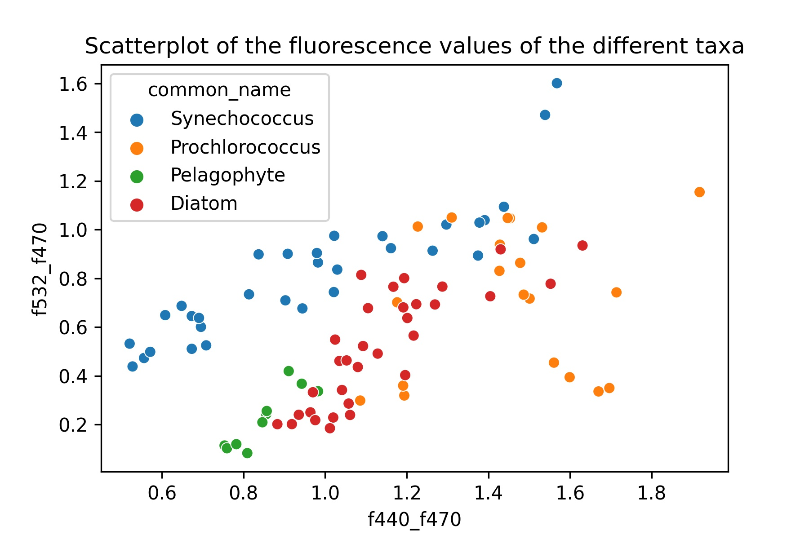
Figure 1 : Scatterplot of wavelength ratios
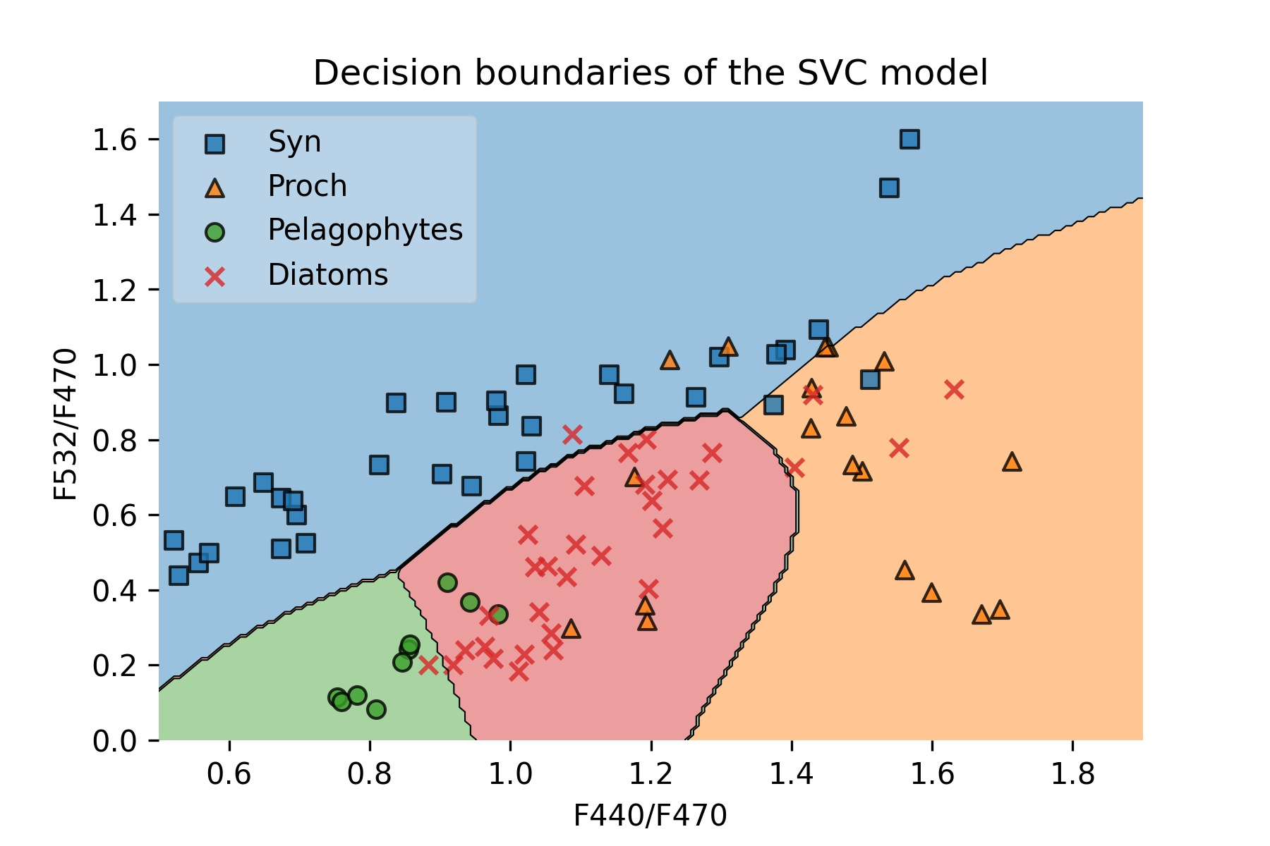
Figure 2 : Decision boundaries of the Support Vector Classifier with a Radial Basis Function kernel.
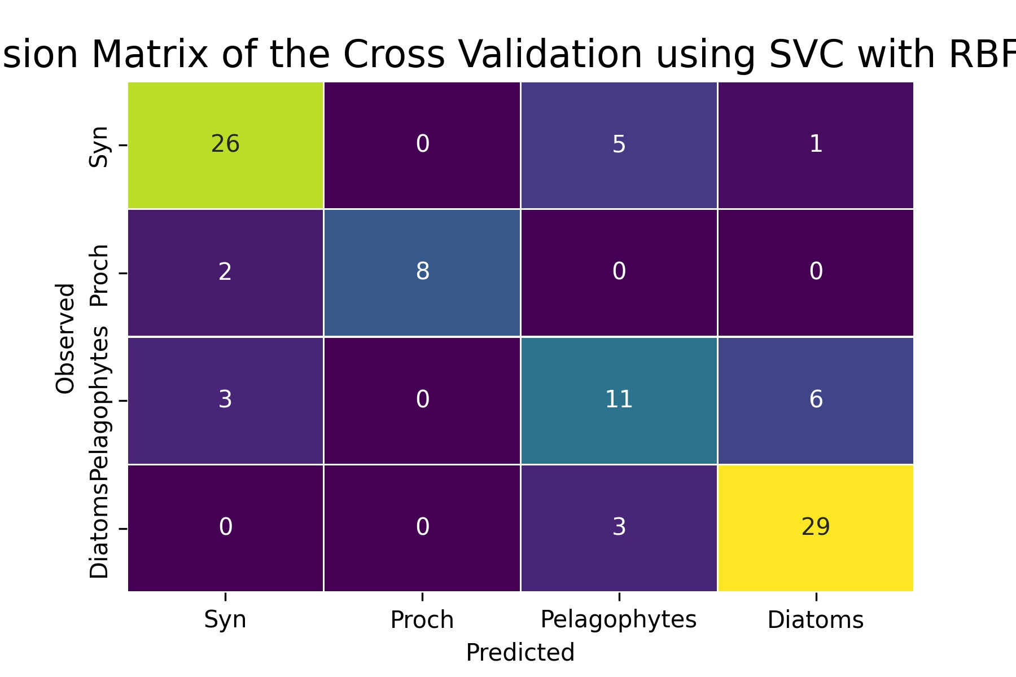
Figure 3 : Confusion matrix of the cross validation of the SVC model.

