|  |
| --- |
| Microsemi |
| Making SIP Calls on Raspberry |
|  |
|  |
| **Verma, Shally** |
| **3/4/2016** |

|  |
| --- |
|  |

# Purpose

This document is a simple covering step-by-step instruction on how to make sip calls to and from Pi with custom raspbian package which is preconfigured with SIP server and client user agent.

Contents

Purpose 1

Introduction 1

Making calls 2

Troubleshooting 3

Appendix 5

A) Setting up linphone on window PC 1 5

# Introduction

Raspbian custom image has preinstalled SIP server named “sipwitch” and a sip client “pjsua”.User just need to write it on SD card. Insert card into Pi and power on.

While server is preinstalled and runs a daemon as soon as Pi boots, sip client is run manually by executing simple script as this app is interactive in nature and need user input

The server currently is preconfigured with 4 user extensions 200 – 203. User can use any of these to register their sip softphone to sipwitch. Please refer to table below summarizing the details for each extension as will be needed by softphone for registration.

|  |  |  |  |
| --- | --- | --- | --- |
| User | Extension | Password | Remarks |
| pi | 200 | Raspberry | User “pi” is special case and used by sip client run on pi |
| phone1 | 201 | SecretSauce201 | User can use this extension to configure any other sip soft phone to register to sipwitch |
| phone2 | 202 | 202 | User can use this extension to configure any other sip soft phone to register to sipwitch |
| phone3 | 203 | 203 | User can use this extension to configure any other sip soft phone to register to sipwitch |

# Making calls

1. Boot pi, enter following login information:

raspberrypi login:pi

Password:raspberry

1. Check sipwitch is running using “sudo sipwitch registry”.

Example pi console snapshot when a softphone using extension 201 is registered to sipwitch. Else you will see output “found 1 entries active of 200”



1. look for /home/pi/run_pjsip.sh
2. run “source run_pjsua.sh”. By default, pjsua uses playback and capture device 0. See Troubleshooting” section for switching between soundcards.

Example snapshot of successful run when RPI ipaddr is 10.60.132.68 with snd_microsemi_dac as playback and capture device.

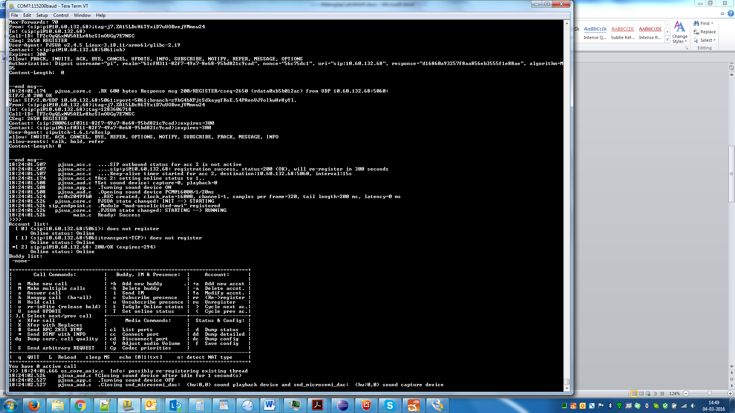

1. If not done already, setup another soft phone using any of the extension 201-203 (table above). For sip proxy server, use IPaddress of raspberry. To get RaspberryPi ip address, run command “ifconfig” on Pi console.

As an example, we took windows based linphone (http://www.linphone.org/). For Quick reference on setting it up, see Appendix A .

1. linphone->pjsua
   1. Dial 200
   2. Pjsua should respond with message “Press a to answer and h for hangup”
   3. Enter “a”
   4. It will ask for answer code
   5. To continue to talk, enter 200 and press enter
   6. Now your talk session is established
2. pjsua->linphone

To make a call from pi to linphone, 1st add linphone as buddy to pjusa

* 1. Enter +b option
  2. Enter uri [sip:phone1@<ip addr of windows machine running linphone>](sip:phone1@%3cip%20addr%20of%20windows%20machine%20running%20linphone%3e)
  3. Linphone may show message “user pi want to connect”
  4. Enter m option
  5. Phone1 will be shown “online” under buddy list, enter 1 to connect to
  6. Call is established

# Troubleshooting

Please update this section as you come across any issue not covered here.

Q. Is there any specific sip soft phone that I should use on windows

A. No. You can use any soft phone complying to standard SIP specification.Zopier and Phonerlite to name a few.

Q. how can I add more users to sipwitch

A. SIPwitch supports phone extensions from 201-299. If user want to add more users. Please do following on Raspberry:

1. Open /etc/sipwitch.conf using command “sudo nano /etc/sipwitch.conf”
2. goto <provision> and start adding lines under it.
   * 1. add following between <provision> and </provision> (make sure entries are outside <!-- and --> tags
     2. <user id=“string giving user a name”>. Note there should be no space around = sign
     3. <extension> integer value identifying extension of user</extension>
     4. <secret>password of the user </secret>
     5. Example, to add user with id “phone4” and extension 204 and password 204, entry in /etc/sipwitch.conf would be:

<provision>

<user id=“phone4”>

<extension>204</extension>

<secret>204</secret>

</user>

</provision>

* + 1. Save and close the file

1. Restart sipwitch service by giving
   1. sudo service sipwitch restart
2. you can run following commands to check if sipwitch successfully started:
   1. sudo sipwitch registry
   2. sudo sipwitch dump

Q. how do I know number of soundcard registered to the system

A. run “aplay –l”

Q. how can I select different soundcard for playback and capture for pjsua

A. Open run_pjsip.sh with command “sudo nano run_pjsip.sh. Look for PLAY_DEV and CAP_DEV variables and change value to as desired

Q. how do I check if pi as SPI client is registered successfully to sipwitch

A. user can have multiple checks here:

* check output of source run_pjsip.sh. Account list section should show SIP response code 200/ok as in snapshot here:

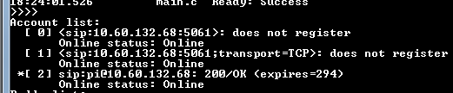

* run “sudo sipwitch registry”. However when pjsua run as a foreground app, then user will not see console prompt. In such case, user can open a telnet session to pi using program “putty” (http://www.putty.org/) and follow the instructions below.

Download and open putty and enter RPI ipaddr under hostname (as encircled) and do open

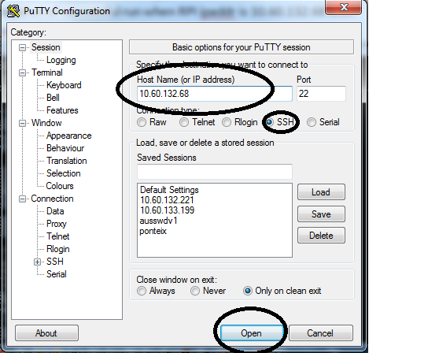

1. Enter following user info:

Login as: pi

password: raspberry

See, snapshot below after login and “sudo sipwitch registry”

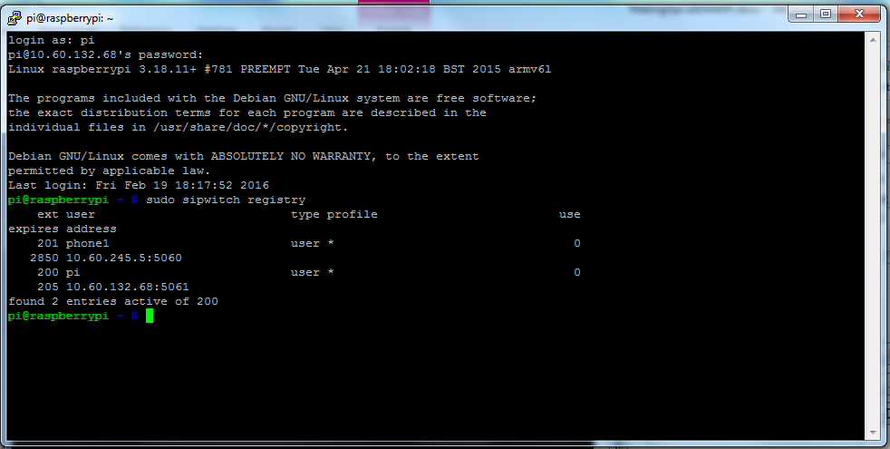

Q. I am unable to call Raspberry Pi from Linphone. Giving me message “forbidden”

A. If call from linphone is failing with this message, then run “sudo sipwitch dump” and check IP address value against “localnames”. If it doesn’t match to current ip address of raspberry pi on which sipwitch server is running, then modify sipwitch.conf to set “localnames” to current ip address of board.

Example snapshot of “sudo sipwitch dump”

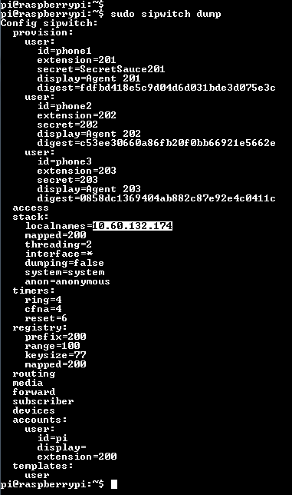

1. sudo nano /etc/sipwitch.conf

2. modify entry <localnames>ipaddress</localnames> , where ipaddress = ip address of raspberry pi running sipwitch server

Example snapshot where ipaddress of machine is 10.60.132.174

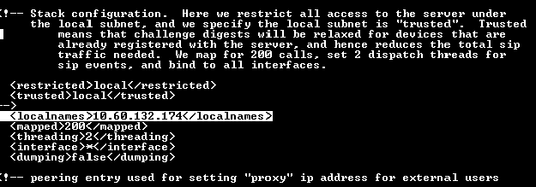

3. Restart sipwitch server. Run “sudo service sipwitch restart”. You should see message:



# Appendix

## Setting up linphone on window PC 1

In current example, we setup linphone as user “phone1” with extension 201.

As you install linphone on windows, add account information:

1. Go to *Options->Preferences->Manage SIP Accounts*->*wizard*

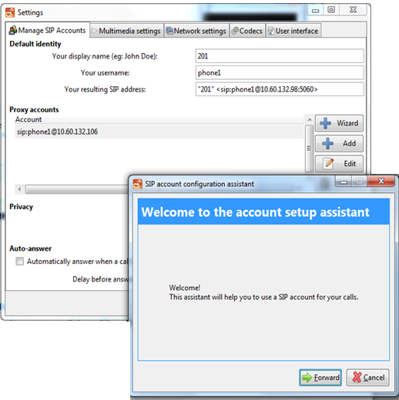

2) Since we already configured sipwitch server with user “phone1” information, we can select option *“I already have a sip account and I just want to use it”*

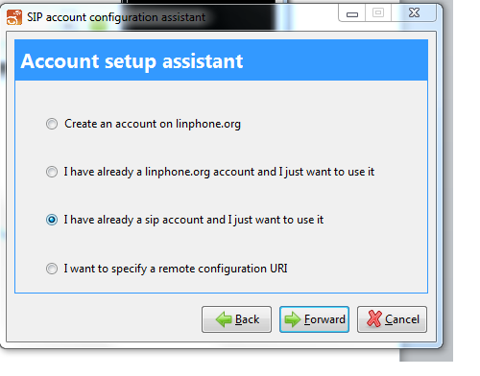

3) Select *forward* tab and to setup linphone as user “phone1”with *extension 201* to connect to sip server with *ipaddr 10.60.132.106.* Fill following and click *Apply*.

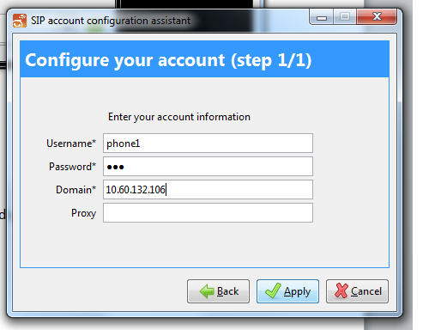

4) Successful registration to sip will show this status bar

