|  |
| --- |
| Microsemi |
| Setting Up Raspberry Pi as Kodi Media Centre |
|  |
|  |
| **Verma, Shally** |
| **11/24/2016** |

|  |
| --- |
|  |

Contents

Introduction 1

Purpose 1

Reference 1

Development Platform 1

Setting up Raspberry 1

Testing with Kodi 2

Testing record and playback on TW1 3

Testing 2 TW device at Raspberry SPI CS0 and CS1 3

Troubleshooting 4

# Introduction

Kodi (previously known as xbmc) is an open source Media Centre available for various Operating Systems. Kodi is available as stand-alone installer OR as dedicated Media Centre package like OpenElec, LibreElec.

# Purpose

This document is a step-by-step instruction on how to set up Kodi on Raspberry pi and how to use Voice Control Kodi Add-on to test Microsemi ASR on kodi using rpi3_kodi_24112016.img

# Reference

[1] <https://kodi.tv/>

# Development Platform

|  |  |
| --- | --- |
| Hardware | Raspberry Pi 3 Model B V1.2 |
| Raspbian Image | rpi3_kodi_24112016.img |

# Setting up Raspberry

1. This image is compatible and tested over Raspberry Pi 3 model.
2. Write Image to SD-Card. You may use Win32DiskImager or See instructions here <https://www.raspberrypi.org/documentation/installation/installing-images/README.md>
3. You must have HDMI, Mouse and Keyboard connected to Raspberry Pi(Or atleast an HDMI and a Mouse)
4. Boot Pi with new SD-card image
5. If required, enter following login information:

raspberrypi login:pi

Password: raspberry

1. Image is also setup for native compilation, it has preloaded ZLS38100_P2.0.0 package with built in libs inside ZLS38100_P2.0.0/RELEASE_ZLS38100_P2.0.0/libs
2. **Do not** alter this as Kodi add-on imports voice recognition module _sr.so from this location.
3. Alternate option is move _sr.so and _sr.pyc to standard /usr/lib or to path searched by python package for import modules

# Testing with Kodi

1. Before you start, make sure on these points:
   1. By default, our kodi voice command add-on (service.xbmc.voicecontrol.zip) reads voice commands from TW1 device. So, after boot up make sure TW1 has 067 in it
   2. If you wish to change Add-on to read from TW2, change ASR_DEVICE=2 in Kodi Add-on (detailed steps given in further section).
   3. Note Raspberry pi ip address. Kodi has issue it is we exited. Sometimes screen turn blank. In such case, we can use **putty** utility to do ssh login and run kodi from command shell.
   4. If you run into any issue, refer to **Troubleshooting** section for help
2. Run Kodi
   1. If you have Raspberry pi UART console or want to run through command shell. Open Terminal window and type in *Kodi*

A successful run should show you message on console as in snapshot (if 2 devices are used). If you run into error, check **Troubleshooting** section for help.

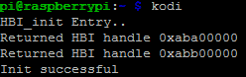

* 1. Else, Goto Raspberry Desktop Menu->Sound&Video->Kodi Media Centre and click on it.
  2. Go to System->Settings->Add-On->My add-ons-> Services->Voice Control.

You should see ‘Voice Control’ as ‘Enabled’.

1. Start testing with following command “Alexa” ,”Volume up”, “Volume Down”
2. Current Voice Control Add-on use TW1 as ASR device. If you wish to change, then go inside service.xbmc.voicecontrol directory in this image (available at svn as well) and change following in service.py

ASR_DEVICE = 2 /* to use TW2 */

ASR_DEVICE=1 /* to use TW1 */

1. If you want to do some modification to current add-on and re-install it
   1. First Uninstall Add-on
      1. Goto System->Settings->Add-On->My Add-on-> Services->Voice Control
      2. Click to enter it
      3. Click ‘Disable’ followed by ‘Uninstall’
      4. Make sure both devices are closed by checking /proc/hbi directory. It should not have dev_00 or dev_01 directory. If it is, then you can also close them using procfs command as mentioned below in Troubleshooting section
   2. If you wish to do some change in Add-on follow this step else skip to next
      1. Go to service.xbmc.voicecontrol directory in this image (you may also get same from svn repo or unzip existing service.xbmc.voicecontrol.zip)
      2. Do your modification
      3. Install zip utility on your local raspberry machine using

sudo apt-get update

sudo apt-get install zip

* + 1. Run zip command
    2. zip -r service.xbmc.voicecontrol.zip service.xbmc.voicecontrol/
  1. Re-installing Add-on
     1. Exit Kodi
     2. Run kodi again
     3. Goto System->Settings->Add-On->Install from zip file -> Home Folder.

Select service.xbmc.voicecontrol.zip

* + 1. You should see “voice control enabled” message on bottom right corner.
    2. It is installed. Now make sure it is enabled as well.

Goto System->Settings->My Add-on->Services->Voice Control

It should be showing as ‘Enabled’. If disabled, click on it to enter Add-on description and click ‘Enable’.

* 1. Now Go to home screen and test your commands.

# Testing 2 TW device at Raspberry SPI CS0 and CS1

1. Run following HBI procfs commands(Initialize, open, read):
   1. cat /proc/hbi/init_driver
   2. echo 0:0 > /proc/hbi/open_device /* bus num 0, chip select 0 */
   3. echo 0:1 > /proc/hbi/open_device /* bus num 0, chip select 1*/
   4. Read registers. Example read 10 bytes from 0x200 register from device 0

echo 200 10 > /proc/hbi/dev_00/read_reg

* 1. Close devices 0 and 1 and terminate driver

echo 0 > /proc/hbi/close_device

echo 1 > /proc/hbi/close_device

cat /proc/hbi/term_driver

Example Screenshot

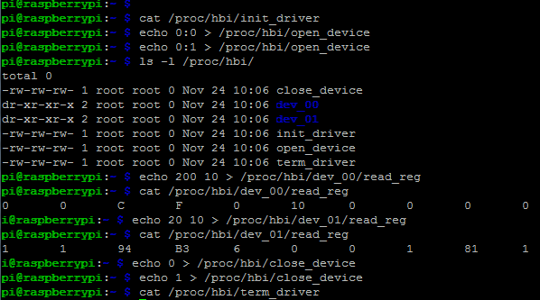

# Testing record and playback on TW1

* 1. Check Microsemi sound card is recognised by kernel. Run command

cat /proc/asound/cards

Should have snd-soc-microsemi-dac listed as one of the card. Here’s is example snapshot:

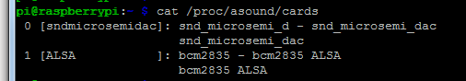

If TW1 device has firmware supporting 2-way communication, then you may do aplay and arecord example run.

Commands:

arecord -D "hw:0,0" -c 2 -r 16000 -f S16_LE -t wav test.wav

aplay -D "hw:0,0" test.wav

# Troubleshooting

Please update this section as you come across any issue not covered here.

Q. Blank Screen after kodi exited

1. It is raspberry pi kodi issue. You can use UART console Or run putty to login to pi and run ‘kodi’ from command line.

Q. Getting error “addon structure incorrect”

A. Either zip is created using windows zip utility OR add-on was enable and user disable ,uninstall and trying to re-install add-on.

If you have zipped your add-on using windows utility and copy it over to linux raspberry machine, then it may throw above error. Solution is install zip on your local machine(where kodi is installed) using ‘sudo apt-get install zip’ and then run ‘zip –r <output zip filename> <add-on source directory>

If you follow above process and still see issue , then read on..

Kodi has issues with reinstallation of zipped version of add-on. If you have an add-on installed and you did some modification, rezip it and uninstalled previous one so that new changes can be loaded. please exit kodi completely and restart a process of installing add-on from zip

Q. Voice Control Add-on shows “Enabled” still no action on Voice Command

A. Possible reasons:

How to check that ASR device is not opened:

1. cat .kodi/temp/kodi.log

if you see log error “err in sr.init()”, if yes then either device is in use by some other application OR owner permission are not set

1. check owner by running ‘ls –l /dev/hbi’ , it should be pi, pi
2. if owner is correct, run dmesg to check for error messages thrown by driver
   1. example, device already opened
   2. run cat /proc/hbi , if its has dev_xx directory that is someone is already using it. close that app Or close this device using proc commands like
      1. echo 0 > /proc/hbi/close_device
      2. cat /proc/hbi/term_device