**Expert system for city recommendation**

**Documentation**

**About this software**

This software is a tool meant for giving advice for a city to live in based on the user’s preferences. It was created for a school project at Politehnica University of Timisoara.

**Intended audience**

This software is intended to be used by any user that is looking for suggestions on which city to live in or travel to.

**System requirements**

Any pc with Java RunTime Enviroment(JRE) or Java SE 8 or better

Maven 3.3.1+

**Customization**

The project was meant to give suggestions on cities but it can be easily modified to add/remove cities or give suggestions on another topic.The program suggestions are based on the “database.xlsx” document.The first column is the suggestion and the second column are relevant descriptors of the proposal(for ex. Paris is described by:europe, warm_weather,culture,luxury,art ,parties,innovation,concerts).

Just modify the suggestions/descriptors as you wish and the program should add your suggestion to the “knowledege”.

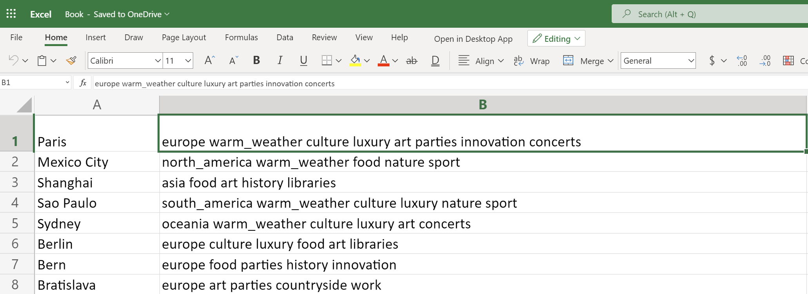**Download**

The project is available on github:

https://github.com/FlaviusAr/ExpertSystemCity

**User Guide**

Before running the program you need to modify the following line in SistemExpert.java with the path to the database.xlsx on your computer.(You can find the database.xlsx in the folder “data”)

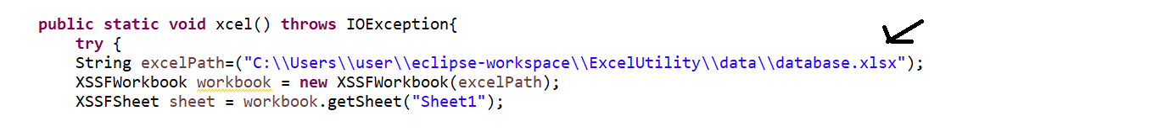After running the program you just have to answer simple yes or no based on your preference

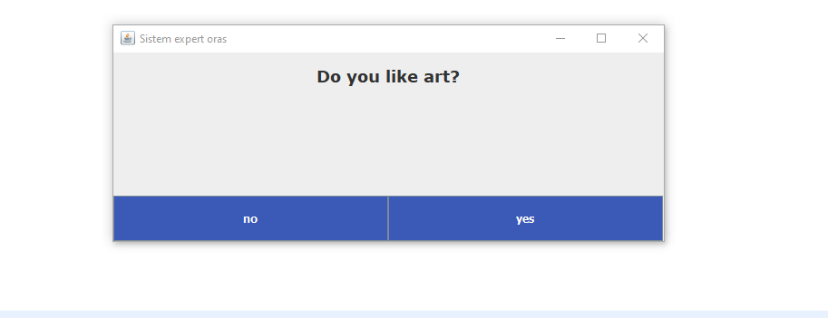

After choosing you will get a recommendation:

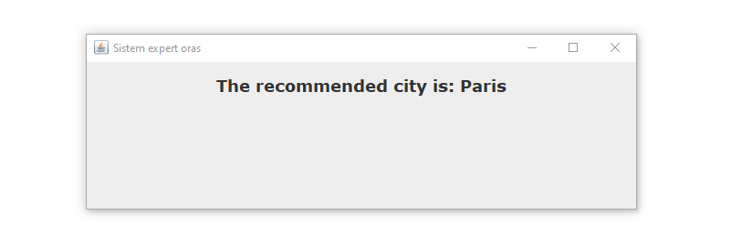

Or if a recommendation was not possible you will get this message:

