##### Abbreviations

|  |  |
| --- | --- |
| Variable | Abbreviation |
| Soil Plant Analysis Development | SPAD |
| Plant height | HGT |
| Relative water content | RWC |
| Leaf osmotic potential | LOP |
| Leaf dry weight | LDW |
| Stem dry weight | SDW |
| Root dry weight | RDW |
| Tuber dry weight | TDW |
| Tuber number | NTUB |
| Root length | RTL |
| Total transpiration | TRS |
| Leaf area | LFA |
| Total dry biomass | TDB |
| Harvest index | HI |
| Specif leaf area | SLA |
| Water use efficiency | WUE |
| Tuber water use efficiency | TWUE |

##### Tables 1

Table 1: Potato genotypes (*Solanum tuberosum* L.) used for water deficit experiment with two commercial varieties and 13 genotypes from advanced breeding population developed by the International Potato Center (CIP).

|  |  |  |  |  |  |
| --- | --- | --- | --- | --- | --- |
| Number | Genotypes | Adaptability | Growning period | Heat tolerance | Dry matter (%) |
| G01 | CIP720088 (Achirana-INTA) |  | Early |  | 19 |
| G02 | CIP392797.22 (UNICA) | Lowland and highland Tropics | Medium |  | 21 |
| G03 | CIP397077.16 | Lowland tropics | Medium |  | 20 |
| G04 | CIP398192.213 | Mid elevation tropics | Medium | Tolerant | 22 |
| G05 | CIP398180.612 |  | Medium |  |  |
| G06 | CIP398208.704 | Mid elevation tropics | Medium | Tolerant | 24 |
| G07 | CIP398098.119 | Mid elevation tropics | Medium | Tolerant | 26 |
| G08 | CIP398190.89 | Mid elevation tropics | Medium | Tolerant | 21 |
| G09 | CIP398192.592 | Mid elevation tropics | Medium | Tolerant | 21 |
| G10 | CIP398201.510 | Mid elevation tropics | Medium | Tolerant | 20 |
| G11 | CIP398203.244 | Mid elevation tropics | Medium | Tolerant | 20 |
| G12 | CIP398203.5 | Mid elevation tropics | Medium | Tolerant | 13 |
| G13 | CIP398208.219 | Mid elevation tropics | Medium | Tolerant | 22 |
| G14 | CIP398208.33 | Mid elevation tropics | Medium | Tolerant | 21 |
| G15 | CIP398208.620 | Mid elevation tropics | Medium | Tolerant | 21 |

##### Tables 2

Table 2: Treatment comparison for seventeen variables between Well-Watered (WW) and Water Deficit (WD) in 15 potato genotypes. The values are represented by the mean ± standard deviation with the significance under t-test with their respective p-values.

|  |  |  |  |
| --- | --- | --- | --- |
| Variable | Water deficit | Well-Watered | p-value |
| Chlorophyll concentration (SPAD) at 29 dap | 56.1 ± 4.9 | 56.7 ± 5.0 | 0.4 |
| Chlorophyll concentration (SPAD) at 59 dap | 47.9 ± 4.4 | 45.8 ± 3.7 | 0.002 |
| Chlorophyll concentration (SPAD) at 76 dap | 46.0 ± 5.4 | 41.7 ± 3.6 | <0.001 |
| Chlorophyll concentration (SPAD) at 83 dap | 44.1 ± 5.9 | 39.7 ± 4.5 | <0.001 |
| Plant height (cm) | 132 ± 15 | 150 ± 16 | <0.001 |
| Relative water content (%) | 58 ± 6 | 69 ± 5 | <0.001 |
| Leaf osmotic potential (MPa) | -2.84 ± 0.30 | -2.25 ± 0.29 | <0.001 |
| Leaf dry weight (g) | 12.0 ± 3.7 | 17.3 ± 5.5 | <0.001 |
| Stem dry weight (g) | 11.6 ± 9.1 | 14.5 ± 6.1 | <0.001 |
| Root dry weight (g) | 3.67 ± 1.94 | 3.50 ± 1.96 | 0.6 |
| Tuber dry weight (g) | 24 ± 11 | 40 ± 19 | <0.001 |
| Tuber number (N°) | 12.0 ± 6.2 | 12.0 ± 4.9 | 0.8 |
| Total transpiration (mL) | 4.52 ± 1.22 | 7.85 ± 2.20 | <0.001 |
| Leaf area (cm2) | 2,488 ± 797 | 7,100 ± 2,380 | <0.001 |
| Root length (cm) | 33.1 ± 6.5 | 32.5 ± 5.8 | 0.4 |
| Total dry biomass (g) | 51 ± 16 | 75 ± 24 | <0.001 |
| Harvest index (HI) | 0.47 ± 0.16 | 0.53 ± 0.14 | 0.020 |
| Specific leaf area (cm2g-1) | 218 ± 62 | 415 ± 82 | <0.001 |
| Relative chlorophyll content (RCC) | 0.021 ± 0.015 | 0.008 ± 0.007 | <0.001 |
| Biomass water use efficiency (gL-1) | 11.32 ± 2.15 | 9.53 ± 1.26 | <0.001 |
| Tuber water use efficiency (gL-1) | 5.31 ± 2.03 | 5.09 ± 1.75 | 0.5 |

##### Figure 1

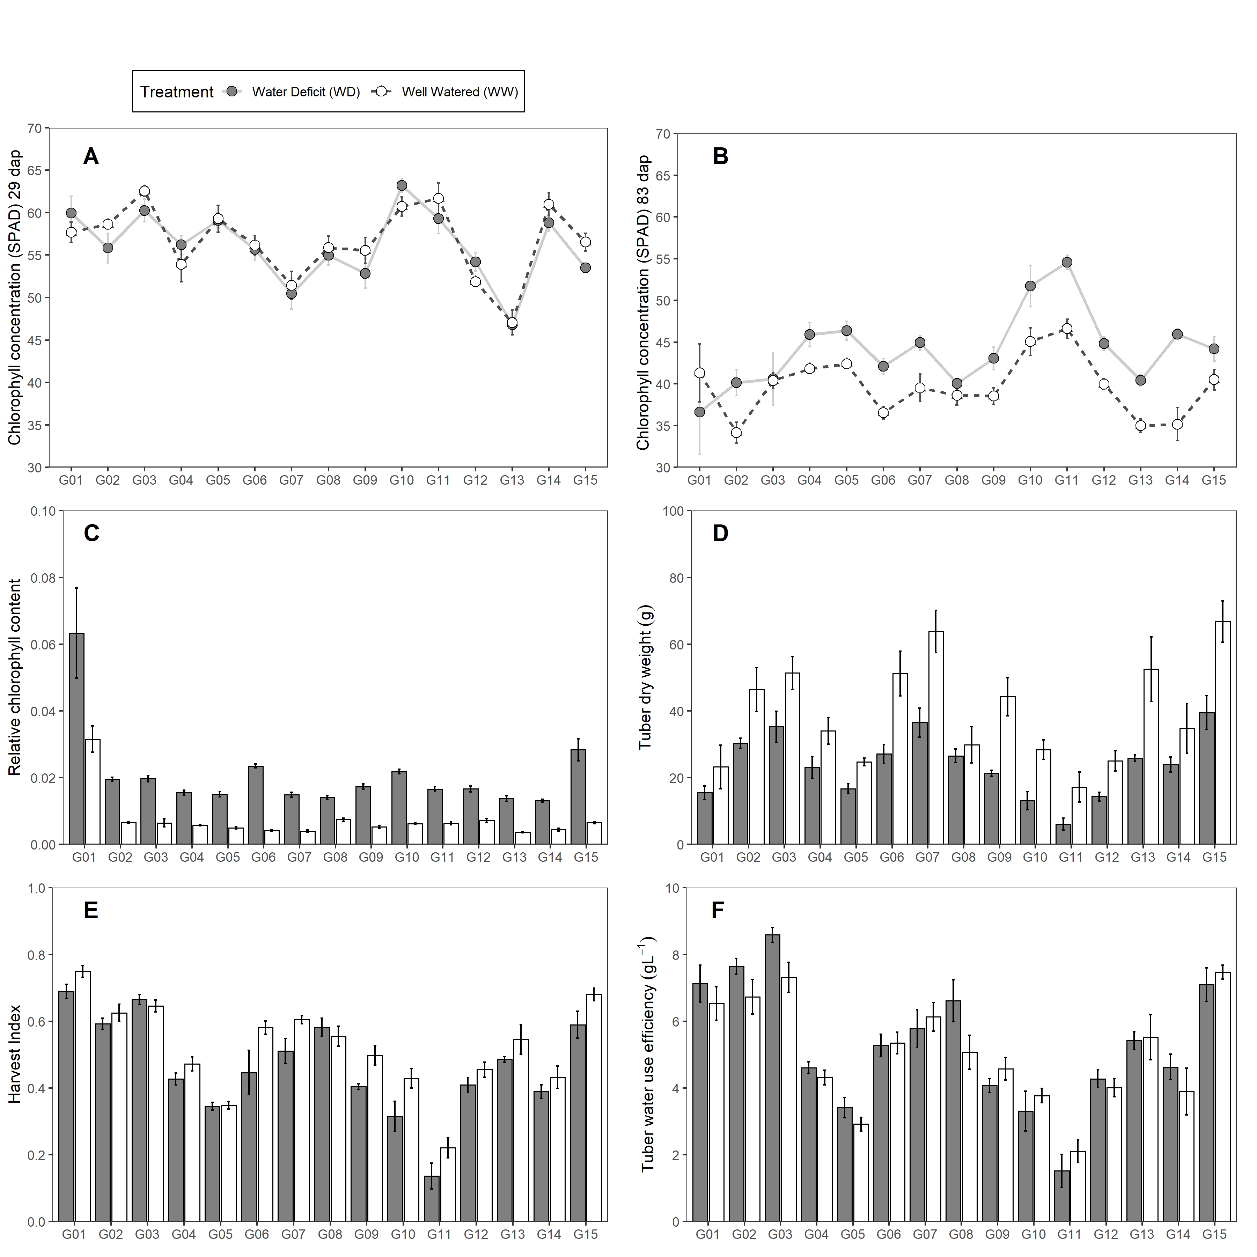

Figure 1: Traits measured in 15 potato genotypes under well-watered (WW) and water deficit (WD) condition. (A-B) Chlorophyll concentration. (C) Tuber dry weight. (D) Relative chlorophyll content. (E) Harvest Index. (F) Tuber Water Use Efficiency. Error bars indicate standard error (n = 5). Days after planting (dap).

##### Figure 2

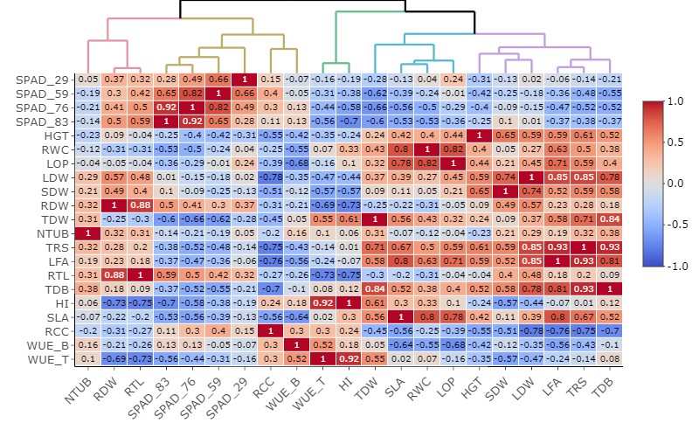

Figure 2: Relationships among agro-morphological traits evaluated in well-watered (WW) and water deficit (WD) condition based on Pearson correlation and Euclidean distance measured in 15 potato genotypes. Where: Chlorophyll Concentration (SPAD), Plant height (HGT; cm), Relative water content (RWC; %), Leaf osmotic potential (LOP; MPa), Leaf dry weight (LDW; g), Stem dry weight (SDW; g), Root dry weight (RDW; g), Tuber dry weight (TDW; g), Tuber number (NTUB; N°), Total transpiration (TRS; mL), Leaf area (LFA; cm2), Root length (RTL; cm), Total dry biomass (TDB; g), Harvest index (HI), Specific leaf area (SLA; cm2g-1), Relative chlorophyll content (RCC), Biomass water use efficiency (WUEB; gL-1), Tuber water use efficiency (WUET; gL-1).

##### Figure 3

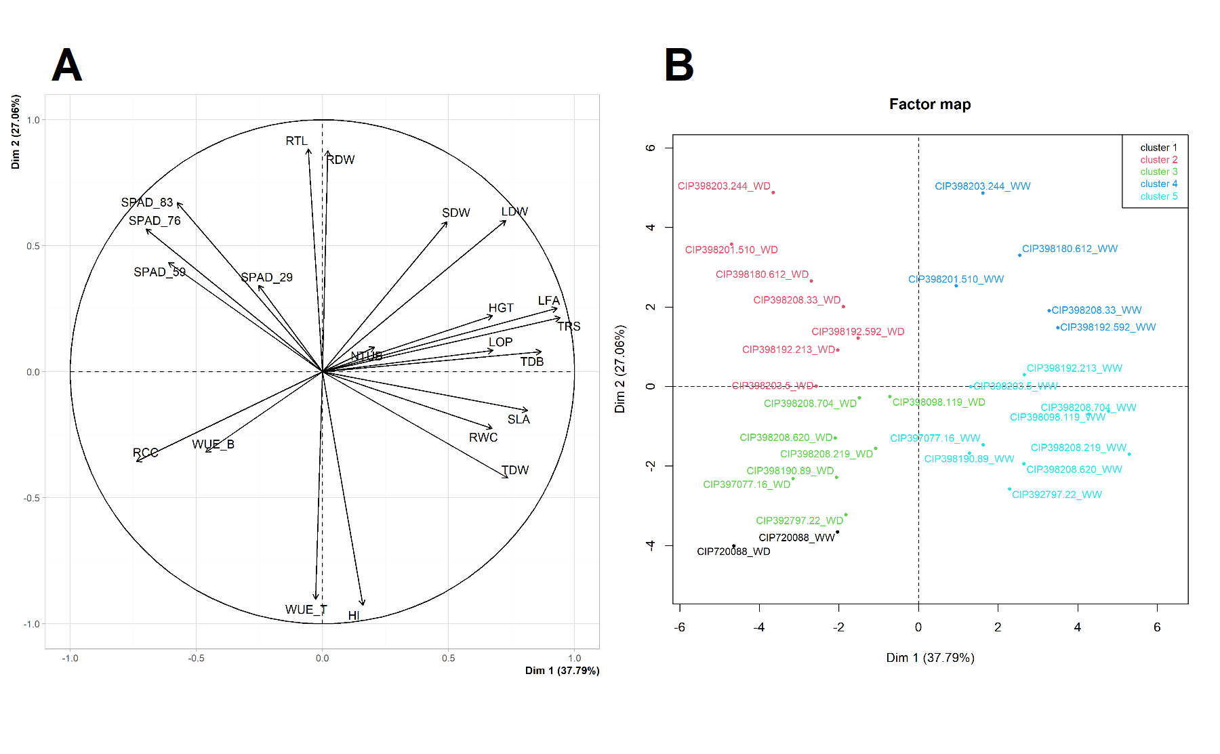

Figure 3: Principal Component Analysis (PCA) from variables measured in 15 potato genotypes under well-watered (WW) and water deficit (WD) condition. (A) PCA for the variables. (B) PCA for the genotypes under WW and WD. Where: Chlorophyll Concentration (SPAD), Plant height (HGT; cm), Relative water content (RWC; %), Leaf osmotic potential (LOP; MPa), Leaf dry weight (LDW; g), Stem dry weight (SDW; g), Root dry weight (RDW; g), Tuber dry weight (TDW; g), Tuber number (NTUB; N°), Total transpiration (TRS; mL), Leaf area (LFA; cm2), Root length (RTL; cm), Total dry biomass (TDB; g), Harvest index (HI), Specific leaf area (SLA; cm2g-1), Relative chlorophyll content (RCC), Biomass water use efficiency (WUEB; gL-1), Tuber water use efficiency (WUET; gL-1).

##### Tables S1

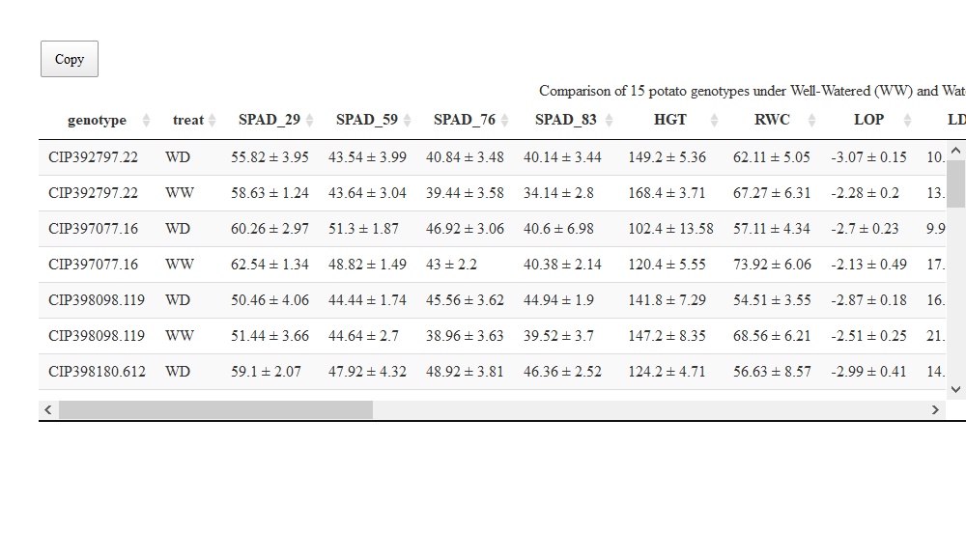

##### Tables S2

Table 3: Broad sense heritability in 15 potatos genotypes. Genetic variance (V.g), Error variance (V.e), Cullis (h2.c) and Piepho (h2.p) heritability

|  |  |  |  |  |  |
| --- | --- | --- | --- | --- | --- |
| Variable | mean ± std | V.g | V.e | h2.c | h2.p |
| Chlorophyll concentration (SPAD) at 29 dap | 56.36 ± 4.14 | 16.20 | 9.19 | 0.95 | 0.95 |
| Chlorophyll concentration (SPAD) at 59 dap | 46.84 ± 3.32 | 10.40 | 6.00 | 0.94 | 0.94 |
| Chlorophyll concentration (SPAD) at 76 dap | 43.88 ± 3.6 | 11.43 | 15.04 | 0.88 | 0.88 |
| Chlorophyll concentration (SPAD) at 83 dap | 42.02 ± 3.66 | 11.57 | 17.60 | 0.87 | 0.86 |
| Plant height (cm) | 141.19 ± 13.62 | 169.19 | 163.20 | 0.91 | 0.91 |
| Relative water content (%) | 63.46 ± 2.73 | 1.19 | 62.53 | 0.16 | 0.16 |
| Leaf dry weight (g) | 14.62 ± 4.17 | 16.00 | 14.12 | 0.92 | 0.92 |
| Stem dry weight (g) | 12.6 ± 4.75 | 19.96 | 9.41 | 0.95 | 0.95 |
| Root dry weight (g) | 3.54 ± 1.76 | 3.02 | 0.63 | 0.98 | 0.98 |
| Tuber dry weight (g) | 31.66 ± 12.18 | 131.65 | 168.57 | 0.87 | 0.88 |
| Tuber number (N°) | 12.04 ± 3.43 | 9.55 | 21.90 | 0.80 | 0.81 |
| Total transpiration (mL) | 6.18 ± 1.39 | 1.49 | 4.53 | 0.77 | 0.77 |
| Leaf area (cm2) | 4938.49 ± 1467.31 | 1431807.63 | 7188488.76 | 0.63 | 0.63 |
| Root length (cm) | 32.85 ± 4.72 | 20.57 | 16.60 | 0.91 | 0.92 |
| Total dry biomass (g) | 62.74 ± 15.58 | 209.08 | 341.65 | 0.85 | 0.86 |
| Harvest index (HI) | 0.5 ± 0.14 | 0.02 | 0.00 | 0.97 | 0.98 |
| Specific leaf area (cm2g-1) | 319.39 ± 43.38 | 115.92 | 14981.60 | 0.06 | 0.06 |
| Relative chlorophyll content (RCC) | 0.01 ± 0.01 | 0.00 | 0.00 | 0.89 | 0.89 |
| Biomass water use efficiency (gL-1) | 10.35 ± 0.92 | 0.64 | 1.54 | 0.79 | 0.82 |
| Tuber water use efficiency (gL-1) | 5.19 ± 1.7 | 2.83 | 0.73 | 0.96 | 0.97 |

##### Figure S1

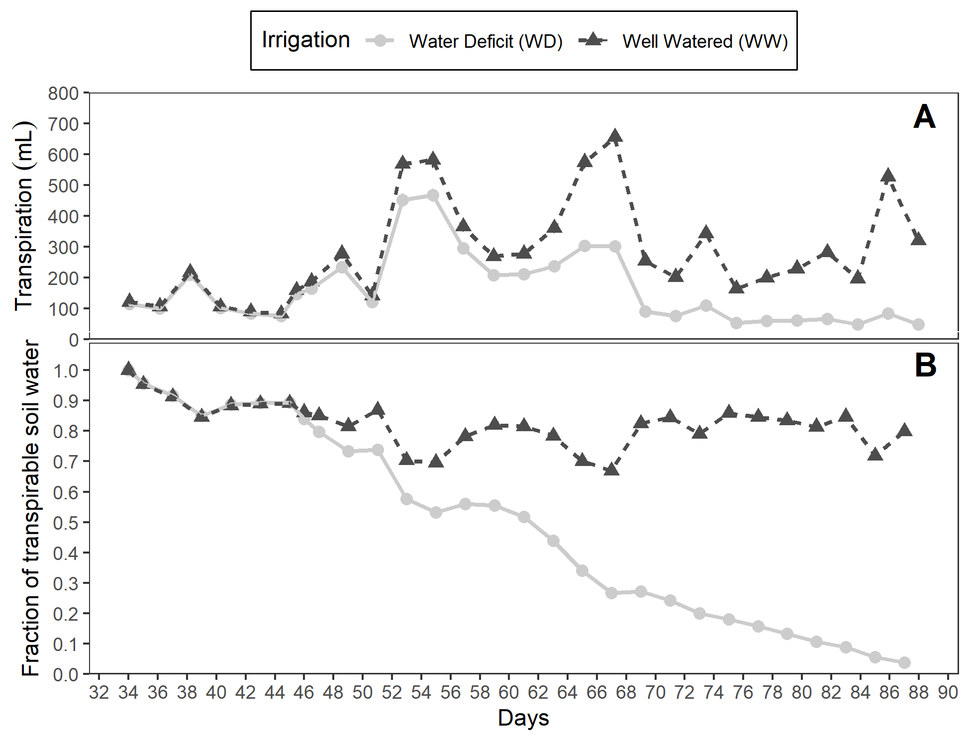

Figure 4: (A) Fraction of transpirable soil water (FTSW). (B) Daily transpiration in 15 potato genotypes under well-watered (WW) and water deficit (WD) condition.

##### Figure S2

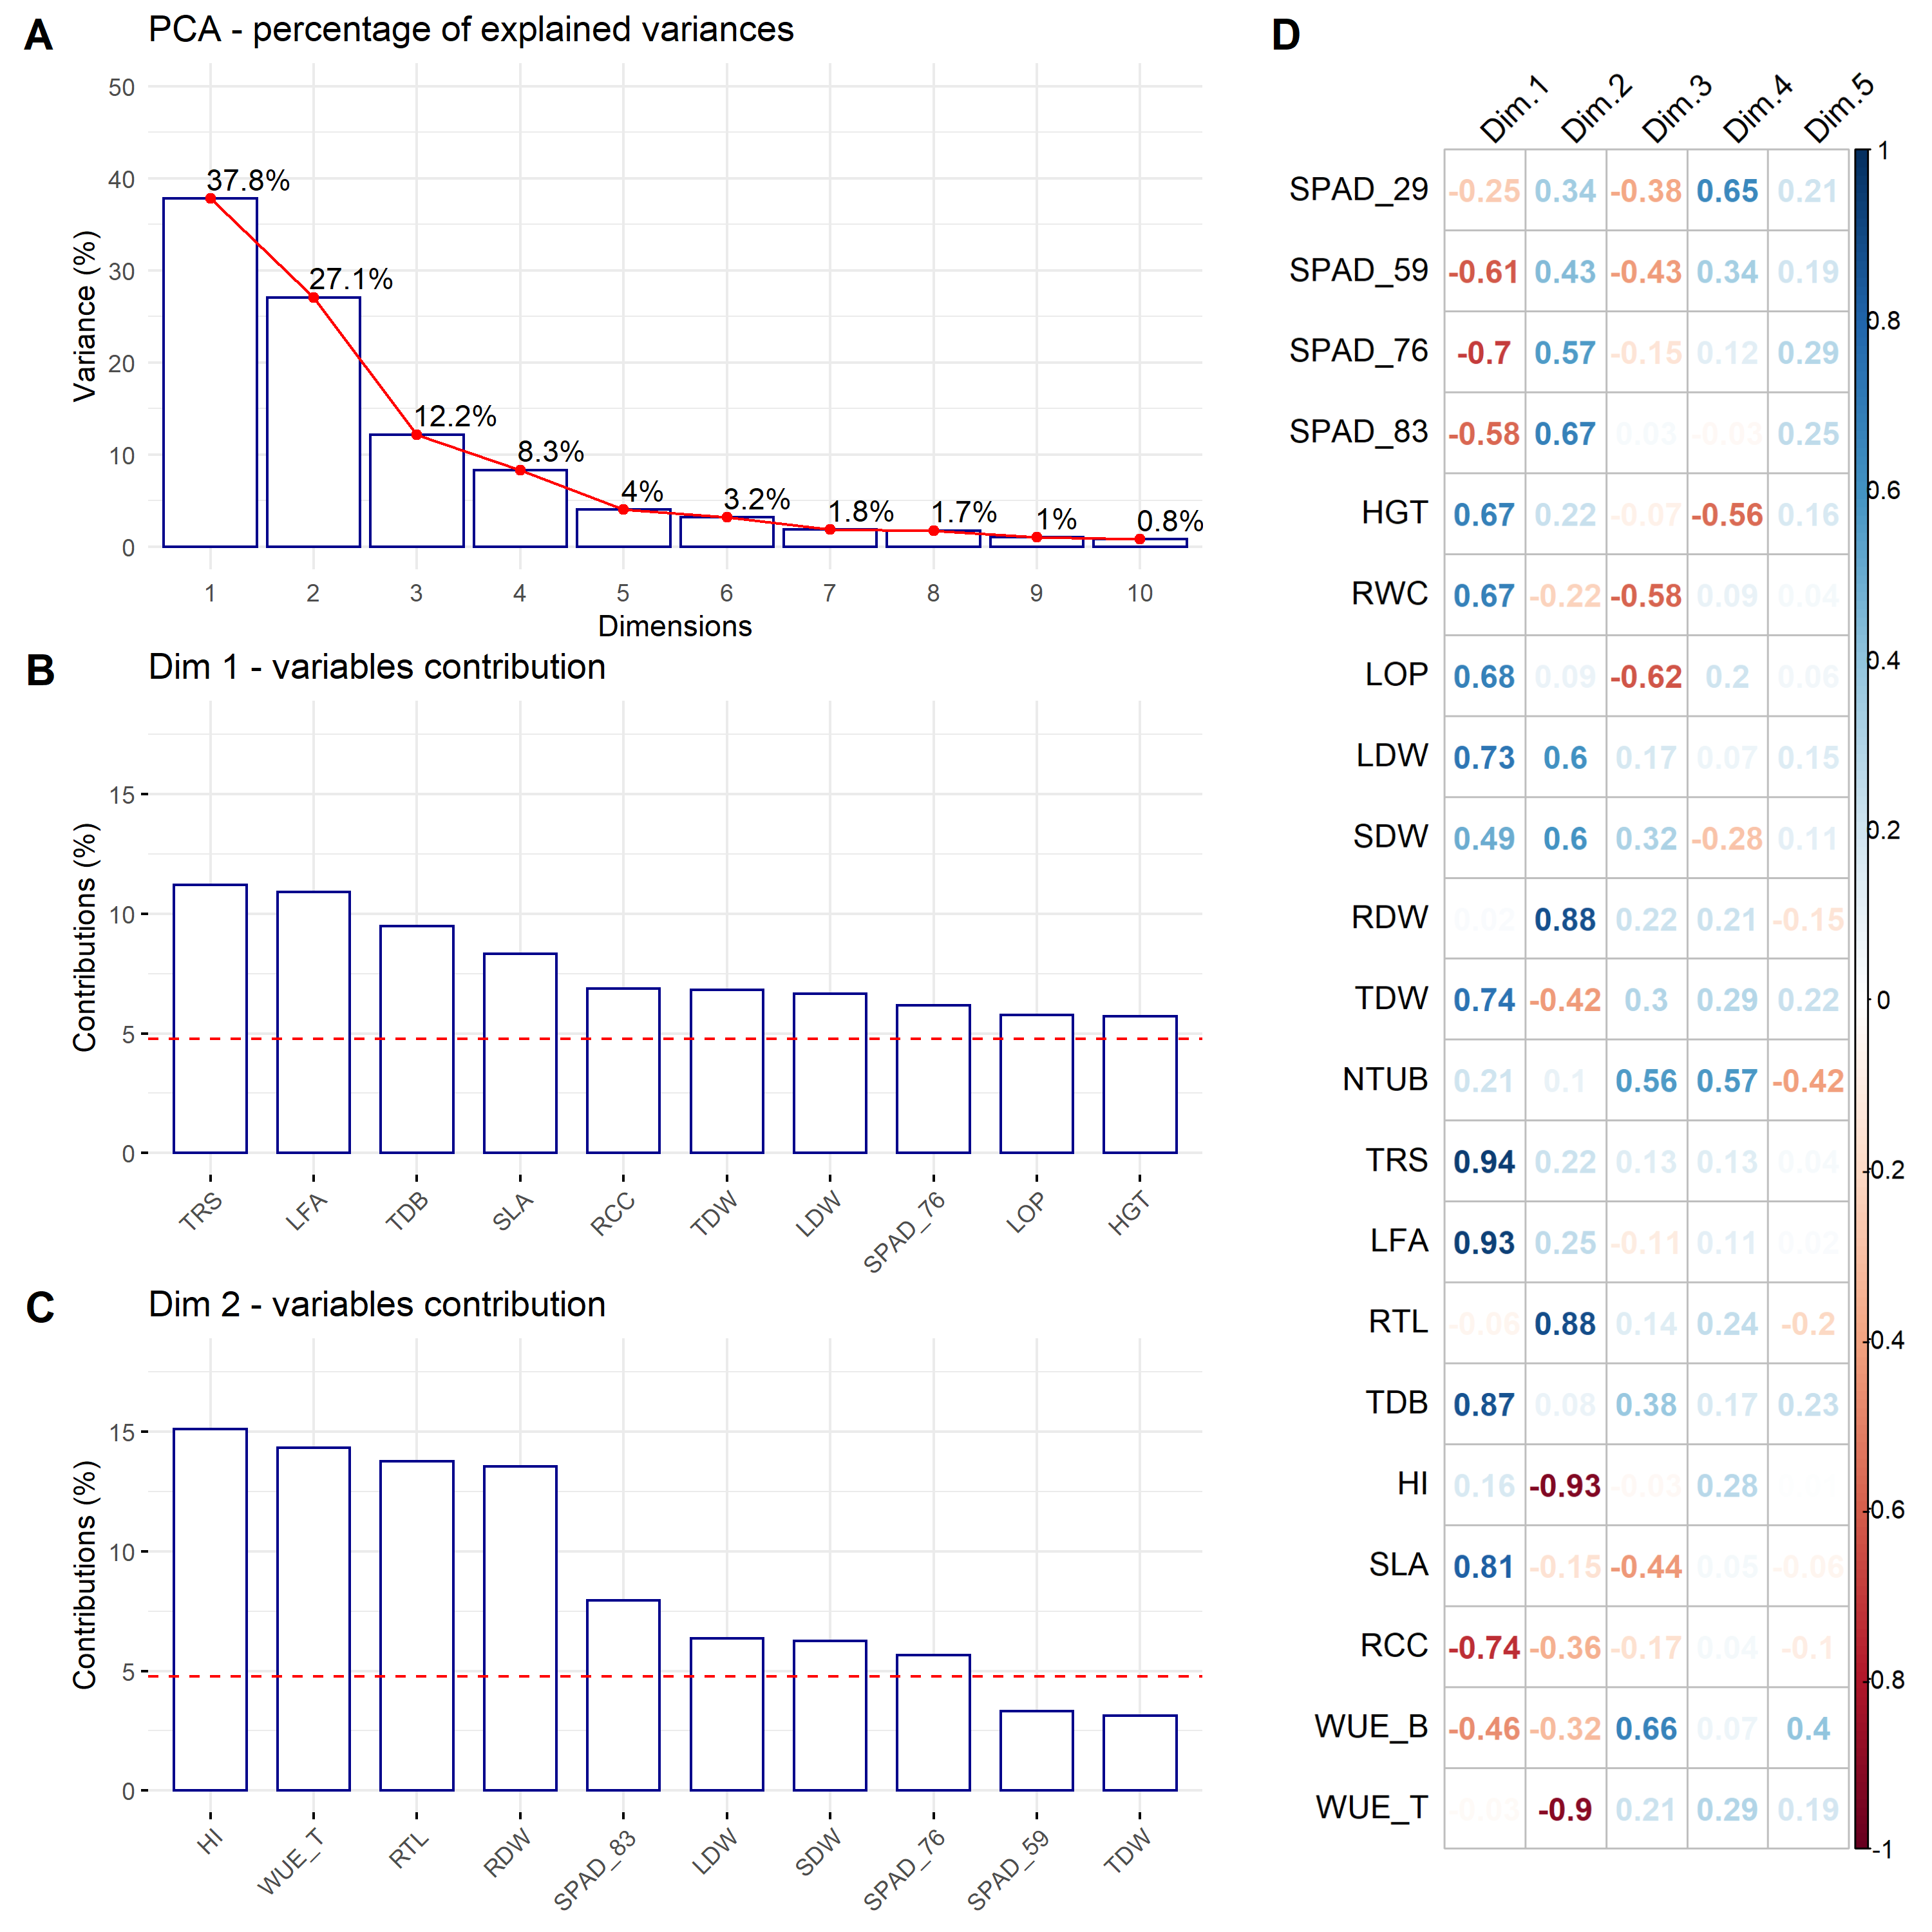

Figure 5: Principal Component Analysis (PCA). (A) Percentage of the explained variance for each dimension. (B) Variance contribution of the first 10 variables in the dimension 1. (C) Variance contribution of the first 10 variables in the dimension 2. (D) Correlation between the studied variables and among the first 5 dimensions. The reference dashed lines on the bar plot corresponds to the expected value if the contribution between the variables where uniform.

##### Figure S3

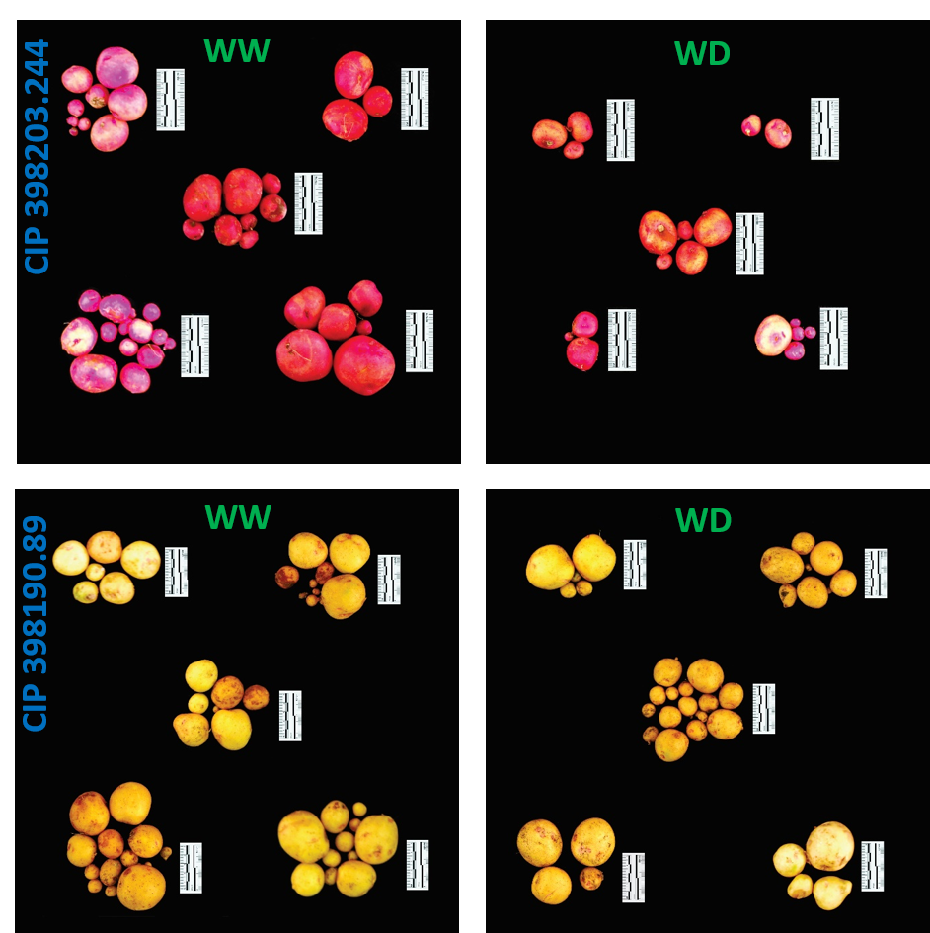

Figure 6: Tuber yield performance from two contrasting potato genotype. Genotype CIP 398203.244 with good performance under well-watered (WW) with reduced yields during water deficit (WD) condition. Genotype CIP 398190.89 with good response under well-watered (WW) and water deficit (WD) treatment. Each group represent one replication (n = 5). Pictures were taken using the 5 cm scale (black/white segment = 1 cm) displayed alongside the tubers.