Impact of water deficit on growth, productivity, and water use and transpiration efficiency in potato (*Solanum tuberosum* L.)

Lozano-Isla, Flavioa; Gutierrez, Raymundoa; Farfan-Vignolo, Evelyna; Blas, Raulb

2018-06-09

# Affiliation

1. International Potato Center (CIP), Av. La Molina 1895, La Molina, Lima 12, Peru
2. Universidad Nacional Agraria La Molina (UNALM), Av. La Molina, Lima 12, Peru

* Corresponding author. E-mail address: [flavjack@gmail.com](mailto:flavjack@gmail.com) (F. Lozano-Isla). Tel.: +55 81 2126 8352; fax: +55 81 2126 7803

# Abstract

Drought stress is a serious constraint affecting yields of almost all crops worldwide. The problem is only expected to get worse with water deficits stemming from climate change and population expansion. In this study, we aim to: find traits that can help the plants tolerate water deficit (WD) without the resultant yield penalties, understand the mechanisms of tolerance, and provide useful information for the selection of tolerance in breeding programs. In order to explore the different responses of potato under drought, we have evaluated fifteen genotypes under well watered and WD conditions for a range of agro-morphological and physiological traits. Critically, tolerant genotypes such as CIP397077.16, CIP398190.89, and UNICA were able to preferentially put limited water toward tuber production rather than biomass. We also found a lower specific leaf area (SLA) under WD, and that potato genotypes with the ability to maintain high SPAD and low SLA under WD can also maintain high WUE.

**Key words:** water use efficiency; water deficit; abiotic stress; harvest index

# Introduction

Water has become a scarce and precious resource and its efficient utilization in the production of food is a key challenge in agriculture worldwide. Yield losses due to water deficit are one of the global problems limiting production. Tracking the consequences of water deficit in plants is a difficult task, as it depends on the timing, intensity, type of crop, and duration of stress (Blum, 2011). Besides this, abiotic stresses never come alone but are coupled in nature with other location-specific environmental stress factors, such as high irradiance and temperature, which makes describing the effect of one single stress in the field nearly impossible.

Peru is the center of potato origin, where native varieties grown are easily accessible for use in breeding for desirable drought tolerance traits. Potato is an important non-grain food crop and is a key component of world food security. Potato is known to be sensitive to water deficit because of its shallow root system, and its fast-closing leaf stomata that reduce transpiration and photosynthesis, considerably reducing tuber yields (Deblonde and Ledent, 2001). Nevertheless, potato has a high harvest index in comparison with cereals and relatively low demand for water.

Tuber initiation is the most critical period of a potato’s life span in terms of water due to its high demand of around 400 to 600 L for 1kg of tuber dry matter (Stark et al., 2013). Thus, an effective water-saving method is highly desirable trait for potato in semi-arid areas. To increase yield per unit of water, crop demand for water should be reduced or be used efficiently. Plants need to be bred for water use efficiency (WUE) by capturing traits that help the plants develop faster, flower earlier, have a lower leaf area index, and be more efficient in capturing radiation (Blum, 2005; Hochman et al., 2009). In addition to the morphological changes, water use can be improved by maintaining low stomatal conductance (gs) during vegetative stages. This simple change is extremely beneficial, as the higher transpiration efficiency (TE) helps to postpone water use to late growing stages and alters the relationship between the dry matter produced and the quantity of soil water consumed (Carli et al., 2014; Condon et al., 2004). The management of water has a marked influence on plant behavior, tuber production, and quality. An important component of adaptation to WUE, the efficiency of the amount of water applied and used for transpiration that goes toward dry matter production. Enhanced WUE can reduce crop water requirements and increase crop yield significantly (Tolk and Howell, 2009). In this way, when a higher WUE under drought is maintained, the effects of water deficit are reduced and the competitiveness for water in drought conditions enhanced (Ogaya and Peñuelas, 2003).

The WUE was found to be greater in the summer due to the greater harvest index (HI) and more-efficient interception of solar radiation per unit of applied water by drought-exposed than by well-watered plots (Trebejo and Midmore, 1990). In normal conditions when irrigation is sufficient to meet the transpiration needs of the crop, genotypes with higher stomatal conductance and low WUE, able to extract more water from the soil, will have higher yield. In contrast, when water is not sufficient, the low WUE arising from a high rate of transpiration leads to low yields in favor of dry matter partitioning to reproductive organs (Tuberosa, 2012).

This study emphasizes the potential penalties in yield of thirteen advanced potato clones and two commercial varieties that are likely to arise in water-limited conditions, and explores the interrelationship between traits that help plants to mitigate yield losses under water-limited conditions. Chlorophyll content (SPAD), relative water content, osmotic potential, specific leaf area (SLA), transpiration efficiency, root length, stolon mass and tolerance to decrease water supply (TDWS), among other traits, were evaluated to identify convenient indicators of plant water status that helps in the selection of clones with high tolerance to water deficit.

# Materials and Methods

## Plant material and experimental design

Thirteen potato clones were selected from advanced breeding population collection at International Potato Center (CIP) and two commercial varieties were grown in an environmentally controlled greenhouse at CIP (La Molina Experimental Station) at 28/15°C day/night with 70±5% average relative humidity.

The experiment was carried out in complete randomize block design where the first factor was the two irrigation treatments: well-watered (WW), treatment where the moisture was maintained at field capacit and water deficit (WD), treatment where the water requirements of each genotype measured at WW treatment until wilting point was reduced 10% inter-daily measurement and the second factor were compound by the fifteen potato genotypes, Table (1). The water decifit treatment were appliyed since 45 DAP and prior to the treatment initiation, the pots from both WW and WD treatments were watered to soaking and then allowed to drain overnight. Next day, the pots were sealed in a plastic bag secured with a twist tie to prevent water loss except by transpiration and all the pots were weighed and it was defined as the initial pot weight.

Each experimental unit was composed for one tuber per pot (5 L) and It was sown containing two kg of dry commercial Sogemix SM2 (75% Peat Moss, perlite, vermiculite, and limestone). Fertilization was done twice with ammonium nitrate; triple superphosphate and potassium sulphate, one before planting (mix with the substrate) and the other applied at the surface at 40 DAP (days after planting).

## Trait evaluation

### Transpiration and water use efficiency

Transpiration was calculated by weighing the pots every two days in the between 13:00 and 15:00 hours (GMT -05:00). The transpiration (TRS) of each plant was calculated by the procedure previously described by Bhatnagar-Mathur et al. (2007) and (Ray and Sinclair, 1998). The inter-daily transpiration rates of WD plants were normalized against WW plant rates to reduce the influence of day-to-day variation ($TRS=\left(\frac{WD_{transpiration}}{WW_{transpiration average}}\right)$). The normalization was achieved by dividing transpiration of each individual plant in the WD regime by the mean transpiration of the WW plants. For compare the TRS between plants, a second normalization was done so that the normalized transpiration rate (NTR) of each plant was defined in 1.0 when the soil water content in each pot was at field capacity (Sinclair and Ludlow, 1986). The available soil water or the fraction of transpirable soil water (FTSW), for each pot was calculated by dividing the pot weight minus the final pot weight by the transpirable soil water of that pot ($FTSW=\left(\frac{pot weight_{inter−daily}−pot weight_{final}}{pot weight_{initial}−pot weight_{final}}\right)$).

The WUE in WD and WW plants was estimated from the total biomass and as weighted average for each of the plant components. WUE for the total biomass was calculated as the total biomass in dry weight produced during the treatment apply divided by the cumulative water transpired during the same period (Dalla Costa et al., 1997).

### Water components

The relative water conten (RWC) was determined by weighing the third leaflet (FW) from the third leaf from the apical part from the youngest fully expanded leaf of each plant. Each leaflet were placing in a 4x3 inch ziploc bag containing distilled water for 24 hours and after these time it was removed to taking turgid weight (TW) afterwards it was dried in an oven at 90 ºC for 24 hours and weighed (DW). The RWC was calculated according to Vasquez-Robinet et al. (2008) by the formula $RWC\left(\%\right)=\left(\frac{leaflet_{FW}−leaflet_{DW}}{leaflet_{TW}−leaflet_{DW}}\right)⋅100$.

Leaf osmotic potential (LOP) was determined using a dew point microvoltmeter (HR-33T Wescor Inc., Logan, UT, USA) with leaf discs of 5 mm diameter, taken from the third fully extended leaf. The leaf discs were put in 1 ml cryogenic tubes and frozen in liquid nitrogen for further analysis. The frozen leaves were incubated at 22°C for 30 min in a sealed C-52 chamber (Wescor Inc., Logan, UT, USA). The total osmotic adjustment (TOA) was defined as the difference in LOP between the WW and the WD plants (Hessini et al., 2009).

## Chlorophyll content (SPAD)

The chlorophyll content of the plant was evaluated by taking SPAD measurements using a SPAD-502 chlorophyll meter (Konica Minolta Sensing, Inc., Osaka, Japan) from the third youngest fully expanded leaf from three points (upper, middle and lower leaflet of a leaf). Individual readings of leaflets were averaged to represent individual measurement of a leaf. The evaluations were done on light adapted leaves at 29, 59, 76, and 83 DAP.

## Post-harvest traits and indices

The harvest was at 90 DAP. The plants were separated in four components: leaves, stems, roots and tubers. The dry weight (g) components were determined by drying them at 80°C for 3 days in a forced air oven: leaf (LDW), stem (SDW), root (RWD), tuber (TDW). The leaf area (LFA) of the plants was measured in cm2 by taking photographs of all the leaves arranged on a wooden board and analyzing the pictures using SisCob v1.0 (EMBRAPA Instrumentação Agropecuária, 2003).

The tolerance to decrease of water supply (TDWS) or the percentage of yield reduction was the index used to evaluated the drougth tolerance and it is used to characterize the response of each genotype to WD (Deblonde et al., 1999; Lahlou et al., 2003). To calculate TDWS the TDW in WD treatment for every genotype was expressed relative to its TDW in the WW treatment. The harvest index (HI) was calculated as the ratio of TDW related to the total dry biomass (TDB) and specific leaf area (SLA) was calculated by dividing the LFA with LDW.

## Statistical analysis

The experiment was carried out in a complete randomize block design with two factros; the irrigation treatments (WW and WD) and fifteen potato genotypes. Each treatment consisted of five replicates with one potato plant for experimental unit. Statistical analysis and graphs were performed in the statistical software R (Lozano Isla et al., 2017; R Core Team, 2018). The analysis of variance (ANOVA) was performed to evaluate the differences between the factors and the comparison of the means with the Student-Newman-Keuls test (p<0.05) from agricoale package (de Mendiburu, 2017). For the multivariate analysis correlation analysis was performed (de Mendiburu, 2017; Wei and Simko, 2017) and principal components analysis were made with FactoMineR package (Husson et al., 2018).

# Result

# Dicussion

# Conclusions

# Acknowledgments

Authors acknowledge the financial support by BMZ/GIZ through a research grant for “Improved potato varieties and water management technologies to enhance water use efficiency, resilience, cost-effectiveness, and productivity of smallholder farms in stress-prone Central Asian environments”.We also thank Jorge Vega and David Saravia for their help during installation and evaluation of the experiment.

# Tables

## Abbreviations

SPAD = Soil Plant Analysis Development  
HGT = Height  
RWC = Relative water content  
LOP = Leaf osmotic potential  
LDW = Leaf dry weight  
SDW = Stem dry weight  
RDW = Root dry weight  
TDW = Tuber dry weight  
NTUB = Tuber number  
TRS = Total transpiration  
LFA = Leaf area  
TDB = Total dry biomass  
HI = Harvest index  
SLA = Specif leaf area  
WUE = Water use efficiency  
TWUE = Tuber water use efficiency

Table 1 List of potato (*Solanum tuberosum* L.) genotypes from advanced breeding population at International Potato Center (CIP) used in the experiment.

|  |  |  |  |  |  |
| --- | --- | --- | --- | --- | --- |
| Number | Genotypes | Adaptability | Growning period | Heat tolerance | Dry matter (%) |
| G01 | CIP720088 |  | early |  | 19 |
| G02 | CIP392797.22 | Lowland and highland Tropics | Medium |  | 21 |
| G03 | CIP397077.16 | Lowland tropics | Medium |  | 20 |
| G04 | CIP398192.213 | Mid elevation tropics | Medium | Tolerant | 22 |
| G05 | CIP398180.612 |  | Medium |  |  |
| G06 | CIP398208.704 | Mid elevation tropics | Medium | Tolerant | 24 |
| G07 | CIP398098.119 | Mid elevation tropics | Medium | Tolerant | 26 |
| G08 | CIP398190.89 | Mid elevation tropics | Medium | Tolerant | 21 |
| G09 | CIP398192.592 | Mid elevation tropics | Medium | Tolerant | 21 |
| G10 | CIP398201.510 | Mid elevation tropics | Medium | Tolerant | 20 |
| G11 | CIP398203.244 | Mid elevation tropics | Medium | Tolerant | 20 |
| G12 | CIP398203.5 | Mid elevation tropics | Medium | Tolerant | 13 |
| G13 | CIP398208.219 | Mid elevation tropics | Medium | Tolerant | 22 |
| G14 | CIP398208.33 | Mid elevation tropics | Medium | Tolerant | 21 |
| G15 | CIP398208.620 | Mid elevation tropics | Medium | Tolerant | 21 |

Table 2 The best genotypes ranking accroding Elston index for best tuber dry weight (TDW), tuber number (NTUB), root dry weight (RWD), leaf area (LFA), harvest index (HI), tuber water use efficency (TWUE). Ref: Elston, R. C. (1963). A weight-free index for the purpose of ranking or selection with respect to several traits at a time. Biometrics. 19(1): 85-97.

|  |  |  |  |  |  |  |  |  |
| --- | --- | --- | --- | --- | --- | --- | --- | --- |
| Genotype | m.TDW | m.NTUB | m.RDW | m.LFA | m.HI | m.TWUE | E.Index | E.Rank |
| CIP398098.119 | 50 | 15.3 | 3.28 | 6671 | 0.56 | 6.0 | 317.4 | 1 |
| CIP397077.16 | 43 | 16.9 | 2.43 | 4458 | 0.66 | 8.0 | 226.6 | 2 |
| CIP398208.704 | 39 | 17.4 | 3.27 | 5342 | 0.51 | 5.3 | 157.4 | 3 |
| CIP398208.620 | 53 | 10.9 | 2.92 | 3954 | 0.63 | 7.3 | 126.6 | 4 |
| CIP398208.33 | 29 | 14.6 | 6.29 | 6010 | 0.41 | 4.3 | 96.1 | 5 |
| CIP398192.592 | 33 | 14.8 | 5.54 | 4934 | 0.45 | 4.3 | 94.8 | 6 |
| CIP398208.219 | 39 | 9.7 | 2.45 | 6324 | 0.52 | 5.5 | 44.1 | 7 |
| CIP398192.213 | 29 | 12.6 | 3.17 | 5176 | 0.45 | 4.5 | 31.7 | 8 |
| CIP392797.22 | 38 | 9.4 | 2.03 | 3734 | 0.61 | 7.2 | 27.9 | 9 |
| CIP398201.510 | 21 | 13.5 | 6.45 | 4830 | 0.37 | 3.5 | 19.9 | 10 |
| CIP398180.612 | 21 | 13.2 | 5.87 | 5893 | 0.35 | 3.2 | 14.8 | 11 |
| CIP398190.89 | 28 | 8.7 | 1.70 | 4076 | 0.57 | 5.8 | 7.7 | 12 |
| CIP398203.5 | 20 | 10.6 | 2.33 | 4248 | 0.43 | 4.1 | 4.3 | 13 |
| CIP720088 | 19 | 7.5 | 0.82 | 1027 | 0.72 | 6.8 | 0.0 | 14 |
| CIP398203.244 | 12 | 6.0 | 5.17 | 5389 | 0.18 | 1.8 | 0.0 | 14 |

# Figures

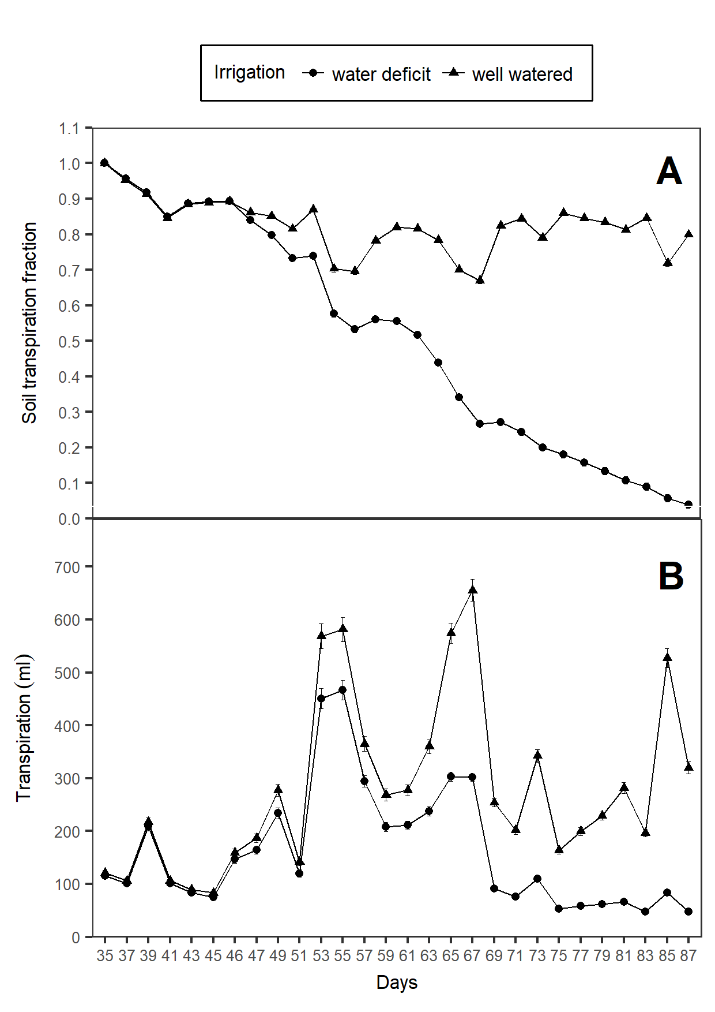

Figure 1 Soil transpiration fraction and transpiration during the experiment

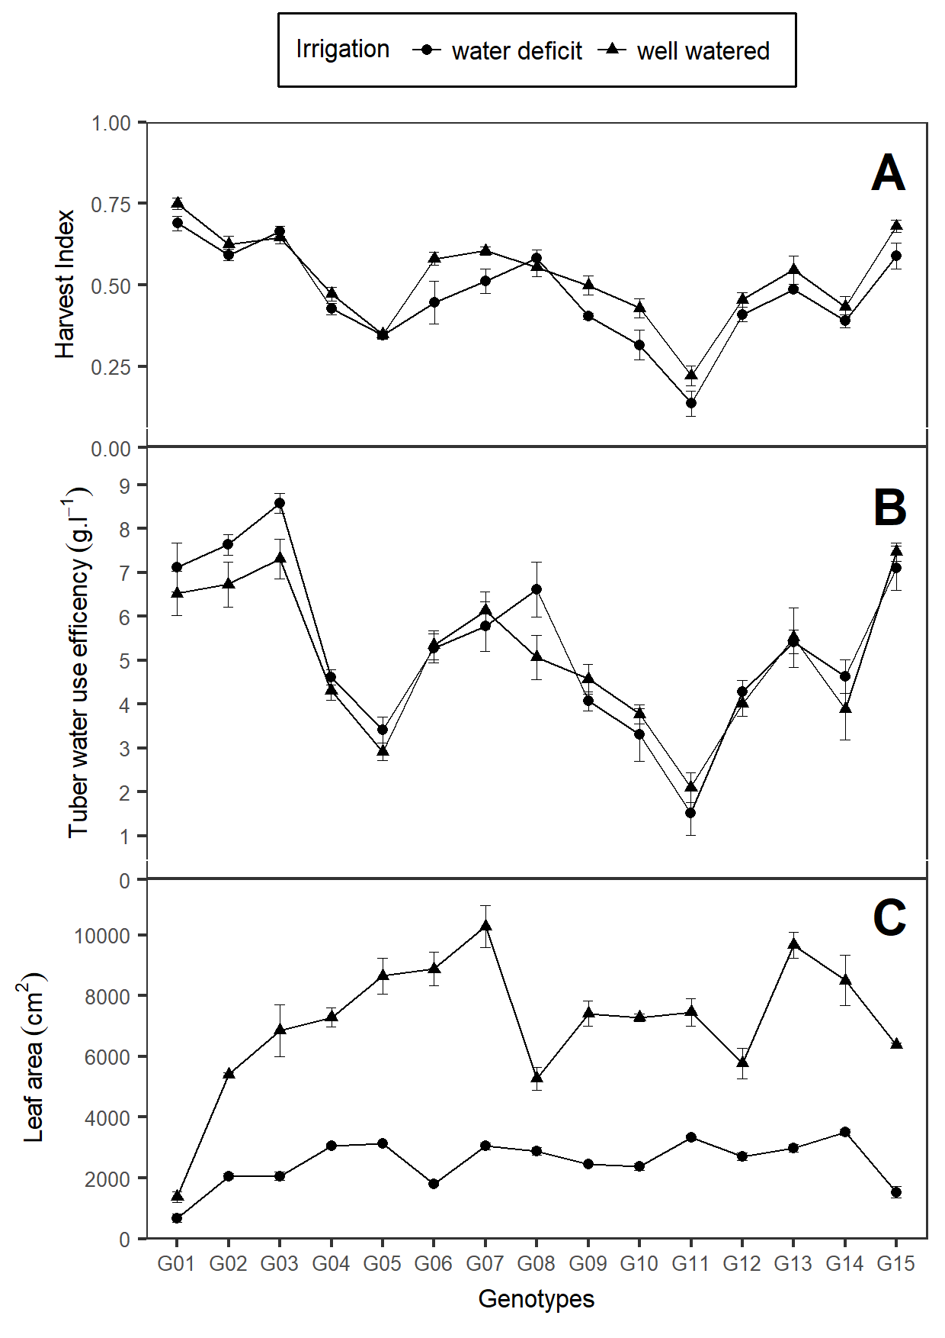

Figure 2 Harvest Index, tuber water use efficency

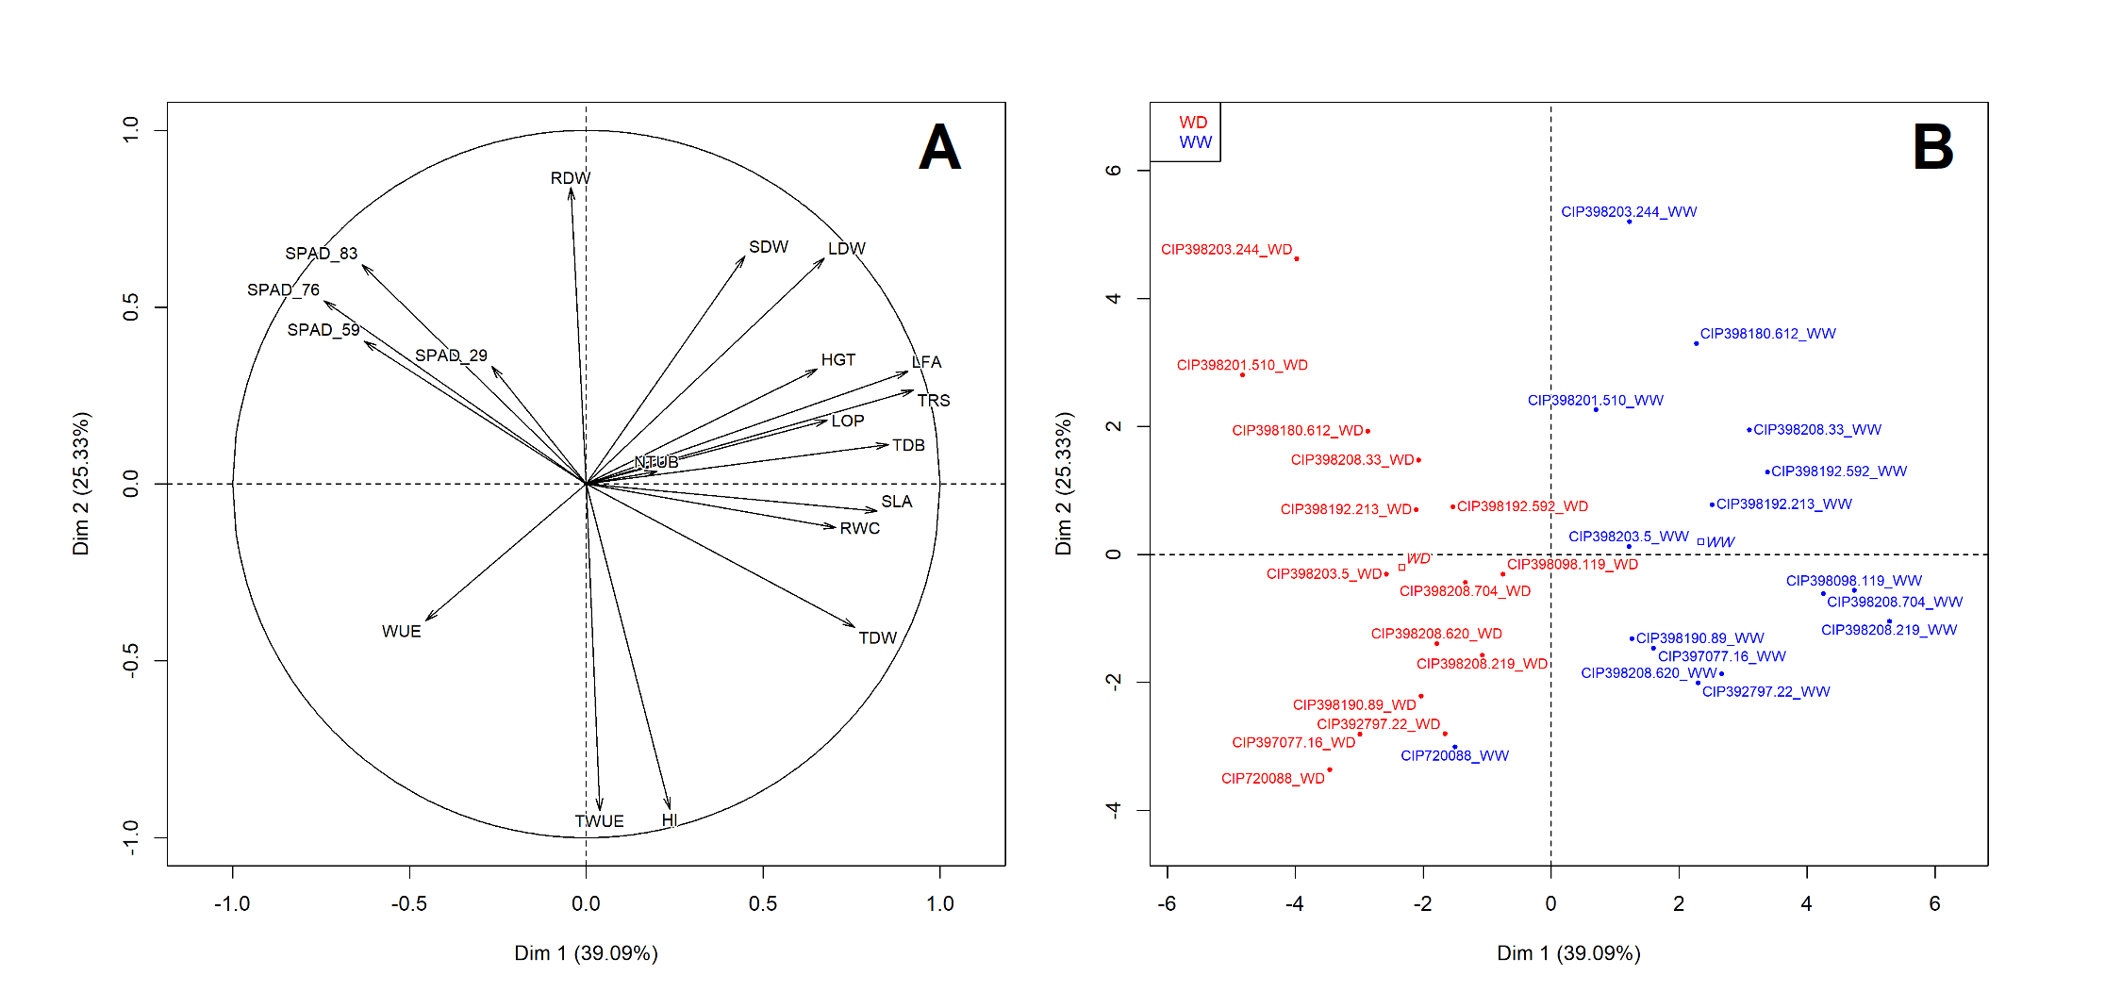

Figure 3 Principal component analysis

# References

Bhatnagar-Mathur, P., Devi, M.J., Reddy, D.S., Lavanya, M., Vadez, V., Serraj, R., Yamaguchi-Shinozaki, K., Sharma, K.K., 2007. Stress-inducible expression of At DREB1A in transgenic peanut (Arachis hypogaea L.) increases transpiration efficiency under water-limiting conditions. Plant Cell Reports 26, 2071–2082. <https://doi.org/10.1007/s00299-007-0406-8>

Blum, A., 2011. Drought resistance - is it really a complex trait? Functional Plant Biology 38, 753. <https://doi.org/10.1071/FP11101>

Blum, A., 2005. Drought resistance, water-use efficiency, and yield potentialAre they compatible, dissonant, or mutually exclusive? Australian Journal of Agricultural Research 56, 1159. <https://doi.org/10.1071/AR05069>

Carli, C., Yuldashev, F., Khalikov, D., Condori, B., Mares, V., Monneveux, P., 2014. Effect of different irrigation regimes on yield, water use efficiency and quality of potato (Solanum tuberosum L.) in the lowlands of Tashkent, Uzbekistan: A field and modeling perspective. Field Crops Research 163, 90–99. <https://doi.org/10.1016/j.fcr.2014.03.021>

Condon, A.G., Richards, R.A., Rebetzke, G.J., Farquhar, G.D., 2004. Breeding for high water-use efficiency. Journal of experimental botany 55, 2447–2460.

Dalla Costa, L., Delle Vedove, G., Gianquinto, G., Giovanardi, R., Peressotti, A., 1997. Yield, water use efficiency and nitrogen uptake in potato: Influence of drought stress. Potato Research 40, 19–34. <https://doi.org/10.1007/BF02407559>

de Mendiburu, F., 2017. Agricolae: Statistical procedures for agricultural research.

Deblonde, P., Haverkort, A., Ledent, J., 1999. Responses of early and late potato cultivars to moderate drought conditions: Agronomic parameters and carbon isotope discrimination. European Journal of Agronomy 11, 91–105. <https://doi.org/10.1016/S1161-0301(99)00019-2>

Deblonde, P., Ledent, J., 2001. Effects of moderate drought conditions on green leaf number, stem height, leaf length and tuber yield of potato cultivars. European Journal of Agronomy 14, 31–41. <https://doi.org/10.1016/S1161-0301(00)00081-2>

Hessini, K., Martínez, J.P., Gandour, M., Albouchi, A., Soltani, A., Abdelly, C., 2009. Effect of water stress on growth, osmotic adjustment, cell wall elasticity and water-use efficiency in Spartina alterniflora. Environmental and Experimental Botany 67, 312–319. <https://doi.org/10.1016/j.envexpbot.2009.06.010>

Hochman, Z., Holzworth, D., Hunt, J.R., 2009. Potential to improve on-farm wheat yield and WUE in Australia. Crop and Pasture Science 60, 708. <https://doi.org/10.1071/CP09064>

Husson, F., Josse, J., Le, S., Mazet, J., 2018. FactoMineR: Multivariate exploratory data analysis and data mining.

Lahlou, O., Ouattar, S., Ledent, J.-F., 2003. The effect of drought and cultivar on growth parameters, yield and yield components of potato. Agronomie 23, 257–268. <https://doi.org/10.1051/agro:2002089>

Lozano Isla, F., Benites Alfaro, O., Pompelli, M.F., 2017. GerminaR: Germination indexes for seed germination variables for ecophysiological studies.

Ogaya, R., Peñuelas, J., 2003. Comparative field study of Quercus ilex and Phillyrea latifolia: Photosynthetic response to experimental drought conditions. Environmental and Experimental Botany 50, 137–148. <https://doi.org/10.1016/S0098-8472(03)00019-4>

R Core Team, 2018. R: A language and environment for statistical computing. R Foundation for Statistical Computing, Vienna, Austria.

Ray, J.D., Sinclair, T.R., 1998. The effect of pot size on growth and transpiration of maize and soybean during water deficit stress. Journal of Experimental Botany 49, 1381–1386. <https://doi.org/10.1093/jxb/49.325.1381>

Sinclair, T., Ludlow, M., 1986. Influence of Soil Water Supply on the Plant Water Balance of Four Tropical Grain Legumes. Australian Journal of Plant Physiology 13, 329. <https://doi.org/10.1071/PP9860329>

Stark, J.C., Love, S.L., King, B.A., Marshall, J.M., Bohl, W.H., Salaiz, T., 2013. Potato Cultivar Response to Seasonal Drought Patterns. American Journal of Potato Research 90, 207–216. <https://doi.org/10.1007/s12230-012-9285-9>

Tolk, J.A., Howell, T.A., 2009. Transpiration and Yield Relationships of Grain Sorghum Grown in a Field Environment. Agronomy Journal 101, 657–662. <https://doi.org/10.2134/agronj2008.0079x>

Trebejo, I., Midmore, D.J., 1990. Effect of water stress on potato growth, yield and water use in a hot and a cool tropical climate. The Journal of Agricultural Science 114, 321. <https://doi.org/10.1017/S0021859600072713>

Tuberosa, R., 2012. Phenotyping for drought tolerance of crops in the genomics era. Frontiers in Physiology 3. <https://doi.org/10.3389/fphys.2012.00347>

Vasquez-Robinet, C., Mane, S.P., Ulanov, A.V., Watkinson, J.I., Stromberg, V.K., De Koeyer, D., Schafleitner, R., Willmot, D.B., Bonierbale, M., Bohnert, H.J., Grene, R., 2008. Physiological and molecular adaptations to drought in Andean potato genotypes. Journal of Experimental Botany 59, 2109–2123. <https://doi.org/10.1093/jxb/ern073>

Wei, T., Simko, V., 2017. Corrplot: Visualization of a correlation matrix.