Impact of water deficit on growth, productivity, and water use efficiency in potato genotypes (*Solanum tuberosum* L.)

Flavio Lozano-Isla $​^{1}$#, Evelyn Farfan-Vignolo $​^{1}$#, Raymundo Gutierrez $​^{1}$#, Raul Blas 1, Khan Awais 2#+

# International Potato Center (CIP), Av. La Molina 1895, La Molina, 1558, Peru.

1 Universidad Nacional Agraria La Molina (UNALM), Av. La Molina, 1558, Peru.

2 Plant Pathology and Plant-Microbe Biology Section, Cornell University, Geneva, NY, 14456, USA.

+ Corresponding author.

# Abstract

Drought stress is a serious constraint affecting yields of almost all crops worldwide. The problem is only expected to get worse with water deficits stemming from climate change and population expansion. Potato (*Solanum tuberosum* L) is one of the most important food crop worldwide and modern cultivars are highly sensitive to drought. The aim of the present work is to study the physiological responses of potato under water deficit condition. In order to explore the different responses and understand the mechanisms of tolerance to drought stress, we evaluated fifteen potato genotypes under well-watered (WW) and water deficit (WD) conditions for a range of agro-physiological traits. Critically, tolerant genotypes, CIP392797.22 (UNICA), CIP397077.16, CIP398190.89, CIP398208.219 and CIP398208.620, were able to preferentially put limited water toward tuber production rather than biomass. These genotypes have a high tuber production under WW conditions and increased photosynthetic activity and water use efficiency under WD. Variables such as harvest index (hi), root dry weight (rdw), relative chlorophyll content (rcc) and chlorophyll concentration (spad) can be used to select drought tolerant potato genotypes in breeding programs.

**Key words:** abiotic stress, harvest index, physiological traits, drought tolerance, SPAD

# Introduction

Water has become a scarce and precious resource and its efficient utilization in the production of food is a key challenge in agriculture worldwide. Drought is one of the most uncontrollable and pervasive factors and one of the global problems limiting production (Obidiegwu et al., 2015). Tracking the consequences of water deficit in plants is a difficult task, as it depends on the timing, intensity, type of crop, and duration of stress (Blum, 2011). Under field conditions, drought caused drastic losses in potato tuber yield and/or quality (Stark et al., 2013; Yang et al., 2016).

Potato (*Solanum tuberosum* L.) is the fourth most important food worldwide crop with an annual production of around 380 million tons (Birch et al., 2012). Potato is an autotetraploid (2n = 4x = 48) and suffers from acute inbreeding depression (Xu et al., 2011) which contributes to a significant barrier for traditional breeding approaches (Kaminski et al., 2015). Potato is known to be sensitive to water deficit because of its shallow root system, and its fast-closing leaf stomata that reduce transpiration and photosynthesis, considerably reducing tuber yields (Deblonde & Ledent, 2001; Joshi et al., 2016). In potato, tolerance to drought is a very complex trait (Anithakumari et al., 2012), some QTLs were associated at different agro-morphological traits (Khan et al., 2015) under drought stress and about 2000 deferentially expressed genes were revealed in potato in response to water deficit (Watkinson et al., 2006) and some genes are related at memory effect on stress with higher expression level when drought occurs again (Chen et al., 2020).

Potato is sensitive to periodic water shortage and tuber initiation is the most critical period of a potato’s life span. Its high demand and management of water of around 400 to 600 L for 1kg of tuber dry matter (Monneveux et al., 2013; Sprenger et al., 2016; Stark et al., 2013) has a marked influence on plant behavior, tuber production, and quality. The modern potato cultivars are very sensitive and variable in response to soil drought (Monneveux et al., 2013; Soltys-Kalina et al., 2016; Sprenger et al., 2016). Therefore, physiological behavior of the plants under drought stress could provide information on their capacity to tolerate water shortage. Differences response have been observed to be caused by drought stress in terms of morphological, physiological, biochemical, and molecular changes among species and cultivars (Liu et al., 2005, 2006). Climate change pressure increase the need to identify potato genotypes that exhibit high tolerance to abiotic stresses (Monneveux et al., 2014).

The aim of the present study is contributed to understand the mechanisms for drought tolerance and yield response in fifteen potato genotypes under water deficit condition. The relation between traits to mitigate yield losses under water-limited conditions was explored by evaluating and identifying convenient indicators that may help in the selection of tolerant genotypes.

# Materials and Methods

## Plant material

Two commercial varieties and thirteen potato genotypes were selected from the advanced breeding population collection of the International Potato Center (CIP) (Table 1). The commercial varieties were, UNICA (CIP392797.22) with a good response to warm and dry environments (Demirel et al., 2020; Gutiérrez-Rosales et al., 2007; Rolando et al., 2015); and Achirana INTA (CIP720088) known for their earliness and drought tolerance (Schafleitner et al., 2007).

## Experimental conditions

The experiment was carried out in complete randomize block design where the first factor was the two irrigation treatments: well-watered (WW) and water deficit (WD). The second factor were the fifteen potato genotypes (Table 1). Each treatment consisted of five replicates with one potato plant for each experimental unit.

## Cultivation and management

The experiment was conducted at the International Potato Center (CIP) experimental station in Lima, Peru (12.1◦ S, 77.0◦ W, 244 m.a.s.l.). The plants were grown in an environmentally controlled greenhouse at 28/15°C day/night with 70±5% average relative humidity (HOBO U12 Outdoor/Industrial model, Onset Computer Corporation, Bourne, MA, USA). Single plants were grown in a greenhouse in 5 L plastic pots and containing 5 kg of dry commercial Sogemix SM2 (75% Peat Moss, perlite, vermiculite and limestone). The potato tubers were pre-sprouted for 2 weeks in dark chamber and planted after in pots at 5–7 cm depth. Fertilization was done each pot twice. The first one at planting, 10 g of a mixture of granular fertilizers was mixed with the substrate. Fertilizer mixture was composed of CO(NH2)2 (urea; 46% N), KCl (potassium chloride; 60% K2O) and (NH4)2HPO4 (diammonium phosphate, 18% N and 46% P2O5) in a ratio of 2:1:2, respectively. The second fertilization was done 40 days after planting (dap) with 5 g of urea, before the starting of the treatment.

## Dry down methodology

Two irrigation treatments were applied: well-watered (WW) treatment where plants were irrigated according to their transpiration demand (Figure 1B); and water deficit (WD) treatment with gradual reduction of water supply until wilting point. At 35 dap, prior to the stress initiation, the pots from both WW and WD treatments were watered to soaking and then allowed to drain overnight. Next morning, the pots were sealed in a plastic bag secured with a twist tie to prevent water loss except by transpiration. Thereafter, all the pots were weighed and this weight was defined as the initial pot weight. The inter-daily weight of the pots was carried out for 10 day for calculate the initial dry down parameters for treatment application (Figure 1A). Water deficit treatment were imposed at 45 dap that coincides with the beginning of the development of the stolons. In order to expose plants under water deficit, WD treatment were reduced 150 mL of water in each irrigation.

## Transpiration rate and soil water supply

Transpiration was calculated by weighing the pots every two days between 13:00 and 15:00 hours (GMT -05:00). The transpiration of each plant was calculated by the procedure previously described by Bhatnagar-Mathur et al. (2007) and Ray & Sinclair (1998). The inter-daily transpiration rates of WD plants were normalized against WW plant rates to reduce the influence of day-to-day variation, as follow, . The normalization was achieved by dividing transpiration of each individual plant in the WD regime by the mean transpiration of the WW plants. For compare the transpiration between plants, a second normalization was done so that the normalized transpiration rate (NTR) of each plant was defined in 1.0 when the soil water content in each pot was at field capacity (Sinclair & Ludlow, 1986). The available soil water or the fraction of transpirable soil water (ftsw), for each pot was calculated by dividing the pot weight minus the final pot weight by the transpirable soil water of that pot, using the following formula, .

## Evaluated traits

**Water use efficiency (wue).** is defined as a ratio of biomass accumulation, total crop biomass or crop grain yield, to water consumed, expressed as transpiration, evapotranspiration, or total water input to the system (Sinclair et al., 1984). According to this concept we calculated the biomass water use efficiency (wueb) and tuber water use efficiency (wuet). The wueb was calculated as the total biomass in dry weight produced divided by the cumulative water transpired (Dalla Costa et al., 1997) and for wuet we used the dry weight from tuber production divide by the total water transpired (trs; mL) during the treatment.

**Relative water content (rwc).** was determined by weighing the third leaflet in fresh weight (FW) from the third leaf from the apical part from the youngest fully expanded leaf of each plant. Each leaflet was placed in a 4x3 inch Ziploc bag containing distilled water for 24 hours and after this time it was removed to taking turgid weight (TW) afterwards it was dried in an oven at 90ºC for 24 hours and weighed (DW). The rwc was calculated according to Vasquez-Robinet et al. (2008) by the formula, .

**Leaf osmotic potential (lop).** was determined using a dew point microvoltmeter (HR-33T Wescor Inc., Logan, UT, USA) with leaf discs of 5 mm diameter, taken from the third fully extended leaf. The leaf discs were put in 1 ml cryogenic tubes and frozen in liquid nitrogen for further analysis. The frozen leaves were incubated at 22°C for 30 min in a sealed C-52 chamber (Wescor Inc., Logan, UT, USA).

**Chlorophyll concentration (spad).** The chlorophyll content of the plant was evaluated in three points (upper, middle and lower leaflet of a leaf) of the third youngest fully expanded leaf. Measurements to obtain the relative concentration of chlorophyll molecules per unit area of the leaf surface (Ling et al., 2011) were taken with a SPAD-502 chlorophyll meter (Konica Minolta Sensing, Inc., Osaka, Japan). Individual readings of leaflets were averaged to represent individual measurement of a leaf. The evaluations were done on light adapted leaves at 29, 59, 76, and 83 day after planting (dap).

**Post-harvest traits.** The harvest was at 90 dap and the plants were separated in four components: leaves, stems, roots and tubers. The dry weight (g) components were determined by drying them at 80°C for 3 days in a forced air oven: leaf (ldw), stem (sdw), root (rdw), tuber (tdw). The leaf area (lfa; cm2) in each plants was measured by taking photographs of all the leaves arranged on a wooden board and analyzing them using ImageJ software (Rueden et al., 2017; Zárate-Salazar et al., 2018).

**Indices.** The harvest index (hi) was calculated as the ratio of tdw related to the total dry biomass (tdb; g) and specific leaf area (sla) was calculated by dividing the leaf area (lfa) with lead dry weight (ldw). The relative chlorophyll content (rcc) were calculated with the relation between spad at 83 dap (spad_83) and leaf area (lfa) multiplied by 100 for better scale interpretation.

## Statistical analysis

Statistical analysis and graphs were performed in the statistical software R (R Core Team, 2019). The analysis of variance (ANOVA) was performed to evaluate the differences between the factors and the comparison of the means with the Student-Newman-Keuls test (p<0.05) with agricolae and GerminaR package (de Mendiburu, 2020; Lozano-Isla et al., 2019). A Student’s t-test was performed between well water and water deficit treatment (p<0.05). For the multivariate analysis, correlation and principal components analysis (PCA) were performed with FactoMineR and heatmaply package (Galili et al., 2018; Husson et al., 2020). For compute the hierarchical clustering between treatments and genotypes were used the Euclidean distance (Lê et al., 2008). For reproducible analysis, the code and statistical analysis used in this manuscript are available in the following GitHub repository <https://github.com/flavjack/20130515LM>.

# Result

## Dry down and soil water supply

Differences among treatments were noted after 4 days. The fraction of transpirable soil water (ftsw) in WW plants the water availability was maintained above 70%, while for the WD treatment the gradual restriction in water supply decreased the water availability. By the end of the experiment the plants in WD had less than 10% of ftsw (Figure 1A). In the case of the transpiration rate, the reduction in the plants in WD was visible after 8 days of after water restriction (Figure 1B).

## Agro-physilogical traits

The chlorophyll concentration (spad) at 29 dap all plants were at the same level as no treatment was applied (Figure 2E). At 59, 76 and 83 dap the spad shown differences in each evaluation and at the end of the experiment the spad values were lower than at 29 dap and the WD values for all the genotypes were higher than the ones at WW conditions (Table 2). The genotypes CIP398190.89 and CIP720088 had the lowest differences among treatments for spad at 83 dap (2.06 and 0.30, respectively), while CIP398203.244 and CIP398208.33 had the largest (14.48 and 17.54, respectively) (Figure 2F).

Leaf relative water content (rwc) and leaf osmotic potential (lop) significantly (p<0.01) decreased in response to WD in all the genotypes (Table 2). The values ranged between 64.96% and 50.09% for CIP720088 and CIP398201.510, respectively. The specific leaf area (sla) reduction was 48% under WD compared to WW (Table 2). CIP398190.89 together with CIP398203.5 were among the clones with lowest reduction (24 and 21% respectively), while CIP398208.219, CIP398098.119, and CIP398208.704 were among the clones with highest sla reduction with 53, 65, and 64% respectively.

Plant high (hgt), leaf dry weight (ldw), stem dry weight (std), leaf area (lfa) decrease significantly (p<0.01) under drought treatment (Table 2). In the case of lfa there was a drastic reduction with 65% in plants under WD compare with WW plants (Table 2 and Figure 2B). While the components such as number of tuber (ntub), root dry weight (rdw) and root length (rdl) did not shown differences between the treatments (p>0.5).

The relative chlorophyll content (rcc) is the relation between the chlorophyll concentration in the leaves (spad) in relation with the leaf area. It has been shown difference between treatment (p<0.001) and it was able to discriminate plants in WW and WD genotypes (Figure 2B). The genotypes with best performance in rcc were CIP720088 (Achirana-INTA), CIP398208.620, CIP398208.704, CIP398201.510, CIP392797.22 (UNICA) and CIP397077.16 (Figure 3B).

## Yield components

Differences existed among genotypes in total dry biomass (tdb) of well-watered (WW) plants at the end of the experiment (Table 2). Water deficit (WD) treatment had a significant effect (p<0.001) with an average reduction of around 32% in comparison with the well-watered treatment (Table 2). In terms of productivity, WD decreased tuber yield (tdw) across genotypes by an average of 40% (p<0.001). CIP398190.89 had greater tuber dry weight (g) in WD compared to its yield in WW treatment with a 5% increase in biomass, while others genotypes like CIP398203.5 and CIP398203.244 presented up to 56% and 48% reduced tuber production (Figure 2A). The genotypes CIP398203.244, CIP398180.612, and CIP398201.510 were among the most sensitive genotypes at 31.56, 46.75 and 48.88% respectively under WD. For harvest index (hi), differences among genotypes (p<0.001) and treatments (p<0.02) were found (Table 2).

Biomass water use efficiency (wueb) was generally higher in WD than WW plants (p<0.001) (Table 2). Under WD treatment, CIP397077.16, CIP398208.620, CIP392797.22 and CIP398190.89 showed the highest wueb with 13.06, 12.03, and 11.59 gL-1, respectively (Figure 3A). The lowest wueb with 8.50 and 9.24 gL-1 were presented by CIP398180.612 and CIP398203.5, respectively. For Tuber Water Use efficiency (wuet) there is not difference between treatments (p=0.5) (Table 2). The genotypes with better wuet under WD were CIP397077.16, CIP392797.22, CIP720088 and CIP398208.620 (Figure 1 and 2D).

## Multivariate analysis

The Principal Component Analysis (PCA) the two first dimension explains 64.9% of the variance in the experiment (Figure S5A). In the first dimension the variables with more contribution are represented by trs (r=0.94), lfa (r=0.93), tbd (r=0.87), sla (r=0.81), tdw (r=0.74) and ldw (r=0.73) show a high correlation and association with WW treatment, in the other side rcc (r=-0.73), spad (r~-0,63) shown an negatives correlation and association with WD treatment (Figure S5B and S5D). In the second dimension the variables with major contribution are represented by rdl (r=0.88) and rdw (r=0.87) have a high correlation and associated at WW treatment and negative correlated with hi (-0.92) and wuet (-0.90) and associated to WD treatment (Figure S5C and S5D).

The clustering analysis show 5 groups and it could be associated in 2 different ways. The first association could by classified by the treatment applied, the cluster 4 and 5 are the well water treatments (WW) and the cluster 2 and 3 associated at the water deficit treatment (WD); the second association is the cluster 1, 3 and 5 with tolerate to water stress, in addition they shown a correlation with wuet, hi and tdw, traits that are important in the yield component (Figure 3). The association between the cluster and variables shown that the genotypes in the cluster 2 are positive correlated with the spad, rdl and rdw and negative correlated to tdw, hi and wuet. The genotypes in the cluster 3 and 1 are positive associated with the rcc and wueb. In the cluster 4 the genotypes are positive correlated with ldw, tdb, lfa and trs. The cluster 5 is associated with sla, tdw and rwc and negative associated with spad and rdw (Figure 3).

According the Pearson correlation analysis (Figure S4) values of tdb and trs were strongly and positively correlated with 0.93 (p<0.05) with Euclidean distance of 0.91 (Figure S4). The spad measurements shown good correlation between them (r~0.80) and at negative correlation with hi (r=-0.07). A negative correlation (r= -0.73) among rdw and hi was found with a Euclidean distance of 4.96. A strong correlation between hi and wuet was found (r=0.92) with an Euclidean distance of 0.68, shown not only a good correlation but also a good association between these two variables (Figure S4). Tuber dry weight (tdw) shown correlation with hi (r=0.61) and wuet (r=0.55) and wueb (r=0.05) with a Euclidean distance of the traits 4.96, shown low association with tdw and wueb (Figure 3 and S4). We also found correlation between hi and wuet was 0.92 with a Euclidean distance 0.91 and a negative correlation with spad (-0.7) at 38 days after treatment application.

Interesting the association between spad with tdw since the application of the drought treatment (Table 2) is negative (r~0.62.7) and Euclidean distance of 4.21 shown no association between them. Apparently spad measure is sensitive to detect the drought stress and it is related with the tuber production (Figure 3 and S4). The inclusion in the analysis of the relative chlorophyll content (rcc) was able to differentiate the genotypes by their photosynthetic and water use efficiency (Figure 3 and 2B).

# Discussion

In field conditions the abiotic stress is a combination of several factors and not only drought, thus study the physiological mechanisms of tolerance to water stress in potato is necessary to be perform under control conditions (Kaminski et al., 2015; Zegada-Lizarazu & Monti, 2013). We applied a water deficit under controlled condition with gradually reduction of the water supply and evaluate the process in fifteen genotypes (Figure 1.

## Potato shown different mechanisms to cope with drought stress

The tolerance to drought in potato is a combination of mechanism and the response change between the different groups of genotypes with difference morpho-physiological adaptation (Figure 3). It is difficult to define a trait or index capable to determine tolerance to drought stress in potato as each genotype can achieve it using different strategies. For instance, some genotypes produce more leaves and roots instead of increase the tuber production (Figure 3). From an agronomical point of view, maintaining yield levels during drought is crucial (Boguszewska-Mańkowska et al., 2018). When the crop have a water shortage the increase of their efficiency in the biomass translocation to maintain tuber yield with high harvest index and tuber water use efficiency, is the best alternative to cope with the stress (Kaminski et al., 2015; Reddy et al., 2020).

The potato genotypes evaluated under water deficit shown a reduction in their transpiration rate based in the reduction of the leaf area, decreased plant growth, tuber yield, tubers per plant and tuber size and quality (Aliche et al., 2020; Dalla Costa et al., 1997; Rolando et al., 2015; Yuan et al., 2003) (Table 2 and Figure S6). While plant biomass accumulation and yield was shown to be inextricably linked to transpiration (Sinclair et al., 1984) (Figure S4). One mechanism to drought resistance is the reduction of transpiration achieved by the reduction of leaf area with thick leaves which often have greater photosynthetic capacity than thin leaves, due to their higher chlorophyll per leaf area (Rolando et al., 2015; Songsri et al., 2009) that in this work could be evidenced with the inclusion of rcc (Figure S2B).

As potato is a tuber crop, the interaction of the variables underground are important because exist a differentiation of the architecture of root system under field condition (Zarzyńska et al., 2017). In our work we did not find difference in root length and root dry weight (Table 2) maybe because root development in all cultivars was limited by the volume of the pots, in which plants were grown (Soltys-Kalina et al., 2016).

## Harvest index is associated with water use efficiency for tuber production

Genotypes in this study shown hi around 53% under WW condition (Table 2) and under water deficit reduced their hi in 11% compared with WW plants, similar results were found for Schafleitner et al. (2007) with 14% under terminal drought. In comparison with other tuber crops like Jerusalem artichoke they presented a reduction of 57% in hi under water stress (Ruttanaprasert et al., 2016) showing that potato have moderate reduction under drought stress and they are considered to use water more efficiently than cereals (Shahnazari et al., 2007).

Genotypes like CIP392797.22 (UNICA) and CIP397077.16 were clustered between the good performed genotypes with high wuet, hi and tuber production with no difference under WW and WD condition (Figure 3 and 2. The same genotypes under field condition were reported tolerance to drought with good nitrogen use efficiency (Saravia et al., 2016). Since hi has been found to be stable for a particular cultivars over wide range of conditions (Donald & Hamblin, 1976; Khan et al., 2015). Some author suggested that one of the main variables for yield increases seen to be the increases in harvest index (Deguchi et al., 2010; McVetty & Evans, 1980). We found strong relation between hi and wuet (Figure 3A and S4). For this reason obtaining high harvest indexes under water-limited conditions is especially important to obtain high water-use efficiency gentoypes (Passioura, 1977), even if in many crops it appears likely that substantial improvements in harvest index could be achieved (McVetty & Evans, 1980).

## Some genotypes improve their photosynthesis efficiency under stress

The chlorophyll content is an indicator of the photosynthetic active and light transmittance of the leaf and correlated with a + b chlorophyll concentration (Lichtenthaler & Wellburn, 1983), usually related with the nitrogenous status and crop senescence (Kaminski et al., 2015; Ramírez et al., 2014; Saravia et al., 2016) and useful factor for assessing environmental stress resistance (Gao et al., 2015; Ramírez et al., 2014). Our results shown that spad measurement are sensitive to detect water stress in potato genotype. Before the treatment application the genotype did not presented difference in the spad content (Figure 2E), but since the plants had a water shortage the spad content show differences between WW and WD plants (Table Table 2, Figure S4 and 2F). And the spad content also present a negative correlation with the tdw (Figure S4). In other works in potato, the spad measurement have been correlated with chlorophyll and carotenoid content and it could allow to discriminate drought tolerance genotypes (Ramírez et al., 2014; Rolando et al., 2015; Saravia et al., 2016).

The multivariate analysis shown that genotypes under drought stress try to increase their spad content (Figure 3) (Rodríguez-Pérez et al., 2017) for offset the reduction in the leaf area because the impose of drought decrease severely the leaf area and lost of water turgor (Table 2) (Ramírez et al., 2014; Rolando et al., 2015). This phenomenon causes that the plants try to be more efficient with less leaf area and increase the photosynthetic activity (Figure 2F). For compare this interaction in this work we introduced a index denominated relative chlorophyll content (rcc) as the quantity of chlorophyll content related to their leaf area. Surprisingly this index helps to discriminate genotypes under WW and WD condition. All genotypes under WW condition have in average the same values of rcc, but it changes for WD conditions showing genotypes with better performance in this index (Figure 2B).

This result shown that potato genotypes with the ability to maintain high relative chlorophyll content under WD conditions, can maintain higher wuet and hi, reducing the losses in the tuber production (Figure 3). Minimal yield losses in some genotypes in cluster 3 and 5 (Figure 3B) like CIP398190.89 under WD could be related to its ability to increase their rcc and reduce the leaf production resulting in a better performance in wuet using the limited water and nutrients available in the soil without a drastically reduction in the final yield (Figure 3 and 2A). For this reason, genotypes that shown increase in their relative chlorophyll content (rcc) under drought stress were associated with better water use efficiency as mechanisms to mitigate the yield reduction (Figure 3A-B).

## Genotypes with better response to drought stress

The perform of multivariate analysis allowed to discern the best genotypes between WW and WD condition such as CIP392797.22 (UNICA), CIP397077.16, CIP398190.89, CIP398208.219, CIP398208.620 located in the cluster 3 and 5 (Figure 3). These genotypes shown good response in tuber production under WW condition as well as they have better water use efficiency and harvest index for tuber production under WD (Figure 3). In previous works, Saravia et al. (2016) presented that two of these five genotypes, CIP392797.22 (UNICA) and CIP397077.16 were tolerant to drought in terms of yield maintenance and used the nitrogen present in the soil more efficiently. Sensitive genotypes such as CIP398203.244 and CIP398201.510 preferred to produce leaves and more roots instead of tubers (Figure S6). In these genotypes more roots seem to contribute to vegetative growth rather than yield components in contradiction to Songsri et al. (2009) who mention that enhanced extraction of water and nutrients from the soil due to large root system and long roots is a drought resistance mechanism in peanut. However, a deeper and more extensive rooting system may have drawbacks, because a greater root biomass would almost surely result in a low harvest index in potato (Figure 3A).

# Conclusions

A fast screening traits would be helpful in selecting valuable genotypes with defined growth strategies that translate to drought tolerance and are suitable for experiments and/or breeding (Soltys-Kalina et al., 2016). The present work gives an overview of the behavior of different potato genotypes under water deficit condition and the penalty for the yield causes by the water shortage. Water stress triggered a range of morphological and physiological mechanisms in the tested potato genotypes. Most measured characteristics shown differences between treatments, pointing to their value in evaluating the impact of drought. Uni-variate analysis shows that it is limited to understand the response of the potato under drought stress. Tolerant genotypes like CIP392797.22 (UNICA), CIP397077.16, CIP398190.89, CIP398208.219, CIP398208.620 preferentially use available water for tuber production rather than biomass production represented by their high wuet. The genotypes with high harvest index and relative chlorophyll present mechanisms for drought avoiding as they present good performance in tuber water use efficient. Variables such as the relative chlorophyll content, harvest index, spad and root dry weight are outlined to be a good indicators for tuber water use efficient and useful traits for direct and indirect selection as selection criteria in drought stress experiments, using fast, easy and inexpensive evaluations for first stage of breeding programs in potato where is required to evaluate large populations.

# Acknowledgments

Authors acknowledge the financial support by BMZ/GIZ through a research grant for “Improved potato varieties and water management technologies to enhance water use efficiency, resilience, cost-effectiveness, and productivity of smallholder farms in stress-prone Central Asian environments”. We also thank Jorge Vega and David Saravia for their help during installation and evaluation of the experiment.

# References

Aliche, E. B., Prusova-Bourke, A., Ruiz-Sanchez, M., Oortwijn, M., Gerkema, E., Van As, H., Visser, R. G. F., & van der Linden, C. G. (2020). Morphological and physiological responses of the potato stem transport tissues to dehydration stress. *Planta*, *251*(2), 45. <https://doi.org/10.1007/s00425-019-03336-7>

Anithakumari, A. M., Nataraja, K. N., Visser, R. G. F., & van der Linden, C. G. (2012). Genetic dissection of drought tolerance and recovery potential by quantitative trait locus mapping of a diploid potato population. *Molecular Breeding*, *30*(3), 1413–1429. <https://doi.org/10.1007/s11032-012-9728-5>

Bhatnagar-Mathur, P., Devi, M. J., Reddy, D. S., Lavanya, M., Vadez, V., Serraj, R., Yamaguchi-Shinozaki, K., & Sharma, K. K. (2007). Stress-inducible expression of At DREB1A in transgenic peanut (Arachis hypogaea L.) Increases transpiration efficiency under water-limiting conditions. *Plant Cell Reports*, *26*(12), 2071–2082. <https://doi.org/10.1007/s00299-007-0406-8>

Birch, P. R. J., Bryan, G., Fenton, B., Gilroy, E. M., Hein, I., Jones, J. T., Prashar, A., Taylor, M. A., Torrance, L., & Toth, I. K. (2012). Crops that feed the world 8: Potato: Are the trends of increased global production sustainable? *Food Security*, *4*(4), 477–508. <https://doi.org/10.1007/s12571-012-0220-1>

Blum, A. (2011). Drought resistance - is it really a complex trait? *Functional Plant Biology*, *38*(10), 753. <https://doi.org/10.1071/FP11101>

Boguszewska-Mańkowska, D., Pieczyński, M., Wyrzykowska, A., Kalaji, H. M., Sieczko, L., Szweykowska-Kulińska, Z., & Zagdańska, B. (2018). Divergent strategies displayed by potato (Solanum tuberosum L.) Cultivars to cope with soil drought. *Journal of Agronomy and Crop Science*, *204*(1), 13–30. <https://doi.org/10.1111/jac.12245>

Chen, Y., Li, C., Yi, J., Yang, Y., Lei, C., & Gong, M. (2020). Transcriptome Response to Drought, Rehydration and Re-Dehydration in Potato. *International Journal of Molecular Sciences*, *21*(1), 159. <https://doi.org/10.3390/ijms21010159>

Dalla Costa, L., Delle Vedove, G., Gianquinto, G., Giovanardi, R., & Peressotti, A. (1997). Yield, water use efficiency and nitrogen uptake in potato: Influence of drought stress. *Potato Research*, *40*(1), 19–34. <https://doi.org/10.1007/BF02407559>

Deblonde, P. M. K., & Ledent, J. F. (2001). Effects of moderate drought conditions on green leaf number, stem height, leaf length and tuber yield of potato cultivars. *European Journal of Agronomy*, *14*(1), 31–41. <https://doi.org/10.1016/S1161-0301(00)00081-2>

Deguchi, T., Naya, T., Wangchuk, P., Itoh, E., Matsumoto, M., Zheng, X., Gopal, J., & Iwama, K. (2010). Aboveground Characteristics, Yield Potential and Drought Tolerance in “Konyu” Potato Cultivars with Large Root Mass. *Potato Research*, *53*(4), 331–340. <https://doi.org/10.1007/s11540-010-9174-x>

de Mendiburu, F. (2020). *Agricolae: Statistical procedures for agricultural research*. <https://CRAN.R-project.org/package=agricolae>

Demirel, U., Morris, W. L., Ducreux, L. J. M., Yavuz, C., Asim, A., Tindas, I., Campbell, R., Morris, J. A., Verrall, S. R., Hedley, P. E., Gokce, Z. N. O., Caliskan, S., Aksoy, E., Caliskan, M. E., Taylor, M. A., & Hancock, R. D. (2020). Physiological, Biochemical, and Transcriptional Responses to Single and Combined Abiotic Stress in Stress-Tolerant and Stress-Sensitive Potato Genotypes. *Frontiers in Plant Science*, *11*. <https://doi.org/10.3389/fpls.2020.00169>

Donald, C. M., & Hamblin, J. (1976). The Biological Yield and Harvest Index of Cereals as Agronomic and Plant Breeding Criteria. In N. C. Brady (Ed.), *Advances in Agronomy* (Vol. 28, pp. 361–405). Academic Press. <https://doi.org/10.1016/S0065-2113(08)60559-3>

Galili, T., O’Callaghan, A., Sidi, J., & Sievert, C. (2018). Heatmaply: An R package for creating interactive cluster heatmaps for online publishing. *Bioinformatics*, *34*(9), 1600–1602. <https://doi.org/10.1093/bioinformatics/btx657>

Gao, Y., Jiang, W., Dai, Y., Xiao, N., Zhang, C., Li, H., Lu, Y., Wu, M., Tao, X., Deng, D., & Chen, J. (2015). A maize phytochrome-interacting factor 3 improves drought and salt stress tolerance in rice. *Plant Molecular Biology*, *87*(4), 413–428. <https://doi.org/10.1007/s11103-015-0288-z>

Gutiérrez-Rosales, R. O., Espinoza-Trelles, J. A., & Bonierbale, M. (2007). UNICA: variedad Peruana para mercado fresco y papa frita con tolerancia y resistencia para condiciones climáticas adversas. *Revista Latinoamericana de La Papa*, *14*(1), 41–50. <http://35.231.225.15/index.php/rev-alap/article/view/143>

Husson, F., Josse, J., Le, S., & Mazet, J. (2020). *FactoMineR: Multivariate exploratory data analysis and data mining*. <https://CRAN.R-project.org/package=FactoMineR>

Joshi, M., Fogelman, E., Belausov, E., & Ginzberg, I. (2016). Potato root system development and factors that determine its architecture. *Journal of Plant Physiology*, *205*, 113–123. <https://doi.org/10.1016/j.jplph.2016.08.014>

Kaminski, K. P., Kørup, K., Kristensen, K., Nielsen, K. L., Liu, F., Topbjerg, H. B., Kirk, H. G., & Andersen, M. N. (2015). Contrasting Water-Use Efficiency (WUE) Responses of a Potato Mapping Population and Capability of Modified Ball-Berry Model to Predict Stomatal Conductance and WUE Measured at Different Environmental Conditions. *Journal of Agronomy and Crop Science*, *201*(2), 81–94. <https://doi.org/10.1111/jac.12091>

Khan, M. A., Saravia, D., Munive, S., Lozano-Isla, F., Farfan, E., Eyzaguirre, R., & Bonierbale, M. (2015). Multiple QTLs Linked to Agro-Morphological and Physiological Traits Related to Drought Tolerance in Potato. *Plant Molecular Biology Reporter*, *33*(5), 1286–1298. <https://doi.org/10.1007/s11105-014-0824-z>

Lê, S., Josse, J., & Husson, F. (2008). FactoMineR: An R Package for Multivariate Analysis. *Journal of Statistical Software*, *25*(1), 1–18. <https://doi.org/10.18637/jss.v025.i01>

Lichtenthaler, H. K., & Wellburn, A. R. (1983). Determinations of total carotenoids and chlorophylls a and b of leaf extracts in different solvents. *Biochemical Society Transactions*, *11*(5), 591–592. <https://doi.org/10.1042/bst0110591>

Ling, Q., Huang, W., & Jarvis, P. (2011). Use of a SPAD-502 meter to measure leaf chlorophyll concentration in Arabidopsis thaliana. *Photosynthesis Research*, *107*(2), 209–214. <https://doi.org/10.1007/s11120-010-9606-0>

Liu, F., Jensen, C. R., Shahanzari, A., Andersen, M. N., & Jacobsen, S.-E. (2005). ABA regulated stomatal control and photosynthetic water use efficiency of potato (Solanum tuberosum L.) During progressive soil drying. *Plant Science*, *168*(3), 831–836. <https://doi.org/10.1016/j.plantsci.2004.10.016>

Liu, F., Shahnazari, A., Andersen, M. N., Jacobsen, S.-E., & Jensen, C. R. (2006). Effects of deficit irrigation (DI) and partial root drying (PRD) on gas exchange, biomass partitioning, and water use efficiency in potato. *Scientia Horticulturae*, *109*(2), 113–117. <https://doi.org/10.1016/j.scienta.2006.04.004>

Lozano-Isla, F., Benites-Alfaro, O. E., & Pompelli, M. F. (2019). GerminaR: An R package for germination analysis with the interactive web application “GerminaQuant for R”. *Ecological Research*, *34*(2), 339–346. <https://doi.org/10.1111/1440-1703.1275>

McVetty, P. B. E., & Evans, L. E. (1980). Breeding Methodology in Wheat. II. Productivity, Harvest Index, and Height Measured on F2 Spaced Plants for Yield Selection in Spring Wheat1. *Crop Science*, *20*(5), cropsci1980.0011183X002000050010x. <https://doi.org/10.2135/cropsci1980.0011183X002000050010x>

Monneveux, P., Ramírez, D. A., Khan, M. A., Raymundo, R. M., Loayza, H., & Quiroz, R. (2014). Drought and Heat Tolerance Evaluation in Potato (Solanum tuberosum L.). *Potato Research*, *57*(3), 225–247. <https://doi.org/10.1007/s11540-014-9263-3>

Monneveux, P., Ramírez, D. A., & Pino, M.-T. (2013). Drought tolerance in potato (S. Tuberosum L.): Can we learn from drought tolerance research in cereals? *Plant Science*, *205-206*, 76–86. <https://doi.org/10.1016/j.plantsci.2013.01.011>

Obidiegwu, J. E., Bryan, G. J., Jones, H. G., & Prashar, A. (2015). Coping with drought: Stress and adaptive responses in potato and perspectives for improvement. *Frontiers in Plant Science*, *6*. <https://doi.org/10.3389/fpls.2015.00542>

Passioura, J. B. (1977). *Grain yield, harvest index, and water use of wheat*. <https://publications.csiro.au/rpr/pub?list=BRO\&pid=procite:16a0b1b4-f4e0-4207-9cf6-3fd561de0889>

Ramírez, D. A., Yactayo, W., Gutiérrez, R., Mares, V., De Mendiburu, F., Posadas, A., & Quiroz, R. (2014). Chlorophyll concentration in leaves is an indicator of potato tuber yield in water-shortage conditions. *Scientia Horticulturae*, *168*, 202–209. <https://doi.org/10.1016/j.scienta.2014.01.036>

Ray, J. D., & Sinclair, T. R. (1998). The effect of pot size on growth and transpiration of maize and soybean during water deficit stress. *Journal of Experimental Botany*, *49*(325), 1381–1386. <https://doi.org/10.1093/jxb/49.325.1381>

R Core Team. (2019). *R: A language and environment for statistical computing*. R Foundation for Statistical Computing. <https://www.R-project.org/>

Reddy, S. H., Singhal, R. K., DaCosta, M. V. J., Kambalimath, S. K., Rajanna, M. P., Muthurajan, R., Sevanthi, A. M., Mohapatra, T., Sarla, N., Chinnusamy, V., S, G. K., Singh, A. K., Singh, N. K., Sharma, R. P., Pathappa, N., & Sheshshayee, S. M. (2020). Leaf mass area determines water use efficiency through its influence on carbon gain in rice mutants. *Physiologia Plantarum*, *n/a*(n/a). <https://doi.org/10.1111/ppl.13062>

Rodríguez-Pérez, L., L, C. E. Ñústez, Moreno F, L. P., Rodríguez-Pérez, L., L, C. E. Ñústez, & Moreno F, L. P. (2017). Drought stress affects physiological parameters but not tuber yield in three Andean potato (Solanum tuberosum L.) Cultivars. *Agronomía Colombiana*, *35*(2), 158–170. <https://doi.org/10.15446/agron.colomb.v35n2.65901>

Rolando, J. L., Ramírez, D. A., Yactayo, W., Monneveux, P., & Quiroz, R. (2015). Leaf greenness as a drought tolerance related trait in potato (Solanum tuberosum L.). *Environmental and Experimental Botany*, *110*, 27–35. <https://doi.org/10.1016/j.envexpbot.2014.09.006>

Rueden, C. T., Schindelin, J., Hiner, M. C., DeZonia, B. E., Walter, A. E., Arena, E. T., & Eliceiri, K. W. (2017). ImageJ2: ImageJ for the next generation of scientific image data. *BMC Bioinformatics*, *18*(1), 529. <https://doi.org/10.1186/s12859-017-1934-z>

Ruttanaprasert, R., Jogloy, S., Vorasoot, N., Kesmala, T., Kanwar, R. S., Holbrook, C. C., & Patanothai, A. (2016). Effects of water stress on total biomass, tuber yield, harvest index and water use efficiency in Jerusalem artichoke. *Agricultural Water Management*, *166*, 130–138. <https://doi.org/10.1016/j.agwat.2015.12.022>

Saravia, D., Farfán-Vignolo, E. R., Gutiérrez, R., De Mendiburu, F., Schafleitner, R., Bonierbale, M., & Khan, M. A. (2016). Yield and Physiological Response of Potatoes Indicate Different Strategies to Cope with Drought Stress and Nitrogen Fertilization. *American Journal of Potato Research*, *93*(3), 288–295. <https://doi.org/10.1007/s12230-016-9505-9>

Schafleitner, R., Gutierrez, R., Espino, R., Gaudin, A., Pérez, J., Martínez, M., Domínguez, A., Tincopa, L., Alvarado, C., Numberto, G., & Bonierbale, M. (2007). Field Screening for Variation of Drought Tolerance in Solanum tuberosum L. By Agronomical, Physiological and Genetic Analysis. *Potato Research*, *50*(1), 71–85. <https://doi.org/10.1007/s11540-007-9030-9>

Shahnazari, A., Liu, F., Andersen, M. N., Jacobsen, S.-E., & Jensen, C. R. (2007). Effects of partial root-zone drying on yield, tuber size and water use efficiency in potato under field conditions. *Field Crops Research*, *100*(1), 117–124. <https://doi.org/10.1016/j.fcr.2006.05.010>

Sinclair, T., & Ludlow, M. (1986). Influence of Soil Water Supply on the Plant Water Balance of Four Tropical Grain Legumes. *Australian Journal of Plant Physiology*, *13*(3), 329. <https://doi.org/10.1071/PP9860329>

Sinclair, T. R., Tanner, C. B., & Bennett, J. M. (1984). Water-Use Efficiency in Crop Production. *BioScience*, *34*(1), 36–40. <https://doi.org/10.2307/1309424>

Soltys-Kalina, D., Plich, J., Strzelczyk-Żyta, D., Śliwka, J., & Marczewski, W. (2016). The effect of drought stress on the leaf relative water content and tuber yield of a half-sib family of “Katahdin”-derived potato cultivars. *Breeding Science*, *66*(2), 328–331. <https://doi.org/10.1270/jsbbs.66.328>

Songsri, P., Jogloy, S., Holbrook, C. C., Kesmala, T., Vorasoot, N., Akkasaeng, C., & Patanothai, A. (2009). Association of root, specific leaf area and SPAD chlorophyll meter reading to water use efficiency of peanut under different available soil water. *Agricultural Water Management*, *96*(5), 790–798. <https://doi.org/10.1016/j.agwat.2008.10.009>

Sprenger, H., Kurowsky, C., Horn, R., Erban, A., Seddig, S., Rudack, K., Fischer, A., Walther, D., Zuther, E., Köhl, K., Hincha, D. K., & Kopka, J. (2016). The drought response of potato reference cultivars with contrasting tolerance. *Plant, Cell & Environment*, *39*(11), 2370–2389. <https://doi.org/10.1111/pce.12780>

Stark, J. C., Love, S. L., King, B. A., Marshall, J. M., Bohl, W. H., & Salaiz, T. (2013). Potato Cultivar Response to Seasonal Drought Patterns. *American Journal of Potato Research*, *90*(3), 207–216. <https://doi.org/10.1007/s12230-012-9285-9>

Vasquez-Robinet, C., Mane, S. P., Ulanov, A. V., Watkinson, J. I., Stromberg, V. K., De Koeyer, D., Schafleitner, R., Willmot, D. B., Bonierbale, M., Bohnert, H. J., & Grene, R. (2008). Physiological and molecular adaptations to drought in Andean potato genotypes. *Journal of Experimental Botany*, *59*(8), 2109–2123. <https://doi.org/10.1093/jxb/ern073>

Watkinson, J. I., Hendricks, L., Sioson, A. A., Vasquez-Robinet, C., Stromberg, V., Heath, L. S., Schuler, M., Bohnert, H. J., Bonierbale, M., & Grene, R. (2006). Accessions of Solanum tuberosum ssp. Andigena show differences in photosynthetic recovery after drought stress as reflected in gene expression profiles. *Plant Science*, *171*(6), 745–758. <https://doi.org/10.1016/j.plantsci.2006.07.010>

Xu, X., Pan, S., Cheng, S., Zhang, B., Mu, D., Ni, P., Zhang, G., Yang, S., Li, R., Wang, J., Orjeda, G., Guzman, F., Torres, M., Lozano, R., Ponce, O., Martinez, D., De la Cruz, G., Chakrabarti, S. K., Patil, V. U., … Wageningen University & Research Centre. (2011). Genome sequence and analysis of the tuber crop potato. *Nature*, *475*(7355), 189–195. <https://doi.org/10.1038/nature10158>

Yang, J., Zhang, N., Zhou, X., Si, H., & Wang, D. (2016). Identification of four novel stu-miR169s and their target genes in Solanum tuberosum and expression profiles response to drought stress. *Plant Systematics and Evolution*, *302*(1), 55–66. <https://doi.org/10.1007/s00606-015-1242-x>

Yuan, B.-Z., Nishiyama, S., & Kang, Y. (2003). Effects of different irrigation regimes on the growth and yield of drip-irrigated potato. *Agricultural Water Management*, *63*(3), 153–167. <https://doi.org/10.1016/S0378-3774(03)00174-4>

Zarzyńska, K., Boguszewska-Mańkowska, D., & Nosalewicz, A. (2017). Differences in size and architecture of the potato cultivars root system and their tolerance to drought stress. *Plant, Soil and Environment*, *63 (2017)*(No. 4), 159–164. <https://doi.org/10.17221/4/2017-PSE>

Zárate-Salazar, J. R., Santos, M. N., Santos, J. N. B., & Lozano-Isla, F. (2018). Comparison of image analysis softwares for the determination of leaf area. *Revista Brasileira de Meio Ambiente*, *3*(1). <https://revistabrasileirademeioambiente.com/index.php/RVBMA/article/view/44>

Zegada-Lizarazu, W., & Monti, A. (2013). Photosynthetic response of sweet sorghum to drought and re-watering at different growth stages. *Physiologia Plantarum*, *149*(1), 56–66. <https://doi.org/10.1111/ppl.12016>

Table 1: Potato genotypes (*Solanum tuberosum* L.) used for water deficit experiment with two commercial varieties and 13 genotypes from advanced breeding population developed by the International Potato Center (CIP).

|  |  |  |  |  |  |
| --- | --- | --- | --- | --- | --- |
| Number | Genotypes | Adaptability | Growning period | Heat tolerance | Dry matter (%) |
| G01 | CIP720088 (Achirana-INTA) |  | early |  | 19 |
| G02 | CIP392797.22 (UNICA) | Lowland and highland Tropics | Medium |  | 21 |
| G03 | CIP397077.16 | Lowland tropics | Medium |  | 20 |
| G04 | CIP398192.213 | Mid elevation tropics | Medium | Tolerant | 22 |
| G05 | CIP398180.612 |  | Medium |  |  |
| G06 | CIP398208.704 | Mid elevation tropics | Medium | Tolerant | 24 |
| G07 | CIP398098.119 | Mid elevation tropics | Medium | Tolerant | 26 |
| G08 | CIP398190.89 | Mid elevation tropics | Medium | Tolerant | 21 |
| G09 | CIP398192.592 | Mid elevation tropics | Medium | Tolerant | 21 |
| G10 | CIP398201.510 | Mid elevation tropics | Medium | Tolerant | 20 |
| G11 | CIP398203.244 | Mid elevation tropics | Medium | Tolerant | 20 |
| G12 | CIP398203.5 | Mid elevation tropics | Medium | Tolerant | 13 |
| G13 | CIP398208.219 | Mid elevation tropics | Medium | Tolerant | 22 |
| G14 | CIP398208.33 | Mid elevation tropics | Medium | Tolerant | 21 |
| G15 | CIP398208.620 | Mid elevation tropics | Medium | Tolerant | 21 |

Table 2: Treatment comparison for seventeen variables between Well-Watered (WW) and Water Deficit (WD) in 15 potato genotypes. Where: Chlorophyll Concentration (spad), Plant height (hgt; cm), Relative water content (rwc; %), Leaf osmotic potential (lop; MPa), Leaf dry weight (ldw; g), Stem dry weight (sdw; g), Root dry weight (rdw; g), Tuber dry weight (tdw; g), Tuber number (ntub; N°), Total transpiration (trs; mL), Leaf area (lfa; cm2), Root length (rdl; cm), Total dry biomass (tdb; g), Harvest Index (hi), Specific Leaf Area (sla; cm2g-1), Relative Chlorophyll Content (rcc), Biomass water use efficiency (wueb; gL-1), Tuber Water Use Efficiency (wuet; gL-1). The values are represented by the mean ± standard deviation with the significance under t-test with their respective p-values.

|  |  |  |  |
| --- | --- | --- | --- |
| **Variable** | **WD**, N = 75 | **WW**, N = 75 | **p-value** |
| **spad_29** | 56.1 ± 4.9 | 56.7 ± 5.0 | 0.4 |
| **spad_59** | 47.9 ± 4.4 | 45.8 ± 3.7 | 0.002 |
| **spad_76** | 46.0 ± 5.4 | 41.7 ± 3.6 | <0.001 |
| **spad_83** | 44.1 ± 5.9 | 39.7 ± 4.5 | <0.001 |
| **hgt** | 132 ± 15 | 150 ± 16 | <0.001 |
| **rwc** | 58 ± 6 | 69 ± 5 | <0.001 |
| **lop** | -2.84 ± 0.30 | -2.25 ± 0.29 | <0.001 |
| **ldw** | 12.0 ± 3.7 | 17.3 ± 5.5 | <0.001 |
| **sdw** | 11.6 ± 9.1 | 14.5 ± 6.1 | <0.001 |
| **rdw** | 3.67 ± 1.94 | 3.50 ± 1.96 | 0.6 |
| **tdw** | 24 ± 11 | 40 ± 19 | <0.001 |
| **ntub** | 12.0 ± 6.2 | 12.0 ± 4.9 | 0.8 |
| **trs** | 4.52 ± 1.22 | 7.85 ± 2.20 | <0.001 |
| **lfa** | 2488 ± 797 | 7100 ± 2380 | <0.001 |
| **rdl** | 33.1 ± 6.5 | 32.5 ± 5.8 | 0.4 |
| **tdb** | 51 ± 16 | 75 ± 24 | <0.001 |
| **hi** | 0.47 ± 0.16 | 0.53 ± 0.14 | 0.020 |
| **sla** | 218 ± 62 | 415 ± 82 | <0.001 |
| **rcc** | 2.13 ± 1.52 | 0.75 ± 0.73 | <0.001 |
| **wueb** | 11.32 ± 2.15 | 9.53 ± 1.26 | <0.001 |
| **wuet** | 5.31 ± 2.03 | 5.09 ± 1.75 | 0.5 |

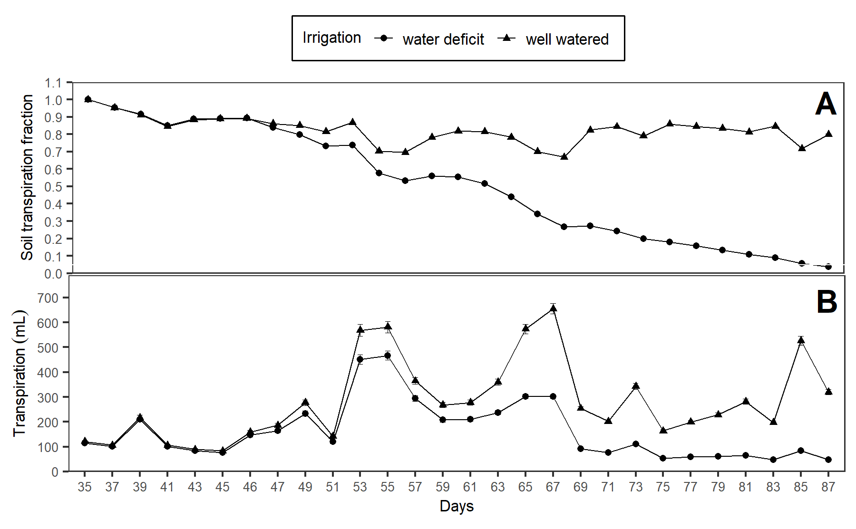

Figure 1: (A) Soil transpiration fraction (ftsw) and (B) Daily transpiration in 15 potato genotypes under well-watered (WW) and water deficit (WD) condition.

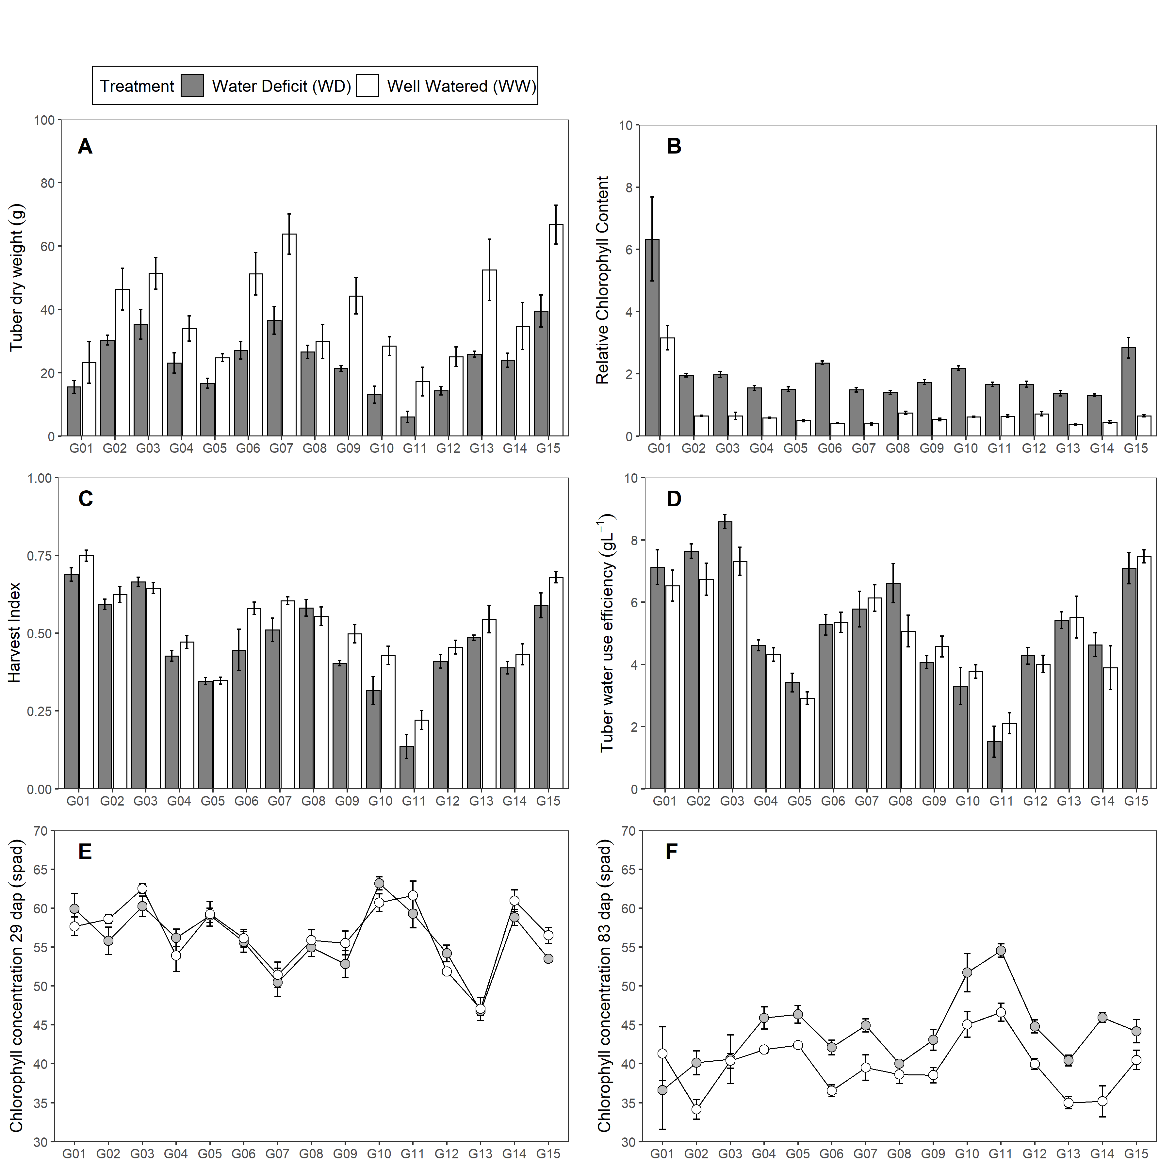

Figure 2: Traits measured in 15 potato genotypes under well-watered (WW) and water deficit (WD) condition. (A) Tuber dry weight (tdw; g). (B) Relative Chlorophyll Content (rcc). (C) Harvest Index (hi). (D) Tuber Water Use Efficiency (wuet; gL-1). D-E Chlorophyll Concentration (spad). Error bars indicate standard error (n = 5). dap is days after planting.

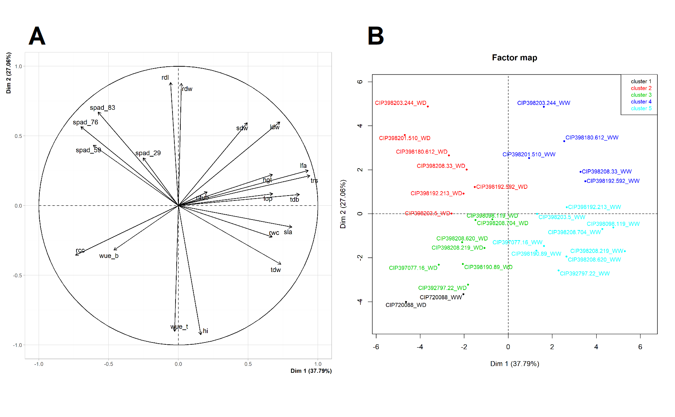

Figure 3: Principal Component Analysis (PCA) from variables measured in 15 potato genotypes under well-watered (WW) and water deficit (WD) condition. (A) PCA for the variables. (B) PCA for the genotypes under WW and WD. Where: Chlorophyll Concentration (spad), Plant height (hgt; cm), Relative water content (rwc; %), Leaf osmotic potential (lop; MPa), Leaf dry weight (ldw; g), Stem dry weight (sdw; g), Root dry weight (rdw; g), Tuber dry weight (tdw; g), Tuber number (ntub; N°), Total transpiration (trs; mL), Leaf area (lfa; cm2), Root length (rdl; cm), Total dry biomass (tdb; g), Harvest Index (hi), Specific Leaf Area (sla; cm2g-1), Relative Chlorophyll Content (rcc), Biomass water use efficiency (wueb; gL-1), Tuber Water Use Efficiency (wuet; gL-1).

# Supplementary figure 1

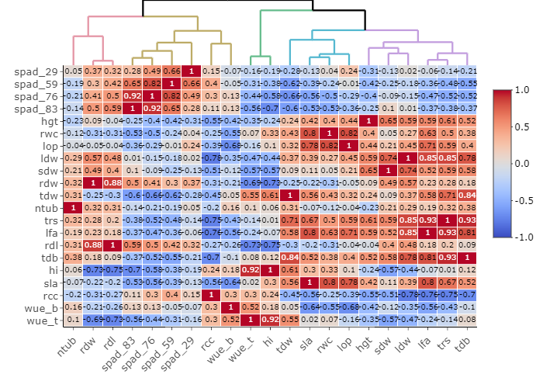

Figure 4: Relationships among agro-morphological traits evaluated in well-watered (WW) and water deficit (WD) condition based on Pearson correlation and Euclidean distance measured in 15 potato genotypes. Where: Chlorophyll Concentration (spad), Plant height (hgt; cm), Relative water content (rwc; %), Leaf osmotic potential (lop; MPa), Leaf dry weight (ldw; g), Stem dry weight (sdw; g), Root dry weight (rdw; g), Tuber dry weight (tdw; g), Tuber number (ntub; N°), Total transpiration (trs; mL), Leaf area (lfa; cm2), Root length (rdl; cm), Total dry biomass (tdb; g), Harvest Index (hi), Specific Leaf Area (sla; cm2g-1), Relative Chlorophyll Content (rcc), Biomass water use efficiency (wueb; gL-1), Tuber Water Use Efficiency (wuet; gL-1).

# Supplementary figure 2

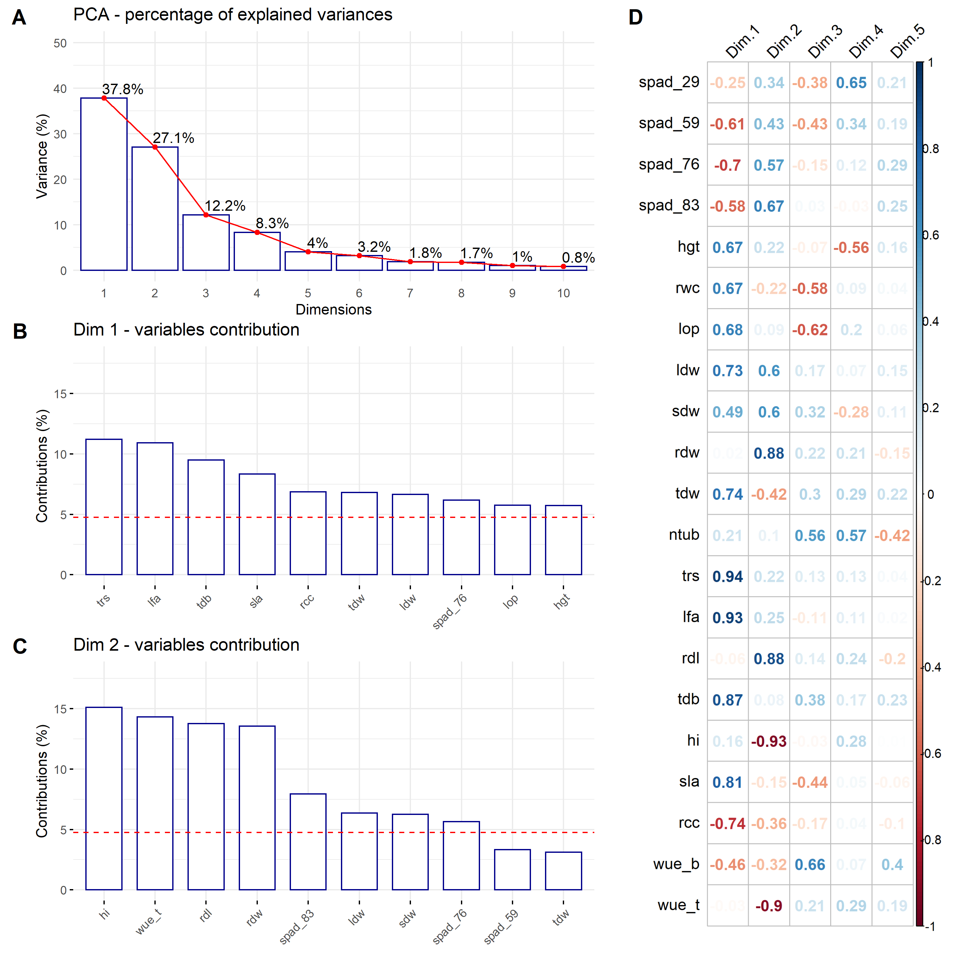

Figure 5: Principal Component Analysis (PCA). (A) Percentage of the explained variance for each dimension. (B) Variance contribution of the first 10 variables in the dimension 1. (C) Variance contribution of the first 10 variables in the dimension 2. (D) Correlation between the studied variables and among the first 5 dimensions. The reference dashed lines on the bar plot corresponds to the expected value if the contribution between the variables where uniform.

# Supplementary figure 3

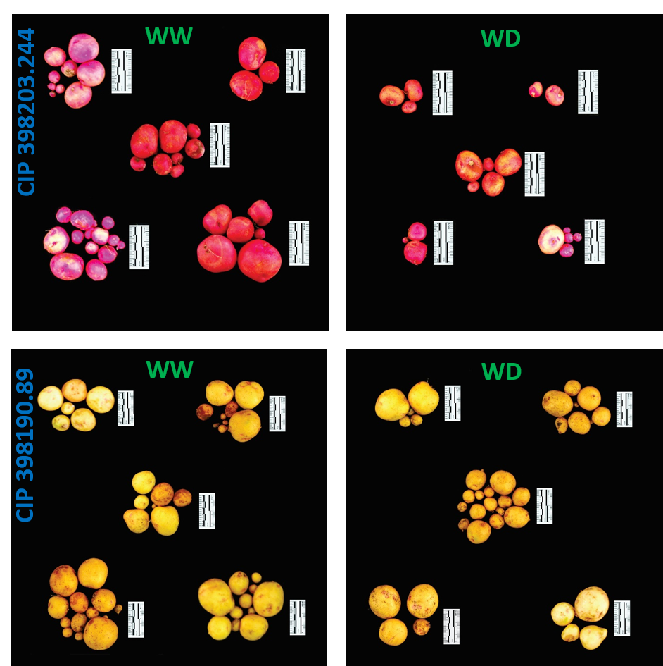

Figure 6: Tuber yield performance from two contrasting potato genotype. Genotype CIP 398203.244 with good performance under well-watered (WW) with reduced yields during water deficit (WD) condition. Genotype CIP 398190.89 with good response under well-watered (WW) and water deficit (WD) treatment. Each group represent one replication (n = 5). Scale displayed alongside the tubers with 5 cm (black/white segment = 1 cm).