Germination behavior of *Jatropha curcas* L. after different imbibition times

Lozano-Isla, F.1, Miranda, PV.1, Pompelli, MF.1,*

2017-12-28

# Afilliation

1 Plant Physiology Laboratory, Federal University of Pernambuco, Department of Botany, Recife, PE, Brazil, 50670901

* Corresponding author. E-mail address: [marcelo.pompelli@ufpe.br](mailto:marcelo.pompelli@ufpe.br) (M.F. Pompelli). Tel.: +55 81 2126 8352; fax: +55 81 2126 7803

# Abstract

*Jatropha curcas* is an important specie for production of bio fuel. The specie can survive and produce fruits and seeds even in drought condition. For an adequate establishment in the field is necessary that seeds have good quality in vigor and viability. In this study, we evaluated the seed water relation with different imbibition times, in deionized water, from 0 to 24 hours. Imbibed seeds were sown in polyethylene trays with 1200 g of river sand. The germination was recorded every day for 25 days. Seeds with at least 10 mm radicle on the soil surface was considered as germinated. To determinate seed water content (SWC), 10 seeds were weighed in fresh (SFW), turgid (STW) and dry weight (SDW) at 105°C for 24 hours. After 24 hours of imbibition our results show a decrease in the germination rate from 85% to 47%, and an increase of the mean germination time from 4.8 to 7.1 days. The initial moisture of the seed used in this experiment was about 8% and after 24 hours of imbibition the SWC was around 60%. The initial low moisture in the seeds produce imbibition damage because the tissue hydration takes place in a not controlled way so that the reconstruction of internal structures of the cells and organelles were affected. According to the PCA analysis the seed germination had a negative correlation with the imbibition time (r = -0.72, p < 0.05) and with the electrical conductive (r = -0.88, p < 0.05), variables related to the seed vigor. This study suggests that electrical conductivity may be useful in *J. curcas* for vigor test and their seeds don’t need previously water imbibition to improve germination from seeds with initial moisture less than 8%.

**Key words:** bio fuel, seed water content, seed moisture, germinability

# Introduction

*Jatropha curcas* L. belongs to the family Euphorbiaceae, is native to the American tropics (Abhilash et al., 2010). This species can present as a small tree with 6 m in height (Sunil et al., 2013). *J. curcas* is a seed-bearing plant and can produce from 1500 to 2000 kg of seed per hectare/year or 540 to 680 liters of biofuel per hectare, considering that *J. curcas* seeds contain about 40% to 58% of oil (Pandey et al., 2012; Marcelo Francisco Pompelli et al., 2010). Moreover, *J. curcas* is a non-edible, eco-friendly, non-toxic, biodegradable fuel-producing plant that has attracted worldwide attention as an alternative sustainable energy source for the future (Dharma et al., 2017). This species can be cultivated on marginal and salt affected areas, without competing with crop food production (Elhag and Gafar, 2014). In general, more than 95% of the oil produced for biodiesel purposes comes from edible oils, like corn and soy, which can have a negative impact on food production (khan et al., 2014). Thus, *J. curcas* seeds seems as a good source of oil and it has great economic potential as an alternative biofuel (Berchmans and Hirata, 2008; Chen et al., 2008).

The seeds of *J. curcas* have a short viability period and they are more sensitive to salinity at germination (Elhag and Gafar, 2014; Moncaleano-Escandon et al., 2013). *J. curcas* is drought tolerant (Arcoverde et al., 2011; Marcelo F. Pompelli et al., 2010) and probably also has salinity tolerant (Lozano-Isla, in prep.).

Seed deterioration is a natural and irreversible process, even under ideal storage conditions (Castellión et al., 2010; Copeland and McDonald, 1999; Marcos-Filho, 1998; Moncaleano-Escandon et al., 2013). While deterioration is both irreversible and inevitable, the speed of the process can be controlled with appropriate harvesting, drying and storage techniques. There are several factors that are known to influence the progress of deterioration during seed storage. Both high temperatures and humidity during storage increase the deterioration speed of seeds (Copeland and McDonald, 1999; Pukacka et al., 2009), and decreasing either of these factors significantly increases the storage life of seeds (Castellión et al., 2010). Dry seeds suffer a variety of biochemical and metabolic changes, including lipid peroxidation, enzyme inactivation and rupture of cellular membranes (Alencar et al., 2015; Moncaleano-Escandon et al., 2013). In another way, seed imbibition is an important process in the plant life cycle and determines whether seed germination and plant growth will be successful or not (Ribeiro et al., 2015). In arid environments, the water needed for germination is available for only short periods and consequently, successful crop establishment depends not only on rapid and uniform germination of the seed, but also on the ability of the seed to germinate under low water availability (Windauer et al., 2007). The speed and uniformity of seed germination are prominent parameters especially for field crop seeds to compete with weed seeds (Ruttanaruangboworn et al., 2017). Water uptake is the fundamental requirement for the initiation and completion of seed germination (Koornneef et al., 2002). Studies on germination and seedling establishment which are the critical stages in the plant life cycle and in *J. curcas* have not been conducted. Knowledge of the capacity of the species to complete this stage successfully is fundamental for crop production (Windauer et al., 2011). Considerable variation was registered in *J. curcas* for seed germination, seedling growth and biomass parameters. The small value of error or environmental variances of the seedling growth traits suggests that the majority of characters are under genetic control (Ginwal et al., 2005).

Based on these, the main objective of this study was to evaluate the behavior of *J. curcas* seeds under different imbibition time, seed water relation and aspects about germination.

# Materials and Methods

## Plant material

The experiment was carried out with 2 kg of *Jatropha curcas* seeds were collected in a commercial plantation from the Atlantic rain forest region (09°28’S; 35°51’W m.a.s.l.). The plantation consisted of plants that were at least 8 years of age, and the spacing between plants was 2 m × 2 m. Fruits of *J. curcas* were randomly collected during the rainy season from 2015. The seeds presented 72% viability and stored as recommended by Moncaleano-Escandon et al. (2013).

## Seed imbibiton test and water relation

The seeds were distributed in 52 frasks (400 mL) with 25 seed for each experimental unit in a controlled room chamber at 25°C. For each frask, 100 ml deionized water was applied, according to the imbibition treatment (0, 2, 4, 6, 8, 10, 12, 14, 16, 18, 20, 22 and 24 hours). The pH (W3B, Bel Engineering, Italy) and electrical conductivity (CD-4306, Lutron, Taiwan) were evaluated with 20 mL of soaking solution for each imbibition treatment. For seed water content, 50 mL deionized water was applied in frasks of 100 mL and were added 10 seed previously weighted in an analytic scale, according to different imbibition time. After each treatment was take the seeds imbibition weight and putted in papers bags for oven at 105°C for 24 hours and determinate seeds dry weight. The water relation variables were calculated according the following formulas: $SMT(\%)=1−(S_{dw}/S_{fw})*100$ and $SWC(\%)=(S_{tw}−S_{fw})/S_{fw}*100$. Where $SMT(\%)$, Seed moisture; $SWC(\%)$ Seed Water content; $S_{dw}(g)$, Seed dry weight; $S_{fw}(g)$, Seed fresh weight and $S_{tw}(g)$, Seed turgid weight.

## Germination test

For each replication treatment, 25 seeds were uniformly distributed in polyethylene trays content 1000 g of river sand and covered with 200 g of the substrate. The germination experiment was carried out in greenhouse condition with average temperature of 27.5°C and 78% relative humidity. Seed germination was evaluated daily according to agronomic criteria consider germinated seed when the radicle had emerged about 10 mm above the soil surface. When no additional germination was observed in all treatments at least in five consecutive days, the germination was considered completed (Moncaleano-Escandon et al., 2013).

## Data analysis

The experiment was carried out in a completely randomized design with 13 treatments of imbibition times (0, 2, 4, 6, 8, 10, 12, 14, 16, 18, 20, 22 and 24 hours) with four replications with seeds of *J. curcas*. Statistical analysis were performed in the statistical software R (R Core Team, 2017). The analysis of variance (ANOVA) was performed to evaluate the differences between the factors and the comparison of the means with the Student-Newman-Keuls test (p <0.05) (de Mendiburu, 2017). The germination variables and graphs were performed according the GerminaR R package (Lozano Isla et al., 2017). For the multivariate analysis, correlation analysis (de Mendiburu, 2017; Wei and Simko, 2017) and principal component analysis were conducted (Husson et al., 2017).

# Results

## Electrical conductivity and pH evaluation

The water solution from the soaked seeds showed variation under the imbibition time for electrical conductivity (EC) and pH, Figure 1 A-B. The pH range from 7.7 to 5.1 showing difference between the different imbibition time with a reduction of the pH in the time (r = -0.88, p<0.05), Figure 1 A. While the EC show a increase in relation to imbibition time (r = 0.80, p<0.05) with value ranges from 0.021 to 0.69 dS m−1, Figure 1 B. According the correlation analysis exits a negative correlation between EC and pH (r = -0.74, p<0.05).

## Seed water relation

The initial seed moisture (SMT) was 7.9% and after 24 hours of imbibition was 9.5%, Figure 1 C. The SMT show a strong positive correlation with the imbibition time (r = 0.89, p<0.05). While the seed water content (SWC) show a fast increase reaching up to 25.7% until the first two hour of imbibition; afterwards, the SWC increases continuously to about 59.2% in 24 hours shown an increase around 6.5 times from initial values, Figure 1 D; this results is supported for a high correlation between imbibition time with the SWC (r = 0.93, p<0.05). Also exist a high correlation (r = 0.96, p<0.05) between SMT and SWC.

## Seed germination analisys

Initial germinability of 85% of the seeds of *J. curcas* decreases significantly after 2 hours of imbibition. After that, the range of germinability was 68% to 44% from 2 to 24 hour of imbibition (Figure 2 A), showing a strong negative correlation with imbibition time (r = -0.72, p<0.05). The mean germination time from seed without imbibition has a value at 4.8 day in comparison with the other treatments with values around 5.9 to 7.1 day for germination for 2 to 24 hours of imbibition (Figure 2 B). Seed germinability presented a negative strong correlation with a mean germination time (r = −0.88, p<0.05). The germination synchrony didn’t show difference between the imbibition times (Figure 2 C); For the experiment, the maximum value for the uncertainty is 4.64 bits and the values ranged from 1.86 to 2.34 bits without difference between treatments and the results didn’t show any trend with the imbibition time. While the germination synchrony show a high correlation (r = −0.92, p<0.05) with the germination uncertainty.

## Multivariate analisys

The principal component analysis according to the studied variables explain 75.03% of the variance between the first and second dimension. In the first dimension there is a high positive correlation between ELC (r = 0.97, p<0.05), SWC (r = 0.96, p<0.05), SMT (r = 0.91, p<0.05), STW (r = 0.91, p<0.05), IBTH (r = 0.87, p<0.05), MGT (r = 0.82, p<0.05) with a negative correlation with the GRP (r = -0.92, p<0.05) while in the second dimension SFW (r = 0.77, p<0.05), SDW (r = 0.71, p<0.05) present positive correlation in contrast with HPT (r = -0.75, p<0.05) with negative correlation.

# Discussion

The water content in seeds with impermeable seed coats has important implications for germination, because impermeable coats prevent germination until environmental conditions promote water absorption by seeds followed by germination (Kestring et al., 2009; Ribeiro et al., 2015). This study found a reduction in the seed germination of *J. curcas*, according to seed water imbibition. It is supposed that seeds need a small amount of water for promote the germination because the water imbibition had linearly decrease the germinability and increase its mean germination time, two parameters related to the seed vigor. This phenomena was previously reported in other species, like corn (Matthews and Hosseini, 2006), rice (Ruttanaruangboworn et al., 2017) castor oil (Ribeiro et al., 2015) and *Astrophytum* species (Sánchez-Salas et al., 2012); however, in contrast of *Mimosa bimucronata* (Kestring et al., 2009) a floodplain species, where the water uptake sharply increases the seed germination. Also, it was observed during the time line of the experiment there was an increase in EC that reflect in lost the seed germinability from seed steeping in water from 2 to 24 hours.

The seeds used in this experiment were stored in dry environments and hence had very low levels of metabolism. We argue that, during seed imbibition, they swell and metabolic activity increases. Hydration of tissue components during imbibition takes place in a not controlled way so that the reconstruction of internal structures of the cells and organelles were affected. So, leakage of stored components and enzymes, colouring, cracking or absence of cotyledons, and overall damage to the hypocotyl may occur during germination (Hobbs and Obendorf, 1972; Pollock et al., 1969). The amount of the constituents of the leaked depended unequivocally on the initial water content of seeds; the lower moisture in seed at the initial water content show more leakage occurring in seeds with the initial water content of 24.2% (ISHIDA et al., 1988). This damage takes place in the early stages of imbibition (Parrish and Leopold, 1977). This indicates that membrane functions are restored, even though the activities of respiration and metabolism are restricted. Water molecules are semi-bound and mobile water necessary for metabolism is deficient for moisture contents between 12-24% (Koizumi et al., 2008). According to these, the loss of viability can be explained base on the initial seed water content of the seeds used in the experiment because they had an initial moisture around 8%, that is low value compared with the moisture at harvest that is around 18% (Marcelo Francisco Pompelli et al., 2010); a possible explanation could be the lost of water by storage condition of the seed for the experiment. In other crops like soybean seeds, water content is usually 10 to 20% at harvest and falls further during storage, seed water contents below 10% were shown to be desirable for long period storage because seeds stop their biological activities and the stored materials are consumed at a minimum level (Windauer et al., 2007). *J. curcas* seeds after 24 hour of imbibition increases 6.5 times its initial moisture as reported in soybean seeds (ISHIDA et al., 1988). Dried seeds can raise their water content to a certain level, two or three times the dry weight, and this rapid increase of water is often accompanied by some deterioration of the tissues, called imbibitional damage. This damage is expressed as a reduced rate of germination and reduced yield of surviving plants (ISHIDA et al., 1988). It can be the reason in decrease in the germination percentage in this research. It was reported that soybean seeds with the water content below 13% suffered seriously from imbibitional damage while those above 17% did not, where respiration and metabolic activity rapidly increase with the increase of moisture content (ISHIDA et al., 1988; Vertucci and Leopold, 1984). Imbibition damage results from the rapid entry of water into the cotyledons during imbibition, leading to cell death and high solute leakage from the seeds (POWELL et al., 1986) and the extensive loss of cellular material and enzymes from the seeds (Duke and Kakefuda, 1981; POWELL and MATTHEWS, 1981) indicates extensive membrane disruption. The electrical conductivity was related to seed water content and the germination for this reason EC tests has been applied to detect vigor differences in many other grain legumes and indeed some other species (Hampton and TeKRONY, 1995; Moncaleano-Escandon et al., 2013). The conductivity will increase as the laboratory germination falls, in addition to the reduced ability of germination seeds to retain cell contents (Matthews and Hosseini, 2006). Reports on pea lots, the EC readings for lots have been found to relate significantly to field emergence (POWELL and MATTHEWS, 1981; THORNTON et al., 1990).

To alleviate the effects of imbibition damage as a result of the increase in the water content of seeds, a slow and controlled hydration is essential as the first step in the reactivation of metabolic processes in dry seed (Vertucci and Leopold, 1984) leading an increase in the germination and growth ability. The EC vigor test would be developed and standardized for these species (Abdullah et al., 1991; Powell, 1986; Yaklich and Kulik, 1979). Furthermore, it was reported than the relationship between field emergence and EC turned out to be not only interesting, but useful in practical seed technology (Matthews and Powell, 2006) as present in these work for *J. curcas*.

# Conclusions

The initial water content in *J. curcas* seeds should be consider at germination because it will alter seed germinability according to the imbibition time. The EC measurement could have a role such us ageing based vigor test or controlled deterioration test, by giving a measure of viability in 24 hours in place of a normal germination test that takes around 15 days or longer in *J. curcas*.

# Acknowledgments

The authors thanks the National Council for Scientific and Technological Development (CNPq Grants 404357/2013-0) for financial support to the work execution. The first author thanks the Coordination of Improvement of Higher Education Personnel (CAPES) for the scholarship. The authors would also like to thank Noellle B. Vanderlei dos Santos for their kind revisions of this manuscript.

# Figures & tables

## Figures

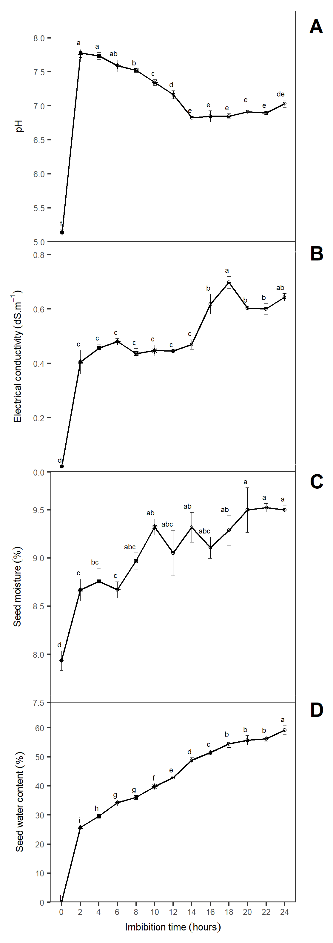

Figure 1 Response of *Jatropha curcas* seeds after different imbition time. (A) pH; (B) Electrical conductivity; (C) Seed moisture and (D) Seed water content. The letter represent the mean difference with Student-Newman-Keuls test (p = 0.05). Means are represent with (±SE). n = 4.

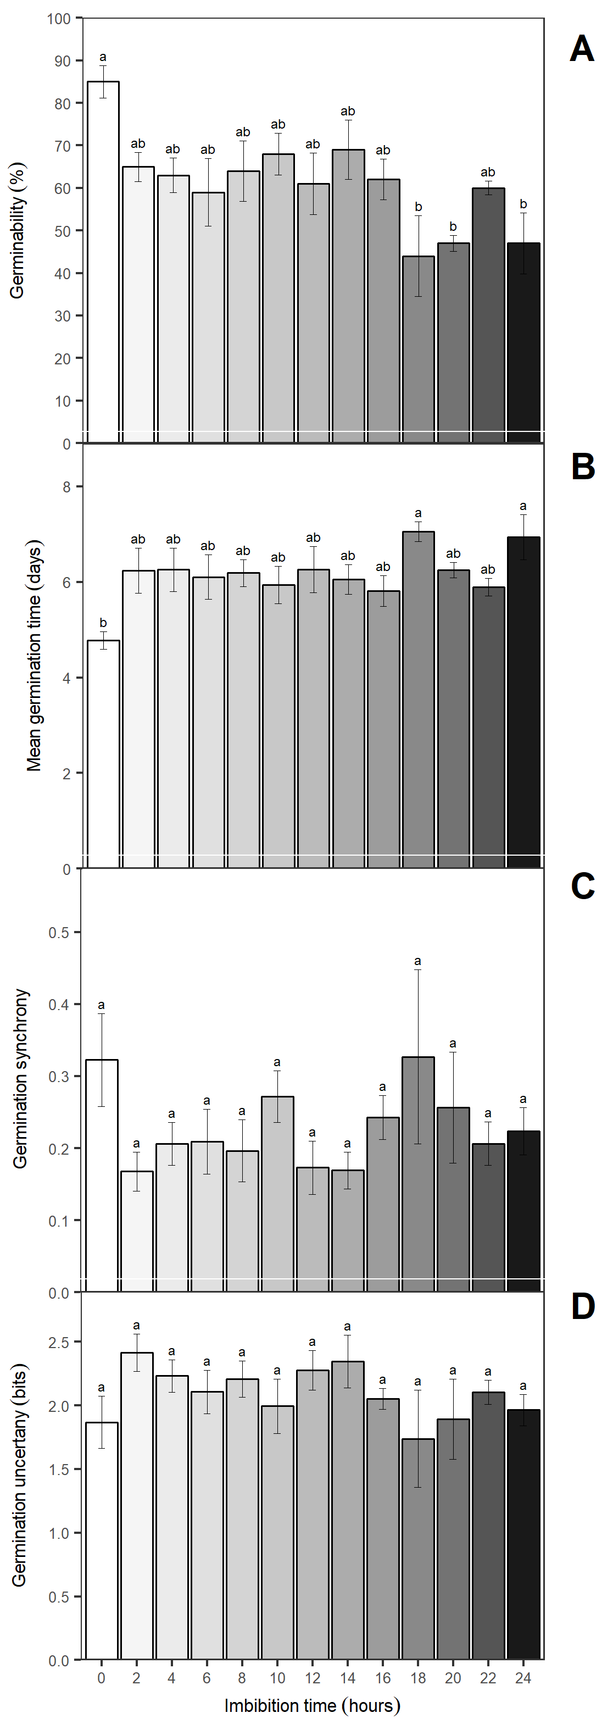

Figure 2 Germination response in *Jatropha curcas* seeds after different imbition times. (A) Germination (%); (B) Mean germination time (days); (C) Germination synchrony and (D) Germination uncertany (bits). The letter represent the mean difference with Student-Newman-Keuls test (p = 0.05). Means are represent with (±SE). n = 4.

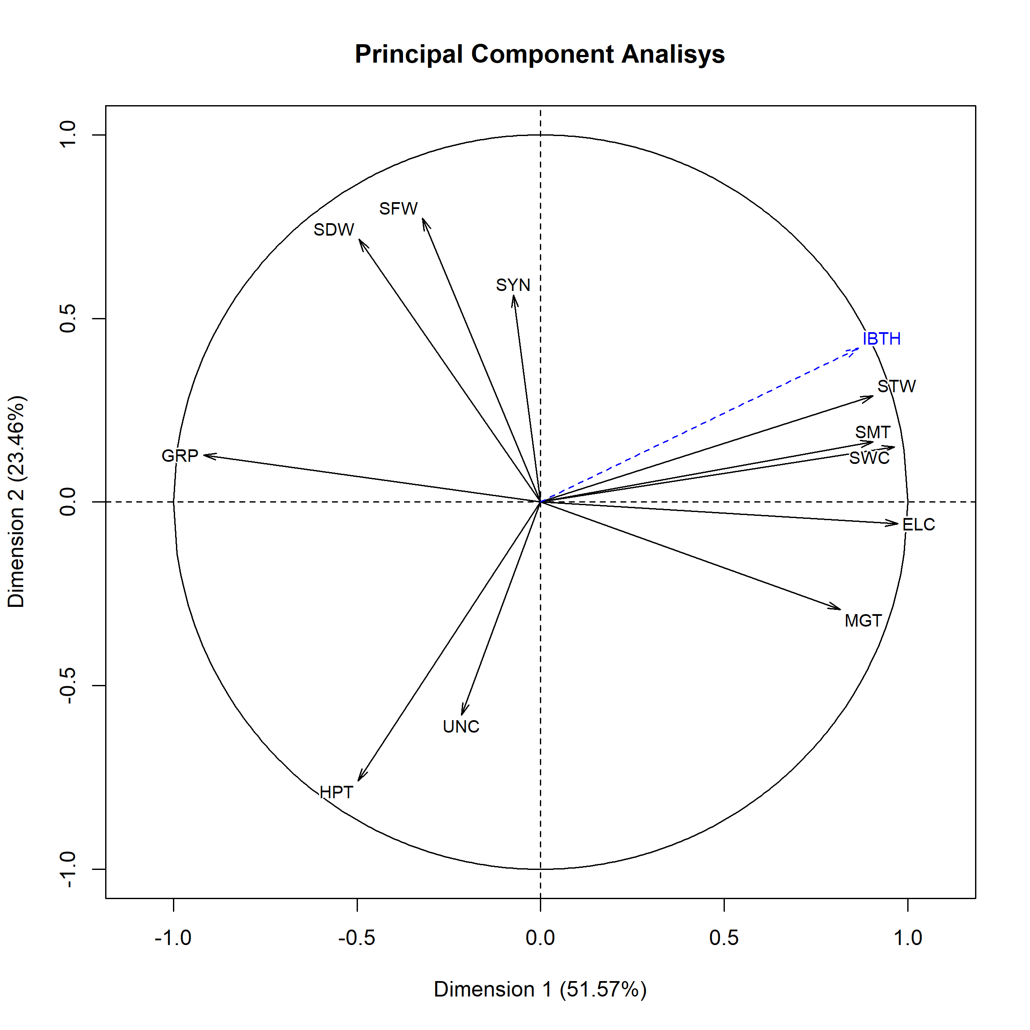

Figure 3 Principal Component Analysis from the variables in *Jatropha curcas* seeds after different imbition times. Where: IBTH, imbibition time; GRP, germination percentage; MGT, mean germination time; SYN, germination synchrony; pH, potential of hydrogen; EC, electrical conducntivity; SWC, seed water content; SMT, seed moisture; SDW, seed dry weight; SFW, seed fresh weight; STW, seed turgid weight.

# References

Abdullah, W.D., Powell, A.A., Matthews, S., 1991. Association of differences in seed vigour in long bean ( vigna sesquipedalis) with testa colour and imbibition damage. The Journal of Agricultural Science 116, 259. <https://doi.org/10.1017/s0021859600077662>

Abhilash, P.C., Srivastava, P., Jamil, S., Singh, N., 2010. Revisited jatropha curcas as an oil plant of multiple benefits: Critical research needs and prospects for the future. Environmental Science and Pollution Research 18, 127–131. <https://doi.org/10.1007/s11356-010-0400-5>

Alencar, N.L.M., Gadelha, C.G., Gall�o, M.I., Dolder, M.A.H., Prisco, J.T., Gomes-Filho, E., 2015. Ultrastructural and biochemical changes induced by salt stress in jatropha curcas seeds during germination and seedling development. Functional Plant Biology 42, 865. <https://doi.org/10.1071/fp15019>

Arcoverde, G.B., Rodrigues, B.M., Pompelli, M.F., Santos, M.G., 2011. Water relations and some aspects of leaf metabolism of jatropha curcas young plants under two water deficit levels and recovery. Brazilian Journal of Plant Physiology 23, 123–130. <https://doi.org/10.1590/s1677-04202011000200004>

Berchmans, H.J., Hirata, S., 2008. Biodiesel production from crude jatropha curcas l. seed oil with a high content of free fatty acids. Bioresource Technology 99, 1716–1721. <https://doi.org/10.1016/j.biortech.2007.03.051>

Castellión, M., Matiacevich, S., Buera, P., Maldonado, S., 2010. Protein deterioration and longevity of quinoa seeds during long-term storage. Food Chemistry 121, 952–958. <https://doi.org/10.1016/j.foodchem.2010.01.025>

Chen, B., Landsman-Ross, N., Naughton, R., Olenyik, K., 2008. Jatropha curcas l.: Biodiesel solution or all hype. A scientific approach, economic and political analysis of the future energy crop. Chicago Univ., Energy and Energy policy, Spring 1001–1005.

Copeland, L.O., McDonald, M.B., 1999. Seed longevity and deterioration. Springer US. <https://doi.org/10.1007/978-1-4615-1783-2_8>

de Mendiburu, F., 2017. Agricolae: Statistical procedures for agricultural research.

Dharma, S., Hassan, M.H., Ong, H.C., Sebayang, A.H., Silitonga, A.S., Kusumo, F., Milano, J., 2017. Experimental study and prediction of the performance and exhaust emissions of mixed jatropha curcas-ceiba pentandra biodiesel blends in diesel engine using artificial neural networks. Journal of Cleaner Production 164, 618–633. <https://doi.org/10.1016/j.jclepro.2017.06.065>

Duke, S.H., Kakefuda, G., 1981. Role of the testa in preventing cellular rupture during imbibition of legume seeds. PLANT PHYSIOLOGY 67, 449–456. <https://doi.org/10.1104/pp.67.3.449>

Elhag, A.Z., Gafar, M.O., 2014. Effect of sodium chloride on growth of jatropha (jatropha curcas l.) young transplants. Universal Journal of Plant Science 2, 19–22.

Ginwal, H., Phartyal, S., Rawat, P., Srivastava, R., others, 2005. Seed source variation in morphology, germination and seedling growth of jatropha curcas linn. in central india. Silvae genetica 54, 76–79.

Hampton, J.G., TeKRONY, D.M., 1995. Handbook of vigour test methods. The International Seed Testing Association, Zurich (Switzerland).

Hobbs, P.R., Obendorf, R.L., 1972. Interaction of initial seed moisture and imbibitional temperature on germination and productivity of soybean1. Crop Science 12, 664. <https://doi.org/10.2135/cropsci1972.0011183x001200050033x>

Husson, F., Josse, J., Le, S., Mazet, J., 2017. FactoMineR: Multivariate exploratory data analysis and data mining.

ISHIDA, N., KANO, H., KOBAYASHI, T., YOSHIDA, T., 1988. Analysis of physical states of water in soybean seeds by NMR. Agricultural and Biological Chemistry 52, 2777–2781. <https://doi.org/10.1271/bbb1961.52.2777>

Kestring, D., Klein, J., Menezes, L.C.C.R. de, Rossi, M.N., 2009. Imbibition phases and germination response of mimosa bimucronata (fabaceae: Mimosoideae) to water submersion. Aquatic Botany 91, 105–109. <https://doi.org/10.1016/j.aquabot.2009.03.004>

khan, T.Y., Atabani, A., Badruddin, I.A., Badarudin, A., Khayoon, M., Triwahyono, S., 2014. Recent scenario and technologies to utilize non-edible oils for biodiesel production. Renewable and Sustainable Energy Reviews 37, 840–851. <https://doi.org/10.1016/j.rser.2014.05.064>

Koizumi, M., Kikuchi, K., Isobe, S., Ishida, N., Naito, S., Kano, H., 2008. Role of seed coat in imbibing soybean seeds observed by micro-magnetic resonance imaging. Annals of Botany 102, 343–352. <https://doi.org/10.1093/aob/mcn095>

Koornneef, M., Bentsink, L., Hilhorst, H., 2002. Seed dormancy and germination. Current Opinion in Plant Biology 5, 33–36. <https://doi.org/10.1016/s1369-5266(01)00219-9>

Lozano Isla, F., Benites Alfaro, O., Pompelli, M.F., 2017. GerminaR: Germination indexes for seed germination variables for ecophysiological studies.

Marcos-Filho, J., 1998. New approaches to seed vigor testing. Scientia Agricola 55, 27–33. <https://doi.org/10.1590/s0103-90161998000500005>

Matthews, S., Hosseini, M.K., 2006. Mean germination time as an indicator of emergence performance in soil of seed lots of maize (zea mays). Seed Science and Technology 34, 339–347. <https://doi.org/10.15258/sst.2006.34.2.09>

Matthews, S., Powell, A., 2006. Electrical conductivity vigour test: Physiological basis and use. Seed Testing International 131, 32–35.

Moncaleano-Escandon, J., Silva, B.C., Silva, S.R., Granja, J.A., Alves, M.C.J., Pompelli, M.F., 2013. Germination responses of jatropha curcas l. seeds to storage and aging. Industrial Crops and Products 44, 684–690. <https://doi.org/10.1016/j.indcrop.2012.08.035>

Pandey, V.C., Singh, K., Singh, J.S., Kumar, A., Singh, B., Singh, R.P., 2012. Jatropha curcas: A potential biofuel plant for sustainable environmental development. Renewable and Sustainable Energy Reviews 16, 2870–2883. <https://doi.org/10.1016/j.rser.2012.02.004>

Parrish, D.J., Leopold, A.C., 1977. Transient changes during soybean imbibition. PLANT PHYSIOLOGY 59, 1111–1115. <https://doi.org/10.1104/pp.59.6.1111>

Pollock, B., Roos, E., Manalo, J., 1969. Vigor of garden bean seeds and seedlings influenced by initial seed moisture, substrate oxygen, and imbibition temperature. Journal of the American Society for Horticultural Science 94, 577–584.

Pompelli, M.F., Barata-Luís, R., Vitorino, H.S., Gonçalves, E.R., Rolim, E.V., Santos, M.G., Almeida-Cortez, J.S., Ferreira, V.M., Lemos, E.E., Endres, L., 2010. Photosynthesis, photoprotection and antioxidant activity of purging nut under drought deficit and recovery. Biomass and Bioenergy 34, 1207–1215. <https://doi.org/10.1016/j.biombioe.2010.03.011>

Pompelli, M.F., Rocha Gomes Ferreira, D.T. da, Silva Cavalcante, P.G. da, Lima Salvador, T. de, Hsie, B.S. de, Endres, L., 2010. Environmental influence on the physico-chemical and physiological properties ofJatropha curcasseeds. Australian Journal of Botany 58, 421. <https://doi.org/10.1071/bt10102>

Powell, A.A., 1986. Cell membranes and seed leachate conductivity in relation to the quality of seed for sowing. Journal of Seed Technology 81–100.

POWELL, A.A., MATTHEWS, S., 1981. A physical explanation for solute leakage from dry pea embryos during imbibition. Journal of Experimental Botany 32, 1045–1050. <https://doi.org/10.1093/jxb/32.5.1045>

POWELL, A.A., OLIVEIRA, M.D.A., MATTHEWS, S., 1986. The role of imbibition damage in determining the vigour of white and coloured seed lots of dwarf french beans (phaseolus vulgaris). Journal of Experimental Botany 37, 716–722. <https://doi.org/10.1093/jxb/37.5.716>

Pukacka, S., Ratajczak, E., Kalemba, E., 2009. Non-reducing sugar levels in beech (fagus sylvatica) seeds as related to withstanding desiccation and storage. Journal of Plant Physiology 166, 1381–1390. <https://doi.org/10.1016/j.jplph.2009.02.013>

R Core Team, 2017. R: A language and environment for statistical computing. R Foundation for Statistical Computing, Vienna, Austria.

Ribeiro, P.R., Willems, L.A., Mudde, E., Fernandez, L.G., Castro, R.D. de, Ligterink, W., Hilhorst, H.W., 2015. Metabolite profiling of the oilseed crop ricinus communis during early seed imbibition reveals a specific metabolic signature in response to temperature. Industrial Crops and Products 67, 305–309. <https://doi.org/10.1016/j.indcrop.2015.01.067>

Ruttanaruangboworn, A., Chanprasert, W., Tobunluepop, P., Onwimol, D., 2017. Effect of seed priming with different concentrations of potassium nitrate on the pattern of seed imbibition and germination of rice ( oryza sativa l.). Journal of Integrative Agriculture 16, 605–613. <https://doi.org/10.1016/s2095-3119(16)61441-7>

Sánchez-Salas, J., Jurado, E., Flores, J., Estrada-Castillón, E., Muro-Pérez, G., 2012. Desert species adapted for dispersal and germination during floods: Experimental evidence in two astrophytum species (cactaceae). Flora - Morphology, Distribution, Functional Ecology of Plants 207, 707–711. <https://doi.org/10.1016/j.flora.2012.08.002>

Sunil, N., Kumar, V., Sujatha, M., Rao, G.R., Varaprasad, K.S., 2013. Minimal descriptors for characterization and evaluation of jatropha curcas l. germplasm for utilization in crop improvement. Biomass and Bioenergy 48, 239–249. <https://doi.org/10.1016/j.biombioe.2012.11.008>

THORNTON, J.M., POWELL, A.A., MATTHEWS, S., 1990. Investigation of the relationship between seed leachate conductivity and the germination of brassica seed. Annals of Applied Biology 117, 129–135. <https://doi.org/10.1111/j.1744-7348.1990.tb04201.x>

Vertucci, C.W., Leopold, A.C., 1984. Bound water in soybean seed and its relation to respiration and imbibitional damage. PLANT PHYSIOLOGY 75, 114–117. <https://doi.org/10.1104/pp.75.1.114>

Wei, T., Simko, V., 2017. Corrplot: Visualization of a correlation matrix.

Windauer, L., Altuna, A., Benech-Arnold, R., 2007. Hydrotime analysis of lesquerella fendleri seed germination responses to priming treatments. Industrial Crops and Products 25, 70–74. <https://doi.org/10.1016/j.indcrop.2006.07.004>

Windauer, L.B., Martinez, J., Rapoport, D., Wassner, D., Benech-Arnold, R., 2011. Germination responses to temperature and water potential in jatropha curcas seeds: A hydrotime model explains the difference between dormancy expression and dormancy induction at different incubation temperatures. Annals of Botany 109, 265–273. <https://doi.org/10.1093/aob/mcr242>

Yaklich, R.W., Kulik, M.M., 1979. Evaluation of vigor tests in soybean seeds: Relationship of the standard germination test, seedling vigor classification, seedling length, and tetrazolium staining to field performance1. Crop Science 19, 247. <https://doi.org/10.2135/cropsci1979.0011183x001900020019x>