GERMINATION OF *Jatropha curcas* L. AFTER DIFFERENT IMBIBITION TIME

Lozano-Isla, Flavio1, Miranda, P.V.V.C1, Pompelli, M.F.1*

2017-06-28

# Authors

1. Department of Botany, Rural Federal University of Pernambuco, Brazil.

**Corresponding author:** [mfpompelli@gmail.com](mailto:mfpompelli@gmail.com) (Marcelo F. Pompelli)

# Abstract

*Jatropha curcas* is a important specie for production of biofuel and his seeds oil content require less water. The plant can survive on infertile and under drougth condition. For an adequate establishment in the field is necessary that seed have good quality in vigor and viability. We studied the seed water relation for aim these objective was performed an experiment with different imbibition time from 0 to 24 hours in deionized water. Imbibed seeds were sown in aluminium containers with 1200 g of sand. The germination was recorded every day for 25 days. Seed with 1 cm radicle under the soild was considered as germinated. To determinate seed water relation were weighed 10 seeds in fresh, turgid and dry weight (104 ◦C for 24 hours). Our results show that exist decrease in germination according to a increase in seed imbibition time. The seed water content was about 8-10% and after 24 hours the seeds water content were around 60% . This study suggest that *J. curcas* don’t need previously water imbibition in order to improve germination percentage in seed with a initial water moisture less than 8%.

**Key words:** *Jatropha curcas* — biofuel — seed water content

# Introduction

*Jatropha curcas* L. belongs to the family Euphorbiaceae and originated in Mexico and Central America. It is a small tree but it can reach 6 meters or more. *J. curcas* is drought tolerant and perhaps also as salinity tolerant it can be cultivated on marginal and salt affected areas, without competing with crop food production (Elhag & Gafar, 2014; Heller, 1996). *J. curcas* is a seed-bearing plant and can produce 1-2 kg of seed per plant/year when the plant is 2-3 years old (Mukherjee, Varshney, Johnson, & Jha, 2011) and can be propagated both by seeds and stem cuttings. However, the seeds have a short viability period and they are more sensitive to salinity at germination (Elhag & Gafar, 2014; Moncaleano-Escandon et al., 2013).

*J. curcas* seeds are a good source of oil and It has great economic potential as an alternative to oil biofuel. The decorticated seeds contain 40-60% oil (Kumar, Makkar, Amselgruber, & Becker, 2010; SHAH, 2005) and is a non-edible, eco-friendly, non-toxic, biodegradable fuel-producing plant has attracted worldwide attention as an alternate sustainable energy source for the future (Mukherjee et al., 2011).

In arid environments, the water needed for germination is available for only short periods and, consequently, successful crop establishment depends not only on rapid and uniform germination of the seed, but also on the ability of the seed to germinate under low water availability (L. Windauer, Altuna, & Benech-Arnold, 2007). Water uptake is the fundamental requirement for the initiation and completion of seed germination (Koornneef, Bentsink, & Hilhorst, 2002). Studies on germination and seedling establishment which are the critical stages in the plant life cycle. In these important species have not been conducted so far. Knowledge of the capacity of the species to complete this stage successfully is fundamental for crop production (L. B. Windauer, Martinez, Rapoport, Wassner, & Benech-Arnold, 2011). Considerable variation was registered in *J. curcas* for seed germination, seedling growth and biomass parameters. The small value of error or environmental variances of the seedling growth traits suggests that majority of characters are under genetic control (Ginwal, Phartyal, Rawat, Srivastava, & others, 2005).

The main objective of this study was to evaluate the behavior of *J. curcas* seeds under different imbibition time, seed water relation and aspects about germination.

# Materials and methods

## Plant material

The experiment was carried out with commercial seeds (Commun Variety, BRSEEDS , Brazil). The seeds presented 72% viability and they were collected in 2013 and stored around 9% humidity with any pesticide treatment.

## Seed imbibiton test and water relation

The seeds was distributed in 52 cups (400 ml) with 25 seed in controled room at 25 °C. For each cup was applied 100 ml deionized water according to the imbibition treatment (0, 2, 4, 6, 8, 10, 12, 14, 16, 18, 20, 22 and 24 hours. The pH (W3B, Bel Engineering , Italy) and electrical conductivity (CD-4306, Lutron, Taiwan) for each treatment were evaluated both measurements were made with 20 ml of soaking solution. For seed water content 52 cups (100 ml) was applied 50 ml deionized water and were added 10 seed previously weight in a analytic scale (ATY224, Shimadzu, Japan) according to different imbibition time. After each treatment was take the imbibition weight and putted in papers bags for oven (104 ◦C for 24 hours) for determinate dry weight.The water relation variables were calculated according the following formulas: $SMT(\%)=1−(S_{dw}/S_{fw})*100$ and $SWC(\%)=(S_{tw}−S_{fw})/S_{fw}*100$. Where $SMT(\%)$, Seed moisture; $SWC(\%)$ Seed Water content; $S_{dw}(g)$, Seed dry weight; $S_{fw}(g)$, Seed fresh weight and $S_{tw}(g)$, Seed turgid weight.

## Germination test

The 25 seed from each treatment was sowing in aluminium trays content 1000 g of river sand at field capacity (1300 g). The seed was distributed in the tray and covered with 200 g sand. The germination experiment was carried out in greenhouse condition with 27.48 ◦C mean temperature and 78.05% relative humidity. Seed germination was evaluated daily according to agronomic criteria consider germinated seed when the radicle had emerged about 1 cm above the surface of sowing media. When no germination was observed in all treatments at least in five consecutive days, the germination was considered completed (Moncaleano-Escandon et al., 2013).

## Data analysis

The experimental was carried out in a completely randomized design with 13 treatments of imbibition times and four replications. The germination variables was calculated according the R package GerminaR (Lozano Isla, Benites Alfaro, & Pompelli, 2017). The data were subjected to analysis of variance (ANOVA) and means were compared by the Student-Newman-Keuls test (p < 0.05) (de Mendiburu, 2016), when significance was detected. The variables were subjected a Pearson Correlation Analysis (de Mendiburu, 2016; Husson, Josse, Le, & Mazet, 2017). The graphics were design under R statistical software (R Core Team, 2017; Wickham & Chang, 2016).

# Results

## Electrical conductivity and pH

The water solution from the imbibition show variation under the imbibiton time line (Figure 1) while there is a increase in the EC occur a decrease in pH. The pH range have a variation from 7.7 to 6.75 (CV = 1.73) and show a difference between the imbibition time (Fv = 33.17). The EC (CV = 8.66) show difference according to the experiment time line (Fv = 43.23) with value ranges 0.15 to 0.69 ds:m−1. There is a weak correlation (r = −0.47∗) between both variables but the EC have a strong correlation with the imbition time (r = 0.84∗∗∗),seed germination (r = −0.90∗∗∗), seed water moisture (r = 0,84∗∗∗) and seed water content (r = 0,90∗∗)∗.

## Seed water relation

The moisture in the seeds at the beginning of the experiment is around 8% and during the experiment time line it arrive around 10% (CV = 2,99). After a two hour of imbibition the seed has around 25% show a difference from the initial seed moisture (13%), afterwards these moment the water content in the seeds increase continuously to arrive around 60% in 24 hours (Figure 1). These increase in the water contest means around 6.5 times the initial moisture value.

## Seed germination analisys

Germination percentage have a significant decrease according to the imbibition time (Fv = 3.94) perceived since the 2 to 24 hours from initial imbibition with a value of 85% for 00 hour soaked to a range between 69-44% for 02 to 24 hour soaked (Figure 2). Germination Percentage present a strong negative correlation with Imbibition time (r = −0.72∗∗∗). Seed mean germination time in seed without imbibiton treatment has a major value with around 4.8 day in comparative with the other treatment with values around 5.81 to 7.00 day for these variable. Seed Germination Percentage negative strong correlation (r = −0.88∗∗∗) with a mean germination time

# Discussion

These study found that exist a reduction in the germination percentage in the seed of *J. curcas* according to imbibiton treatment. Is suppose that seed precise a mount of water for initiation of the germination but in these case the seeds summit a soaking have a decrease in germination and increase en mean germination time. It can be explain for the initial seed water content because seeds used in these experiment have a initial moisture around 8% low water content according to moisture in harvest is around 18 % (Pompelli et al., 2010) also in other crops like soybean seeds is usually 10 to 20% at harvest and falls further during storage, Water contents below 10% were shown to be desirable for long period storage because seeds stop their biological activities and the stored materials are consumed at a minimum level (L. Windauer et al., 2007).

*J. Curcas* seed after 24 hour of imbition arrive 6.5 times initial moisture as reported by Ishida et al. (1988) (ISHIDA, KANO, KOBAYASHI, HAMAGUCHI, & YOSHIDA, 1988), dried seeds is elevated to a certain level, two or three times the dry weight of seeds, and this rapid increase of water is often accompanied by some deterioration of the tissues, called imbibitional damage. Since the damage is expressed as a reduced rate of germination and reduced yield of surviving plants. It can be the reason in decrease in the germination percentage in these research. It was reported that soybean seeds with the water content below 13% suffered seriously from imbibitional damage while those above 17% did no, where respiration and metabolic activity rapidly increase with the increase of moisture content (ISHIDA et al., 1988; Vertucci & Leopold, 1984).

The seeds used in these experiment were stored dry and hence have very low levels of metabolism. During imbibition of water, they swell and metabolic activity increases. Hydration of tissue components during imbibition takes place in a not controlled way so that the reconstruction of internal structures of the cells and organelles was affected. Leakage of stored materials and enzymes, colouring, cracking or absence of cotyledons, and overall damage to the hypocotyl may occur during germination (Hobbs & Obendorf, 1972; Pollock, Roos, & Manalo, 1969). This damage takes place in the early stages of imbibition (Parrish & Leopold, 1977) steeping in water. This indicates that membrane functions are restored, even though the activities of respiration and metabolism are restricted. Water molecules are semi bound and that mobile water necessary for metabolism is deficient for moisture contents between 12-24% (Koizumi et al., 2008).

Also is observed during the time line of the experiment there is a increase in EC that reflect in lost the viability of the seed and it does not present difference since 02 a 24 hours in the germination. The amount of these constituents leaked depended unequivocally on the initial water content of seeds; the lower moisture in seed at the initial water content show more leakage that no occur with seeds with the initial water content of 24.2% (ISHIDA et al., 1988). The electrical conductivity were related with seed water content and the germination for these reason EC tests have also been applied to detect vigor differences in many other grain legumes and indeed some other species (Hampton & TeKRONY, 1995). The methods would be developed and standardized for these species (Abdullah, Powell, & Matthews, 1991; POWELL, OLIVEIRA, & MATTHEWS, 1986; Yaklich & Kulik, 1979).In many reports on peas, the EC readings for lots have been found to relate significantly to field emergence (POWELL & MATTHEWS, 1981).The conductivity will increase as the laboratory germination falls, in addition to the reduced ability of germination seeds to retain cell contents (Stan Matthews & Powell, 2006).Imbibition damage results from the rapid entry of water into the cotyledons during imbibition, leading to cell death and high solute leakage from the seeds (POWELL & MATTHEWS, 1978). the extensive loss of cellular material and enzymes from the seeds (Duke & Kakefuda, 1981; POWELL & MATTHEWS, 1981) indicates extensive membrane disruption.

# Conclusions

The initial seed water content in *J. curcas* seed should be consider because It will be alter the response of the seed at the imbibition time and will be reflected in the germination variables. To alleviate of the effects of soaking injury as a result of the increase in the moisture content of seeds before imbibition is related to the reduced binding energy of water molecules and the appearance of respiratory activity Vertucci & Leopold (1984) (Vertucci & Leopold, 1984). Slow and controlled hydration is essential as the first step in the reactivation of metabolic processes in the dry seed,leading to germination and growth.

The measurement of EC could also have a role alongside ageing based vigor tests, like the accelerated ageing and controlled deterioration tests, by giving a measure of viability following ageing in 24 hours in place of a germination test around 15 to 30 days or longer (THORNTON, POWELL, & MATTHEWS, 1990) in *J. curcas*. Furthermore was reported than the relationship between field emergence and EC turned out to be not only interesting, but useful in practical seed technology (S Matthews & Bradnock, 1967) as present in these work for *J. curcas*.

# Acknowledgments

Grateful to the Conselho Nacional de Desenvolvimento Cient´ıfico e Tecnologico (CNPq) for financial support.

# Figures & tables

## Figures

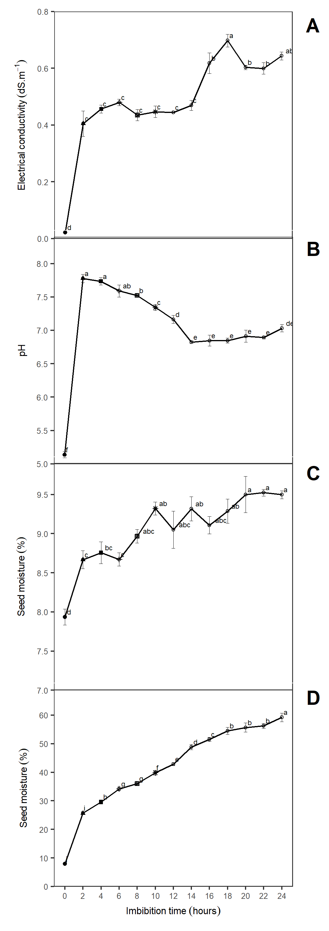

Figure 1 Response of *Jatropha curcas* seeds after different imbition time. (A) Electrical conductivity; (B) pH; (C) Seed moisture and (D) Seed water content. The letter represent the mean difference with Student-Newman-Keuls test (p ≤ 0.05). Means are represent with (±SE). n = 4.

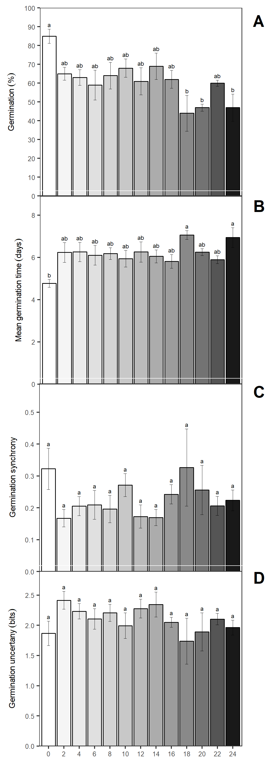

Figure 2 (A) Germination (%); (B) Mean germination time (days); (C) Germination synchrony and (D) Germination uncertany (bits) in *Jatropha curcas* seeds after different imbition times. The letter represent the mean difference with Student-Newman-Keuls test (p ≤ 0.05). Means are represent with (±SE). n = 4.

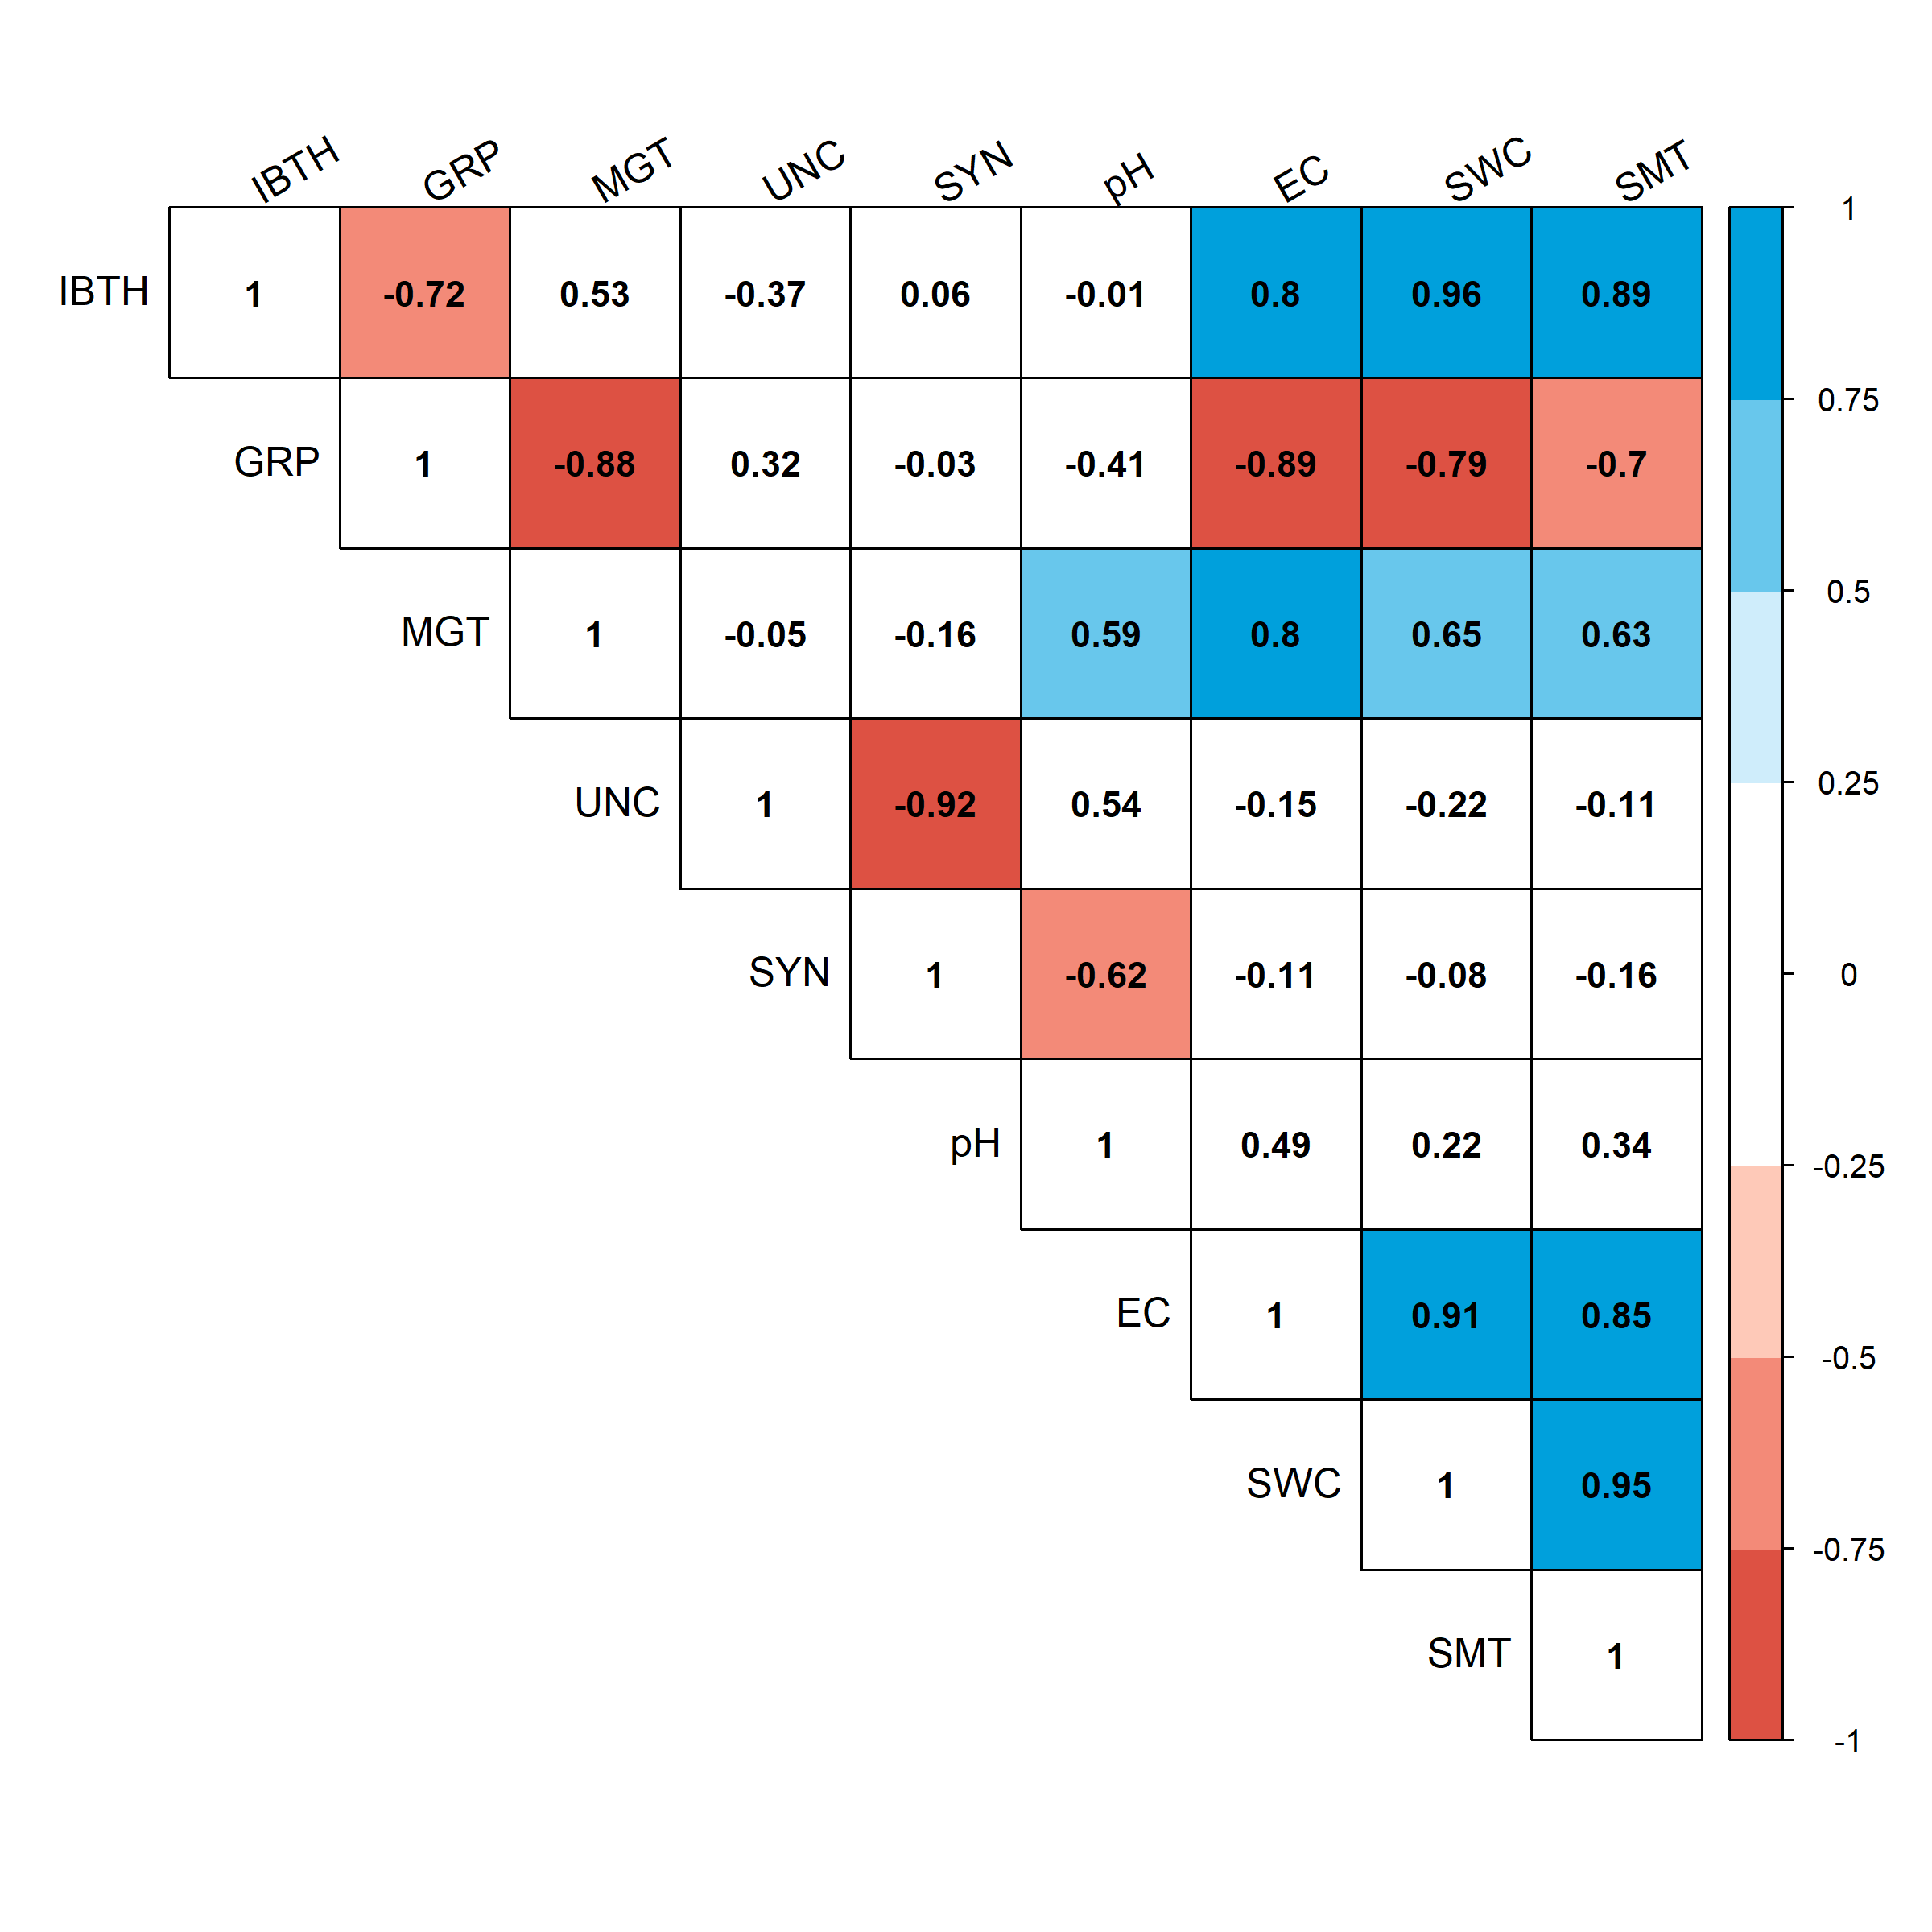

Figure 3 Pearson correlation (p < 0.05) matrix in *Jatropha curcas* seeds after different imbition times. Where: IBTH, imbibition time; GRP, germination percentage; MGT, mean germination time; SYN, germination synchrony; pH, potential of hydrogen; EC, electrical conducntivity; SWC, seed water content; SMT, seed moisture.

# References

Abdullah, W. D., Powell, A. A., & Matthews, S. (1991). Association of differences in seed vigour in long bean ( vigna sesquipedalis) with testa colour and imbibition damage. *The Journal of Agricultural Science*, *116*(02), 259. <https://doi.org/10.1017/s0021859600077662>

de Mendiburu, F. (2016). *Agricolae: Statistical procedures for agricultural research*. Retrieved from <https://CRAN.R-project.org/package=agricolae>

Duke, S. H., & Kakefuda, G. (1981). Role of the testa in preventing cellular rupture during imbibition of legume seeds. *PLANT PHYSIOLOGY*, *67*(3), 449–456. <https://doi.org/10.1104/pp.67.3.449>

Elhag, A. Z., & Gafar, M. O. (2014). Effect of sodium chloride on growth of jatropha (jatropha curcas l.) young transplants. *Universal Journal of Plant Science*, *2*(1), 19–22.

Ginwal, H., Phartyal, S., Rawat, P., Srivastava, R., & others. (2005). Seed source variation in morphology, germination and seedling growth of jatropha curcas linn. in central india. *Silvae Genetica*, *54*(2), 76–79.

Hampton, J. G., & TeKRONY, D. M. (1995). *Handbook of vigour test methods.* The International Seed Testing Association, Zurich (Switzerland).

Heller, J. (1996). Physic nut. jatropha curcas l. promoting the conservation and use of underutilized and neglected crops. 1. *Roma: IBPGR*.

Hobbs, P. R., & Obendorf, R. L. (1972). Interaction of initial seed moisture and imbibitional temperature on germination and productivity of soybean1. *Crop Science*, *12*(5), 664. <https://doi.org/10.2135/cropsci1972.0011183x001200050033x>

Husson, F., Josse, J., Le, S., & Mazet, J. (2017). *FactoMineR: Multivariate exploratory data analysis and data mining*. Retrieved from <https://CRAN.R-project.org/package=FactoMineR>

ISHIDA, N., KANO, H., KOBAYASHI, T., HAMAGUCHI, H., & YOSHIDA, T. (1988). The relationship between imbibitional damage and initial water content of soybeans. *Agricultural and Biological Chemistry*, *52*(11), 2771–2775. <https://doi.org/10.1271/bbb1961.52.2771>

Koizumi, M., Kikuchi, K., Isobe, S., Ishida, N., Naito, S., & Kano, H. (2008). Role of seed coat in imbibing soybean seeds observed by micro-magnetic resonance imaging. *Annals of Botany*, *102*(3), 343–352. <https://doi.org/10.1093/aob/mcn095>

Koornneef, M., Bentsink, L., & Hilhorst, H. (2002). Seed dormancy and germination. *Current Opinion in Plant Biology*, *5*(1), 33–36. <https://doi.org/10.1016/s1369-5266(01)00219-9>

Kumar, V., Makkar, H. P., Amselgruber, W., & Becker, K. (2010). Physiological, haematological and histopathological responses in common carp (cyprinus carpio l.) fingerlings fed with differently detoxified jatropha curcas kernel meal. *Food and Chemical Toxicology*, *48*(8-9), 2063–2072. <https://doi.org/10.1016/j.fct.2010.05.007>

Lozano Isla, F., Benites Alfaro, O., & Pompelli, M. F. (2017). *GerminaR: Germination indexes for seed germination variables for ecophysiological studies*.

Matthews, S., & Bradnock, W. (1967). The detection of seed samples of wrinkle-seeded peas (pisum sativum l.) of potentially low planting value. *International Seed Testing Association*, *32*, 553–563.

Matthews, S., & Powell, A. (2006). Electrical conductivity vigour test: Physiological basis and use. *Seed Testing International*, *131*, 32–35.

Moncaleano-Escandon, J., Silva, B. C., Silva, S. R., Granja, J. A., Alves, M. C. J., & Pompelli, M. F. (2013). Germination responses of jatropha curcas l. seeds to storage and aging. *Industrial Crops and Products*, *44*, 684–690. <https://doi.org/10.1016/j.indcrop.2012.08.035>

Mukherjee, P., Varshney, A., Johnson, T. S., & Jha, T. B. (2011). Jatropha curcas: A review on biotechnological status and challenges. *Plant Biotechnology Reports*, *5*(3), 197–215. <https://doi.org/10.1007/s11816-011-0175-2>

Parrish, D. J., & Leopold, A. C. (1977). Transient changes during soybean imbibition. *PLANT PHYSIOLOGY*, *59*(6), 1111–1115. <https://doi.org/10.1104/pp.59.6.1111>

Pollock, B., Roos, E., & Manalo, J. (1969). Vigor of garden bean seeds and seedlings influenced by initial seed moisture, substrate oxygen, and imbibition temperature. *Journal of the American Society for Horticultural Science*, *94*, 577–584.

POWELL, A. A., & MATTHEWS, S. (1978). The damaging effect of water on dry pea embryos during imbibition. *Journal of Experimental Botany*, *29*(5), 1215–1229. <https://doi.org/10.1093/jxb/29.5.1215>

POWELL, A. A., & MATTHEWS, S. (1981). A physical explanation for solute leakage from dry pea embryos during imbibition. *Journal of Experimental Botany*, *32*(5), 1045–1050. <https://doi.org/10.1093/jxb/32.5.1045>

POWELL, A. A., OLIVEIRA, M. D. A., & MATTHEWS, S. (1986). The role of imbibition damage in determining the vigour of white and coloured seed lots of dwarf french beans (phaseolus vulgaris). *Journal of Experimental Botany*, *37*(5), 716–722. <https://doi.org/10.1093/jxb/37.5.716>

R Core Team. (2017). *R: A language and environment for statistical computing*. Vienna, Austria: R Foundation for Statistical Computing. Retrieved from <https://www.R-project.org/>

SHAH, S. (2005). Extraction of oil from jatropha curcas l. seed kernels by combination of ultrasonication and aqueous enzymatic oil extraction. *Bioresource Technology*, *96*(1), 121–123. <https://doi.org/10.1016/j.biortech.2004.02.026>

THORNTON, J. M., POWELL, A. A., & MATTHEWS, S. (1990). Investigation of the relationship between seed leachate conductivity and the germination of brassica seed. *Annals of Applied Biology*, *117*(1), 129–135. <https://doi.org/10.1111/j.1744-7348.1990.tb04201.x>

Vertucci, C. W., & Leopold, A. C. (1984). Bound water in soybean seed and its relation to respiration and imbibitional damage. *PLANT PHYSIOLOGY*, *75*(1), 114–117. <https://doi.org/10.1104/pp.75.1.114>

Wickham, H., & Chang, W. (2016). *Ggplot2: Create elegant data visualisations using the grammar of graphics*. Retrieved from <https://CRAN.R-project.org/package=ggplot2>

Windauer, L. B., Martinez, J., Rapoport, D., Wassner, D., & Benech-Arnold, R. (2011). Germination responses to temperature and water potential in jatropha curcas seeds: A hydrotime model explains the difference between dormancy expression and dormancy induction at different incubation temperatures. *Annals of Botany*, *109*(1), 265–273. <https://doi.org/10.1093/aob/mcr242>

Windauer, L., Altuna, A., & Benech-Arnold, R. (2007). Hydrotime analysis of lesquerella fendleri seed germination responses to priming treatments. *Industrial Crops and Products*, *25*(1), 70–74. <https://doi.org/10.1016/j.indcrop.2006.07.004>

Yaklich, R. W., & Kulik, M. M. (1979). Evaluation of vigor tests in soybean seeds: Relationship of the standard germination test, seedling vigor classification, seedling length, and tetrazolium staining to field performance1. *Crop Science*, *19*(2), 247. <https://doi.org/10.2135/cropsci1979.0011183x001900020019x>