Germination and growth *Jatropha curcas* after storage and salt stress

Flavio Lozano-Isla1, Mariana L.O. Campos1, Lauricio Endres2, Agnaldo R. Chaves, Egidio B. Neto3, Marcelo F. Pompelli1

2017-06-23

# authors

1. Plant Physiology Laboratoty, Federal University of Pernambuco, Department of Botany, Recife, PE, Brazil, 50670901; 2. Plant Physiology Laboratory, Federal University of Alagoas, Center of Agronomy, Maceió, AL, Brazil; 3. Department of Chemistry, Federal Rural University of Pernambuco, Recife, PE, Brazil.

# Abstract

*Jatropha curcas* L. is a plant that can be used in the production of biofuel with strong resistance to drought. However, the crop presents two important problems: i) rapid loss of viability, resulting from the high respiratory rate of the seeds during the storage period; ii) seed sensitivity when germinated under salinity conditions. To achieve these objectives, two experiments were developed. In the first experiment were verified how the storage of seeds in a drier environment can influence germination, respiration rate and the main biochemical and physiological parameters. In the second experiment, five different genotypes (114, 133, 171, 183 and 218) originating from different producing regions of Brazil were studied under the effect of the addition of NaCl (0, 50, 75, 100 and 150 mM) in water irrigation. In this experiment, we evaluate the germination and initial growth. The results of the first experiment show that the use of desiccant, can stabilized the germinability of the seeds stored, a fact corroborated by the reduction of the water potential of the seeds and reduction of the respiratory rates. On the other hand, we showed that *J. curcas* presents a moderate tolerance to salinity, being able to germinate up to 150 mM NaCl, even though a drastic reduction in the biomass accumulation was observed with the increase of the salt concentration in the irrigation water. The results show that the germination was reduced to values close to 4% in the treatment of 150 mM, while the mean germination time was increased with the increase in the concentration of salts. The biometric and biomass componets were strongly affected by the increase of the salts, while in the biomass allocation parameters, accumulation was observed in the stem of the seedlings. In this sense, genotypes 114, 171 and 183 were shown to be potentially tolerant while genotypes 218 and 133 were sensitive.

**Key words:** salinity tolerance, seed germination, biomass, biofuel, NaCl

# Highlights

* Reduction of water in the interstice of the seeds in *J. curcas* helps to maintain seed viability and oils content.
* The NaCl in the irrigation water can affect the seedlings since 75 mM, producing reduction in the biometrics and germination parameters.
* Exist a different levels of tolerance between the genotypes of *J. curcas* from different regions of Brazil
* The biometric parameter explain better *J. curcas* behavior under salinity condition.

# Introduction

*Jatropha curcas* (purgint nut) is a species belonging to the family Euphorbiaceae with multiple uses, abundantly distributed in many tropical and subtropical regions in the Americas, Africa and Asia (Heller, 1996; Takeda and others, 1982). Over the last 20 years they have gained a lot of attention as a potential crop for bioenergy production, since their seed oil can easily be converted to good quality biodiesel. In addition, the species does not present as edible and therefore does not compete with the other oilseeds (Pompelli et al., 2011). It has a high growth rate, easy propagation, short period until the first fruit harvest, low seed cost (Heller, 1996), high oil content (40-58%) (Pandey et al., 2012; Marcelo Francisco Pompelli et al., 2010), and good adaptation to different agroclimatic conditions (Divakara et al., 2010; Fini et al., 2013; Gao et al., 2008).

Germination is the process that determines when and where the seeds will initiate their growth (Günster, 1994), allowing the embryo to germinate and develop as a photosynthetically active organism. It begins with the imbibition of the quiescent seed and ends as the elongation of the embryonic axis, which can be visualized by the emergence of soil surface. At the moment, the reserves contained in the seeds begin to be mobilized by yielding energy to the developing embryo (Bewley et al., 2012; Sánchez-Linares et al., 2012). In this sense, salinity can affect germination, limiting the absorption of water in the seeds (osmotic effect) (Almansouri et al., 2001; HEGARTY, 1977) increases the toxicity by ions or the combination of both (Apse, 1999). In addition, NaCl may affect the mobilization of reserves (Bouaziz and Hicks, 1990), structural organization and protein synthesis in embryos (Alencar et al., 2015). In saline environments, plant adaptation during germination are decisive stages for species establishment, and such factors may negatively influence this process (Ungar, 1995).

If we take into account that *J. curcas* is a potential species for the large-scale generation of biodiesel, it is easy to think that it will be necessary to plant hundreds or thousands of hectares of trees to produce a satisfactory amount for commercial exploitation (Contran et al., 2013; Yang et al., 2010). In this sense, it is also salutary to remember that in times of harvest market prices usually fall a lot (Sumner and Mueller, 1989) and that is where the storage of seeds comes in. However, seed storage is the most factor that negatively affects seed viability, which includes the time elapsed between harvesting and utilization (Marcos Filho et al., 1984; Marcos-Filho, 1998). Marcos-Filho (Marcos-Filho, 1998) describes that seed storage is a major problem for agriculture (TeKrony, 2006), since it is responsible for large losses worldwide, especially in the tropics, where high temperatures and high relative humidity prevail during seed maturation and storage (Bilia et al., 1994). *J. curcas* does not escape this pattern, since it presents high metabolism, causing its seeds to rapidly lose their viability with storage (Moncaleano-Escandon et al., 2013). Although deterioration is irreversible and unavoidable, the speed of the process can be controlled by appropriate harvesting, drying and storage techniques (Sumner and Mueller, 1989). In this sense, the use of drier atmosphere environments could protect seeds (Hay et al., 2012; Hay and Probert, 2013; Rao et al., 2006).

Another factor that negatively influences agriculture is salinity, mainly in irrigated crops (Kumar et al., 2008), with NaCl being the predominant salt. Approximately 20% of the world's cultivated land is affected by salts (Sun et al., 2008). This problem is more relevant in arid and semiarid regions, where the lack of rainfall and the high evaporative demand caused by high temperatures and low relative humidity contribute to soil salinity intensification. In addition, salinity affects plant growth and development (Munns and Tester, 2008), negatively influencing different stages of its development (Almansouri et al., 2001; Khajeh-Hosseini et al., 2003; Khan and Gulzar, 2003). However, throughout their evolution, plants have developed mechanisms for regulation and tolerance to salts.

Some studies have described the ecophysiological aspects of the tolerance of *J. curcas* to NaCl (Díaz-López et al., 2012; Elhag and Gafar, 2014; Marcelo F. Pompelli et al., 2010; Rajaona et al., 2012); However, these studies focused on only one genotype. Although interest in the growth response of *J. curcas* is increasing, there is no known research that has examined the effect of NaCl on different genotypes during germination and early development of seedlings. In this work five distinct genotypes of *J. curcas* exposed to different NaCl treatments were studied to determine tolerance and to understand the morphological and physiological responses of this species under conditions of salinity in their germination and initial development.

Thus, the main hypotheses of this work were (i) to verify if the use of a desiccant agent could help to maintain the viability and germinability of the seeds of *J. curcas* when stored for long periods of time, and (ii) to study the mechanims of the tolerance of *J. curcas* to salinity between the genotypes cultivated in Brazil.

# Materials and methods

## Aging tests.

To test the effect of storage on seed viability, an artificial aging test was used to reduce the water content in the interstices of the seeds with a desiccant material composed of silica gel (Sigma-Aldrish, part number 10087). The genotype used in this experiment was 171 from Maceió, AL, Brazil. In each experimental unit 50 seeds of *J. curcas*, arranged in germination boxes (110 x 110 x 35 mm) were added under a stainless steel mesh suspended 2 cm from the desiccant. Five storage times (i.e., 0, 3, 6, 9, 12 months) were tested and stored under refrigerator at 4 ± 2°C. After each storage period, the seeds were removed to the germination boxes with desiccant and then placed to germinate.

## Germination tests with aged seeds.

After removed from germination boxes with desiccant, the seeds were allowed to germinate in germination boxes (110 x 110 x 35 mm) containing two sheets of germination test paper soaked with 2x the weight of the paper in water and were sealed and placed in a growth chamber (mod. NT 708, New Technical Instruments, Piracicaba, SP, Brazil). The incubator was equipped with four cold white fluorescent lamps of 20 W with 40 μmoles m-2 s-1 at the level of the germination boxes. The photoperiod was 12 h and the temperature conditions were 25 ± 0.5°C. Germination were daily evaluated for a period of 25 days. It was considered germinated, the seed whose radicle has emerged from the integument.

## Biochemical analysis of the seeds used in the aging test.

A portion of 10% of the aged seeds was carefully ground in liquid nitrogen and stored at -20°C until use. For extraction of soluble carbohydrates (TSC), soluble amino acids (TSA) and starch (STR), samples were solubilized in 50% (v/v) ethanol (Trethewey et al., 1998), whereas for analysis of total soluble proteins (TSP), the samples were extracted in Stitt buffer (Armengaud et al., 2009). The measures of soluble carbohydrates and starch, soluble proteins and soluble amino acids the methodologies described by Dubois (DuBois et al., 1956), Bradford (Bradford, 1976) and Moore and Stein (Moore et al., 1954) were used, respectively. For the quantification of the oil content (OIL) the methodology described in detail by Ahmad (Ahmad et al., 1981). To quantification of glucose (GLC), fructose (FTS) and sucrose (SCR) (Stitt et al., 1989), coupled to the production of 6-phosphogluconate, in the sequential presence of hexokinase, phosphoglucoisomerase, glucose-6-phosphate dehydrogranase and invertase enzymes were used, as described in Stitt (Stitt et al., 1989). All these analyzes were performed in triplicate.

## Physiological analyzes coupled to the aging test.

The relative water content (RWC) of seeds was calculated as described to Moncaleano-Escandon (Moncaleano-Escandon et al., 2013). The water potential (WTP) of the seeds was quantified with the dewpoint water potential meter (WP4C; Decagon Devices, Pullman, WA, USA), where the seeds were lightly cracked to allow water to pass through the seeds to the internal environment. The values were obtained in MPa. For respiratory rate estimation (RPR), 5% of the seeds used in each storage period were inserted whole in a CO2 flow chamber (6400-09; LiCOR, Lincoln, NE, USA). For each storage time, 10 different samples were used as replicates. In each measurement procedure three cycles of 102 seconds were performed, with a 2 second interval between the readings. During this time the increase in CO2 concentration inside the chamber was monitored. The reference CO2 was calibrated, at each measurement, according to the CO2 concentration of the environment (~ 400 μmol CO2 m-2 s-1). The net respiration rate was expressed in μmol CO2 h-1 g-1 seed.

## Germination tests in the presence of NaCl.

For this experiment seeds of five genotypes (Table 1) of *J. curcas* originating from different producing regions of Brazil, given by EMBRAPA Agroenergia (Brasília, DF – Brazil), where kept at 4°C until their use. The germination was carried out in a greenhouse at the Federal University of Pernambuco, Department of Botany, Recife, PE (8°02"59.0' S; 34°56"54.9' W, 4 masl). The average temperature being recorded during the experiments using a portable mini climatic estation (mod. KR420, Akron Measure Instrument, Leuven, Belgium). In this experiment, five different concentrations of NaCl (0, 50, 75, 100 and 150 mM) were tested in the irrigation water, with zero being destiled water. After the soaking, all seeds were disinfected with NaOCl (2%) for 10 minutes and triply rinsed with distilled water.Thus, the seeds were germinated in polypropylene boxes (200 x 200 x 50 mm) containing 2,500 g of river washed sand, air-dried, where 25 seeds were soaked. Each boxes containing 25 seed were considered as an experimental unit. The boxes were irrigated daily with 300 mL of water containing Hoagland nutrient solution (Hammond and Epstein, 1972) at the concentration of 25%, this being the volume of irrigation required (i.e., previously tested) to leach excess salts and prevent their accumulation in soil. The germination was evaluated daily for 25 consecutive days until the seedlings were collected. In this experiment, it was considered seed germinated when the aerial part emerged from the soil. The experiment were replicated five times.

## Evaluation of germination parameters.

For the two experiments the different germination parameters were calculated: germinability (GRP), mean germination time (MGT), germination uncertainty (GRU) and germination synchrony (GRS). All calculations, graphs and statistics were performed with GerminaR package (Lozano Isla et al., 2017).

## Evaluation of biometric parameters and biomass.

The mean seedling height (HGT) and mean stem diameter (STD) were evaluated at the end of the experiment (Moncaleano-Escandon et al., 2013). For this, the seedlings were collected and separated into three components: leaves, stems and roots. The stem diameter were measured by a digital caliper (Digital Caliper, ROHS, ZAAS Precision, Piracicaba, SP). Leaf area (LFA) was evaluated by plant and for experimental unit (TLFA) (Pompelli et al., 2012). To estimate dry biomass, all samples were dried by a forced ventilation oven at 70°C for 72 hours. Leaf dry weight (LDW), stem dry weight (STDW) and root dry weight (RDW) were used to calculate several biomass parameters, such as: total dry weight (TDW); shoot dry weight (STDW); Leaf weight ratio (LWR; ratio between LDW and TDW); stem dry weight ratio (SWR; ratio between STDW and TDW); shoot dry weight ratio (STWR, ratio between STDW and TDW) and root dry weight ratio (RWR; ratio between RDW and TDW).

## Experimental design and statistical analysis.

Both germination experiments were conducted in a completely randomized design. For the seed storage experiment, five storage times (0, 3, 6, 9 and 12 months) were used. The salinity experiment was composed of a factorial, where five genotypes of *J. curcas* and five different concentrations of NaCl in irrigation water (0, 50, 75, 100 and 150 mM). Each treatment consisted of four replicates with 25 seeds. Statistical analysis and generation of graphs were performed in the statistical software R (R Core Team, 2017). The analysis of variance (ANOVA) was performed to evaluate the differences between the factors and the comparison of the means with the Student-Newman-Keuls test (p <0.05) (de Mendiburu, 2016). For the multivariate analysis, correlation analysis was performed (de Mendiburu, 2016; Wei and Simko, 2016) and principal components analysis were made (Husson et al., 2017).

# Results

## Germination of aged seeds.

The germination of the *J. curcas* seeds submitted to storage ranged from 9% to 15%, with values that are statistically similar to each other (Figure 1A). Although germination was not affected by storage, the mean germination time was significantly increased with storage time (Figure 1B). The germination was completely asynchronous for all storage times, with a mean of 0.16 being recorded before storage and close to zero at other times (Figure 1C). As it was observed, the germination in the time was significantly affected by the storage time. However, the germination uncertainty was not affected by the storage (Figure 1D). It is verified that the seeds before storage and stored for 3 months began their germination on the 3rd and the 4th day after sowing respectively, while in other times the germination of the first seed was only computed from the 6th day. The time for stabilization of the germination was increased as the storage time was increased, being completed at 15 days without storage and at 23 days at 12 months of storage.

## Biochemical responses of seeds submitted to aging.

It was verified that the oil content in the seeds remained practically stable until the sixth month of storage at the rate of 35%, with significant reductions from 12th month of storage, when the oil content was approximately 29% (Figure 2A). We verified a strong and negative correlation between oil content in the seeds and storage time (r = -0.91, p ≤ 0.05). On the other hand, the starch was rapidly metabolized with approximate reduction of 33% with time 12 months of storage (Figure 2B). Total soluble protein and total soluble amino acid content was increased by 160% and approximately 67% during storage (Figure 2C-D). A strong and positive correlation (r = 0.92, p ≤ 0.05) is shown between total soluble proteins and amino acid syntheses. There was a gradual reduction in the total soluble carbohydrate content at the 3rd month of storage compared to the control, without showing differences until the 12th month of storage (Figure 3A). Sucrose levels had a reduction of approximately 49% between 3 and 12 months of storage (Figure 2B), while glucose levels remained stable until the 3rd month of storage when compared to non-stored seeds. From the 6th month, the glucose was rapidly elevated, reaching 71% in the 12th month in relation to the non-stored seeds (Figure 3C). On the other hand, fructose levels did not show a trend during the months evaluated (Figure 3D). We showed that while sucrose levels decreased (r = -0.57, p ≤ 0.05) throughout the storage period, glucose (r = 0.67, p ≤ 0.05) had an opposite behavior, with increase with storage.

## Physiological responses of seeds submitted to aging.

With the storage time in desiccant agent, it was verified that the water content in the seeds was greatly reduced (Figure 4). Non-stored seeds had 8% of water content, while seeds stored by 12 months had 5.5% (Figure 4A). Concomitantly the water content, the seeds water potential had a strong reduction with the storage time, presenting a strong correlation (r = 0.83, p ≤ 0.05) between these two characteristics. We verified that the water potential of non-stored seeds were -35 MPa, but water potential were reduced to -124 MPa at 12 months of storage (Figure 4B). With the reduction of the relative water content and the water potential there was a strong reduction in the respiratory rate of the seeds (r = 0.88, p ≤ 0.05), ranging 115 mmol CO2 h-1 g-1 MF, in non-stored seeds to 10 mmol CO2 h-1 g-1 MF after 12 months of storage (Figure 4), a reduction of 91% over the seeds storage (Figure 4C).

## Seed germination treated with NaCl.

These experiments were conducted in greenhouse condition. The temperature was 30.6 ± 1.1°C and relative humidity of 70.4 ± 5.8%. The environmental data were collected every fifteen minutes during all days, 24 hours per day. In this experiment, we verified that the germination was almost zero at 150 mM NaCl for all genotypes. In 0 mM NaCl, seeds of genotype 183 and 114 had 71% and 86% of germination, respectively, with gradual decrease with the increase in NaCl concentration, from 4% to 100 mM and 0% to 150 mM. In another way, genotypes 218 and 133 did not differ by up to 100 mM NaCl, although germination was reduced to approximately 5% at the concentration of 150 mM. Seeds of the genotype 171 showed 65% germination in the control, reducing to 32% and 9% in 50 mM and 150 mM NaCl respectively (Figure 5A). The mean germination time for 0 mM NaCl was 5 to 7 days for all genotypes, while for the 150 mM NaCl concentration the interval was longer, ranging from 7.2 days to 12.3 days. No significant differences were observed in mean germination time from 50 mM to 75 mM, with a general average of 7.5 days for all genotypes (Figure 5B). There was no difference in the germination synchrony for the genotypes up to 75 mM NaCl. However, the synchronization at 100 mM was null at genotype 183, 114 and 218, as well as for genotype 133 in the concentration at 150 mM NaCl. It was observed that the synchrony were always lower than 0.25 for all concentrations and genotypes (Figure 5C), denoting a asynchronous profile. The maximum value for the uncertainty in germination in this experiment was 4.64 bits. Genotypes 183 and 114 showed a tendency to reduce uncertainty with the increase in NaCl concentration. The germination uncertainty was stable up to 75 mM NaCl, but with a significant increase in the concentration of 100 mM, where the uncertainty was 0.5 and 0.3 for the genotype 183 and 114, respectively. Genotypes 218, 171 and 133 showed a trend in increasing uncertainty from 0 mM to 100 mM without showing significant differences. At 150 mM, the uncertainty was 0.3, 0.7 and 0.5 for genotypes 218, 171 and 133 respectively (Figure 5D). The germination in time showed differences for each of the genotypes. The germination in the treatments without salt began between the 3rd and 4th day after sowing; for the treatments with NaCl addition the maximum values of germination were observed between the 9th and 12th day (Figure 6A-E). Regardless of the genotypes, first germination was observed on the 3rd day in 0 mM NaCl, while in the 50 mM and 75 mM NaCl, the germination was generally initiated on the 4th day, but arranged 5th day and 7th day in 100 mM and 150 mM NaCl, respectively. However, regardless of treatments and salinity levels, germination became stable since 13th day (Figure 6).

## Biometric and biomass components.

Although the germination was evaluated up to the concentration of 150 mM NaCl, the biomass production was only computed up to 100 mM NaCl because above this concentration the plants did not have enough vigor to resist salinity and eventually languished. The biomass parameters were strongly affected by the increase in salinity. There was a reduction trend for plant height (HGT) with salt increasing. The HGT reached approximately 13 cm in the control, but was strongly reduced until values smaller than 3 cm to 100 Mm of NaCl, fact clearly recorded in genotype 183 (Figure 7A). The root dry weight ratio (RWR) showed a distinct behavior for each genotype, with genotypes 171, 133 and 218, increasing biomass of the roots up to 75 mM. On the other hand, the genotype 183 showed increment up to 50 mM and from there had its values reduced. Genotype 114 was apparently unaffected by the increase in NaCl concentration (Figure 7B). The stem diameter (STD) presented reduction with the increase of the concentration of NaCl, even without statistical differences for concentration from 50 to 100 Mm for genotypes 218, 171 and 133. At concentrations of 100 mM the genotype 183 had the lowest values for STD (Figure 7C). A distinct profile is verified in the stem dry weight ratio (SWR), which was increased with elevation of salinity, even though no significant effect was observed up to the 50 mM concentration. For the 75 mM concentration, genotype 183 was better performance than the other while the genotypes 183, 171 and 133 for 100 mM concentration (Figure 7D). The leaf area (LFA) was possible to be evaluated until the concentration of 75 mM NaCl, since these was the most affected parameter by the increase of NaCl in the irrigation solution. The genotypes 218 presented the highest values for the control concentration, while for 50 mM the genotypes 133, 114 and 183 showed the highest performance. For the leaf dry weight ratio (LWR), it is possible to observe a trend in the reduction of biomass according salinity increase, being genotype 218 presenting a ratio of 0.42, followed by genotype 183 with a ratio of 0.39 for 0 mM treatment. Genotype 171 did not show significant difference in leaf weight ratio up to 50 mM, while genotype 114 increased his biomass accumulation to 50 mM. All genotypes showed drastic reduction of LWR since 75 mM NaCl (Figure 7F).

## Multivariate analysis of the salinity experiment.

The germination parameters were negatively affected by the increase in the salt concentration; There was a negative correlation between germination percentage (r = -0.55, p ≤ 0.05) and germination synchrony (r = -0.69, p ≤ 0.001). On the other hand, the mean germination time was positively significant when correlated with the increase of salts (r = 0.66, p ≤ 0.001). However, there was no significant correlation between germination uncertainty and salt increase (r = -0.23, p = 0.321). The salt concentration affected all biomass parameters, e.g., r = -0.86 (to leaf dry weight), r = -0.89 (to leaf area), and r = -0.89 (to plant height) and r = -0.91 (to stem diameter). Likewise, all growth ratios were negatively influenced by salt adicion, e.g., r = -0.90 (to leaf weight ratio), r = -0.94 (to leaf area ratio). Unlike stem dry weight ratio were positively influenced (r = 0.74) by salt adition. The principal components analysis (PCA) shows that approximately 74.4% of the variation can be explained by the parameters studied in this work. In the first component the variables LDW, LFA, HGT and TDW were the ones that presented the greatest contribution in the variance and are negatively correlated with the increase of NaCl, while the variables with positive correlation were the MGT and SWR. The genotypes 114, 171 and 183 were the bested between all tested and genotypes 133 and 218 seemingly were salt susceptible (Figure 8).

# Figures & tables

## Tables

Table 1 Information and location of the five genotypes of *Jatropha curcas* studied under salinity conditions.

|  |  |  |  |  |
| --- | --- | --- | --- | --- |
| Genotype | City | State | Location | Altitude (masl) |
| 183 | Jaíba | Minas Gerais | 23°47'55.0'' S 53°18'48'' W | 478 |
| 114 | Umuarama | Paraná | 15°10'27.0'' S 43°53'18'' W | 430 |
| 218 | São Miguel do Araguaia | Goiás | 13°55'57.0'' S 50°09'17'' O | 350 |
| 171 | Maceió | Alagoas | 09°27'60.0'' S 35°49'41'' W | 131 |
| 133 | Santa Inês | Maranhão | 03°39'24.9'' S 45°22'36'' W | 31 |

## Figures

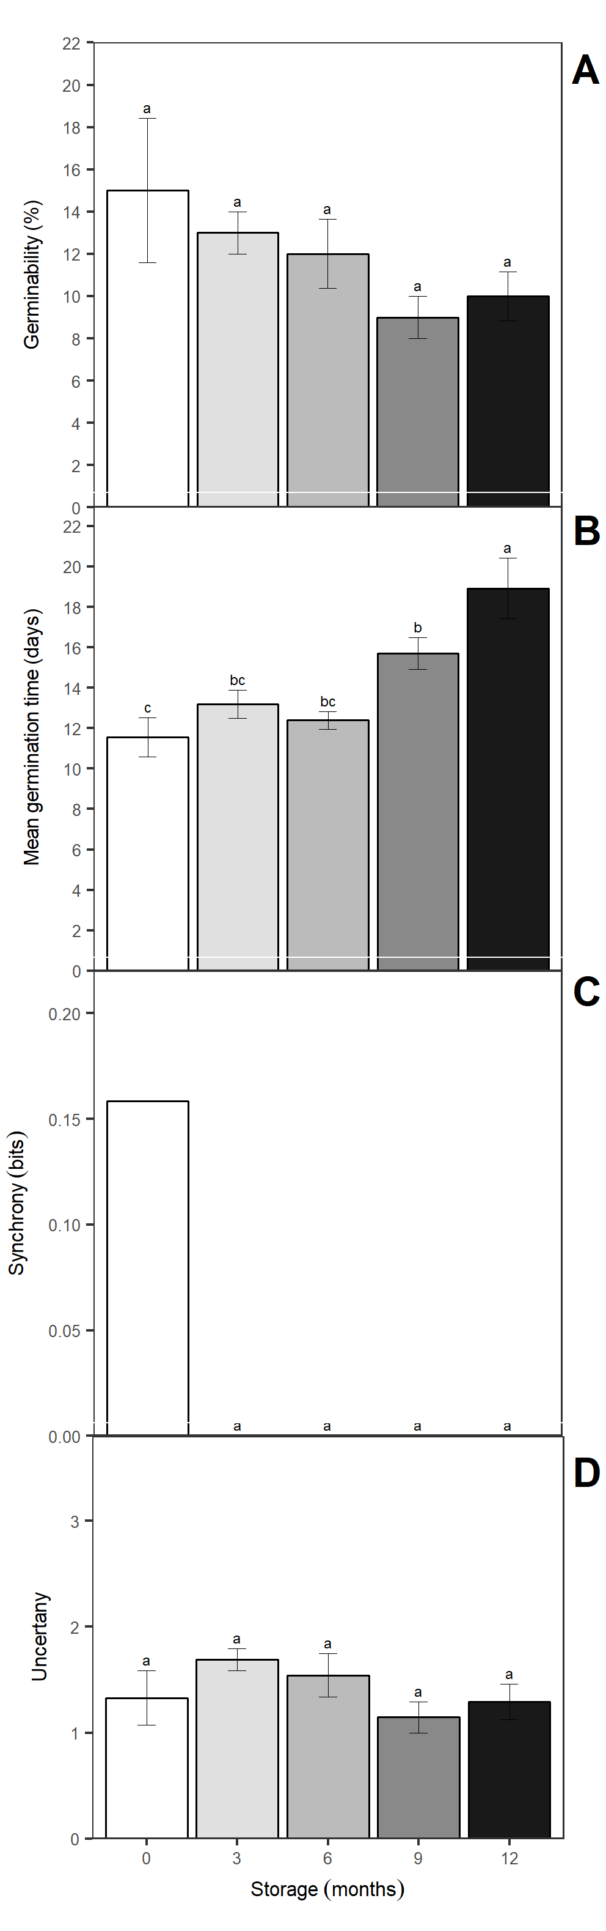

Figure 1 Germinability (A), mean germination time (B), synchrony index (C), germination uncertainty (D). The bars represent the mean (± SE). The mean differences between the storage months are represented by the lower case letters (SNK, p = 0.05). n = 4

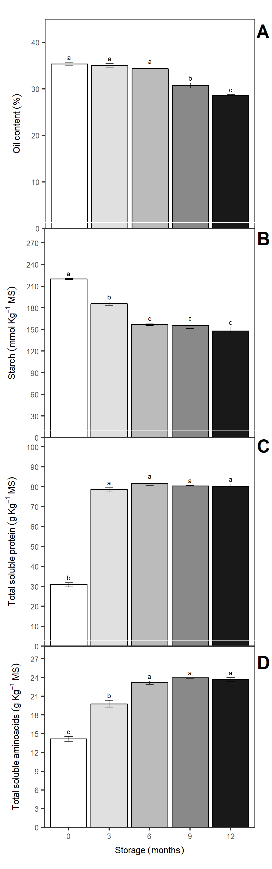

Figure 2 Oil content (A), starch (B), total soluble protein (C), total soluble amino acids (D) evaluated in *Jatropha curcas* seeds in genotype 171 stored for 0, 3, 6, 9 and 12 months. The bars represent the mean (± SE). The mean differences between the storage months are represented by the lower case letters (SNK, p = 0.05). n = 4

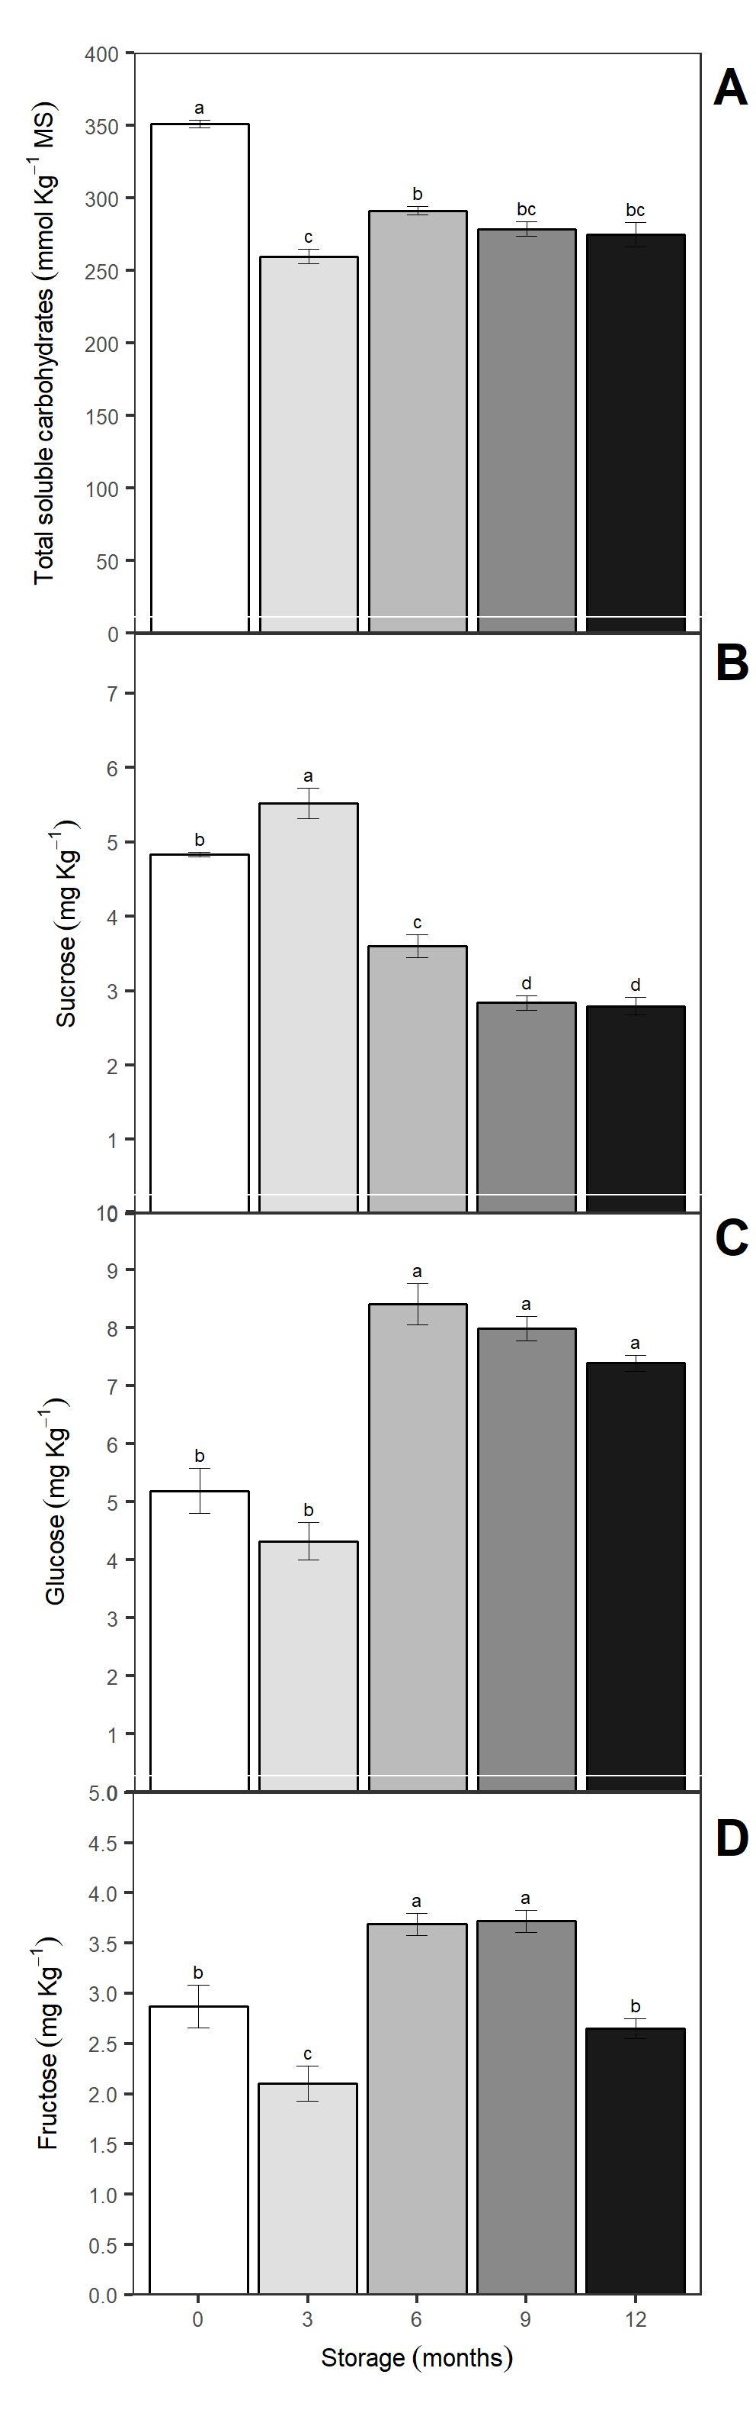

Figure 3 Total soluble carbohydrates (A), sucrose (B), glucose (C) and fructose (D) evaluated in *Jatropha curcas* seeds in genotype 171 were stored for 0, 3, 6, 9 and 12 months. The bars represent the mean (± SE). The mean differences between the storage months are represented by the lower case letters (SNK, p = 0.05). n = 4

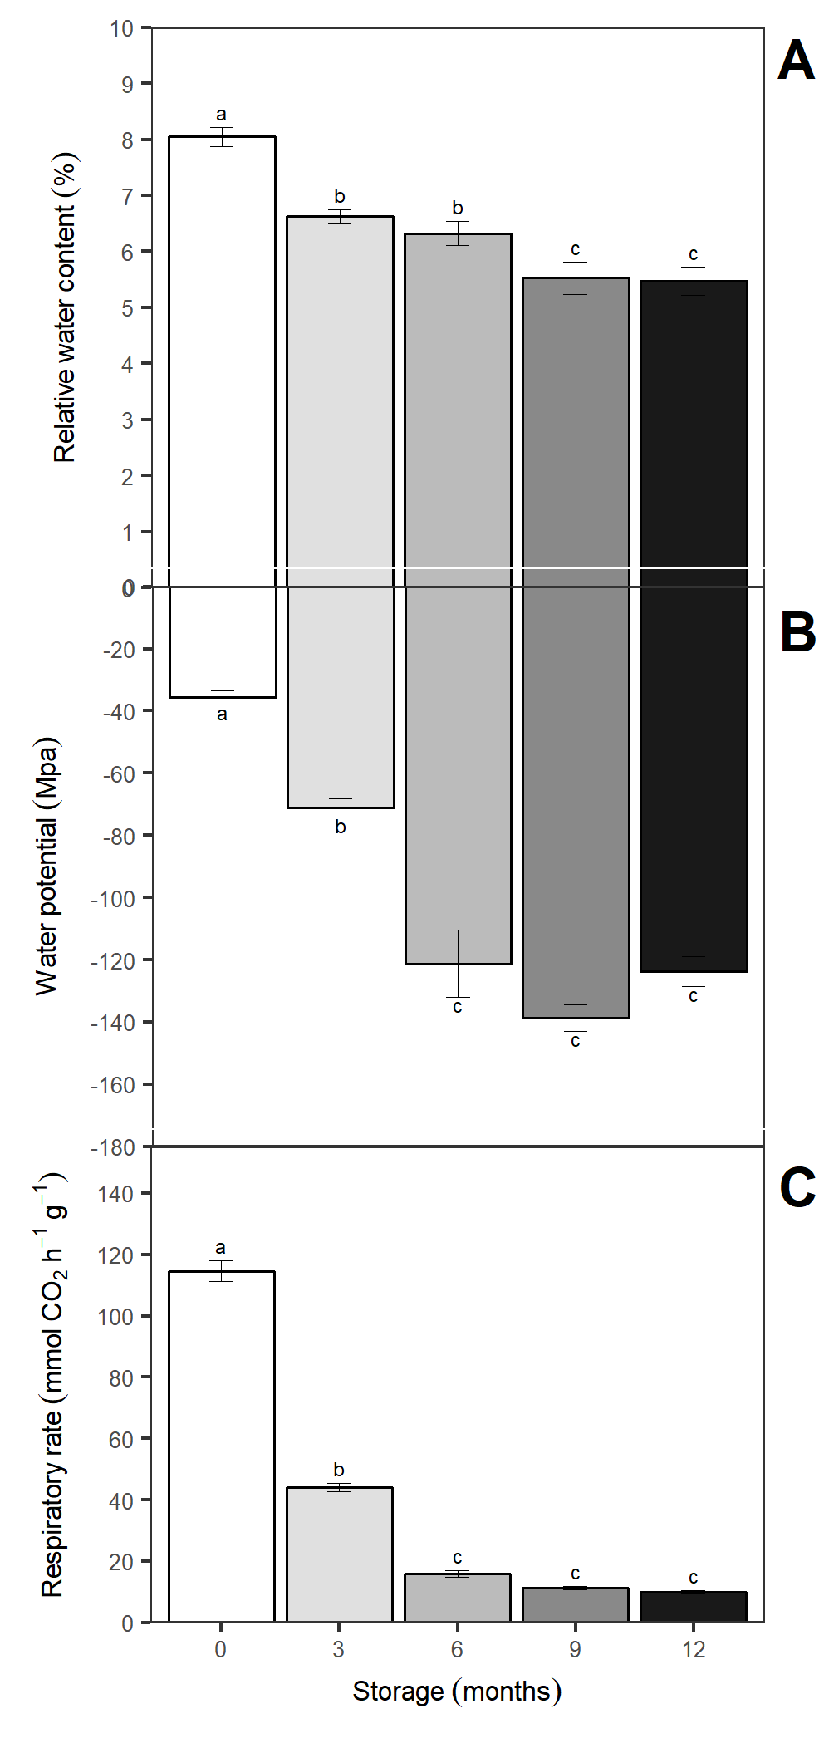

Figure 4 Relative water content (A), water potential (B), seed respiratory rate (C), evaluated in *Jatropha curcas* seeds in genotype 171 stored at 0, 3, 6, 9 and 12 months. The bars represent the mean (± SE). The mean differences between the storage months are represented by the lower case letters (SNK, p = 0.05). n = 4.

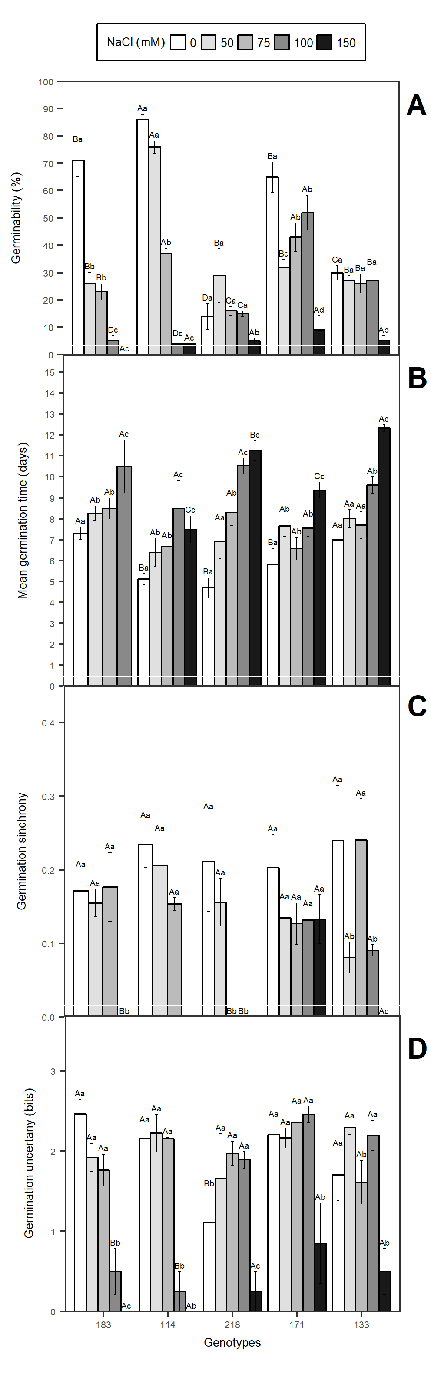

Figure 5 Germinability (A), mean germination time (B), germination synchrony (C) germination uncertainty (D) evaluated in five genotypes of *Jatropha curcas* L. under different NaCl concentrations (0, 50, 75, 100 and 150 mM). The vertical bars represent the mean (± SE). The mean differences between the accessions are represented by different capital letters and between salt levels by different lowercase letters (SNK, p = 0.05). n = 4

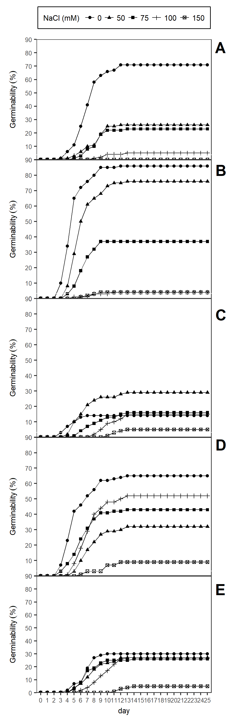

Figure 6 Cumulative germination in the time evaluated in five genotypes of Jatropha curcas L. under different concentrations of NaCl (0, 50, 75, 100 and 150 mM). Genotype 183 (A), 114 (B) 218 (C), 171 (D) and 133 E)

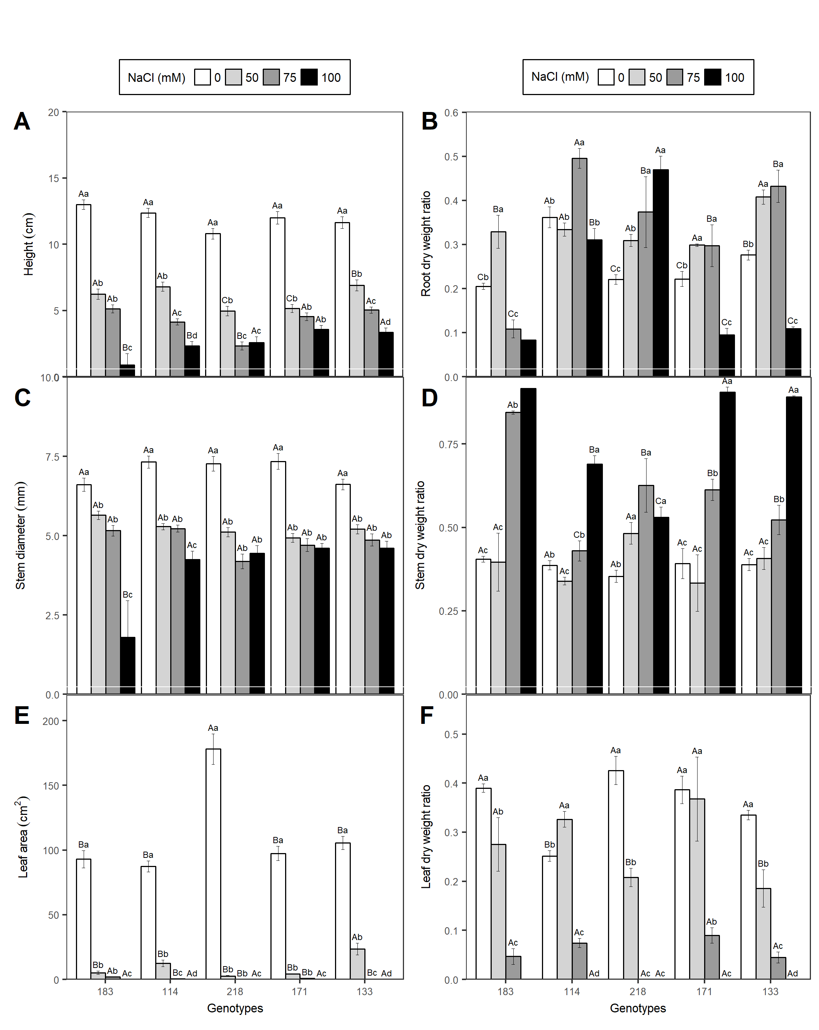

Figure 7 Leaf dry weight ratio (A), stem dry weight ratio (B), root dry weight ratio (C) and shoot dry weight ratio (D) evaluated in five genotypes of *Jatropha curcas* L. under different concentrations NaCl (0, 50, 75, 100 and 150 mM). The vertical bars represent the mean (± SE). The mean differences between the accessions are represented by different capital letters and between salt levels by different lowercase letters (SNK, p = 0.05). n = 4.

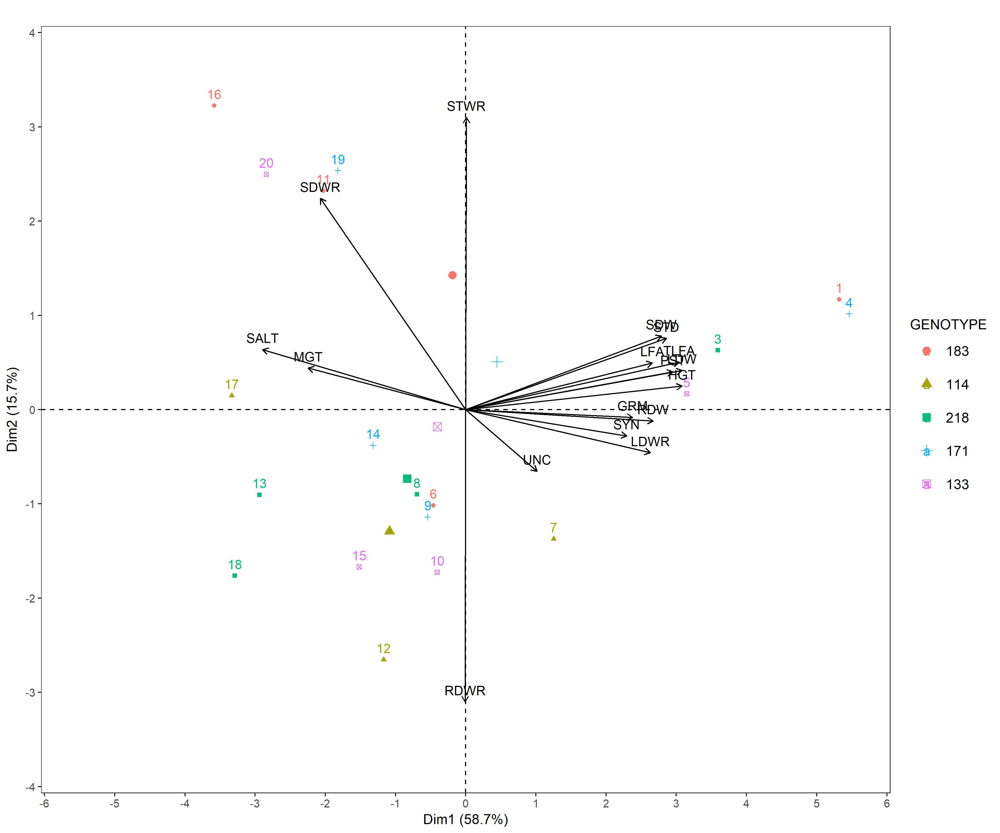

Figure 8 Principal components analysis (PCA) of the variables evaluated in five genotypes of *Jatropha curcas* L. under different concentrations of NaCl (0, 50, 75, 100 and 150 mM). GRM, Germinability; MGT, mean germination time; UNC, Uncertainty of germination; SYN, Synchronism of germination; LDW, leaf dry weight; RDW, root dry weight; SDW, stem dry weight; TDW, total dry weight; LFA,leaf area; TLFA, total leaf area; LWR, leaf dry weight ratio; SWR, stem dry weight ratio; RWR, root dry weight ratio; STWR, shoot dry weight ratio; HGT, plant height; STD, stem diameter.

# Discussion

The seeds of *J. curcas* are classified as orthodox (Hay and Probert, 2013), resistant to desiccation and can present water contents up to 18% (Marcelo Francisco Pompelli et al., 2010) when freshly harvested. Moncaleano-Escandon et al. (2013) (Moncaleano-Escandon et al., 2013), showed that the seeds of *J. curcas* can drastically reduce their germinability during storage at temperatures of 4°C or 25°C, accompanied by the reduction of some compounds such as starch and total soluble proteins. This author also showed that at 4°C it was more interesting for the storage of seeds of this species. All our tests were performed in 4ºC. With the use of desiccant. We observed a reduction of the relative humidity in the interstice of the seeds, reducing the water content of the seeds and consequently the water potential. Coupled to these facts, the respiration rate were strongly reduced, but not zero, which allowed the viability of the embryo at the expense of the solubilization of reserves, that supported the germinability of the seeds during the storage without significant reduction. However, we shows a strong and positive correlation (r = 0.92, p ≤ 0.05) between total soluble proteins and amino acid syntheses. A possible explanation could be that structural proteins were mobilized to generate carbon skeleton to respiration or amino acids as a compatible solutes that allows maintain the respiration even with reduction of seed moisture. Similarly described previously, we showed a significant correlation between decrease of sucrose and elevation to glucose (r = -0.87, p ≤ 0.05) and fructose (r = -0.56, p ≤ 0.05). The total soluble carbohydrates content must have been reduced by the metabolism of sucrose, which acted as the carbon source for the embryo. Circumstantial evidence of this idea is based on the elevation of glucose and fructose contents while there has been a reduction in the levels of starch and sucrose. Thus, the respiration rate, even low, foresees the live embryo, which allowed the same germination rate, even 12 months after storage, a fact that diverges of Moncaleano-Escandon et al. (2013) (Moncaleano-Escandon et al., 2013) which describes that the germination of *J. curcas* seeds drop near to zero after 12 months of storage, but six months after start of experiments the seed germination drop 27%. It should be noted that Moncaleano-Escandon et al. (2013) (Moncaleano-Escandon et al., 2013), stored its seeds without any type of desiccant and, in this study, we used a desiccant which promoted a with very low RH into seeds interstices. Another high evidence of respiration was responsible for the mobilization of reserves can be corroborated by the strong negative correlation between oil, starch and sucrose contents with its degradation products (i.e., total soluble proteins, total soluble amino acids and glucose). In addition, it was reported that seeds containing between 6% and 8% of moisture had a suddenly reduction in seed oil content in the first 3 months of storage, together with an increase in the concentration of free fatty acids (Akowuah et al., 2012; DHARMAPUTRA et al., 2009) Thus, it is verified that the moisture control in the interstice of the seeds should be taken into account to preserve both the viability and the oil content of the seeds of *J. curcas*.

The negative effects of saline stress were reflected in the delay in the mean germination time, from 3 days in the 0 mM NaCl and up to 13 days in 150 mM NaCl, which is confirmed by the significant reduction in germination rate. Same patter was previously reported by Alencar et al. (2015) (Alencar et al., 2015) which describes that *J. curcas* present a strong and negative correlation between germination rate and mean germination time. Regardless of the storage time, germination was initiated between the third and fifth day, with complete finishing after 23 days of sowing, which occurred mainly with 12 months of storage. Both salinity and storage delayed germination; but among them, storage seems to be the factor that promotes a better storage time, while NaCl seems to be toxic for germination in *J. curcas*. It was observed that the germination synchrony was reduced with the increase of the salts concentration, and the salinity promoted a more disorganized germination; a fact corroborated by the high values of germination uncertainty. That *J. curcas* has an asynchrony in germination, mainly in salt stress, is already very well studied (Alencar et al., 2015; Islam et al., 2009; Moncaleano-Escandon et al., 2013; Marcelo Francisco Pompelli et al., 2010; Silva et al., 2012). Therefore, if we analyze the previously published data with those presented of this study we can postulate that synchrony and the uncertainty of the germination can not be considered a good parameters for judgment, at least in *J. curcas*. A possible explanation for this could arise from the fact that *J. curcas* is not yet a domesticated species (Achten et al., 2010), which makes it present high levels of uncertainty in germination (Ranal and Santana, 2006). A factor highly related to the survival of the species in its original habitat (Maes et al., 2009) and very unstable from the physiological point of view. Seeds of *J. curcas* can not tolerate up to 150 mM NaCl in the irrigation water for seed germination, and it has very difficulties for seedlings development in concentrations above 75 mM of NaCl. The delay of the germination accompanied with the decrease of the development of the leaves and the reduction of the root growth promotes delay of the autotrophic phase of the plants, in extreme cases, leads to the death of the seedling in the first days after germination. A possible explanation for this is presented by Alencar et al. (2015) (Alencar et al., 2015) since there was a great increase of the Na+ and Cl- contents in the embryonic axes and in the endosperm of the seeds of *J. curcas*. Another possibility is loss of mobilization of cotyledon reserves on germination (Liu et al., 2010) affecting seedling establishment (Marques et al., 2013).

It is very commont that plants increase their stem biomass to the detriment of other organs when subjected to salinity (Dantas et al., 2007; Munns and Termaat, 1986; Praxedes et al., 2009). Munns (Munns and Termaat, 1986) describes this fact as an indirect effect of decreasing water uptake by roots and lower leaf expansion, while Praxedes (Praxedes et al., 2009) describes this effect as lower relative growth rate of the plant as a whole. Many studies (Bayuelo-Jiménez et al., 2002; Debez et al., 2004) describes that all biometric components are reduced in non-halophytes plants when submitted to salinity. In addition, Hasewaga (Hasegawa et al., 2000) attributed salt stress as reductor of growth reduction to a number of factors such as changes in the water status of the plant caused by the osmotic effect of the salts, increase in the concentration of toxic ions, which could be produce physiological and biochemical variations and alteration in the absorption of essential nutrients, as potassium and calcium.

# Conclusion

Results presented here, indicates that: 1) biometric parameters explain better the salinity response than the germination parameters. Thus, genotypes 114, 171 and 183 would be considered interesting candidates for salt stress tolerance, whereas genotypes 133 and 218 show sensitivity to NaCl addition. 2) the viability of germination and oil content in seeds of *J. curcas* can be maintained provided if there is control of moisture in the interstices of the seed during storage. 3) considering only salt stress experiments we can somehow describes that genotypes, 114, 171 and 183 could be considered as potential candidates for future breeding programs.

# Acknowledgments

The authors thank the National Council for Scientific and Technological Development (CNPq Process nº 404357/2013-0) for the financial support. The first author thanks the Coordination of Improvement of Higher Education Personnel (CAPES) for the scholarship. Special thanks to Dr. Agnaldo Rodrigues de Melo Chaves, Tropical Semiarid Agricultural Research Center, Embrapa Semiárido, Petrolina, PE, Brazil and Embrapa Agroenergy, Brasília, DF, Brazil for giving the seeds used in this study. The authors would also like to extend special thanks to Mrs. Ana Maria Meucci Dal Cin for her teaching and dedication to better formation, which benefited Marcelo Francisco Pompelli, at about 30 years ago.

# References

Achten, W.M., Nielsen, L.R., Aerts, R., Lengkeek, A.G., Kjær, E.D., Trabucco, A., Hansen, J.K., Maes, W.H., Graudal, L., Akinnifesi, F.K., others, 2010. Towards domestication of *jatropha curcas*. Biofuels 1, 91–107. doi:[http://dx.doi.org/10.4155/bfs.09.4](https://doi.org/http://dx.doi.org/10.4155/bfs.09.4)

Ahmad, M.U., Husain, S.K., Osman, S.M., 1981. Ricinoleic acid inPhyllanthus niruri seed oil. Journal of the American Oil Chemists’ Society 58, 673–674. doi:[10.1007/bf02899445](https://doi.org/10.1007/bf02899445)

Akowuah, J., Addo, A., Kemausuor, F., others, 2012. Influence of storage duration of *jatropha curcas* seed on oil yield and free fatty acid content. ARPN J Agric Biol Sci 7, 41–45.

Alencar, N.L., Gadelha, C.G., Gallão, M.I., Dolder, M.A., Prisco, J.T., Gomes-Filho, E., 2015. Ultrastructural and biochemical changes induced by salt stress in jatropha curcas seeds during germination and seedling development. Functional Plant Biology 42, 865. doi:[10.1071/fp15019](https://doi.org/10.1071/fp15019)

Almansouri, M., Kinet, J.-M., Lutts, S., 2001. Effect of salt and osmotic stresses on germination in durum wheat (*triticum durum*Triticum durum desf.). Plant and Soil 231, 243–254. doi:[10.1023/a:1010378409663](https://doi.org/10.1023/a:1010378409663)

Apse, M.P., 1999. Salt tolerance conferred by overexpression of a vacuolar na+/h+ antiport in arabidopsis. Science 285, 1256–1258. doi:[10.1126/science.285.5431.1256](https://doi.org/10.1126/science.285.5431.1256)

Armengaud, P., Sulpice, R., Miller, A.J., Stitt, M., Amtmann, A., Gibon, Y., 2009. Multilevel analysis of primary metabolism provides new insights into the role of potassium nutrition for glycolysis and nitrogen assimilation in arabidopsis roots. PLANT PHYSIOLOGY 150, 772–785. doi:[10.1104/pp.108.133629](https://doi.org/10.1104/pp.108.133629)

Bayuelo-Jiménez, J.S., Craig, R., Lynch, J.P., 2002. Salinity tolerance of species during germination and early seedling growth. Crop Science 42, 1584. doi:[10.2135/cropsci2002.1584](https://doi.org/10.2135/cropsci2002.1584)

Bewley, J.D., Bradford, K.J., Hilhorst, H.W.M., Nonogaki, H., 2012. Mobilization of stored reserves. Springer New York. doi:[10.1007/978-1-4614-4693-4_5](https://doi.org/10.1007/978-1-4614-4693-4_5)

Bilia, D., Fancelli, A., Filho, J.M., Machado, J., 1994. Comportamento de sementes de milho híbrido durante o armazenamento sob condições variáveis de temperatura e umidade relativa do ar. Scientia Agricola 51, 153–157. doi:[10.1590/s0103-90161994000100022](https://doi.org/10.1590/s0103-90161994000100022)

Bouaziz, A., Hicks, D.R., 1990. Consumption of wheat seed reserves during germination and early growth as affected by soil water potential. Plant and Soil 128, 161–165. doi:[10.1007/bf00011105](https://doi.org/10.1007/bf00011105)

Bradford, M.M., 1976. A rapid and sensitive method for the quantitation of microgram quantities of protein utilizing the principle of protein-dye binding. Analytical Biochemistry 72, 248–254. doi:[10.1016/0003-2697(76)90527-3](https://doi.org/10.1016/0003-2697(76)90527-3)

Contran, N., Chessa, L., Lubino, M., Bellavite, D., Roggero, P.P., Enne, G., 2013. State-of-the-art of the jatropha curcas productive chain: From sowing to biodiesel and by-products. Industrial Crops and Products 42, 202–215. doi:[10.1016/j.indcrop.2012.05.037](https://doi.org/10.1016/j.indcrop.2012.05.037)

Dantas, B.F., Sá Ribeiro, L. de, Aragão, C.A., 2007. Germination, initial growth and cotyledon protein content of bean cultivars under salinity stress. Revista Brasileira de Sementes 29, 106–110. doi:[10.1590/s0101-31222007000200014](https://doi.org/10.1590/s0101-31222007000200014)

de Mendiburu, F., 2016. Agricolae: Statistical procedures for agricultural research.

Debez, A., Hamed, K.B., Grignon, C., Abdelly, C., 2004. Salinity effects on germination, growth, and seed production of the halophyte cakile maritima. Plant and Soil 262, 179–189. doi:[10.1023/b:plso.0000037034.47247.67](https://doi.org/10.1023/b:plso.0000037034.47247.67)

DHARMAPUTRA, O.S., WORANG, R.J.L., SYARIEF, R., MIFTAHUDIN, M., 2009. The quality of physic nut (jatropha curcas) seeds affected by water activity and duration of storage. Microbiology Indonesia 3, 139–145. doi:[10.5454/mi.3.3.6](https://doi.org/10.5454/mi.3.3.6)

Divakara, B., Upadhyaya, H., Wani, S., Gowda, C.L., 2010. Biology and genetic improvement of jatropha curcas l.: A review. Applied Energy 87, 732–742. doi:[10.1016/j.apenergy.2009.07.013](https://doi.org/10.1016/j.apenergy.2009.07.013)

Díaz-López, L., Gimeno, V., Lidón, V., Simón, I., Martínez, V., García-Sánchez, F., 2012. The tolerance of jatropha curcas seedlings to NaCl: An ecophysiological analysis. Plant Physiology and Biochemistry 54, 34–42. doi:[10.1016/j.plaphy.2012.02.005](https://doi.org/10.1016/j.plaphy.2012.02.005)

DuBois, M., Gilles, K.A., Hamilton, J.K., Rebers, P.A., Smith, F., 1956. Colorimetric method for determination of sugars and related substances. Analytical Chemistry 28, 350–356. doi:[10.1021/ac60111a017](https://doi.org/10.1021/ac60111a017)

Elhag, A.Z., Gafar, M.O., 2014. Effect of Sodium chloride on Growth of Jatropha (Jatropha curcas L. ) Young Transplants. Universal Journal of Plant Science 2, 19–22. doi:[10.13189/UJPS.2014.020103](https://doi.org/10.13189/UJPS.2014.020103)

Fini, A., Bellasio, C., Pollastri, S., Tattini, M., Ferrini, F., 2013. Water relations, growth, and leaf gas exchange as affected by water stress in jatropha curcas. Journal of Arid Environments 89, 21–29. doi:[10.1016/j.jaridenv.2012.10.009](https://doi.org/10.1016/j.jaridenv.2012.10.009)

Gao, S., Ouyang, C., Wang, S., Xu, Y., Tang, L., Chen, F., others, 2008. Effects of salt stress on growth, antioxidant enzyme and phenylalanine ammonia-lyase activities in *jatropha curcas* l. seedlings. Plant Soil Environ 54, 374–381.

Günster, A., 1994. Seed bank dynamics longevity, viability and predation of seeds of serotinous plants in the central namib desert. Journal of Arid Environments 28, 195–205. doi:[10.1016/s0140-1963(05)80057-6](https://doi.org/10.1016/s0140-1963(05)80057-6)

Hammond, H.D., Epstein, E., 1972. Mineral nutrition in plants: Principles and perspectives. Bulletin of the Torrey Botanical Club 99, 102. doi:[10.2307/2484208](https://doi.org/10.2307/2484208)

Hasegawa, P.M., Bressan, R.A., Zhu, J.-K., Bohnert, H.J., 2000. PLANTCELLULAR ANDMOLECULARRESPONSES TOHIGHSALINITY. Annual Review of Plant Physiology and Plant Molecular Biology 51, 463–499. doi:[10.1146/annurev.arplant.51.1.463](https://doi.org/10.1146/annurev.arplant.51.1.463)

Hay, F., Thavong, P., Taridno, P., Timple, S., 2012. Evaluation of zeolite seed ’Drying Beads?’ for drying rice seeds to low moisture content prior to long-term storage. Seed Science and Technology 40, 374–395. doi:[10.15258/sst.2012.40.3.09](https://doi.org/10.15258/sst.2012.40.3.09)

Hay, F.R., Probert, R.J., 2013. Advances in seed conservation of wild plant species: A review of recent research. Conservation Physiology 1, cot030–cot030. doi:[10.1093/conphys/cot030](https://doi.org/10.1093/conphys/cot030)

HEGARTY, T.W., 1977. Seed and seedling susceptibility to phased moisture stress in soil. Journal of Experimental Botany 28, 659–668. doi:[10.1093/jxb/28.3.659](https://doi.org/10.1093/jxb/28.3.659)

Heller, J., 1996. Physic nut, *jatropha curcas* l. Bioversity international.

Husson, F., Josse, J., Le, S., Mazet, J., 2017. FactoMineR: Multivariate exploratory data analysis and data mining.

Islam, A., Anuar, N., Yaakob, Z., 2009. Effect of genotypes and pre-sowing treatments on seed germination behavior of jatropha. Asian Journal of Plant Sciences 8, 433–439. doi:[10.3923/ajps.2009.433.439](https://doi.org/10.3923/ajps.2009.433.439)

Khajeh-Hosseini, M., Powell, A., Bingham, I., 2003. The interaction between salinity stress and seed vigour during germination of soyabean seeds. Seed Science and Technology 31, 715–725. doi:[10.15258/sst.2003.31.3.20](https://doi.org/10.15258/sst.2003.31.3.20)

Khan, M.A., Gulzar, S., 2003. Light, salinity, and temperature effects on the seed germination of perennial grasses. American Journal of Botany 90, 131–134. doi:[10.3732/ajb.90.1.131](https://doi.org/10.3732/ajb.90.1.131)

Kumar, N., Pamidimarri, S., Kaur, M., Boricha, G., Reddy, M., 2008. Effects of NaCl on growth, ion accumulation, protein, proline contents and antioxidant enzymes activity in callus cultures of jatropha curcas. Biologia 63. doi:[10.2478/s11756-008-0054-7](https://doi.org/10.2478/s11756-008-0054-7)

Liu, J., Guo, W.Q., Shi, D.C., 2010. Seed germination, seedling survival, and physiological response of sunflowers under saline and alkaline conditions. Photosynthetica 48, 278–286. doi:[10.1007/s11099-010-0034-3](https://doi.org/10.1007/s11099-010-0034-3)

Lozano Isla, F., Benites Alfaro, O., Pompelli, M.F., 2017. GerminaR: Germination indexes for seed germination variables for ecophysiological studies.

Maes, W., Trabucco, A., Achten, W., Muys, B., 2009. Climatic growing conditions of jatropha curcas l. Biomass and Bioenergy 33, 1481–1485. doi:[10.1016/j.biombioe.2009.06.001](https://doi.org/10.1016/j.biombioe.2009.06.001)

Marcos Filho, J., Pescarin, H.M., Komatsu, Y.H., Demétrio, C.G., Fancelli, A.L., 1984. Testes para avaliação do vigor de sementes de soja e suas relações com a emergência das plântulas em campo. Pesquisa Agropecuária Brasileira 19, 605–613.

Marcos-Filho, J., 1998. New approaches to seed vigor testing. Scientia Agricola 55, 27–33. doi:[10.1590/s0103-90161998000500005](https://doi.org/10.1590/s0103-90161998000500005)

Marques, E.C., Freitas, P.A.F. de, Alencar, N.L.M., Prisco, J.T., Gomes-Filho, E., 2013. Increased na+ and cl- accumulation induced by NaCl salinity inhibits cotyledonary reserve mobilization and alters the source-sink relationship in establishing dwarf cashew seedlings. Acta Physiologiae Plantarum 35, 2171–2182. doi:[10.1007/s11738-013-1254-5](https://doi.org/10.1007/s11738-013-1254-5)

Moncaleano-Escandon, J., Silva, B.C., Silva, S.R., Granja, J.A., Alves, M.C.J., Pompelli, M.F., 2013. Germination responses of jatropha curcas l. seeds to storage and aging. Industrial Crops and Products 44, 684–690. doi:[10.1016/j.indcrop.2012.08.035](https://doi.org/10.1016/j.indcrop.2012.08.035)

Moore, S., Stein, W.H., others, 1954. A modified ninhydrin reagent for the photometric determination of amino acids and related compounds. Journal of Biological Chemistry 211, 907–913.

Munns, R., Termaat, A., 1986. Whole-plant responses to salinity. Australian Journal of Plant Physiology 13, 143. doi:[10.1071/pp9860143](https://doi.org/10.1071/pp9860143)

Munns, R., Tester, M., 2008. Mechanisms of salinity tolerance. Annual Review of Plant Biology 59, 651–681. doi:[10.1146/annurev.arplant.59.032607.092911](https://doi.org/10.1146/annurev.arplant.59.032607.092911)

Pandey, V.C., Singh, K., Singh, J.S., Kumar, A., Singh, B., Singh, R.P., 2012. Jatropha curcas: A potential biofuel plant for sustainable environmental development. Renewable and Sustainable Energy Reviews 16, 2870–2883. doi:[10.1016/j.rser.2012.02.004](https://doi.org/10.1016/j.rser.2012.02.004)

Pompelli, M., Antunes, W., Ferreira, D., Cavalcante, P., Wanderley-Filho, H., Endres, L., 2012. Allometric models for non-destructive leaf area estimation of jatropha curcas. Biomass and Bioenergy 36, 77–85. doi:[10.1016/j.biombioe.2011.10.010](https://doi.org/10.1016/j.biombioe.2011.10.010)

Pompelli, M.F., Barata-Luís, R., Vitorino, H.S., Gonçalves, E.R., Rolim, E.V., Santos, M.G., Almeida-Cortez, J.S., Ferreira, V.M., Lemos, E.E., Endres, L., 2010. Photosynthesis, photoprotection and antioxidant activity of purging nut under drought deficit and recovery. Biomass and Bioenergy 34, 1207–1215. doi:[10.1016/j.biombioe.2010.03.011](https://doi.org/10.1016/j.biombioe.2010.03.011)

Pompelli, M.F., Jesús, A.D., Orozco, J., Oliviera, M.T.D., Rafael, B., Rodrigues, M., Barbosa, M.O., Santos, M.G., 2011. Crise energética mundial e o papel do Brasil na problemática de biocombustíveis. Agronomía Colombiana 29, 361–371.

Pompelli, M.F., Rocha Gomes Ferreira, D.T. da, Silva Cavalcante, P.G. da, Lima Salvador, T. de, Hsie, B.S. de, Endres, L., 2010. Environmental influence on the physico-chemical and physiological properties ofJatropha curcasseeds. Australian Journal of Botany 58, 421. doi:[10.1071/bt10102](https://doi.org/10.1071/bt10102)

Praxedes, S.C., Lacerda, C.F.D., DaMatta, F.M., Prisco, J.T., Gomes-Filho, E., 2009. Salt tolerance is associated with differences in ion accumulation, biomass allocation and photosynthesis in cowpea cultivars. Journal of Agronomy and Crop Science 196, 193–204. doi:[10.1111/j.1439-037x.2009.00412.x](https://doi.org/10.1111/j.1439-037x.2009.00412.x)

R Core Team, 2017. R: A language and environment for statistical computing. R Foundation for Statistical Computing, Vienna, Austria.

Rajaona, A., Brueck, H., Seckinger, C., Asch, F., 2012. Effect of salinity on canopy water vapor conductance of young and 3-year old jatropha curcas l. Journal of Arid Environments 87, 35–41. doi:[10.1016/j.jaridenv.2012.06.014](https://doi.org/10.1016/j.jaridenv.2012.06.014)

Ranal, M.A., Santana, D.G. de, 2006. How and why to measure the germination process? Revista Brasileira de Botânica 29, 1–11. doi:[10.1590/s0100-84042006000100002](https://doi.org/10.1590/s0100-84042006000100002)

Rao, R., Singh, P., Rai, M., 2006. Storability of onion seeds and effects of packaging and storage conditions on viability and vigour. Scientia Horticulturae 110, 1–6. doi:[10.1016/j.scienta.2006.06.002](https://doi.org/10.1016/j.scienta.2006.06.002)

Sánchez-Linares, L., Gavilanes-Ruíz, M., Díaz-Pontones, D., Guzmán-Chávez, F., Calzada-Alejo, V., Zurita-Villegas, V., Luna-Loaiza, V., Moreno-Sánchez, R., Bernal-Lugo, I., Sánchez-Nieto, S., 2012. Early carbon mobilization and radicle protrusion in maize germination. Journal of Experimental Botany 63, 4513–4526. doi:[10.1093/jxb/ers130](https://doi.org/10.1093/jxb/ers130)

Silva, L.J. da, Santos Dias, D.C.F. dos, Carmo Milagres, C. do, Santos Dias, L.A. dos, 2012. Relationship between fruit maturation stage and physiological quality of physic nut (jatropha curcas l.) seeds. Ciência e Agrotecnologia 36, 39–44. doi:[10.1590/s1413-70542012000100005](https://doi.org/10.1590/s1413-70542012000100005)

Stitt, M., Lilley, R.M., Gerhardt, R., Heldt, H.W., 1989. [32] metabolite levels in specific cells and subcellular compartments of plant leaves. Elsevier. doi:[10.1016/0076-6879(89)74035-0](https://doi.org/10.1016/0076-6879(89)74035-0)

Sumner, D.A., Mueller, R.A.E., 1989. Are harvest forecasts news? USDA announcements and futures market reactions. American Journal of Agricultural Economics 71, 1. doi:[10.2307/1241769](https://doi.org/10.2307/1241769)

Sun, J., Chen, S., Dai, S., Wang, R., Li, N., Shen, X., Zhou, X., Lu, C., Zheng, X., Hu, Z., Zhang, Z., Song, J., Xu, Y., 2008. NaCl-induced alternations of cellular and tissue ion fluxes in roots of salt-resistant and salt-sensitive poplar species. PLANT PHYSIOLOGY 149, 1141–1153. doi:[10.1104/pp.108.129494](https://doi.org/10.1104/pp.108.129494)

Takeda, Y., others, 1982. Development study on *jatropha curcas* (sabu dum) oil as a substitute for diesel engine oil in thailand. Journal of the Agricultural Association of China 1–8.

TeKrony, D.M., 2006. Seeds. Crop Science 46, 2263. doi:[10.2135/cropsci2005.12.0445](https://doi.org/10.2135/cropsci2005.12.0445)

Trethewey, R.N., Geigenberger, P., Riedel, K., Hajirezaei, M.-R., Sonnewald, U., Stitt, M., Riesmeier, J.W., Willmitzer, L., 1998. Combined expression of glucokinase and invertase in potato tubers leads to a dramatic reduction in starch accumulation and a stimulation of glycolysis. The Plant Journal 15, 109–118. doi:[10.1046/j.1365-313x.1998.00190.x](https://doi.org/10.1046/j.1365-313x.1998.00190.x)

Ungar, I., 1995. Seed germination and seed-bank ecology in halophytes. Seed development and germination 599–628.

Wei, T., Simko, V., 2016. Corrplot: Visualization of a correlation matrix.

Yang, C.-y., Deng, X., Fang, Z., Peng, D.-P., 2010. Selection of high-oil-yield seed sources ofJatropha curcas l.for biodiesel production. Biofuels 1, 705–717. doi:[10.4155/bfs.10.40](https://doi.org/10.4155/bfs.10.40)